Geographical Shifts in US Cattle Production in Response to Warming-Induced Impacts on Alfalfa Hay Availability
Francis Tsiboe*, Research Agricultural Economist, United States Department of Agriculture, Economic Research Service, 805 Pennsylvania Avenue, Kansas City, MO 64105, USA
Hannah Shear, Assistant Professor, Oklahoma State University, Agricultural Economics, 420 Agriculture Hall, Stillwater, Oklahoma, 74078, USA
Jesse Tack, Professor, Department of Agricultural Economics, Kansas State University, 218 Waters Hall,1603 Old Claflin Place, Manhattan, KS 66506, USA
Jisang Yu, Associate Professor, Department of Agricultural Economics, Kansas State University, 318 Waters Hall,1603 Old Claflin Place, Manhattan, KS 66506, USA
*Correspondence to Francis Tsiboe, United States Department of Agriculture, Economic Research Service, 805 Pennsylvania Avenue, Kansas City, MO 64105, USA (Email: francis.tsiboe@usda.gov ).

Acknowledgment
The authors gratefully acknowledge the National Agricultural Statistics Service (NASS), PRISM Climate Group, Professor Wolfram Schlenker, and the Natural Resources Conservation Service (NRCS) for the dataset used for the study. The authors are also grateful for data processing on Beocat Research Cluster at Kansas State University. All errors are the responsibility of the authors. The findings and conclusions in this publication are those of the author(s) and should not be construed to represent any official USDA or U.S. Government determination or policy. This research was supported in part by the U.S. Department of Agriculture, Economic Research Service

Abstract

Keywords;
JEL; Q54, Q24
Geographical Shifts in US Cattle Production in Response to Warming-Induced Impacts on Alfalfa Hay Availability

1. Introduction
The Intergovernmental Panel on Climate Change (IPCC) has conclusively established that Earth's climate is undergoing significant changes due to the accumulation of greenhouse gases in the atmosphere [14,15]. These changes pose a threat to agriculture, evidenced by rising temperatures (citations), shifting precipitation patterns (citations), extreme weather events (citations), and dwindling water supplies (citations). Empirical studies have consistently shown that these climatic shifts result in a marked decrease in the yields of feed grains [1,16–19]. There has been less research on how these changes might also impact pasture and feed supplies, as well as the quality of forage available to grazing livestock, though the existing studies suggest a negative effect [3].
The occurrence of longer and more severe droughts, driven by higher summer temperatures and reduced rainfall in certain regions, could compel ranchers to seek alternative feed sources [4]. This situation is exacerbated by the competition between livestock and humans for major grain crops (citations), highlighting the importance of understanding how climate change might affect forage production. This has both direct implications (through grain consumption) and indirect implications (through livestock consumption) on domestic food availability and exports. Additionally, climate change could shift the geographic distribution of forage crops, potentially increasing the costs of livestock feeding. For rancher’s dependent on feed grains, either as a supplement or replacement for pasture grazing, changes in forage production due to drought could lead to increased production costs due to higher feed grain prices and the escalated costs of searching for and transporting feed [4].

Alfalfa production in the United States is a pivotal case study for exploring the effects of climate change on livestock feed. The U.S. hosts the largest livestock industry globally, accounting for #% of the world's energy and #% of protein consumption (citations). The growth and scale of the U.S. livestock sector depend significantly on the availability and production of feed grains and forage crops [10,11]. This dependency was dramatically highlighted by the nationwide drought in 2012, which severely degraded over 70% of U.S. pasturelands and led to a significant decrease in cow-calf returns, dropping more than $100 per cow [4]. Alfalfa, ranking as the fourth-largest crop in the U.S. by acreage [13], stands out for its high protein content and nitrogen-fixing ability, which lessens the reliance on synthetic fertilizers. In 2019, the U.S. harvested more than 54 million tons of alfalfa, with a value of approximately $8.4 billion [13]. Annually, the total acreage dedicated to hay, including alfalfa, is about 128 million, valued at an estimated $17 billion. Alfalfa is primarily cultivated in the northwestern U.S., especially in states such as California, Idaho, Nevada, Oregon, Wyoming, and Washington (see Figure 1). This regional concentration highlights the potential risks and challenges climate change poses to alfalfa production, affecting the entire livestock feed industry on both local and global scales.
This paper centers on alfalfa hay, aiming to bridge the gap in existing research by exploring three interrelated questions. The first question investigates the direct impact of global warming on alfalfa yields. The second question examines potential shifts in the spatial distribution of alfalfa availability, considering both local production within a county and the influence of neighboring counties' output. The third question assesses how changes in alfalfa availability might influence the geographical distribution of cattle production. To answer these questions, the study utilizes two main methods of analysis. The first applies reliable models of temperature-yield relationships [16,17,19] to county-level data from 1951 to 2022 to estimate temperature thresholds above which alfalfa yields begin to decline. Given these thresholds, the study then estimates the degree to which yields decline for incremental changes in temperatures. The second analysis uses simulations to determine the spatial distribution of alfalfa availability and its impact on where cattle are produced given the effects from the first analysis and projected warming scenarios.
The results show that increased exposure to beneficial heat (14°C-29°C) positively correlates with alfalfa hay yields, while exposure to heat above 29°C is detrimental. Incremental warming by 0.5°C shows a progression of yield reduction, with significant decreases under scenarios from 1°C to 3°C warming. Regionally, the Northeast sees yield gains in states like Connecticut, Rhode Island, and Massachusetts due to cooler climates reducing heat stress. In contrast, the South, along with parts of the Midwest and West, experiences notable declines, particularly in Texas, Louisiana, Oklahoma, Kansas, and Arizona, attributed to increased heat and potential drought. A 0.5°C increase boosts yield in some northern states, but substantial decreases occur in southern states such as Alabama, Arizona, and Florida, with Florida facing a 2.77% drop. As temperatures rise further, the impacts intensify, with Florida and Texas experiencing significant losses of 22.55% and 25.49% at a 3°C increase. This demonstrates the varying regional vulnerabilities of US livestock production to climate change, with northern gains diminishing or reversing beyond a 2°C rise.
[Insert availability and cattle shift results: 1 paragraph]
[insert broader implications 1 paragraph]
[insert value added relative to literature 1-2 paragraph]
In the following sections, we first describe the data sources, including yield measurements and temperature records, and outline the methodology for defining the alfalfa growing season and constructing variables such as growing degree days. Our methods section starts with a metric for alfalfa availability, a model for heat impact on yield, and concluding with simulations to project future warming scenarios. The results, presents comprehensive findings, including nonlinear relationship between alfalfa hay yields and heat, the differential impacts of uniform warming scenarios on yields, and the subsequent effects on alfalfa availability. Additionally, this section explores the geographical adaptation strategies of U.S. cattle production in response to these changes. The conclusion synthesizes the findings, emphasizing their importance for agricultural strategies and climate resilience.

2. Data
We utilize a county-level unbalanced panel dataset of alfalfa production outcomes (yield, area, and production output), livestock inventory, and weather variables constructed from multiple sources. The county-level alfalfa production outcomes and livestock inventory data are sourced from the USDA National Agricultural Statistics Service (NASS) Quick Stats database [13]. Weather variables are derived from the Parameter-elevation Regressions on Independent Slopes Model (PRISM) weather dataset, which provides grid-level (2.5 x 2.5 mile) daily weather data processed according to related literature [16,17]. Degree-day variables (detailed in Section 3) are calculated based on the interpolation procedure [16].
All weather variables were first aggregated to the county level as the weighted mean of all the PRISM grids within each county, using the proportion of each PRISM grid related to alfalfa and pasture cover based on cropland data layers (CDLs) from NASS CropScape (2008-2022) [20] as the aggregation weights. Subsequently, the daily degree days and precipitation were further aggregated over each year’s growing season for each county. The growing seasons are defined by state according to the NASS definition of the marketing year for hay. Within each state-defined range, we aggregated data only over the first seven months.
Table 1 presents summary statistics of the data, which spans 1,877 counties and includes 62,987 observations. On average, counties have 15.34 thousand acres devoted to alfalfa cultivation, yielding a production output of 44.28 thousand tons. The average yield of alfalfa stands at 3.04 tons per acre, indicating a productive use of the land under typical conditions. Boxplot of the yield data shown in Figure 1 panel (a) exhibits significant temporal and spatial variation. Weather conditions during the first seven months of the alfalfa growing season include an average precipitation of 19.11 inches. Temperature accumulation, measured in degree-days, shows varied growing conditions: 2,029.05 degree-days are recorded below 14°C; 1,116.59 degree-days between 14°C and 29°C, an optimal range for alfalfa (as shown in section 3); and only 23.51 degree-days above 29°C, indicating exposure to heat that could stress the plants. Boxplots of all the weather variables are shown in Figure 1 panels (b) – (e) and they exhibit significant temporal and spatial variations.
Figure 2, panels (a)-(c), depicts the spatial distribution of county-level alfalfa production metrics and cattle inventory across the US, focusing on the period from 2002 to 2022. To enhance the spatial coverage, we incorporated missing county-level data from the US agricultural censuses conducted in 2002, 2007, 2017, and 2022. Alfalfa production is dominated by Western U.S., where counties report exceptionally high average yield of 3.42 tons per acre on an average of 18.71 thousand acres per county. Key contributors exhibiting significant alfalfa (area [1000 acres], production [1000 tons], yield [tons per acre]) include Arizona (20.02, 154.68, 6.23), California (21.24, 140.37, 5.27), Idaho (24.39, 95.48, 3.39), Nevada (17.07, 73.52, 4.37), and Utah (18.23, 70.06, 3.52). Western counties are followed by those in the Midwest, where mean county yield is estimated at 2.82 tons per acre on an average of 9.93 thousand acres per county. Leading Midwestern states include South Dakota (30.02, 54.24, 2.07), Wisconsin (18.36, 49.8, 2.61), North Dakota (27.71, 45.05, 1.89), Nebraska (11.61, 38.00, 3.45), and Minnesota (11.32, 32.32, 2.93). At the low end, Southern counties exhibit much smaller alfalfa areas averaging about 0.95 thousand acres per county, with yields averaging only 2.33 tons per acre. The lowest performing Southern counties are found in Mississippi (0.08, 0.19, 2.02), South Carolina (0.11, 0.27, 2.23), Georgia (0.23, 0.45, 2.27), Louisiana (0.22, 0.49, 2.04), and North Carolina (0.24, 0.54, 2.14).
The correlation between alfalfa production and livestock density, particularly in cattle farming, reveals a strategic alignment within the agricultural landscape that emphasizes the importance of forage management. With a significant correlation of 0.53 between county-level cattle inventory and alfalfa production, regions with abundant alfalfa tend to have higher cattle production. However, the correlation of 0.32 with alfalfa yield suggests that while the presence of alfalfa is essential, the highest yields are not necessarily required for successful cattle operations. This indicates that cattle farming is optimized more for the availability of sufficient forage rather than achieving maximum yield per acre. Moreover, the strategic alignment of alfalfa production with local economic and climatic conditions is becoming increasingly crucial as global warming introduces new challenges. Shifts in weather patterns could alter precipitation levels and increase temperatures, potentially disrupting alfalfa availability and directly impacting the livestock sector reliant on this crop for feed. Consequently, a decline in alfalfa availability could escalate feed costs or necessitate reductions in herd sizes, significantly affecting the agricultural economy. This underscores the critical need for adaptive forage production and management strategies to maintain robust cattle farming operations in the face of climatic changes.
In what follows, we ascertain the potential shifts in alfalfa availability induced by warming, aiming to identify geographical adaptive strategies that can sustain alfalfa and livestock production in the face of these challenges.

3. Methods
Our methodology consists of three stages. Initially, we develop a novel metric to measure alfalfa availability and analyze its association with cattle inventories specific to different locations. In the second stage, we estimate the effects of rising temperatures on alfalfa yields. This information is then used to evaluate the potential impacts on alfalfa availability and subsequently, on cattle inventories.

3.1 A metric for alfalfa availability
We define a metric for alfalfa availability that combines the local production of alfalfa in a county with the average production from nearby counties. For each county ($i$), local alfalfa production ($z_{i}$) is calculated as the mean production level from 2002 to 2022, as presented in Figure 2, Panel B. The production from surrounding counties is determined by a spatially weighted average of these local production values ($z_{i}$), where the weights ($w_{ij}$) are defined by a specific kernel function. Specifically, for i^{th} county, the estimate of nearby alfalfa production ($m\left(z_{i}\right)$) is given by:
$m\left(z_{i}\right)=\frac{1}{\sum_{j∈I,j≠i}{w_{ij}}}\sum_{j∈I,j≠i}{w_{ij}z_{j}}$ (1)
The weight matrix was computed as
$w_{ij}=\left\{\begin{matrix}1 & if \left|d_{ij}\right|<b \\ 0 & otherwise\end{matrix}\right.$ (2)
Here, $d_{ij}$ denotes the Euclidean distance between counties $i$ and $j$, and $b$ represents the bandwidth. The bandwidth was determined via cross-validation (Lu et al. 2014; Gollini et al. 2015). The weights assigned to county $j$ are set to one if the county falls within the distance $b$ from county $i$, and zero otherwise. This method offers computational efficiency by including only observations within the specified bandwidth. However, it also faces discontinuity challenges, as the estimated nearby production can change drastically when the point of estimation shifts. As we will demonstrate later, integrating alternative methods less prone to these discontinuity issues does not significantly alter our conclusions. The final value of alfalfa availability for a given county is calculated as $z_{i}+m\left(z_{i}\right)$.
For each county, the relationship between alfalfa availability ($X$) and cattle inventories ($Y$) is estimated using the formula ${\left(X^{'}W_{i}X\right)}^{-1}X^{'}W_{i}Y$, where $X^{'}$ is the transpose of $X$, and $W_{i}$​ is the spatial weight matrix specific to county i. This matrix (same as Equation (2)) is designed to adjust for spatial dependencies within the data.

3.2 Heat impact on yield
The study makes use of the large variation present in the assembled dataset to identify parameters of interest by applying models of climate change effects on crop yields proposed in the literature [16,17,19]. The model assumes a cumulative effect of temperature on seasonal alfalfa yields, and that yield is proportional to cumulative exposure. The implication is that the effect of temperature on the growth rates of alfalfa yields are the same and additively substitutable during the growing season. [16] provides the empirical validity of this assumption, where they specify that yield growth depends nonlinearly on heat (h) such that log yield ($\ln{y_{it}}$) for county i and year t is
$\ln{y_{it}}=\int_{\underline{h}}^{\overline{h}}{g\left(h\right)ϕ_{it}\left(h\right)dh}+w_{it}δ+ε_{it}$ (3)
Where $ϕ_{it}\left(h\right)$ is the time distribution of h over the growing season for county i and year t. The observed temperatures during the growing season range between $\underline{h}$ and $\overline{h}$. The vector $w_{it}$contains other control factors, including quadratic function of cumulative precipitation to capture the nonlinear effects of rainfall, quadratic time trend by state to capture state-specific technological change, and county fixed effect to control for cross-sectional heterogeneity. Finally, $ε_{it}$ captures any remaining unobserved heterogeneity and is assumed to be heteroskedastic.
Following related works [16], Equation (3) is approximated with the piecewise linear degree-day approach, which is like the concept of growing degree-days where alfalfa yield growth increases linearly up to an endogenous temperature threshold (i.e., the optimal temperature) and then decreases linearly for every 1°C increase above that threshold. The specification for the degree-day model is given by:
$\ln{y_{it}}=β_{0}+β_{L}{DDL}_{it}+β_{M}{DDM}_{it}+β_{H}{DDH}_{it}+w_{it}δ+u_{i}+ε_{it}$ (4)
The three temperature variables, ${DDL}_{it},{DDM}_{it},{DDH}_{it}$, capture respectively degree days between zero and the lower threshold, the lower threshold and the upper threshold, and above the upper threshold. Essentially, these variables admit a piecewise linear relation between temperature and log yield over three ranges of temperatures defined endogenously by the placement of cut points (thresholds). The temperature thresholds are endogenously determined by looping over all threshold-pairs between 0-39°C, estimate the least-squares segment slopes for each pair, and then pick the threshold and segment slopes that have the best model fit in terms of R-squared. This looping produced the lower and upper temperature thresholds at 14°C and 29°C, respectively. Finally, we cluster the standard errors at year level to account for possible spatial correlations as done in related works (citations).

3.3 Simulations
The Representative Concentration Pathway (RCP) trajectory adopted by the Intergovernmental Panel on Climate Change (IPCC) for its fifth Assessment Report (AR5) in 2014 suggests global warming increase projections that range from 0.4 to 4.8°C [15]. This study considers warming scenarios of 0.5 to 3°C in 0.5 increments to ascertain the respective changes in alfalfa yields. The predictions for each scenario were obtained via a three-step process. First, each daily temperature observation for the periods and location in the dataset was increased by the respective warming scenario. For instance, daily min and max temperatures of -15 and 18 °C recorded on say July 8, 1986, were changed to (-15 + k) and (18 + k) °C for the case of the k°C warming scenario, respectively. Using these new temperatures, the study then calculates the associated degree-days as ${DDL}_{k}$, ${DDM}_{k}$, and ${DDH}_{k}$. Finally, given the estimates from the piecewise linear degree-day approach, the predicted percentage change in alfalfa yield following an k°C increase in temperature is estimated as
$θ_{k}=\left[e^{{\hat{β}}_{L}\left({DDL}_{k}-DDL\right)+{\hat{β}}_{M}\left({DDM}_{k}-DDM\right)+{\hat{β}}_{H}\left({DDH}_{k}-DDH\right)}-1\right]×100\%$. (5)
We estimated yield shocks for each county based on the specified warming scenarios. Mean county yields over the period 2002-2022 (see Figure 2) were then adjusted according to each scenario before recalculating the availability of alfalfa over the period 2002-2022 and assessing the resultant shocks. We subsequently linked these alfalfa availability shocks to the cattle inventory associations we established in our initial analysis. This series of extrapolations was designed to evaluate how cattle production might geographically adapt in response to the impacts of warming on alfalfa availability.

4. Results

4.1 Alfalfa hay availability and its regional association with cattle inventories

4.2 Alfalfa hay yields drop sharply with exposure to temperatures over 29°C
The coefficients of Equation (4) are presented in Table 2. We estimate Equation (4) across six different growing season weather aggregation windows, with our preferred seven-month window achieving the highest R-squared value of 26.48%. It is important to note that interpreting the estimated coefficients of the degree day variables requires caution, as a change in a degree day implies changes in the entire temperature distribution. However, several significant observations hold true regardless of the aggregation window. Increased exposure to beneficial heat (degree days between 14°C and 29°C) is positively correlated with crop yields, whereas exposure to harmful heat (degree days above 29°C) is negatively correlated. The relationship between temperature and alfalfa yields, using the seven-month window (Figure 4), shows that temperatures below 14°C result in negligible yield improvements of 0.0000427%. Conversely, exposures from 14°C to 29°C yield a modest improvement of about 0.0000634%. However, temperatures above 29°C are associated with a significant yield reduction of 0.0014901%, indicating negative impacts from warming. Although the specific thresholds differ, the pattern of beneficial and detrimental temperature exposures observed in Figure 4 aligns with previous studies [16,17,19]. Regarding precipitation, the estimates in Table 2 indicate that it positively affects yields up to approximately # inches, after which the benefit declines. Given that the mean annual precipitation is only # inches, yields are unlikely to decline due to excessive annual precipitation. However, periodic destructive rainfall could still lead to yield declines, resulting from physical crop damage rather than agronomic limitations.

4.3 Impact of uniform warming on alfalfa hay yield
The dominance of beneficial (at or below 29°C) and detrimental (above 29°C) temperature exposures over one another will determine the overall impact of warming. To ascertain which of the two dominates, the study predicts yield impacts following a +1°C uniform temperature change. Figure 5(a) shows that relative to the current NOAA recommended baseline climate period of 1991-2020, a 1°C warming scenario produces an average 1.638% decrease in alfalfa hay yields in the US. Altering the warming intensity also shows that larger declines expected at hotter scenarios with alfalfa hay yields expected to decline by 0.621, 2.988, 4.673, 6.53, and 8.57% for a +0.5, +1.5, +2.0, +2.5, and +3.0°C uniform temperature change.
Our baseline climate period of 1991 to 2020 follows NOAA recommendations, but alternative periods may be more informative (IPCC, 1994). Earlier periods, such as 1961 to 1990, show more significant anthropogenic trends due to sulphate aerosols, especially in the eastern USA (Karl et al., 1996). Ideally, the 19th century would be the best baseline when anthropogenic impacts were minimal. Evaluating the +1°C alfalfa yield impact with different baselines reveals significant variations. The 1981-2010 period shows a slightly higher impact of -1.738%, while earlier periods, such as 1961-1990 (-3.304%), exhibit more substantial negative impacts. The highest impact is in 1971-2000 at -3.744%. These findings highlight the importance of considering various historical periods to fully understand climatic influences on agricultural productivity.
Hay harvesting presents unique challenges due to its multiple cuttings throughout the year, unlike crops such as corn and soybeans, which have specific growing seasons. The period from seeding to the last cut varies widely by location, making it difficult to define a uniform growing season. Our preferred specification aggregates data only over the first seven months within each state-defined range. To evaluate the robustness of the +1°C alfalfa yield impact, we independently adjust the weather data accumulation window. Our analysis reveals that the yield impact of a +1°C temperature increase varies with the data window. A 10-month window shows -2.032%, while a 7-month window, our preferred specification, yields -1.638%. Shorter windows like 6 months (-1.231%) and 5 months (–0.733%) show decreasing impacts. Finally, non-alfalfa hay types show a slightly higher impact of -1.863% following a +1°C warming scenario indicating that different types of hay respond differently to warming temperatures, with alfalfa hay being the most resilient.
The predicted impacts of a +1°C climate change scenario on U.S. alfalfa hay yields vary significantly by region (See Figure 6). Counties in the Northeast generally show positive trends, with those in Connecticut (county average = +1.54%), Rhode Island (+1.47%), and Massachusetts (+1.34%) experiencing the most significant increases, likely due to the cooler climate mitigating heat stress. The Midwest presents a mixed response; with counties in states like North Dakota (+1.10%), Wisconsin (+1.02%), and Minnesota (+1.04%) see slight gains, possibly benefiting from warmer temperatures improving growing conditions, while those in Kansas (-4.24%) and Nebraska (-2.73%) face notable decreases. The South, characterized by already higher temperatures, largely experiences negative impacts, with counties in Texas (-8.13%), Louisiana (-7.78%), and Oklahoma (-7.07%) observing the sharpest declines in yields, possibly exacerbated by increased heat and drought conditions. In the West, outcomes are diverse; counties in Oregon (+0.58%) and Washington (+0.48%) see minor improvements, suggesting some areas may benefit from modest warming, whereas counties in Arizona (-6.99%) and Nevada (-1.24%), located in arid regions, encounter declines.
Figure 6 also illustrates the geographical changes in alfalfa yields with temperature increases across various regions. The impact on yields varies significantly with increasing temperature gradients. For example, with only a 0.5°C increase, counties in states like Connecticut, Maine, and Massachusetts experience an increase in yields, while counties in southern states such as Alabama, Arizona, and Florida see a notable decrease, with Florida experiencing a yield drop of 2.77%. As the temperature increase reaches 1.5°C, counties in Arizona and Florida show dramatic decreases in yields by 10.57% and 9.65%, respectively. The negative impact intensifies at a 3°C increase, particularly affecting states like Florida and Texas with county yield reductions averaging 22.55% and 25.49%, respectively. Interestingly, northern states such as Connecticut, Maine, and Massachusetts continue to see yield increases or less severe decreases up to a 2°C temperature increase, after which the impact becomes neutral or negative. By contrast, southern and central states experience accelerating declines as temperatures rise, with Missouri and Kansas notably impacted by 15.83% and 12.57% decreases at a 3°C increase, coinciding with these states being major cattle-producing areas. These estimates are indicative of broader regional vulnerabilities of livestock production as the temperature continues to rise.

4.4 Impact of warming on alfalfa hay availability

4.5 Geographical adaptation of US cattle production

5. Conclusion

References
1. Malikov E, Miao R, Zhang J. Distributional and temporal heterogeneity in the climate change effects on U.S. agriculture. J Environ Econ Manage. 2020;104: 102386. doi:10.1016/j.jeem.2020.102386
2. Brown ME, Antle JM, Backlund P, Carr ER, Easterling WE, Walsh MK, et al. Climate Change, Global Food Security, and the U.S. Food System. Washington, DC; 2015. doi:10.7930/J0862DC7
3. Gauly M, Bollwein H, Breves G, Brügemann K, Dänicke S, Daş G, et al. Future consequences and challenges for dairy cow production systems arising from climate change in Central Europe – a review. Animal. 2013;7: 843–859. doi:10.1017/S1751731112002352
4. Kemper N, Flanders A, Watkins B, Popp M. Impact of the 2012 Drought on Field Crops and Cattle Production in Arkansas - Preliminary Report. In: Department of Agriculture, Research and Extension, University of Arkansas System [Internet]. 2013. Available: https://www.uaex.edu/environment-nature/disaster/drought-effects/Ark_Drought_Report_August2012.pdf
5. Fuquay JW. Heat Stress as it Affects Animal Production. J Anim Sci. 1981;52: 164–174. doi:10.2527/jas1981.521164x
6. St-Pierre NR, Cobanov B, Schnitkey G. Economic Losses from Heat Stress by US Livestock Industries. J Dairy Sci. 2003;86: E52–E77. doi:10.3168/jds.S0022-0302(03)74040-5
7. Key N, Sneeringer S. Potential effects of climate change on the productivity of U.S. dairies. Am J Agric Econ. 2014. doi:10.1093/ajae/aau002
8. Hurt C. The Economic Importance of U.S. Animal Agriculture. In: farmdoc daily (9):158, Department of Agricultural and Consumer Economics, University of Illinois at Urbana-Champaign, [Internet]. 2019. Available: https://farmdocdaily.illinois.edu/2019/08/the-economic-importance-of-u-s-animal-agriculture.html
9. Morrison RM, Melton A, Kassel K. Ag and Food Sectors and the Economy. In: ERS, Ag and Food Statistics: Charting the Essentials [Internet]. 2019. Available: https://www.ers.usda.gov/data-products/ag-and-food-statistics-charting-the-essentials/ag-and-food-sectors-and-the-economy/
10. Simmons WM, Rizek RL. Performance of the Livestock-Feed-Grain Sector. J Farm Econ. 1966;48: 1455. doi:10.2307/1237161
11. Marsh JM. Cross-sector relationships between the corn feed grains and livestock and poultry economies. J Agric Resour Econ. 2007;32: 93–114.
12. Capehart T. Feedgrains Sector at a Glance. 2019. Available: https://www.ers.usda.gov/topics/crops/corn-and-other-feedgrains/feedgrains-sector-at-a-glance/#:~:targetText=Corn is the primary U.S.,energy ingredient in livestock feed.
13. United States Department of Agriculture [USDA]. USDA - National Agricultural Statistics Service, Quick Stats 2.0. 2019 [cited 5 May 2019]. Available: http://quickstats.nass.usda.gov/
14. Intergovernmental Panel on Climate Change (IPCC). Climate Change 2007: Impacts, Adaptation and Vulnerability. Contribution of Working Group II to the Fourth Assessment Report of the Intergovernmental Panel on Climate Change. Parry ML, Canziani OF, Palutikof JP, Linden PJ van der, Hanson CE, editors. Cambridge: Cambridge University Press; 2007. Available: http://www.cambridge.org/9780521880107
15. Intergovernmental Panel on Climate Change (IPCC). Climate Change 2013 the Physical Science Basis: Working Group I Contribution to the Fifth Assessment Report of the Intergovernmental Panel on Climate Change. Stocker TF, Qin D, Plattner GK, Tignor MMB, Allen SK, Boschung J, et al., editors. Cambridge: Cambridge University Press; 2013. doi:10.1017/CBO9781107415324
16. Schlenker W, Roberts MJ. Nonlinear temperature effects indicate severe damages to U.S. crop yields under climate change. Proc Natl Acad Sci U S A. 2009. doi:10.1073/pnas.0906865106
17. Tack J, Barkley A, Nalley LL. Effect of warming temperatures on US wheat yields. Proc Natl Acad Sci. 2015;112: 6931–6936. doi:10.1073/pnas.1415181112
18. Zhang P, Zhang J, Chen M. Economic impacts of climate change on agriculture: The importance of additional climatic variables other than temperature and precipitation. J Environ Econ Manage. 2017;83: 8–31. doi:10.1016/j.jeem.2016.12.001
19. Shew AM, Tack JB, Nalley LL, Chaminuka P. Yield reduction under climate warming varies among wheat cultivars in South Africa. Nat Commun. 2020;11: 4408. doi:10.1038/s41467-020-18317-8
20. USDA National Agricultural Statistics Service. CropScape - Cropland Data Layer (2019 release). 2019. Available: https://nassgeodata.gmu.edu/CropScape/

Table and Figures

Table 1: Means and standard deviations of county level alfalfa production and weather
Variables | Mean  (Standard deviation)
Alfalfa production area (1,000 acres) | 15.34 (17.97)
Alfalfa production output (1,000 tons) | 44.28 (59.01)
Alfalfa yield (tons/acre) | 3.04 (1.12)
Cattle inventory (1,000 head) | 45.48 (42.25)
Alfalfa growing season precipitation (inches) | 19.11 (8.68)
Alfalfa growing season degree-day (below 14°C) | 2497.86 (626.03)
Alfalfa growing season degree-day (14°C to 29°C) | 648.22 (489.08)
Alfalfa growing season degree-day (above 29°C) | 23.51 (50.89)
Number of counties | 1,877
Number of observations | 62,987
Notes: Summary statistics are based on data from 1951 to 2022.

Table 2: Regression coefficients
 | Growing season weather aggregation window
 | 7 months†† | 5 months | 6 months | 8 months | 9 months | 10 months
Degree-day (below 14°C) | 0.043*** (0.016) | -0.029 (0.035) | -0.014 (0.026) | 0.020 (0.027) | -0.004 (0.012) | 0.001 (0.006)
Degree-day (14°C to 29°C) | 0.063*** (0.018) | -0.021 (0.035) | 0.012 (0.024) | 0.043** (0.021) | 0.001 (0.025) | 0.002 (0.020)
Degree-day (above 29°C) | -1.490*** (0.200) | -0.792*** (0.175) | -1.002*** (0.154) | -1.714*** (0.313) | -1.737*** (0.232) | -1.395*** (0.239)
Precipitation (inches) | 23.395*** (3.500) | 34.901*** (4.520) | 30.469*** (4.070) | 19.795*** (3.173) | 16.767*** (2.702) | 17.007*** (2.838)
Precipitation (inches) squared | -0.321*** (0.062) | -0.619*** (0.112) | -0.478*** (0.085) | -0.241*** (0.046) | -0.182*** (0.035) | -0.165*** (0.034)
No. of observations | 62,987 | 62,987 | 62,987 | 62,874 | 62,860 | 62,860
No. of counties | 1,877 | 1,877 | 1,877 | 1,877 | 1,877 | 1,877
R-squared | 0.265 | 0.253 | 0.257 | 0.264 | 0.263 | 0.248
Test for no degree-day fixed effect | 72.006*** | 20.810*** | 45.999*** | 77.982*** | 107.827*** | 84.303***
Test for no precipitation effect | 54.138*** | 80.382*** | 71.616*** | 41.727*** | 40.678*** | 41.956***
Test for no weather effect | 168.882*** | 124.861*** | 134.582*** | 168.651*** | 245.096*** | 148.274***
Test for no county fixed effect | 560.601*** | 542.952*** | 562.374*** | 547.835*** | 543.017*** | 534.419***
The preferred model is ††. Significance levels: * p<0.10, ** p<0.05, ***p<0.01. Standard errors are in parentheses and clustered at year level.

Figure 1. Distribution of Regression Variables
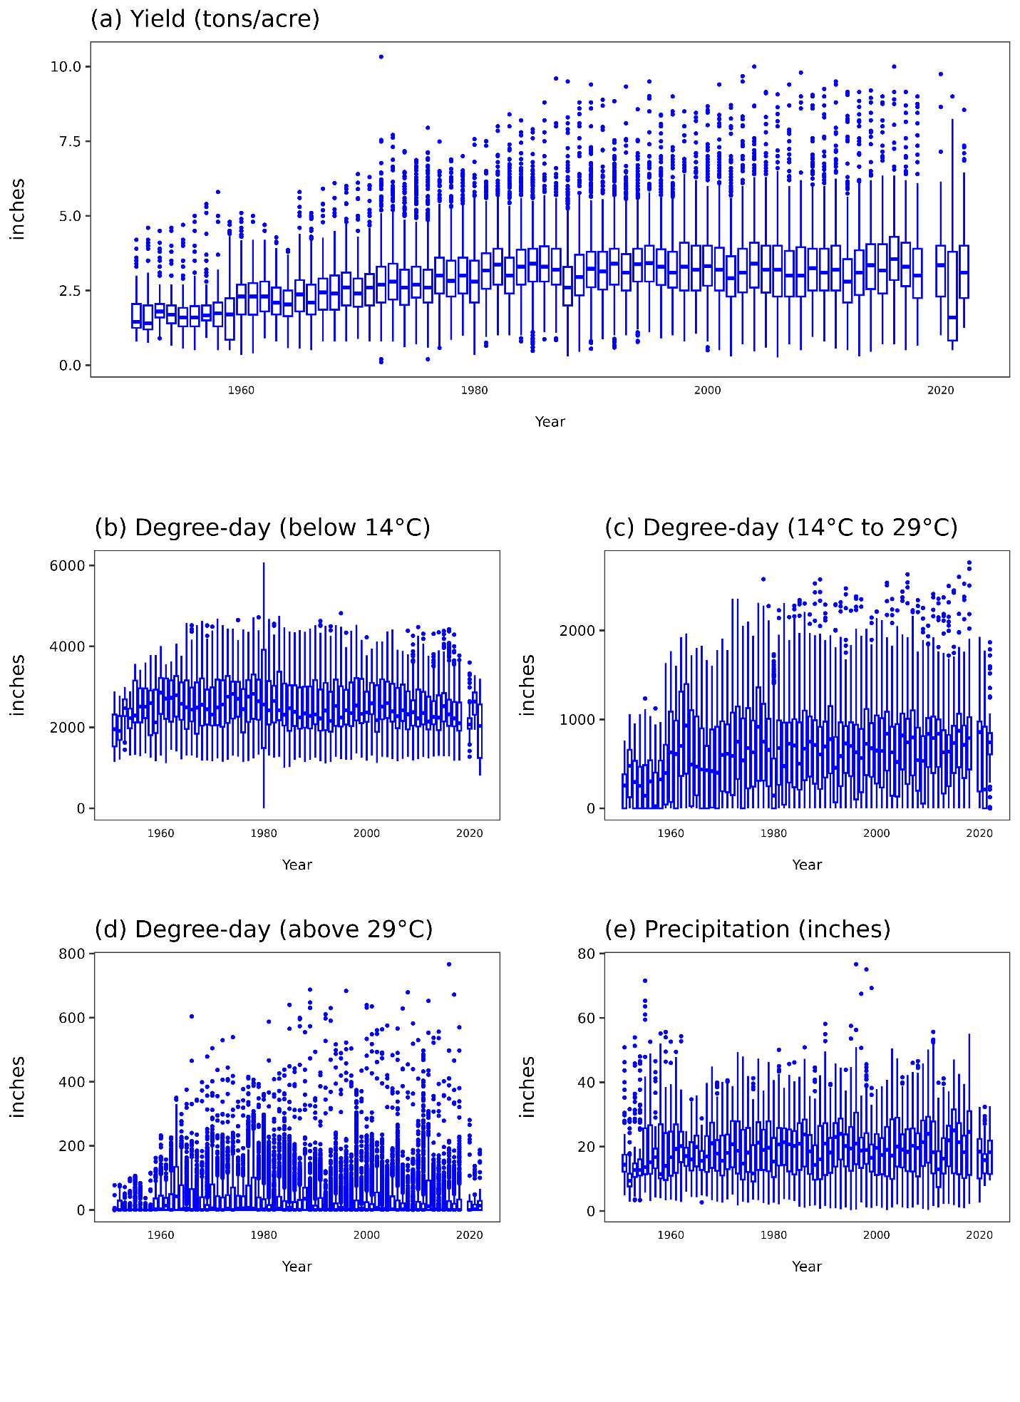

Figure 2. Alfalfa and Cattle Producing Areas in the U.S. (2002-2022)
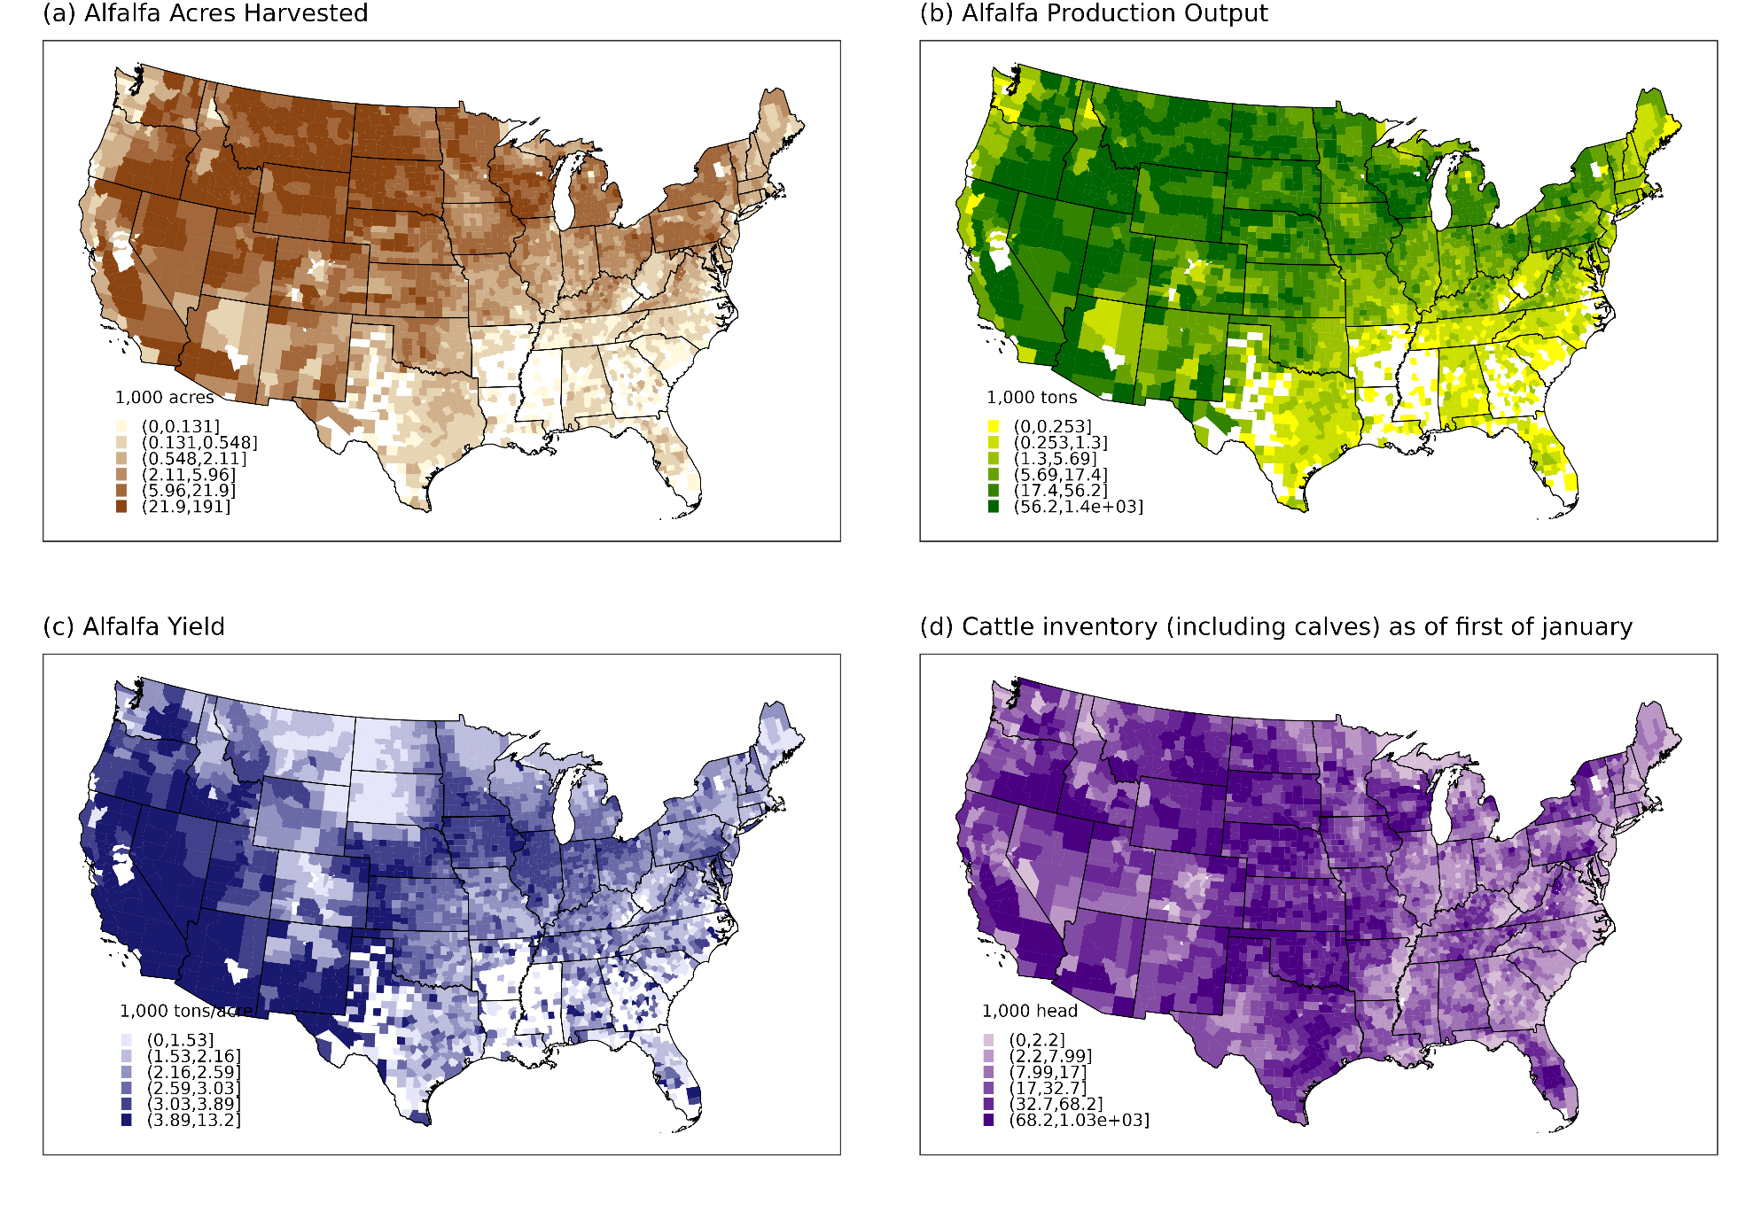

Figure 3. Alfalfa availability and its association with cattle inventories
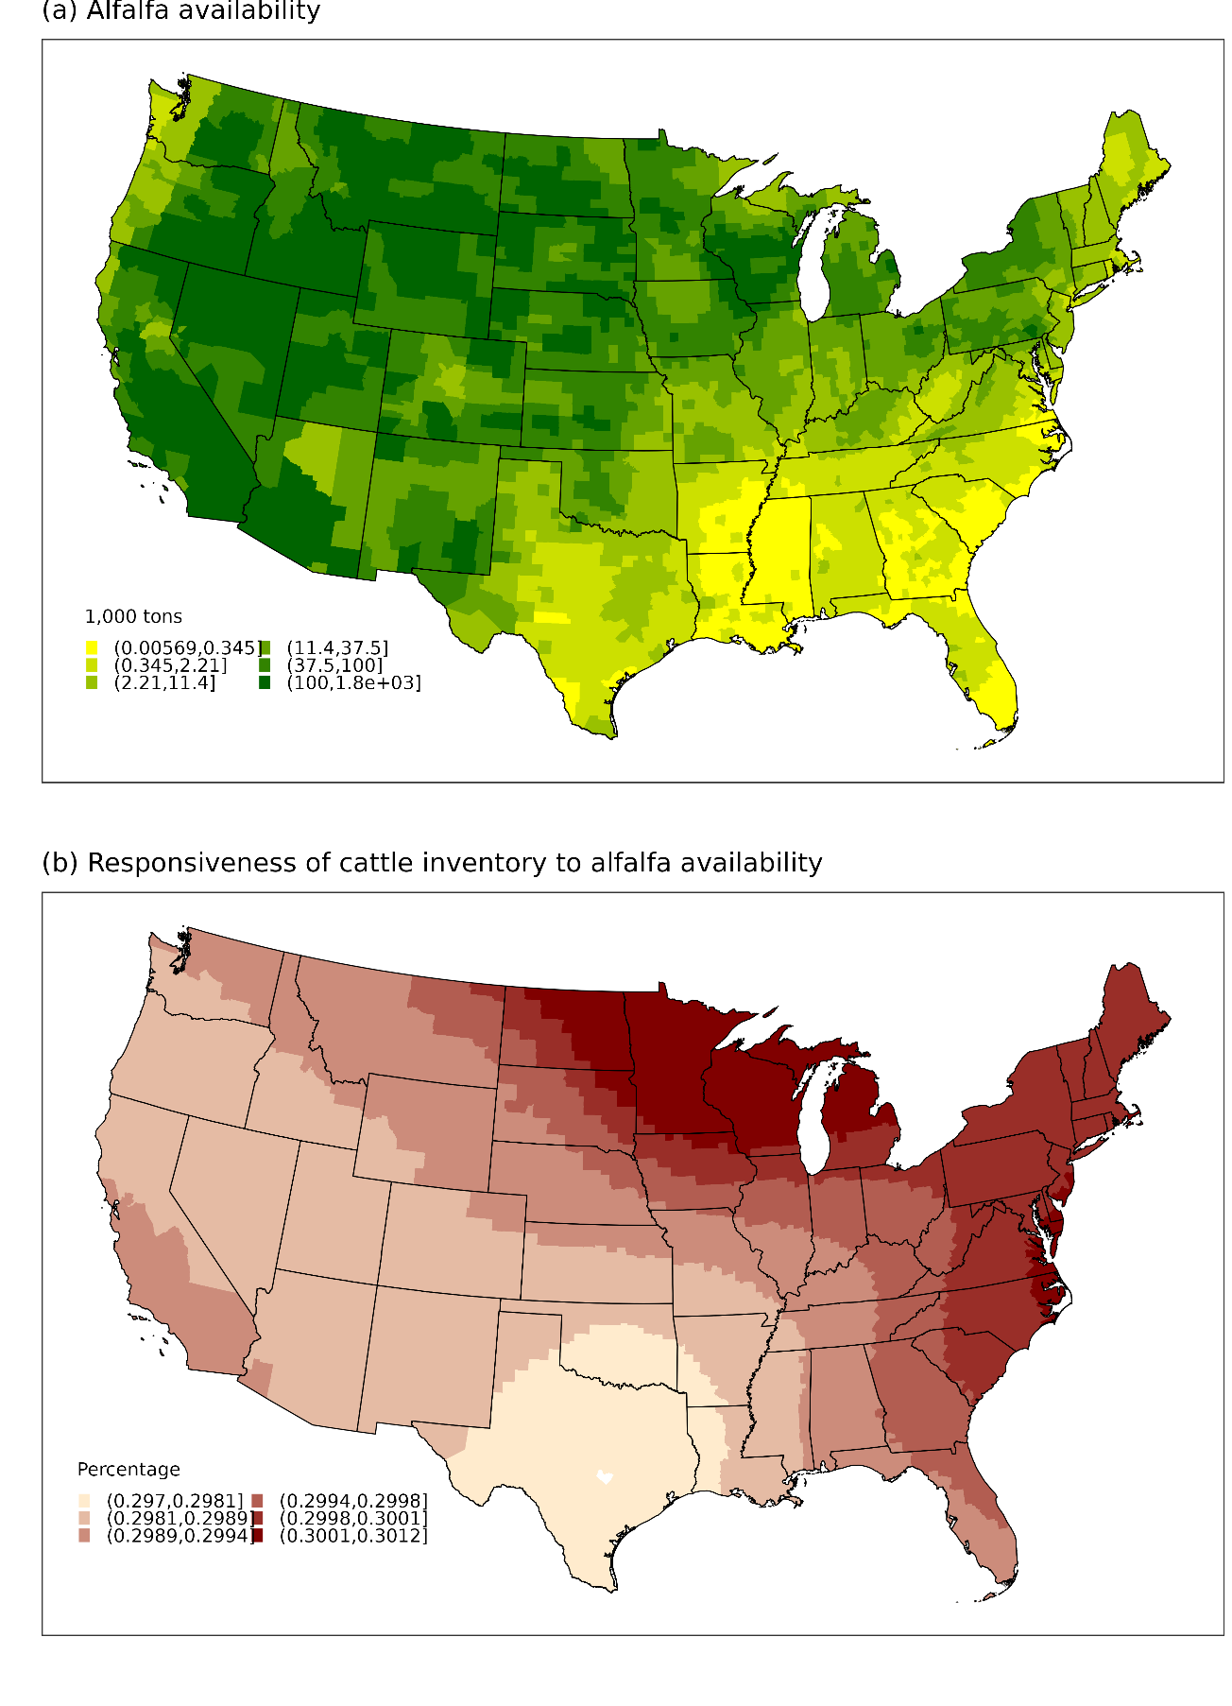

Figure 4. Nonlinear Relation Between Temperature and U.S. Alfalfa Yields (1951-2022)
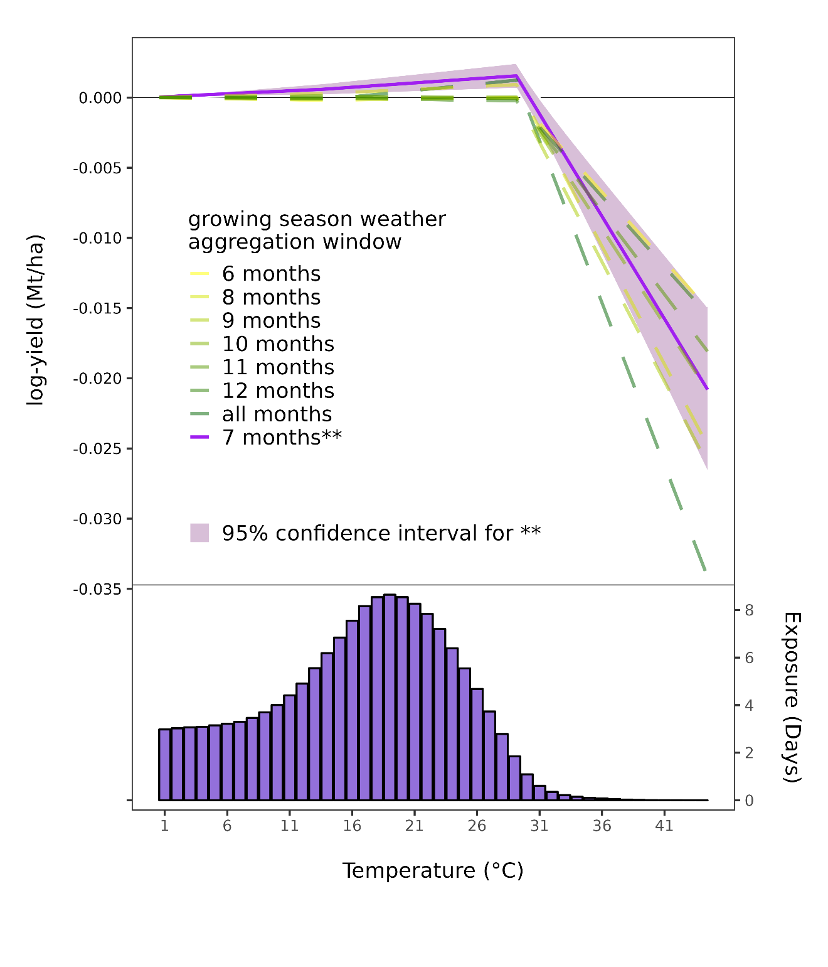

Figure 5. Predicted Impacts
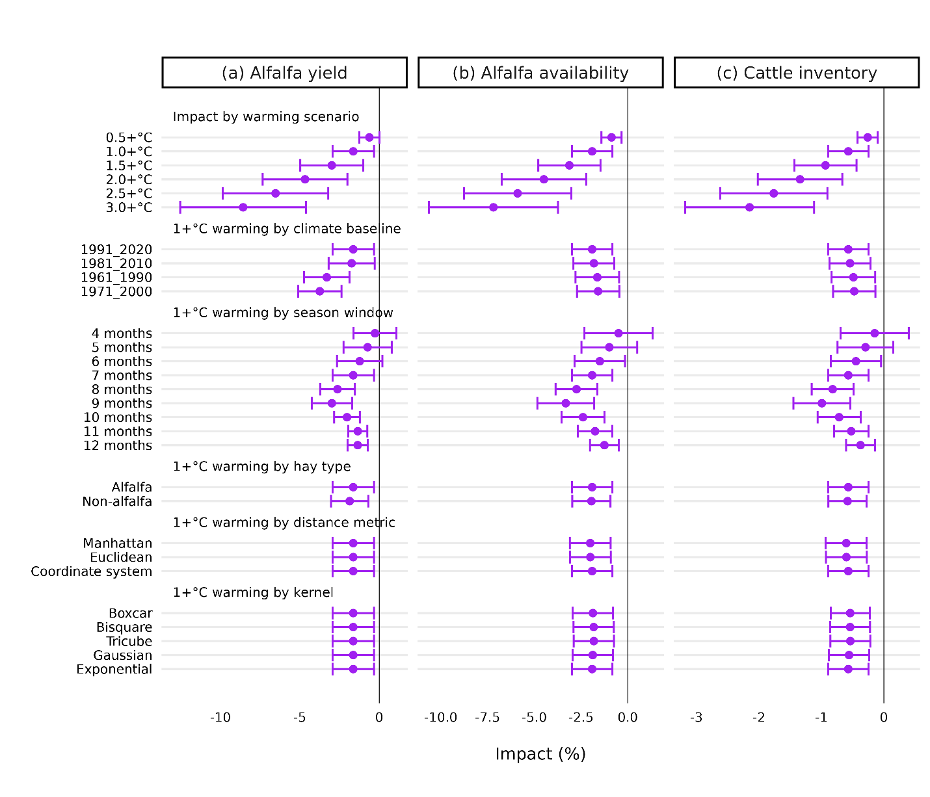

Figure 6. Predicted County Level Impacts
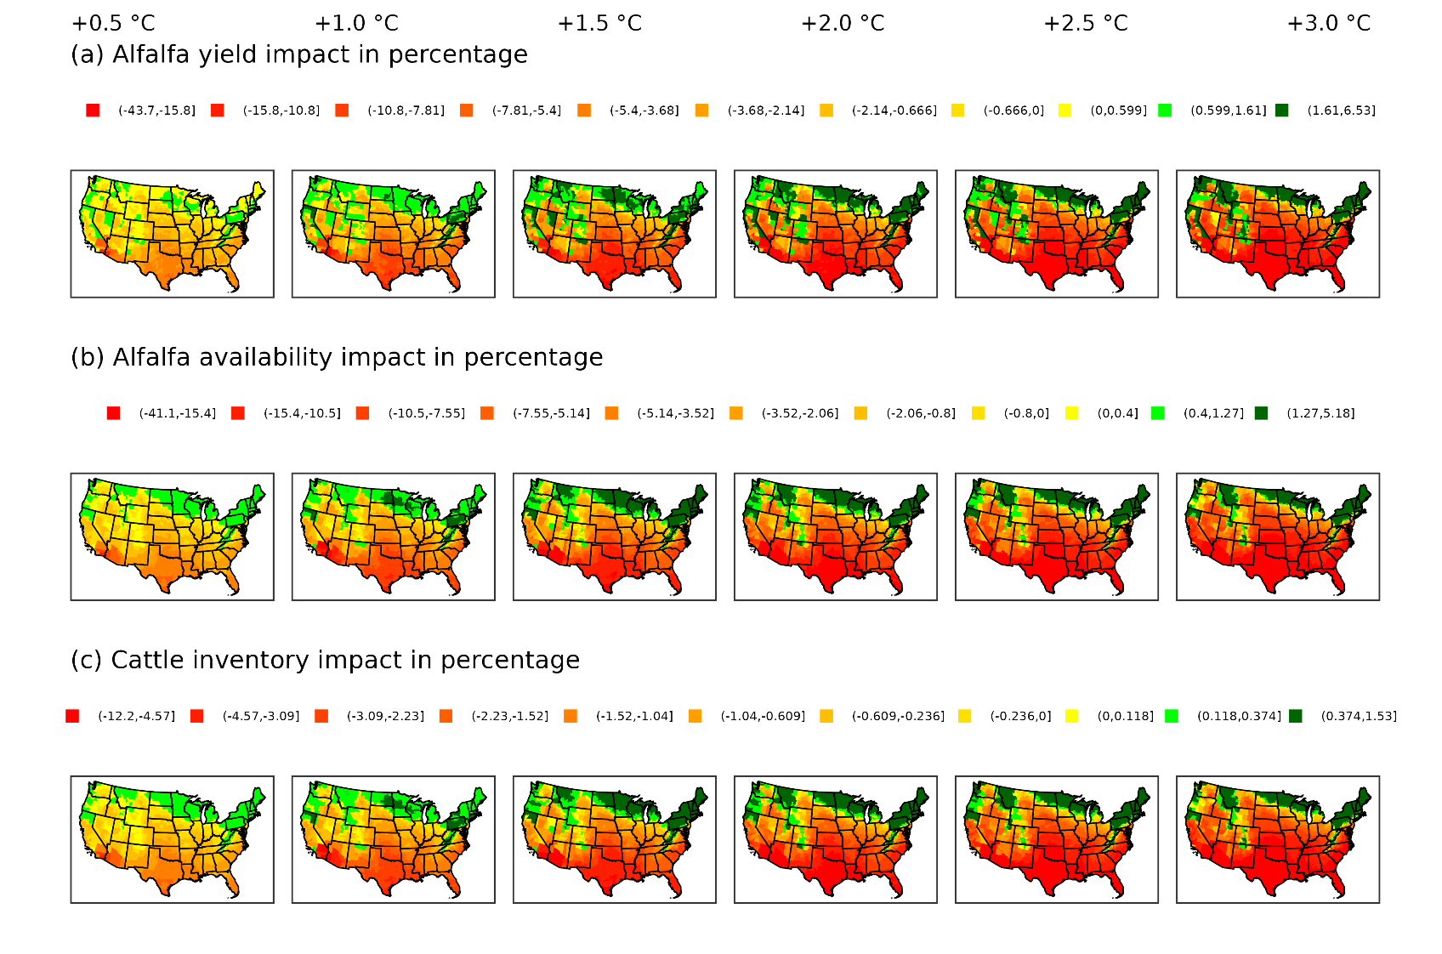

Appendix

Figure S#. Alfalfa availability robusetness
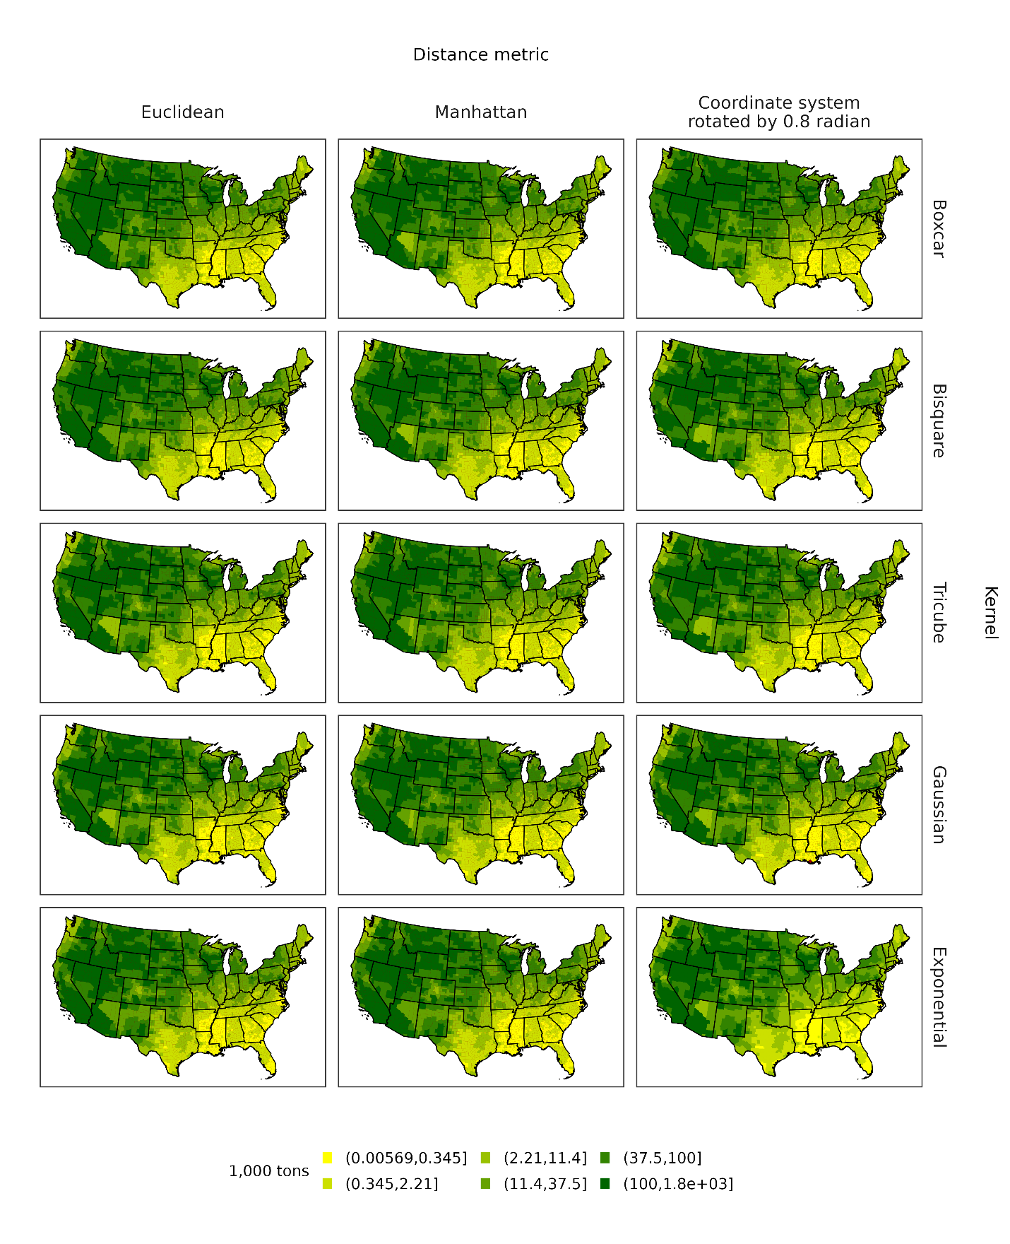

An acre of alfalfa, on average, will fix about 200kg of nitrogen per year.
United States (general): May 1 to April 30; Arizona and California: April 1 to March 31; Alabama, Arkansas, Colorado, Florida, Georgia, Kansas, Kentucky, Louisiana, Mississippi, Missouri, Nevada, New Mexico, North Carolina, Oklahoma, Pennsylvania, South Carolina, Tennessee, Texas, Utah, and Virginia: May 1 to April 30; and all other states: June 1 to May 31.
All data and models were processed on Beocat, a High-Performance Computing cluster at Kansas State University (https://beocat.ksu.edu/)

