Temperature Induced Yield Impacts and Geographic Shifts in US Alfalfa Production

Acknowledgment
The authors gratefully acknowledge the National Agricultural Statistics Service (NASS), PRISM Climate Group, Professor Wolfram Schlenker, and the Natural Resources Conservation Service (NRCS) for the dataset used for the study. The authors are also grateful for data processing on Beocat Research Cluster at Kansas State University. The views expressed in this publication are solely those of the authors and do not reflect the official positions or policies of their affiliated institutions

Abstract

Keywords;
JEL; Q54, Q24
Temperature Induced Yield Impacts and Geographic Shifts in US Alfalfa Production

1. Introduction
The Intergovernmental Panel on Climate Change (IPCC) has conclusively established that Earth's climate is undergoing significant changes due to the accumulation of greenhouse gases in the atmosphere [1], [2]. These changes pose a threat to agriculture, evidenced by rising temperatures [3], shifting precipitation patterns [4], extreme weather events [5], and dwindling water supplies [6]. Empirical studies have consistently shown that these climatic shifts result in a marked decrease in the yields of feed grains [7], [8], [9], [10], [11]. There has been less research on how these changes might also impact pasture and feed supplies, as well as the quality of forage available to grazing livestock, though the existing studies suggest a negative effect [12].
The occurrence of longer and more severe droughts, driven by higher summer temperatures and reduced rainfall in certain regions, could compel ranchers to seek alternative feed sources [13]. This situation is exacerbated by the competition between livestock and humans for major grain crops [14] highlighting the importance of understanding how climate change might affect forage production. This has both direct implications (through grain consumption) and indirect implications (through livestock consumption) for domestic food availability and exports. Additionally, climate change could shift the geographic distribution of forage crops, potentially increasing the costs of livestock feeding. For rancher’s dependent on feed grains, either as a supplement or replacement for pasture grazing, changes in forage production due to drought could lead to increased production costs due to higher feed grain prices and the escalated costs of searching for and transporting feed [13].
Alfalfa production in the United States is a pivotal case study for exploring the effects of climate change on livestock feed. The U.S. livestock industry ranks among the largest in the world, and its size and economic importance make the stability of domestic forage supply a matter of national agricultural consequence, not merely a regional agronomic concern. The growth and scale of the U.S. livestock sector depend significantly on the availability and production of feed grains and forage crops [15], [16]. This dependency was dramatically highlighted by the nationwide drought in 2012, which severely degraded over 70% of U.S. pasturelands and led to a significant decrease in cow-calf returns, dropping more than $100 per cow [13]. Alfalfa, ranking as the fourth-largest crop in the U.S. by acreage [17], stands out for its high protein content and nitrogen-fixing ability, which lessens the reliance on synthetic fertilizers. In 2019, the U.S. harvested more than 54 million tons of alfalfa, with a value of approximately $8.4 billion [17]. Annually, the total acreage dedicated to hay, including alfalfa, is about 128 million, valued at an estimated $17 billion. Alfalfa is primarily cultivated in the northwestern U.S., especially in states such as California, Idaho, Nevada, Oregon, Wyoming, and Washington (see Figure 1). This regional concentration highlights the potential risks and challenges climate change poses to alfalfa production, affecting the entire livestock feed industry on both local and global scales.
This paper centers on alfalfa hay, aiming to bridge the gap in existing research by exploring two interrelated questions. The first addresses the issue of whether global warming has any tangible effect on alfalfa hay yields. Given projected changes in climates, the second asks whether there will be shifts in the spatial distribution of alfalfa hay production. To answer these questions, the study utilizes two main methods of analysis. The first applies reliable models of temperature-yield relationships [7], [8], [10] to county-level data from 1951 to 2022 to estimate temperature thresholds above which alfalfa hay yields begin to decline. Given these thresholds, the study then estimates the degree to which yields decline for incremental changes in temperatures. The second analysis uses simulations to determine the spatial distribution of alfalfa production given the effects from the first analysis and projected warming scenarios.
The results show that increased exposure to beneficial heat (14°C-29°C) positively correlates with alfalfa hay yields, while exposure to heat above 29°C is detrimental. Incremental warming by 0.5°C shows a progression of yield reduction, with significant decreases under scenarios from 1°C to 3°C warming. Regionally, the Northeast sees yield gains in states like Connecticut, Rhode Island, and Massachusetts due to cooler climates reducing heat stress. In contrast, the South, along with parts of the Midwest and West, experiences notable declines, particularly in Texas, Louisiana, Oklahoma, Kansas, and Arizona, attributed to increased heat and potential drought. A 0.5°C increase boosts yield in some northern states, but substantial decreases occur in southern states such as Alabama, Arizona, and Florida, with Florida facing a 2.77% drop. As temperatures rise further, the impacts intensify, with Florida and Texas experiencing significant losses of 22.55% and 25.49% at a 3°C increase. This demonstrates the varying regional vulnerabilities of US livestock production to climate change, with most northern gains diminishing or reversing beyond a 2°C rise.
Livestock production must adapt to continue functioning optimally under the impact of climate change and rising temperatures. Warmer temperatures have led to significant changes in water consumption [18], production [19], [20], reproduction [21], and forage types [22]. It has been found that for each 1-degree Celsius increase in temperature above the optimal temperature of 25 degrees Celsius, daily water consumption increases by 0.65 kg in beef cattle. Along with climate change causing heat stress that impacts water consumption, there is also a decline in milk output and beef production in the cattle industry. Decreases in production in both sectors of the cattle industry result from reduced feed intake due to heat stress and prolonged periods of this stress caused by climate change. [21] shows that conception rates in the dairy industry have a strong inverse relationship with average summer temperature, as higher temperatures cause hyperthermia in cattle and lead to an additional 5% decrease in conception rate when temperatures are 1.5 degrees Celsius above average. Under rising temperatures and varying rainfall caused by climate change, the prevalence of forage for livestock shifts from more C3 (cool season) forages to more C4 (warm season) forages, which do better under these new conditions.
In the literature, [8], [23]established the use of the endogenous piecewise degree-day framework; however, both studies focused on grain crops, and no prior work has applied this approach to alfalfa hay specifically. This study extends that methodological foundation to the forage sector, where the literature on climate focused yield impacts remains sparse relative to field crops[8], [9], [23], [24], [25].The forage and livestock feed supply chain and its potential disruptions under warming have been left largely unexamined compared to the extensive body of work on prominent field crops, despite alfalfa ranking as the fourth-largest U.S. crop by acreage and serving as a primary protein source for the nation's cattle industry. To date, this study represents the most comprehensive spatial and temporal analysis of alfalfa production, drawing on over 70 years of county-level data spanning 2,573 counties.
County cattle inventory and alfalfa production are found to have a correlation of 0.53, presenting this question as more than a purely agronomic issue, but one that impacts the U.S. beef and dairy industry's vulnerability to an inevitable problem. While [12]identify climate risks to dairy systems, their work is focused on Central Europe, where applied county-level estimates of heat thresholds and yield penalties specific to U.S. alfalfa production remain absent from the published literature. This study addresses that gap through its second research question, delivering county-level yield shock simulations across six warming scenarios that provide the regional and state-level granularity needed to meaningfully inform local supply chain planning and adaptation. Furthermore, it compares alfalfa hay responses to non-alfalfa hay, providing an empirical signal within forage distinction in climate sensitivity, offering a novel implication that the existing literature has not drawn.
In the following sections, we first describe the data sources, including yield measurements and temperature records, and outline the process for defining the alfalfa growing season and constructing variables such as growing degree days. Our methods section begins with a model for heat impact on yield and concludes with simulations to project future warming scenarios. The results section presents comprehensive findings, including the nonlinear relationship between alfalfa hay yields and heat, as well as the geographically differentiated impacts of uniform warming scenarios on yields. In the discussion, we situate our results within the broader context of climate change adaptation, focusing on livestock production shifts and potential crop switching under the Ricardian framework. The final section provides our concluding remarks.

2. Data
We utilize a county-level unbalanced panel dataset of alfalfa production outcomes (yield, area, and production output), livestock inventory, and weather variables constructed from multiple sources. The county-level alfalfa production outcomes and livestock inventory data are sourced from the USDA National Agricultural Statistics Service (NASS) Quick Stats database [17]. Weather variables are derived from the Parameter-elevation Regressions on Independent Slopes Model (PRISM) weather dataset, which provides grid-level (2.5 x 2.5 mile) daily weather data processed according to related literature [7], [8]. Degree-day variables (detailed in Section 3) are calculated based on the interpolation procedure [7].
All weather variables were first aggregated to the county level as the weighted mean of all the PRISM grids within each county, using the proportion of each PRISM grid related to alfalfa and pasture cover based on cropland data layers (CDLs) from NASS CropScape (2008-2022) [26] as the aggregation weights. Subsequently, the daily degree days and precipitation were further aggregated over each year’s growing season for each county. The growing seasons are defined by state according to the NASS definition of the marketing year for hay. Within each state-defined range, we aggregated data only over the first seven months.
Table 1 presents summary statistics of the data, which spans 2,573 counties and includes 70890 observations. On average, counties have 14.10 thousand acres devoted to alfalfa cultivation, yielding a production output of 40.92 thousand tons. The average yield of alfalfa stands at 3.00 tons per acre, indicating a productive use of the land under typical conditions. Boxplot of the yield data shown in Figure 1(panel a) exhibits significant temporal and spatial variation. Weather conditions during the first seven months of the alfalfa growing season include an average precipitation of 19.47 inches. Temperature accumulation, measured in degree-days, shows varied growing conditions: 1,695.61 degree-days are recorded below 14°C; 1549.01 degree-days between 14°C and 29°C, an optimal range for alfalfa (as shown in section 3); and only 51.58 degree-days above 29°C, indicating exposure to heat that could stress the plants. Boxplots of all the weather variables are shown in Figure 1 panels (b) – (e) and they exhibit significant temporal and spatial variations.
Figure 2, panels (a)-(c), depicts the spatial distribution of county-level alfalfa production metrics and cattle inventory across the US, focusing on the period from 2002 to 2022. To enhance the spatial coverage, we incorporated missing county-level data from the US agricultural censuses conducted in 2002, 2007, 2017, and 2022. Alfalfa production is dominated by Western U.S., where counties report exceptionally high average yield of 3.42 tons per acre on an average of 18.71 thousand acres per county. Key contributors exhibiting significant alfalfa (area [1000 acres], production [1000 tons], yield [tons per acre]) include Arizona (20.02, 154.68, 6.23), California (21.24, 140.37, 5.27), Idaho (24.39, 95.48, 3.39), Nevada (17.07, 73.52, 4.37), and Utah (18.23, 70.06, 3.52). Western counties are followed by those in the Midwest, where mean county yield is estimated at 2.82 tons per acre on an average of 9.93 thousand acres per county. Leading Midwestern states include South Dakota (30.02, 54.24, 2.07), Wisconsin (18.36, 49.8, 2.61), North Dakota (27.71, 45.05, 1.89), Nebraska (11.61, 38.00, 3.45), and Minnesota (11.32, 32.32, 2.93). At the low end, Southern counties exhibit much smaller alfalfa areas, averaging about 0.95 thousand acres per county, with yields averaging only 2.33 tons per acre. The lowest performing Southern counties are found in Mississippi (0.08, 0.19, 2.02), South Carolina (0.11, 0.27, 2.23), Georgia (0.23, 0.45, 2.27), Louisiana (0.22, 0.49, 2.04), and North Carolina (0.24, 0.54, 2.14).

3. Methods
The study makes use of the large variation present in the assembled dataset to identify parameters of interest by applying models of climate change effects on crop yields proposed in the literature [7], [8], [10]. The model assumes a cumulative effect of temperature on seasonal alfalfa yields, and that yield is proportional to cumulative exposure. The implication is that the effect of temperature on the growth rates of alfalfa yields is the same and additively substitutable during the growing season. [7] provides the empirical validity of this assumption, where they specify that yield growth depends nonlinearly on heat (h) such that log yield ($\ln{y_{it}}$) for county i and year t is
$\ln{y_{it}}=\int_{\underline{h}}^{\overline{h}}{g\left(h\right)ϕ_{it}\left(h\right)dh}+w_{it}δ+ε_{it}$ (1)
Where $ϕ_{it}\left(h\right)$ is the time distribution of h over the growing season for county i and year t. The observed temperatures during the growing season range between $\underline{h}$ and $\overline{h}$. The vector $w_{it}$contains other control factors, including quadratic function of cumulative precipitation to capture the nonlinear effects of rainfall, quadratic time trend by state to capture state-specific technological change, and county fixed effect to control for cross-sectional heterogeneity. Finally, $ε_{it}$ captures any remaining unobserved heterogeneity and is assumed to be heteroskedastic.
Following related works [7], Equation (1) is approximated with the piecewise linear degree-day approach, which is like the concept of growing degree-days where alfalfa yield growth increases linearly up to an endogenous temperature threshold (i.e., the optimal temperature) and then decreases linearly for every 1°C increase above that threshold. The specification for the degree-day model is given by:
$\ln{y_{it}}=β_{0}+β_{L}{DDL}_{it}+β_{M}{DDM}_{it}+β_{H}{DDH}_{it}+w_{it}δ+u_{i}+ε_{it}$ (2)
The three temperature variables, ${DDL}_{it},{DDM}_{it},{DDH}_{it}$, capture respectively degree days between zero and the lower threshold, the lower threshold and the upper threshold, and above the upper threshold. Essentially, these variables admit a piecewise linear relation between temperature and log yield over three ranges of temperatures defined endogenously by the placement of cut points (thresholds). The temperature thresholds are endogenously determined by looping over all threshold-pairs between 0-39°C, estimate the least-squares segment slopes for each pair, and then pick the threshold and segment slopes that have the best model fit in terms of R-squared. This looping produced lower and upper temperature thresholds at 14°C and 29°C, respectively. Finally, we cluster the standard errors at year level to account for possible spatial correlations as done in related works [27], [28].
The Representative Concentration Pathway (RCP) trajectory adopted by the Intergovernmental Panel on Climate Change (IPCC) for its fifth Assessment Report (AR5) in 2014 suggests global warming increase projections that range from 0.4 to 4.8°C [2]. This study considers warming scenarios of 0.5 to 3°C in 0.5 increments to ascertain the respective changes in alfalfa yields. The predictions for each scenario were obtained via a three-step process. First, each daily temperature observation for the periods and location in the dataset was increased by the respective warming scenario. For instance, daily min and max temperatures of -15 and 18 °C recorded on say July 8, 1986, were changed to (-15 + k) and (18 + k) °C for the case of the k°C warming scenario, respectively. Using these new temperatures, the study then calculates the associated degree-days as ${DDL}_{k}$, ${DDM}_{k}$, and ${DDH}_{k}$. Finally, given the estimates from the piecewise linear degree-day approach, the predicted percentage change in alfalfa yield following an k°C increase in temperature is estimated as
$θ_{k}=\left[e^{{\hat{β}}_{L}\left({DDL}_{k}-DDL\right)+{\hat{β}}_{M}\left({DDM}_{k}-DDM\right)+{\hat{β}}_{H}\left({DDH}_{k}-DDH\right)}-1\right]×100\%$. (3)
We estimated yield shocks for each county based on specified warming scenarios.

4. Results

4.1 Alfalfa hay yields drop sharply with exposure to temperatures over 29°C
The coefficients of Equation (2) are presented in Table 2. We estimate Equation (2) across six different growing season weather aggregation windows, with our preferred five-month window achieving the second highest R-squared value of 0.268. It is important to note that interpreting the estimated coefficients of the degree day variables requires caution, as a change in a degree day implies changes in the entire temperature distribution. However, several significant observations hold true regardless of the aggregation window. Increased exposure to beneficial heat (degree days between 14°C and 29°C) is positively correlated with crop yields, whereas exposure to harmful heat (degree days above 29°C) is negatively correlated. The relationship between temperature and alfalfa yields, using the seven-month window (Figure 3), shows that temperatures below 14°C result in significant yield improvements of $0.671×{10}^{-3}$%. Conversely, exposures from 14°C to 29°C yield a insignificant reduction of about $0.024×{10}^{-3}$%. However, temperatures above 29°C are associated with a significant yield reduction of $2.047×{10}^{-3}$%, indicating negative impacts from warming. Although the specific thresholds differ, the pattern of beneficial and detrimental temperature exposures observed in Figure 3 aligns with previous studies [7], [8], [10]. Regarding precipitation, the estimates in Table 2 indicate that it positively affects yields up to approximately 27.451 inches, after which the benefit declines. Given that the growing season means annual precipitation is only 19.47 inches, yields are unlikely to decline due to excessive annual precipitation. However, periodic destructive rainfall could still lead to yield declines, resulting from physical crop damage rather than agronomic limitations.

4.2 Impact of uniform warming on alfalfa hay yield
The dominance of beneficial (at or below 29°C) and detrimental (above 29°C) temperature exposures over one another will determine the overall impact of warming. To ascertain which of the two dominates, the study predicts yield impacts following a +1°C uniform temperature change. Figure 4 shows that relative to the current NOAA recommended baseline climate period of 1991-2020, a 1°C warming scenario produces an average 6.576% decrease in alfalfa hay yields in the US. Altering the warming intensity also shows that larger declines expected at hotter scenarios with alfalfa hay yields expected to decline by 0.621, 2.988, 4.673, 6.53, and 8.57% for a +0.5, +1.5, +2.0, +2.5, and +3.0°C uniform temperature change.
Our baseline climate period of 1991 to 2020 follows NOAA recommendations, but alternative periods may be more informative (IPCC, 1994). Earlier periods, such as 1961 to 1990, show more significant anthropogenic trends due to sulphate aerosols, especially in the eastern USA (Karl et al., 1996). Ideally, the 19th century would be the best baseline when anthropogenic impacts were minimal. Evaluating the +1°C alfalfa yield impact with different baselines reveals significant variations. The 1981-2010 period showed the highest impact of -5.359%, while earlier periods, such as 1961-1990 (-4.913%), exhibit substantial negative impacts. The lowest impact is in 1971-2000 at -3.676%. These findings highlight the importance of considering various historical periods to fully understand climatic influences on agricultural productivity.
Hay harvesting presents unique challenges due to its multiple cuttings throughout the year, unlike crops such as corn and soybeans, which have specific growing seasons. The period from seeding to the last cut varies widely by location, making it difficult to define a uniform growing season. Our preferred specification aggregates data only over the first seven months within each state-defined range. To evaluate the robustness of the +1°C alfalfa yield impact, we independently adjust the weather data accumulation window. Our analysis reveals that the yield impact of a +1°C temperature increase varies with the data window. A 10-month window shows -6.603%, while a 5-month window, our preferred specification, yields -6.716%. Other windows like 6 months (-6.727%) and 7 months (-6.576%) show decreasing impacts. Finally, non-alfalfa hay types show a slightly higher impact of -6.613% following a +1°C warming scenario indicating that different types of hay respond differently to warming temperatures.
The predicted impacts of a +1°C climate change scenario on U.S. alfalfa hay yields vary significantly by region (See Figure 5). Counties in the Northeast generally show positive trends (144 out of 244 counties), with those in Connecticut (+0.205%), Vermont (+1.319%), Rhode Island (+0.510%), Massachusetts (+0.455%), and Maine (+1.371%) experiencing the most significant increases, likely due to the cooler climate mitigating heat stress. The South, characterized by already higher temperatures, largely experiences negative impacts, with counties in Texas (-13.088%), Louisiana (-11.377%), Oklahoma (-8.682%), Mississippi (-9.552%), and Florida (-10.810%) observing the sharpest declines in yields, possibly exacerbated by drought conditions. The Midwest and West both present a mixed response with 18% and 40% Midwestern and Western counties having a positive trend, respectively. Midwestern counties in Minnesota (+0.131%), Wisconsin (+0.439%), and Michigan (+0.577%) see slight gains, possibly benefiting from warmer temperatures improving growing conditions, while those in Ohio (-1.231%), South Dakota (-1.746%), Iowa (-1.271%), Indiana (-0.167%), and Illinois (-2.676%) face notable decreases. In the West, outcomes are diverse; counties in Washington (+0.884%), Oregon (+0.640%), and Montana (+0.216%), see minor improvements, suggesting some areas may benefit from modest warming, whereas counties in Wyoming (-0.202%), Idaho (-0.167%), Utah (-1.599%), Colorado (-0.401%), and California (-4.598%), located in arid regions, encounter declines.
Figure 5 also illustrates the geographical changes in alfalfa yields with temperature increases across various regions. The impact on yields varies significantly with increasing temperature gradients. For example, with only a 0.5°C increase, counties in states like Connecticut, Maine, and Massachusetts experience an increase in yields, while counties in southern states such as Alabama, Arizona, and Florida see a notable decrease, with Florida experiencing a yield drop of 2.77%. As the temperature increase reaches 1.5°C, counties in Arizona and Florida show dramatic decreases in yields of 10.57% and 9.65%, respectively. The negative impact intensifies at a 3°C increase, particularly affecting states like Florida and Texas with county yield reductions averaging 22.55% and 25.49%, respectively. Interestingly, northern states such as Connecticut, Maine, and Massachusetts continue to see yield increases or less severe decreases up to a 2°C temperature increase, after which the impact becomes neutral or negative. By contrast, southern and central states experience accelerating declines as temperatures rise, with Missouri and Kansas notably impacted by 15.83% and 12.57% decreases at a 3°C increase, coinciding with these states being major cattle-producing areas. These estimates are indicative of broader regional vulnerabilities of livestock production as the temperature continues to rise.

5. Discussion
The correlation between alfalfa production and livestock density, particularly in cattle farming, reveals a strategic alignment within the agricultural landscape that emphasizes the importance of forage management. With a significant correlation of 0.53 between county-level cattle inventory and alfalfa production, regions with abundant alfalfa tend to have higher cattle production. However, the correlation of 0.32 with alfalfa yield suggests that while the presence of alfalfa is essential, the highest yields are not necessarily required for successful cattle operations. This indicates that cattle farming is optimized more for the availability of sufficient forage rather than achieving maximum yield per acre. Moreover, the strategic alignment of alfalfa production with local economic and climatic conditions is becoming increasingly crucial as global warming introduces new challenges. Shifts in weather patterns could alter precipitation levels and increase temperatures, potentially disrupting alfalfa availability and directly impacting the livestock sector reliant on this crop for feed. Consequently, a decline in alfalfa availability could escalate feed costs or necessitate reductions in herd sizes, significantly affecting the agricultural economy. This underscores the critical need for adaptive forage production and management strategies to maintain robust cattle farming operations in the face of climatic changes.
The vulnerability that this pose is best illustrated by the 2012 drought, which led to degradation of over 70% of pastureland in the U.S., along with lowered returns of cow-calf by over $100 a cow (Kemper et al, 2013). While this is a very severe example, it is a mere single-season disruption that foreshadows what the warming scenarios that were modeled could mean on a permanent and progressive scale. Unlike the drought, where rainfall led to recovery, these yield declines reflect an environmental shift in overall growing conditions. Counties in Texas, Louisiana, Oklahoma, Florida, Missouri, and Kansas are all facing very large losses in primary feed, despite being some of the states with the largest cattle density in the country. This regional concentration of forage loss is especially impactful when considering that [29]estimated that annual heat stress losses already exceed $2 billion dollars in the U.S for production costs. Implications of this are those producers at risk for major forage yield decline, such as in the South and Plains, are also facing pressure from heat stress impacting livestock alongside the availability of a primary feed source declining. Inversely, northeastern counties within Connecticut, Maine, and Massachusetts experience alfalfa yield gains under warming while having relatively lower densities of cattle. The geographic distribution of alfalfa under warming is not aligned with livestock prevalence, which will lead producers to pay the higher shipping costs to get the alfalfa needed or incur the cost of transitioning to new feed sources.
Within the Ricardian framework, farmers respond to relative profitability shifts by reallocating land toward crops that best suit prevailing climate conditions. Under the warming scenarios presented, there is potential for significant disruption to alfalfa production even at the mildest simulation. As shown in Figure 5, a +1°C increase alone produces yield declines of 13.088% and 10.810% in Texas and Florida, respectively. With this decrease in yield possible, profitability shocks of sufficient magnitude then push producers toward land reallocation away from alfalfa. As warming intensifies and most U.S. counties face declining alfalfa yields, the competitive advantage of alternative forage species grows accordingly. Alfalfa is a C3 cool-season crop, and C4 warm-season grasses are increasingly better suited to southern growing conditions under rising temperatures, a transition consistent with the broader forage literature. Crop switching in this context is not a failure of adaptation, and it is the expected Ricardian response to a permanent shift in returns.
However, crop switching is not a seamless transition. Transitioning from the annual forage of alfalfa to perennial forage takes several years of time and investment for proper establishment, as well as changes in irrigation infrastructure, and agronomic knowledge gaps are often under assumed. Particularly in the South, realistic substitutes that are already prevalent include bermudagrass hay and sorghum-Sudan hybrids, as they are better suited than alfalfa to higher temperatures. A major negative to this switch is the loss of protein in feed, as alfalfa has a crude protein of approximately 15-20% compared to gross hay, typically ranging from 8-12%. This has major implications for livestock performance and the cost of supplemental feed and rationing. In the Midwest, corn silage is the most sensible substitute; however, an increased demand for corn silage acreage would directly compete with grain corn production that is predominant in the region. This would transmit the alfalfa yield shock under these conditions into the broader feed grain market, an intersection documents by [15], [16]. Of interesting significance in the behavior of the area in the transition zone. These counties within Kansas, Missouri, and other southern Plains states are where C3 and C4 species coexist, and their forage balance is at risk as warming causes this region to move further north. Producers in this historically reliable cool-season Alfalfa region begin to lose their ability to rely on local production of alfalfa, with Kansas and Missouri facing over a 6% and 4% decrease in respective yield under only the +1°C increase. The regional heterogeneity of yields impacts shows there is not a uniform solution to climate-driven distribution in alfalfa production, as the compounding pressures presented demand regionally targeted strategies and action from producers and policymakers. 6. Conclusion
The study addresses two questions: whether warming temperatures have a measurable effect on U.S. alfalfa hay yields, and whether projected warming will shift the geographic distribution of alfalfa production. This was completed using a county-level panel of the contiguous U.S. using data from 1951-2022 through a piecewise degree-day framework. It was found with the data in the study that temperatures between 14°C and 29°C modestly improve yields, and temperatures above 29°C led to decreasing yields at an increasing rate. Nationally, alfalfa yields decline by XXX% under +0.5°C and rise to XXX% under 3°C. Results are found to be robust across different baseline climate periods and growing season window lengths.
A considerable variation of impact was found geographically, as northern counties experience modest yield gains under warming, whereas the South and Central Plains, where cattle production is most predominant, experience some of the largest losses. States such as Texas, Florida, Oklahoma, and Kansas experience respective losses of 13.088%, 10.810%, 8.682%, and 6.011% at just a 1°C increase in temperature, with those losses intensifying substantially under higher warming scenarios. The counties experiencing yield gains under warming scenarios hold comparatively little cattle operation significance, meaning the net effect is not only a northward shift in alfalfa production, but a structural movement away from the livestock-dense regions most dependent on domestic high-protein forage. Along with this, if producers in affected regions lose access to a feed source they previously produced locally, shipping feed in becomes a significant logistical and financial burden, directly impacting their bottom line in an industry where margins are already thin. Crops switching towards warm-season grasses is the expected Ricardian response, particularly in the south, but the protein and other nutritional differences in substitutions and establishment constraints could limit the extent to which market reallocation could offset the potential production losses. This remains especially true for the West, as irrigation constraints with warming temperatures could lead to unavoidable losses in industry. This analysis treats several variables as fixed that could lead to an underestimation of long-run adaptation, such as land use, irrigation technology, and management practices. The simulations performed assume uniform temperature increase nationwide, with no account for changes in other factors that could modify estimated impacts in either direction. Future work should incorporate water availability and irrigation constraints into the simulation framework, to best capture the impact of thermal and hydrological stress. As global temperatures continue to rise, along with the estimates from the RCP, the county-level yield estimated, and spatial warming simulations offer both a diagnostic of current vulnerabilities and a tangible foundation for regional adaptation policy in the forage and livestock sectors across the country.

References
[1] Intergovernmental Panel on Climate Change (IPCC), Climate Change 2007: Impacts, Adaptation and Vulnerability. Contribution of Working Group II to the Fourth Assessment Report of the Intergovernmental Panel on Climate Change. Cambridge: Cambridge University Press, 2007. Accessed: Dec. 01, 2020. [Online]. Available: http://www.cambridge.org/9780521880107
[2] Intergovernmental Panel on Climate Change (IPCC), Climate Change 2013 the Physical Science Basis: Working Group I Contribution to the Fifth Assessment Report of the Intergovernmental Panel on Climate Change. Cambridge: Cambridge University Press, 2013. doi: 10.1017/CBO9781107415324.
[3] D. B. Lobell, W. Schlenker, and J. Costa-Roberts, “Climate Trends and Global Crop Production Since 1980,” Science, vol. 333, no. 6042, pp. 616–620, Jul. 2011, doi: 10.1126/science.1204531.
[4] X. Yuan et al., “Impacts of Global Climate Change on Agricultural Production: A Comprehensive Review,” Agronomy, vol. 14, no. 7, p. 1360, Jul. 2024, doi: 10.3390/agronomy14071360.
[5] C. Lesk, P. Rowhani, and N. Ramankutty, “Influence of extreme weather disasters on global crop production,” Nature, vol. 529, no. 7584, pp. 84–87, Jan. 2016, doi: 10.1038/nature16467.
[6] X. Liu, W. Liu, Q. Tang, B. Liu, Y. Wada, and H. Yang, “Global Agricultural Water Scarcity Assessment Incorporating Blue and Green Water Availability Under Future Climate Change,” 2022, doi: 10.1029/2021EF002567.
[7] W. Schlenker and M. J. Roberts, “Nonlinear temperature effects indicate severe damages to U.S. crop yields under climate change,” Proc. Natl. Acad. Sci. U. S. A., vol. 106, no. 37, pp. 15594–15598, 2009, doi: 10.1073/pnas.0906865106.
[8] J. Tack, A. Barkley, and L. L. Nalley, “Effect of warming temperatures on US wheat yields,” Proc. Natl. Acad. Sci., vol. 112, no. 22, pp. 6931–6936, Jun. 2015, doi: 10.1073/pnas.1415181112.
[9] P. Zhang, J. Zhang, and M. Chen, “Economic impacts of climate change on agriculture: The importance of additional climatic variables other than temperature and precipitation,” J. Environ. Econ. Manag., vol. 83, pp. 8–31, May 2017, doi: 10.1016/j.jeem.2016.12.001.
[10] A. M. Shew, J. B. Tack, L. L. Nalley, and P. Chaminuka, “Yield reduction under climate warming varies among wheat cultivars in South Africa,” Nat. Commun., vol. 11, no. 1, p. 4408, Dec. 2020, doi: 10.1038/s41467-020-18317-8.
[11] E. Malikov, R. Miao, and J. Zhang, “Distributional and temporal heterogeneity in the climate change effects on U.S. agriculture,” J. Environ. Econ. Manag., vol. 104, p. 102386, Nov. 2020, doi: 10.1016/j.jeem.2020.102386.
[12] M. Gauly et al., “Future consequences and challenges for dairy cow production systems arising from climate change in Central Europe – a review,” Animal, vol. 7, no. 5, pp. 843–859, 2013, doi: 10.1017/S1751731112002352.
[13] N. Kemper, A. Flanders, B. Watkins, and M. Popp, “Impact of the 2012 Drought on Field Crops and Cattle Production in Arkansas - Preliminary Report,” Department of Agriculture, Research and Extension, University of Arkansas System.
[14] A. Mottet, C. de Haan, A. Falcucci, G. Tempio, C. Opio, and P. Gerber, “Livestock: On our plates or eating at our table? A new analysis of the feed/food debate,” Glob. Food Secur., vol. 14, pp. 1–8, Sep. 2017, doi: 10.1016/j.gfs.2017.01.001.
[15] W. M. Simmons and R. L. Rizek, “Performance of the Livestock-Feed-Grain Sector,” J. Farm Econ., vol. 48, no. 5, p. 1455, Dec. 1966, doi: 10.2307/1237161.
[16] J. M. Marsh, “Cross-sector relationships between the corn feed grains and livestock and poultry economies,” J. Agric. Resour. Econ., vol. 32, no. 1, pp. 93–114, 2007.
[17] United States Department of Agriculture [USDA], “USDA - National Agricultural Statistics Service, Quick Stats 2.0.” Accessed: May 05, 2019. [Online]. Available: http://quickstats.nass.usda.gov/
[18] C. M. Ahlberg et al., “Environmental effects on water intake and water intake prediction in growing beef cattle,” J. Anim. Sci., vol. 96, no. 10, pp. 4368–4384, Sep. 2018, doi: 10.1093/jas/sky267.
[19] L. Chen, V. M. Thorup, A. B. Kudahl, and S. Østergaard, “Effects of heat stress on feed intake, milk yield, milk composition, and feed efficiency in dairy cows: A meta-analysis,” J. Dairy Sci., vol. 107, no. 5, pp. 3207–3218, May 2024, doi: 10.3168/jds.2023-24059.
[20] A. Summer, I. Lora, P. Formaggioni, and F. Gottardo, “Impact of heat stress on milk and meat production,” Anim. Front., vol. 9, no. 1, pp. 39–46, Jan. 2019, doi: 10.1093/af/vfy026.
[21] D. Wolfenson and Z. Roth, “Impact of heat stress on cow reproduction and fertility,” Anim. Front., vol. 9, no. 1, pp. 32–38, Jan. 2019, doi: 10.1093/af/vfy027.
[22] Q. Xie et al., “Satellite-observed shifts in C3/C4 abundance in Australian grasslands are associated with rainfall patterns,” Remote Sens. Environ., vol. 273, p. 112983, May 2022, doi: 10.1016/j.rse.2022.112983.
[23] W. Schlenker and M. J. Roberts, “Nonlinear temperature effects indicate severe damages to U.S. crop yields under climate change,” Proc. Natl. Acad. Sci., vol. 106, no. 37, pp. 15594–15598, Sep. 2009, doi: 10.1073/pnas.0906865106.
[24] E. Malikov, R. Miao, and J. Zhang, “Distributional and temporal heterogeneity in the climate change effects on U.S. agriculture,” J. Environ. Econ. Manag., vol. 104, p. 102386, Nov. 2020, doi: 10.1016/j.jeem.2020.102386.
[25] A. M. Shew, J. B. Tack, L. L. Nalley, and P. Chaminuka, “Yield reduction under climate warming varies among wheat cultivars in South Africa,” Nat. Commun., vol. 11, no. 1, p. 4408, Sep. 2020, doi: 10.1038/s41467-020-18317-8.
[26] USDA National Agricultural Statistics Service, “CropScape - Cropland Data Layer (2019 release).” [Online]. Available: https://nassgeodata.gmu.edu/CropScape/
[27] M. A. Petersen, “Estimating Standard Errors in Finance Panel Data Sets: Comparing Approaches,” Rev. Financ. Stud., vol. 22, no. 1, pp. 435–480, Jan. 2009, doi: 10.1093/rfs/hhn053.
[28] A. C. Cameron, J. B. Gelbach, and D. L. Miller, “Robust Inference With Multiway Clustering,” J. Bus. Econ. Stat., vol. 29, no. 2, pp. 238–249, Apr. 2011, doi: 10.1198/jbes.2010.07136.
[29] N. R. St-Pierre, B. Cobanov, and G. Schnitkey, “Economic Losses from Heat Stress by US Livestock Industries1,” J. Dairy Sci., vol. 86, pp. E52–E77, Jun. 2003, doi: 10.3168/jds.S0022-0302(03)74040-5.

Table and Figures

Table 1: Means and standard deviations of county level alfalfa production and weather
Variables | Mean  (Standard deviation)
Alfalfa production area (1,000 acres) | 14.10 (17.61)
Alfalfa production output (1,000 tons) | 40.92 (59.41)
Alfalfa yield (tons/acre) | 3.00 (1.14)
Cattle inventory (1,000 head) | 43.97 (43.85)
Alfalfa growing season precipitation (inches) | 19.47 (8.83)
Alfalfa growing season degree-day (below 14°C) | 1695.61 (233.54)
Alfalfa growing season degree-day (14°C to 29°C) | 1549.01 (496.92)
Alfalfa growing season degree-day (above 29°C) | 51.58 (64.27)
Number of counties | 2,573
Number of observations | 70,890
Notes: Summary statistics are based on data from 1950 to 2024.

Table 2: Regression coefficients
 | Growing season weather aggregation window
 | 5 months†† | 6 months | 7 months | 8 months | 9 months | 10 months
Degree-day (below 14°C) | 0.671*** (0.237) | 0.484*** (0.142) | 0.326*** (0.104) | 0.213** (0.092) | 0.219*** (0.081) | 0.171** (0.078)
Degree-day (14°C to 29°C) | -0.024 (0.074) | -0.012 (0.066) | 0.025 (0.063) | 0.040 (0.060) | 0.032 (0.061) | 0.042 (0.060)
Degree-day (above 29°C) | -2.047*** (0.210) | -2.100*** (0.206) | -2.220*** (0.224) | -2.305*** (0.225) | -2.326*** (0.222) | -2.382*** (0.216)
Precipitation (inches) | 21.192*** (3.287) | 19.632*** (3.011) | 17.623*** (2.890) | 15.118*** (2.818) | 12.897*** (2.537) | 10.802*** (2.314)
Precipitation (inches) squared | -0.386*** (0.087) | -0.314*** (0.065) | -0.247*** (0.052) | -0.186*** (0.043) | -0.139*** (0.034) | -0.104*** (0.028)
No. of observations | 70,890 | 70,890 | 70,890 | 70,802 | 70,785 | 70,785
No. of counties | 2,573 | 2,573 | 2,573 | 2,573 | 2,573 | 2,573
R-squared | 0.268 | 0.269 | 0.267 | 0.264 | 0.264 | 0.262
Test for no degree-day fixed effect | 110.511*** | 109.695*** | 101.762*** | 106.010*** | 110.461*** | 122.515***
Test for no precipitation effect | 60.577*** | 55.795*** | 45.891*** | 34.394*** | 30.411*** | 27.352***
Test for no weather effect | 221.702*** | 225.135*** | 201.628*** | 190.920*** | 177.994*** | 200.425***
Test for no county fixed effect | 536.226*** | 531.993*** | 530.493*** | 526.213*** | 523.865*** | 521.136***
The preferred model is ††. Significance levels: * p<0.10, ** p<0.05, ***p<0.01. Standard errors are in parentheses and clustered at year level.

Figure 1. Distribution of Regression Variables
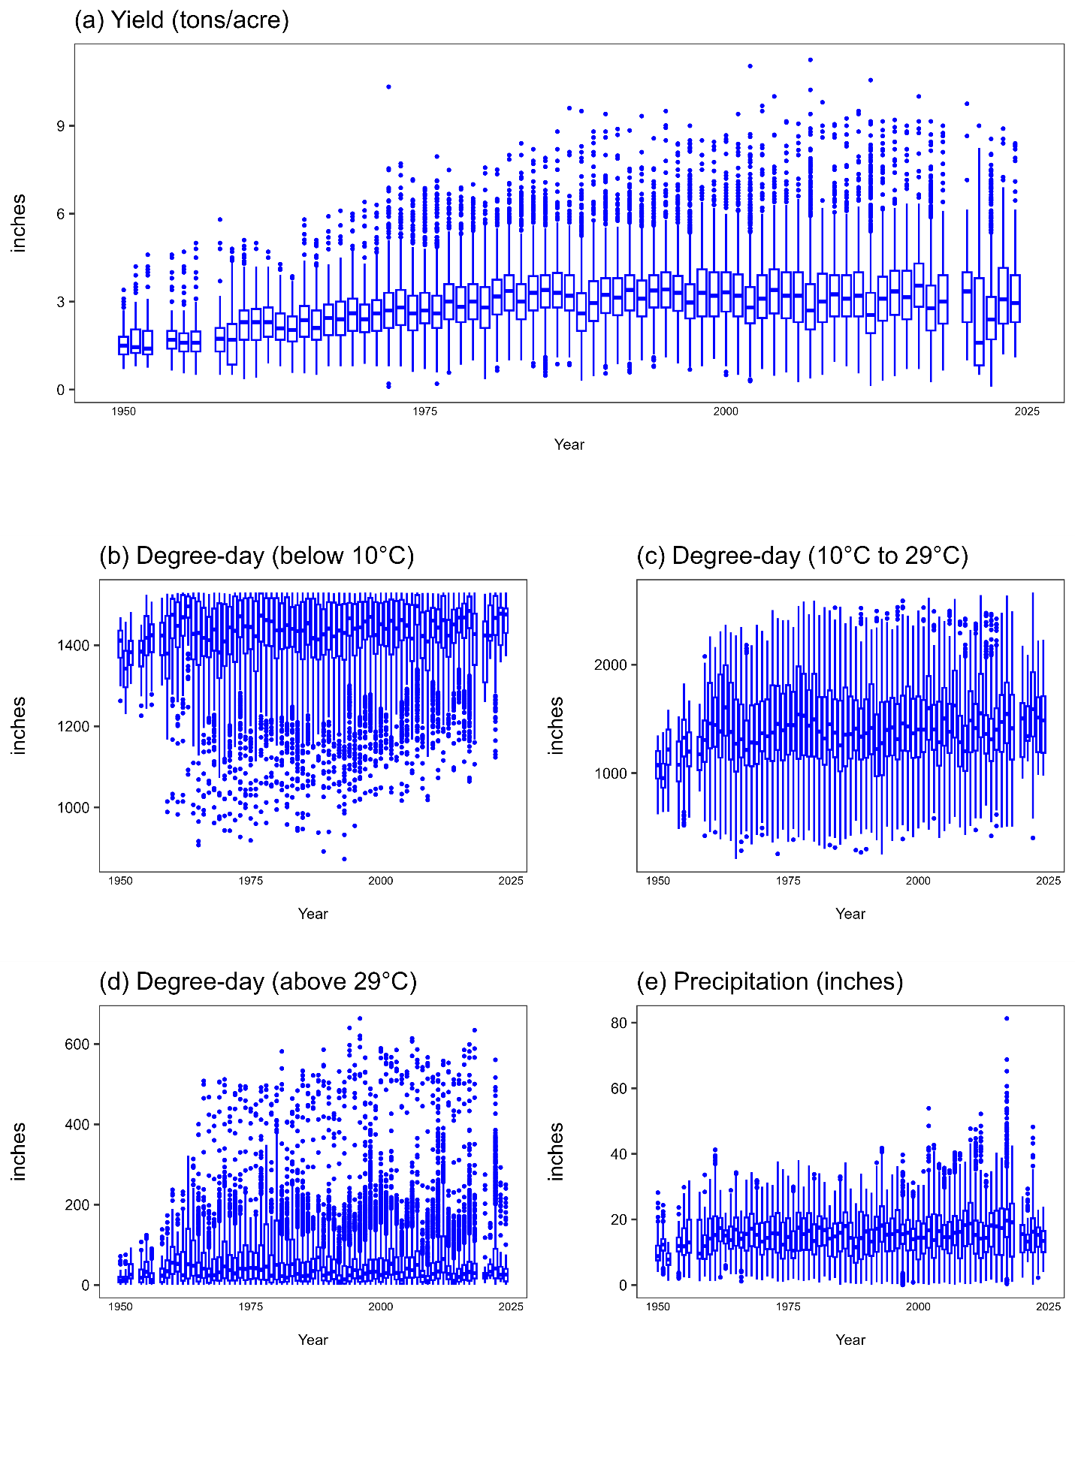

Figure 2. Alfalfa and Cattle Producing Areas in the U.S. (2002-2022)
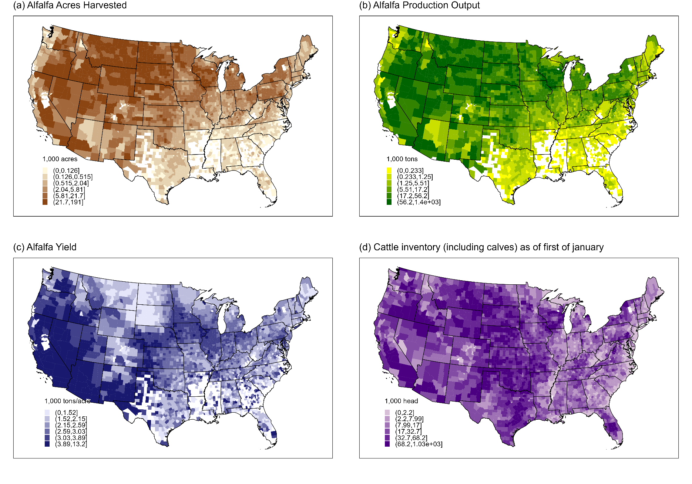

Figure 3. Nonlinear Relation Between Temperature and U.S. Alfalfa Yields (1951-2022)
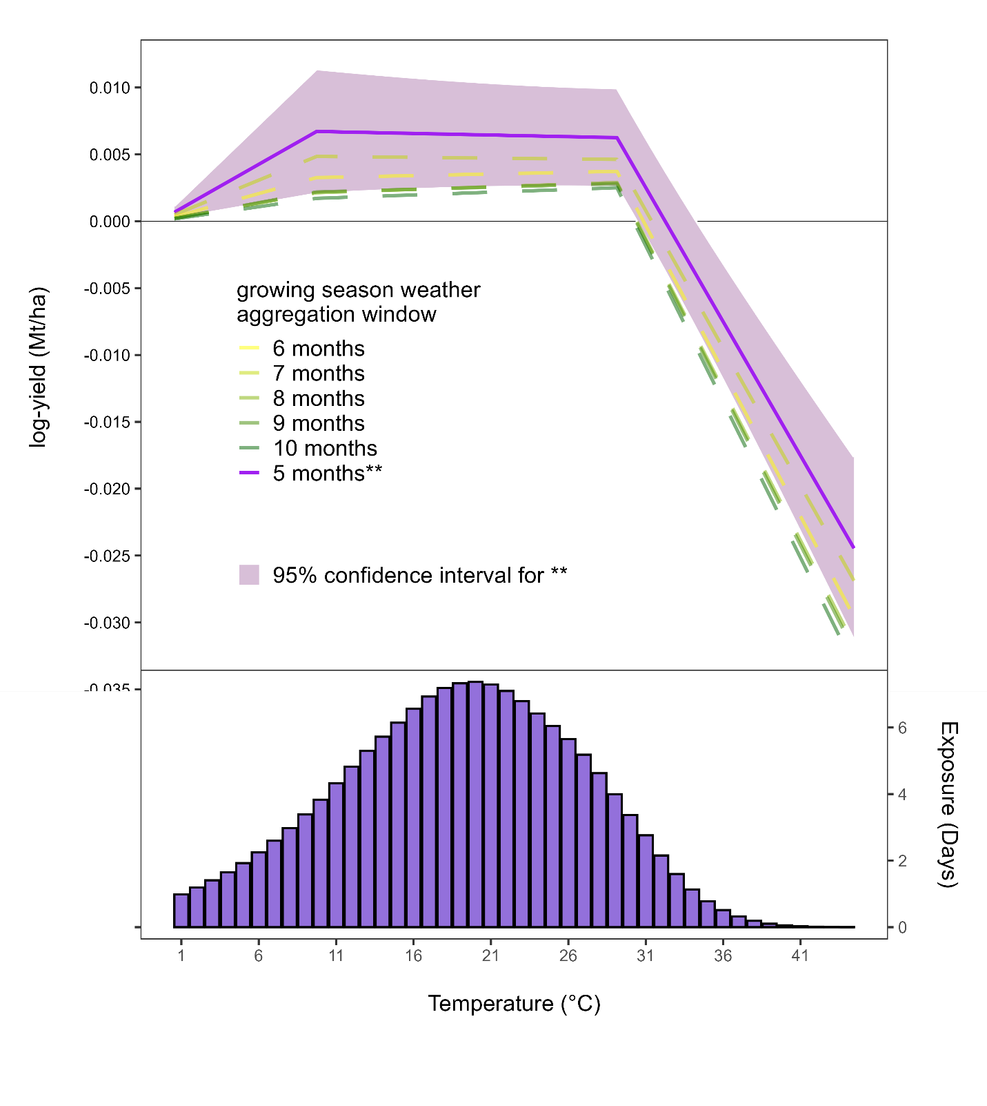

Figure 4. Predicted Impacts
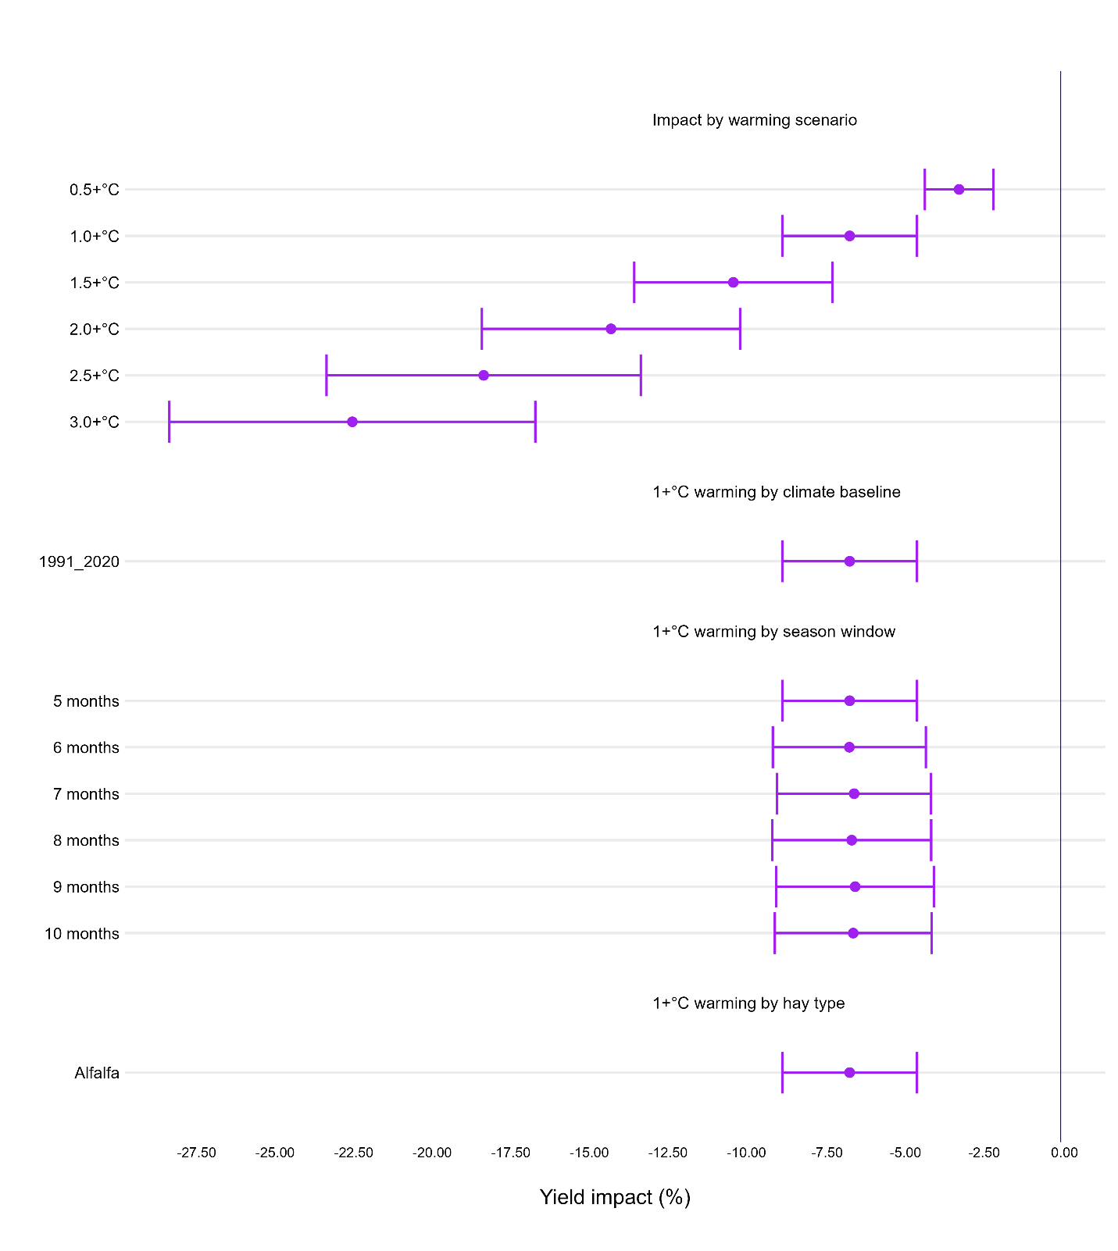

Figure 5. Predicted County Level Impacts
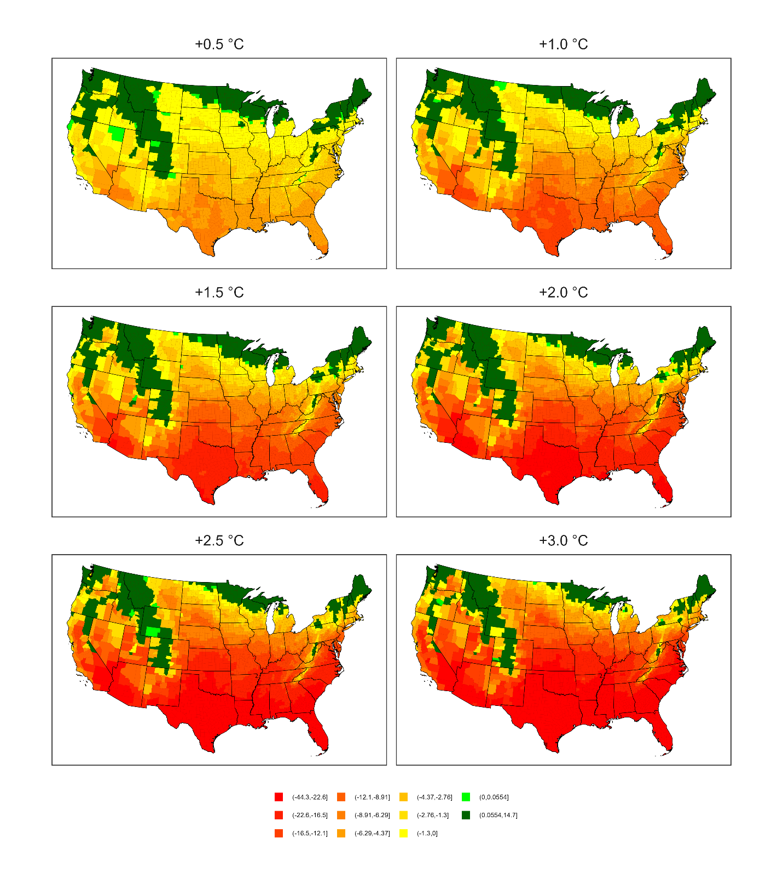

An acre of alfalfa, on average, will fix about 200kg of nitrogen per year.
United States (general): May 1 to April 30; Arizona and California: April 1 to March 31; Alabama, Arkansas, Colorado, Florida, Georgia, Kansas, Kentucky, Louisiana, Mississippi, Missouri, Nevada, New Mexico, North Carolina, Oklahoma, Pennsylvania, South Carolina, Tennessee, Texas, Utah, and Virginia: May 1 to April 30; and all other states: June 1 to May 31.
All data and models were processed on Beocat, a High-Performance Computing cluster at Kansas State University (https://beocat.ksu.edu/)

