PSMtools: Matlab Utilities for Processing of Power System Response Records

Summary Description

Summary
The Power System Monitoring (PSM) Toolset, or PSMtools, is a collection of processing utilities that is contained within the Dynamic System Identification (DSI) Toolbox developed by the Bonneville Power Administration (BPA) and the Pacific Northwest National Laboratory (PNNL) [1,2]. The DSI Toolbox is the latest Matlab [3] version of BPA systems analysis tools that trace their origins to wide area control projects in the mid 1970’s, and that have undergone extensive use and refinement since that time. As indicated in Fig. 1 and Table 1, the DSI Toolbox accepts both measured and modeled data for power system performance.
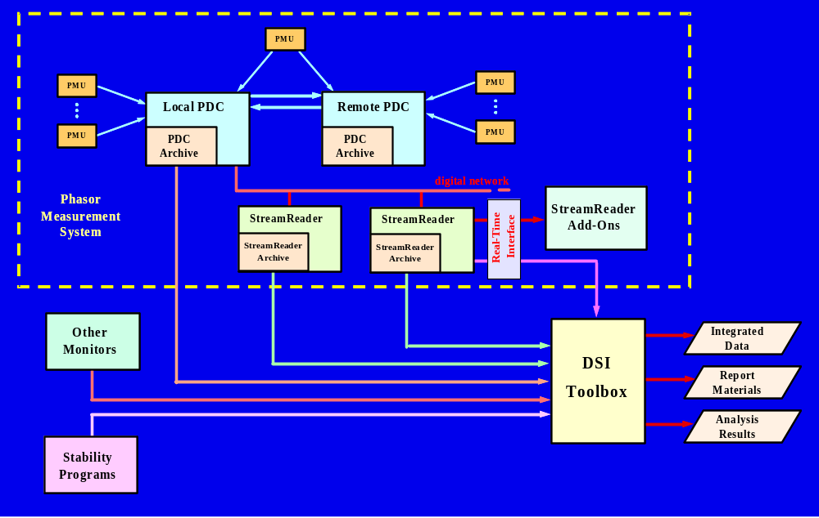
Fig. 1. Integration of multi-source data with the DSI Toolbox
The DSI Toolbox was expressly designed for flexible and efficient analysis of large data sets originating from a multiplicity of sources. This involves thousands of signals from monitors of many kinds, and composite records that may be hours long. Some of the implicit design tradeoffs that are discussed in the sections below.
The DSI Toolbox is an "interactive batch" tool that is optimized for dynamic systems analysis in a planning or control engineering environment. Development of a general GUI for PSMtools has been deferred until all toolset functionalities have been clearly established, and until the value of such a GUI is sufficient to justify the associated costs. A general GUI for PSMtools seems at odds with the openness, flexibility, and general economy of the present "interactive batch" version.
Table 1. Overview of the DSI Toolbox
• General description:
– Latest generation of an evolving toolset that has supported BPA and WSCC performance validation work since 1975.
– Initially designed for design & operation of advanced stability controls. Extensively used in HVDC & FACTS control.
– Optimized for dynamic systems analysis in a planning or control engineering environment. Oriented toward high volume analysis & report generation.
– Open Matlab code, easily customized. Readily links to third party tools for signal analysis, controller design, or other special tasks.
• Structure:
Power System Measurements (PSM) Tools:
– data management, high volume analysis, report generation
– signal extraction, repair, integration, analysis, and display
– translation and export of data in standard forms
Ringdown GUI:
– Prony analysis with Fourier accessories
– analysis of oscillatory dynamics
– model construction for controller design
Extensive application examples & documentation
• Availability:
– Established WSCC standard in disturbance monitoring plan submitted to NERC.
– Core code is distributed as freeware from BPA internet site ftp://ftp.bpa.gov/outgoing/WAMS%20Information/
– Associated training can be arranged via BPA, PNNL, or WECC staff.

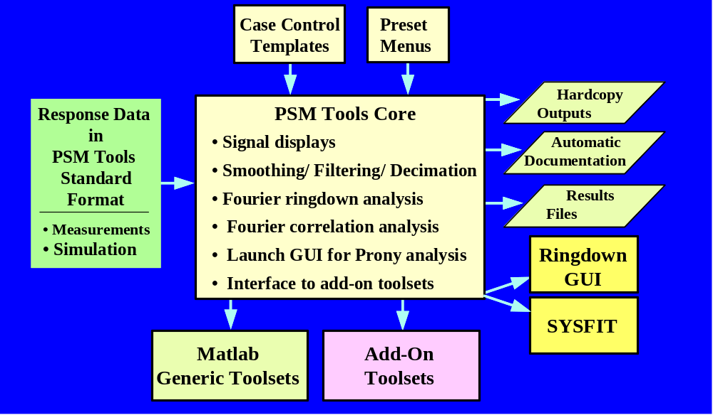
Fig. 2. General functionalities provided by PSM Tools
PSMtools provides a general processing framework for the DSI Toolbox. In its present form, PSMtools provides the functionalities indicated in Fig. 2. These include
• Import of power system monitor (PSM) data, or simulated PSM data, into the Matlab environment. This includes extraction of designated signals from multiple PSM records and linking them together. The data sources accommodated include BPA's Phasor Data Concentrator (PDC), the BPA PPSM and PSAM, the Macrodyne PMU, and leading computer programs for simulation of power system dynamics.
• Export of power system monitor data and analysis results from the Matlab environment into other environments.
• Interactive batch processing that includes automatic processing of the following kinds:
– signal extraction and joining
– repair of record defects (e.g., lost PMU messages)
– calculation of derived signals (e.g., rms signals from phasor data)
– filtering and smoothing
– record decimation
– spectral analysis via periodograms [4-5]
– Fourier ringdown analysis
– launching of the Ringdown Graphical User Interface (GUI) for Prony ringdown analysis
– launching of Matlab add-on toolsets (e.g., wavelet analysis)
– scanning of PSM archives for evidence of dynamic events*
• automatic documentation of processing cases.
Asterisks here indicate features that are custom, experimental, or in some other respect not available for general distribution. PSM Tools, as a general platform for customized menu-driven utilities, is continually evolving to meet the needs of an expanding applications base.
A list of those elements that make up PSMtools is provided in the detailed user documentation. Many of these elements are shared with other portions of the DSI Toolbox and, more generally, with other portions of the Dynamic Information Technology Package (DITPAK).

Introduction
Dealing with power system dynamics is cyclic process that involves both measurements and models. In Fig. 3 it is assumed that the objective is to develop a major control system. Less demanding objectives still produce the same basic cycle. Better measurements produce better models. Together, the measurements and the models lead to a better understanding of the power system and its needs – which, often enough, include better measurements.
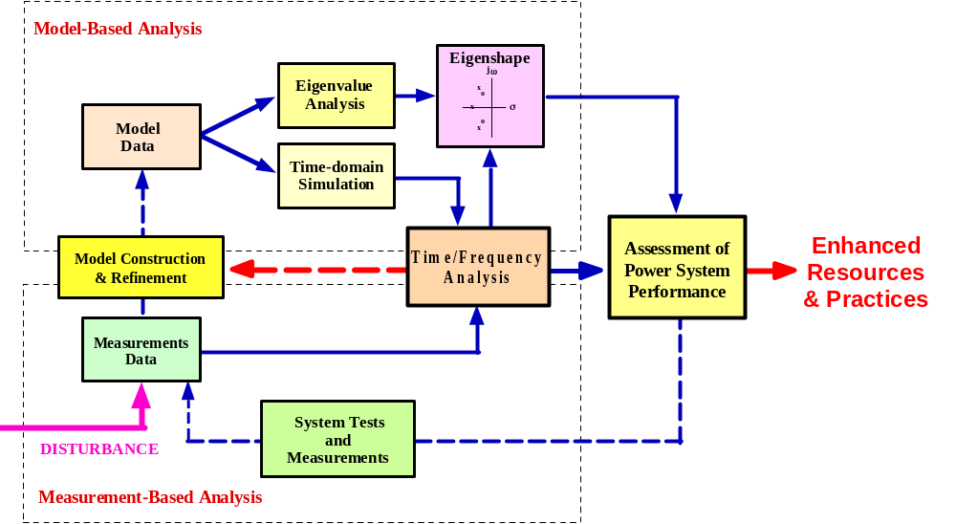
Fig. 3. Interactions among measurements and models

In the present context measurements are considered to be acquired data plus whatever information has been extracted from them. Obtaining such measurements and using them in combination with model based analysis are critical elements in dynamic system engineering.
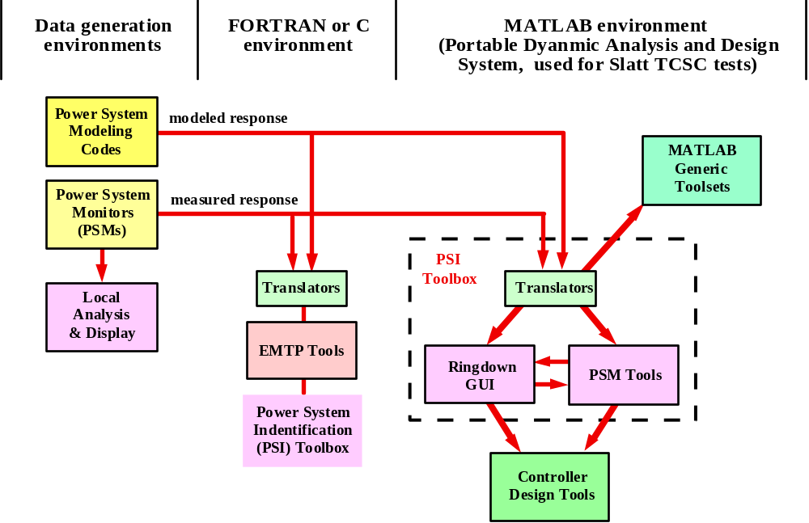
Fig. 4. Typical environments for analysis of dynamic response
Fig. 4 illustrates some of the environments in which DITPAK is used for analysis of dynamic response. The FORTRAN or C environment is typical for power system planning, and it is often the environment for the power system modeling codes. The Matlab environment is particularly well suited to integrated systems analysis, which may take place as an extension of systems planning, or in the field, or even in a system operations center. Implicit but not shown is a very wide range of instrumentation environments associated with the measurement of power system response [1]. The most advanced DITPAK configuration provides all of the functionalities needed to test and retune a control system in the field.
Value engineering solutions for the several environments of Fig. 4 differ considerably in their treatment of costs, flexibility, processing power, and ease of use. Ease of use can be very high for a simple "pushbutton" instrument – provided that there are just a few signals to process. Processing large numbers of signals can be very laborious, however, and case documentation may require handwritten notes. At the other extreme, programs written for FORTRAN or C environments usually have very good bulk processing capabilities plus highly structured case documentation. But, like the pushbutton instrument, the menus they offer are not easily modified and thus they score low on flexibility. LabVIEW is a long step toward more intelligent instruments, but the user still interacts through a predefined menu that is not casually modified. This implies a need for expert software support that seems generic to graphical interfaces, no matter what the language in which they are coded.
Matlab permits direct interactive access to a vast and expanding range macro functions, in any order that the user wishes, and it is very well established within the engineering community. It is particularly well suited to the engineering of advanced control systems. After careful study, it became the BPA standard for this a decade ago.
The flexibility in Matlab incurs a cost that is generic to interactive processing. That cost is case documentation. Built-in documentation for an interactive programming language may just be a very verbose diary for all the keyboard entries plus the software responses to them. This is particularly ill suited to systems analysis work, where it is common to repeatedly analyze large quantities of data from many different perspectives. Applications of this kind merit some investment in customized documentation tools, in the form of
• automatic utilities provided by or to the user.
• a disciplined style of language use.
The next section describes the general approach taken to these issues in PSM Tools.

Overview of PSMtools
PSMtools is a collection of processing utilities that is contained within the Dynamic System Identification Toolbox. These are intended for use in a Matlab programming environment, and the more important elements of PSMtools are provided as Matlab code. A few, however, are coded in languages such as LabVIEW or C. These are usually provided as compiled code ready for execution.
Performance objectives for the utilities are that they should
• provide interactive menus for the bulk processing tasks often encountered in the analysis and display of dynamic response data.
• provide automatic internal documentation for each case executed.
• be easily used, even by non-experts.
• be easily customized, even by those whose Matlab skills are still modest.
Some of the PSM Tools, such as PSMbrowser, converse with the user through simple dialog boxes and require no Matlab skills at all. For high volume applications, however, most users will eventually seek utilities that are tailored to their particular needs and working environment. The programming skills needed for this are abundant among engineers (the power industry being a notable exception), and they are easily acquired by those with prior experience in languages such as FORTRAN or ALGOL.
Full and efficient use of PSMtools requires that certain general procedures be followed. It is recommended that the case processing commands be build into a Matlab "case script" file, starting with one of the example files which accompany PSMtools as templates. Then
• the entire case can be re-executed at any future time, by invoking the case script file name in the Matlab Command Window (MCW).
• portions of the case can be executed by copying the associated commands from the case script into the MCW.
Case scripts are usually brief enough that they can be used as partial documentation. Further documentation is produced by standard commands within the case script or the utilities that it invokes. This produces a case comment file (CaseCom) containing information such as
• a case name (CaseID), typed in by the user in response to a program prompt.
• a case time (casetime), determined automatically from the computer clock.
• optional comments that the user may add during case execution, in response to program prompts.
• source file name(s) for the processed data.
• extent of the data, time step, channel names, etc.
• parameter values for filtering, data decimation, Fourier analysis, or other signal processing operations.
The values of CaseID and casetime are "stamped" on all case results to assist later identification. The role of these and related control parameters are shown in Fig. 5.

User Interfaces for PSMtools
A user dialog with PSMtools ordinarily follows a convention that was specified several years ago by G. L. Keenan at the BPA Division of System Planning. This convention calls for self-explanatory text prompts, with indicated defaults, plus the occasional dialog box. A typical prompt driven menu is shown below:
In Case Script PSDScase_Ex1:
caseID = PSDScase_Ex1
Select processing type: Options are
1 Batch Plots
2 Angle/Freq Refs
3 Filter/Decimate
4 Backload Filtered
5 Fourier
6 Histograms
7 Ringdown GUI
8 Ringdown Utilities
9 AutoCorrelations
21 ModeMeter
22 EventScan
41 Phasor Utilities
42 Backload Phasor Results
51 Special Displays
94 Downselect Signals
95 Load new data
96 save results
97 keyboard
98 Defaults on/off
99 end case

Indicate processing type - enter number from list above []:

The square bracket shows a standard default value (1) that will be accepted by the prompt if the user simply presses the Enter or Return key. Such defaults can be preloaded in a variety of ways, and there is an option for accepting them automatically.
The GLK interface produces a user dialog that is intendedly verbose. One reason for this is that the prompts to the user are tutorial, and constitute built-in documentation on use of the tools. Another reason is that the MCW display can be stored as a Matlab diary file, providing a counterpart to the “log file” that is generated by some transient stability programs.
Developing graphical user interfaces to PSMtools is straightforward, but not necessarily desirable. The present text-based interface is very flexible, and it is readily modified by experienced users. A GUI, in the other hand, is usually customized to some specific application environment. This often involves the removal of functionalities that are not immediately useful, plus "freezing" of the retained code. Modifying an existing GUI for use in other environments tends to be expensive, and to require specialized programming support.
The present strategy for PSMtools is to defer development of a general GUI until all toolset functionalities have been clearly established, and until the value of such a GUI is sufficient to justify the associated costs. A general GUI for PSMtools seems at odds with the openness, flexibility, and general economy of the present "interactive batch" version.

Documentation for PSMtools
PSMtools is in daily use at PNNL, and new features are added on a regular basis. The formal documentation, though generally indicative of programming and user methodologies, is no longer up to date with respect to some details. Such documentation is of primary interest to those who would modify or maintain the software, and it will be updated as time allows.
The primary documentation for PSMtools is directly embedded within the GLK interface itself. There is also a suite of self-executing tutorial examples, and available instruction that includes relevant theory for use of such tools in systems analysis. Extensive application examples for PSMtools and the Ringdown GUI are provided in the indicated references.

APPENDIX A. Technical Details

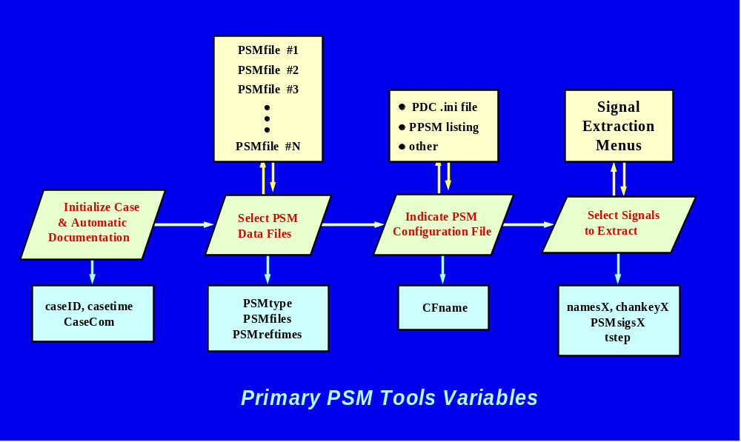
Fig. 5. Case startup controls for PSMtools

REFERENCES

[1] J. F. Hauer, W. A. Mittelstadt, R. Adapa, W. H. Litzenberger, and M. K. Donnelly, Direct Analysis of Wide Area Dynamics. Materials for CRC Electric Power Engineering Handbook, Chapter 11: Power System Dynamics and Stability. Published winter 20000. Available at WAMS web site http://www.transmission.bpa.gov/orgs/opi/Wide_Area/index.shtm.
[2] J. F. Hauer, D. J. Trudnowski, G. J. Rogers, W. A. Mittlestadt, W. H. Litzenberger, and J. M. Johnson, "Keeping an Eye on Power System Dynamics," IEEE Computer Applications in Power, pp. 50-54, October 1997.
[3] MATLAB: The Language of Technical Computing. The Math Works, Inc.: Natick, MA, 2000.
[4] J. S. Bendat and A. G. Piersol, Engineering Applications of Correlation and Spectral Analysis. New York: John Wiley, 1980.
[5] J. G. Proakis and D. G. Manolakis, Digital Signal Processing – Principles, Algorithms, and Applications (Second edition). New York: McMillan, 1992.
[6] INTERIM REPORT ON WSCC SUMMER 2000 STAGED SYSTEM TESTS AND VALIDATION STUDIES — PART 1: OSCILLATORY DYNAMICS. WSCC Performance Validation Task Force of the Modeling and Validation Work Group. Draft of October 26, 2000. Available at web site http://web.wscc.com/committees/PCC/system_performance_validation.htm.
[7] Preliminary Examination of the Alberta Trip on August 4, 2000, J. F. Hauer. PVTF Working Note, August 15, 2000. Available at web site http://web.wscc.com/committees/PCC/system_performance_validation.htm.
[8] "Dynamic Performance Validation in the Western Power System," J. F. Hauer, M. J. Beshir, and W. A. Mittelstadt, in association with the WSCC Performance Validation Task Force. APEx 2000 Conference, Kananaskis, Alberta, October 2000. Available at web site http://web.wscc.com/committees/PCC/system_performance_validation.htm.

