A User Guide to PSM Tools:

Utilities for Matlab Processing of Power System Response Records

Prepared for the
Transmission Reliability Program
Office of Power Technologies
Assistant Secretary for Energy Efficiency and Renewable Energy
U.S. Department of Energy

Principal Authors

John F. Hauer and Jeffrey M. Johnson, Pacific Northwest National Laboratory

February 2001

Table of Contents
1. Background 4
2. Introduction 5
3. Application Environments for PSM Tools 7
4. Distribution of PSM Tools 8
5. Getting Started with PSM Tools – Examining the Installation 17
5.1 Naming Things in Matlab 18
5.2 Basic Types of Matlab files 18
5.3 Examining the Internal Documentation for a PSMT Data File 19
5.4 Navigating to .mat Files 21
5.5 Other File Types Associated With PSM Tools 22
6. Getting Started with PSM Tools – Tutorial Examples 23
6.1 Getting Started with PSM Tools – Matlab Examples 23
6.2 Getting Started with PSM Tools – Browser Examples 24
6.3 Getting Started with PSM Tools – Names for PDC Signals 25
6.4 Getting Started with PSM Tools – keyboard Commands 27
6.5 Getting Started with PSM Tools – Signal Plotting 28
6.6 Getting Started with PSM Tools – Signal Selection 34
6.7 Getting Started with PSM Tools – Experimental Plot Types 36
7. Case Documentation in PSM Tools 39
8. Detailed Operation of PSMbrowser 40
8.1 Detailed Operation of PSMbrowser – The Case Definition Menu 41
8.2 Detailed Operation of PSMbrowser – Signal Extraction Menus 42
8.3 Detailed Operation of PSMbrowser – Merging of Multi-Source Data 47
8.4 Detailed Operation of PSMbrowser – Report Generation 48
9. Signal Filtering 49
10. Fourier Analysis 57
10.1 Fourier Ringdown Analysis 59
10.2 Fourier Correlation Analysis 62
10.3 Fourier Analysis in Real Time 66
11. Linking to Add-On Toolsets 66
11.1 Launching the Prony Analysis GUI 66
11.2 Launching the Control System Toolbox 66
11.3 Launching the Signal Processing Toolbox 67
11.4 Launching the Wavelet Analysis Toolbox 67
11.5 Launching the System Identification Toolbox 67
12. Concluding Remarks 67

A User Guide to PSM Tools:

Utilities for Matlab Processing of Power System Response Records

Background
The western power system is notable in North America for being loosely connected, and for its very long transmission paths. Consequently the system capability and behavior in one region may hinge upon system conditions and equipment performance in other regions that are very far away. These matters can be neither anticipated, nor assessed after the fact, without access to system-wide information.
Major dynamic events on the western system are very likely to involve the whole system. Full understanding of such events calls for an overall view of actual system behavior, followed by construction and use of a validated system planning model. This holds true for disturbances, for staged tests of system dynamics, and for precautionary surveillance of background system activity.
The requisite operational data is collected on a variety of recording systems, and contributed to the analysis effort by a number of owning utilities. This is followed by data integration, by model construction & validation, and by tandem analysis of measurements and model simulation results [,,,]. The work is usually a collective effort of WSCC staff plus those WSCC institutions most involved in the event.
At present no institution in the western system – utility, ISO, or RTO – has measurement facilities to observe or record overall system behavior. A collective response to this need is underway, however, and a formal WSCC policy in this respect is taking form in response to recently established NERC standards for the monitoring of power system performance [,]. The primary facilities for dynamic monitoring are a result of the ongoing WSCC/DOE/EPRI WAMS effort, and are conveniently referred to as WSCC WAMS [,].
The WAMS effort has produced many technologies for the collection and use of dynamic information. Within these, PSM Tools is the most general of the analysis toolsets. This is an expanded Matlab version of BPA systems analysis tools that have served WSCC needs since 1975. It is expressly designed to support event analysis as described above, and as a bridge to the control systems design and extended tools development that may be needed to sense or to mitigate system disturbances. It does so by providing the following functions for data handling and analysis:
• Extraction, integration, display, and basic analysis of measured signals from binary files collected with the monitor types most commonly used in the WSCC.
• Selective extraction and export of measured signals for contribution to the WSCC event analysis effort.
• Entry, display, and basic analysis of transient stability simulation results for comparison against the measured data.
• Generation of computer and hardcopy graphics for use in engineering reports.
PSM Tools can accept and integrate data from all major monitor types now operating within the western power system, and from the more important transient stability programs.
Core elements of PSM Tools are being distributed to WSCC institutions as an element in the WSCC Plan for Dynamic Performance and Disturbance Monitoring [Error: Reference source not found]. Various aspects of this distribution are funded by the BPA, by the WSCC organization, and by the Consortium for Electric Reliability Technology Solutions (CERTS) as a reliability outreach activity of the U.S. Department of Energy (DOE). Special development and installations of PSM Tools are funded by the BPA, and by CERTS as a reliability outreach activity of the California Energy Commission (CEC).

Introduction
This document is a basic guide to operation of that WAMS technology package known as PSM Tools. Depending upon context, PSM may denote either power system monitor or power system measurements. In the latter sense it is taken to include synthetic measurements produced through computer simulations.
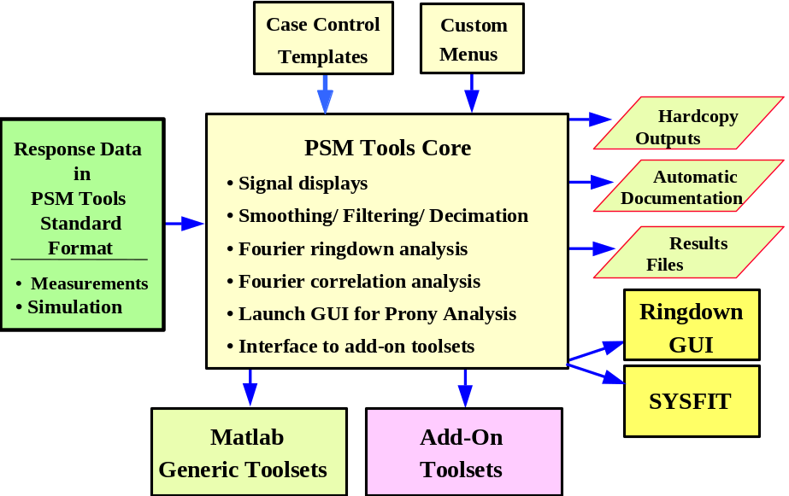
Fig. 1 Processing functions provided by PSM Tools
PSM Tools is the most general of the analysis toolsets contained among the WAMS technologies. Broadly described, the defining functionalities for PSM Tools are to import PSM data into a standardized processing environment, and to provide a flexible structure there for signal analysis and perhaps engineering design (see Fig. ). PSM Tools can accept and integrate data from all major monitor types now operating within the western power system, and from the more important transient stability programs. New features, such as translators for additional data sources, are readily added by knowledgeable users or by key developers at the Pacific Northwest National Laboratory (PNNL).
PSM Tools is contained in a broader toolset called the Power System Identification (PSI) Toolbox. This is a Matlab version of BPA systems analysis tools that trace their origins to wide area control projects in the 1970’s and 1980’s [,]. Within the framework of Fig. 1, the PSI Toolbox provides the indicated Time/Frequency analysis and is a supplement or partial alternative to Eigenvalue Analysis []. These BPA tools have undergone extensive use and refinement over the decades, and they have been a central element in the overall WAMS effort as reflected in [,,,,,,]. These references, and the additional references cited therein, constitute application notes that illustrate the many ways that PSI Toolbox functionalities are used in dynamic system analysis. Future documentation may extract and consolidate summary materials from these documents as a guide to the general methodology underlying such work.
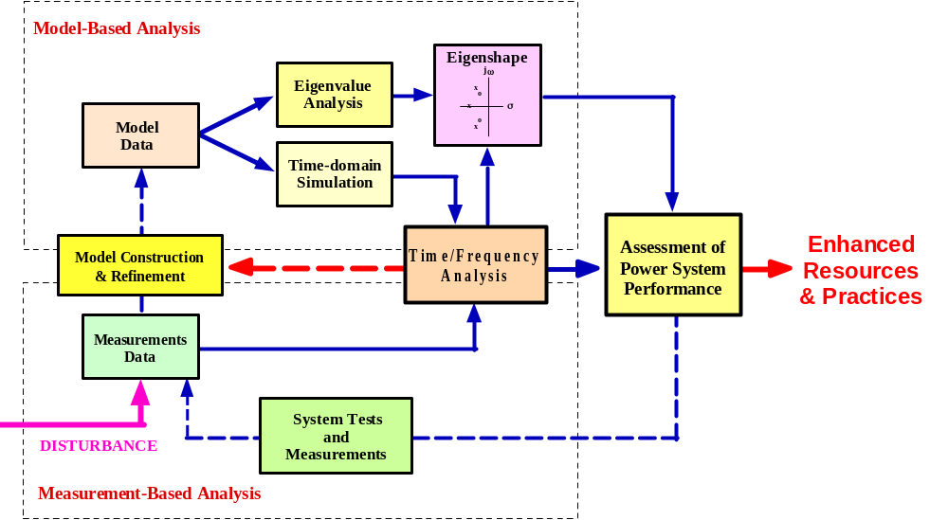
Fig. 1. Interactions among measurements and models
The present version of PSM Tools (early 2001) has a primary driver called PSMbrowser, and is coded for Matlab version 5.3 or higher [,]. The installation procedure for PSM Tools are detailed in [] and summarized later in this document. Users who have an installed version of PSM Tools can get a general introduction to it by first launching Matlab, and then entering the name PSMbrowser into the Matlab Command Window (MCW). PSM Tools will then communicate with the user through a series of self-explanatory prompts in the general form
In PSMbrowser: Use standard defaults for present case? Enter y or n [n]:
Pressing the enter key manually accepts the indicated default n, shown within the square brackets. If the user response to this particular prompt is y, then the default returns for all later prompts are accepted automatically. A prompt for which the default return is empty is an exception to this, and it absolutely requires a manual response by the user. Pressing the enter key is interpreted as n.
This particular convention for presenting the PSM Tools Operating Menu is referred to as the GLK Interface . By design, this interface is sufficiently tutorial that most users will rarely draw upon written materials such as the present document. The primary and most up-to-date documentation for PSM Tools is built into the GLK interface itself, with support in the form of various self-executing examples that are discussed later.
PSM Tools must do many different things for many different users. Consequently it has been “value engineered” [Error: Reference source not found] with a strong emphasis upon flexible application, and upon easy portability among developers and users. For these reasons key elements of PSM Tools are written as Matlab code open to the user, and the core version uses simple text-driven interfaces that are readily customized by those who are familiar with FORTRAN-like languages. Knowledge of Matlab is not a requirement for ordinary use of PSM Tools, once the processing menus and other conveniences have been customized to a particular facility.
Users who work within control center operating environments may prefer graphical user interfaces (GUIs) over text driven interfaces. Matlab provides rather good tools for GUI development, and PSM Tools is structured for progressive replacement of text interfaces by graphical interfaces. The value engineering aspects of GUIs should be carefully considered, however. No matter what programming language is used, the convenience of a GUI comes at the expense of reduced flexibility and of more specialized software support. Presenting the PSM Tools Operating Menu through a pushbutton GUI will produce a custom version of PSM Tools that is specialized to a particular environment, and perhaps to a particular facility. Extensive GUI development should not be undertaken before all functional requirements are clearly established and the essential algorithms are working reliably. The remainder of this document is intended to present useful insights into these matters.

Application Environments for PSM Tools
The PSI Toolbox can support all of the application environments shown in Fig. 2. The widest range of required functionalities is found in extended planning environments. These include advanced activities such as direct testing and analysis of system performance, the validation of planning models, and the engineering of major control systems. These functionalities define the capabilities required of PSM Tools, and the core version has been value engineered for use in extended planning. Versions of PSM Tools that are optimized for some other environment may offer fewer functionalities.
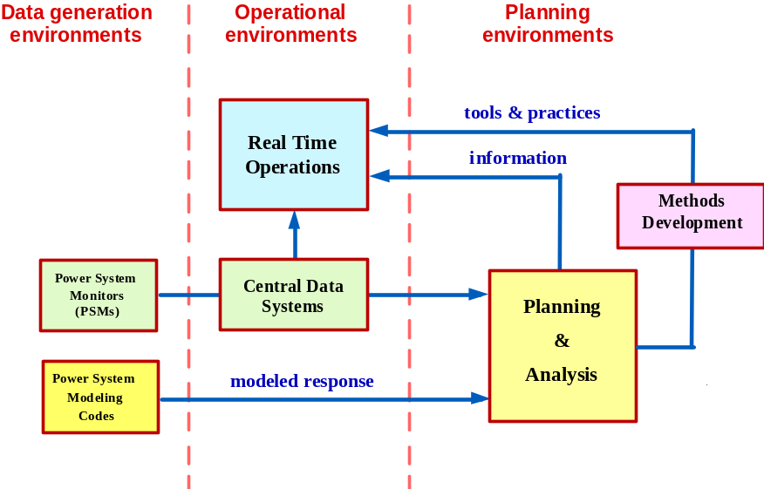
Fig. 2. User environments for power system performance data
The key functionalities of PSM Tools include the following:
• Import of measured or simulated PSM data into the Matlab environment. This includes extraction of designated signals from multiple PSM records and linking them together. The data sources accommodated include BPA's Phasor Data Concentrator (PDC), the BPA PPSM and PSAM, the Macrodyne PMU, and leading computer programs for simulation of power system dynamics.
• Export of extracted signals and analysis results from the Matlab environment into other environments.
• Alignment and Merging of signals extracted from multiple data sources, which need not be of the same type. E.g., signals collected on one or more PDC units can be merged with signals collected on PPSM units.
• Interactive batch processing of the following kinds:
– repair of record defects such as lost PMU messages
– calculation of derived signals, such as rms signals based upon phasor data
– graphical displays for signals and computational results
– filtering, smoothing, and decimation of extracted signals
– spectral analysis via Fourier periodograms [,]
– Fourier ringdown analysis of transient waveforms
– launching of the Ringdown GUI for Prony analysis of transient waveforms or correlation functions
– launching of the SYSFIT program for frequency domain fitting of structured models to transfer function data*
– launching of Matlab add-on toolsets (e.g., wavelet analysis and controller design)
• automatic documentation of processing cases.
• automatic reruns of interactive processing cases*
• automatic scanning of PSM archives to detect and summarize dynamic events*
Asterisks here indicate features that are custom, experimental, or in some other respect not available for general distribution.

Distribution of PSM Tools
The preferred method for the distribution of PSM Tools is to post it as a compressed data object (a “zipped” object) on one or more web sites established for the exchange of data, toolsets, and information relevant to the WSCC Wide Area Measurements System (WAMS). Distribution by means of zip cartridges is also done, but these may lack the storage capacity needed to accommodate the large record sets involved in the tutorial examples. Updates to the software alone can usually be delivered as email attachments.
PSM Tools is in daily use at PNNL and other institutions. Refinements and new functionalities are added as needed, which is fairly often. Updates to the external documentation – such as this document – are done less frequently, so new versions of PSM Tools may provide features that are not shown here. The basic operating rules for PSM Tools will be the same, however, and the new features will be explained via the GLK Interface. Major new features will also be demonstrated by means of new tutorial examples plus an announcement routed to known users.
The majority of these examples are based upon actual WSCC records for system events of special interest. The events presently used for this purpose include the following:
• WSCC breakup of August 10, 1996
• WSCC performance validation tests of June 7, 2000
• WSCC system oscillations following Alberta separation on August 4, 2000
When used to name the related files or folders, data information such as 08/10/96 is contracted to 081096. The names for files produced by hardware monitors such as the PDC are usually left in their original form.
The general nature of the example records for system events is provided in Fig. 3 through Fig. 7. The general nature of examples using data from the General Electric (GE) stability program PSDS is indicated in Fig. 8 through Fig. 10. The Prony analysis tool of Fig. 10 is an add-on to PSM Tools, and is distributed separately.
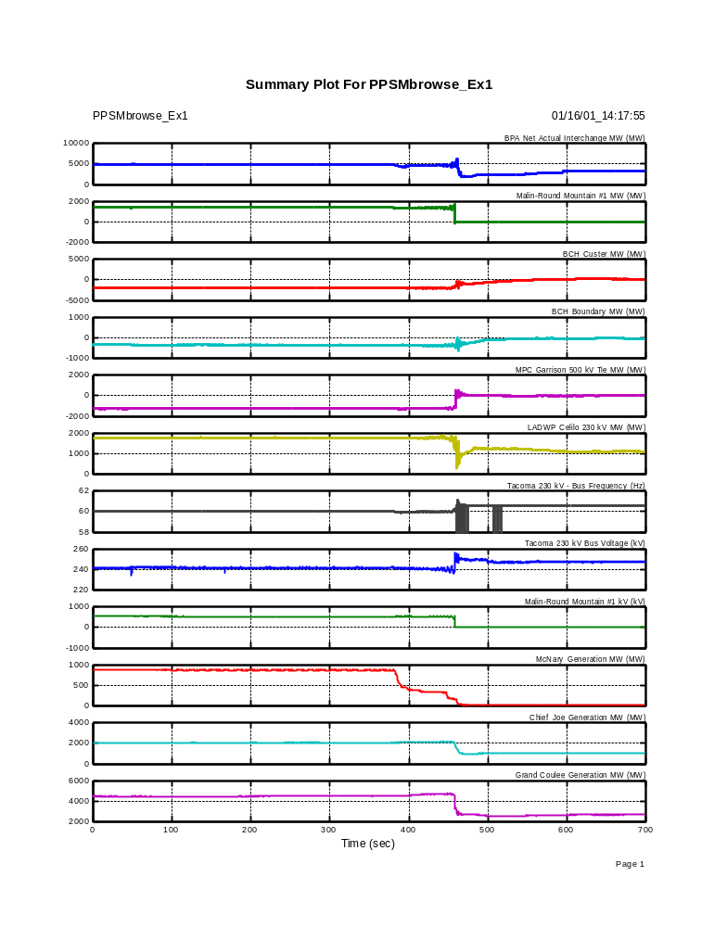
Fig. 3. Summary plot for WSCC breakup of August 10, 1996
Data collected on PPSM unit at BPA’s Dittmer Control Center
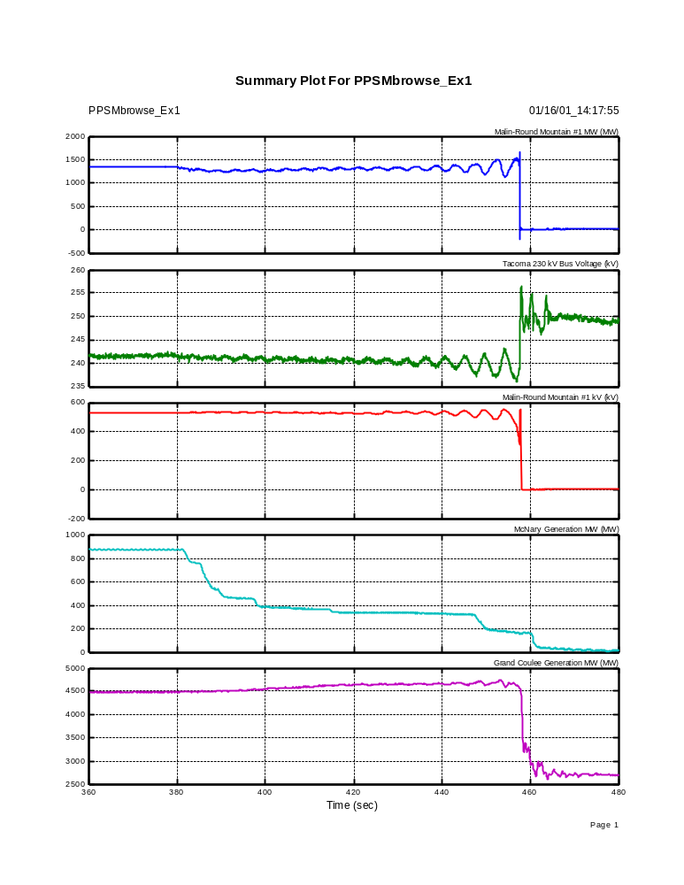
Fig. 4. Summary plot for WSCC breakup of August 10, 1996 (detail)
Data collected on PPSM unit at BPA’s Dittmer Control Center
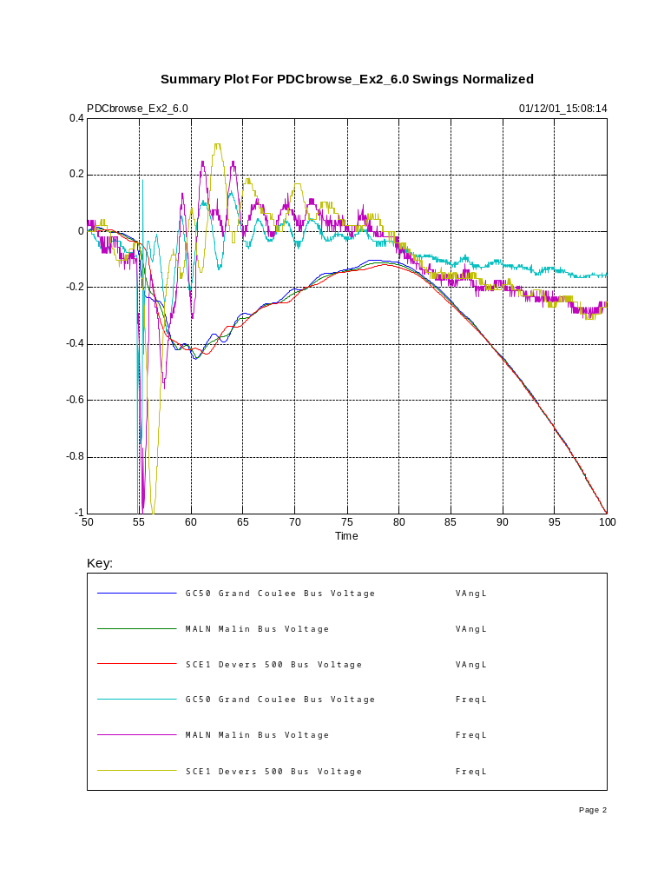
Fig. 5. Brake insertion #1, WSCC tests of 06/07/00
Normalized signals with offsets removed
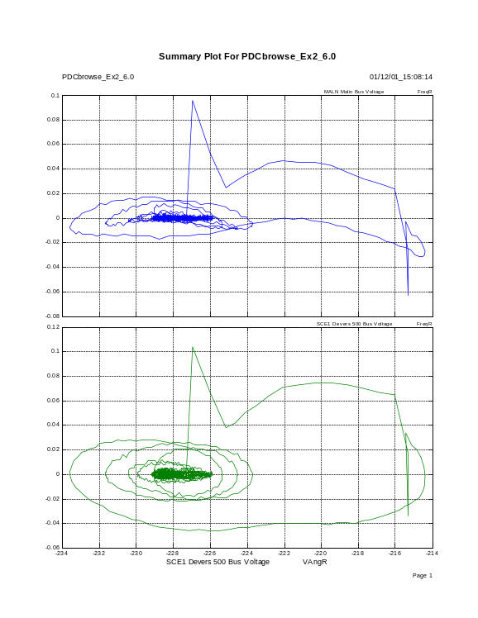
Fig. 6. Referenced frequencies against referenced voltage angle
Brake insertion #1, WSCC tests of 06/07/00
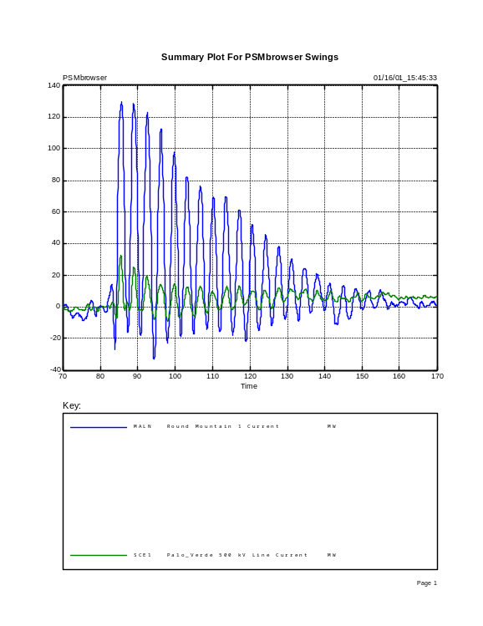
Fig. 7. System oscillations following Alberta separation on August 4, 2000
Data collected on PDC unit at BPA’s Dittmer Control Center
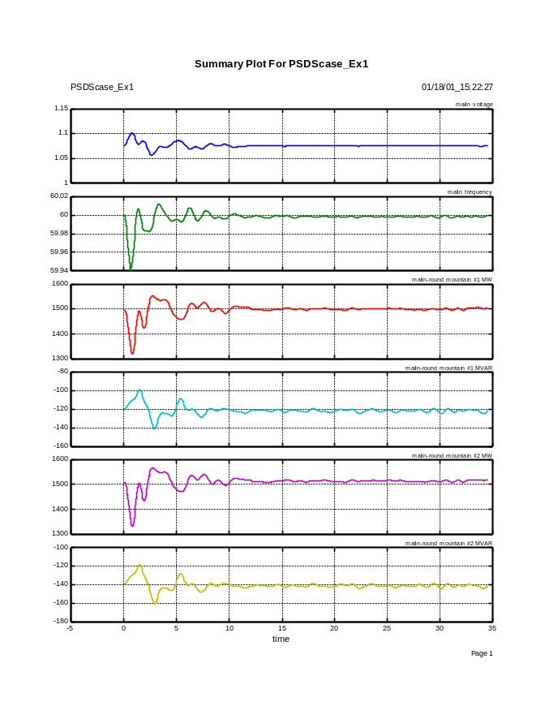
Fig. 8. Ringdown signals for insertion of Chief Joseph dynamic brake
Data exported from GE stability program PSDS
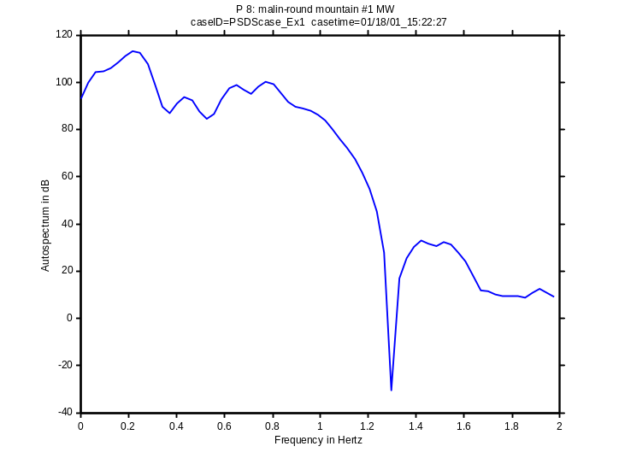
Fig. 9. Ringdown autospectrum for insertion of Chief Joseph dynamic brake
Data exported from GE stability program PSDS
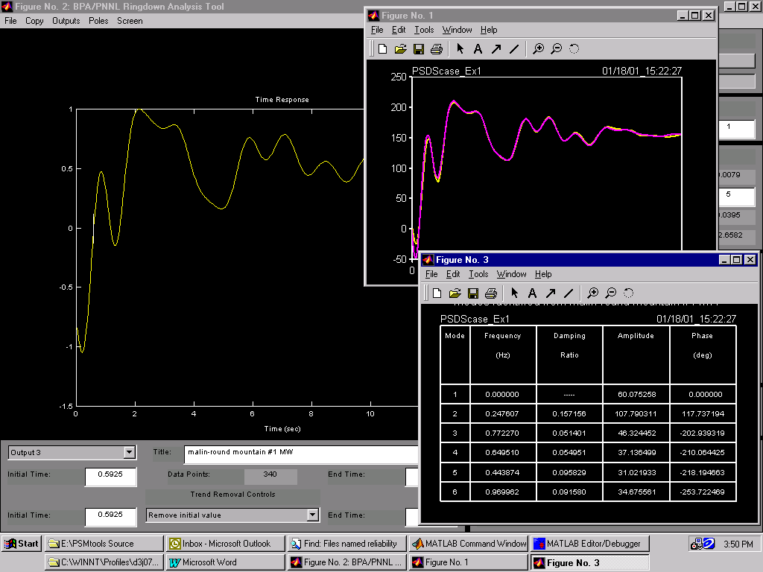
Fig. 10. Prony analysis of ringdown signal for insertion of Chief Joseph dynamic brake
Data exported from GE stability program PSDS

Getting Started with PSM Tools – Examining the Installation
This is a tutorial Section intended for new users of PSM Tools, and for users who may not be experienced with Matlab. Experienced users may prefer to review it quickly and then proceed to later Sections.
Software for the Dynamic System Identification (DSI) Toolbox is distributed in two primary folders, one for the Ringdown GUI and one for PSM Tools [Error: Reference source not found]. The primary PSM Tools folder usually has a name like PSMtools Source, and a directory structure as indicated in Fig. 11. In this particular case the folder has been named PSMtools Source_010301, where the appended digit string indicates the distribution date. Usual practice is to make a working copy of the primary folder, with the distribution date omitted from the folder name.
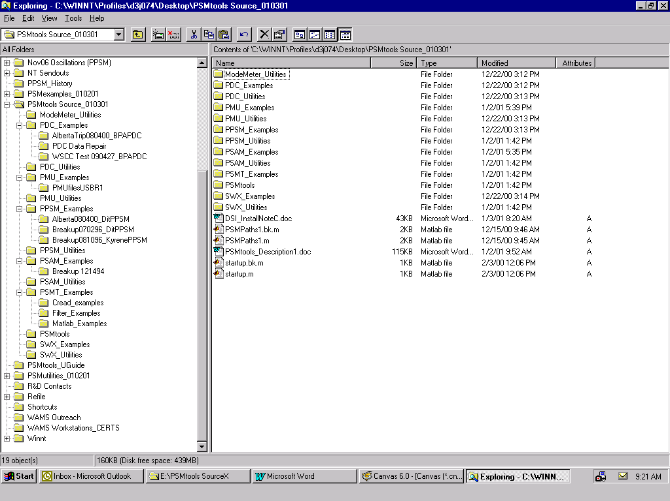
Fig. 11. File structure for PSM Tools
The upper-level subfolders within PSMtools Source are of two kinds:
• Software folders:
– PSMtools
– folders with names like PDC_Utilities
• Example folders:
– PSMT_Examples
– folders with names like PDC_Examples
Installation is done in two steps: [Error: Reference source not found]
a) “Drag and drop” each of the two primary folders, from the medium where it was received, to an appropriate location on the user’s PC.
b) Set Matlab paths to the contents of each primary folder, so that Matlab can find the contents while processing. The Set Path command in Matlab 6.0 does this in one step, but users of Matlab 5.3 should launch a utility with a name like PSMpaths1.
Partial updates to the DSI Toolbox usually involve just the first step. This requires that the new primary folder have the same name and internal directory structure as the one to be updated. Then “dropping” the new version of the primary folder onto the older one will cause new file versions to replace earlier ones, and the original paths remain correct.

Naming Things in Matlab
Matlab treats variable names as case sensitive – caseID and caseid would denote two different variables. Matlab does not treat file names as case sensitive, however. Since Matlab functions are stored as files and referenced by the names of the containing files, a function name like PSMsave can also be written as psmsave.
Various names in Matlab are reserved for built-in functions. Those most commonly encountered include if, else, for, while, try, break, continue, end. Depending upon context, Matlab will sometimes allow the user to employ reserved names that are more specialized. It is best to avoid this where possible, however.

Basic Types of Matlab files
PSMtools Source contains three basic types of Matlab file. The types are indicated in the file names, which end with character strings .m, .p, or .mat. A representative example of each file type is discussed below.
MatlabEx1.m
An m-file can be either a function, or a script. A function is declared to be such in the first command, which will then define input and output variables. A script will simply process whatever variables happen to be present in the Matlab workspace.
The contents of an m-file can be viewed or modified with the Matlab editor. One can do this by double-clicking on the m-file icon, or by entering the command edit MatlabEx1 into the Matlab Comand Window (MCW). Entering the command MatlabEx1 will launch the m-file (i.e., cause it to execute).
PSMsave.p
A p-file is a “parsed” version of a corresponding m-file. A p-file corresponds to the compiled code modules of some other computer languages, and cannot be examined with the editor.
NOTE: p-files take precedence on the Matlab path, so Matlab would use an old p-file in preference to a newly edited m-file that has the same name. Mysteries of this sort can often be resolved through commands like which PSMsave (to find out which version is in use on the path). To learn more about the which function and other functions related to it, use the command help which.
WSCC_Breakup_081096Ex1.mat
A mat-file is a Matlab binary file for data storage. The contents are variables exported from the Matlab workspace. The mat-file stores not just the value of each variable, but also its name and all attributes. Loading such variables back into the Matlab workspace restores them in full. This also overstores any previous variables that have the same names as those returning from the mat-file.
A mat-file cannot be edited, but its contents can be determined in summary form through a command like whos -file WSCC_Breakup_081096Ex1.mat. The results for this particular mat-file are shown in Table 1. To learn more about the whos function and other functions related to it, use the command help whos.
The variables contained in this file are standard for PSM data that has been translated into PSM Tools (PSMT) format, and the file itself is called a PSMT data file. The rather long name assigned to this file reflects typical practice in working with PSM data. Placing key information within file names is a useful aid in navigating among the many thousands of files that such work commonly involves.

Table 1. Using the whos command to check contents of a mat-file in PSMT format
>> whos -file WSCC_Breakup_081096Ex1.mat
Name Size Bytes Class

CFname 1x18 36 char array (global)
CaseComR 31x77 4774 char array
PSMfiles 2x29 116 char array (global)
PSMreftimes 1x2 16 double array (global)
PSMsigsX 14000x8 896000 double array
PSMtype 1x4 8 char array (global)
chankeyX 8x41 656 char array
namesX 8x34 544 char array
tstep 1x1 8 double array

Grand total is 115070 elements using 902158 bytes
The previously extracted signals are stored as columns of array PSMsigsX, of which the first column is time. Character array namesX contains the signal names, and chankeyX provides a numeric “key” to the channels.

Examining the Internal Documentation for a PSMT Data File
Every PSMT file contains a text array with the name CaseComR (or sometimes just CaseCom). This is a case processing log that indicates the source of the PSM data, what has been done to the data, and where to find processing results that are stored externally to the PSMT data file.
The nature of a particular PSMT data file can be determined by loading CaseComR into the Matlab workspace and displaying it. This can be done for WSCC_Breakup_081096Ex1.mat by the following two commands:
>> load WSCC_Breakup_081096Ex1.mat CaseComR
>> CaseComR
The results are shown in Table 2. CaseComR is sometimes too large for convenient display. In such case a command like the one below can be used to display selected lines:
>> CaseComR(1:20,:)
In this particular command the entry 1:20 indicates lines 1 through 20, and the colon : is a “wild card” symbol indicating that the full line length should be used.
Some of the more important information shown in CaseComR is also stored as separate variables, both for user convenience and for use in continued processing. Variables CFname and PSMtype indicate the data source, and variables PSMfiles and PSMreftimes indicate the names and reference times for the data files from which signals in PSMsigsX were extracted. These variables are readily examined with commands such as those used in Table 3 to display the channel key chankeyX.
When variables are reloaded from a .mat file they will overstore any previous variables of the same names. For this reason the internal documentation for an active case is developed as CaseCom but stored and retrieved as CaseComR.
Table 2. Examining CaseComR
>> load WSCC_Breakup_081096Ex1.mat CaseComR
>> CaseComR
CaseComR =

Case ID = WSCC Breakup_081096 Example1
Case Time = 01/08/01_11:22:38
Example data for use of PSM Tools -- Event is WSCC breakup of August 10, 1996
In PSM Utility PSMbrowser: General Browsing

Starting menu = Interactive selection of channels(modified)
ChansX=
[9 33 34 37 6 5 11]
PPSM File Extracted = Files@DITT 08_10_96 15H41m20s
Time Step = 0.05000 Max Time = 349.950
PPSM Reference Time = 3048705680.00000 Seconds
PPSM Reference Time = 10-Aug-1996 22:41:20.000 GMT Standard
PPSM File Extracted = Files@DITT 08_10_96 15H47m10s
Time Step = 0.05000 Max Time = 349.950
PPSM Reference Time = 3048706030.00000 Seconds
PPSM Reference Time = 10-Aug-1996 22:47:10.000 GMT Standard

In PPSMload: 2 Files Extracted:
Time axis has been inserted at column 1 of signal array
No decimation during signal extraction
Time Step = 0.05000 Max Time = 699.950
Configuration file = Dittmer #9 Listing

% 1 Time (sec)
% 2 Malin-Round Mountain #1 MW (MW)
% 3 BCH Custer MW (MW)
% 4 BCH Boundary MW (MW)
% 5 LADWP Celilo 230 kV MW (MW)
% 6 Tacoma 230 kV - Bus Frequency (Hz)
% 7 Tacoma 230 kV Bus Voltage (kV)
% 8 Malin-Round Mountain #1 kV (kV)

Table 3. Examining chankeyX
» load WSCC_Breakup_081096Ex1.mat chankeyX
» chankeyX
chankeyX =
% 1 Time (sec)
% 2 Malin-Round Mountain #1 MW (MW)
% 3 BCH Custer MW (MW)
% 4 BCH Boundary MW (MW)
% 5 LADWP Celilo 230 kV MW (MW)
% 6 Tacoma 230 kV - Bus Frequency (Hz)
% 7 Tacoma 230 kV Bus Voltage (kV)
% 8 Malin-Round Mountain #1 kV (kV)

Navigating to .mat Files
The name of a file like WSCC_Breakup_081096Ex1.mat may not be known exactly, and the file might not be located on the Matlab path. A user can “browse” for the file of interest with some general tool such as Widows Explorer or Find File. This may require sorting through numerous files that are of the wrong type, however.
Within Matlab, the command uiload will launch a dialog box that seeks mat-files only. This is shown in Fig. 12. Another option is to set the Matlab working directory (e.g., with the cd command) and then use the dir command to generate a corresponding directory. Such functionalities are built into PSM Tools. If the installation was done correctly, tools for navigating to the files of interest will be presented automatically.
Many folder names in PSM Tools and in the user’s PSM data archives are likely to contain blanks. The cd command, and some others, will refuse to process such names unless the name is included within single quotes. This is illustrated in Table 4.
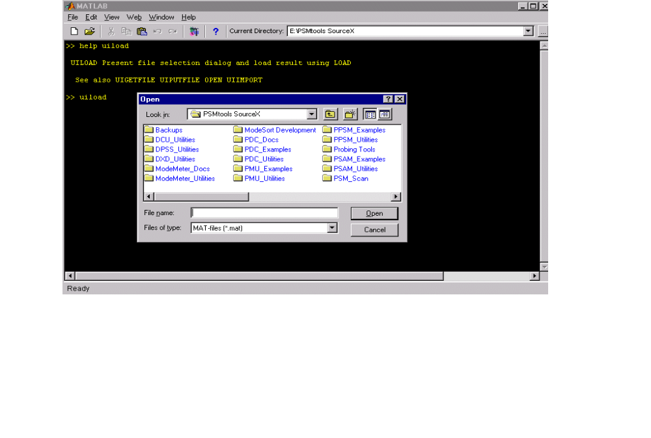
Fig. 12. Dialog box for Matlab utility uiload
Table 4. Accommodating blanks in the cd command
>> which BPA2_0006072029.dst
E:\PSMtools SourceX\PDC_Examples\WSCC Test 060700_BPAPDC\BPA2_0006072029.dst
>> cd E:\PSMtools SourceX\PDC_Examples\WSCC Test 060700_BPAPDC\
??? Error using ==> cd
Too many input arguments.

>> cd 'E:\PSMtools SourceX\PDC_Examples\WSCC Test 060700_BPAPDC\'
>> dir

. BPA2_0006072014.dst PDCbrowse_Ex1.bk.m
.. BPA2_0006072029.dst PDCbrowse_Ex1.m
BPA1X_122099.ini PDCbrowseEx1.m WSCCtests_060700Ex1.mat

Other File Types Associated With PSM Tools
The primary folder for PSM Tools contains a variety of document files of types .doc, .xcl, and .txt. In most cases these files were generated with Microsoft Word, Microsoft Excel, or the Windows Notepad. Presence of .bk in a file name like DSI_InstallNoteC.bk.doc indicates a backup version to some important file that has the same name except for the .bk.
PSM data are contained in raw data files, which are usually accompanied by a configuration file unique to the data source. Some examples are shown in Table 5 below.

Table 5. Typical names for PSM raw data files
Phasor Data Concentrator (PDC) Units
Data files Configuration files
BPA1_9904272040_B7.dst BPA1X_122099.ini
BPA2_0006072029.dst
BPA2_0006072014.dst
BPAS_0006072015.dst
wapa_0006072012.dst WAPAX_110398.ini
wapa_0006072017.dst
SCES_0006072012.dst sce1X_122999.ini
SCES_0006072015.dst
Portable Power System Monitor (PPSM) Units
Data files Configuration files
Files@DIT2 06-07-00 13H07m05s Dittmer #18 Listing.txt
Files@DIT2 06-07-00 13H13m05s
Files@GC22 06_07_00 13h13m40s COULEE G22 LISTING.txt
Files@GC22 06_07_00 13h14m30s
Files@GC22 06_07_00 13h15m20s
Files@MPSN 06-07-00 A14H10m00s Midpoint #1 Listing
Files@MPSN 06-07-00 A14H20m00s
Transient Stability Programs
Data files Configuration files
HS030BrakeA_Genpower.swx.txt (none as yet)
HS030BrakeA_Lines.swx.txt

Getting Started with PSM Tools – Tutorial Examples
PSM Tools contains a number of tutorial examples. Most of these are found in folders with names like PSMT_Examples, Matlab_Examples, PPSM_Examples, PDC_Examples, and so on. The simpler examples can be launched by entering the name of the associated m-file into the MCW. Most examples can execute in a number of different ways, depending upon how the user responds to choices presented in the MCW.
The tutorial examples are of two kinds – those which provide a very basic introduction to Matlab programming, and those which provide an introduction to PSMbrowser.

Getting Started with PSM Tools – Matlab Examples
A very basic introduction to Matlab programming is provided by scripts MatlabEx1.m and MatlabEx2.m. Prior to executing these examples, the user should open these files with the Matlab editor (else MS Word) and print them. The hardcopy printout can then be used to then compare the Matlab code step-by-step against the computer display as the examples execute.
Other examples in PSMT_Examples deal with programming features that are somewhat more advanced. A few of these are functions (rather than scripts), and the user will have to call them with a command from the MSW.

Getting Started with PSM Tools – Browser Examples
The highest level of PSM Tools code is the case script. PSMbrowser is the case script for general purpose browsing with the present version of PSM Tools. PSMbrowser is also a template from which knowledgeable users can develop special case scripts that process pre-designated files, or that process data in special ways. A future version of PSMtools will record the processing steps for an interactive case and allow the case to be repeated in response to a single user command.
There are three phases of PSMbrowser execution. These are
1. Case Definition
2. Signal Extraction
3. Signal Processing
All of these are controlled through menus presented to the user via the GLK interface (or some future GUI). These menus can be customized so that a specific type of case is executed with just one or two commands. However, the user who would use the full range of PSM Tools capability – or who would do the customization – must be able to understand and perhaps modify the associated Matlab code. It is suggested that the user print out the Matlab code for various browser examples (using the Matlab editor or MS Word) and then compare the code step-by-step against the computer display as the examples execute.
The browser examples are customized versions of PSMbrowser, and they have names like PSMTbrowse_Ex1.m and PDCbrowse_Ex1.m. Lines of code that has been modified are tagged as [CUSTOM] within an associated comment field, as in
CSname='PSMTbrowse_Ex1' %Internal name of case script [CUSTOM]
All text past the % sign is treated as commenting information and will not affect Matlab execution. The user can use the editor to scan for this tag, and thus locate the more useful processing controls within PSMbrowser.
The browser examples execute upon entry of the file name into the MCW (reminder: do not include the .m). The internal code is customized to accept the standard defaults, and some of these are customized as well. Such examples are usually constructed so that Case Definition is entirely automatic, and the only inputs actually required of the user during Signal Extraction are a few responses with the enter key.
Depending upon the processing power of the supporting computer, PSMtools may become unresponsive to the user when signals are being extracted from large data files (especially text files). This is not always indicated by the usual “hourglass” symbol, so the user should allow a minute or so for the computer to do its work.
It may occasionally be desirable to abort PSMtools during execution. Situations that might call for this include signal extraction from the wrong source file, a blanket extraction of all signals from a very large source file, or accidentally sending are very large collection of plots to the printer or to a computer disk (as .eps files). Pressing the control key together with the c key (ctrl-c) will usually abort PSMtools execution, and return control of Matlab to the MSW. If this is unsuccessful after several attempts, the user may wish to invoke the Task Manager and abort Matlab entirely.
Table 6. Presentation of signal processing menu
Select processing type: Options are
1 Batch Plots
2 Angle/Freq Refs
3 Filter/Decimate
4 Backload Filtered
5 Fourier
6 Histograms
7 Ringdown GUI
8 ModeMeter
9 EventScan
96 save results
97 keyboard
98 Defaults on/off
99 end case

Indicate processing type - enter number from list above [1]:
In the Signal Processing phase the user is repeatedly presented with the signal processing menu of Table 6. PSMbrowser requires an explicit selection, and the user is also required to confirm this selection through a prompt such as
Indicated processing type = 1: Batch Plots
In PSMTbrowse_Ex1: Batch plots of extracted signals? Enter y or n [ ]: y
Prompts to the user are shown here in boldface, and user inputs to the MCW are indicated by bold italic; use of just the enter key is indicated by the left arrow ←.
Selection of processing option 11 allows the user to turn off the standard processing defaults and thereby regain detailed control of PSMbrowser. Users are encouraged to do this at some point while exploring the browser examples.

Getting Started with PSM Tools – Names for PDC Signals
There are several locations where the signals are selected by type, or where new types are selectively constructed. This is especially necessary for PDC data, in part because such data necessarily entails the conversion of phasor data to a more broadly defined set of rms quantities. Some of these quantities are constructed as the difference between some initially calculated bus angle or bus frequency and some reference signal selected by the user.
The primary rms signal types into which PDC phasors are converted are the following:
1 Freq Frequency as determined from bus voltage angel VAng
2 Vmag Voltage magnitude
3 Vang Voltage angle
4 Imag Current magnitude
5 Iang Current angle
6 MW Real power in MW
7 Mvar Reactive power in Mvar
Further derived signals are formed as weighted combinations of these primary types. The most common form of derived signals are those from which some reference signal has been subtracted. Custom forms of derived signals include total power flows on a transmission path or into a facility, and the “projection” of a measured voltage phasor to the far end of a transmission line for which the impedance is known.
The PSMT convention for the naming of referenced PDC signals is illustrated in Table 7 (which, for convenience, repeats materials from earlier tables). Referencing is generally used only for Vang, IAng, and Freq signals. The referencing for a particular signal is indicated by a final character appended to the signal type field at the end of the signal name. The rules for this are the following:
L Local quantity as originally measured (no referencing done yet)
A Absolute quantity, used as a reference for others
R Referenced quantity, from which the most recently defined absolute quantity of like type has been subtracted
Signal referencing is usually done as Option 2 in the processing menu of Table 6. This can be done repeatedly, so the sequence in which signals are referenced can be important.
Table 7 and Fig. 13 show data in which the VAng signals have been referenced against VangL and FreqL measured for GC50 Grand Coulee Bus Voltage. The referenced signals VangR and FreqR for GC50 Grand Coulee Bus Voltage become horizontal lines, and the original local information for these signals would be lost if it were not saved as VangA and FreqA.

Table 7. PSMT Names for referenced PDC signals
K>> disp(caseID)
PDCbrowse_Ex2_6.0
K>> chankeyX
chankeyX =
% 1 Time
% 2 MALN Round Mountain 1 Current MW
% 3 SCE1 Palo_Verde 500 kV Line Current MW
% 4 BE23 Celilo 3 Current MW
% 5 GC50 Grand Coulee Bus Voltage VMag
% 6 MALN Malin Bus Voltage VMag
% 7 SCE1 Devers 500 Bus Voltage VMag
% 8 GC50 Grand Coulee Bus Voltage VAngL
% 9 MALN Malin Bus Voltage VAngL
% 10 SCE1 Devers 500 Bus Voltage VAngL
% 11 GC50 Grand Coulee Bus Voltage FreqL
% 12 MALN Malin Bus Voltage FreqL
% 13 SCE1 Devers 500 Bus Voltage FreqL
% 14 GC50 Grand Coulee Bus Voltage VAngA
% 15 GC50 Grand Coulee Bus Voltage VAngR
% 16 MALN Malin Bus Voltage VAngR
% 17 SCE1 Devers 500 Bus Voltage VAngR
% 18 GC50 Grand Coulee Bus Voltage FreqA
% 19 GC50 Grand Coulee Bus Voltage FreqR
% 20 MALN Malin Bus Voltage FreqR
% 21 SCE1 Devers 500 Bus Voltage FreqR

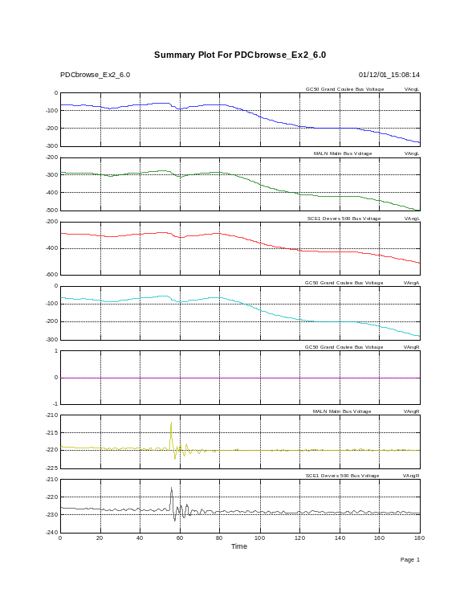
Fig. 13. Referenced PDC signals of Table 7.
Brake insertion #1, WSCC tests of 06/07/00

Getting Started with PSM Tools – keyboard Commands
There are many points at which PSMbrowser and other PSMT functions may pass keyboard control to the user. Table 8 a simple example for this, in which the user has modified and verified the time range for signal plotting. The symbol K» is a standard Matlab prompt indicating that the user has control of the keyboard. The entered line, TRange=[50 80]; return actually contains two commands. Use of the semicolon is an optional convenience that prevents MCW display of results from the command preceding the semicolon.
Table 8. Use of the keyboard command to modify the time range for signal plotting
In PSMplot2: Select plot range:
EXAMPLE FOLLOWS:
TRange=[ 0.00 179.97 ]
Invoking "keyboard" command - Enter "return" when you are finished
K» TRange=[50 100]; return
In PSMplot2: Indicated TRange = [ 50.00 100.00 ]
In PSMplot2: Is this plot range ok? Enter y or n [y]: ←

When Matlab is operating in keyboard mode the user has total control over Matlab processing. This can be used to inspect or modify workspace variables, to perform special calculations, to “paste in” portions of PSMbrowser code for execution, to modify or annotate existing plots, and to generate special plots.
Invoking the keyboard command is also a useful way to suspend PSMT execution while the user does other things. These include “copy & paste” operations of selected figures and MCW contents into technical reports, special data saves into files, and perhaps the modification of PSMT m-files. If a new version of a PSMT m-file is defined, and that file is not in execution, then the command clear functions should cause Matlab to use the new file version as processing continues. Otherwise Matlab will use the old file version until the user launches a new processing case.

Getting Started with PSM Tools – Signal Plotting
Signal plotting in PSM Tools is designed to be very flexible, and to accommodate very large data sets. Any signal can be plotted against any other signal, and the results can be saved in a variety of ways. Table 9 provides a summary of the more important plotting controls that are presented to the user by the present version of PSM Tools.
As indicated in Table 9, there are four plot styles available to the user. Examples of these plot styles are presented as Fig. 14 through Fig. 20. The quantities in Fig. 19 are bus voltage angle and bus voltage frequencies relative to those at Grand Coulee (see later Section for details). Fig. 20 shows the first page of the header plot for a PSMT plot set. All pages of the plot set are “stamped” with the case tags caseID and casetime.

Table 9. Plot controls used in a dialog with PSMbrowser
Indicate processing type - enter number from list above [1]: ←
Indicated processing type = 1: Batch Plots

In PDCbrowse_Ex1: Batch plots of extracted signals? Enter y or n [ ]: y
In PDCbrowse_Ex1: Close all plots? Enter y or n [y]: ←
In PSMplot2: Generate new case tags? Enter y or n [n]: ←
In PSMplot2: Print generated plots? Enter y or n [n]: y
In PSMplot2: Save generated plots to file(s)? Enter y or n [n]: y
In PSMplot2: Indicated TRange = [ 50.00 100.00 ]
In PSMplot2: Is this plot range ok? Enter y or n [y]: ←
In PSMplot2: Select signals to plot
Select desired options from list below:
• • •
In PSMplot2: Use time as X-axis? Enter y or n [y]: n
In PSMplot2: Use sample number as X-axis? Enter y or n [n]: ←
Select desired option from list below:
• • •
In PSMplot2: Select a plotting style - options are
option 1: Detailed plots, 1 per page
option 2: Summary plots, max 12 per page (1 trace each)
option 3: Summary plots, 1 per page (max 12 traces each)
option 4: Summary plot, all traces on one page
Select a value between 1 and 4: [2]: ←
How many traces per page?
In PSMplot2: Remove initial offsets? Enter y or n [n]: ←
In PSMplot2: Normalize all signals? Enter y or n [n]: ←
In PDCbrowse_Ex1: Do you want the keyboard? Enter y or n [n]: ←

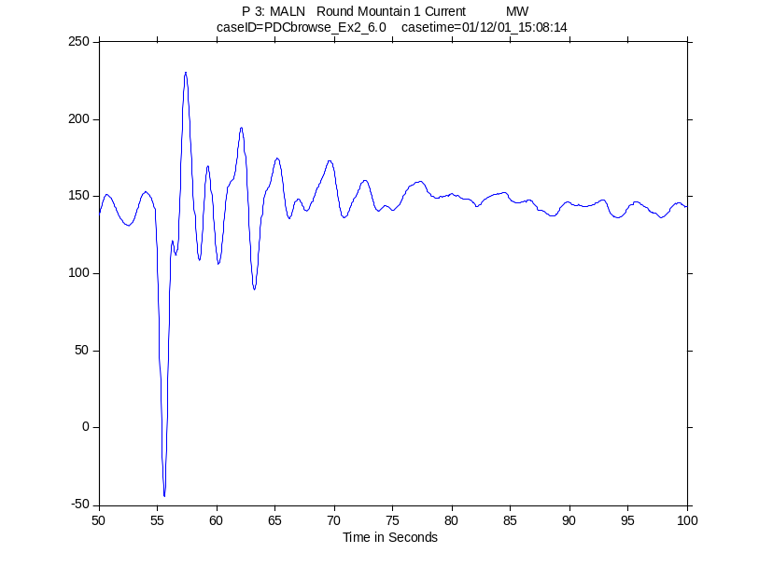
Fig. 14. Style #1 plot: Brake insertion #1, WSCC tests of 06/07/00
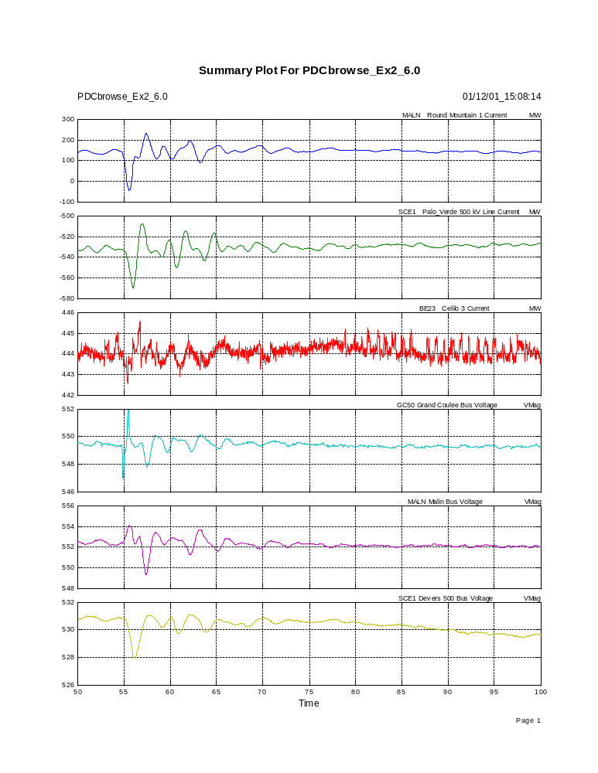
Fig. 15. Style #2: Brake insertion #1, WSCC tests of 06/07/00
Fig. 16. Style #3: Brake insertion #1, WSCC tests of 06/07/00
Normalized signals with offsets removed
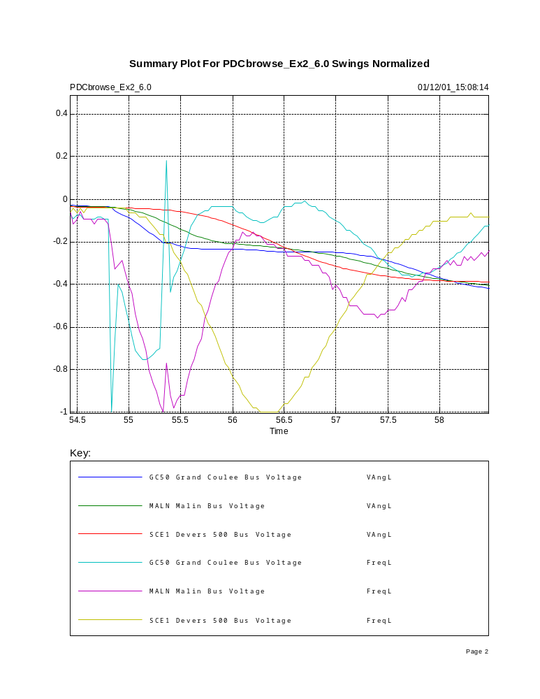
Fig. 17. Style #3: Brake insertion #1, WSCC tests of 06/07/00
Normalized signals with offsets removed
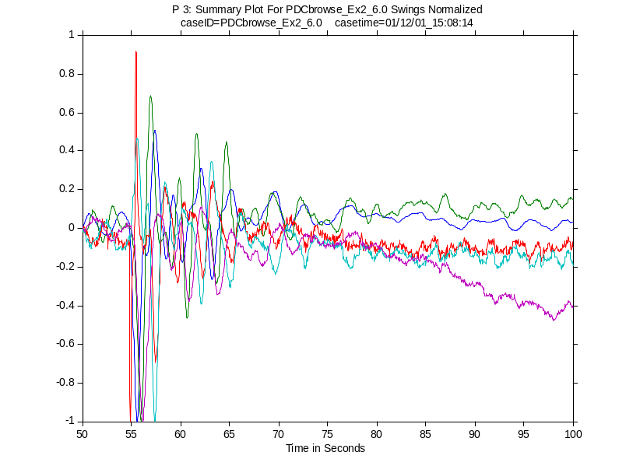
Fig. 18. Style #4: Brake insertion #1, WSCC tests of 06/07/00
Normalized signals with offsets removed
Fig. 19. Style #2: Referenced frequencies against referenced angle
Brake insertion #1, WSCC tests of 06/07/00

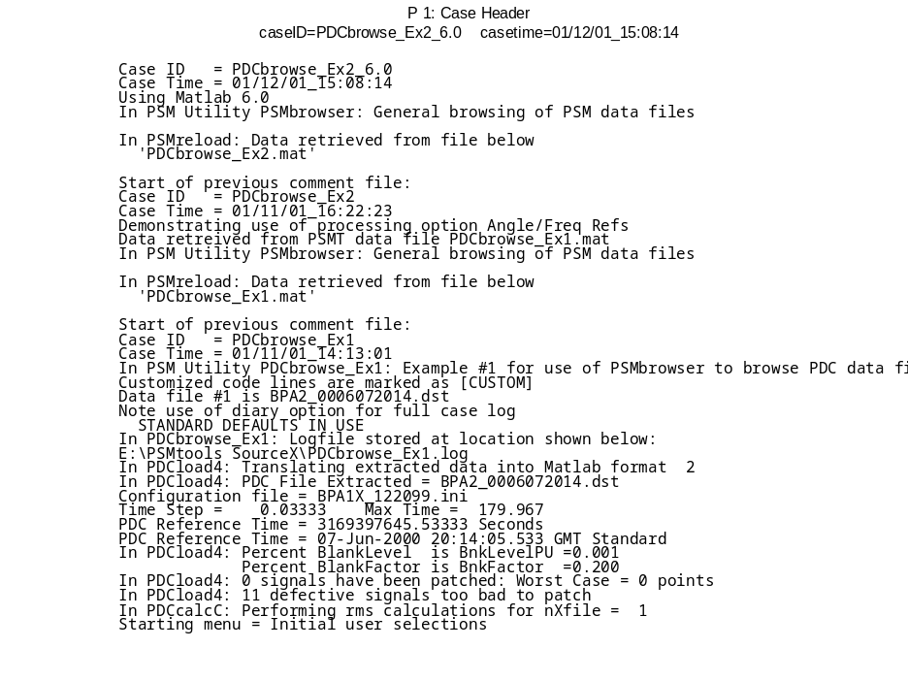
Fig. 20. First page of the header plot for a PSMT plot set
(direct paste from Matlab 6.0)

Getting Started with PSM Tools – Signal Selection
PSMT signals are stored as columns of a signal array and are referred to by their column number. This is also called their channel number, for historical reasons. The signal array is usually named PSMsigsX, though names like PSMsigsF and PSMsigsN may be used during some stages of processing.
Channels to be extracted, plotted, or analyzed are indicated by means of signal selection vectors with names like chansX, chansP, and chansA. The signals of interest can appear there in any order, and more than once. This can be particularly useful for organizing batch plots by signal locations or by signal types, possibly with the same reference signal appearing at the top of each page.
Initial values of the signal selection vectors are set within PSMbrowser. Later menus permit the user to replace or augment these initial vectors with other pre-defined selections, and to directly edit the final result. Table 10 provides a typical example for this.
The dialog of Table 10 has placed PSM Tools in keyboard mode, which provides the user with full control over Matlab processing of those variables within the workspace. This could have been used to confirm the intended value of VAL, or to experiment a bit with custom plotting. Some possibilities for this are shown as Table 11. The command figure initiates a new figure, and avoids overplotting a figure that already exists. More details regarding this can be determined through the command help figure. The command deblank has been used to trim off trailing blanks from namesX(1,:) so that the remaining text will appear at the center of the plot’s x-axis label.
Table 10. Signal selection by channel number
In PSMplot2: Select signals to plot
Select desired options from list below:
% 1 Time
% 2 MALN Round Mountain 1 Current MW
% 3 SCE1 Palo_Verde 500 kV Line Current MW
% 4 BE23 Celilo 3 Current MW
% 5 GC50 Grand Coulee Bus Voltage VMag
% 6 MALN Malin Bus Voltage VMag
% 7 SCE1 Devers 500 Bus Voltage VMag
% 8 GC50 Grand Coulee Bus Voltage VAngL
% 9 MALN Malin Bus Voltage VAngL
% 10 SCE1 Devers 500 Bus Voltage VAngL
% 11 GC50 Grand Coulee Bus Voltage FreqL
% 12 MALN Malin Bus Voltage FreqL
% 13 SCE1 Devers 500 Bus Voltage FreqL
% 14 GC50 Grand Coulee Bus Voltage VAngA
% 15 GC50 Grand Coulee Bus Voltage VAngR
% 16 MALN Malin Bus Voltage VAngR
% 17 SCE1 Devers 500 Bus Voltage VAngR
% 18 GC50 Grand Coulee Bus Voltage FreqA
% 19 GC50 Grand Coulee Bus Voltage FreqR
% 20 MALN Malin Bus Voltage FreqR
% 21 SCE1 Devers 500 Bus Voltage FreqR

Present selections shown below:
% 2 MALN Round Mountain 1 Current MW
% 3 SCE1 Palo_Verde 500 kV Line Current MW
% 4 BE23 Celilo 3 Current MW
• • •
% 21 SCE1 Devers 500 Bus Voltage FreqR
Is this ok? Enter y or n [y]: n

Do you want all options? Enter y or n [n]:
Do you want no options? Enter y or n [n]:

Update selection vector shown below:
val=[2 3 4 5 6 7 8 9 10 11 12 13 14 15 16 17 18 19 20 21]
Invoking "keyboard" command - Enter "return" when you are finished
K>> Val=[2 3 6 7 16 17 20 21]; return

Present selections shown below:
% 2 MALN Round Mountain 1 Current MW
% 3 SCE1 Palo_Verde 500 kV Line Current MW
% 6 MALN Malin Bus Voltage VMag
% 7 SCE1 Devers 500 Bus Voltage VMag
% 16 MALN Malin Bus Voltage VAngR
% 17 SCE1 Devers 500 Bus Voltage VAngR
% 20 MALN Malin Bus Voltage FreqR
% 21 SCE1 Devers 500 Bus Voltage FreqR
Is this ok? Enter y or n [y]:
In PSMplot2: Number of selected signals= 8

Table 11. Navigating PSMsigsX by channel number
K>> chankeyX
chankeyX =
% 1 Time
% 2 MALN Round Mountain 1 Current MW
% 3 SCE1 Palo_Verde 500 kV Line Current MW
% 4 BE23 Celilo 3 Current MW
% 5 GC50 Grand Coulee Bus Voltage VMag
• • •
% 21 SCE1 Devers 500 Bus Voltage FreqR
K>> figure
K>> plot(PSMsigsX(:,2))
K>> title(namesX(2,:))
K>> xlabel('Time in Samples')

val=[2 3 4];
K>> namesX(val,:)
ans =
MALN Round Mountain 1 Current MW
SCE1 Palo_Verde 500 kV Line Current MW
BE23 Celilo 3 Current MW
K>> figure
K>> plot(PSMsigsX(:,val))
K>> figure
K>> plot(PSMsigsX(:,1),PSMsigsX(:,val))
K>> xlabel(deblank(namesX(1,:)))

Getting Started with PSM Tools – Experimental Plot Types
Many aspects of dynamic behavior may be poorly visible in PSM signals as they are first received for analysis. This visibility can often be greatly enhanced through filtering, or through frequency domain methods such as Fourier analysis and Prony analysis. Examples of this are provided in later sections.
It is apparent in Fig. 13 that the dynamic content of VAng signals has become much more visible when they are compared against a suitable common reference. Related views of their dynamic content are provided by the corresponding frequency signals. The frequency signals are obtained from the angle signals by numerical differentiation, which may be thought of as a variety of high pass (HP) or bandpass (BP) filtering.
System conditions and behavior can sometimes be made more apparent simply through a change of the x-axis. Fig. 19 and Fig. 21 through Fig. 23 some example “event signatures” that have been constructed in this manner. There are many ways to form such signature displays, and they are considered as experimental.
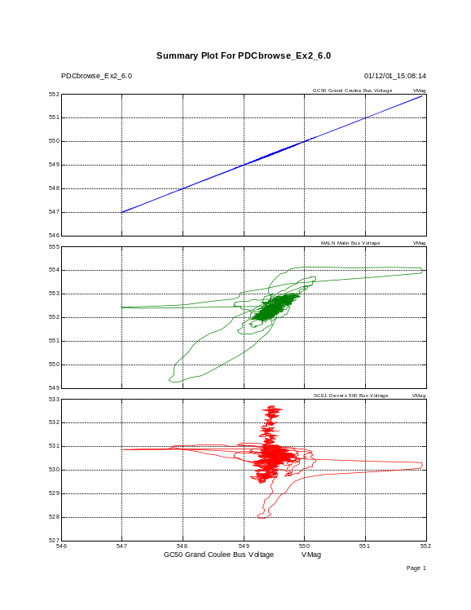
Fig. 21. Voltage magnitudes against voltage magnitude at Grand Coulee
Brake insertion #1, WSCC tests of 06/07/00

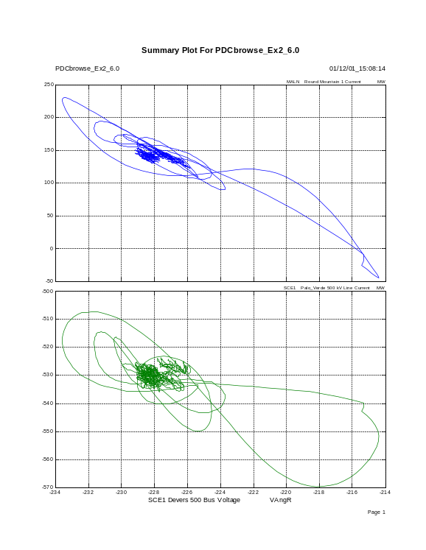
Fig. 22. Line MW against North-South voltage angle
Brake insertion #1, WSCC tests of 06/07/00

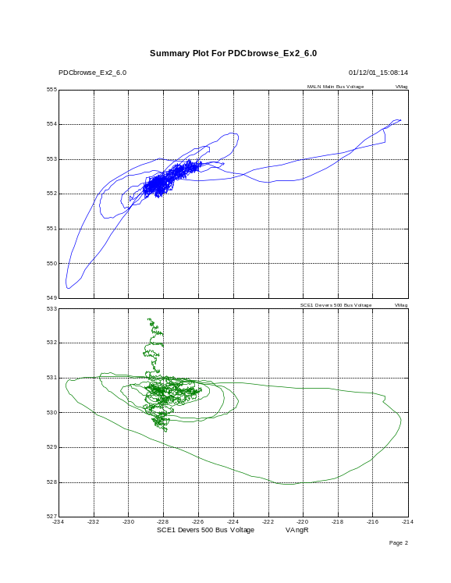
Fig. 23. Voltage magnitudes against North-South voltage angle
Brake insertion #1, WSCC tests of 06/07/00

Case Documentation in PSM Tools
PSM Tools is used to integrate and browse through very large data sets. The results, in the form of processed data and technical reports, may be of recurring interest for many years. When such results are retrieved for later use there must be no mysteries as to where the data originated, and as to what processing was applied.
With the exception of historically important data, the long-term saving of processed signals is wasteful and should be avoided. It is usually better to regenerate the processed signals through a repeat case. The automatic documentation features within PSM Tools facilitate this, and future versions of PSM Tools will permit the processing steps of even very complicated interactive cases to be recorded and repeated automatically.
At present the documentation for a PSM Tools browser case is stored in three places:
CaseCom
This text array of case comments is automatically constructed under the name CaseCom as the case proceeds, and then stored along with PSMT numerical results as CaseComR. (See Table 1.) The user is prompted to add special comments at the start of the case, as indicated in Table 13, and the user can insert further comments under keyboard control. Special result files for signal filtering or spectral analysis may contain case comment arrays with names like CaseComF or CaseComS. CaseCom is printed out at the start of hardcopy plotting, and linked to later displays through the casetag “stamps” caseID and casetime. CaseCom provides the necessary minimum of information for re-executing the case.
The case log file
The case log file is an ascii text file that has a name build from caseID and with the assigned file type .log. The log file is a Matlab diary file containing the full MCW display for the case. It can be thought of as an expanded version of CaseCom, but CaseCom may contain some information that was not displayed in the MCW and thus is not contained in the log file. Such conventions are readily adjusted to user preferences.
The case script
The case script itself can be used to save the file names of interest plus parameter values for filtering, data decimation, Fourier analysis, or other signal processing operations. The case script should be assigned a suitable name and modified along the lines indicated in Section 6.2. If there is a likelihood that the case must be re-executed at some far future time then the user should also save the present version of the PSMtools folder and perhaps the necessary Utilities folder (e.g., PDC_Utilities). The names of these folders should be modified to show the date, and to remove the folders from the standard Matlab path.
Additional case documentation will be need in the future to store processing commands for use in repeat case execution. Conventions for this are under development.
Knowledgeable users can incorporate things like the case log, the case script, and associated configuration files directly into the PSMT results file. Suitable commands for this are shown in Table 12. They can be easily incorporated into PSMbrowser as an additional processing option for users who wish them.
Table 12. Appending text documentation to a PSMT results file
[data,CaseLog]=cread('PSDScase_Ex1.log','',0,1);
K» save PSDScase_Ex1.mat CaseLog -append
K» whos -file PSDScase_Ex1.mat
Name Size Bytes Class
CaseComR 39x89 6942 char array
CaseLog 340x120 81600 char array
PSMfiles 1x25 50 char array
PSMsigsX 4489x7 251384 double array
PSMtype 1x4 8 char array
RefTimes 0x0 0 double array
chankeyX 7x35 490 char array
namesX 7x28 392 char array
tstep 1x1 8 double array

The PSMT function cread has been used to read the log file and convert it into the Matlab text object CaseLog. Users should open cread with the editor to determine necessary details.

Detailed Operation of PSMbrowser
Each phase of PSMbrowser execution is controlled through one or more associated menus. These are the
1. Case definition menu
2. Signal extraction menus
3. Signal processing menu
All of these menus are presented to the user through the GLK interface, or through some equivalent future GUI. The primary menus are internal to PSMbrowser.
The signal extraction phase also involves custom menus that recognize particular data sources and present the user with corresponding choices for the signals to extract. Typical names for these PSM source menus are PDCmenu and PPSMmenu. The variable used to identify particular data sources is the configuration file name CFname, which was indicated earlier in Table 1. Typical values for CFname are shown in Table 2 and Table 5.
Examples for the primary PSMbrowser menus are shown in Sections 8.1 through 8.2. The user is cautioned that these examples are typical but not exhaustive. Future menus may differ somewhat in their details, but they will adhere to the same conventions.

Detailed Operation of PSMbrowser – The Case Definition Menu
A typical dialog with the case definition menu is shown in Table 13. As in earlier examples, user inputs to the MCW are indicated as bold italic, and use of just the enter key is indicated by the left arrow ←.
Table 13. A Dialog with the Case Definition Menu
» PSMbrowser
In Case Script PSMbrowser
In PSM Utility PSMbrowser: General browsing of PSM data files

Setting path to working directory: CD file = PSMsave
User may want to customize this later

In PSMbrowser: Define local case tags
In CaseTags:
In CaseTags: caseID = PSMbrowser
In CaseTags: Is this ok? Enter y or n [y]: n
In CaseTags: Enter name for present case: WSCCtests_060700Brake_#1_BPAdataA
In CaseTags: caseID = WSCCtests_060700Brake_#1_BPAdataA
In CaseTags: Is this ok? Enter y or n [y]: ←
In CaseTags: Case Time = 01/11/01_10:36:23
In AddCom: Add a line of text to Case Comments? Enter y or n [n]: y
Type New Line: Processing data for WSCC performance validation tests of 060700
In AddCom: Add a line of text to Case Comments? Enter y or n [n]: y
Type New Line: Event is brake insertion #1, at 1315 hr. Pacific daylight time
In AddCom: Add a line of text to Case Comments? Enter y or n [n]: y
Type New Line: Data taken from BPA's PDC unit #1 at the Dittmer Control Center
In AddCom: Add a line of text to Case Comments? Enter y or n [n]: ←

In PSMbrowser: Use standard defaults for present case? Enter y or n [n]: ←
In PSMbrowser: Standard defaults declined

In PSMbrowser: Logfile for present case? Enter y or n [n]: y
In PSMbrowser: Opening Logfile for present case:
Case ID = WSCCtests_060700Brake_#1_BPAdataA
Case Time = 01/11/01_10:36:23
Processing data for WSCC performance validation tests of 060700
Event is brake insertion #1, at 1315 hr. Pacific daylight time
Data taken from BPA's PDC unit #1 at the Dittmer Control Center
In PSM Utility PSMbrowser: General browsing of PSM data files

In PSMbrowser: Logfile stored at location shown below:
E:\PSMtools Source\WSCCtests_060700Brake_#1_BPAdataA.log

Through this dialog the user has done the following things:
• Assigned a special Case ID (WSCCtests_060700Brake_#1_BPAdataA) for the case being executed.
• Inserted three special comment lines into the case processing summary CaseCom
• Declined use of the standard defaults
• Accepted a detailed log file (WSCCtests_060700Brake_#1_BPAdataA.log) for the case being executed.
The value for the Case Time is taken from the internal computer clock when the value for Case ID is assigned within the PSMT function CaseTags. These values are conspicuously displayed in all output files or graphics produced by PSM Tools.

Detailed Operation of PSMbrowser – Signal Extraction Menus
PSMbrowser can either extract signals from “raw” PSM data files, or reload previously extracted signals that are contained within standard PSMT data files. The primary menus for this are contained within PSMT scripts PSMload and PSMreload. These may be followed by secondary menus that are specific to the type and location of the PSM data source.
PSMreload also contains logic for aligning and merging data that have been obtained from multiple sources. These sources may be located at different sites, and they may involve different technologies. Full merging of multi-source data may require decimation or resampling to achieve a common time base. Partial merging stops short of this, and retains a separate time base for each data source. The functionalities and menus for PSMreload are evolving rapidly, and are documented by example.
A typical dialog with the primary menu for extracting signals from raw PSM data is shown in Table 14. The indicated PSM type, a Phasor Data Concentrator (PDC), requires special menus to control data repair and to control the calculation of standard rms quantities. These are shown in Table 15 and Table 16, with much of the diagnostic display omitted. These diagnostics are optional, and they can be exported to an external data repair log.
As indicated in Table 16, some sources of PSM data can provide hundreds of signals. It may not be useful or even practical to examine all signals with a single processing case, especially when many files are joined together to form a long composite record. PSMT functions like PDCmenu and PPSMmenu present source-specific from which the user can select predefined signal subsets to process.
Table 17 presents a lengthy but otherwise typical dialog for this. The next step would be to edit these menu selections under keyboard control, along the lines indicated earlier in Table 10. This is a fairly advanced example, in which no combination of the standard menu options quite serves the intentions of the user. If this particular signal combination is likely to be used very often then it should be added to the signal selection menu. As indicated in the various browser examples, it is useful to define a special version of PSMbrowser in which the initial value of chansX provides a good starting point for selecting signals from the data source of interest.
Table 14. A Dialog with the Primary Signal Extraction Menu
In PSMbrowser: Extract signals from PSM source files? Enter y or n [ ]: y
In PSMload: Initial PSMtype = PDC
PickNo = 1: PDC
Is this ok? Enter y or n [y]: n
Select desired option from list below:
% 1 PDC
% 2 PPSM
% 3 SWX
% 4 PMU
% 5 DCU
% 6 PSAM
% 7 special
% 8 .mat
% 9 none
Enter 1 to 9 [1]: 1
PickNo = 1: PDC
Is this ok? Enter y or n [y]: ←
In PSMload: Selected PSMtype = PDC

In PSMload: Select range of files to load? Enter y or n [ ]: ←
In PSMload: Select individual files to load:

Locate file 1 to load (else press Cancel to end)
Processing paused - press any key to continue
[DIALOG BOX HERE] BPAS_0008041955.dst
In PSMload: Changing to directory shown below:
E:\PSMtools SourceX\PDC_Examples\AlbertaTrip080400_BPAPDC\
Files already selected:
BPAS_0008041955.dst
Locate file 2 to load (else press Cancel to end)
Processing paused - press any key to continue
[DIALOG BOX HERE] Cancel
Selections complete -- processing

Number of files to load = 1
File names in array PSMfiles are
BPAS_0008041955.dst
In PSMload: Is this ok? Enter y or n [y]: ←

Table 15. A Dialog with the PDC Data Repair Menu
In PDCloadN: Seeking data from 1 files:
BPAS_0008041955.dst
In PDCloadN: Load option = 4
In PDCloadN: rms option = 2
In PDCloadN: Display diagnostic plots? Enter y or n [n]: ←
In PDCload4: Seeking data on file BPAS_0008041955.dst
In PDCload4: Enter Matlab format for translated files (1 or 2) [2]: ←
In PDCload4: Translating extracted data into Matlab format 2
In PDCload4: PDC File Extracted = BPAS_0008041955.dst
In inicopy: Launching dialog box:
[DIALOG BOX HERE] BPA1X_122099.ini
In inicopy: configuration file is
E:\PSMtools SourceX\PDC_Examples\AlbertaTrip080400_BPAPDC\BPA1X_122099.ini
Configuration file = BPA1X_122099.ini
• • •
PDC Reference Time = 3174407700.00000 Seconds
PDC Reference Time = 04-Aug-2000 19:55:00.000 GMT Standard

In PDCload4: Scaling phasors & scanning for data outliers:
In PDCload4: Display full patching log? Enter y or n [n]: ←
In PDCload4: Plot patched signals? Enter y or n [n]:
In PDCload4: Percent BlankLevel is BnkLevelPU =0.001
Percent BlankFactor is BnkFactor =0.200
PlotPatch Control is PlotPatch = 0
LogPatch Control is LogPatch = 0
Patching Control is PatchMode = 1
In PDCload4: Are these values ok? Enter y or n [y]: ←
In PDCload4: Percent BlankLevel is BnkLevelPU =0.001
Percent BlankFactor is BnkFactor =0.200
Phasor 1 1: 7 points repaired for GC50 Grand Coulee Bus Voltage
Phasor 1 2: 7 points repaired for GC50 Bank 1 Current
• • •
In PDCload4: 59 signals have been patched: Worst Case = 20 points
In PDCload4: 11 defective signals too bad to patch
Returning from PDCload4

Table 16. A Dialog with the PDC Menu for RMS Calculations
In PDCcalcC: Performing rms calculations for nXfile = 1

In SetExtrP: Number of stored signals=224
Includes time axis inserted at column 1
In SetExtrP: Display full channel key? Enter y or n [y]: ←
% 1 Time
% 2 GC50 Grand Coulee Bus Voltage VMag
% 3 GC50 Grand Coulee Bus Voltage VAngL
% 4 GC50 Grand Coulee Bus Voltage FreqL
% 5 GC50 Bank 1 Current MW
% 6 GC50 Bank 1 Current Mvar
% 7 GC50 Bank 1 Current IMag
% 8 GC50 Bank 1 Current IangL
• • •
% 218 SCE1 Devers 500 Bus Voltage VMag
% 219 SCE1 Devers 500 Bus Voltage VAngL
% 220 SCE1 Devers 500 Bus Voltage FreqL
% 221 SCE1 Palo_Verde 500 kV Line Current MW
% 222 SCE1 Palo_Verde 500 kV Line Current Mvar
% 223 SCE1 Palo_Verde 500 kV Line Current IMag
% 224 SCE1 Palo_Verde 500 kV Line Current IAngL
Left column shows indexing for signals (including time)
In SetExtrP: Processing is paused - press any key to continue

Table 17. A Dialog with the PDC Signal Selection Menu
In PDCmenu: CFname = BPA1X_122099.ini
In PDCmenu: Match found to BPA1X_122099.ini

In SetExtrP: Initial value of chansX follows:
chansX=[1 2 3 4 5];
% 1 Time
% 2 GC50 Grand Coulee Bus Voltage VMag
% 3 GC50 Grand Coulee Bus Voltage VAngL
% 4 GC50 Grand Coulee Bus Voltage FreqL
% 5 GC50 Bank 1 Current MW
Are these the signals to extract? Enter y or n [ ]: ←

Building signal extraction list: Submenu options are
001 Initial user selections
002 All channels
003 No channels
004 Interactive selection of channels
005 Sort by signal type
006 Ringdown Summary
007 Interactions Summary
008 BigView Summary
009 Voltage & Frequency Summary
010 Voltage/Angle/Frequency Summary
011 Malin Overall
012 Celilo Overall
013 Sylmar Overall
014 HVDC Overall
015 Colstrip Overall
016 Generation Summary
017 Coulee/Devers Summary

Select submenu - enter 1 to 17 []: 6
Submenu 006: Ringdown Summary
% 1 Time
% 63 MALN Round Mountain 1 Current MW
% 221 SCE1 Palo_Verde 500 kV Line Current MW
% 17 GC50 Chief Joseph Current MW
% 52 JDAY Marion 1 Current MW
% 56 JDAY Hanford 1 Current MW
% 82 COLS Broadview 1 Current MW
% 214 SCE1 Midway 1 MW
% 101 BE23 Celilo 3 Current MW
% 148 BE50 Celilo 1 Current MW
Add this submenu to extraction list? Enter y or n [y]: y
Add more submenus? Enter y or n [n]: y

Building signal extraction list: Submenu options are
001 Initial user selections
002 All channels
003 No channels
004 Interactive selection of channels
• • •
017 Coulee/Devers Summary

Select submenu - enter 1 to 17 []: 5
Submenu 005: Sort by signal type
Add this submenu to extraction list? Enter y or n [y]: ←

In SetExtrP: Remaining extraction options are
% 1 Time
% 2 Freq
% 3 VMag
% 4 VAng
% 5 IMag
% 6 IAng
% 7 MW
% 8 Mvar
% 9 end
Select a value between 1 and 9: [2] 2
Freq signals available:
% 4 GC50 Grand Coulee Bus Voltage FreqL
% 23 JDAY John Day Bus Voltage FreqL
% 62 MALN Malin Bus Voltage FreqL
% 81 COLS Colstrip Bus Voltage FreqL
% 100 BE23 Big Eddy 230 Bus Voltage FreqL
% 139 BE50 Big Eddy 500 Bus Voltage FreqL
% 158 SYLM Sylmar Bus Voltage FreqL
% 177 MPLV Maple Valley Bus Voltage FreqL
% 196 KEEL Keeler 500 kV Voltage FreqL
% 213 SCE1 Vincent Voltage FreqL
% 220 SCE1 Devers 500 Bus Voltage FreqL
Add these signals to extraction list? Enter y or n [y]: ←
In SetExtrP: Remaining extraction options are
% 1 Time
% 2 Freq
• • •
% 8 Mvar
% 9 end
Select a value between 1 and 9: [2] 9
end signals available:
Add no more signals to extraction list? Enter y or n [y]: ←

FULL EXTRACTION MENU FOLLOWS:
% 1 Time
% 63 MALN Round Mountain 1 Current MW
% 221 SCE1 Palo_Verde 500 kV Line Current MW
% 17 GC50 Chief Joseph Current MW
% 52 JDAY Marion 1 Current MW
% 56 JDAY Hanford 1 Current MW
% 82 COLS Broadview 1 Current MW
% 214 SCE1 Midway 1 MW
% 101 BE23 Celilo 3 Current MW
% 148 BE50 Celilo 1 Current MW
% 4 GC50 Grand Coulee Bus Voltage FreqL
% 23 JDAY John Day Bus Voltage FreqL
% 62 MALN Malin Bus Voltage FreqL
% 81 COLS Colstrip Bus Voltage FreqL
% 100 BE23 Big Eddy 230 Bus Voltage FreqL
% 139 BE50 Big Eddy 500 Bus Voltage FreqL
% 158 SYLM Sylmar Bus Voltage FreqL
% 177 MPLV Maple Valley Bus Voltage FreqL
% 196 KEEL Keeler 500 kV Voltage FreqL
% 213 SCE1 Vincent Voltage FreqL
% 220 SCE1 Devers 500 Bus Voltage FreqL
Do you want to edit this menu? Enter y or n [n]:

Detailed Operation of PSMbrowser – Merging of Multi-Source Data
PSMbrowser will fully integrate any data that it can read, provided that the time bases are consistent. For time bases to be consistent in this sense it is necessary that their sample spacings be uniform, and that their sample rates be integer multiples of the same (lower) rate.
As a typical example, suppose that PDC data collected at 30 samples per second (sps) is to be integrated with data collected on two different PPSM units at rates of 20 sps and 100 sps respectively. PSM Tools would decimate the data from these sources with factors of 3, 2, and 10, so that all have the same rate of 10 sps. The decimated records would then align the decimated records on the basis of their associated time stamps, determine the maximum time span common to all records, and then consolidate the record segments for that time span into an integrated signal array.
This degree of integration is not necessary when the only purpose is to display multi-source data (as opposed to performing cross-analysis). If applications arise, an option will be provided for retaining a separate time base for data source and retaining all data in the display. This would be appropriate for integrated displays of PDC and SCADA records.
Present conventions require that merging of multi-source data be done in two steps. All raw data of interest individually translated into standard PSMT data files (.mat files), through individual PSMT processing cases. When this has been done successfully a final PSMT case is performed to merge these files together, as described above. PSM Tools can be revised to perform the entire process as one case, but graceful recovery from user errors would involve complicated code that might require maintenance by software specialists. For the present time such features are reserved for custom installations.

Detailed Operation of PSMbrowser – Report Generation
The generation of graphics for engineering reports is an important PSM Tools functionality. As indicated in earlier examples, the user can readily set up menus so that predetermined signals are extracted from disturbance records and sent to computer files or to a printer for hardcopy generation.
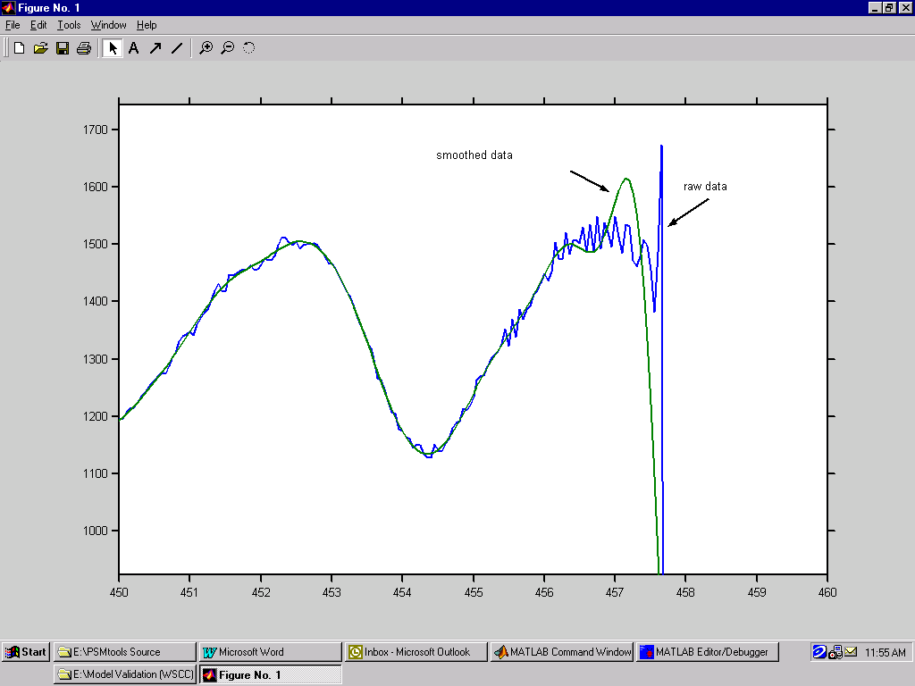
Fig. 24. Annotation and zoom controls for Matlab figure

It is also useful to copy results from Matlab into report documents that are being prepared with a word processing application such as Microsoft Word©. Results that are in text form can be copied from the MCW or the case log. Figures can be saved to and later retrieved from graphics files (usually of .eps type), or they can be copied from figure displays such as that shown here as Fig. 24.
The upper toolbar in the figure display is very useful for this sort of work. Some of the functions available there are the following:
• Under the edit menu, the user can use Copy Options and Copy Figure to obtain various representations of the figure for pasting into the report.
• When using the copy option Match Figure Screen Size the user can adjust the figure size for best results before copying it. Otherwise the figure size will be established on the basis of general parameters that have been defined elsewhere in the Matlab setup.
• The toolbar provides simple annotation tools for adding arrows, lines, and labels to the figure. Some features of the figure can also be modified with these tools.
• The “magnifying glass” can be used to zoom in and zoom out of particular regions of the figure.
Matlab also provides a variety of special copying utilities for users who have special needs for precision graphics. Details concerning these utilities are best obtained from the Matlab Digest at web address http://www.mathworks.com/company/digest/.

Signal Filtering
Actual system behavior is almost always viewed through some kind of filter. The very concept of rms (root mean square) measurements implies some sort of averaging process to estimate mean values. Transducers use filters for this purpose, and the filter bandwidths range from about 1 Hz to a bit more than 20 Hz. Microwave channels that transmit signals in analog form may also impose various degrees of filtering, and
As a result, signals that have different filtering histories may present different and seemingly inconsistent views of the same event. A notable example of this is shown in Fig. 25. This can be very misleading if the analyst does not recognize the situation. Mathematical removal of filter effects is tedious and usually not fully successful. It also requires characteristic data for the various filters in use. Obtaining such data is a routine matter, but the effort that it requires should be reserved for important signals that must be obtained from “legacy” measurement systems. Digital measurement systems tend to be far superior in this respect.

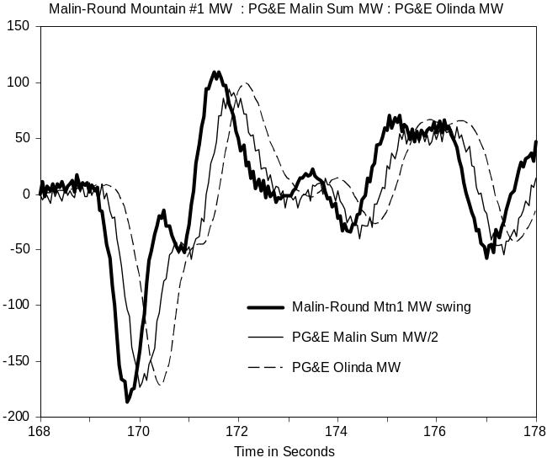
Fig. 25. Time response of Malin area transducers for insertion of
Chief Joseph dynamic brake on August 10, 1996
Additional filtering is often applied to signals after they are recorded. Reasons for this include the following:
• To remove excess measurement noise
• To enhance the visibility of the signal components within a particular frequency range
• To limit the signal spectrum prior to decimation (i.e., to avoid aliasing)
PSMbrowser presents many prompts with respect to decimation. It is important to know that decimation by a factor of n is done by discarding all but every nth data sample, and that it requires at least two samples per cycle to represent a sine wave. So, for a sample rate of N samples per second (sps), the highest frequency that can be properly represented is the Nyquist frequency N/2. Signal components at frequencies above the Nyquist frequency, if they are present, will be “aliased” so that they appear to lie at lower frequencies. Anti-aliasing filters, with bandwidths on the order of N/5 Hz, should be used when this possibility exists.
The more important PSMbrowser options for signal filtering are shown in Table 18. Invoking option 3 from the PSMbrowser processing menu of Table 6 will backload the filtered data into the working array PSMsigsX, and all further processing will be applied to the filtered signals rather than the signals originally extracted from the source data files.
The following remarks apply to the proper use of the options shown in Table 18:
• Decimation by a factor of n is done by discarding all but every nth data sample.
• Abbreviations LP, BP, and HP are used to designate lowpass, bandpass, and highpass filters.
• Decimation of raw data (prior to filtering) is safely done only when the signal spectra have no significant energy above the resulting Nyquist frequency (calculated as half the sample rate expressed in samples per second). This is often the case for swing export (SWX) data produced by transient stability simulations, and it is sometimes the case for PDC data. Decimation of such oversampled data may be needed just to produce numerically stable filters.
• General decimation should be preceded by filtering, to assure that the resulting signal spectra have no significant energy above the resulting Nyquist frequency.
• Signal offsets (the initial value of each signal) are usually removed to minimize filter transients. Restoring these offsets is rarely appropriate after BP filtering, since this kind of filtering is generally intended to remove offsets plus slow activity in the signal.
• Filter delays may be apparent in signals that have been subjected to general filtering. The smoothing filter has been designed to avoid this, however.

Table 18. PSMT options for signal filtering
In PSDScase_Ex1: Filter extracted signals? Enter y or n [ ]: y
In PSDScase_Ex1: Close all plots? Enter y or n [y]:
In PSMfilt: Generate new case tags? Enter y or n [n]:
Decimate raw data? Enter y or n [ ]: y
In PSMfilt: Local decimation factor = 1
Is this decimation factor ok? Enter y or n [y]:
In PSMfilt: Remove signal offsets? Enter y or n [y]:
In PSMfilt: Select signal filtering type
Select desired option from list below:
% 0 No Smoothing or Filtering
% 1 Smoothing with Moving-Average (MA) filter
% 2 General filtering
Enter 0 to 2 [0]: 2
In PSMButr4: Constructing Butterworth filter:
Select desired option from list below:
% 1 LP
% 2 BP
% 3 HP
Enter 1 to 3 [1]: 2
Filter Settings:
HPcorner= 0.10 Hz (0.0095 Nyquist)
LPcorner= 1.00 Hz (0.0948 Nyquist)
FilOrd = 4
In PSMButr4: Is this ok? Enter y or n [y]:
In PSMButr4: Plot filter characteristics? Enter y or n [n]:
In PSMButr4: Filter all signals? Enter y or n [y]:
In PSMfilt: Show sample of filter effects? Enter y or n [n]:
Processing paused - press any key to continue
In PSMfilt: Restore signal offsets? Enter y or n [y]:
Decimate filtered data? Enter y or n [n]:
In PSMfilt: Invoking utility to save filtered signals
In PSMsave: Save results data to a file? Enter y or n [ ]:
In PSDScase_Ex1: Batch plots of filtered signals? Enter y or n [ ]:

A representative variety of filtering examples are provided in Fig. 26 through Fig. 35. The smoothing filter of Fig. 26 each point in the filtered signal as the weighted sum of nearby time points in the original signal. The weighting function is formed by multiplying the function sinc(x)=sin(x)/x by the “Hanning function” 1+cos(y). Scale factors and axis shifts are used to produce the characteristics shown in the figure.
Gain response for the “Hanned sinc”smoothing window and the underlying sinc function are shown in Fig. 27. As a reminder, gain in dB is calculated as db(z)=20log10(z) for z a real number greater than zero. Thus dB gains of -20 dB and -40 dB correspond to scalar gains of 10% and 1% respectively. It may be noted that the Hanned sinc filter is comparatively ripple-free from 0 to 1 Hz, and that its sidelobe gains above 1 Hz are much lower than those of the sinc function without Hanning. Cutoff of these filtering functions is much less sharp that that of more general filters, however.

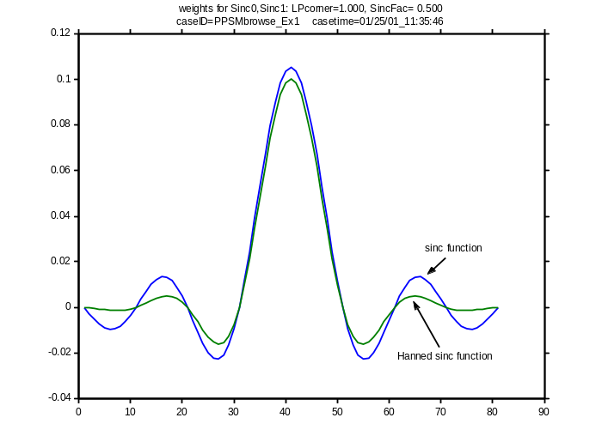
Fig. 26. Weighting functions for sinc and Hanned sinc smoothing filters
(LPcorner=1.0 Hz, SincFac= 0.5)
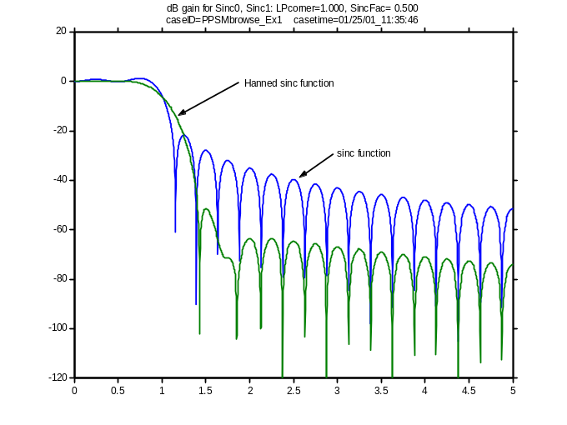
Fig. 27. Gain response for sinc and Hanned sinc smoothing filters
(LPcorner=1.0 Hz, SincFac= 0.5)
Fig. 28 shows results for application of this Hanned sinc filter to a noisy signal that contains an abrupt transient step. The noise has been smoothed out rather well, but the filter is much too sluggish to track the step. This is partly due to the low bandwidth of the filter, and partly due to the nature of the filter function (it was not designed for transient performance). As shown in Fig. 29 and Fig. 30, transient filter effects for a more general filter of the same bandwidth can be less severe. This filter is still sluggish, however, and there is a great deal of filtering delay. Use of a “faster” filter, with six times the bandwidth, produces the more acceptable transient response of Fig. 31 – but with less noise removal.
It is not unusual to apply several different filters to achieve a variety of results for different segments of the overall signal record. Fig. 32 shows a signal from Fig. 3 that has been BP filtered to strongly reduce signal components outside the range of 0.1 Hz to 1.0 Hz. Signal components associated with interarea oscillations have become much more visible, and use of the absolute value function provides a convenient view of their overall level of activity (shown in Fig. 33). As shown in Fig. 34 and Fig. 35, bandpass filtering is also useful for visual examination of possible correlations among several different signals.
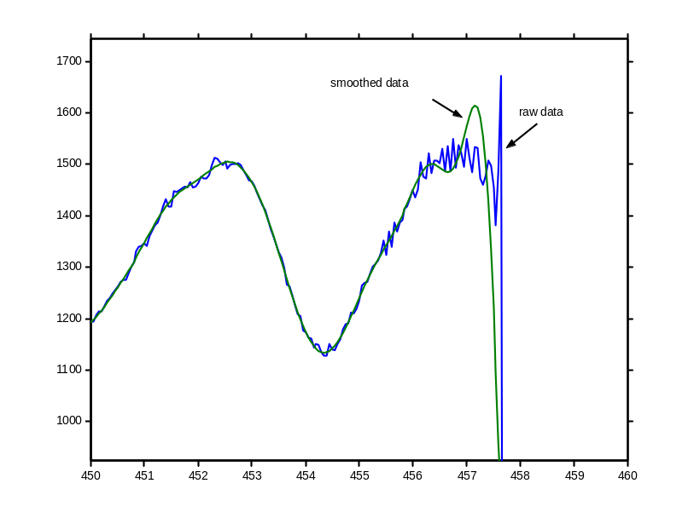
Fig. 28. Transient effects for Hanned sinc smoothing filter
(LPcorner=1.0 Hz, SincFac= 0.5)

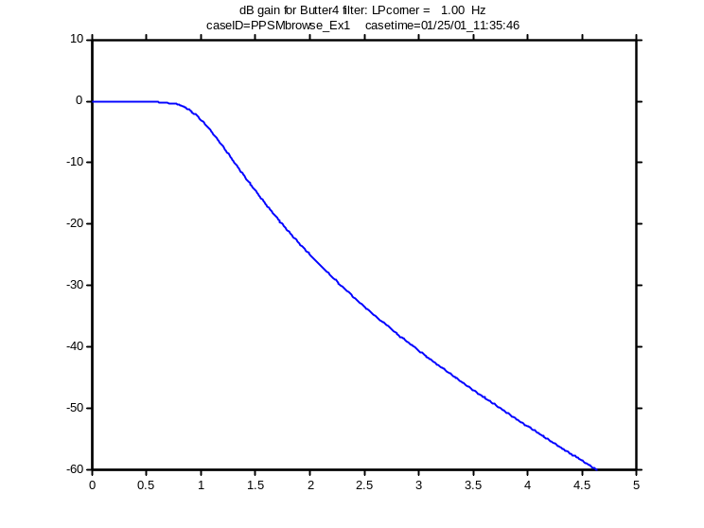
Fig. 29. Gain response of lowpass Butterworth filter
(LPcorner=1.0 Hz, FilOrd=4)
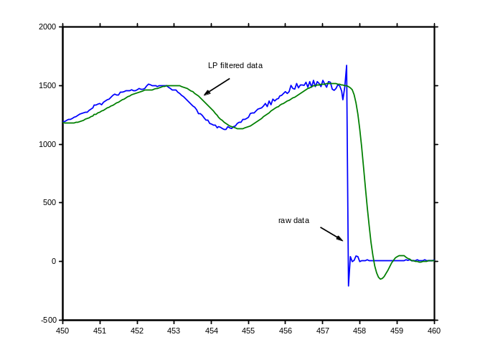
Fig. 30. Transient effects for lowpass Butterworth filter
(LPcorner=1.0 Hz, FilOrd=4)
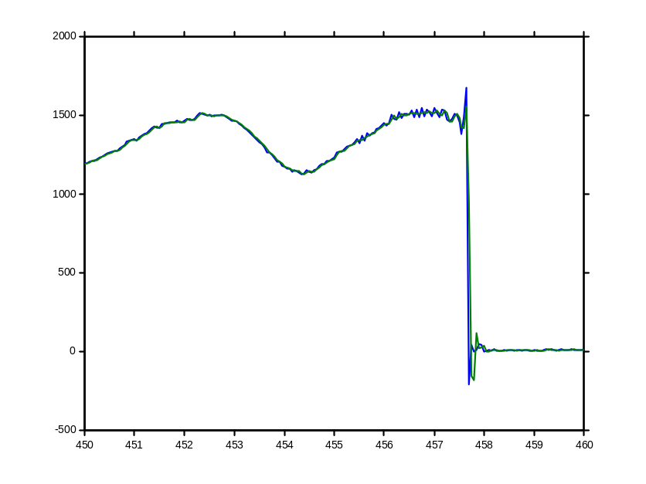
Fig. 31. Transient effects for lowpass Butterworth filter
(LPcorner=6.0 Hz, FilOrd=2)
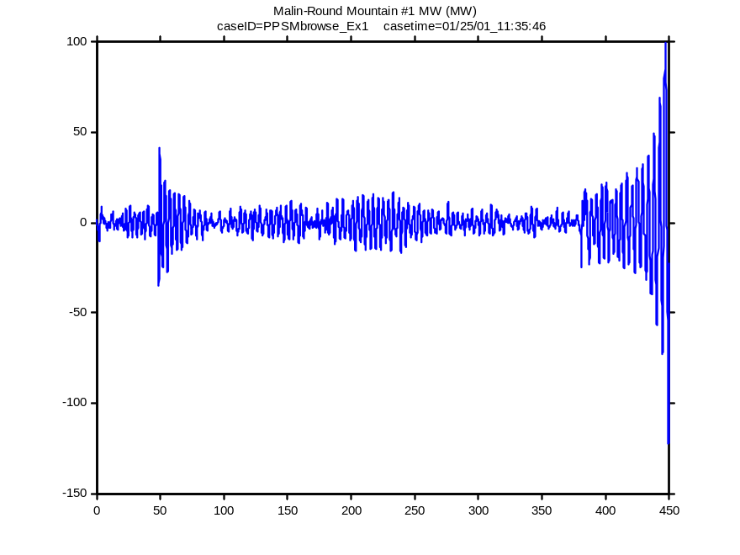
Fig. 32. BP filtered view of signal for WSCC breakup of August 10, 1996
(BP corners=[0.1 1.0] Hz, FilOrd=4)
(see Fig. 3)

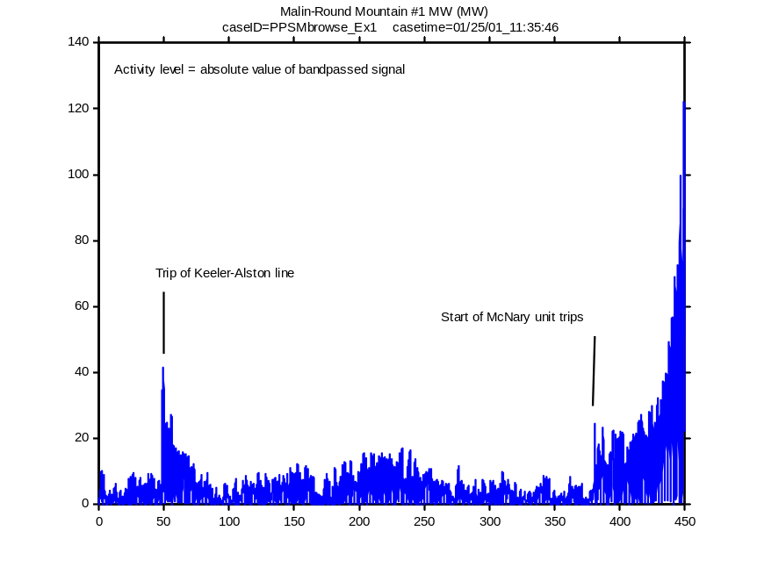
Fig. 33. Activity signal for WSCC breakup of August 10, 1996
(BP corners=[0.1 1.0] Hz, FilOrd=4)
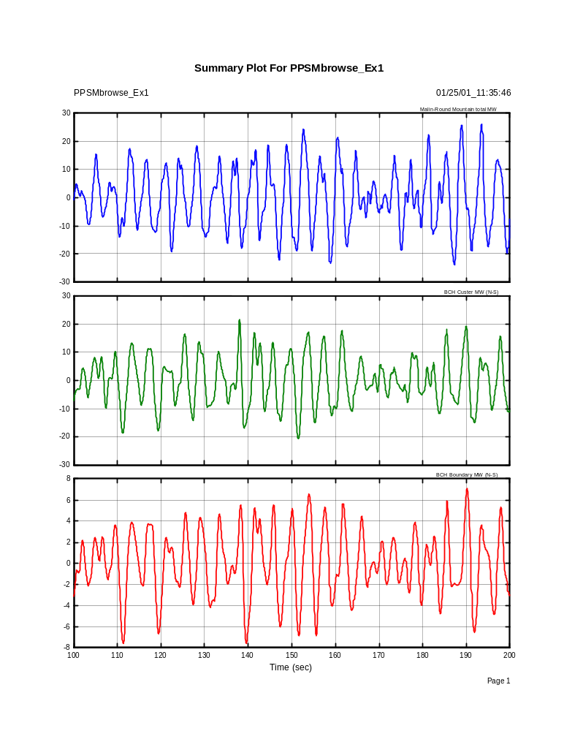
Fig. 34. Bandpassed view of Canada-California interactions for August 10, 1996
(BP corners=[0.1 1.0] Hz, FilOrd=4)
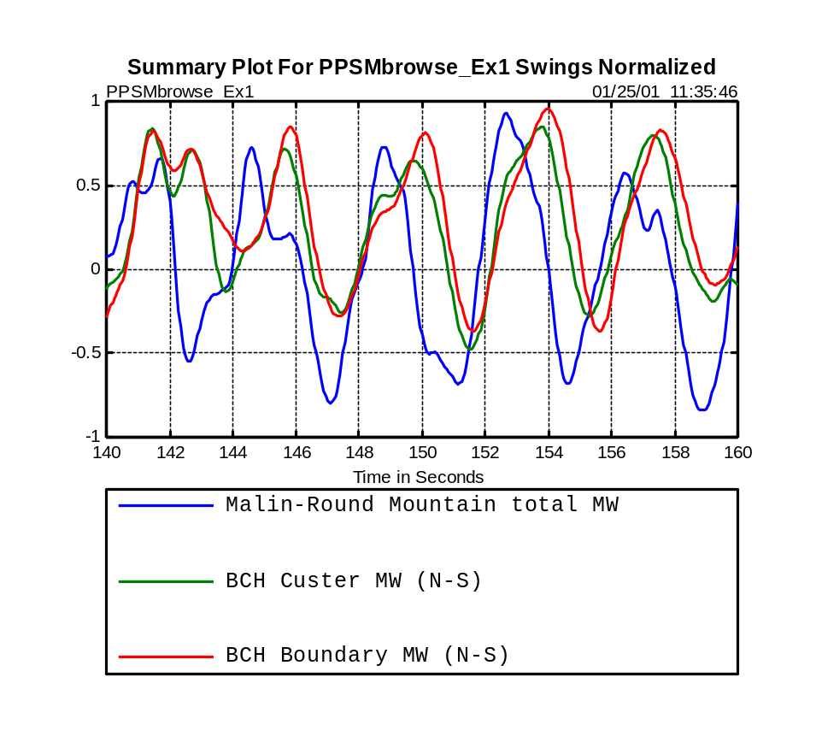
Fig. 35. Bandpassed view of Canada-California interactions for August 10, 1996
(BP corners=[0.1 1.0] Hz, FilOrd=4)

Fourier Analysis
Fourier analysis provides an alternate, frequency domain view of signals acquired in time domain. The associated algorithms – mostly based upon some variety of Fast Fourier Transform (FFT) – are highly efficient. Time domain results such as signal filtering are often calculated in frequency domain and then returned to time domain through FFT inversion.
Table 19 shows the more important prompts through which the user selects Fourier analysis options in a dialog with PSMbrowser. Examples of Fourier processing are provided in the remainder of this Section.
Table 19. PSMT options for Fourier analysis
In PSMspec1: Generate new case tags? Enter y or n [n]:
In PSMspec1: Select Fourier window type
Select desired option from list below:
% 0 Boxcar window
% 1 Hanning window
% 2 Hanning squared
% 3 Hamming window
% 4 Hamming squared
Enter 0 to 4 [2]:
PickNo = 2: Hanning squared
Is this ok? Enter y or n [y]:
In PSMspec1: Enter ringdown setup? Enter y or n [ ]:
[maxpoints nsigsX] = 14000 13
Record time span = 0.00 699.95
In PSMspec1: Remove signal offsets? Enter y or n [y]:

In PSMspec1: Select channels to analyze
Select desired options from list below:
% 1 Time (sec)
% 2 BPA Net Actual Interchange MW (MW)
% 3 Malin-Round Mountain total MW
% 4 BCH Custer MW (N-S)
% 5 BCH Boundary MW (N-S)
% 6 MPC Garrison 500 kV Tie MW (MW)
% 7 LADWP Celilo 230 kV MW (MW)
% 8 Tacoma 230 kV - Bus Frequency (Hz)
% 9 Tacoma 230 kV Bus Voltage (kV)
% 10 Malin-Round Mountain #1 kV (kV)
% 11 McNary Generation MW (MW)
% 12 Chief Joe Generation MW (MW)
% 13 Grand Coulee Generation MW (MW)

Present selections shown below:
% 2 BPA Net Actual Interchange MW (MW)
% 3 Malin-Round Mountain total MW
% 4 BCH Custer MW (N-S)
% 5 BCH Boundary MW (N-S)
% 6 MPC Garrison 500 kV Tie MW (MW)
% 7 LADWP Celilo 230 kV MW (MW)
% 8 Tacoma 230 kV - Bus Frequency (Hz)
% 9 Tacoma 230 kV Bus Voltage (kV)
% 10 Malin-Round Mountain #1 kV (kV)
% 11 McNary Generation MW (MW)
% 12 Chief Joe Generation MW (MW)
% 13 Grand Coulee Generation MW (MW)
Is this ok? Enter y or n [y]:
ChansA=
[2 3 4 5 6 7 8 9 10 11 12 13]

In PSMspec1: Set reference channel
Select desired option from list below:
% 0 none
% 1 Time (sec)
% 2 BPA Net Actual Interchange MW (MW)
% 3 Malin-Round Mountain total MW
% 4 BCH Custer MW (N-S)
% 5 BCH Boundary MW (N-S)
% 6 MPC Garrison 500 kV Tie MW (MW)
% 7 LADWP Celilo 230 kV MW (MW)
% 8 Tacoma 230 kV - Bus Frequency (Hz)
% 9 Tacoma 230 kV Bus Voltage (kV)
% 10 Malin-Round Mountain #1 kV (kV)
% 11 McNary Generation MW (MW)
% 12 Chief Joe Generation MW (MW)
% 13 Grand Coulee Generation MW (MW)
Enter 0 to 13 [0]:

In PSMspec1: Verify time range? Enter y or n [n]:
In ShowRange: Max TRange = [ 0.00 699.95 ]
In ShowRange: Indicated TRange = [ 100.00 350.00 ]
Is this range ok? Enter y or n [y]:

In PSMspec1: Window types are WinTypes=
% 1 Boxcar window
% 2 Hanning window
% 3 Hanning squared
% 4 Hamming window
% 5 Hamming squared

In PSMspec1: Check parameters for FFT processing
tstart = 100.00 tstop = 350.00
nfft = 2048 lap = 0.90
Signal Detrending: SpecTrnd = 01
Window Type: WinType = 02
Frequency Range: Frange = 0.00 1.20
Is this ok? Enter y or n [ ]: y

In PSMspec1: Plot hardcopy or other special operations? Enter y or n [y]:
In PSMspec1: Show transfer function? Enter y or n [n]:
In PSMspec1: Show time signals? Enter y or n [n]:
In PSMspec1: Print generated plots? Enter y or n [ ]:
In PSMspec1: Save generated plots to file(s)? Enter y or n [n]:
In PSMspec1: Show waterfall plots for autospectra? Enter y or n [n]:

In PSMspec1: Processing 12 Signals

Fourier Ringdown Analysis
There are many circumstances in which Fourier methods are useful to the analysis of power system dynamics. Fig. 36 represents a fundamental but frequently encountered application. The ringdown signal has returned to its initial value, and there are no record defects. It is save to expect good results from FFT processing.
This is not the case in Fig. 37, however. The major offset between the initial and the final values of the ringdown signal make it very difficult to approximate as a Fourier series, and FFT results would be dominated by the Fourier spectrum for a repeating square wave [Error: Reference source not found]. It is far better to process waveforms of this kind with “parametric” methods such as Prony analysis. These approximate the waveform with a fitted model that is much more general than that of Fourier analysis, though at the expense of more complex processing.
Fourier analysis of any kind is usually preceded by signal conditioning. This generally consists of the following steps:
• Detrending. Typically done through algebraic removal of initial or final offsets, mean value, or a fitted ramp. May also involve highpass filtering to reduce or eliminate low frequency components in the signal.
• Padding. Extends detrended signal by adding samples on one or both sides of the record segment to be processed. The values of these samples are usually fixed (e.g., zero). Fig. 38 shows an example of leftward padding with zeros.
• Windowing. After detrending and padding, the record segment to be processed is multiplied point-by-point by a bell-shaped function such as that of Fig. 39.
An FFT autospectrum for the padded ringdown signal of Fig. 38 is shown in Fig. 40. In this case neither detrending nor windowing were applied.
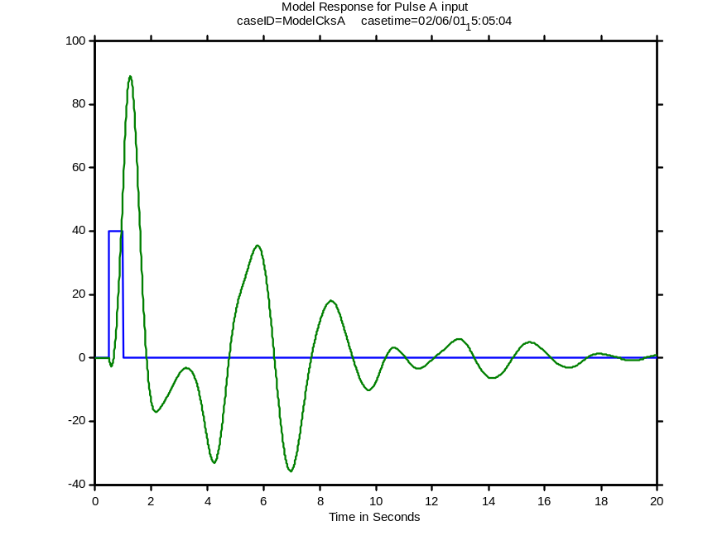
Fig. 36. System ringdown from a pulse input
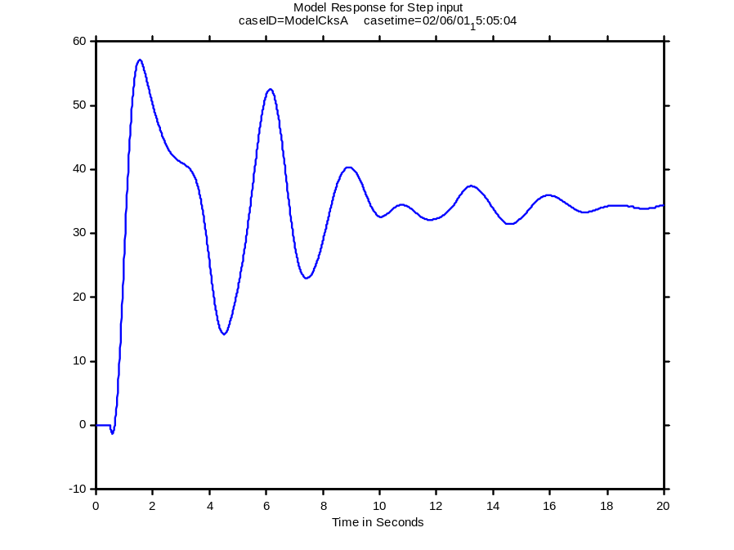
Fig. 37. System ringdown from a step input
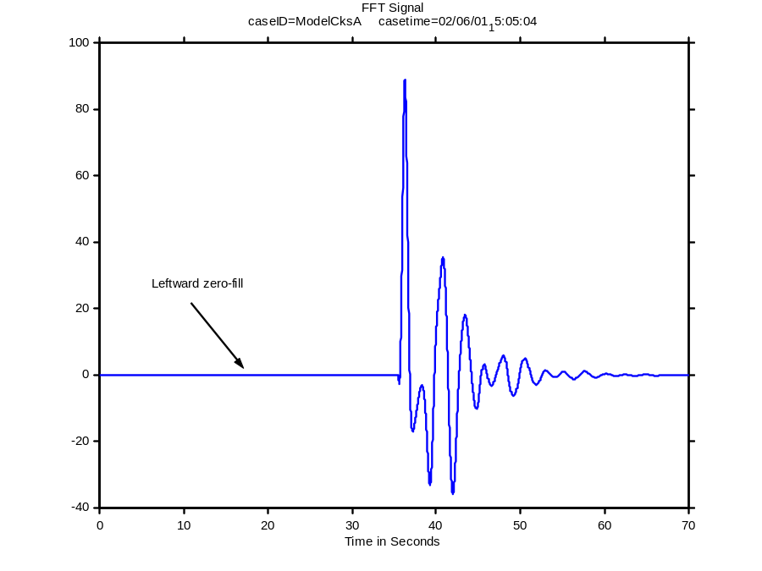
Fig. 38. Ringdown signal with leftward zero-fill
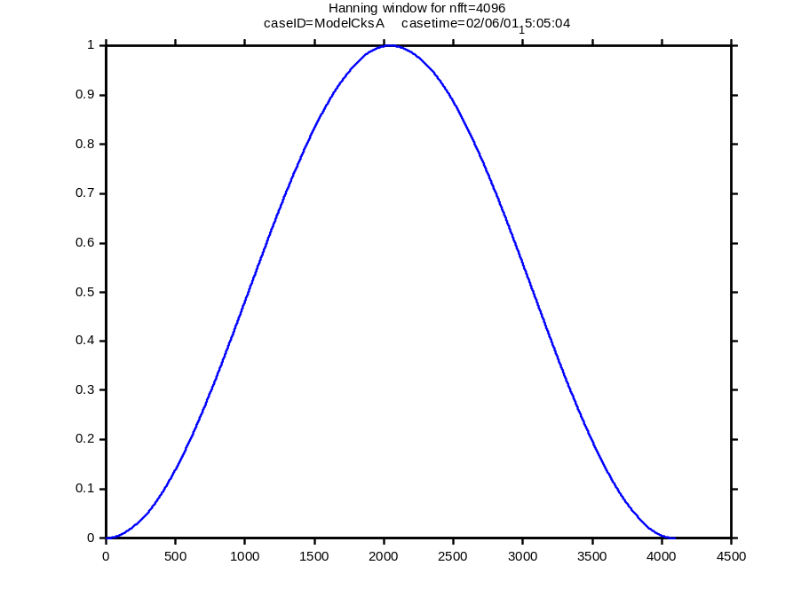
Fig. 39. Hanning window for nfft=4096
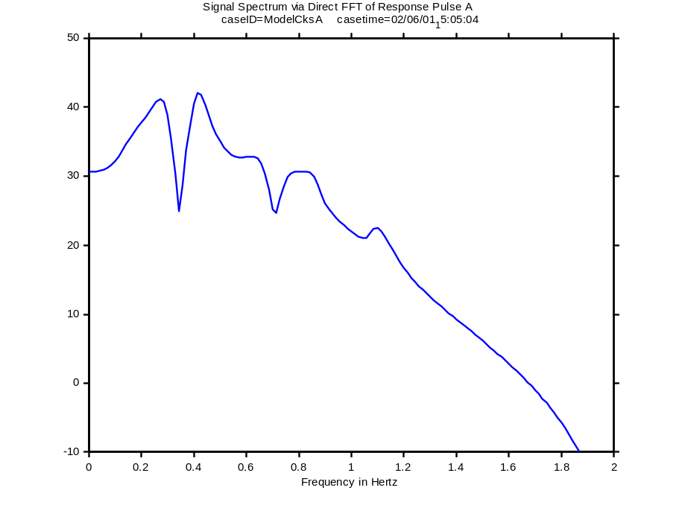
Fig. 40

Fourier Correlation Analysis
Correlation analysis is a common application of Fourier methods to dynamic measurements. The general idea is to analyze long signal records in overlapping segments and then average the results in together to form “periodograms.” The process may be thought of as estimating impulse response functions that are equivalent to the pulse ringdown of Fig. 36.
FFT calculations should be preceded by removing offsets and very low frequencies from the signals, and then by “tapering” each processed segment by applying a window such as that in Fig. 41. The windowing assures that each processed segment begins and ends smoothly at the same level, and it also provides a useful degree of control over the averaging process [Error: Reference source not found,Error: Reference source not found]. The segment shown in Fig. 42 is typical.
Fig. 43 and Fig. 44 show periodogram results that were obtained from PPSM data with a segment length of nfft=1024 samples. The PPSM sample rate was 20 sps, so the segment length in seconds is Tbar=1024/20=51.2 sec. Resolution of the calculated FFTs is 1/Tbar=0.01953 Hz between adjacent samples. This seems to be toward the low end of what is needed to resolve the sharp features often found in spectral signatures for WSCC dynamics.
The autospectrum of Fig. 43 indicates the average frequency distribution of power in the analyzed signal. The pattern of spectral peaks is typical, though their amplitude and locations are somewhat abnormal because of stressed system conditions. Fig. 44 shows autospectra for two signals, plus the (squared) coherency between them. The latter is a normalized measure of the degree to which the two signals vary together.
Ongoing investigations suggest that sharp coherency peaks indicate the frequency locations of dynamic modes that are active in the correlated signals []. Fig. 45 and Fig. 46 show that such peaks become more visible as FFT resolution is increased, but that this advantage is offset by a more irregular estimate for the autospectra. Tradeoffs of this kind are examined more thoroughly in [Error: Reference source not found] and in the Working Notes attached to it.
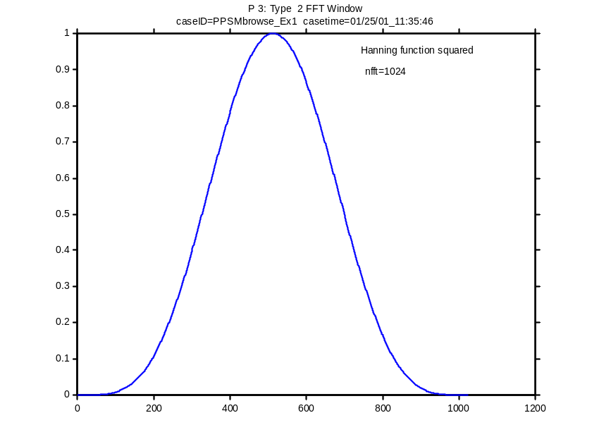
Fig. 41. Hanning-squared window for nfft=1024
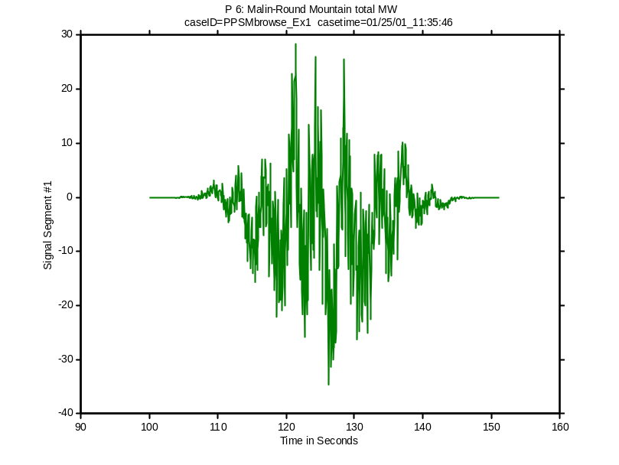
Fig. 42. Windowed data segment for periodogram analysis of system noise
(nfft=1024, Tbar=nfft*tstep=51.2 sec.)
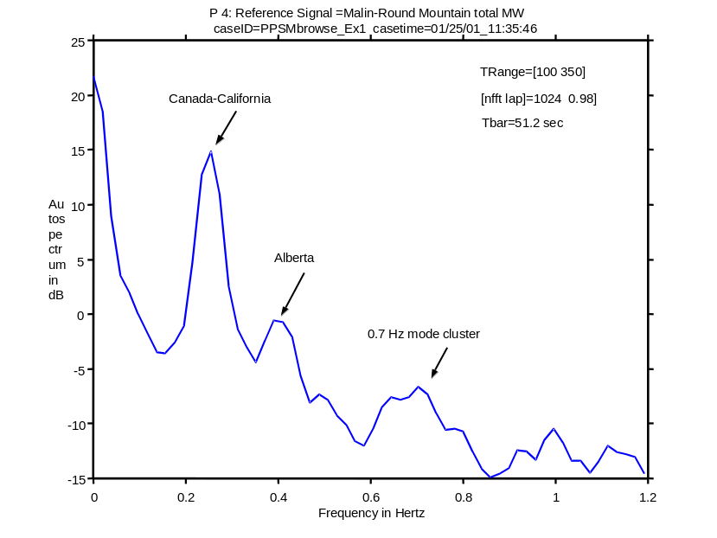
Fig. 43. Low resolution autospectrum just prior to
the WSCC breakup of August 10, 1996
(see Fig. 3 & Fig. 32)
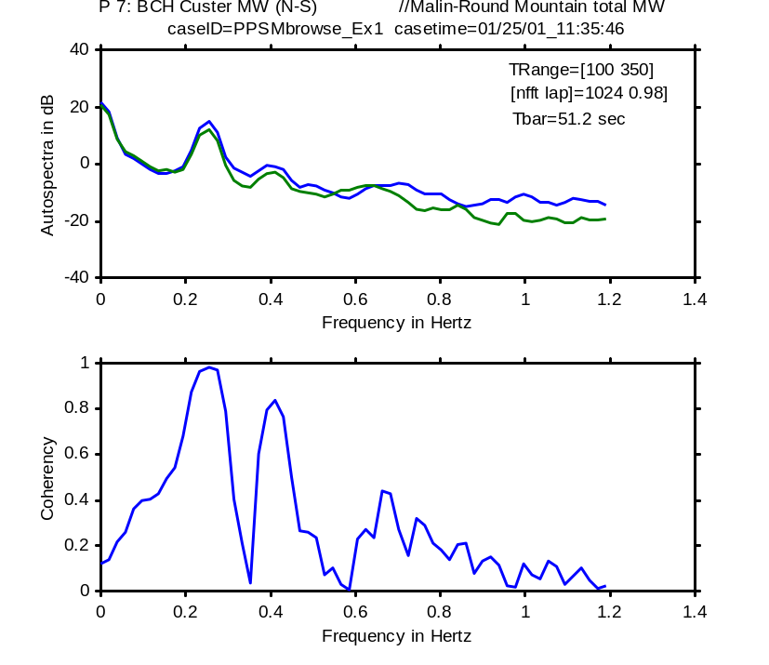
Fig. 44. Low resolution autospecta & coherency just prior to
the WSCC breakup of August 10, 1996

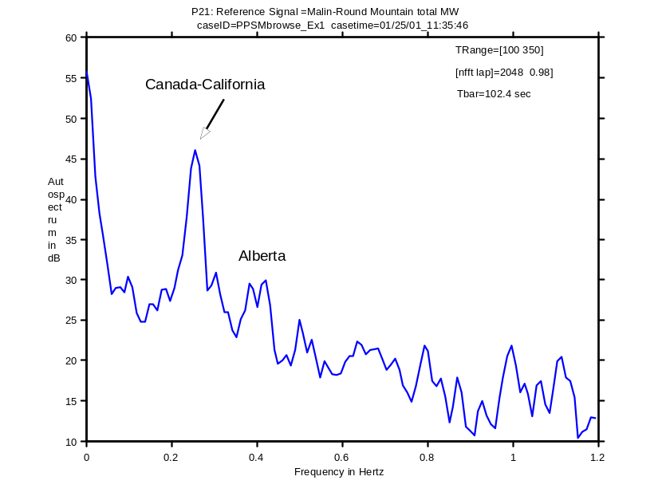
Fig. 45. High resolution autospectrum just prior to
the WSCC breakup of August 10, 1996
(see Fig. 3 & Fig. 32)
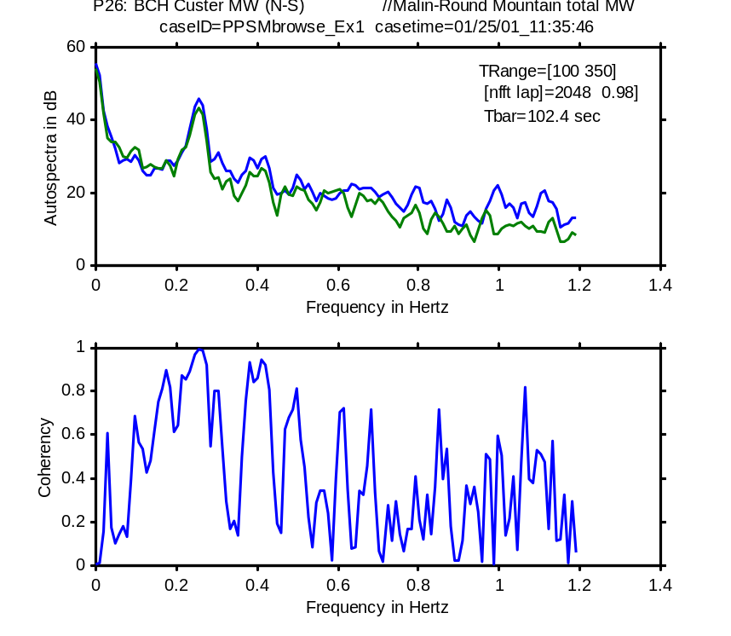
Fig. 46. High resolution autospecta & coherency just prior to
the WSCC breakup of August 10, 1996

Fourier Analysis in Real Time
Periodograms displays are useful tools for scanning very long record sets, and for real-time assessment of power system activity. It is necessary, of course, that the averaging process gradually “forget” past data as they age. This is a routine functionality in dynamic signal analyzers (DSAs), and in PSM Tools. A typical “waterfall” display is shown in Fig. 47

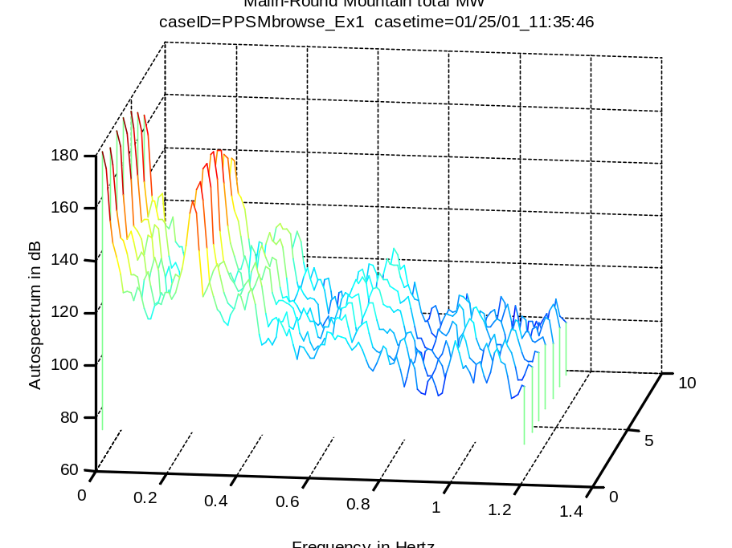
Fig. 47. Waterfall plot for evolution of autospectrum in Fig. 45

Linking to Add-On Toolsets
PSMbrowser provides a useful link between raw PSM data and various add-on toolsets for advanced processing or design. Such toolsets can be launched while PSMbrowser is under keyboard control, or they may be used to retrieve data that has been saved to PSMT files. The sections below provide a few guidelines on such matters.

Launching the Prony Analysis GUI
Ringdown

Launching the Control System Toolbox
LTIview

Launching the Signal Processing Toolbox
SPtool
FDAtool

Launching the Wavelet Analysis Toolbox
Wavemenu

Launching the System Identification Toolbox
Ident

Concluding Remarks

APPENDICES

REFERENCES

WAMS is an acronym for Wide Area Measurement System. BY context, it embraces all elements of a full infrastructure for gathering and use of dynamic information.
Copyrighted as the Dynamic System Identification (DSI) Toolbox
Named after BPA’s Gary L. Keenan, who recommended it for use by system planning engineers.
[?] J. F. Hauer and J. R. Hunt, in association with the WSCC System Oscillations Work Groups, "Extending the Realism of Planning Models for the Western North America Power System," V Symposium of Specialists in Electric Operational and Expansion Planning (SEPOPE), Recife (PE) Brazil, May 19-24, 1996.
[?] D. N. Kosterev, C. W. Taylor, and W. A. Mittelstadt, "Model Validation For The August 10, 1996 WSCC System Outage," IEEE Trans. Power Systems, Vol. 14, No. 3, pp. 967-979, August 1999.
[?] August 10, 1996 Disturbance Model Validation Study. Report by the WSCC August 10, 1996 Disturbance: Model Validation Task Force, Les Pereira, Chairman; November 27, 2000.
[?] Model Validation and Analysis of WSCC System Oscillations following Alberta Separation on August 4, 2000. Draft report to the WSCC Modeling & Validation Work Group by staff at BPA and BCH; January 9, 2001.
[?] WSCC Plan for Dynamic Performance and Disturbance Monitoring, prepared by the WSCC Disturbance Monitoring Work Group. (Includes extensive attachments.) October 4, 2000. Available at http://www.transmission.bpa.gov/orgs/opi/Wide_Area/WSCC_Plan_100400.doc.
[?] WSCC Disturbance/Performance Monitor Plan Siting Requirements, prepared by the WSCC Disturbance Monitoring Work Group. Draft of January 30, 2001.
[?] Wide Area Measurements For Real-Time Control And Operation of Large Electric Power Systems – Evaluation And Demonstration Of Technology For The New Power System, J. F. Hauer, W. A. Mittelstadt, W. H. Litzenberger, C. Clemans, D. Hamai, and P. Overholt. Prepared for U.S. Department of Energy Under BPA Contracts X5432-1, X9876-2; January 1999. This report and associated attachments are available on compact disk.
[?] A Dynamic Information Manager for Networked Monitoring of Large Power Systems, J. F. Hauer, F. J. Hughes, D. J. Trudnowski, G. J. Rogers, J. W. Pierre, L. L. Scharf, and W. H. Litzenberger. EPRI Report TR-112031, May 1999.
[?] R. L. Cresap, W. A. Mittelstadt, D. N. Scott, and C. W. Taylor, "Operating Experience with modulation of the Pacific HVDC Intertie," IEEE Trans. PAS, pp. 1053-1059, July/August 1978.
[?] J. F. Hauer, "Reactive Power Control as a Means for Enhanced Interarea Damping in the Western U. S. Power System—A Frequency-Domain Perspective Considering Robustness Needs," Application of Static Var Systems for System Dynamic Performance, IEEE Publication 87TH0187-5-PWR, pp. 79-92.
[?] P. Kundur, G. J. Rogers, D. Y. Wong, L. Wang, and M. G. Lauby, "A Comprehensive Computer Program Package for Small Signal Stability Analysis of Power Systems," IEEE Trans. Power Systems, pp. 1076-1083, Nov. 1990.
[?] Evaluation of Low Frequency System Response: Study Results and Recommendations. Report of the WSCC 0.7 Hz Oscillation Ad Hoc Work Group to the WSCC Technical Studies Subcommittee, September 1990.
[?] J. F. Hauer and J. R. Hunt, in association with the WSCC System Oscillations Work Groups, "Extending the Realism of Planning Models for the Western North America Power System," V Symposium of Specialists in Electric Operational and Expansion Planning (SEPOPE), Recife (PE) Brazil, May 19-24, 1996. (USE XREF)
[?] Direct Analysis of Wide Area Dynamics, J. F. Hauer, W. A. Mittelstadt, R. Adapa, W. H. Litzenberger, and M. K. Donnelly. Materials for CRC Electric Power Engineering Handbook, Chapter 11: Power System Dynamics and Stability. Published winter 20000. Available at WAMS web site http://www.transmission.bpa.gov/orgs/opi/Wide_Area/index.shtm.
[?] J. F. Hauer, D. J. Trudnowski, G. J. Rogers, W. A. Mittlestadt, W. H. Litzenberger, and J. M. Johnson, "Keeping an Eye on Power System Dynamics," IEEE Computer Applications in Power, pp. 50-54, October 1997.
[?] INTERIM REPORT ON WSCC SUMMER 2000 STAGED SYSTEM TESTS AND VALIDATION STUDIES — PART 1: OSCILLATORY DYNAMICS. WSCC Performance Validation Task Force of the Modeling and Validation Work Group. Draft of October 26, 2000. Available at web site http://web.wscc.com/committees/PCC/system_performance_validation.htm.
[?] Preliminary Examination of the Alberta Trip on August 4, 2000, J. F. Hauer. PVTF Working Note, August 15, 2000. Available at http://web.wscc.com/committees/PCC/system_performance_validation.htm.
[?] J. F. Hauer, M. J. Beshir, and W. A. Mittelstadt, in association with the WSCC Performance Validation Task Force, "Dynamic Performance Validation in the Western Power System". APEx 2000 Conference, Kananaskis, Alberta, October 2000. Available at web site http://web.wscc.com/committees/PCC/system_performance_validation.htm.
[?] MATLAB: The Language of Technical Computing. The Math Works, Inc.: Natick, MA, 2000.
[?] S. J. Chapman, Matlab Programming for Engineers. Brooks/Cole, 2000. ISBN 0-534-95151-1.
[?] Installation of the BPA/PNNL Dynamic Systems Identification (DSI) Toolbox, J. F. Hauer. WAMS Working Note, January 2001.
[?] J. S. Bendat and A. G. Piersol, Engineering Applications of Correlation and Spectral Analysis. New York: John Wiley, 1980.
[?] J. G. Proakis and D. G. Manolakis, Digital Signal Processing – Principles, Algorithms, and Applications (Second edition). New York: McMillan, 1992.
[?] J. F. Hauer and D. J. Trudnowski, ”Using the Coherency Function in Measurement Based Small-Signal Analysis of Large Power Systems,’ presented on July 18, 2000, to the IEEE/PES Panel Session on Recent Applications of Small-Signal Stability Analysis Techniques at the IEEE/PES 2000 Summer Meeting, Seattle WA.

