Application Guide
Volume
4

DSITools
Power System Modal Analysis

Application Guide
© 1995-1998 Battelle Memorial Institute

Authors:
Daniel Trudnowski
John Hauer
Graham Rogers

Table of Contents

Introduction 2
Power System Dynamics 3
Linear Analysis of Power Systems 3
Modal Analysis Theory 5
Controllability and Observability 8
Applying Modal Analysis 8
Modal Analysis via Prony Analysis 10
References 10
Prony Analysis Guidelines 11
Linearity of Signal Analyzed 11
No switching actions 11
Controls should operate within limits 12
Magnetic saturation 12
Choosing analysis signals 12
Multi-signals and mode shape 13
Known Modes 13
Detrending and normalizing 13
Prony Fitting Options 14
Example 1: Modal Analysis from Transient Simulation. 16
Inter-Area Mode Identification 17
Local Mode Identification 19
Generators 1 and 2 19
Generators 3 and 4 21
Summary 23
Example 2: Modal Analysis from Field Measured Data 24
Practical Considerations for the Analysis of Measured Data 24
Example Background 25
Signal Pre-Processing 27
Detrending 27
Filtering 27
Choice of Analysis Parameters 28
Prony Analysis Results 29
Prony fit with only Inter-Area Modes 30
Excitation Limiting 31
Summary 33

Introduction
Chapter
1
The Dynamic System Identification (DSI) Toolbox is a collection of MATLAB based routines for identifying dynamic system models and performing modal analysis of transient records. Core algorithms solve the following fundamental problems:
- estimate the modal content (frequency, damping, and mode shape) from a transient (or ringdown) system response
- identify a linear reduced-order model of the system
- identify specific parameters of a dynamic system or a component in the system.
Those unfamiliar with the DSI toolbox or system identification techniques are encouraged to read Volume 1 for an overview of the entire package.
This manual provides guidelines and examples for applying the Ringdown Analysis Tool to power system modal analysis problems. Instructions for installing and operating the Tool are provided in Volume 2, the DSI Toolbox Application Guide.

Power System Dynamics
Chapter
2
Oscillations and their damping control are important topics in power system planning and operation. The use of synchronous interconnection between AC generators in power systems means that, whenever a power system is disturbed, oscillations can be observed. These are due to the synchronizing torques which act on the generators so as to bring them back to a steady synchronous operating state. Essentially, the generators exchange energy through the oscillations. As one set of generators speed up others slow down. The synchronizing or electromechanical oscillations of a power system’s generators should decay with time. If they do not, the system is unstable. In the worst case, the instability may cause an interconnected power system to collapse. In the best case, unstable oscillations will build up to reach a constant amplitude and require corrective operator action to enable a steady, non-oscillatory state to be achieved.
Power system oscillations consist of a combination of many different modes. Each mode is associated with a specific set of generators and has a natural frequency and damping which depends on the loading conditions of the system and on the controls associated with the generators and other dynamic system devices. It is not easy to identify the oscillatory modes by visual inspection of transient records, regardless of whether the records are produced by direct system response measurement or by simulation.
The primary technique for analyzing oscillations is linear analysis. Because of this, Prony analysis provides considerable information on the oscillation characteristics. This section provides an overview of power system dynamic analysis via linear analysis. For more detailed information on power system dynamics, one should review one of the many references on the subject, including [1].

Linear Analysis of Power Systems
In examining the electromechanical stability of a power system, it is often useful to study the linearized behavior of the low-frequency oscillations (i.e., the small-signal stability). In many cases, the data is in the form of a “ringdown” in that the system is in a natural state of oscillation due to a sudden switching. Prony analysis is ideally suited for analyzing ringdowns to determine the modal content (i.e. modal analysis) and for developing reduced-order transfer functions.
Consider a system model in Figure 2- . Input u(t) causes a free or natural response of the system measured at the outputs y_{m}(t), m = 1, 2, ..., M. Examples include step or pulse inputs and sudden discontinuities (such as a breaker opening). Assume that initially the system is operating in a steady-state balanced power-flow condition and the input is such that the system returns to its original configuration (e.g., a line opening with a reclosure). Also assume the system is transient stable so that it does not lose synchronism during the first swing. Then, the response to u(t) is an electromechanical oscillation about the pre-input equilibrium power flow.
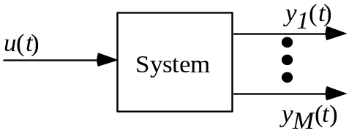
Figure 2- : System model.
A fundamental technique for analyzing the oscillations is to linearize the system about the pre-input equilibrium. Extraction of such linear models can be done using two basic approaches: model the system using theoretical derivations and linearize about a given operating condition using Taylor series expansion; or use a mathematical fitting technique to optimally fit a linear model to specified measured system response. Prony analysis uses the second approach.
The electromechanical dynamics of a power system are linearized about an operating point and written as the state-space linear differential equation
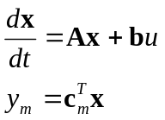 (2. )
where
A is a square state matrix
x is the state vector
b and c_{m} are the input and output vectors, respectively.
u is the input
y_{m} is the mth system output
There is one differential equation for each dynamic state. A dynamic state is a variable, which, in conjunction with all the other state variables, completely describes the dynamics of the system. If n dynamic states are required, the state matrix has n rows and columns, the state vector has length n, the b matrix has n rows and the c_{m} has n columns. The superscript T denotes the transpose operation.
In a power system the state vector consists of small changes in generator angles and speeds, the magnetic fluxes associated with the field and amortisseur windings, variables required to describe the exciter and governor dynamics, and variables representing the dynamic system loads. Other states may be required to describe HVDC links and FACTS devices and their controls. In large interconnected power systems there may be thousands of dynamic states.

Modal Analysis Theory
By understanding the modal characteristics of the linearized model in (2.1), one can obtain detailed information on the dynamic characteristics of the system. In what follows, we discuss the theoretical foundation for modal analysis.
Each of the natural (or characteristic) modes of oscillation associated with a set of linear state equations has the form K_{i}exp(λ_{i}t), where K_{i} (a vector of length n) and λ_{i} (a scalar) may be real or complex. A complex eigenvalue 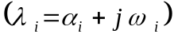 implies that the mode is oscillatory at frequency 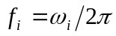 with damping ratio 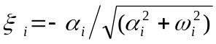.
In a system with n states, there will be n characteristic modes. Each mode satisfies the unforced differential equation
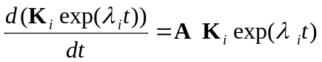 (2. )
This implies that, for a non-trivial solution
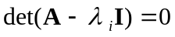 (2. )
where det(•) is the determinant. Equation (2.3) may be solved for the n eigenvalues (λ_{i}).
The vectors K_{i} are constant which allow the characteristic modes to be weighted so as to give the response to a forcing function u, and to satisfy the initial values of the states.
If the eigenvalues are distinct, we can define the following associated vectors :
right eigenvectors which satisfy
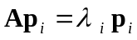 (2. )
and left eigenvectors which satisfy
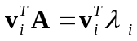 (2. )
for i=1, … , n. Both p_{i} and v_{i} are dimension n by 1. The left and right eigenvectors are orthogonal, and are usually scaled to be orthonormal. That is
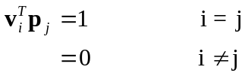 (2. )
Any vector of length n may be expressed as a series of the right eigenvectors of A. If the state vector x is so expanded
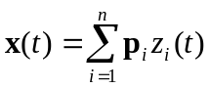 (2. )
then
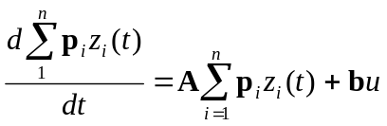 (2. )
Multiplying by the left eigenvector v_{j}, gives
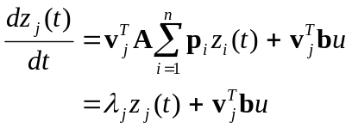 (2. )
This process has decoupled the differential equations. If the input u(t) is the unit impulse and x = zero at t = 0, then
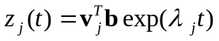 (2. )
The state vector solution is
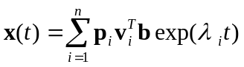 (2. )
Thus, the right eigenvector describes the distribution of the corresponding mode throughout the states of the system: we refer to right eigenvectors as mode shapes. The left eigenvector, together with the input matrix b, determines the amplitude of each mode.
The system output, y_{m} is given by
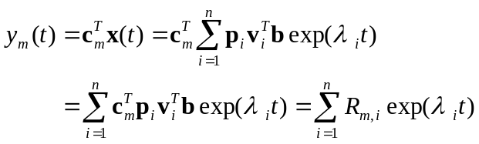 (2. )
where the scalar R_{i} is called the residue associated with the i^{th} mode and the mth output. One can take the Laplace transform of (2.12) and obtain
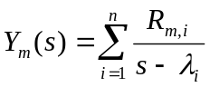 (2. )
If the input u(t) is not an impulse, but any input, one can use a similar process to show that the Laplace transfer function from input u(t) to output y_{m}(t) is
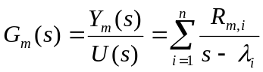 (2. )
This is in the form where Prony analysis can be used to estimate the residues and eigenvalues.

Controllability and Observability
Depending on where in the system we take a measurement, we may or may not be able to see a particular mode in the record. We say that the mode is observable (unobservable) if the mode can (cannot) be detected in the measurement. If the i^{th} mode is unobservable, the scalar 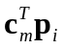 is zero.
Depending on the distribution of the input disturbance throughout the system (defined by the input vector b), some modes may not be excited. We say that the mode is controllable (uncontrollable) if the mode is (is not) excited by the input disturbance. If the i^{th} mode is uncontrollable, the scalar 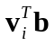 has is zero.
If a mode is either unobservable or uncontrollable, its residue R_{i} is zero. In control terms, feedback between the input and the output will have no effect on such a mode.

Applying Modal Analysis
Modal analysis attempts to answer the following questions:
What are the modal frequencies and damping and how do they change with system steady-state loading?
How strongly does a variable participate in a mode?
What is the mode shape (e.g., for a given mode, which generators swing together and which swing out of phase)?
This knowledge along with the linear model provides rich information in designing control systems and determining safe operating conditions.
The modal frequencies are the imaginary part of the eigenvalues and the modal dampings are the real part. Therefore, knowledge of the eigenvalues directly provides the mode frequencies and dampings.
How strongly a variable participates in an oscillation is determined by the magnitude of the . For example, assume one is interested in comparing how strongly different generators participate in mode i. This could be done by comparing the magnitude of correponding to measuring each generator’s speed deviation. The larger a particular , the more that generator’s speed deviates form synchronous during oscillations.
The same participation information is obtained by comparing the residues for a given output (i.e., 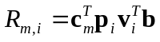). This is because for a given input, the term is the same for each residue. Using the same example above, one could compare 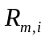 for each generator’s speed deviation. The larger the magnitude of a particular , the more that generator’s speed deviates form synchronous during oscillations.
Mode shape information is determined from the relative angle of . For example, assume one is interested in comparing the relative mode shape between two generators. This could be done by comparing the phase of correponding to measuring each generator’s speed deviation. If the relative phase between the ’s is close to 180°, the generators oscillate against each other. Alternatively, if the relative phase is near 0°, the generators swing together.
As with the magnitude information, the mode shape information can also be determined from the relative angles of the residues 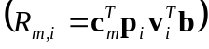. This is because, for a given input, the angle between two given ’s is the same as the relative angles between the ’s.

Modal Analysis via Prony Analysis
The previous section established that a system’s modal information is contained in the eigenvalues and the residues. Prony analysis is the primary technique available in the DSI Toolbox for extraction of this information. For a given oscillatory response, the time-domain data is analyzed resulting in output residues and eigenvalue estimates. If the system input is known, transfer function residue estimates can also be obtained.
If one is interested in determining the mode shape and participation levels, either the output or transfer function residues can be used. Both provide the same information [2].

References
- Kundur, P., Power System Stability and Control, McGraw-Hill, Inc., 1994.
- D. J. Trudnowski, J. M. Johnson, and J. F. Hauer, “Advances in Prony Analysis for System Identification: SIMO Modeling, Repeated Poles, and Power System Applications,” IEEE Transactions on Control Systems Technology, (In review).
Prony Analysis Guidelines
Chapter
3
Power system responses are inherently nonlinear, while Prony analysis attempts to fit a linear model to a time response function. Therefore, Prony analysis should only be used with response data that appears to be linear. Measurement points should be chosen at which the modes of interest are highly observable. In light of this, the following general guidelines should be followed.

Linearity of Signal Analyzed
It is possible to classify oscillations into two categories
- the system is moving toward a new post-fault equilibrium. An example is a line opening with no reclosure. If the system is stable, the post fault system response tends to a new steady equilibrium point, which satisfies the constraints imposed by the modified system.
- the system is oscillating about the pre-fault equilibrium. An example is a line opening with a successful reclosure. The system response tends towards the pre-fault equilibrium point
The second response is a true ringdown, and it is easier to identify a portion of the response that is essentially linear. However, provided a transfer function is not being sought, Prony analysis applied to the first type of fault should be accurate if the identification is performed over a time period in which the oscillations are effectively small changes about the new equilibrium point.

No switching actions
Switching actions (such as breakers and switched capacitors) act as additional forcing functions in a power system oscillation. The result of such actions is often to alter the system structure and hence the system’s characteristic modes. Therefore, Prony analysis should only be applied to portions of the response where no switching actions occur.

Controls should operate within limits
Dynamic device control action may be limited during large deviations from their nominal values (e.g., excitation limiting). This often occurs in the initial period following a system fault. Prony analysis often produces grossly inaccurate system mode estimates if such highly non-linear characteristics are included in the analysis records. One should analyze a portion of the data where limiting is less prevalent or, if possible, provide a weaker disturbance that reduces the tendency for control limiting.

Magnetic saturation
Magnetic-saturation of the generators’ field windings leads to electromechanical mode damping which is higher than that determined by a linearized model. This is more evident under high generator loading and for an input that produces high amplitude oscillations of the generators’ states. Because Prony analysis fits a linear model to the nonlinear oscillations, it identifies modes with the added damping introduced by the changes in saturation. Typically, the nonlinear damping is less than 20% more than the linearized damping (e.g., a nonlinear damping ratio of 0.05 versus a linear damping ratio of 0.04).

Choosing analysis signals
Signals should be chosen for analysis in which the modes of interest are clearly observable. The more dominant a given mode in a ringdown, the more accurately it will be identified by Prony analysis.
Signals that have a linear trending factor (or a ramping term) should be avoided, or digital filtering should be used to remove the trending effect. Over a typical 10 second to 20 second data record, a ramping effect caused by very low frequency oscillations associated with generator governors can often be observed in generator angle signals.
In light of these observations, a few general comments can be made concerning specific signals.
- Generator and voltage angles are usually dominated by very low frequency oscillations, which are often observed as ramping effects.
- Frequency error and generator-speed error show smaller governor effects and usually provide a good compromise of information for both low frequency and higher frequency oscillations. In general, these signals should be the first choice for analysis.
- Real power signals tend to contain higher frequencies with very little evidence of governor effects.
- Reactive power and bus voltage magnitude signals are good choices if the oscillations have a high reactive content. They may be good signals to monitor in a voltage weak system.

Multi-signals and mode shape
In theory, once the system is oscillating about its final equilibrium point, all measured signals consist of different linear combinations of the modes characterizing the system response. Multi-signal Prony analysis identifies a mode set to best represent all signals simultaneously.
If the objective is to study the mode shape of a particular oscillation, then the residues of like signals should be compared. For example, the speed errors at the generators can be analyzed and then the residue angles compared for a given mode to determine which generators are swinging in phase and which are out of phase.
If the objective is to study interarea oscillations, it is often effective to add several signals from an area where the machines swing together. In the composite signal local mode effects tend to cancel and interarea modes become more dominant. Signals having the same dominant modes should be analyzed simultaneously to improve the accuracy of the mode estimates.
To maintain numerical robustness, caution should be exercised to not choose too many signals for simultaneous analysis. When using the Ringdown Analysis Tool, the number of signals to analyze should be chosen so as to keep the total number of data points below 500, preferably between 200 and 300.

Known Modes
Prony analysis most accurately identifies the dominant modes in a signal. Therefore, it is often wise to conduct a series of fits using different inputs chosen to excite different modes. The dominant modes identified from one fit are included as known modes for subsequent fits.

Detrending and normalizing
Many signals to be analyzed will have a significant offset. For example, real-power swings are usually tens to hundreds of MW about some steady-state value of thousands of MW. Detrending such a signal removes the offset, which will often improve the accuracy of the Prony fit.
When simultaneously fitting to multiple signals, the signals should have similar magnitudes. If the signals do not have similar magnitudes, they should be normalized. For example, consider a simultaneous fit to a real-power signal and a frequency-error signal. The real-power signal will likely have swings in the hundreds of MW while the frequency-error signals will have swings in the mHz. Without normalization, the modal information in the real-power signal will overly dominate the information in the frequency-error signal. Normalization forces the Prony analysis to effectively equally weight both signals.

Prony Fitting Options
The Ringdown Analysis Tool allows the user to select several options for pre-processing and windowing in on the Prony analysis data:
Decimate sets the interval between the data points extracted from the input signal in terms of the number of time steps in the supplied data set.
Time Zero Reference sets the time the multi-signal Prony model will reference as time zero.
Initial Time sets the times (relative to time zero) at which the Prony analysis will begin for each signal.
End Time sets the times (relative to time zero) of the last sample used in the Prony analysis of each signal.
Detrend selects the trend to be removed from each signal prior to performing the Prony analysis.
Detrend Initial Time sets the times (relative to time zero) of the initial points to use when calculating trends to remove.
Detrend End Time sets the times (relative to time zero) of the last points to use when calculating trends to remove.
Normalize all signals normalizes each signal so the maximum absolute value of each is one prior to performing the Prony analysis.
The Decimate and Time Zero Reference controls are set once at the beginning of each Prony run. Decimate should be chosen to make the resulting time step between 0.02 s and 0.1 s
Three criteria should be considered when choosing the end time:
- at least one full cycle of the minimum-frequency oscillatory mode should be included (more data is preferred)
- if data is collected in a noisy environment (i.e., field data), the record should be short enough to keep the signal-to-noise ratio (SNR) above 20 dB. That is, the pre-disturbance variations in the signal should be approximately 10 times smaller in amplitude than the variations during the ringdown.
- the total number of data points being analyzed should follow numerical limits recommended in the user manual.
Initial Time specifies the points from each signal at which the Prony analysis begins. Initial Time should be chosen to exclude nonlinear effects that often occur at the start of the ringdown. For example, the first cycle of a ringdown may include exciter limiting; therefore, initial time should be adjusted so that the first cycle is not included in the analysis. When using the Ringdown Analysis Tool with known input pulses, the initial time is forced to be at least one data point past the last switching point of the input.

Chapter
4
Example 1: Modal Analysis from Transient Simulation.
The simple four-machine power system shown in Figure 4- is used to illustrate the application of Prony analysis to transient simulation records. The objective is to determine the characteristics of the three electromechanical modes. This includes identifying the damping, frequency, and shape of each mode. Generators are represented using detailed two-axis models with no magnetic saturation and first-order fast exciters. Exciter limits are set at 2.5 p.u. and -2 p.u. for generators 1 and 3, and 3.5 p.u. and -2 p.u. for generators 2 and 4.
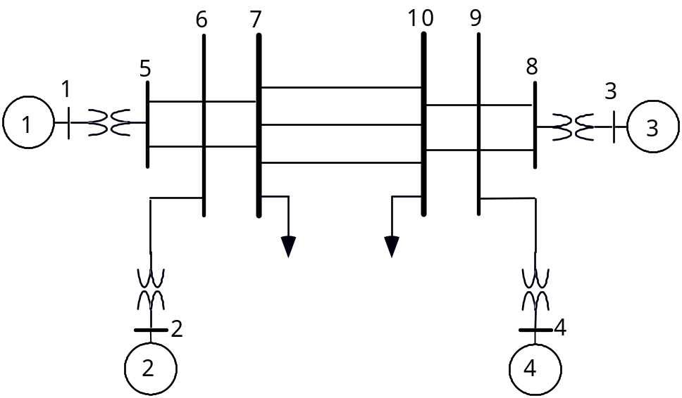
Figure 4- : Four-machine system.

Inter-Area Mode Identification
From the system topology, one would expect an interarea mode in which generators 1 and 2 oscillate against 3 and 4. This hypothesis is tested by simulating the system response to a disturbance created by opening one of the lines between buses 7 and 10 at 1.0 s and reclosing it 0.5 s later. Figures 4-2 through 4-4 show the generator field voltages, real electrical power outputs, and speed errors. The exciters outputs are not limited; therefore, there is no need to delay the initial time of the analysis.
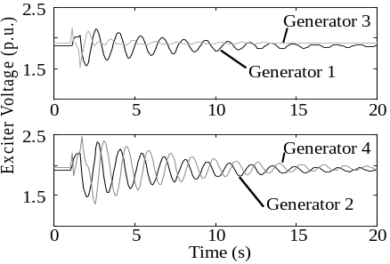
Figure 4- : Exciter voltages.

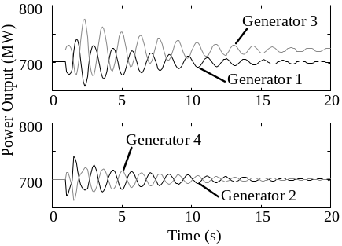
Figure 4- : Generator real powers.

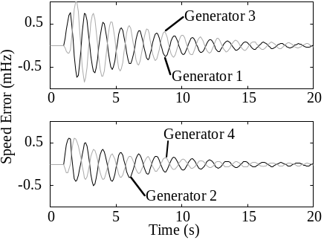
Figure 4- : Generator speed-error.

A multi-signal Prony analysis is conducted on the four generator speed errors shown in Figure 4- . The analysis has
- time zero reference = 1.5 s
- time step = 0.1 s
- end time = 8.5 s for each output
- initial time = 0.1 s for each output.
The time zero reference is the instant of line reclosure. The end time of 8.5 s allows several oscillations of the ringdown but requires sufficiently few data points to avoid numerical problems. Initial time is set close to zero because the exciters are not output limited.

A dominant mode is identified having a frequency of 0.739 Hz, and 3.56% damping (residues are shown in Table 4-1. The residue angles of generators 1 and 2 are nearly equal and in antiphase with the residue angles of generator 3 and 4. This indicates that generators 1 and 2 oscillate in phase against generators 3 and 4. Figure 4-5 compares the identified generator frequency error and the original signal. It can be seen that the agreement is excellent.
Table 4- : Residues for 0.739 Hz, 3.56% damping mode.
Generator | |Residue|  (x10⁻³) | Residue Angle  (Degrees)
1 | 0.427 | 44.0
2 | 0.299 | 52.0
3 | 0.510 | -116.2
4 | 0.239 | -131.2

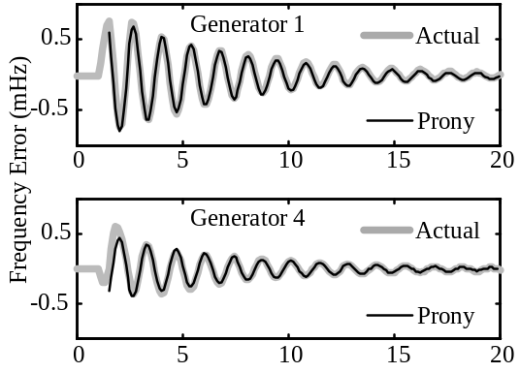
Figure 4- : 0.739 Hz mode Prony fit compared with original record.

Local Mode Identification

Generators 1 and 2

With the interarea mode identified, we can continue to identify the remaining two local modes. It is reasonable to suppose that in one local mode generators 1 and 2 oscillate against each other. A fault near generator 2 is likely to excite such a mode, so the line connecting generator 2 to the system is opened at 1.0 s and reclosed 0.1 s later. Generators 1 and 2 exciter voltages, for this fault, are shown in Figure 4-6.
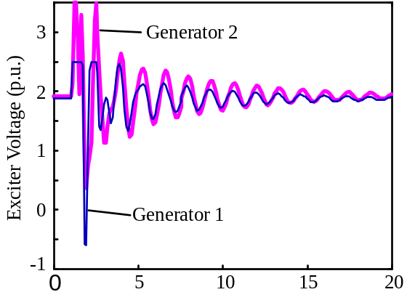
Figure 4- : Exciter voltage responses to fault at generator 2.

It can be seen that the exciter of generator 1 is output limited to a time of 2.5 s. Therefore, Prony analysis should only use data after 2.5 s.
A multi-signal Prony analysis is conducted on the real power outputs from generators 1 and 2 using the 0.739-Hz interarea mode previously identified as a known mode and with the following parameters
- time zero reference = 1.1 s,
- time step = 0.1 s,
- end time = 8.5 s for each output
- initial time = 1.6 s for each output
The initial time of 1.6 s is chosen to exclude data where the exciter is output limited.
The Prony analysis determines that the signals contain two dominant modes; one at 1.239 Hz, 11.0% damping and one at 0.739 Hz, 3.56% damping. As indicated in Table 4-2, the 1.239 Hz mode has generators 1 and 2 oscillating against each other. The 0.739-Hz mode is the previously identified mode.

Table 4- : Residues for 1.239 Hz, 11.0% damping mode.
Generator | |Residue| | Residue angle  Degrees
1 | 395.1 | 92.4
2 | 443.3 | -83.5

Prony fits for these two modes are compared with the original records in Figure 4-7. As can be seen, the fits are very accurate.
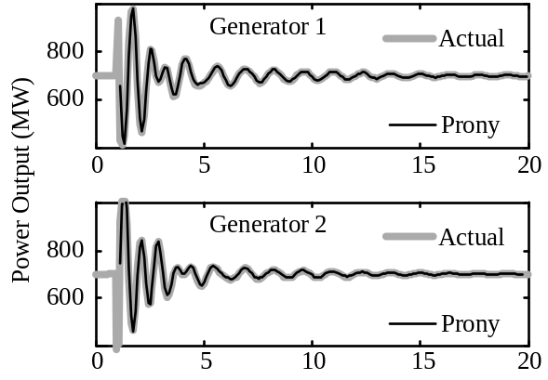
Figure 4- : 0.739-Hz and 1.239-Hz modes comparison of Prony fit with original records.

Generators 3 and 4

It is reasonable to suspect that mode 3 is similar to mode 2, but with generators 3 and 4 oscillating against each other rather than generators 1 and 2. A fault near generator 4 is likely to excite this mode, so the line connecting generator 4 to the system is opened for 0.1 s. Figure 4-8 shows generator 3 and generator 4 exciter voltages. In this case, both exciters are output limited until 2.6 s after the fault.
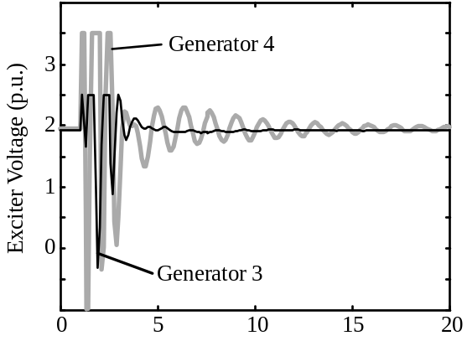
Figure 4- : Exciter voltage responses to disturbance at generator 4.

Multi-signal Prony analysis on the real power out of generators 3 and 4, with the 0.739-Hz mode included as a known mode, is conducted using the following parameters:
- start time = 1.1 s
- time step = 0.1 s
- end time = 8.9 s for each output
- initial time = 1.7 s for each output.
The 1.239-Hz mode identified above between generators 1 and 2 is not included as a known mode because generators 3 and 4 do not significantly participate in this mode.
Two dominant modes are identified. The first is 1.278 Hz, 26.2% damping and the second is the specified inter-area mode, 0.739 Hz, 3.56% damping. As indicated in Table 4-3, generators 3 and 4 oscillate against each other in the 1.278 Hz mode.

Table 4- : Residues for 1.278 Hz, 26.2% damping mode.
Generator | |Residue| | Residue angle (degrees)
3 | 1048 | 79.0
4 | 1039 | -79.0

The Prony fit is compared to the original records in Figure 4-9. While the Prony-model response has considerable more overshoot than the actual simulated response during exciter limiting, it matches the fitted part of the data closely. This demonstrates the nonlinear impact of the exciter limiting on the response of the local mode in the first cycles of the transient.
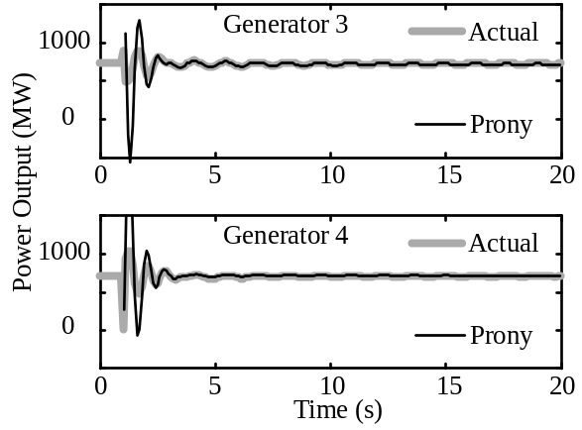
Figure 4- : 0.739-Hz and 1.278-Hz modes response (Prony) versus actual data for disturbance at generator 4.

Summary
Prony analysis of transient simulation records using the DSI toolbox is quite straightforward provided that the guidelines of Chapter 3 are followed.
The exciter output voltages should be monitored for those generators close to the fault to give an indication of whether or not they are output limited. The offset should be chosen to eliminate such nonlinearities from the analysis.
One is unlikely to be able to excite all modes of interest with a single disturbance, and some knowledge of the power system structure is helpful for complete modal identification.

Example 2: Modal Analysis from Field Measured Data
Chapter
5

Practical Considerations for the Analysis of Measured Data

In addition to the guidelines of Chapter 3, field data analysis requires attention to signal noise. Mathematically, the system is represented in Figure 5-1 which is similar to Figure 2-1, but with system noise effects included. In Figure 5- , u(t) is an input that initiates the ringdown at time t, n_{p}(t) is unknown process noise, and n_{m}(t) is measurement noise. The process noise represents the many random factors that constantly excite the system under ambient conditions. This includes varying load and generation effects, system switching effects, and small disturbances. Measurement noise represents the noise associated with measurement and signal transmission devices. In most cases, measurement noise can be mitigated by filtering and by instrumentation refinements. Process noise, on the other hand, is more difficult to handle because it produces energy within the bandwidth of the system characteristics of interest. In the following, we refer to the component of y(t) due to u(t) as the signal, and to the components due to n_{p}(t) and n_{m}(t) as the noise.

In order to obtain accurate mode estimates, the ringdown must be dominated by the signal. To be specific, the signal energy should be 20dB above that of the noise energy. Since it is impossible to separate these effects, determining the point at which data becomes useful requires the subjective opinion of an experienced analyst. Although the choice is subjective, the following guidelines outline some of the factors that should be considered.
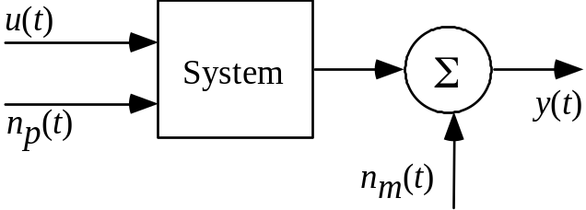
Figure 5- : System with noise.
Immediately after u(t) is applied to the system, the signal energy is at its highest while the noise component energy remains relatively constant. That is to say, the signal-to-noise ratio (SNR) is at its maximum (SNR is the ratio of signal energy to noise energy). Due to system damping, the farther one goes out on the ringdown, the lower the SNR. Therefore, one should use as much of the initial data as possible, but continue to follow the guidelines on excitation limiting.
Data should be used out to the point on the ringdown where the effect of the signal is clearly evident.

Example Background
This example is based on the identification of inter-area modes associated with the western North American interconnected system. A map is shown in Figure 5- . Bonneville Power Administration routinely energizes the 1400 MW Chief-Jo resistive brake which causes a 0.5 second pulse of real power demand on the system. The main objective of the brake tests is to determine the characteristic frequency, damping, and shape of the dominant system modes. The data used in this example is from a brake test conducted on October 12, 1994.
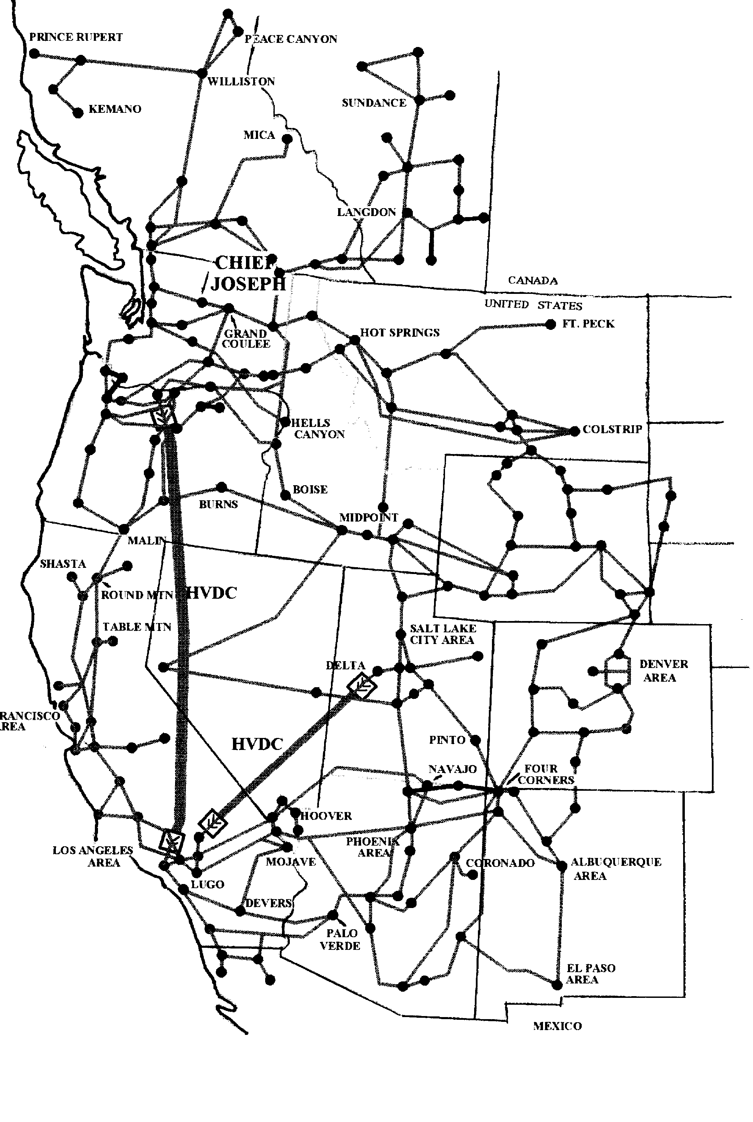
Figure 5- : Western North American Power System.
The brake at Chief Jo tends to consistently excite two modes, one near 0.33 Hz and one near 0.45 Hz. The 0.33-Hz mode is primarily a north-south mode. The 0.45-Hz mode represents the Alberta part of the Canadian system swinging against generators in the northern United States.
In this example, multi-output Prony analysis is used to identify these two inter-area modes in ringdowns measured at a number of points in the system. The signals chosen are three that have historically been dominated by the 0.33-Hz and 0.45-Hz modes
- the Malin-to-Round-Mountain power flows in northern California
- the BC Hydro Ingledow power flow near the Canadian border
- the PG&E Captain-Jack power flow in northern California.

Signal Pre-Processing
The analysis signals require pre-processing to increase the accuracy of the fitted response.

Detrending
First order detrending was used to subtract the signal average from the original signal so that the resulting records for analysis oscillate about zero.

Filtering
A fourth-order Butterworth digital filter with a corner frequency of 2.5 Hz was used to remove the high frequency noise in the original record.
Figure 5- shows the Malin signal before and after detrending and filtering using the detrend, butter, and filter commands from the MATLAB Signal Processing Toolbox. For data sampled at 20 Hz, the calling arguments recommended for building the filter is [num,den] = butter(4,0.25).
Note: Detrending and filtering can also be done using Ringdown Analysis Tool options.

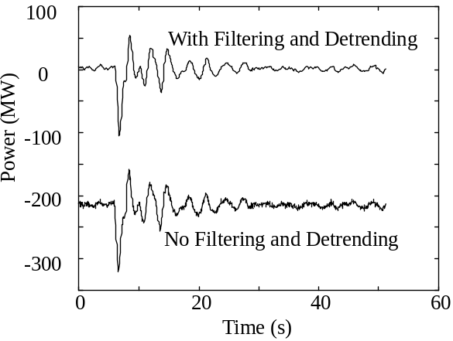
Figure 5- : Effects of detrending and filtering.

Choice of Analysis Parameters
The basic parameters for conducting any Prony analysis are time zero reference, sample rate, initial time, and end time.
Time Zero Reference is the time at which the brake is first turned on; all swings are referenced to this time.
Sample rate is set at 0.1 s, since we are attempting to analyze multiple signals and looking for relatively low frequencies.
End time is selected so that several oscillations of the modes are included, but not so long that the signal to noise ratio is reduced significantly.
Initial time is used to start the analysis after the brake pulse is off and when the excitation systems are not limited.
Because the excitation voltages are not recorded during a brake test, it is impossible to know if and when limiting occurs. However, a brake test tends to excite mainly interarea modes and it is likely that if any generator exciters do limit, they will be close to the brake. To check this assumption, several Prony fits are conducted with varying initial times.

Prony Analysis Results
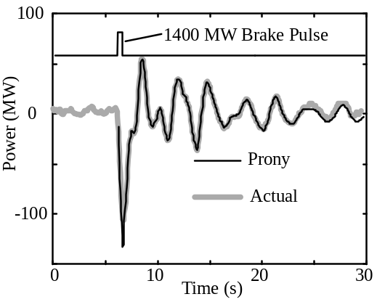
Figure 5- : Malin-Round Mountain.

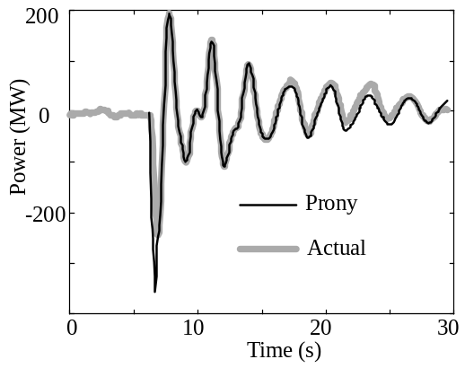
Figure 5- : BC Hydo Ingledow.

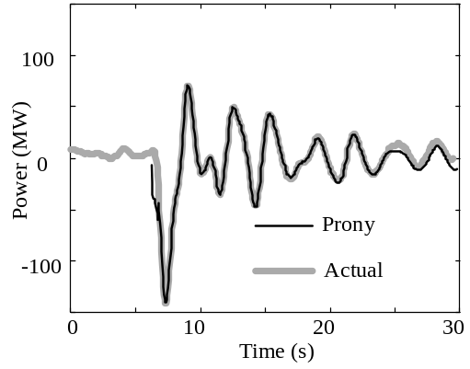
Figure 5- : PG&E Captain-Jack .

In this analysis
- the time zero reference = 6.2s
- the sample rate = 0.1s
- For each signal, the initial time is selected to occur just 2 samples after the brake is turned off (offset time = 0.7 s)
- the end time is 15 s past the initiation of the brake
Figures 5-4 through 5-7 show the results of a multi-output Prony analysis on the three signals. Figure 5- also shows the brake pulse. It can be seen that the full Prony model accurately represents the data over the whole record.
The two dominant modes identified in the analysis are 0.319 Hz, 4.24% damping, and 0.457 Hz, 4.39% damping. The BPA Malin and PG&E Captain Jack signals are dominated by both the 0.319 Hz and 0.457 Hz modes, and the BC Hydro Ingledow signal by the 0.319 Hz mode.

Prony fit with only Inter-Area Modes

Figures 5-7 to 5-9 show the Prony model with only the dominant modes retained. As can be seen, these two modes match the signals quite accurately.
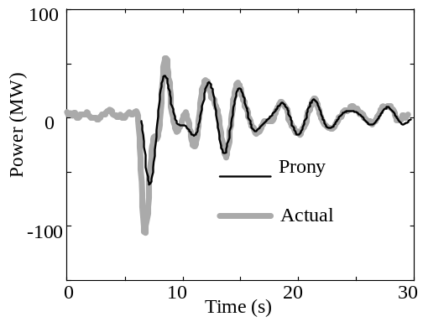
Figure 5- : Malin-Round Mountain.

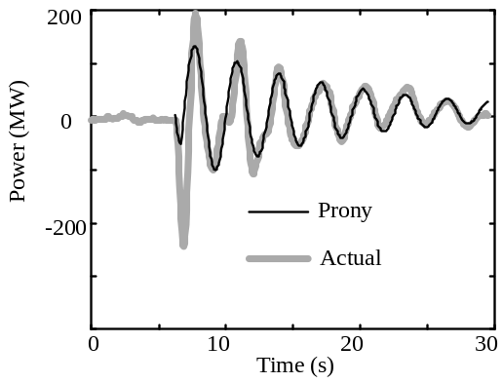
Figure 5- : BC Hydro Ingledow.
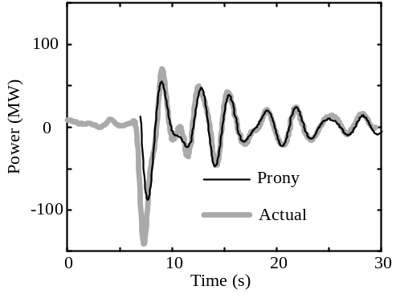

Figure 5- : PG&E Captain-Jack.

Excitation Limiting
The possibility of significant excitation limiting must be investigated by performing additional analyses with different initial times. In this example, two additional Prony fits are carried out.
- Fit 2 uses initial times of 1.0s for both the Malin signal and the BC Hydro Ingledow signal, and 1.7s for the PG&E Captain-Jack signal. This eliminates the first swing from the Prony analysis. The end time for each signal is unaltered at 15s.
- Fit 3 uses initial times of 3.0s for Malin and BC Hydro Ingledow signals, and 3.7s for the PG&E Captain-Jack signal. The end times are increased to 17s.
In all cases, the identified dominant modes are almost identical (see Table 5- ).

Table 5- : Dominant modes from three Prony fits.
Prony fit | 0.33 Hz mode  (Hz /%damping) | 0.45 Hz mode  (Hz/ %damping)
1 | 0.319 / 4.24 | 0.457 / 4.39
2 | 0.319 / 4.09 | 0.457 / 4.23
3 | 0.319 / 4.06 | 0.454 / 4.80

Figures 5-10 to 5-12 show the Prony fits for the three fitting conditions. The agreement is excellent and indicates that in this example possible nonlinearities introduced by exciter limiting are not significant.
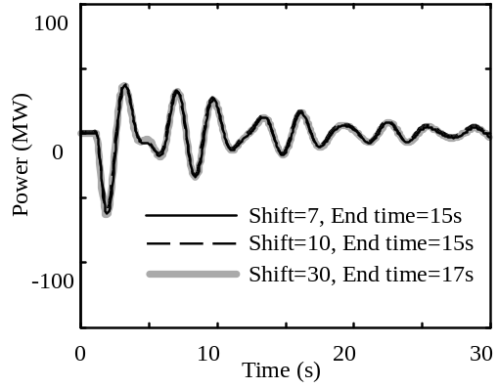
Figure 5- : Malin-Round-Mountain

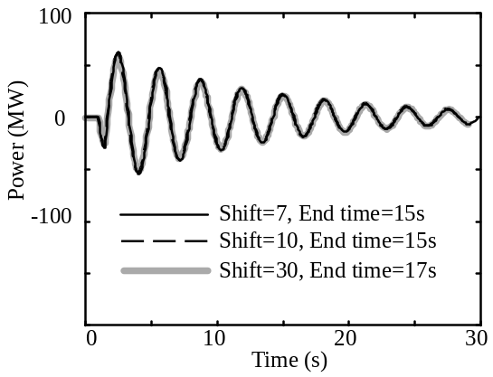
Figure 5- : BC Hydro Ingledow .

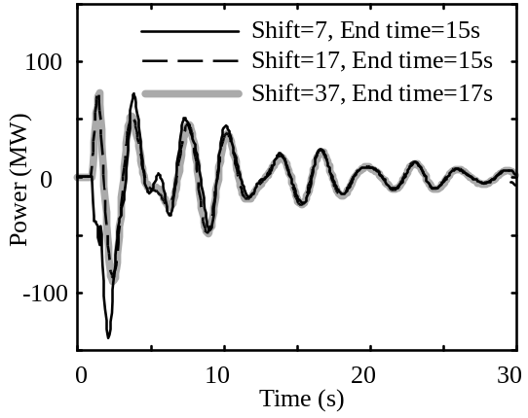
Figure 5- : : PG&E-Captain-Jack .

Summary
In fitting measured data, it is important to ensure that the data contains sufficient information to be able to achieve the analysis objectives. To do this
- Select signals that are dominated by oscillatory modes of interest.
- Pre-process the signals to eliminate trends and high frequency noise.
- Select the Prony Analysis parameters to ensure that
- The modal information is retained
- The analysis is conducted over an essentially linear portion of the record
- The signal to noise ratio is kept as high as possible
- Check for nonlinearities in the initial parts of the records by performing additional Prony fits with different initial and end times.

MATLAB is a registered trademark of The MathWorks, Inc., Natick, MA

