A User Guide to PSM Tools:

Utilities for Matlab Processing of Power System Response Records

Prepared for the
Transmission Reliability Program
Office of Power Technologies
Assistant Secretary for Energy Efficiency and Renewable Energy
U.S. Department of Energy

Principal Authors

John F. Hauer and Jeffrey M. Johnson, Pacific Northwest National Laboratory

February 2001

EXTRACTED MATERIALS RELATING TO FILTERING
Table of Contents
1. Background 4
2. Introduction 5
3. Application Environments for PSM Tools 7
4. Distribution of PSM Tools 8
5. Getting Started with PSM Tools – Examining the Installation 17
5.1 Naming Things in Matlab 18
5.2 Basic Types of Matlab files 18
5.3 Examining the Internal Documentation for a PSMT Data File 19
5.4 Navigating to .mat Files 21
5.5 Other File Types Associated With PSM Tools 22
6. Getting Started with PSM Tools – Tutorial Examples 23
6.1 Getting Started with PSM Tools – Matlab Examples 23
6.2 Getting Started with PSM Tools – Browser Examples 24
6.3 Getting Started with PSM Tools – Names for PDC Signals 25
6.4 Getting Started with PSM Tools – keyboard Commands 27
6.5 Getting Started with PSM Tools – Signal Plotting 28
6.6 Getting Started with PSM Tools – Signal Selection 34
6.7 Getting Started with PSM Tools – Experimental Plot Types 36
7. Case Documentation in PSM Tools 39
8. Detailed Operation of PSMbrowser 40
8.1 Detailed Operation of PSMbrowser – The Case Definition Menu 41
8.2 Detailed Operation of PSMbrowser – Signal Extraction Menus 42
8.3 Detailed Operation of PSMbrowser – Merging of Multi-Source Data 47
8.4 Detailed Operation of PSMbrowser – Report Generation 48
9. Signal Filtering 49
10. Fourier Analysis 57
10.1 Fourier Ringdown Analysis 59
10.2 Fourier Correlation Analysis 62
10.3 Fourier Analysis in Real Time 66
11. Linking to Add-On Toolsets 66
11.1 Launching the Prony Analysis GUI 66
11.2 Launching the Control System Toolbox 66
11.3 Launching the Signal Processing Toolbox 67
11.4 Launching the Wavelet Analysis Toolbox 67
11.5 Launching the System Identification Toolbox 67
12. Concluding Remarks 67

9. Signal Filtering
Actual system behavior is almost always viewed through some kind of filter. The very concept of rms (root mean square) measurements implies some sort of averaging process to estimate mean values. Transducers use filters for this purpose, and the filter bandwidths range from about 1 Hz to a bit more than 20 Hz. Microwave channels that transmit signals in analog form may also impose various degrees of filtering, and
As a result, signals that have different filtering histories may present different and seemingly inconsistent views of the same event. A notable example of this is shown in Fig. 1. This can be very misleading if the analyst does not recognize the situation. Mathematical removal of filter effects is tedious and usually not fully successful. It also requires characteristic data for the various filters in use. Obtaining such data is a routine matter, but the effort that it requires should be reserved for important signals that must be obtained from “legacy” measurement systems. Digital measurement systems tend to be far superior in this respect.

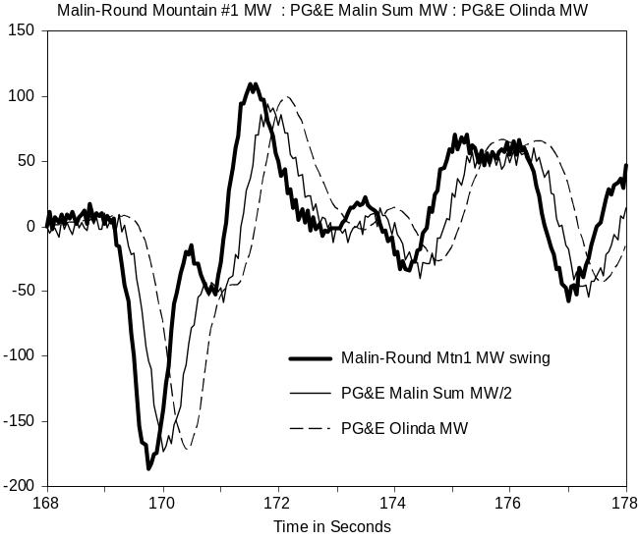
Fig. 1. Time response of Malin area transducers for insertion of
Chief Joseph dynamic brake on August 10, 1996
Additional filtering is often applied to signals after they are recorded. Reasons for this include the following:
• To remove excess measurement noise
• To enhance the visibility of the signal components within a particular frequency range
• To limit the signal spectrum prior to decimation (i.e., to avoid aliasing)
PSMbrowser presents many prompts with respect to decimation. It is important to know that decimation by a factor of n is done by discarding all but every nth data sample, and that it requires at least two samples per cycle to represent a sine wave. So, for a sample rate of N samples per second (sps), the highest frequency that can be properly represented is the Nyquist frequency N/2. Signal components at frequencies above the Nyquist frequency, if they are present, will be “aliased” so that they appear to lie at lower frequencies. Anti-aliasing filters, with bandwidths on the order of N/5 Hz, should be used when this possibility exists.
The more important PSMbrowser options for signal filtering are shown in Table 1. Invoking option 3 from the PSMbrowser processing menu of Error: Reference source not found will backload the filtered data into the working array PSMsigsX, and all further processing will be applied to the filtered signals rather than the signals originally extracted from the source data files.
The following remarks apply to the proper use of the options shown in Table 1:
• Decimation by a factor of n is done by discarding all but every nth data sample.
• Abbreviations LP, BP, and HP are used to designate lowpass, bandpass, and highpass filters.
• Decimation of raw data (prior to filtering) is safely done only when the signal spectra have no significant energy above the resulting Nyquist frequency (calculated as half the sample rate expressed in samples per second). This is often the case for swing export (SWX) data produced by transient stability simulations, and it is sometimes the case for PDC data. Decimation of such oversampled data may be needed just to produce numerically stable filters.
• General decimation should be preceded by filtering, to assure that the resulting signal spectra have no significant energy above the resulting Nyquist frequency.
• Signal offsets (the initial value of each signal) are usually removed to minimize filter transients. Restoring these offsets is rarely appropriate after BP filtering, since this kind of filtering is generally intended to remove offsets plus slow activity in the signal.
• Filter delays may be apparent in signals that have been subjected to general filtering. The smoothing filter has been designed to avoid this, however.

Table 1. PSMT options for signal filtering
In PSDScase_Ex1: Filter extracted signals? Enter y or n [ ]: y
In PSDScase_Ex1: Close all plots? Enter y or n [y]:
In PSMfilt: Generate new case tags? Enter y or n [n]:
Decimate raw data? Enter y or n [ ]: y
In PSMfilt: Local decimation factor = 1
Is this decimation factor ok? Enter y or n [y]:
In PSMfilt: Remove signal offsets? Enter y or n [y]:
In PSMfilt: Select signal filtering type
Select desired option from list below:
% 0 No Smoothing or Filtering
% 1 Smoothing with Moving-Average (MA) filter
% 2 General filtering
Enter 0 to 2 [0]: 2
In PSMButr4: Constructing Butterworth filter:
Select desired option from list below:
% 1 LP
% 2 BP
% 3 HP
Enter 1 to 3 [1]: 2
Filter Settings:
HPcorner= 0.10 Hz (0.0095 Nyquist)
LPcorner= 1.00 Hz (0.0948 Nyquist)
FilOrd = 4
In PSMButr4: Is this ok? Enter y or n [y]:
In PSMButr4: Plot filter characteristics? Enter y or n [n]:
In PSMButr4: Filter all signals? Enter y or n [y]:
In PSMfilt: Show sample of filter effects? Enter y or n [n]:
Processing paused - press any key to continue
In PSMfilt: Restore signal offsets? Enter y or n [y]:
Decimate filtered data? Enter y or n [n]:
In PSMfilt: Invoking utility to save filtered signals
In PSMsave: Save results data to a file? Enter y or n [ ]:
In PSDScase_Ex1: Batch plots of filtered signals? Enter y or n [ ]:

A representative variety of filtering examples are provided in Fig. 2 through Fig. 11. The smoothing filter of Fig. 2 each point in the filtered signal as the weighted sum of nearby time points in the original signal. The weighting function is formed by multiplying the function sinc(x)=sin(x)/x by the “Hanning function” 1+cos(y). Scale factors and axis shifts are used to produce the characteristics shown in the figure.
Gain response for the “Hanned sinc”smoothing window and the underlying sinc function are shown in Fig. 3. As a reminder, gain in dB is calculated as db(z)=20log10(z) for z a real number greater than zero. Thus dB gains of -20 dB and -40 dB correspond to scalar gains of 10% and 1% respectively. It may be noted that the Hanned sinc filter is comparatively ripple-free from 0 to 1 Hz, and that its sidelobe gains above 1 Hz are much lower than those of the sinc function without Hanning. Cutoff of these filtering functions is much less sharp that that of more general filters, however.

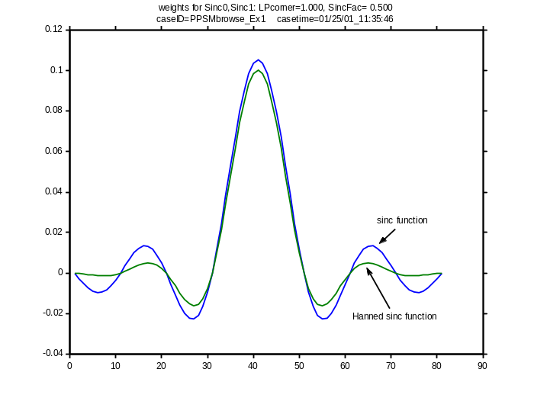
Fig. 2. Weighting functions for sinc and Hanned sinc smoothing filters
(LPcorner=1.0 Hz, SincFac= 0.5)
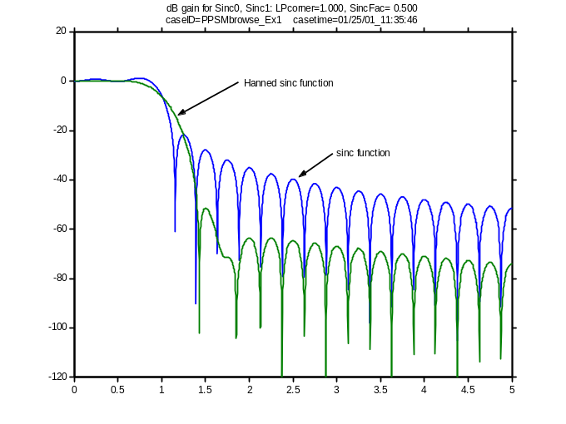
Fig. 3. Gain response for sinc and Hanned sinc smoothing filters
(LPcorner=1.0 Hz, SincFac= 0.5)
Fig. 4 shows results for application of this Hanned sinc filter to a noisy signal that contains an abrupt transient step. The noise has been smoothed out rather well, but the filter is much too sluggish to track the step. This is partly due to the low bandwidth of the filter, and partly due to the nature of the filter function (it was not designed for transient performance). As shown in Fig. 5 and Fig. 6, transient filter effects for a more general filter of the same bandwidth can be less severe. This filter is still sluggish, however, and there is a great deal of filtering delay. Use of a “faster” filter, with six times the bandwidth, produces the more acceptable transient response of Fig. 7 – but with less noise removal.
It is not unusual to apply several different filters to achieve a variety of results for different segments of the overall signal record. Fig. 8 shows a signal from Error: Reference source not found that has been BP filtered to strongly reduce signal components outside the range of 0.1 Hz to 1.0 Hz. Signal components associated with interarea oscillations have become much more visible, and use of the absolute value function provides a convenient view of their overall level of activity (shown in Fig. 9). As shown in Fig. 10 and Fig. 11, bandpass filtering is also useful for visual examination of possible correlations among several different signals.
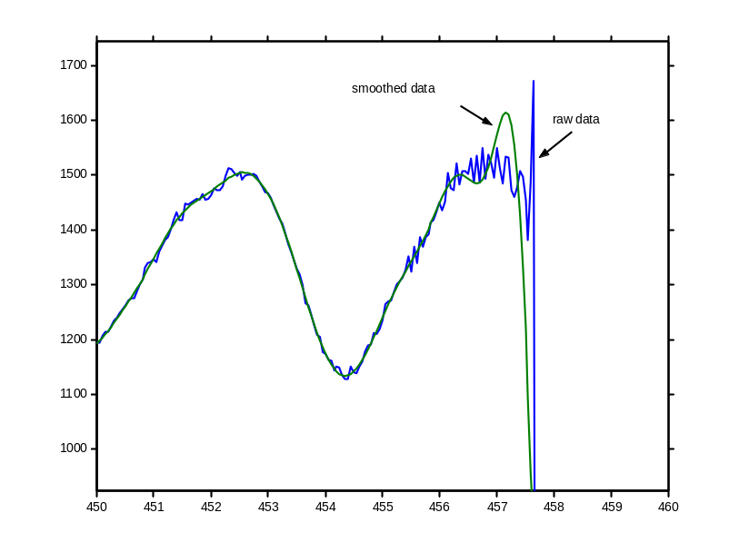
Fig. 4. Transient effects for Hanned sinc smoothing filter
(LPcorner=1.0 Hz, SincFac= 0.5)

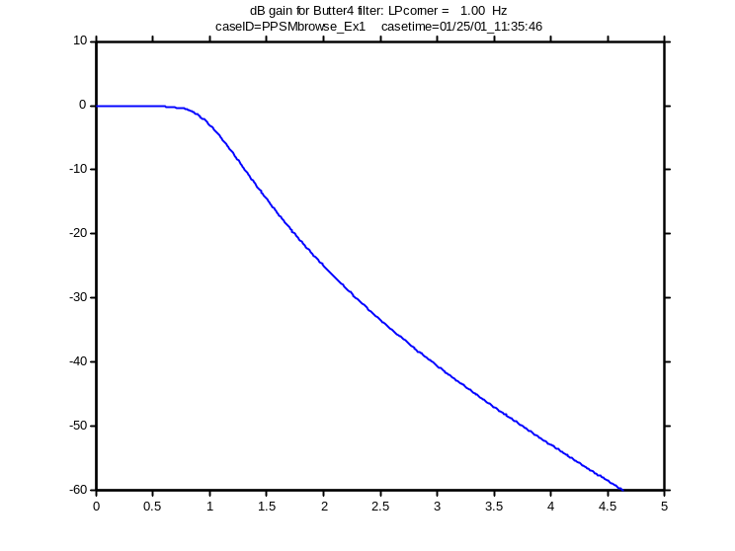
Fig. 5. Gain response of lowpass Butterworth filter
(LPcorner=1.0 Hz, FilOrd=4)
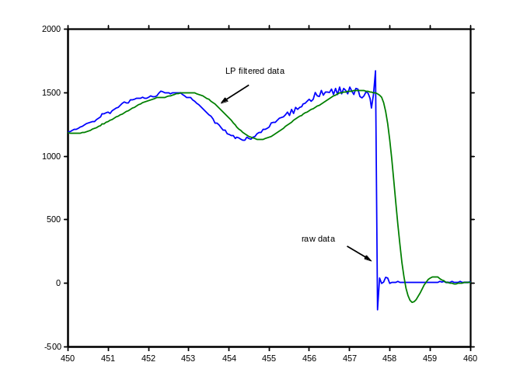
Fig. 6. Transient effects for lowpass Butterworth filter
(LPcorner=1.0 Hz, FilOrd=4)
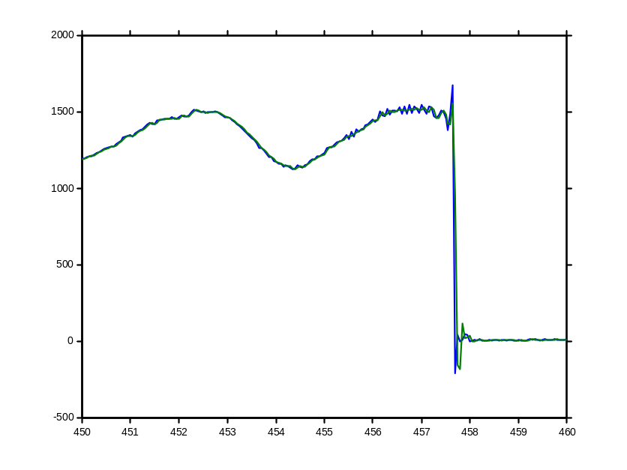
Fig. 7. Transient effects for lowpass Butterworth filter
(LPcorner=6.0 Hz, FilOrd=2)
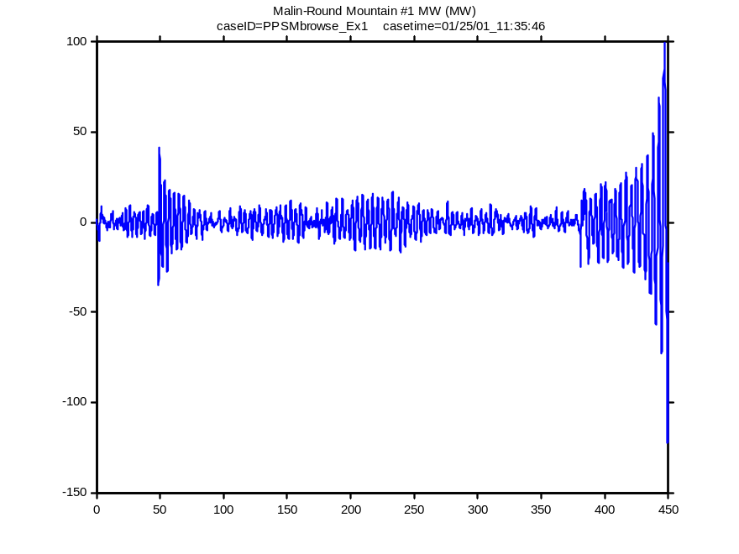
Fig. 8. BP filtered view of signal for WSCC breakup of August 10, 1996
(BP corners=[0.1 1.0] Hz, FilOrd=4)

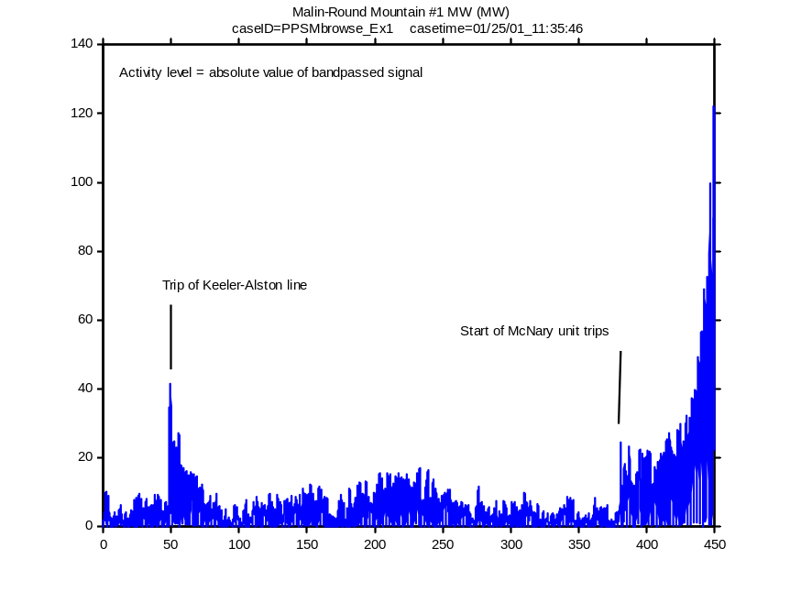
Fig. 9. Activity signal for WSCC breakup of August 10, 1996
(BP corners=[0.1 1.0] Hz, FilOrd=4)
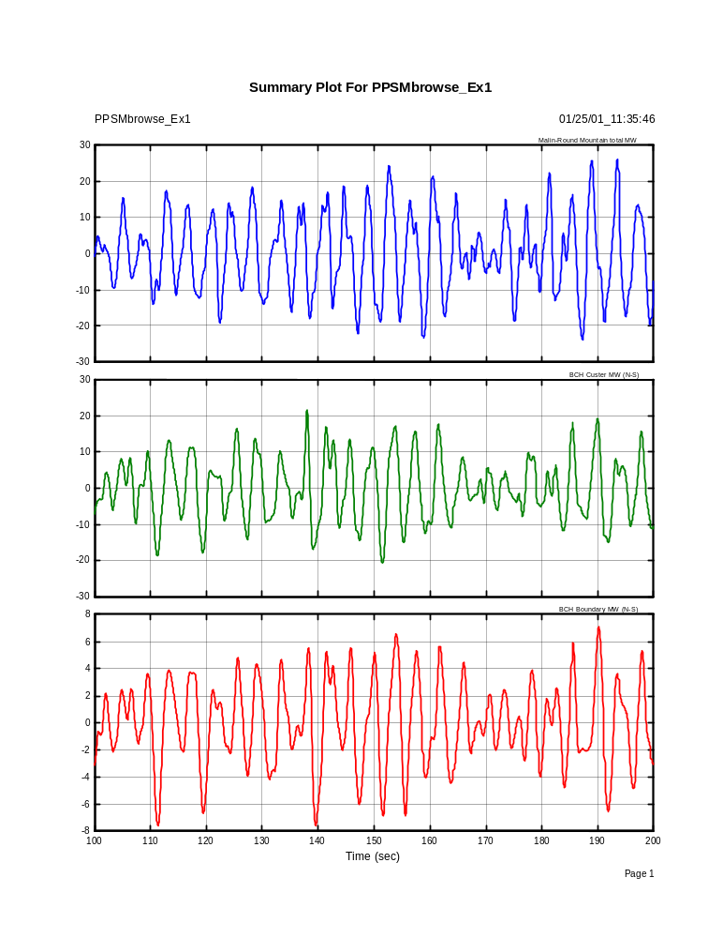
Fig. 10. Bandpassed view of Canada-California interactions for August 10, 1996
(BP corners=[0.1 1.0] Hz, FilOrd=4)
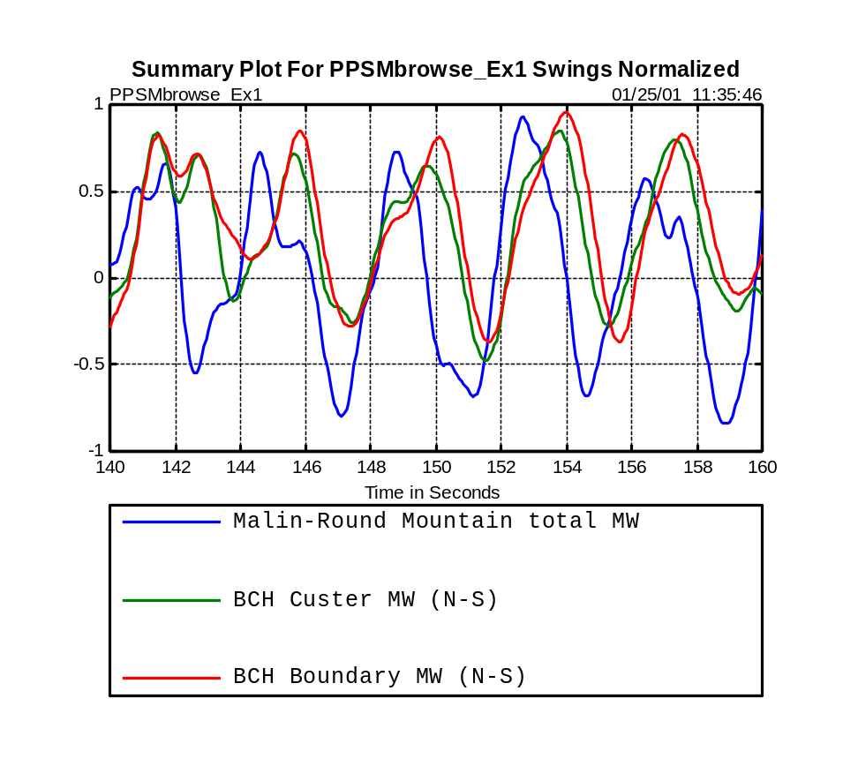
Fig. 11. Bandpassed view of Canada-California interactions for August 10, 1996
(BP corners=[0.1 1.0] Hz, FilOrd=4)

