Installation of the BPA/PNNL Dynamic Systems Identification (DSI) Toolbox

September 30, 2002

J. F. Hauer

Pacific Northwest National Laboratory

Richland, WA 99352
1. Overview 1
2. Introduction 3
3. A Nominal Installation Process 4
4. Testing the Installation 5
5. Customizing PSM Tools 5
5.1 Customizing the Starting Directory 5
5.2 Customizing the Signal Extraction Menus 6
5.3 Customizing PSM Configuration Files 6
5.4 Custom Versions of the PSMbrowser 7

Overview
Software for the Dynamic System Identification (DSI) Toolbox resides in two primary folders, one for the Ringdown GUI and one for PSM Tools. Previous installation guides assumed that these two folders would be distributed separately, and recommended that they be installed at two widely separated regions of the computer directory. The present installation guide recommends that the two primary folders be stored together in a folder containing the entire DSI Toolbox. The file structure of Fig. 1 is typical.
Installation consists of two steps:
a) Drag and drop the DSI Toolbox folder, from the medium where it was received, to an appropriate location on the user’s PC.
b) Set Matlab paths to the contents of the DSI Toolbox folder, so that Matlab can find those contents while processing. The Set Path command in Matlab 6.0 does this in one step, but users of Matlab 5.3 should launch a utility called PSMpaths1.
Partial updates to the DSI Toolbox usually involve just the first step and just one of the primary folders. This requires that the new primary folder have the same name and internal directory structure as the one to be updated (see Fig. 2). Then “dropping” the new version of the primary folder onto the older one will cause new file versions to replace earlier ones, and the original paths remain correct. There may also be some entirely new files, and perhaps some “stranded” older files that are no longer used. Full updates involve total replacement of all files, and will eliminate any stranded files.
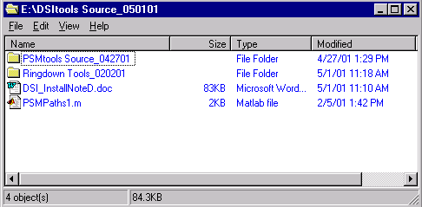
Fig. 1. A typical file structure for the DSI Toolbox
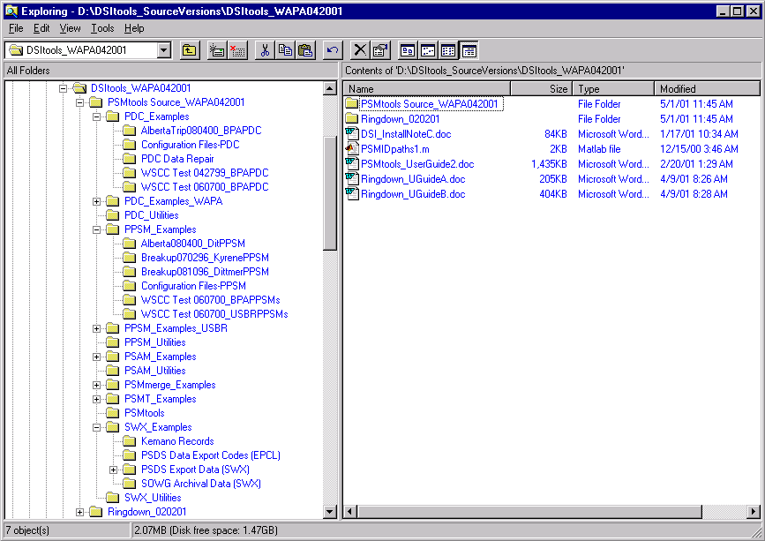
Fig. 2. File structure for PSM Tools

Introduction
Software and documentation for the DSI Toolbox are usually provided as a large SendOut folder with a name that indicates the
– content & means of distribution
– intended recipients
– date of distribution
The SendOut folder is typically provided on a zip cartridge, on a compact disk, or as a file object to be downloaded from a web site. In some cases there may be accompanying SendOut folders to accommodate large document sets or large numerical records for use in processing examples. Typical names for a DSI Toolbox SendOut folder are DSItools_FTP042001.zip, PSMtools_BPA40901.zip, and Ringdown_050101.
A DSI Toolbox SendOut folder will contain some or all of the following general things:
• Software and examples for PSM Tools
• Software and examples for the Ringdown GUI
• Software and examples for specialized tools such as SYSFIT
• User documentation for the DSI Toolbox and its various elements
• Technical reports and other engineering documents that illustrate use of the DSI Toolbox
These contents are grouped into a number of inner folders. Two of these folders contain primary software, and they require special treatment: Typical names for these primary software folders are the following:
• PSMtools Source_020601, containing software and examples for PSM Tools.
• Ringdown Tools_020201, containing software and examples for the Ringdown GUI
The primary software folders require special treatment that the other top-level folders and documents do not:
• These folders and their contents must be placed on the Matlab path so that they can be located during program execution.
• Some contents of these folders cannot be renamed without changing some of the Matlab code to match the new names.
The names of the primary folders themselves are not critical, and some users may prefer to change them. This should be done before setting the Matlab paths, however, and the new names should not coincide with names already in use. The name PSMtools is reserved for an existing subfolder within the primary folder for PSM Tools.

A Nominal Installation Process
For purposes of example, assume that the sendout folder is DSItools_FTP050201.zip and that it is posted on the web at BPA’s outgoing ftp site ftp://ftp.bpa.gov/outgoing/WAMS%20Information/DSI_Tools/. The following steps are suggested for downloading the DSI Toolbox:
1. Examine the website for information documents that describe the software, the most recent updates to the software, or the installation procedure. Typical document names are PSMtools_UserGuide2.doc, DSI_Update050101, and DSI_InstallNoteD. Download and examine those documents that seem relevant.
2. Download DSItools_FTP050201.zip and place it in a convenient disc location for long-term storage.
3. Unzip DSItools_FTP050201.zip and move the DSI Tools folder to a convenient location. Verify that this folder has the structure indicated in Fig. 1 and Fig. 2. Do not expect the names of the primary folders to match those of the figures, or that of the zipped sendout file DSItools_FTP050201.zip.
4. The DSI Tools folder will usually be contained within a series of accessory nested folders that were produced during file compression and decompression. Once the DSI Tools folder has been moved these accessory files will be empty, and should be deleted.
The following is suggested as a convenient procedure for new Matlab users to install the DSI Toolbox, while learning a bit of Matlab semantics in the process.
A. Launch Matlab if it is not already open. Then, under the File menu for the Matlab Command Window (MCW), select Set Path.
B. For Matlab 6.0, press the Add with Subfolders button, navigate to the DSI Toolbox folder, and highlight the folder name. Then press Save, and Close.
C. For Matlab 5.3, highlight some path and folder associated with toolbox, then click the button for Browse and navigate to navigate to the DSI Toolbox folder. Within the Browse window, highlight the DSI Toolbox folder name and press ok. The folder name and the path to the folder will now appear in the Current Directory box of the Set Path window. Now click in the Current Directory box, open the Path menu and select Add to Path. A file with a name like PSMpaths1.m should appear in the window that displays files contained at the top level of the DSI Toolbox folder.
The DSI Toolbox folder should now be the current directory for MCW processing. To verify this, enter cd into the MCW and observe the response.
At the highest level of the DSI Toolbox folder there is a utility file with a name like PSMpaths1.m. This utility provides the Add with Subfolders functionality of Matlab 6.0. If it is missing at this location then copy it from the backup provided at the highest level of the PSM Tools folder. Determine the exact spelling of this file name, then enter the command
PSMpaths1
into the MCW. (Adjust the file name if needed.) This will automatically place the DSI Toolbox folder and all of its subfolders on the Matlab path. Then, within the Set Path window, open the File menu and select Save Path.

Testing the Installation
The full DSI Toolbox should now be ready to use. To verify this, enter the commands
help ringdown
help CaseTags
into the MCW. If Matlab cannot find these DSI Toolbox functions then some elements of the path are not yet correct, and some of the earlier installation steps should be repeated.
Further verification of the installation can be obtained by executing one or more test cases. Two of the simpler ones are Matlab_Ex1.m and Matlab_Ex2.m (in folder PSMT_Examples). These are intended as small Matlab tutorials, and the user may wish to read their Matlab code as it is executed. To do this,
a) Open MatlabEx1.m with the Matlab editor. This can be done by entering the command edit Matlab_Ex1 into the MCW. Alternatively, one can locate the icon for Matlab_Ex1.m in the normal manner, and then double-click on the icon to launch the Matlab editor. It is useful to print a hardcopy of the code to read during Matlab execution.
b) Launch Matlab_Ex1.m by entering the command Matlab_Ex1 into the MCW. The prompts issued to the user are typical of those used by PSM Tools.
A more complete test is obtained by launching the general-purpose case script – presently called PSMbrowser – that is the primary driver for PSM Tools. New users can respond with a simple carriage return (the enter key) down through the prompts below:
In PSMbrowser: Extract signals from PSM source files? Enter y or n [ ]:
In PSMbrowser: Retrieve previously extracted PSM signals? Enter y or n [y]:
The user should then navigate to a file such as AlbertaTrip080400Ex1.mat (within folder PDC_Examples), and “ok” the loading of it. PSMbrowser will then present a series of processing options for the user to explore.

Customizing PSM Tools
The next steps in the installation process involve customizing PSM Tools to a particular work environment. This involves modest code changes within PSMbrowser, and within one or more menu utilities with names like PDCmenu and PPSMmenu. The general approach to this is described below.

Customizing the Starting Directory
Open the file PSMbrowser.m with the Matlab editor, and look for lines of code like those below:
%Define starting directory for data extraction
CDpath=''
%CDpath='e:\Monitor Analysis (WSCC)\'

All characters to the right of a % sign are treated as a comment, and '' indicates an empty character string. If string CDpath is left empty, the present the code uses a cd command to initialize the directory for Matlab processing one or two folders up from a standard PSM Tools file named PSMsave. If you don't want this, convert the line
%CDpath='e:\Monitor Analysis (WSCC)\'
into a command that indicates a preferable directory location (e.g., closer to your working data). When you are done, update the comment line
% Last modified DATE PERSON
and make a backup file with a name like PSMbrowser.bk.m

Customizing the Signal Extraction Menus
Files PDCmenu.m and PPSMmenu.m contain simple but lengthy code that uses the name of the configuration file (CFname) to recognize particular recording units and then generates a set of special menus for each unit. It is a straightforward matter to modify the present menus, or to add new ones.
Pending enhancements to PSM Tools will provide menu extensions that define additional signals as weighted sums of those signals already extracted. Typical examples of this are
a) Total multi-path flow on an interconnection or into a facility
b) Difference between two signals
c) Projection of a measured voltage phasor to the far end of a line for which the impedance is known
The present version of PSM Tools does not recognize the menu utilities if their file names are changed. This restriction may be relaxed in later versions, however.

Customizing PSM Configuration Files
Monitors such as the PDC and the PPSM ordinarily acquire and store raw data as 16 bit integer records. The data are scaled to make effective use of the dynamic range that such integers allow--i.e., they are in some sense “normalized.” Scale factors for converting the normalized data into engineering units are provided accompanying configuration file (CF). The CF will usually contain further information, such as initial names for the acquired signals and the conditions under which the particular record was acquired. The CF for PDC data will also indicate how the voltage and current phasors there are related. This information is essential for the calculation of derived quantities such as real and reactive line power.
Situations where it is desirable to edit the original CF are not unusual. Typical reasons for this include the insertion of additional header information, removal of extraneous tabs or errors from the signal names, or modification of the signal names to assure that each is unique to just one signal in the overall database. The resulting non-standard CF should be assigned a unique name, and (if possible) the nature and date of the modification should be indicated within the header comments. Thus a CF received as BPA1_122099.ini might become BPA1X_122099.ini.
Configuration files for PDC data require more extensive revisions. The present standard for such files is not fully mature, and there are three slightly different kinds in use. PDC data collected with SCE technology uses a CF containing many statements that the corresponding BPA technology ignores, but that PSM Tools does not expect. Both BPA and SCE use a special indexing convention for signals transmitted which are received from a remote PDC instead of a PMU. By contrast, the indexing convention for PSM Tools just treats a remote PDC as though it were another PMU.
Future versions of PSM Tools will process such CF files directly, but not until a more complete standard is in place. The present remedy is to first remove superfluous statements, and then to revise the information for PDC signals. Examples of this are provided in folder PDC_Examples, and are discussed in the PSM Tools User Guide.

Custom Versions of the PSMbrowser
The case script PSMbrowser is designed to support a wide variety of tasks, in an arbitrary order, with data from many different sources. This flexibility requires that the user must respond to many different prompts, or else accept a set of processing defaults that are directly coded into PSM Tools. The most important of these defaults are defined within PSMbrowser itself, so that the knowledgeable user can customize them to particular circumstances.
Custom versions of PSMbrowser are usually developed to streamline the processing control for specific kinds of cases, or to facilitate later re-execution of cases that process specific PSM records in special ways. It is important that any custom version of PSMbrowser be given a new name! The internal name (CSname) is defined within the lines shown below:
%User should change local script name if custom features are added
CSname='PSMbrowser'; %Internal name of this case script
disp(['In Case Script ' CSname])
This internal name need not match the external name assigned to the file.
In addition, it is recommended that the user modify the new case script in the following ways:
a) Revise or augment the first several comment lines (they start with a % sign) to describe the nature of the revised case script.
b) Update the modification date, in a comment line of form
% Last modified DATE PERSON
c) Revise the case header comments, for which the original form is typically as shown below:
%*************************************************************************
%Define case header (unique to this case script)
%User should modify case header if custom features are added to case script
CaseHead=''; %Clear case header
%Build case header
str1=['In PSM Utility ' CSname ': '];
strs=[str1 'General browsing of PSM data files'];
strs=str2mat(strs,' ');
CaseHead=strs;
disp(CaseHead)
%*************************************************************************

More detailed information on these matters is provided in the PSM Tools User Guide.

