ICS MASTER
Best-practice PIM architecture
Product Information Management in Microsoft Dynamics 365 Business Central
Akeneo-style enrichment · Same Item No. across companies · Shopify-style preview

Application | ICS Master (publisher ZVG)
Platform | Dynamics 365 Business Central 27 · AL runtime 16
Object ranges | 50350–50399 and 50600–50700
Companies | Master + DE, AT, ES, CH, NP, CZ
Document type | Solution architecture

1. Executive summary
This architecture puts Product Information Management (PIM) inside Business Central. It follows the Akeneo pattern (families, attributes, options, categories, completeness) without replacing the ERP Item. Sales and purchase in every country keep the same Item No. PIM stores commercial truth; the Item Card keeps posting, inventory, and documents.
A master product company enriches items. PIM Company Sync copies product-master data into child companies in the same environment using ChangeCompany. An internal Shopify-style control add-in previews published products. This is not a public website and not a live Shopify connector.
Principle | Decision
Identity | Item No. is the same in master and in every country company.
Separation of concerns | PIM is additive. Inventory, unit cost, and documents stay on standard Item.
Master → child | Commercial / product-master data flows one way in this version.
Storefront | Catalog shows only items with Published to Webshop.
PTE coexistence | PIM does not use or overwrite PTE Marketplace Code / Master SKU.
Tenancy | Sync works only when countries are companies in the same BC environment.

2. Context diagram
People enrich in the master company. Child companies receive the same Item No. with commercial data. Country users continue to sell and buy on that number.
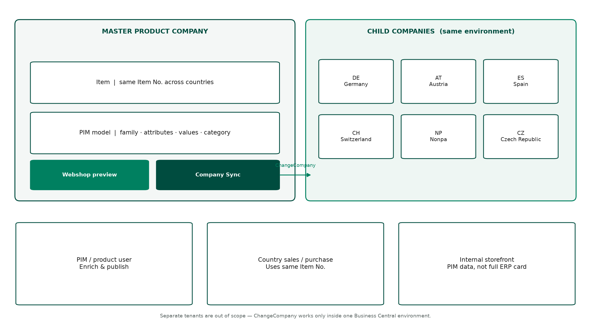
Figure 1 — Master product company, six child companies, and user roles

3. Architecture layers
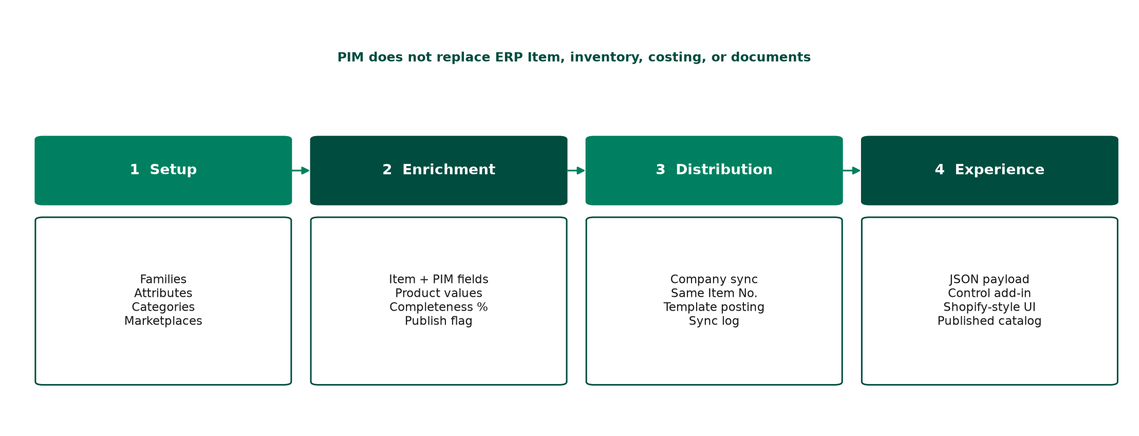
Figure 2 — Setup, enrichment, distribution, experience
Layer | Responsibility | Main objects
1. Setup | Reference data: families, attributes, groups, options, categories, marketplaces. | Tables 50600–50605, 50636; pages 50610–50617, 50640; install 50634
2. Enrichment | Per-item family, values, completeness, publish flag, marketplace ticks. | Item ext 50607; table 50606; pages 50618–50619; codeunit 50632; pageext 50353–50354
3. Distribution | Copy product master into child companies; log success and errors. | Codeunit 50639; tables 50637–50638; pages 50641–50642
4. Experience | JSON storefront for published items (internal preview). | Pages 50351–50352; codeunit 50633; control add-in ProductVisualViewer

4. Data model
The model is Akeneo-shaped and sits next to Item. Only three fields are added on Item: PIM Family Code, PIM Category Code, and PIM Published. All attribute values live in PIM Product Value.
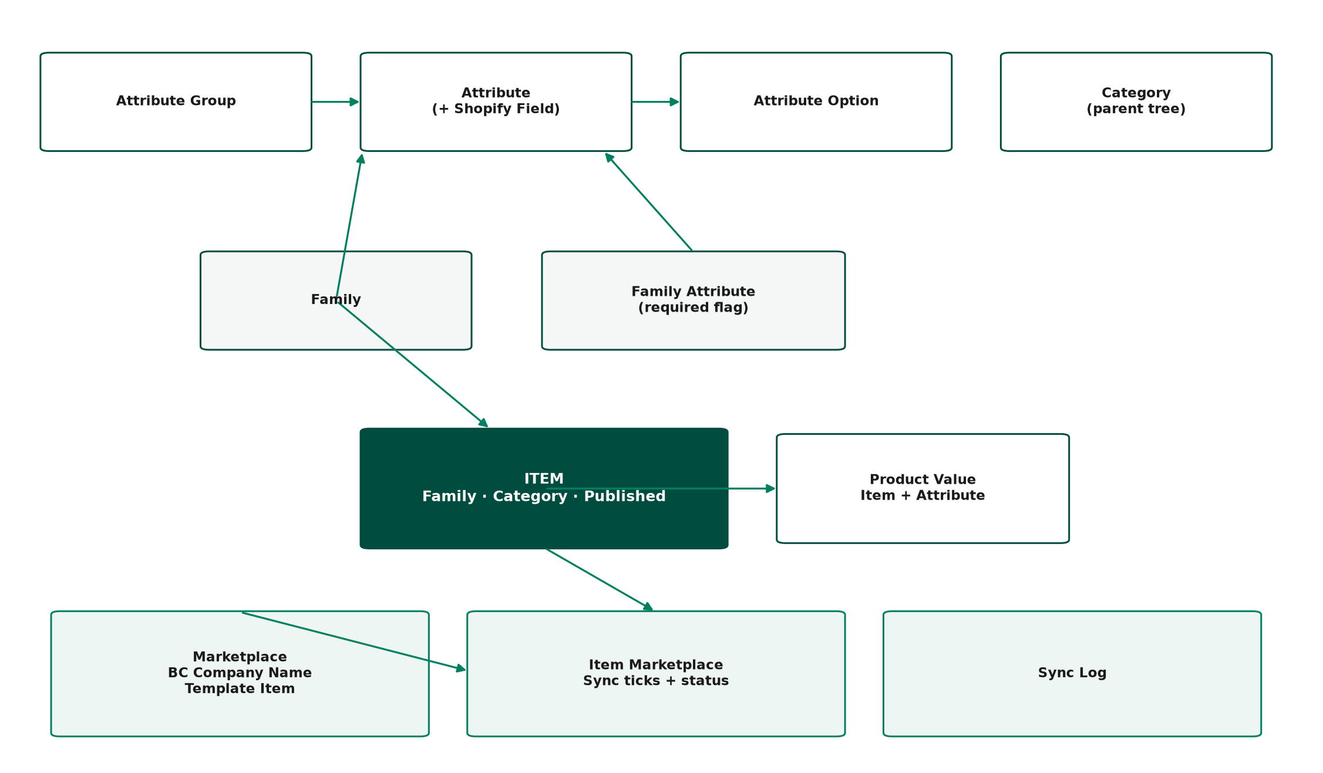
Figure 3 — PIM entities and their relationship to Item

4.1 Akeneo mapping
Akeneo concept | Business Central object | Notes
Family | PIM Family + PIM Family Attribute | Required flags drive completeness %
Attribute group | PIM Attribute Group | IDENT, MARKETING, SPECS, SEO in the default seed
Attribute | PIM Attribute | Text, Number, Yes/No, Option, Date
Attribute options | PIM Attribute Option | For example Color: Black, White, Grey, Blue, Red
Category tree | PIM Category | Parent Code for hierarchy
Product values | PIM Product Value | Keyed by Item No. + Attribute Code
Completeness | PIM Enrichment codeunit | Filled required attributes / required × 100
Channel | PIM Marketplace | Mapped to a BC Company Name, not a Shopify channel yet
Export mapping | Shopify Field on attribute | title, vendor, body_html, metafields.* — preview map only

4.2 Marketplace
Each marketplace (DE, AT, ES, CH, NP, CZ) stores the exact Business Central company name, Enabled, optional Template Item No. in the target company (posting groups on insert only), and flags to copy unit price or posting groups from master. PIM Item Marketplace is the per-item tick list: which countries receive this product.

5. Enrichment process
1. Tell Me → PIM Families → Create default PIM setup (or rely on app install seed).
2. Tell Me → PIM Marketplaces → set Company Name (copy from Companies), Enabled, Template Item No. in the child, then Sync PIM setup to this company.
3. Open an Item. Set family DEFAULT (or another family), category, and Published to Webshop.
4. PIM Enrichment → Load family attributes → fill values. Completeness % uses required family attributes.
5. Tick Sync to companies, then run Sync to companies. Check PIM Sync Log.
Validating the family on the Item creates empty PIM Product Value rows so the enrichment page is ready immediately.

6. Company sync
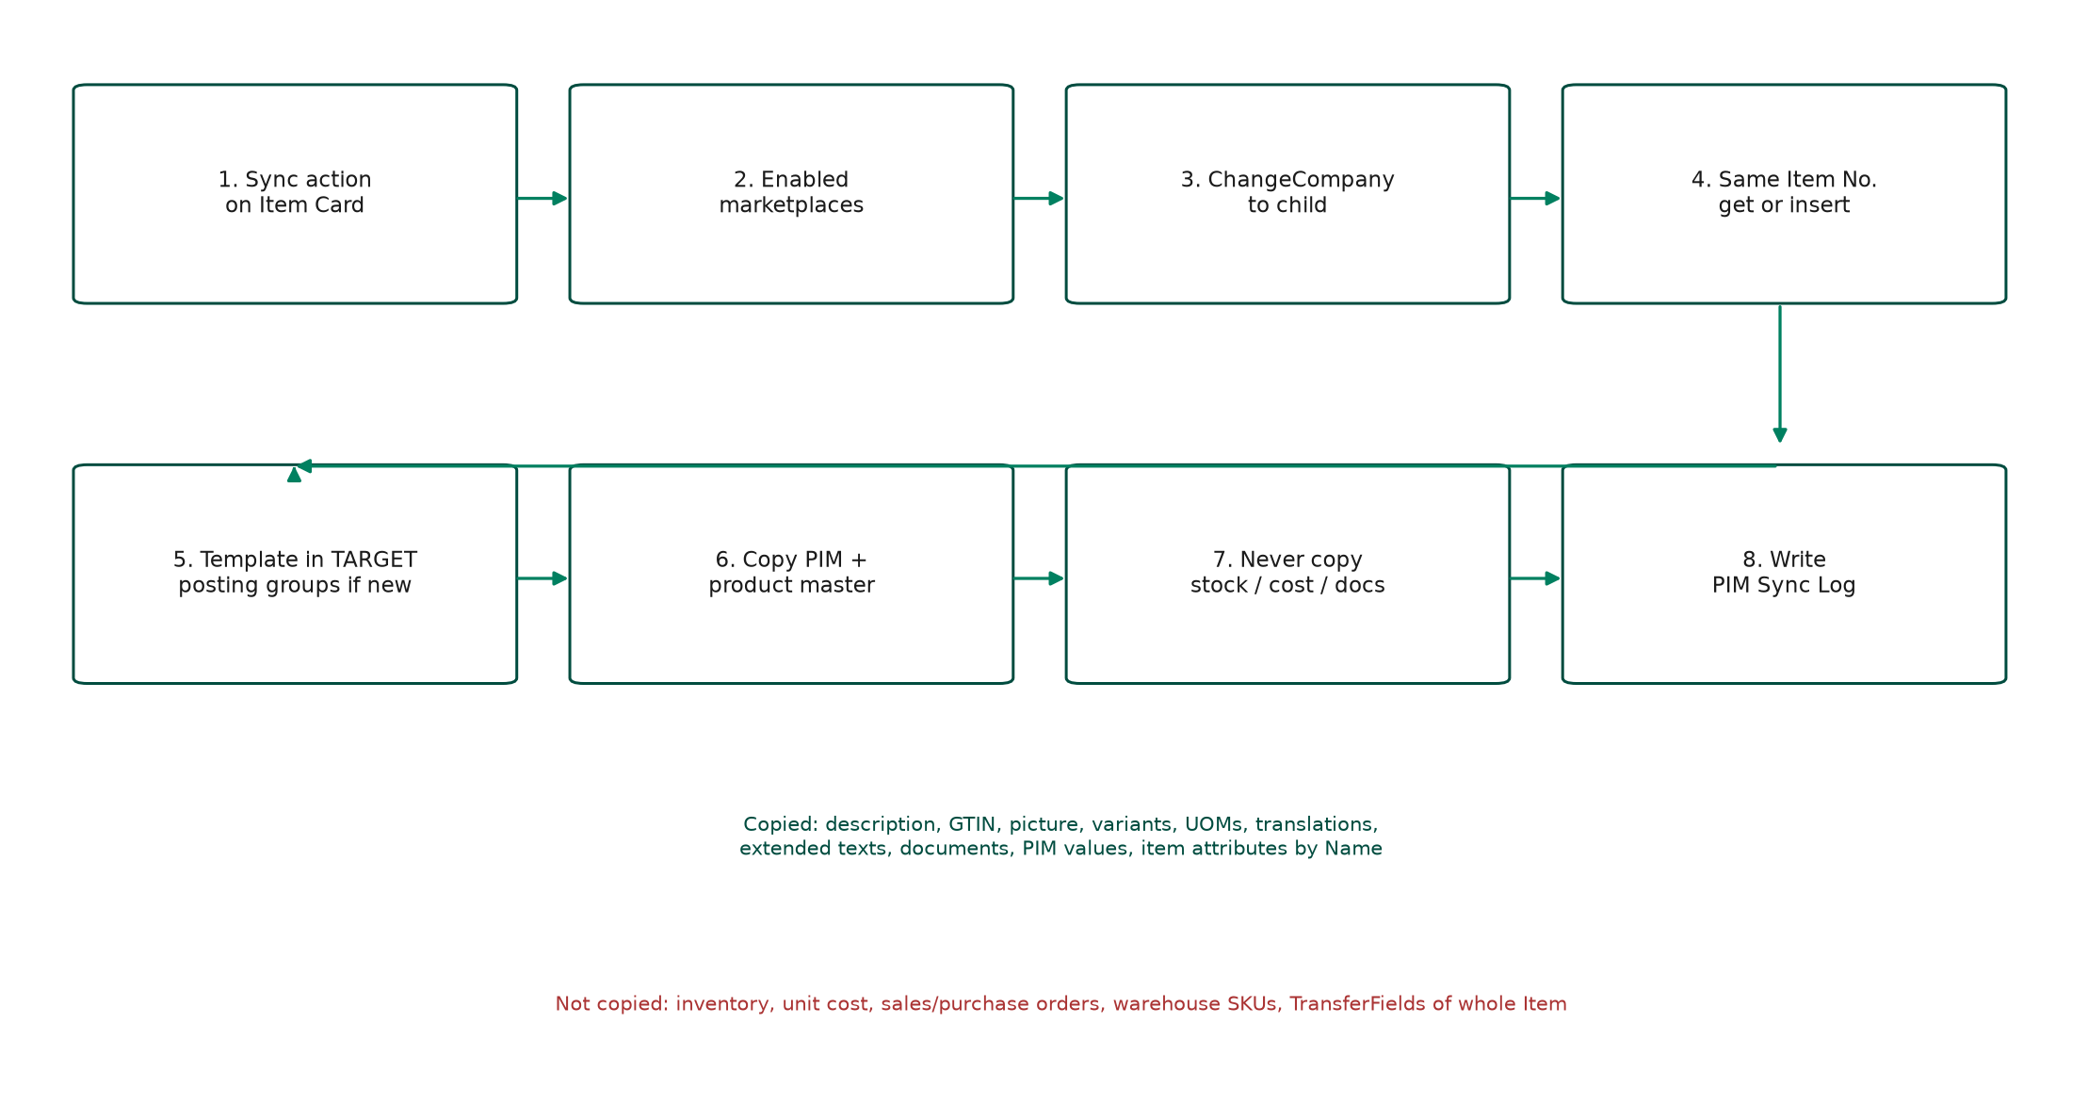
Figure 4 — Master to child sync. Same Item No. Template item is never used as the number.

6.1 What is copied
Copied (product master) | Not copied (ERP operations)
Description, search description, GTIN, tariff, origin, weights | Inventory / stock
Sales and purchase units of measure, item UOMs, master UOM | Unit cost
Item category, PIM family / category / published, PIM values | Sales and purchase documents
Picture (MediaSet), variants, translations | Warehouse SKUs
Extended text headers and lines | Full TransferFields of Item
Item references, document attachments (media and URL/URI) | PTE Marketplace Code / Master SKU
Standard Item Attributes matched by Name (IDs stay local)
Optional: unit price; optional: posting groups from master

On insert, posting groups can come from a template item that already exists in the target company. Standard Item Attribute IDs must not be copied; each company generates its own IDs and matching is by Name.

6.2 Tenancy limit
ChangeCompany only works inside one Business Central environment. If Germany (or any country) is a separate tenant or SaaS organisation, this sync cannot reach it. That requires APIs (not in this package).

7. Webshop preview
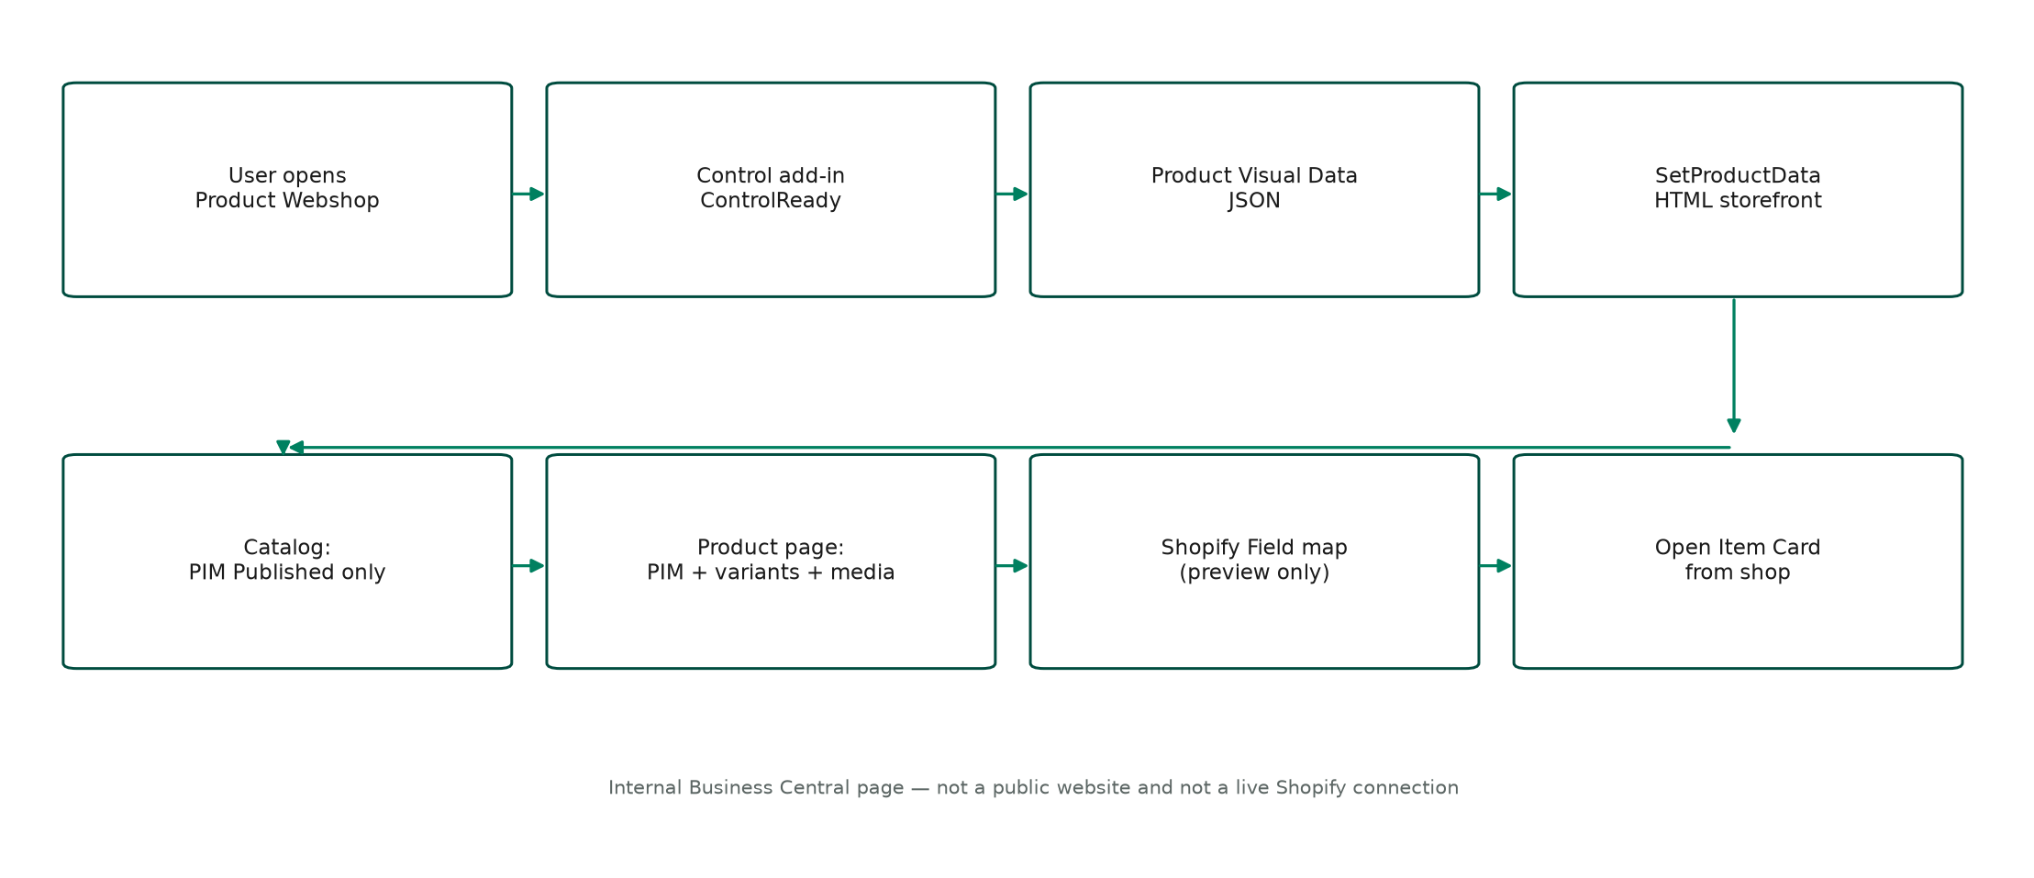
Figure 5 — Control add-in flow. Catalog is filtered to PIM Published and capped at 48 items.
Product JSON includes PIM attributes, standard item attributes, Shopify field map, variants, UOMs, translations, extended texts, documents, and pictures. Control add-in scripts and CSS paths are relative to app.json. If the Webshop folder is under src, use src/Webshop/scripts/... and src/Webshop/styles/productViewer.css.

8. Object catalogue
ID | Object | Role
50600 | Enum PIM Attribute Type | Text, Number, Yes/No, Option, Date
50600–50606 | PIM tables | Groups, attributes, options, family, family attrs, category, values
50607 | Tableext PIM Item Ext | Family, category, published on Item
50632 | Codeunit PIM Enrichment | Ensure family rows, completeness %
50633 | Codeunit Product Visual Data | Catalog and product JSON
50634 / 50635 | Install / Upgrade | Seed defaults per company
50636–50638 | Marketplace, Item Marketplace, Sync Log | Distribution model
50639 | Codeunit PIM Company Sync | ChangeCompany copy
50610–50619 | PIM setup and enrichment pages | Tell Me administration and lists
50640–50642 | Marketplaces, item ticks, sync log pages | Sync administration
50351 / 50352 | Product Visual Card / Product Webshop | Storefront pages
50353 / 50354 | Item Card / Item List extensions | PIM FastTab and actions
50355 | Permission set PIM and Webshop | Assignable
— | Control add-in ProductVisualViewer | HTML/JS/CSS shop

9. Deployment and test
Publish ICS Master (including the Webshop folder) in the master company and in every child company. Assign permission set PIM and Webshop if Tell Me is empty.
Step | Where | Expected result
Download symbols, zero Problems, F5 | VS Code / AL | App publishes
Create default PIM setup | PIM Families | DEFAULT family, attributes, DE–CZ marketplaces
Set Company Name + Enabled + template | PIM Marketplaces | Exact names from the Companies page
Enrich one item, set Published | Item Card / PIM Enrichment | Completeness % moves
Open Product Webshop | Tell Me or Item actions | Shopify-style catalog of published items
Sync to one child, open same Item No. | Child company | Commercial data present; stock not copied

10. Design rules (do not break)
1. Item No. is the identity across countries.
2. PIM is additive. Do not TransferFields the whole Item.
3. Do not copy inventory, unit cost, or documents.
4. Do not clash with PTE Marketplace Code or Master SKU.
5. Match standard Item Attributes by Name, never by ID.
6. Unpublished items must not appear in the catalog.
7. Template Item No. supplies posting groups in the target only; it is never the product number.
8. Webshop is an internal preview, not a customer storefront and not Shopify OAuth.

11. Later extensions (not in this package)
REST/OData if countries are separate tenants. Locale-specific PIM values per marketplace. Push to Shopify Admin API using Shopify Field. Approval before publish. Catalog paging beyond 48 items.

12. Glossary
Term | Meaning in this solution
Master product company | The BC company where PIM enrichment is done.
Child / marketplace | A BC company (DE, AT, ES, CH, NP, CZ) that receives a copy of the item.
Family | The set of attributes that apply to a product type.
Completeness | Percentage of required family attributes that have a value.
Published | Item.PIM Published — required for catalog visibility.
ChangeCompany | AL API to read/write another company in the same environment.
Control add-in | Embedded HTML/JS UI hosted on a BC page.

This document is the architecture baseline for ICS Master PIM. Change tables, sync, or the control add-in against these rules.

