Stat 415: Regression Classwork/Lab 5

Frankie Tyndall

2022-07-11

## Data

x <- c(1, 3, 3, 4, 5, 7, 8, 11, 13, 14, 15, 17, 18, 19, 22)  
x

## [1] 1 3 3 4 5 7 8 11 13 14 15 17 18 19 22

y <- c(6, 12, 16, 18, 19, 24, 29, 34, 40, 45, 48, 53, 59, 67, 71)  
y

## [1] 6 12 16 18 19 24 29 34 40 45 48 53 59 67 71

## Create a scatterplot

qplot(x = x, y = y, geom = "point")

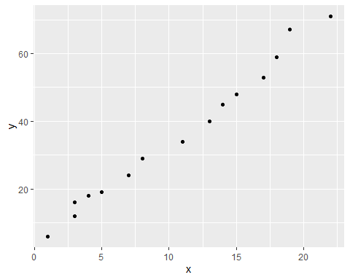 ## Produce the lm model and summary

bon <- lm(y ~ x)  
bon

##   
## Call:  
## lm(formula = y ~ x)  
##   
## Coefficients:  
## (Intercept) x   
## 3.692 3.035

summary(bon)

##   
## Call:  
## lm(formula = y ~ x)  
##   
## Residuals:  
## Min 1Q Median 3Q Max   
## -3.1487 -1.2014 -0.7269 0.8513 5.6404   
##   
## Coefficients:  
## Estimate Std. Error t value Pr(>|t|)   
## (Intercept) 3.69171 1.21544 3.037 0.00953 **   
## x 3.03515 0.09727 31.203 1.31e-13 ***  
## ---  
## Signif. codes: 0 '***' 0.001 '**' 0.01 '*' 0.05 '.' 0.1 ' ' 1  
##   
## Residual standard error: 2.452 on 13 degrees of freedom  
## Multiple R-squared: 0.9868, Adjusted R-squared: 0.9858   
## F-statistic: 973.6 on 1 and 13 DF, p-value: 1.312e-13

slope (B1) = 3.035  
y intercept (B0) = 3.692

standard error of BO = 1.21544 standard error of B1 = 0.09727

## Find the bonferroni 90% confidence intervals for B0 and B1

Interval for B1 = 3.035 +/- 2.16037(0.09727) = 2.82 <= B1 <= 3.24 Interval for B0 = 3.692 +/- 2.16037(1.21544) = 1.06 <= BO <= 6.32