Assignment 1

- Program 1.1
First parallel phase 2 in SOR benchmark, and two code lines is added.
#pragma omp parallel
{
Phase 2
in inner loop print the thread id

}
Compile sor.c
$gcc -o sor -fopenmp sor.c
$ export OMP_NUM_THREADS=2(change the number of threads)
$./sor
Figure 1 shows part of result when 2 threads and 8 threads are set.

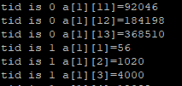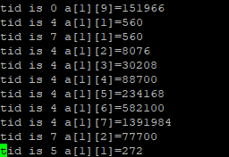

Figure1 the number of threads is 2 and 8
- Program 1.2
Add some code lines in original codes.
#pragma omp parallel
{
#pragma omp sections
{
#pragma omp section
{
Phase 1
int tid= omp_get_thread_num();
}
#pragma omp section
{
Phase 2
Int tid = omp_get_thread_num();
}
}
}
Compile matrix.c
$gcc -o matrix -fopenmp matrix.c
$ export OMP_NUM_THREADS=2
$./matrix

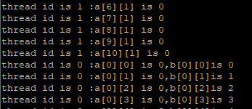
Figure 2 part of result of matrix.c
3.In this problem, I create two threads by pthread_create(arguments) and use pthread_join to run them. I use mutex to allow the thread run in my order, and conditional variables are set to wake up threads. In the code, two threads all have mutex_lock in the beginning, and anyone can get lock first, but the thread2 needs workerCV to signal, so thread1 will run firstly. Then, thread1 will run until equals to multiple of 5, then get lock and wakes up thread2. MainCV is set to stop running thread1. thread2 runs to print multiple of 5, then wakes up thread1 by mainCV.The result is showed in Figure 3.
$gcc -pthread q3.c -o q3
$./q3
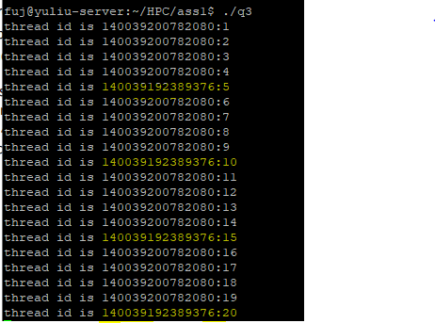
Figure 3 the result of program2.1

