- Two code lines(purple codes) are added in Figure 1
#pragma omp parallel for private(j)
this code is to speed up, j is private because every thread has its own j, which help every thread visit the right j.
#pragma omp parallel for private(j) reduction(max:dt)
this code is to speed up and uses reduction to get combined the max,then finally get the max value.
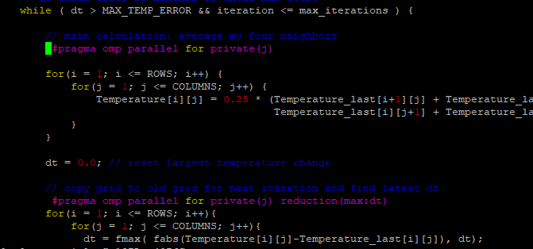
Figure 1 Source code
- The result of codes
- The initial result in Figure 2
$ gcc -fopenmp -o laplace_serial laplace_serial.c -lm
$ ./laplace_serial
The total time is 0.561232s
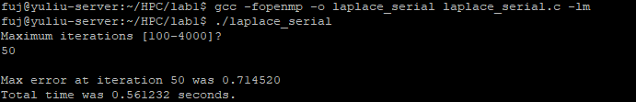
Figure 2: The initial result
- The speed up result in Figure 3
$ gcc -fopenmp -o laplace_serial laplace_serial.c -lm
$ ./laplace_serial
The total time is 0.090346s
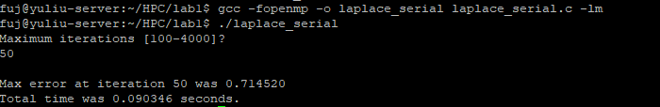
Figure 3: The speed up result

