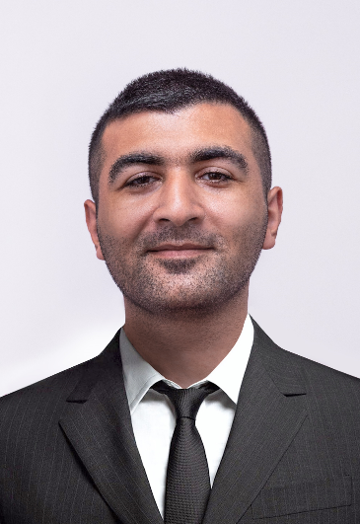
Fuad Ibrahimzada
Web Developer
05.04.1991.
Azerbaijan, Baku.
+994 555861083
fuad.ibrahimzada@gmail.com
Work Experience

Portfolio
Github Portfolio
• The ability to follow instructions and deliver quality results.

• The ability to work under pressure and multi-task

• The ability to work in a team environment, as well as independently

Objectives
Skills

Web Development (2019 – now)
Junior .Net Web Developer –Agile Solutions– 2020.05.06-now
Full Stack Php Developer –New Media– 2019.11-2020.02

Scripts Development (2018 – 2019)
Cartv.eu - Auction Pricing Script
Quantitative Investment Scripts
Web Scraping

Freelance (2015)
Android Developer (news app, file transfer utility)
Glow Cells - Android Game

Education
Asp.net Core
PHP/Laravel:
Vue.js/Angular 2/Angular.js:
JS, Bootstrap:

2
Azerbaijan State Oil Academy (2008-2012)
International Economic Relations and Management

Languages
English (Fluent)
Russian (Intermediate)

