[Q1] [20 points]

[01] $ ls

[02] $ pwd

[03] $ xy

[04] $ cd ..



[05] $ pwd

[06] $ cd

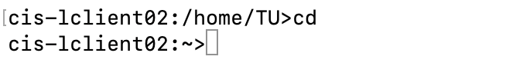

[07] $ pwd

[08] $ cd /usr/local

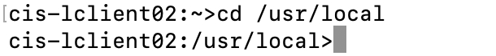

[09] $ ls

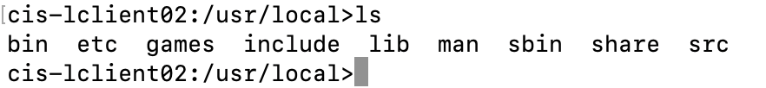

[10] $ cd

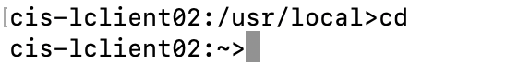

[Q2] [20 points]

|  |  |  |
| --- | --- | --- |
| # | Cat | Concatenate files and print on the standard output. |
| 1 | More | File perusal filter for crt viewing. |
| 2 | Cp | Copy files and directories. |
| 3 | Mv | Move or rename file. |
| 4 | Rm | Remove file or directories. |
| 5 | Ls | List directory contents. |
| 6 | Mkdir | Make directories. |
| 7 | Cd | No manual entry for cd. |
| 8 | Pwd | Print name of current/working directory |
| 9 | Rmdir | Remove empty directories. |
| 10 | whoami | tun62034 |

[Q3] [10 points]

MKDIR(1) User Commands MKDIR(1)

NAME

mkdir - make directories

SYNOPSIS

mkdir [OPTION]... DIRECTORY...

DESCRIPTION

Create the DIRECTORY(ies), if they do not already exist.

Mandatory arguments to long options are mandatory for short options

too.

-m, --mode=MODE

set file mode (as in chmod), not a=rwx - umask

-p, --parents

no error if existing, make parent directories as needed

-v, --verbose

print a message for each created directory

-Z set SELinux security context of each created directory to the

default type

--context[=CTX]

like -Z, or if CTX is specified then set the SELinux or SMACK

security context to CTX

--help display this help and exit

--version

output version information and exit

AUTHOR

Written by David MacKenzie.

REPORTING BUGS

GNU coreutils online help: <http://www.gnu.org/software/coreutils/>

Report mkdir translation bugs to <http://translationproject.org/team/>

COPYRIGHT

Copyright © 2016 Free Software Foundation, Inc. License GPLv3+: GNU

GPL version 3 or later <http://gnu.org/licenses/gpl.html>.

This is free software: you are free to change and redistribute it.

There is NO WARRANTY, to the extent permitted by law.

SEE ALSO

mkdir(2)

Full documentation at: <http://www.gnu.org/software/coreutils/mkdir>

or available locally via: info '(coreutils) mkdir invocation'

GNU coreutils 8.25 February 2017 MKDIR(1)

[Q4] [10 points]

[Q5] [15 points]

$ cal 4

$ cal 52

$ cal 1752

$ cal 1952

$ cal 2004

$ cal 2005

b. yes, because the cal 2004 feb has 29 days.

c. year 1752 have 355, 34,500,000 results showed up, The principal change was to space leap years differently so as to make the average calendar year 365.2425 days long, more closely approximating the 365.2422-day. <https://en.wikipedia.org/wiki/Gregorian_calendar>

[Q6][ 15 points]

$ uname

$ uname -u

$ uname -p

a. What is the name of your operating system?

- Linux

b. What is the domain name of your computer system?

- cis-lclient07

c. What CPU is in your computer system?

- x86_64

[Q7] [5 points]

How many users are currently using your UNIX system?

* 2 users

[Q8] [5 points]

