**Bangladesh University of Business and Technology (BUBT)**

**PROJECT**

**Report on**

**Student Management System**

Presented to the Department of Computer Science & Engineering of **“Bangladesh University of Business & Technology”** (BUBT)



**BANGLADESH UNIVERSITY OF BUSINESS AND TECHNOLOGY (BUBT)**

Plot # 77-78, Road # 9, Rupnagar, Mirpur-2, Dhaka-1216

**Student Management System**

**Declaration**

We hereby declare that the work presented in “Student Management System” is the outcome of the efforts carried by us under the supervision of **Md. kamruzzaman**, Lecturer of the department of CSE, BUBT.

We further declare to the best of our knowledge that no part of this project has been or is being submitted elsewhere for the award of any degree or diploma.

**Signatures**

………………………………….

Fuad Hasan Emon

ID: 14152103034

Section: 01, Intake: 29th

………………………………….

Md. Jahid Hasan Sheum

ID: 14152103002

Section: 01, Intake: 29th

………………………………….

Md. Mahmudul Hasan

ID: 14153103134

Section: 03, Intake: 30th

**Approval**

**To Whom It May Concern**

This is to certify that Fuad Hasan Emon of the Department of CSE of Bangladesh University of Business and Technology have completed the project entitled “Student Management System”, under the supervision of **Md. kamruzzaman**, Lecturer of the Department of CSE of Bangladesh University of Business and Technology.

……………………………………….

**Md. kamruzzaman**

Project Supervisor

Lecturer, Dept. of CSE

Bangladesh University of Business and Technology

**Abstract**

The Student Management System is an application for maintaining students data like name, id also can attendance and exam schedule. In this project I tried to show the working of student management system and cover the basic functionality of a Student Management System.

The Student Management System undertaken as a project is based on relevant technologies. The main aim of this project is to develop software for School, College and University Management System. This project has been developed to carry out the processes easily and quickly, which is not possible with the manuals systems, which are overcome by this software. This project is developed using C language. Creating and managing requirements is a challenge of IT, systems and product development projects or indeed for any activity where you have to manage a contractual relationship. Organization need to effectively define and manage requirements to ensure they are meeting needs of them, while proving compliance and staying on the schedule and within budget.

**Acknowledgement**

All praise be to Allah, the most Merciful, and the most Gracious, Who has been the prime support behind all our efforts to this point of success.

We would like to express our sincere gratitude to our project supervisor, teacher, and mentor, **Md. kamruzzaman** for his continuous support, endless patience, insight, and immense knowledge.

We are immensely grateful to our teachers and friends, who have always been supportive and willing to give their best suggestions. This project would have been difficult without their endless help and support.

Last but not least, we would like to thank our parents and siblings, for their constant encouragement and spiritual guidance.

**Contents**

Declaration of Authorship…………………………………....... 2

Approval……………………………………………………….. 3

Abstract………………………………………………………… 5

Acknowledgement……………………………………………... 6

Contents

1. **Introduction**
   1. . Background information 9
   2. . About student management system 9
   3. . Main purpose 10
   4. . What to expect 10
   5. . Features of SMS 11
   6. . Goals and objectives 11
   7. Problems of the manual system 12
   8. Discussion on language 12
2. **Literature Review**
   1. . Literature review 13
   2. . System Quality 13
   3. . Security System 14
   4. . Time Efficiency 14
   5. . Usability 16

1. **System Analysis and Design**
   1. Introduction 17
   2. System Analysis 17
   3. Analysis of the Existing System 18
   4. Analysis of proposed System 18
   5. Requirements Definition 19
   6. Analysis of proposed System 19
   7. System Design 20
   8. System Modifying 20
2. **System Implementation**
   1. Screen shots 21
   2. Limitations 24

1. **Bibliography**
   1. Summary 25
   2. Conclusion 25
   3. References 26
   4. Books References 26

**Chapter One**

**Introduction**

* 1. **Background information**

**student management system** is a management for education establishments to manage student data. Student information systems provide capabilities for students details, results of student tests and other  building student schedules, tracking student attendance; and managing many other student-related data needs in a school, college and university.

* 1. **About student management system**

**Student management system** (SMS) is software to manage all day to day operations for a school. They are also called **student information systems** (SIS), **Student information management systems** (SIMS), Student records system (SRS). Functionalities of such systems are not the same and this may reflect in the name adopted by educational institution. This makes the user friendly and provides more flexibility.

* 1. **Main Purpose**

Computer technology is used to provide facilities to user to perform their jobs quickly and accurately. That is why computer is used in most organizations to maximize the efficiency and performance of the organization. The objectives of the latest technology are to speed up the system, to reduce the errors and to develop error free inputs, as invalid inputs are the main cause of computer mistakes and a computer never makes mistakes of its own.

Every nation in the world want to develop the technological excellence to reduce problems and store its progress in the record, so we as developing nation should realize this trend and should need to adopt this high speed technology. Computer technology is not used only in science and arts, but it is also applied in all sorts of data processing activities

* 1. **What to expect**

Here are some of the features available through student management system :

1. **Add students**: Firstly login with your password. Then you can add student name, id etc.

2. **Show value**: When you add your students then you can show values of your data.

3**. Attendance**: You can also store attendance with this application.

4. **Exams**: we can also store exam, class test marks in it.

* 1. **Features of SMS**
* User can login with there password.
* Adding students.
* Show values.
* Collect attendance.
* Marking exam results and store them.
* Admin can add/edit/delete
  1. **Goals and Objectives**

1. **Main Goals:**

* Our motto is to develop a software program for managing the entire student management process.
* Hereby, our main objective is the user’s satisfaction considering today’s faster in the world.
  1. **Problems of the manual system**

Managing a school and bringing together departments and campuses to achieve the mission is always a big challenge for school management. Transforming schools with high technology-enabled automation tools to support the academic and administrative processes will make it easy to achieve their goals. To succeed in everyday tasks of schools, there is an emerging demand to modernize education with cloud, mobile and digital technologies to improve operational efficiency and manage the institution effectively.

**1. Paper-based processes**

Educational institutions are burdened by cumbersome paperwork and manual processes, and they find it difficult to maintain records, attendance etc.

* 1. **Benefits of the proposed system**

### **1. Smart management of student’s data**

Students examination, attendance can be accessed directly using a unique identification number per student. This can be used by a student or the management for tracking their schedules.

* 1. **Discussion on Language**

We use C language in our system.

**C** is a high-level and general-purpose programming **language** that is ideal for developing firmware or portable applications. Originally intended for writing system software, **C** was developed at Bell Labs by Dennis Ritchie for the Unix Operating System in the early 1970s.

**Chapter Two**

**Literature review**

* 1. **Literature review**

The system is capable of converting the collected data from the routine user and machine interactions in to the effective information which later on is used by the decision makers to make efficient decisions. In the management information system, the most important entity is system itself which is set of defined and interrelated components which are generally described as all of the direct or indirect complex components or elements that are related in a casual network. Within any particular time period, all of these complex components are related in more or less stable way with at least some other components. So a well-developed and interactive system is one which provides best and useful information to the managers at all levels.

The revolution in the information and communication technologies (ICTs) has greatly influenced the life style of whole world. Over the past several years, ICT infrastructure is considered as a symbol for a country’s development. In every way of life, there is a vital role of these Information and Communication Technologies (ICTs) by all means to improve the quality, standardizing the different stakeholders’ role and imparting the operating procedures

**2.2 System Quality**

Delone and McLean 1992, proposed to subdivide success measures of management information systems into six distinct categories that define the five dimensions of measuring success of system development as follows

1. System quality
2. Information quality
3. Usage
4. User satisfaction
5. Individual impact &
6. Organizational impact

Within each category several attributes could contribute to success.

The information processing system itself is a assessed with system quality attributes, information attributes, concern the input and output of the system. Usage refers to system usage, information usage, or both. Examples of attributes of usage are numbers of entries are total data entry time. User satisfaction can concern the system itself or its information, although they are hard to disentangle. Delone and McLean included user satisfaction in addition to usage, because in cases of obligatory use, user satisfaction is an alternative measure of system value.

**2.3 Security System**

|  |
| --- |
| From the threats above, it became obvious that there is an urgent need for efficient security models by banks which offer online access to their banking systems. The online banking is carried out through a series of transactions in various environments between the end user and the system, and these transactions are always vulnerable to attacks from hackers. It must protect the end users of online banking with a multi-faceted security solution that understands all the trends of hacking and gathering all the technologies that can ensure security for end user’s data input, security for web browsing, and security for the connection network used. |
|  |

**2.4 Time Efficiency**

We as humans have evolved from being wild cavemen to the well-sophisticated populace, which is large because of our curiosity and our eagerness to learn. Therefore, through the ages, the education system has constantly been evolving to accord us with knowledge essential to not only remain as the dominant species but also make the world a better place. Therefore, to keep up with new modes of information and new channels of education we need to evolve our education system by automating the traditional ways and bringing more structure to the curriculum. Managing an educational system requires careful planning and time management on everybody’s part, and therefore the automated management system has become not only a norm but a necessity in today’s world. These smart technologies improve the efficiency of teachers to educate their pupils in the most unique ways of bringing out the true creativity in them.

With an enormous amount of information available on various channels and such little time to grasp it, time management becomes much more crucial. The same goes for an educational organization trying to manage a crowd of students, with efficiency and effectiveness only a system can provide. With such requirements, it comes important to include a managing tool to save everybody’s precious time. A student management system brings in various features like admission, attendance, fee collection library, examination, timetable, transport tracking, student performance report etc. All these are low complexity tasks which require high accountability and accuracy, therefore these tasks can easily be delegated to our lesser counterparts; the machines (or software’s). Student management system has become an essential part of school management, offering efficacy where it matters.

These systems provide a 360-degree view over the students, to manage their various needs and tracking their educational performance. A single platform can offer an access to all these elements and aid in tracking the data on the fly. Fedena with such extensive features is a web-based software which can be accessed from anywhere and at any time.

**2.5 Usability**

Industry experts estimate that 90% of higher education institutions use course management systems (CMS) to assist in delivering content to students, either as supplements to courses delivered face-to-face or as an entire course offered online (Green, 2006). A key factor in students and instructors adopting the technology is the ease-of-use of the course management system. Our study conducted usability testing on three CMS: WebCT, Sakai and Moodle. Usability was measured from the perspective of a student using the system for the first time.

**Chapter Three**

**System Analysis and Design**

**3.1 Introduction**

System is a collection of an interrelated components that works together to achieve a purpose. System analysis is referred to the systematic examination or detailed study of a system in order to identify problems of the system, and using the information gathered in the analysis stage to recommend improvements or solution to the system. System design is an abstract representation of a system component and other relationship and which describe the aggregated functionality and performance of the system. System design is also the overall plan and blueprint for how to obtain answer to the question being asked. The design specifies which of the various type of approach.

**3.2 System Analysis**

System analysis is the study of sets of interacting entities, including computer system analysis. This field is closely related to requirements analysis or operations research. It is also “an explicit formal inquiry carried out to help someone identify a better course of a action and make a better decision than he might otherwise have made. System analysis is a methodology that involves the application of systematic approaches to collects facts about an existing system with the aim of improving it or replacing it with more efficient within the context of the available resources .

**3.3 Analysis Existing System**

In the existing system the transactions are done only manually but in proposed  
system we have to computerize all the banking transaction using the software student management system system .

PROBLEMS WITH EXISTING SYSTEM

* Lack of security of data
* More man power
* Time consuming
* Consumes large volume of pare work
* Needs manual calculations
* No direct role for the higher officials
* Damage of machines due to lack attention

To avoid all these limitations and make the working more accurately the system needs to be computerized

**3.4 Proposed System**

The aim of proposed system is to develop a system of improved facilities. The  
proposed system can overcome all the limitations of the existing system. The system  
provides proper security and reduces the manual work.

Advantages of the proposed System

The system is very simple in design and to implement. The system requires very low  
system resources and the system will work in almost all configurations. It has got  
following features

* Security of data
* Ensure data accuracy’s
* Proper control of the higher officials
* Reduce the damages of the machines
* Minimize manual data entry
* Minimize time needed for the various processing
* Greater efficiency
* Better Service
* User friendliness and interactive
* Minimum time required

**3.5 Requirements Definition**

Preliminary investigation plays an important role in developing a satisfactory requirement. It’s as a result of through investigation of how to current system works using the facts gathered at the preliminary investigation that leads to focusing on the possibility of replacing the existing system or improving the existing system. This tasks involves information gathering.

**3.6 System Design**

System design is the process of defining the architecture, components, modules, interfaces and data for a system to satisfy specified requirements through system modeling. One could see it as the application of systems theory to produce development. The design of this system will be user friendly. It shall be designed in such a way that it consists of design activities that produce system specifications satisfying the functional requirements that were developed in the system analysis process. System design specifies how the system will accomplish. System design is the structural implementation of the system analysis.

**3.8 System Modifying**

During the system requirements and design activity, systems may be modeled as a set of components and relationships between these components. These are normally illustrated graphically in a system architecture model that give the reader an overview of the system organization. System modeling helps to give more detailed.

System specifications which are in form of graphical representation that can describe problem to be solved or the system that is to be developed. Because of the graphical representations used, models are often more understandable than detailed natural language description of the system requirements. Examples of such modeling tool are a System Flowchart.

**Chapter Four**

**System Implementation**

* 1. **Screen shots**

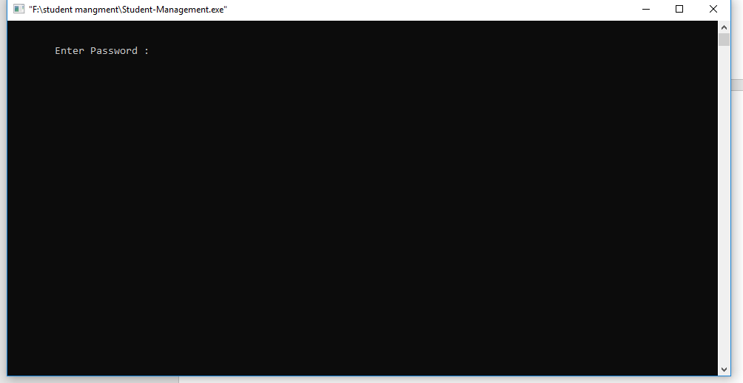

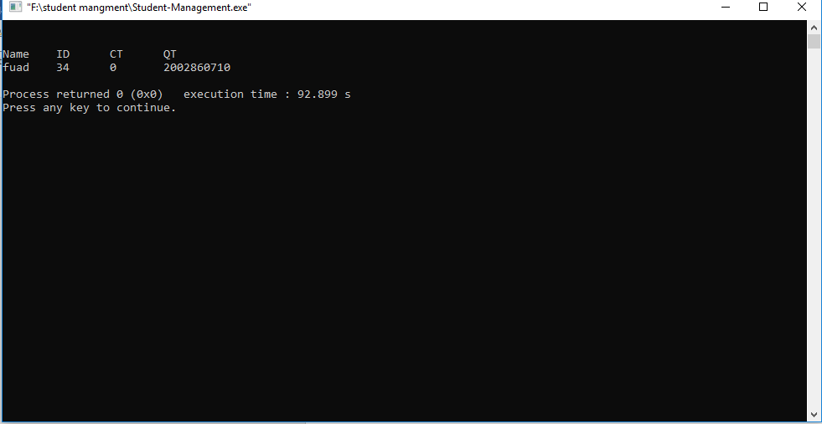

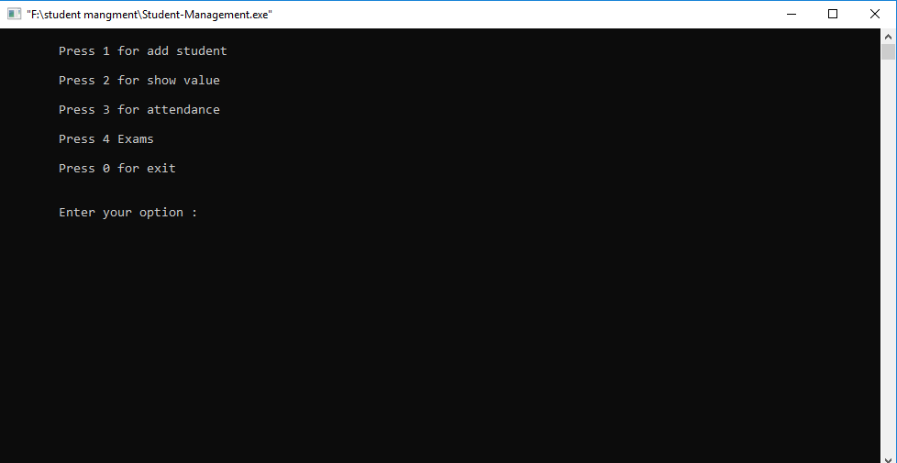

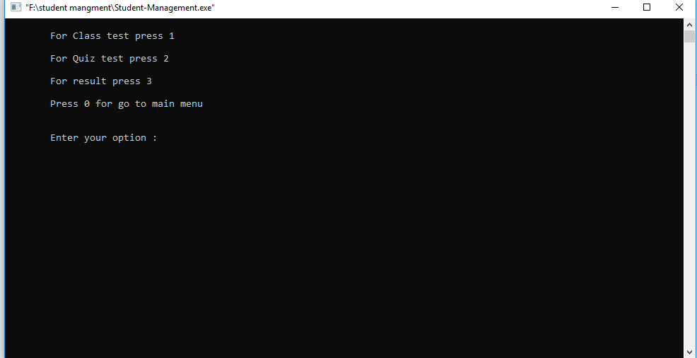

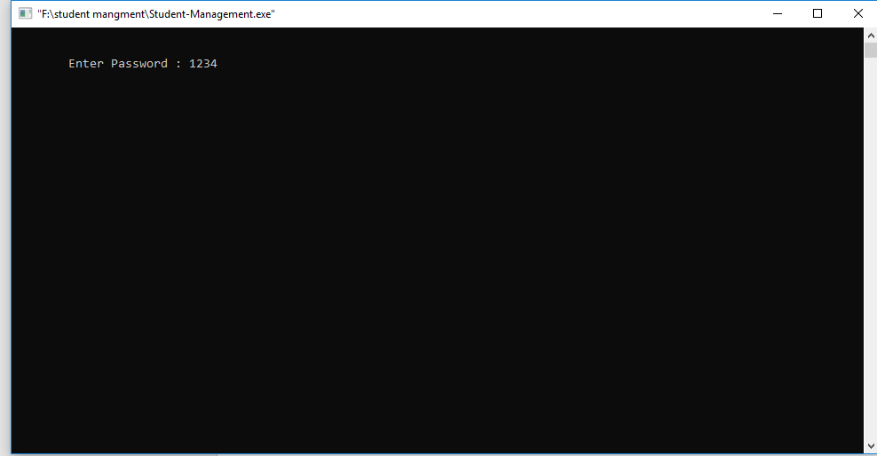

* 1. **Limitation**

**Our program has no database connection for this we can not store student details permanently, in future we will work with database.**

**Chapter Five**

**Bibliography**

**5.1 Summary**

Student management system can handle all the detail about student. The details include all the information about the student such as, student personal details, academic details etc.

The student management system is an automated version of manual student management system.

**5.2 Conclusion**

Student management system is a management information system for education establishments to manage student data.

It provide capabilities to teachers for tracking student attendance and submitting students marks.

Ensure data integrity, privacy and security in an open-access environment.

**5.3 References**

Various sites referred to during making of the project are as follows:

* [www.google.com](http://www.google.com)
* [www.wikipedia.com](http://www.wikipedia.com)
* [www.scribd.com](http://www.scribd.com)
* [www.stackoverflow.com](http://www.stackoverflow.com)
* [www.khanacademy.org](http://www.khanacademy.org)
* [www.slideshare.net](http://www.slideshare.net)
* www.w3cschools.com

**5.4 Book references are as follows:**

* The **C** Programming **Language** (2nd Edition) - Brian W. Kernighan and Dennis M. Ritchie.
* **C**: A Reference Manual (5th Edition) - Samuel P. Harbison and Guy R. Steele.
* C : The Complete Reference by Herbert Schildt.