LAUNDRRY

Laundry Marketplace Management System
  - Software Engineering Documentation and Software Requirements Specification

Document field | Value
Course | CSE327 — Software Engineering
Document type | Pre-implementation SRS, UML, database design, and testing plan
Prepared for | University project review and implementation baseline
Project team | Team Beta
Version | 1.0
Date | 2026-08-25
Status | Approved architecture — design baseline

Document Control
Version | Date | Description | Status
1.0 | 2026-08-25 | Initial complete pre-implementation specification | Baseline

Purpose of This Document
This document defines the requirements, system behavior, UML design, simplified relational database, and verification strategy for transforming the existing static LAUNDRRY website into a multi-role laundry marketplace. It is the agreed reference for design, implementation, testing, demonstration, and change control.

Intended Audience
- CSE327 course faculty and evaluators
- Team Beta developers and testers
- Future maintainers of the university project
- Stakeholders acting as Customer, Rider, Laundry Partner, or Admin

Definitions and Abbreviations
Term | Definition
API | Application Programming Interface
SRS | Software Requirements Specification
RBAC | Role-Based Access Control
OTP | One-Time Password used to verify handover
Partner | A registered and approved laundry business
Delivery task | One logistics leg: Customer-to-Partner or Partner-to-Customer
MVP | Minimum Viable Product

Document Conventions
Requirements use stable identifiers: FR for functional requirements, NFR for non-functional requirements, BR for business rules, UC for use cases, and TC for test cases. “Shall” indicates a mandatory requirement. Priority values are Must, Should, or Could.

1. Software Requirements Specification

1.1 Project Overview
LAUNDRRY is a web-based marketplace that connects customers with verified laundry partners and riders. Customers select a partner and services, schedule pickup, and track the order. A rider transports clothes to the partner; the partner verifies and processes them; a rider returns the completed laundry. Admin supervises users, approvals, orders, and platform records.
The existing HTML/CSS/JavaScript frontend provides the visual foundation: branded navigation, landing content, service cards, process steps, reviews, FAQ, and authentication screens. The implementation will preserve its orange, yellow, blue, gray, typography, illustrations, and friendly consumer-service character while replacing static data with role-aware React views and backend services.

1.2 Problem Statement
The current website represents a single laundry service and cannot coordinate independent partners, riders, customers, or administrators. Booking, authentication, pricing, assignment, tracking, processing, reviews, and persistence are absent. Customers lack transparent partner choices and lifecycle visibility; laundry businesses lack a shared digital ordering channel; riders lack controlled task assignment; and administrators lack governance and auditability.

1.3 Objectives
- Convert the static site into a secure multi-user laundry marketplace without discarding its established branding.
- Allow customers to discover partners, compare services, place orders, and follow status changes.
- Model pickup and return as two controlled delivery tasks that riders can accept and complete.
- Allow approved partners to manage services, prices, order verification, processing, and readiness.
- Provide administrators with approval, monitoring, moderation, and reporting functions.
- Apply modular design, data integrity, authorization, traceability, and systematic testing suitable for CSE327.

1.4 Scope

In Scope
- Responsive web application
- Customer, Rider, Partner, and Admin roles
- Authentication and RBAC
- Partner/rider application and admin approval
- Partner catalog and service pricing
- One-partner-per-order checkout
- Two-leg rider delivery workflow
- Order status history and notifications
- Cash on delivery and simulated/sandbox digital payment
- Reviews, complaints, and basic administrative reports

Out of Scope for the MVP
- Native Android/iOS applications
- Machine-learning rider dispatch
- Production-scale GPS route optimization
- Multi-partner shopping cart
- In-app voice/video communication
- Cross-city logistics
- Automated tax and legal compliance
- Complex subscription plans and enterprise settlement

1.5 Product Perspective and Architecture
The system is a modular monolith with a React client, REST API, Node.js/Express application, and PostgreSQL database. This design separates presentation, HTTP handling, business services, authorization, and persistence while remaining practical for a university team. Optional polling or Socket.IO may provide timely status updates; the database remains the source of truth.

1.6 User Roles
Role | Purpose | Principal permissions
Customer | Purchases laundry services | Register, manage addresses, browse approved partners, create/cancel eligible orders, track, pay, review, complain
Rider | Performs pickup and return logistics | Apply, set availability, view/accept eligible tasks, verify handovers, update assigned task status, view earnings
Laundry Partner | Processes customer laundry | Apply, manage business profile/services/prices, receive orders, verify items, update processing status, view settlement
Admin | Governs the platform | Approve/suspend accounts, manage categories, monitor orders/payments/complaints, view audit and reports

1.7 Functional Requirements
ID | Name | Requirement | Priority
FR-01 | Account registration | The system shall allow a visitor to register as Customer or submit a Rider or Partner application. Public Admin registration shall not exist. | Must
FR-02 | Authentication | The system shall authenticate active users and establish a secure role-aware session. | Must
FR-03 | Account approval | The system shall prevent pending or rejected Rider/Partner accounts from performing operational actions. | Must
FR-04 | Profile management | Users shall view and update permitted profile fields; customers shall manage multiple addresses. | Must
FR-05 | Partner discovery | Customers shall browse and filter approved, open partners serving their area. | Must
FR-06 | Service catalog | Partners shall create, update, enable, and disable their services, unit types, prices, and estimated processing time. | Must
FR-07 | Order quotation | The backend shall calculate subtotal, delivery fees, discount, and total from persisted prices before order creation. | Must
FR-08 | Order placement | A Customer shall create an order for exactly one approved Partner using selected services, quantities, addresses, and pickup slot. | Must
FR-09 | Pickup task creation | Successful order placement shall create an available Customer-to-Partner delivery task. | Must
FR-10 | Rider task acceptance | An available approved Rider shall accept one available task; the operation shall prevent double assignment. | Must
FR-11 | Pickup verification | The Rider and Customer shall confirm clothes handover using an OTP or equivalent verification. | Must
FR-12 | Partner receipt | The Partner shall confirm receipt and may verify quantities or propose justified adjustments. | Must
FR-13 | Laundry processing | The Partner shall update an accepted order from confirmed to processing and then ready for return. | Must
FR-14 | Return task creation | Marking an order ready shall create a Partner-to-Customer delivery task. | Must
FR-15 | Return delivery | An assigned Rider shall collect from the Partner and deliver to the Customer with handover verification. | Must
FR-16 | Status history | Every accepted order transition shall record previous status, new status, actor, time, and optional note. | Must
FR-17 | Order tracking | Authorized participants shall view current state and history relevant to their order or assigned task. | Must
FR-18 | Cancellation | A Customer shall cancel only when the configured lifecycle rules permit; reason and actor shall be recorded. | Must
FR-19 | Payment recording | The system shall record payment method, amount, reference, and state; client claims shall not independently confirm online payment. | Should
FR-20 | Notifications | The system shall create in-app notifications for material assignment and order-status events. | Should
FR-21 | Reviews | A Customer shall submit at most one review for a completed order. | Should
FR-22 | Complaints | A Customer shall open a complaint linked to an order; Admin shall record resolution. | Should
FR-23 | Administration | Admin shall search and manage users, approvals, orders, categories, complaints, and platform status. | Must
FR-24 | Reporting | Admin shall view basic totals for users, orders, statuses, revenue records, and service performance. | Should
FR-25 | Audit | The system shall audit approval, suspension, sensitive status, refund, and complaint-resolution actions. | Should

1.8 Business Rules
ID | Rule
BR-01 | One order belongs to one Customer and one Laundry Partner.
BR-02 | Only approved, active Partners may receive orders; only approved, available Riders may accept tasks.
BR-03 | One order creates two delivery tasks during normal completion: outbound pickup and return.
BR-04 | Only the backend calculates authoritative prices and totals.
BR-05 | Only one Rider may hold an active assignment for a delivery task.
BR-06 | Partners may change only orders assigned to their own business and only through valid transitions.
BR-07 | A completed order may receive at most one Customer review.
BR-08 | Admin accounts are provisioned through protected administration or database seed, never public registration.
BR-09 | Historical order items retain price/name snapshots.
BR-10 | All cancellations and rejected adjustments require a reason.

1.9 Non-functional Requirements
ID | Quality | Measurable requirement
NFR-01 | Security | Passwords shall be salted and hashed; protected APIs shall enforce authentication, role, ownership, and validation.
NFR-02 | Performance | Under normal university-demo load, 95% of non-report API requests should complete within 2 seconds excluding external gateway delay.
NFR-03 | Availability | The deployed MVP should be available during scheduled demonstrations and testing, with recoverable restart procedures.
NFR-04 | Reliability | Order creation, rider acceptance, status transitions, and payment updates shall use database transactions where partial updates could corrupt state.
NFR-05 | Usability | Core tasks shall be accessible through clear role dashboards and responsive interfaces consistent with existing LAUNDRRY branding.
NFR-06 | Accessibility | Forms shall have labels, keyboard navigation, visible focus, meaningful errors, and sufficient color contrast; images shall have suitable alternatives.
NFR-07 | Maintainability | Frontend and backend shall use modular folders, consistent naming, linting, documentation, and separation of controllers, services, and persistence.
NFR-08 | Scalability | Lists shall use pagination and indexed queries; application modules shall permit later extraction without requiring microservices in the MVP.
NFR-09 | Data integrity | Foreign keys, unique constraints, checks, enums/reference values, and immutable order snapshots shall protect relational consistency.
NFR-10 | Privacy | Sensitive documents and personal information shall be accessible only to authorized users and excluded from logs and client responses where unnecessary.
NFR-11 | Auditability | Security-sensitive and lifecycle-changing actions shall include actor and timestamp records.
NFR-12 | Compatibility | The responsive web client should support current desktop/mobile versions of Chrome, Edge, and Firefox.

1.10 User Stories and Acceptance Criteria
ID | Role | Story | Acceptance criteria
US-C01 | Customer | I want to browse partners serving my address so that I can choose a suitable laundry. | Only approved/open partners in range appear; rating, services, prices, and turnaround are visible.
US-C02 | Customer | I want to receive a server-calculated quotation and place an order. | Invalid services are rejected; persisted prices are used; an order number and pickup task are created atomically.
US-C03 | Customer | I want to track each handover and processing stage. | Current state, timestamps, and assigned rider information are visible only when applicable.
US-C04 | Customer | I want to review a finished service. | Review is allowed only after completion and only once per order.
US-R01 | Rider | I want to see eligible tasks and accept one. | Only available tasks are shown; concurrent acceptance gives the task to one rider only.
US-R02 | Rider | I want verified pickup and delivery steps. | OTP/equivalent must match before protected handover status is accepted.
US-P01 | Partner | I want to define my services and prices. | Only the owning approved Partner can change its catalog; historical orders remain unchanged.
US-P02 | Partner | I want to manage my processing queue. | Only valid statuses are offered; every transition is recorded.
US-A01 | Admin | I want to approve Rider and Partner applications. | Decision, reviewer, time, and optional reason are audited; rejected users cannot operate.
US-A02 | Admin | I want to monitor disputes and orders. | Admin can search records, inspect lifecycle history, and record complaint resolution.

1.11 System Constraints
- Web-first implementation using React, REST, Node.js/Express, and PostgreSQL unless course requirements mandate equivalent technology.
- Existing LAUNDRRY UI palette, logo treatment, and assets must remain recognizable.
- University time, hosting budget, and team size limit production-grade dispatch, GPS, and payment functions.
- External maps, SMS, email, or payment functions depend on third-party availability and credentials.
- All monetary calculations use a single configured currency for the MVP.
- The system serves one configured operating region initially.

1.12 Assumptions
- Customers have a valid phone number and serviceable address.
- Partners inspect received items before processing.
- Riders have a suitable vehicle and can access pickup/drop-off locations.
- An Admin verifies Rider and Partner documents manually.
- Internet connectivity is available during operational status updates.
- A Rider may handle either or both legs; the two tasks need not use the same Rider.
- Cash on delivery may be used when a production payment gateway is unavailable.

1.13 External Interface Requirements

User Interface
The public interface retains existing colors and branding. Authenticated users receive role-specific navigation, dashboards, loading states, empty states, validation messages, confirmations, and responsive layouts.

Software Interfaces
- RESTful JSON API under /api/v1
- PostgreSQL relational database
- Optional object storage for verification documents and proof images
- Optional payment, maps, SMS, or email providers through replaceable adapters

Communication Interfaces
The client communicates with the API over HTTPS. Authentication credentials use secure transport and a protected token/session strategy. Real-time updates may use polling initially and Socket.IO as an enhancement.

2. UML Design

2.1 Use Case Diagram
The use case model separates customer commerce, rider logistics, partner operations, and administrative governance. Authentication is shared, while operational privileges depend on approval, role, ownership, and lifecycle state.
Figure 1 — Marketplace use case diagram
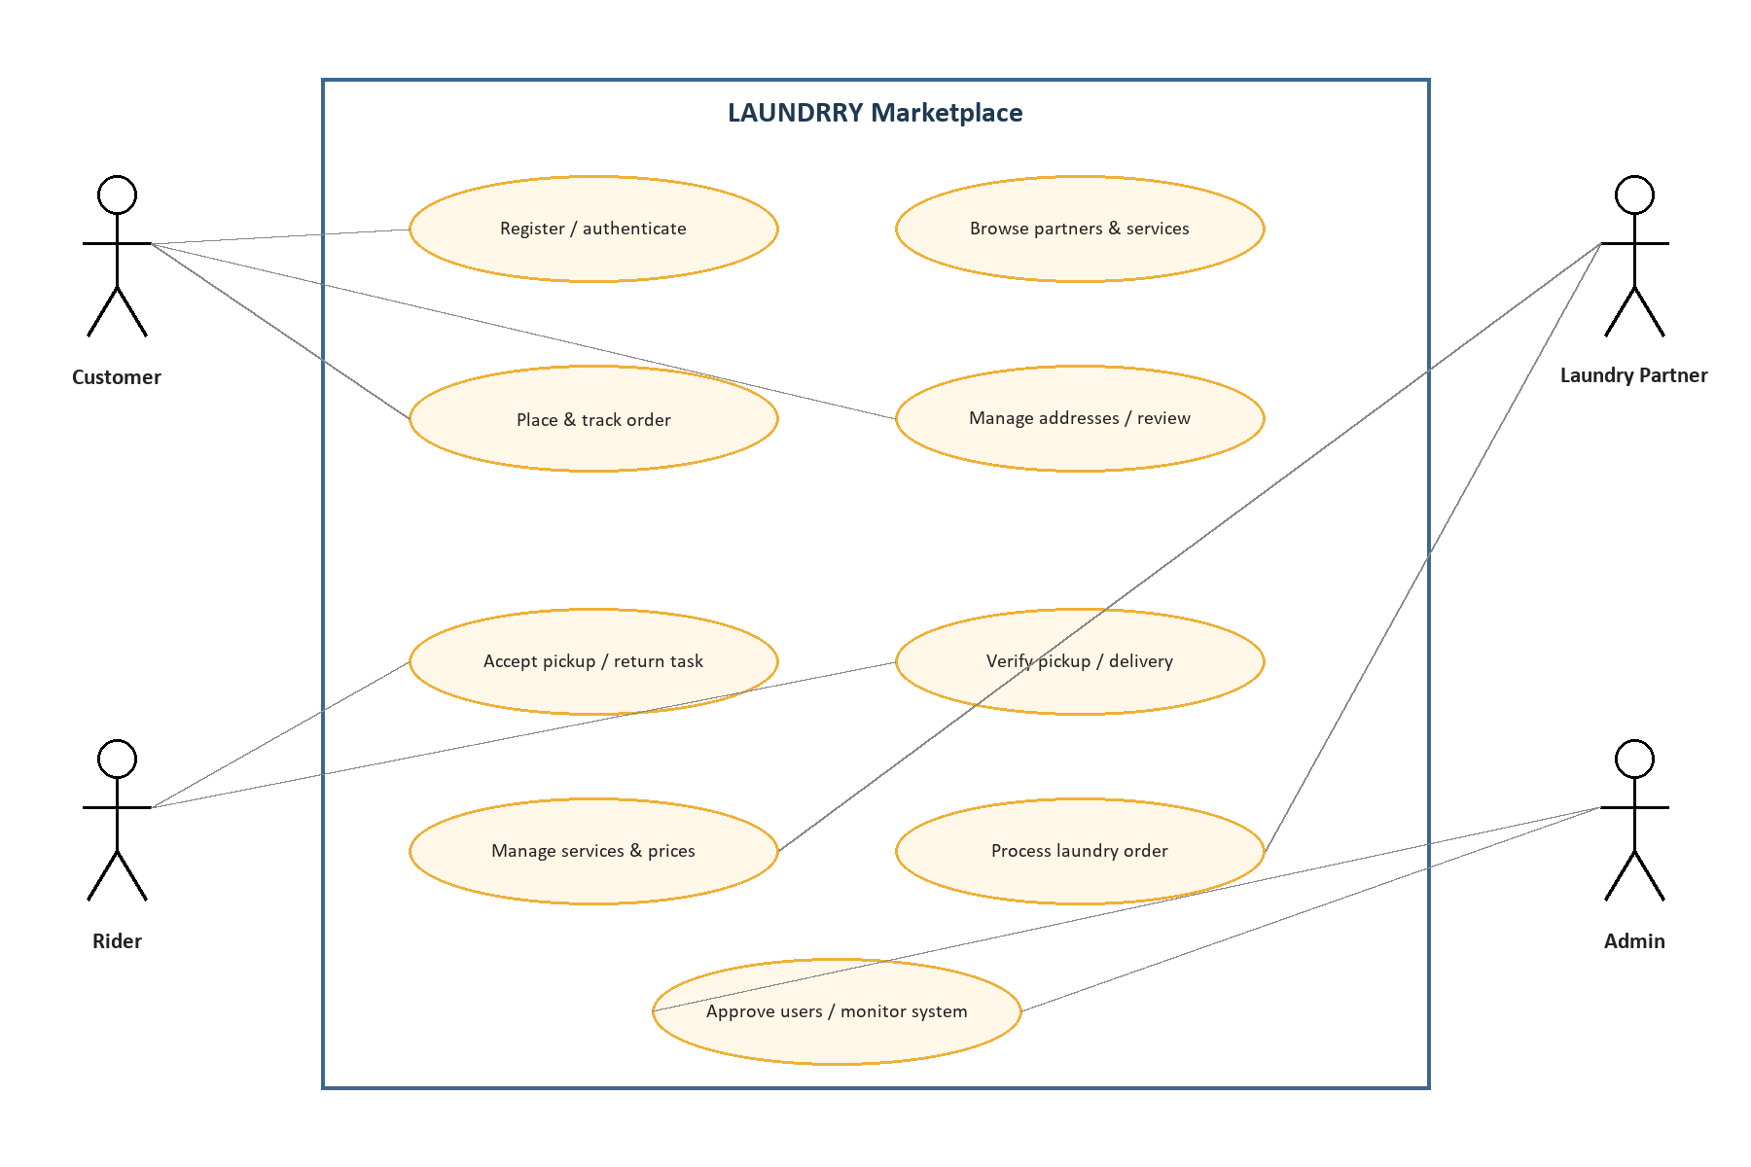

Key Use Cases
UC | Primary actor | Precondition | Success outcome
UC-01 Place order | Customer | Authenticated; address and approved partner available | Order, items, history, and pickup task committed
UC-02 Accept pickup | Rider | Approved, available; task unassigned | Task atomically assigned and customer notified
UC-03 Process laundry | Partner | Order received at owning partner | Order confirmed, processed, and marked ready
UC-04 Complete return | Rider | Return task assigned | Verified customer handover and completed order
UC-05 Approve application | Admin | Pending Rider/Partner application | Approved account can operate and decision is audited

2.2 Activity Diagram — Order Lifecycle
The activity diagram uses swimlanes to show responsibility transfer. The system coordinates validation, state, task creation, notification, completion, and settlement; humans confirm physical handovers.
Figure 2 — End-to-end order activity
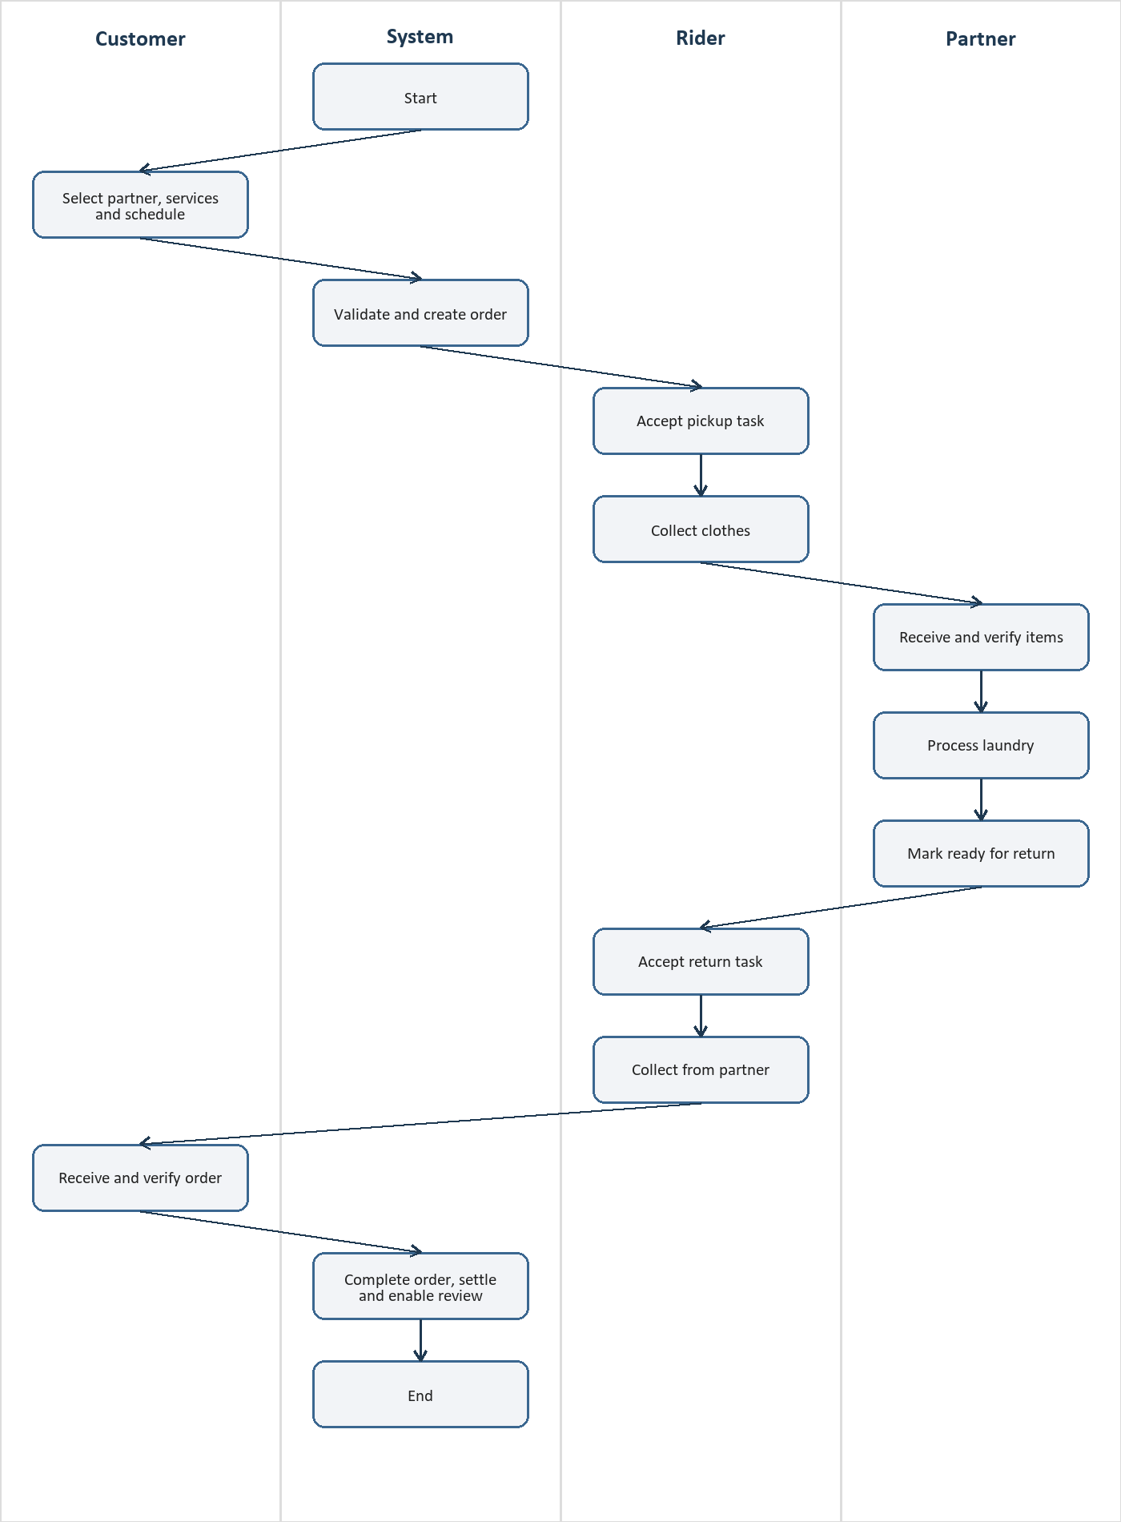

Lifecycle Guards
- Validation failure returns the Customer to order correction without creating database records.
- Failure to obtain the pickup task lock leaves the task available or assigned to the successful Rider.
- A Partner adjustment pauses processing until Customer approval or authorized resolution.
- Failed delivery is recorded as an exception; it does not silently complete the order.
- Cancellation branches depend on current order state and configured fees.

2.3 Sequence Diagram — Place, Pickup, Process, Return
The sequence combines the four requested scenarios into one transaction-oriented interaction. The API delegates business rules to the Order Service; database commits precede notifications. UI actors never directly update the database.
Figure 3 — Main success sequence
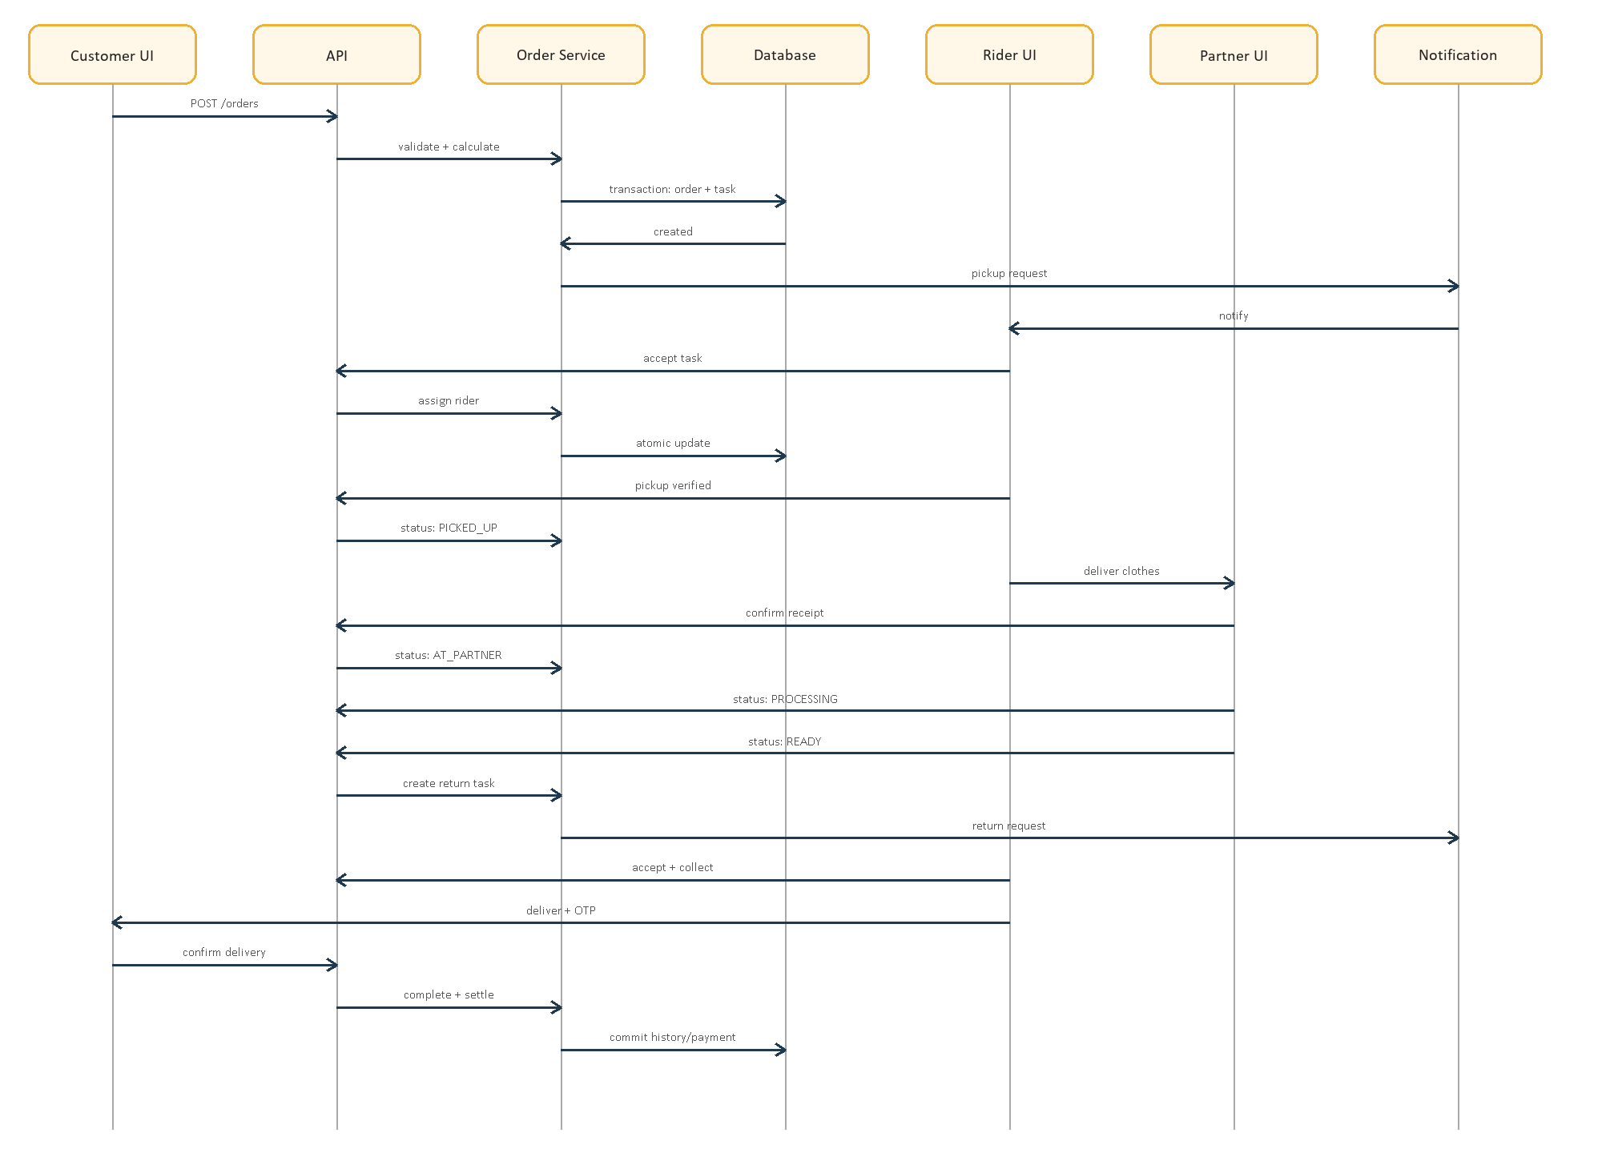

Sequence Responsibilities
Stage | Initiator | Critical system responsibility
Order placement | Customer | Recalculate total, validate partner/service/slot, atomically persist order and pickup task
Rider pickup | Rider | Atomically assign task, verify handover, append status history
Laundry processing | Partner | Enforce ownership and transition rules, record receipt/processing/readiness
Rider delivery | Rider/Customer | Verify final handover, complete order, record financial allocation and enable review

2.4 Class Diagram
The conceptual class model emphasizes the simplified academic domain. User contains common identity; RiderProfile and PartnerProfile extend role-specific data. Order aggregates items, two delivery tasks, status history, and an optional review.
Figure 4 — Simplified domain class diagram
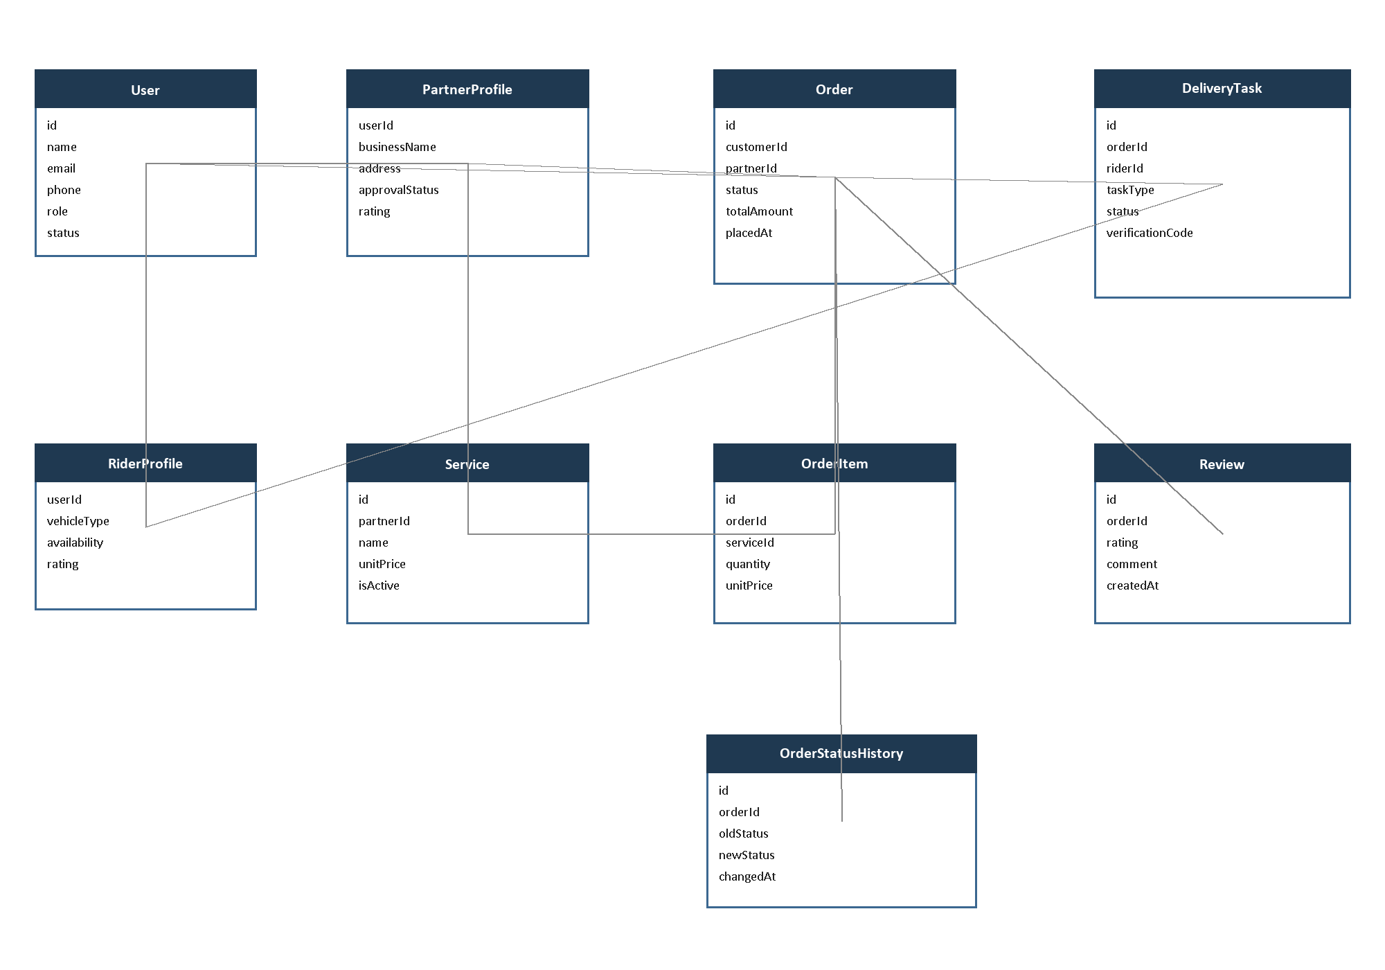

Class Invariants
- Order.totalAmount is derived from immutable item price snapshots and fees.
- DeliveryTask.taskType is either CUSTOMER_TO_PARTNER or PARTNER_TO_CUSTOMER.
- Review requires a completed order and a matching customer.
- Service belongs to exactly one Partner and can be disabled without deleting order history.
- Status history is append-only in normal application operation.

3. Simplified Database Design

3.1 Design Approach
The schema intentionally focuses on Users, Laundry Partners, Riders, Services, Orders, Order Status, and Reviews. Addresses, order items, delivery tasks, and status history are included because they are necessary to express the required workflow correctly. Payments, notifications, documents, complaints, and settlements may be added as extensions without changing the core relationships.

3.2 Core Tables
Table | Important columns | Purpose
users | id PK; name; email UQ; phone UQ; password_hash; role; account_status; created_at; updated_at | Common identity and authorization
rider_profiles | user_id PK/FK; vehicle_type; vehicle_registration; availability_status; verification_status; average_rating | Rider-specific data
partner_profiles | user_id PK/FK; business_name; address; latitude; longitude; service_radius_km; verification_status; is_open; average_rating | Laundry partner business data
addresses | id PK; user_id FK; label; address_line; area; city; latitude; longitude; is_default | Reusable customer address
services | id PK; partner_id FK; name; category; unit_type; unit_price; estimated_hours; is_active | Partner-specific catalog and prices
orders | id PK; order_number UQ; customer_id FK; partner_id FK; pickup_address_id FK; return_address_id FK; status; subtotal; delivery_fee; discount; total; placed_at; completed_at | Order header and current state
order_items | id PK; order_id FK; service_id FK; service_name_snapshot; quantity; unit_price_snapshot; line_total | Purchased service snapshots
delivery_tasks | id PK; order_id FK; rider_id FK NULL; task_type; status; verification_code_hash; accepted_at; collected_at; delivered_at | Pickup or return logistics leg
order_status_history | id PK; order_id FK; old_status; new_status; changed_by FK; note; created_at | Append-only lifecycle audit
reviews | id PK; order_id UQ/FK; customer_id FK; partner_id FK; rider_id FK NULL; partner_rating; rider_rating; comment; created_at | Verified post-completion feedback

3.3 Relationships and Cardinality
Relationship | Cardinality | Meaning
users → addresses | 1 : many | A Customer may store several addresses.
users → rider_profiles | 1 : 0..1 | Only Rider users require a Rider profile.
users → partner_profiles | 1 : 0..1 | Only Partner users require a Partner profile.
partner_profiles → services | 1 : many | A Partner publishes many services.
users(Customer) → orders | 1 : many | A Customer places many orders.
partner_profiles → orders | 1 : many | Each order is processed by one Partner.
orders → order_items | 1 : many | Each order contains one or more items.
orders → delivery_tasks | 1 : 2 normally | One pickup leg and one return leg.
rider_profiles → delivery_tasks | 1 : many | A Rider may perform many tasks.
orders → order_status_history | 1 : many | Each accepted transition is recorded.
orders → reviews | 1 : 0..1 | At most one review per completed order.

3.4 Enumerated Values
Field | Allowed MVP values
users.role | CUSTOMER, RIDER, PARTNER, ADMIN
users.account_status | PENDING, ACTIVE, SUSPENDED, REJECTED
orders.status | PLACED, PICKUP_REQUESTED, PICKUP_ASSIGNED, PICKED_UP, AT_PARTNER, PARTNER_CONFIRMED, PROCESSING, READY_FOR_RETURN, RETURN_ASSIGNED, OUT_FOR_DELIVERY, DELIVERED, COMPLETED, CANCELLED
delivery_tasks.task_type | CUSTOMER_TO_PARTNER, PARTNER_TO_CUSTOMER
delivery_tasks.status | AVAILABLE, ACCEPTED, ARRIVED, COLLECTED, DELIVERED, FAILED
services.unit_type | ITEM, KG

3.5 Keys, Constraints, and Indexes
- Unique indexes on normalized user email, phone, and order number.
- Foreign keys prevent orphan profiles, services, orders, items, tasks, history, and reviews.
- CHECK constraints require positive quantity/prices, ratings from 1 to 5, and nonnegative totals.
- Unique order_id on reviews enforces one review per order.
- A partial unique index or transactional lock prevents more than one active Rider assignment per task.
- Indexes on orders(customer_id, created_at), orders(partner_id, status), delivery_tasks(status, rider_id), services(partner_id, is_active), and history(order_id, created_at).
- Soft-disable services and suspend users rather than deleting records required by order history.

3.6 Transaction Boundaries
Operation | Records committed together
Place order | Order, order items, initial history, pickup delivery task
Accept task | Task rider assignment, task status, order state/history
Partner marks ready | Order state/history, return delivery task
Confirm final delivery | Task state, order state/history, payment/earning records when implemented

4. Testing Plan

4.1 Test Strategy
Testing follows a risk-based pyramid. Pure business rules receive fast unit tests; database and API boundaries receive integration tests; user-visible behavior receives black-box and end-to-end tests. Every Must requirement must have at least one passing verification before release. Defects are logged with severity, environment, reproduction steps, expected result, actual result, and evidence.

4.2 Test Environment
Area | Proposed environment
Frontend | React test runner, browser automation, Chrome/Edge responsive views
Backend | Node test runner with isolated environment variables
Database | Dedicated PostgreSQL test database reset between suites
API | HTTP integration client against test server
Fixtures | Seeded Admin, Customer, approved/pending Rider, approved/pending Partner, services, addresses
External services | Mocks/sandbox for notification and payment adapters

4.3 Unit Testing
- Order quotation and total calculation
- Valid and invalid order-state transitions
- Cancellation eligibility and fee rule
- Role/ownership policy decisions
- Partner service validation
- OTP comparison and expiration behavior
- Rating and review eligibility
- Task eligibility and earnings calculation
- Response mapping that removes sensitive fields

4.4 Integration Testing
- Registration, login, refresh/logout, and protected route access
- Rider/Partner application approval persistence
- Order creation transaction and rollback
- Concurrent Rider acceptance of the same task
- Partner ownership and lifecycle updates
- Return-task generation exactly once
- Status-history append behavior
- Review uniqueness and completion requirement
- Payment callback signature and idempotency when implemented

4.5 Black-box Testing
Black-box tests derive inputs from requirements without inspecting implementation. Equivalence partitioning covers valid/invalid roles, statuses, quantities, and ratings. Boundary-value analysis covers zero/maximum quantities, rating limits, time slots, and field lengths. Decision tables cover cancellation and authorization. State-transition tests cover the order lifecycle.

4.6 Entry and Exit Criteria
Gate | Criteria
Test entry | Approved requirements; runnable build; migrated test database; stable test data; known environment documented
Feature exit | All Must acceptance criteria pass; no open Critical/High defect; changed modules have unit and integration coverage
Release exit | End-to-end success workflow passes; security-negative cases pass; backup/setup/demo instructions verified; residual risks documented

4.7 Detailed Test Cases
ID | Scenario | Precondition/Input | Action | Expected result | Trace
TC-01 | Customer registration | Unique valid name/email/phone/password | Submit registration | ACTIVE Customer created; password not stored plainly | FR-01
TC-02 | Reject duplicate identity | Existing email | Register with same email | Validation error; no new user | FR-01
TC-03 | Block public Admin registration | Role payload ADMIN | Submit registration API request | 403/validation failure; no Admin created | FR-01
TC-04 | Login success | Active Customer | Submit correct credentials | Authenticated session and Customer role returned | FR-02
TC-05 | Login failure | Existing user | Submit wrong password | Generic authentication error; no session | FR-02,NFR-01
TC-06 | Pending Rider blocked | Pending Rider | Request available tasks | Access denied | FR-03
TC-07 | Admin approves Partner | Pending Partner, Admin logged in | Approve application | Partner ACTIVE; audit entry created | FR-03,FR-25
TC-08 | Partner list filtering | Approved/open and rejected partners | Search service area | Only eligible partners returned | FR-05
TC-09 | Create service | Approved Partner | Submit valid name/unit/price | Service belongs to Partner and is visible | FR-06
TC-10 | Reject invalid price | Approved Partner | Submit zero/negative price | Validation error; no service persisted | FR-06,NFR-09
TC-11 | Server quotation | Customer selects active services | Request quote | Correct subtotal, fees, discount, total | FR-07
TC-12 | Reject manipulated total | Client sends lower total | Place order | Server ignores/rejects client total and calculates authoritative amount | FR-07
TC-13 | Place valid order | Customer, address, partner, services | Confirm checkout | Order/items/history/pickup task committed | FR-08,FR-09
TC-14 | Rollback invalid order | One inactive service | Place order | No partial order/task remains | FR-08,NFR-04
TC-15 | Concurrent task acceptance | Two approved Riders, one task | Accept simultaneously | Exactly one Rider succeeds | FR-10
TC-16 | Pickup OTP success | Assigned Rider, valid OTP | Confirm collection | Task COLLECTED; order PICKED_UP; history appended | FR-11,FR-16
TC-17 | Pickup OTP failure | Assigned Rider, wrong OTP | Confirm collection | Rejected; state unchanged | FR-11
TC-18 | Partner confirms receipt | Owning Partner, PICKED_UP order | Confirm receipt | Order AT_PARTNER/PARTNER_CONFIRMED per transition | FR-12
TC-19 | Wrong Partner access | Different Partner | Open/update order | 404/403; no information or state change | FR-12,NFR-01
TC-20 | Processing lifecycle | Owning Partner | Confirm → Processing → Ready | Transitions accepted and timestamped | FR-13,FR-16
TC-21 | Invalid status jump | Partner at AT_PARTNER | Set COMPLETED | Rejected; state unchanged | FR-13
TC-22 | Generate return once | Order PROCESSING | Mark ready twice/retry request | Exactly one return task exists | FR-14,NFR-04
TC-23 | Return delivery | Assigned Rider and Customer | Collect, deliver, verify OTP | Task delivered; order completed | FR-15
TC-24 | Tracking authorization | Unrelated Customer | Request another order tracking | Access denied/no sensitive data | FR-17,NFR-01
TC-25 | Early cancellation | Customer, unassigned order | Cancel with reason | Order CANCELLED; task closed; history records actor/reason | FR-18
TC-26 | Late cancellation | Order PROCESSING | Customer requests cancellation | Automatic cancellation rejected; complaint/admin path offered | FR-18
TC-27 | Review completed order | Owner Customer, completed order | Submit ratings 1–5 | Review saved; aggregates recalculated | FR-21
TC-28 | Duplicate review | Reviewed completed order | Submit second review | Conflict response; only one review remains | FR-21
TC-29 | Responsive order flow | Mobile viewport | Browse through checkout | No clipped controls; keyboard/form interaction works | NFR-05,NFR-06
TC-30 | API response performance | Representative seeded dataset | Execute standard list/detail calls | 95% complete within 2 seconds in test profile | NFR-02

4.8 Requirement Traceability Summary
Requirement area | Primary verification
Identity and approval | TC-01 through TC-07
Partner catalog | TC-08 through TC-10
Quotation and ordering | TC-11 through TC-14
Pickup logistics | TC-15 through TC-17
Partner processing | TC-18 through TC-22
Return and tracking | TC-23 through TC-24
Cancellation and feedback | TC-25 through TC-28
Quality attributes | TC-05, TC-14, TC-15, TC-19, TC-24, TC-29, TC-30

4.9 Defect Severity
Severity | Meaning | Example
Critical | Security/data loss or no usable core workflow | Unauthorized Admin creation; corrupted orders
High | Core scenario fails without reasonable workaround | No Rider can accept pickup
Medium | Feature defect with workaround | Incorrect filter ordering
Low | Cosmetic or minor usability issue | Noncritical spacing inconsistency

5. Implementation Governance

5.1 Recommended Delivery Order
- Finalize SRS, diagrams, ER model, and acceptance criteria.
- Migrate existing public UI to reusable React components.
- Implement database migrations, seed Admin, authentication, and RBAC.
- Implement Partner approval, catalog, and discovery.
- Implement Customer quotation and order transaction.
- Implement pickup task, Rider acceptance, and verified handover.
- Implement Partner verification and processing lifecycle.
- Implement return task, verified delivery, and completion.
- Add reviews, notifications, complaints, payment sandbox, and reporting.
- Complete testing, security review, deployment, and demonstration documentation.

5.2 Change Control
A change affecting scope, roles, order states, database relationships, authorization, or acceptance criteria shall be recorded as a change request. The team assesses impact on requirements, design, implementation, tests, schedule, and demo. Approved changes increment the document version and update traceability before implementation.

5.3 Definition of Done
- Requirement and acceptance criteria are implemented.
- Code follows agreed module boundaries and passes linting/review.
- Unit and integration tests pass.
- Relevant negative authorization and invalid-state tests pass.
- Database migration and rollback implications are documented.
- Responsive UI includes loading, empty, error, and success states.
- API/OpenAPI and user-facing documentation are updated.
- No unresolved Critical or High defect remains.

Appendix A — Order Transition Authority
From | To | Authorized actor | Guard
PLACED | PICKUP_REQUESTED | System | Order transaction succeeds
PICKUP_REQUESTED | PICKUP_ASSIGNED | System/Rider service | Eligible Rider wins atomic assignment
PICKUP_ASSIGNED | PICKED_UP | Assigned Rider | Valid handover verification
PICKED_UP | AT_PARTNER | Partner/assigned Rider | Partner confirms receipt
AT_PARTNER | PARTNER_CONFIRMED | Owning Partner | Items verified
PARTNER_CONFIRMED | PROCESSING | Owning Partner | Processing started
PROCESSING | READY_FOR_RETURN | Owning Partner | Service completed
READY_FOR_RETURN | RETURN_ASSIGNED | System/Rider service | Return task assigned
RETURN_ASSIGNED | OUT_FOR_DELIVERY | Assigned Rider | Collected from Partner
OUT_FOR_DELIVERY | DELIVERED | Assigned Rider/Customer | Valid final handover
DELIVERED | COMPLETED | System | Completion transaction succeeds
Eligible early states | CANCELLED | Customer/Admin/System | Cancellation policy satisfied

Appendix B — Role Permission Matrix
Capability | Customer | Rider | Partner | Admin
Manage own profile | Yes | Yes | Yes | Yes
Browse marketplace | Yes | No | No | Yes
Place order | Yes | No | No | No
Accept delivery task | No | Yes | No | No
Update assigned delivery | No | Yes | No | Admin oversight
Manage partner services | No | No | Own only | Yes
Update processing status | No | No | Own orders | Admin exception
Approve accounts | No | No | No | Yes
Monitor all orders | Own only | Assigned only | Own only | Yes
Submit review | Completed own order | No | No | Moderate
Resolve complaint | No | No | No | Yes

