Article Metadata
title: "Modern Pangasius Farming: A Reliable Step-by-Step Guide"
meta_title: "Pangasius Farming: A Practical Modern Guide (2026)"
meta_description: "Modern pangasius farming guide: system comparison, phase-based feeding, water quality targets, FCR benchmarks, and pre-harvest purging for clean meat."
slug: "modern-pangasius-farming-guide"
language: "en"
primary_keyword: "pangasius farming"
secondary_keywords:
- "how to farm pangasius"
- "pangasius hypophthalmus culture"
- "pangasius pond systems"
- "pangasius feed by phase"
- "pangasius FCR"
- "pangasius water quality"
- "biofloc pangasius"
- "pangasius harvest purging"
- "pangasius fingerling stocking"
- "Indonesian pangasius production"
internal_links:
- url: "/en/news/best-aquaculture-fish-feed-stp"
anchor: "STP feed range for cultured fish"
- url: "/en/news/tilapia-feed"
anchor: "tilapia feed"
external_citations:
- url: "https://kkp.go.id/news/news-detail/pendederan-patin-siam-tanpa-pemberian-artemia-dan-cacing-sutera-di-bpbat-sg-jambi-91vx.html"
context: "BPBAT Sungai Gelam Jambi (MMAF, September 2024) — minimum 40% crude protein for P. hypophthalmus larvae, crumble 0.4-0.7 mm, 4 feeds/day"
- url: "https://doi.org/10.31850/jgt.v12i2.1065"
context: "Safir et al. (2023), Journal Galung Tropika — pangasius siam culture in biofloc with varying molasses frequency"
- url: "http://repository.ipb.ac.id/handle/123456789/14095"
context: "Mukti (2005), IPB University — purging technology removes muddy off-flavour in pangasius: significant within 12 hours, full removal at 60 hours"
brief_id: "budidaya-ikan-patin-01"
word_count: 1872
publish_month: "2026-05"

Modern Pangasius Farming: A Reliable Step-by-Step Guide
International buyers know pangasius as a Vietnamese white-fish staple, but Indonesia is no longer a footnote in that story. National pangasius output passed 400,000 tonnes in 2023, processing capacity is expanding, and the country now offers a credible second source for fillet importers looking to diversify beyond the Mekong Delta. For farmers building on this momentum, the question is not whether pangasius pays. It is how to run a cycle that actually hits target FCR, survival, and clean meat quality. This guide covers system selection, pond preparation, phase-based feeding, water quality targets, and pre-harvest purging in the level of detail an operator needs before tying up six months of capital.
Pangasius rewards discipline, not luck. The species itself is forgiving, tolerating low dissolved oxygen and high stocking densities, but the gap between an average farm and a top-quartile farm comes down to operational rigour: measured water parameters, phase-correct feed, biosecurity at the gate, and a clean purge before harvest. STP, the aquaculture arm of JAPFA, runs a dedicated pangasius processing plant in Banyuwangi as part of its three-plant seafood network. That downstream anchor gives STP a perspective on the species that pure feed suppliers rarely match.
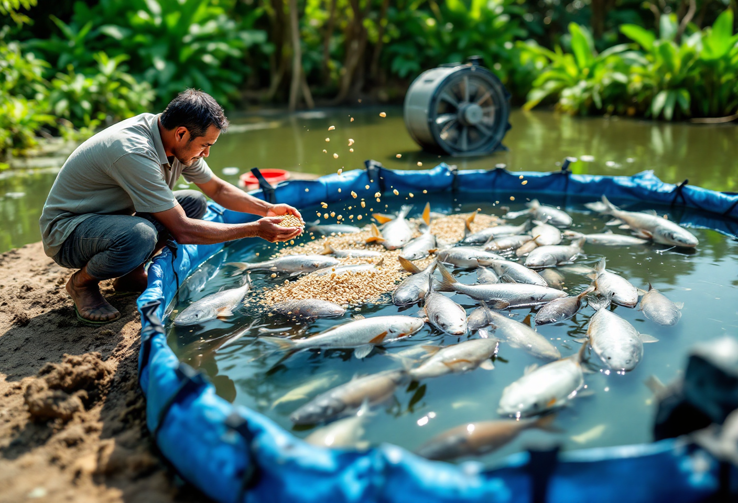
hero. Round tarpaulin pond with adult pangasius visible at the surface, an active aerator producing fine ripples, a farmer holding floating pellets, bright midday light

What Is Modern Pangasius Farming?
Modern pangasius farming is the controlled culture of Pangasianodon hypophthalmus (pangasius siam) or Pangasius djambal (jambal) in tarpaulin ponds, concrete tanks, biofloc systems, or floating net cages, using measured water parameters and phase-based nutrition. From a 5 cm fingerling, market-size fish of 800 grams to 1 kilogram are produced in 5 to 8 months, with feed conversion ratios (FCR) in the 1.2-1.6 range and survival rates of 80-90% in well-managed intensive systems.
What separates the modern approach from traditional earthen-pond culture is not the pond material. It is the operator’s mindset. The pond is treated as a production line. Water parameters are checked daily, not weekly. Feed is matched to the fish’s biological phase, not to whatever sack is cheapest at the local store. Biosecurity starts at the gate, not after the first disease outbreak.
P. hypophthalmus dominates commercial output because it grows fast, tolerates dense stocking, and converts feed efficiently. P. djambal is the premium pick for white-fleshed fillet exports; it commands higher prices in European and North American markets but is harder to hatchery-breed, so fingerling supply is tighter.

Which Pond System Fits Your Pangasius Operation?
No single system wins on every metric. Choice depends on capital, target output, land availability, and water access. The table below summarises five options that Indonesian farmers actively use today.
System | Stocking density | Capex | Water quality control | FCR estimate | Practical note
Earthen pond (traditional) | 5-15 fish/m² | Low | Minimal | 1.6-2.0 | Longer cycle, higher off-flavour risk
Tarpaulin pond (modern entry-level) | 20-40 fish/m² | Medium | Good | 1.3-1.6 | Beginner-friendly; better biosecurity
Concrete intensive | 50-100 fish/m² | High | Full | 1.2-1.4 | Best FCR; needs intensive aeration
Biofloc | 80-150 fish/m² | Medium-high | Full + recycling | 1.2-1.5 | Water-saving; flocs supplement feed
Floating net cage (reservoir) | 100-200 fish/m³ | Medium (infra) | Reservoir-dependent | 1.4-1.7 | Fast scale-up; vulnerable to water source
Tarpaulin ponds dominate among new entrants for a straightforward reason: the capex is manageable, installation is fast, and water-quality control is far closer to concrete-tank performance than to traditional earthen ponds. Concrete tanks become the obvious upgrade once an operator is ready to absorb higher capex in exchange for tighter FCR and 2 to 4 times the stocking density.
Biofloc draws farmers willing to learn a new technique. Safir et al. (2023), writing in the Journal Galung Tropika, confirmed that P. hypophthalmus can be cultured in biofloc with stable floc dynamics when molasses is added every two days. The headline benefit is feed cost reduction; the headline risk is the steeper learning curve around carbon-to-nitrogen ratio and total suspended solids.
Net cages suit farmers with reservoir access who need fast scale-up. The trade-off is loss of full control: if the reservoir’s water quality drops during a dry season or eutrophication event, the operator cannot intervene quickly.

Pond Preparation: The Pre-Stocking Checklist
Cutting corners on pond preparation usually shows up two weeks later as stressed fish, high mortality in week one, and an FCR that drifts off-target from day one. The standard sequence used by semi-intensive operators runs as follows:
- Dry the pond bottom for 5-7 days (earthen ponds only) to kill residual pathogens and oxidise organic load from the previous cycle.
- Apply CaCO₃ at 100-200 g/m² to stabilise bottom pH and break the pathogen cycle.
- Fill the pond gradually from a clean water source (well, irrigation canal, or spring); a mechanical filter at the inlet keeps wild fish out.
- Inoculate beneficial microbes 5-7 days before stocking, particularly important for biofloc and tarpaulin systems aiming to suppress ammonia.
- Measure baseline parameters: pH 6.5-7.5, DO at least 4 ppm, temperature 26-30°C, free ammonia (NH₃) below 0.5 ppm.
- Leach new tarpaulin for 3-5 days with fresh water to remove residual plasticisers and factory chemicals.
For new concrete tanks, 7-10 days of curing with circulating water prevents pH spikes from fresh cement. One detail that catches inexperienced operators: free ammonia, not total ammonia nitrogen, is the parameter that matters for fish toxicity. Two ponds with identical TAN readings can have radically different free-NH₃ loads if their pH differs by half a point.

How to Select and Stock Pangasius Fingerlings
Good fingerlings are easy to identify if the operator knows what to look for. Size is uniform: 3 to 5 cm for nursery stocking, or 5 to 8 cm for direct grow-out. Movement is active, body posture upright, no lesions on fins or gills, colour bright, and when the holding tank is gently stirred, fingerlings orient into the current rather than tumbling with it.
Source discipline matters as much as physical inspection. Certified hatcheries provide traceable origin, age uniformity, and (where applicable) vaccination records; all three are nearly impossible to validate when buying from a roadside supplier.
Acclimation is the step most often rushed. Float sealed transport bags on the pond surface for 20-30 minutes to equalise temperature, then introduce pond water into the bag gradually over 10-15 minutes before releasing fish. Stock early morning (06:00-08:00) or late afternoon (16:00-18:00), when water temperature is most stable.
Stocking density follows the system selected. New operators should run 10-20% below the upper band shown in the system comparison table; the margin absorbs minor errors in feeding and aeration during the first cycle.

comparative silhouette illustration showing pangasius at 5 cm fingerling, 10 cm juvenile, 20 cm grower, and 30+ cm harvest size, with weight and duration labels under each stage

Phase-Based Feed Management for Pangasius
Pangasius cycles through four nutritional phases that differ biologically, not just by size. Protein requirement falls as the fish ages, not because the animal becomes less efficient, but because metabolic priority shifts from tissue formation to muscle and lipid deposition. The schedule below reflects guidance from Indonesian fisheries research and the protein floors set by MMAF’s BPBAT Sungai Gelam in Jambi.
Phase | Fish size | Protein (%) | Feed format | Feeding rate | Frequency | Duration
Starter / fry | 3-5 cm | 40 | Crumble/powder ≤ 0.7 mm | 5-10% body weight/day | 4-6/day | 0-30 days
Nursery | 5-15 cm | 30-32 | Pellet 1-2 mm | 5-8% BW/day | 3-5/day | 30-90 days
Grow-out | 15-30 cm | 26-30 | Pellet 3-5 mm | 3-5% BW/day | 3-4/day | 90-180 days
Pre-harvest | over 30 cm | 26 (low fat) | Pellet 3-5 mm | 1.5-2% BW/day | 2-3/day | 2-4 weeks
Indonesia’s Ministry of Marine Affairs and Fisheries documents the starter standard in detail. At BPBAT Sungai Gelam Jambi (published September 2024), pangasius siam larvae are reared on 40% crude protein crumble at 0.4-0.7 mm, fed four times per day. Drop protein below 38% in this phase and growth flattens; survival follows.
For commercial operators, STP’s freshwater feed range carries phase-appropriate protein profiles that align with pangasius nutritional requirements. PA GOLD (40% protein, 3% crude fibre) matches the starter phase with a crumble format suited to fry mouth-opening. Moving into nursery, STP NGA 10 at 32% protein supports rapid growth alongside improved phosphorus uptake, which reduces nitrogenous load in the pond. From grow-out through pre-harvest, STP SPF Extruder (26% protein, 6% fat) delivers the FCR efficiency required when biomass peaks, and its moderate lipid profile assists the pre-harvest cleansing process. These feeds were originally formulated for tilapia, but the protein curve maps cleanly onto pangasius nutrition; the same principles also apply to tilapia feed selection by phase.
Satiation feeding, which means observing when the fish stop feeding aggressively, beats paper-calculated doses in practical operation. Operators who feed on a rigid schedule without reading the satiation cue typically over-feed by 8-12%, which shows up directly in FCR and water quality.

How to Manage Water Quality and Fish Health
Pangasius has a reputation for being hardy because it can supplement gill respiration via a suprabranchial labyrinth organ. That biology is real, and treating it as an excuse to under-invest in aeration is an expensive mistake. At 80 fish/m² and above, growth and FCR are highly sensitive to dissolved oxygen. Holding DO above 4 ppm delivers more consistent average daily gain than letting it swing between 2 and 3 ppm.
Five parameters merit daily monitoring:
- Temperature: target 26-30°C; above 32°C add shade or increase inflow.
- pH: target 6.5-7.5; dolomite lime raises pH, fresh water dilution lowers it.
- DO: target at least 4 ppm; aerators run hardest at night and pre-dawn when photosynthesis stops.
- Free ammonia (NH₃): target below 0.1 ppm; if it rises, exchange 30% of water and inoculate nitrifying probiotics.
- CO₂: target below 5 ppm; high CO₂ usually signals over-feeding or insufficient aeration.
To maintain DO above 3 ppm in intensive ponds, the AT21 ME500 aerator from STP’s Aquaculture Technology Department is an energy-efficient option for small-to-medium ponds. Larger setups step up to the ME1500 variant.
Three pathogens recur in pangasius farming: Aeromonas hydrophila (a bacterium that can drive mass mortality if untreated), Trichodina sp. (a parasite of skin and gills), and Saprolegnia sp. (an opportunistic fungus on stressed or injured fish). Prevention is far cheaper than treatment: avoid overstocking, exchange water on schedule, sterilise equipment between ponds, and never let wet feed sit on the pond bottom. When clinical signs appear, consult a fish veterinarian or extension officer before reaching for antibiotics.
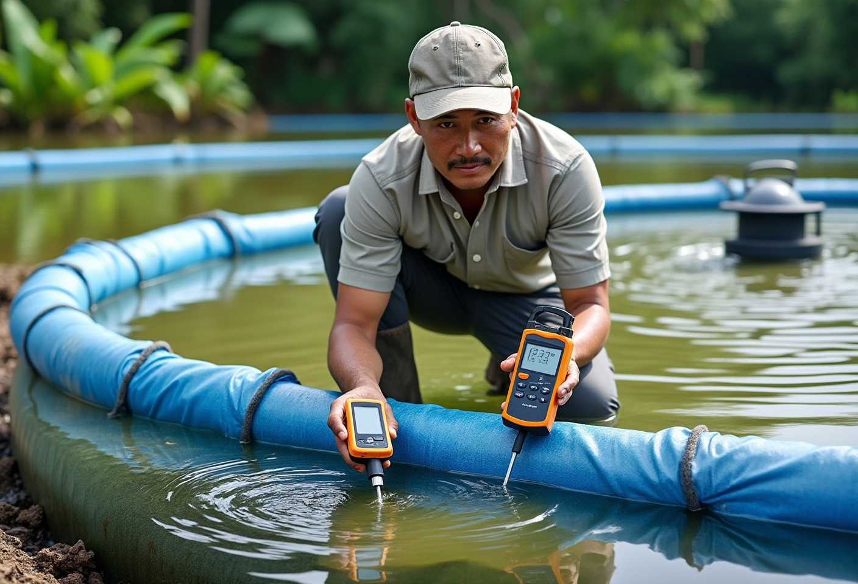
a farmer checks water parameters with a handheld DO meter and pH meter at the edge of a tarpaulin pond, an active aerator visible in the background

Harvest: Timing and the Off-Flavour Fix
Harvest size depends on the market. The fresh domestic trade absorbs fish at 800 grams to 1 kilogram. Fillet processors, including STP’s Banyuwangi pangasius plant, prefer 1.5 to 2 kilograms because fillet yield per fish climbs at higher weights.
The classic problem with pond-raised pangasius is muddy off-flavour, caused by geosmin and 2-methylisoborneol (2-MIB) accumulating in muscle tissue. The compounds are produced by blue-green algae and certain bacteria thriving in sediment-rich water. The fix is purging: holding fish in clean flowing water before harvest while feed is withdrawn or sharply reduced.
Mukti (2005), publishing through IPB University, quantified the dynamics with unusual precision. In flowing water at 3 litres/second, 32°C, and a stocking ratio of 1 kg of fish per 19 litres, muddy off-flavour declined significantly within 12 hours and was fully eliminated by 60 hours. Commercial operators typically run a 5-7 day purge cycle, which builds operational margin into Mukti’s biological minimum. During purging, fish are either fasted or fed a low-fat ration; STP SPF Extruder at 6% fat is often used as the transition feed before full fasting.
Post-harvest handling is the last quality lever. Fish are netted out, killed rapidly with an ice slurry at 0-2°C to prevent stress-driven flesh deterioration, and dispatched to the buyer or processor inside 6 hours.

Frequently Asked Questions

How long does a pangasius growth cycle take?
From a 5 cm fingerling, pangasius reaches a market weight of 800 grams to 1 kilogram in 5 to 8 months. Biofloc and intensive concrete systems with precise feed management can approach the 5-month floor. Tarpaulin ponds typically harvest in month 5 or 6. Traditional earthen ponds usually need 7 to 8 months because stocking density is lower and feed conversion is less efficient.

Can pangasius be farmed in a small backyard tarpaulin pond?
Yes. A round tarpaulin pond 3-5 metres in diameter with 80-100 cm of water depth supports household-scale culture at 20-40 fish/m². The non-negotiable items: minimum aeration (DO at least 3 ppm), 3-5 days of leaching for new tarpaulin to remove residual chemicals, and a 30% water exchange every 2-3 weeks to manage ammonia.

What is the difference between pangasius siam and jambal for farming?
Pangasianodon hypophthalmus (siam) dominates commercial output because it grows fast, tolerates low DO, and delivers better FCR. Flesh is yellowish-white. Pangasius djambal (jambal) produces clean white flesh prized in European, North American, and high-end Asian fillet markets, but is harder to hatchery-breed and the cycle is more complex. Jambal fingerlings became commercially available around the year 2000.

Is pangasius suited to biofloc systems?
Yes. Pangasius siam tolerates high stocking density and can use microbial flocs as a supplementary nutrient source, which reduces purchased feed cost. Safir et al. (2023) in the Journal Galung Tropika confirmed that biofloc culture for pangasius siam runs reliably when molasses is added every two days. The keys to success are intensive aeration, controlling carbon-to-nitrogen ratio, and disciplined monitoring of total suspended solids.

Why does pangasius sometimes taste muddy, and how do you fix it?
Muddy off-flavour comes from geosmin and 2-MIB compounds that accumulate from blue-green algae and sediment bacteria. The solution is pre-harvest purging in clean flowing water at 28-32°C while feeding is reduced or stopped. IPB research (Mukti, 2005) measured that off-flavour drops significantly within 12 hours and is fully eliminated by 60 hours; modern operations apply a 5-7 day purge as standard practice.

What FCR should pangasius farmers target?
Pangasius FCR ranges from 1.2 to 1.6 depending on the production system and management quality. Well-run tarpaulin ponds reach 1.2-1.3 over a 120-day cycle (practitioner data). Concrete intensive systems sit at 1.2-1.4. Floating net cages typically register 1.4-1.7 because water quality cannot be fully controlled. Biofloc lands at 1.2-1.5 because microbial flocs contribute supplementary nutrition.

Does pangasius need aeration if it can breathe air?
Pangasius does have a suprabranchial labyrinth organ that allows aerial respiration, but that biology is not a substitute for aeration. At 80 fish/m² and above, low DO (below 3 ppm) suppresses growth and worsens FCR even when fish survive. Aeration maintains DO at 4 ppm or higher so that feed converts efficiently into biomass; keeping fish alive is a much lower bar than keeping them productive.

Pangasius farming is not about following the most fashionable system. It is about closing the gap between fish biology and operator discipline. System choice, clean pond preparation, phase-correct feed, daily water-quality monitoring, and consistent pre-harvest purging are the five control points that separate a farm running at FCR 1.3 from one stuck at FCR 1.8. STP, a total-solution aquaculture company operating since 1987, supports this full cycle with feed, hatchery supply, on-farm aeration technology, and a Banyuwangi pangasius processing plant that anchors the downstream end of the value chain. Operators planning a next cycle can review the STP feed range for cultured fish to match nutritional profiles to their production targets.

