Article Metadata
title: "Floating Net Cage Aquaculture Business: Capital Investment and Profit Outlook"
meta_title: "Floating Net Cage Aquaculture: Capital & Profit 2026"
meta_description: "Inside the floating net cage (KJA) aquaculture business: capital breakdown from US$5,000-10,000, three-scenario profit modeling, and systemic risks."
slug: "floating-net-cage-aquaculture-business-capital-profit"
language: "en"
primary_keyword: "floating net cage aquaculture"
secondary_keywords:
- "floating net cage business"
- "KJA aquaculture investment"
- "floating cage capital"
- "tilapia cage farming profit"
- "cage aquaculture ROI"
- "lake cage farming Indonesia"
- "freshwater cage culture"
- "cage aquaculture risks"
- "upwelling fish kill"
- "HDPE floating cage"
internal_links:
- url: "https://stpaquaculture.com/en/news/pakan-ikan-budidaya-terbaik-stp"
anchor: "STP feed range for cultured fish"
- url: "https://stpaquaculture.com/en/news/pakan-ikan-nila"
anchor: "tilapia feed"
external_citations:
- url: "https://www.antaranews.com/berita/5314777/sekitar-142873-ton-ikan-mati-dampak-upwelling-air-danau-maninjau"
context: "Lake Maninjau upwelling December 2025 — 1,428.73 tons of tilapia killed, IDR 32.86 billion in losses"
- url: "https://kkp.go.id/news/news-detail/menteri-trenggono-berhasil-tingkatkan-produksi-perikanan-budi-daya-136-di-2024-vQq0.html"
context: "Indonesian aquaculture production 2024 — 6.37 million tons, up 13.64% year-on-year"
- url: "https://www.aimspress.com/article/doi/10.3934/environsci.2022001"
context: "AIMS Environmental Science peer-reviewed study on Lake Maninjau cage capacity, productivity, and feed supplier market structure"
brief_id: "keramba-jaring-apung-01"
word_count: 1842
publish_month: "2026-05"
editor_run_date: "2026-05-26"

Floating Net Cage Aquaculture Business: Capital Investment and Profit Outlook
The floating net cage aquaculture business, known locally in Indonesia as Keramba Jaring Apung (KJA), is one of the more realistic entry points into commercial fish farming. Capital outlay sits well below land-based pond systems, harvest cycles are short, and Indonesia’s large freshwater reservoirs offer thousands of hectares of productive surface water. This article unpacks the actual numbers: how much money it takes to set up four standard cages, which species make sense for which capital tier, how a one-year profit projection looks across conservative, moderate, and optimistic scenarios, and which risks can erase a year of margin overnight.
Data released by Indonesia’s Ministry of Marine Affairs and Fisheries (KKP) shows national aquaculture output reached 6.37 million tons in 2024, up 13.64% year-on-year. Tilapia alone accounted for 1.38 million tons. That growth has drawn new investors into cage farming. Many of them, however, run the numbers using optimistic assumptions and are caught off-guard when their first cycle barely breaks even. The framing here is built to keep readers on the right side of that line.
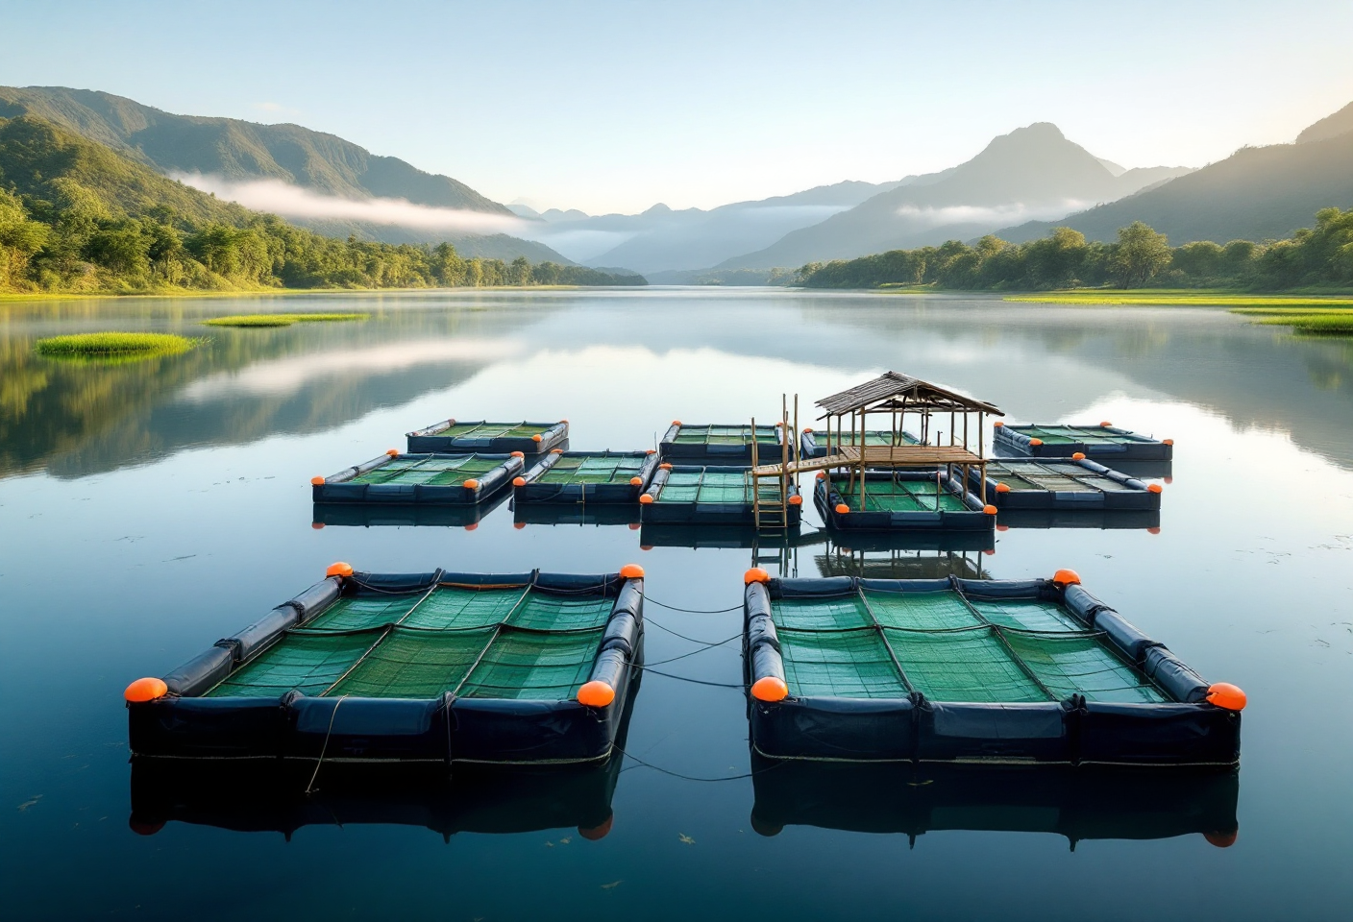
hero — row of HDPE floating net cages on a tropical reservoir at sunrise, calm water, green hills in background, light mist

What Floating Net Cage Aquaculture Is and Why Investors Are Watching
Floating net cage (KJA) aquaculture is the culture of fish in open water bodies (lakes, reservoirs, or sheltered coastal areas) using nets suspended from a buoyant frame. Indonesian operators raise tilapia, common carp, pangasius, gourami, and (in marine cages) grouper and snapper. A four-cage entry-level setup runs roughly IDR 72-153 million (approx. US$4,500-9,500), depending on whether the frame is bamboo or HDPE. Because the water body itself serves as the culture medium, the system eliminates pumping, wells, and most water-treatment costs.
The international parallels are familiar. Norwegian salmon producers operate massive HDPE cages in coastal fjords. Mekong Delta farmers in Vietnam run pangasius cages on river arms. Indonesia’s version is concentrated in inland reservoirs and deep volcanic lakes: Cirata, Saguling, and Jatiluhur in West Java, plus Lake Toba, Maninjau, and Singkarak in Sumatra. A peer-reviewed AIMS Environmental Science study (2022) recorded tilapia productivity of 12 kg/m³ per cycle in Lake Maninjau cages, with common carp at 11.5 kg/m³ and pangasius at 8.89 kg/m³. Those output densities are difficult for pond systems to match in the same water volume.
Popularity has consequences. Waduk Cirata now holds roughly 91,000 KJA units, more than 15 times the recommended carrying capacity of around 6,000 units. Saguling sits at 51,418 cages and Jatiluhur at 46,270, with thousands dismantled annually by the Citarum Harum task force. Any investor eyeing these three reservoirs needs to check zoning status before placing an order for cage frames.

Which Species Are Most Profitable in Floating Cages?
Species selection drives the capital structure, cash-cycle length, and risk profile of the entire operation. Match the species to your capital, your patience for long cycles, and your tolerance for disease shocks.
Species | Cycle length | Stocking density (fish/m³) | Productivity (kg/m³/cycle) | Typical FCR | Farm-gate price (May 2026 est.) | Investor profile
Tilapia (Oreochromis niloticus) | 4-6 months | 50-100 | 12 | 1.5-1.7 | IDR 23,000-27,000/kg (~US$1.40-1.65) | Small to mid-capital
Common carp (Cyprinus carpio) | 4-5 months | 50-80 | 11.5 | 1.6-1.8 | IDR 28,000-40,000/kg* | Small to mid-capital; high KHV risk
Pangasius (Pangasius sp.) | 6-8 months | 40-70 | 8.89 | 1.8-2.2 | IDR 14,000-16,000/kg | Mid-capital
Gourami (Osphronemus goramy) | 12-18 months | 20-40 | 10.4 | 1.8-2.0 | IDR 35,000-55,000/kg* | Mid to large capital; premium margin
Grouper / snapper (marine) | 12-18 months | 10-20 | varies | 3.0-4.5 | IDR 80,000-150,000/kg* | Large capital; export market
*Estimate range for 2025-2026; verify against Bursa Ikan KKP (bursaikan.kkp.go.id) before investment decisions.
Tilapia remains the most sensible entry-level species. The cycle is short, the fish tolerates fluctuations in temperature and water quality reasonably well, and domestic demand absorbs steady volume year-round. Common carp commands higher per-kilo prices but is vulnerable to Koi Herpesvirus (KHV), which can erase 80-100% of biomass within weeks. The 150-ton kill at Waduk PLTA Koto Panjang in Kampar, Riau in February 2023 is the cautionary tale farmers cite. Gourami suits operators with patience and a stable market. Marine grouper and snapper belong to large-capital operators with established export buyer relationships.

Capital Breakdown for a Four-Cage Floating Net Cage Operation
The figures below assume four standard cages measuring 4 × 4 × 3 meters, stocked with 10,000 tilapia per cycle in freshwater (lake or reservoir).
Component | Bamboo/wood frame | HDPE frame | Notes
Frame + flotation | IDR 10-15 million | IDR 25-40 million | HDPE service life up to 15 years vs 2-3 years for bamboo
Nets (4 bags + spare) | IDR 5-10 million | IDR 8-15 million | Mesh size matched to fish size
Anchors + mooring lines | IDR 2-5 million | IDR 3-5 million | Line length ≥2.5× depth at high water
Tilapia fingerlings (10,000 head, ~5 g) | IDR 5-8 million | IDR 5-8 million | IDR 500-800 per fingerling
Feed for first cycle (~4-5 months) | IDR 35-60 million | IDR 35-60 million | Assumes FCR 1.5, target harvest 2 tons
Operations (labor, transport) | IDR 8-12 million | IDR 8-12 million | Per cycle
Contingency (10%) | IDR 7-11 million | IDR 8-13 million
TOTAL STARTUP CAPITAL | IDR 72-121 million (US$4,500-7,600) | IDR 92-153 million (US$5,750-9,600) | Micro-small scale
HDPE costs more up front, but on a 10-year total cost of ownership basis, it is the cheaper option. Bamboo frames need structural replacement every 2-3 years; HDPE lasts up to 15 years, resists corrosion, and demands less maintenance. For operators planning incremental expansion, HDPE is the default choice.
One practical note that catches first-time investors off-guard: feed is the largest single cost line, often 50-60% of the cycle budget. Feed selection and feeding discipline are therefore the two variables that decide whether the cycle ends in profit or in a break-even shrug.
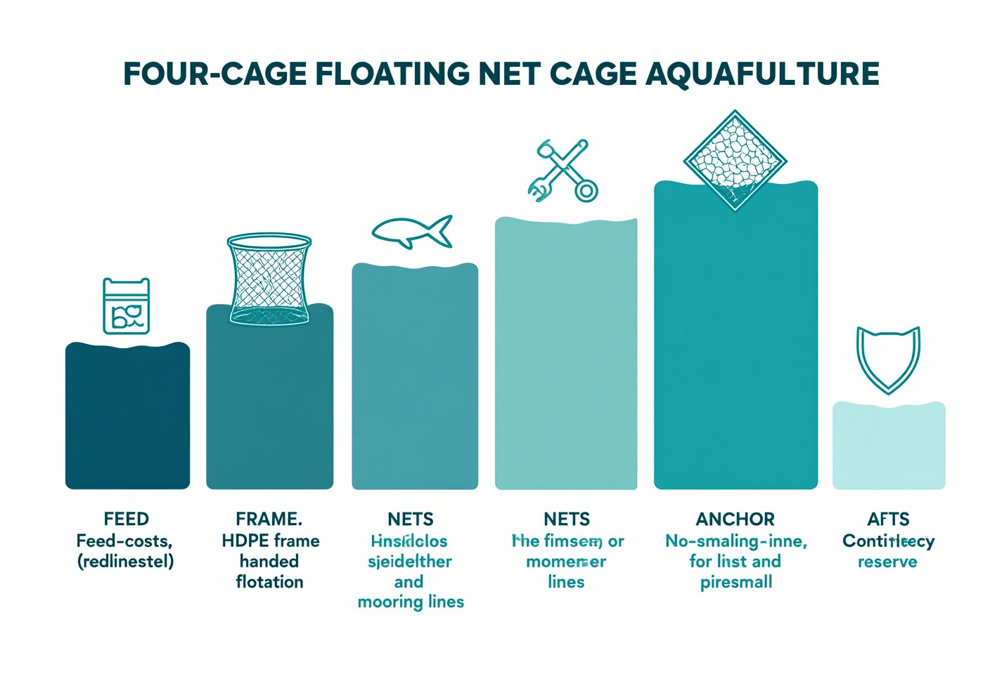
infographic showing capital breakdown for four-cage KJA setup — labeled components (frame, flotation, nets, anchors) with cost ranges, flat design, blue-green palette

Worked Example: One-Year Profit Outlook Across Three Scenarios
Most KJA business calculators circulating online produce a single, suspiciously rosy profit figure. Field reality is more jagged. Three scenarios below share the same baseline assumptions: four cages × 2,500 fish (10,000 per cycle), survival rate (SR) 80-90%, two cycles per year, FCR 1.5-1.7.
Conservative scenario (tilapia price IDR 25,000/kg, SR 80%, FCR 1.7):
- Harvest per cycle: 8,000 fish × 250 g = 2 tons
- Revenue per cycle: IDR 50 million
- Feed cost (3.4 tons × IDR 15,000): ~IDR 51 million
- Operations + amortization: ~IDR 12 million
- Annual outcome: near break-even to slight loss in year one
Moderate scenario (IDR 27,000/kg, SR 85%, FCR 1.6):
- Harvest per cycle: 8,500 fish × 250 g = 2.125 tons
- Annual revenue: IDR 114.75 million
- Annual feed + operations: ~IDR 95 million
- Net annual profit: ~IDR 19 million (~US$1,200)
Optimistic scenario (IDR 28,000/kg, SR 90%, FCR 1.5, direct-to-consumer access):
- Harvest per cycle: 9,000 fish × 250 g = 2.25 tons
- Annual revenue: IDR 126 million
- Annual total cost: ~IDR 89 million
- Net annual profit: ~IDR 37 million (~US$2,300), ROI ~25-30%, payback period around 3 years
These figures align with a published farm analysis from Sragen Regency in the Buletin Ilmiah Marina (a KKP-affiliated journal): operating cost IDR 131.5 million, revenue IDR 182.2 million, net profit IDR 50.75 million, R/C ratio 1.3. Real profitability shows up when at least two of three variables (sale price, SR, and FCR) are actively controlled.

Phase-based feeding to push FCR down
A 0.2-point drop in FCR can shift annual margin by tens of millions of rupiah. Phase-based feeding is the most consistent way to chase that improvement. For tilapia in cages, the tilapia feed lineup from STP offers a working reference:
- Fry phase (1-5 g, 2-3 weeks): crumble feed at 40% protein such as PA GOLD, fed 4-6 times daily to support early tissue formation.
- Nursery to grower (5-30 g, 3-5 weeks): small pellets at 32% protein such as STP NGA 10, accelerating growth before transfer to grow-out bags.
- Grow-out (30-200 g, 2-3 months): extruded floating pellets at 26% protein such as STP SPF Extruder. Because the pellets float, leftover feed is visible and easily monitored, and uneaten feed does not foul the lake bed.
- Pre-harvest (>200 g, 2-4 weeks): continued extruded feed combined with a cleansing protocol to clear off-flavors before harvest.
Floating feed has a second advantage in cages. Operators can read feeding behavior directly from the water surface: if 80-90% of the ration disappears within 15 minutes, the rhythm is right. If too much remains, drop the dose next feeding. That simple discipline is what separates the operator running FCR 1.5 from the one stuck at 1.8.

Siting and Permits
Site quality is a silent contract between the operator and the lake. A bad site cannot be rescued by premium feed. The minimum technical criteria reference SNI 8175:2015:
- Water depth 7-15 meters minimum, with ≥3 m clearance between net bottom and lake floor
- Optimal current 0.1-0.3 m/second
- Minimum spacing 0.5 m between cages on the same raft; 2 m between separate rafts
- Anchor line length ≥2.5× water depth at high water
- Year-round road or boat access for feed delivery and harvest
On permits: for inland waters (lakes, reservoirs), licensing is handled by the provincial or regency-level Marine Affairs and Fisheries Office, referenced against the local spatial plan (RTRW). For marine cages, operators must hold a marine space utilization approval (PKKPRL) from KKP. Micro and small enterprises can file a Self-Declaration via the risk-based OSS system. Compliance is not paperwork theater. KKP regulations on aquaculture water-body zoning are actively enforced, including the 2023 seizure of a 2-hectare unlicensed cage cluster in Batam.
For Cirata, Saguling, and Jatiluhur specifically, prospective operators must confirm zoning status with the Citarum Harum task force before purchasing frames. In 2023, 1,710 cages were dismantled at Saguling and 2,179 at Jatiluhur, with another 10,000 targeted for removal at Jatiluhur. This is not territory for unconfirmed investment.

Systemic Risks and How to Manage Them
This section is the one most often skipped by first-time investors. It also covers the events most capable of erasing several years of margin in a single morning.
Upwelling is the most brutal risk in Indonesian volcanic lakes. In December 2025, an upwelling event at Lake Maninjau killed approximately 1,428.73 tons of harvest-ready tilapia in a single episode, with farmer losses estimated at IDR 32.86 billion (around US$2 million), according to ANTARA News. It was not a one-off. February 2022 saw 130 tons killed; May 2023, 15.2 tons. Upwelling occurs when cold anoxic bottom water inverts to the surface, typically triggered by strong winds or sudden temperature shifts. Dissolved oxygen can drop from 6 ppm to below 2 ppm within hours.
Practical mitigation that operators have actually found effective:
- Hold stocking density to 70-80% of recommended maximum
- Install automated DO meters with alarm thresholds below 4 ppm
- Keep portable paddle-wheel aerators on site as emergency response
- Diversify locations; do not concentrate all cages in a single lake
- Consider aquaculture insurance, especially at scales of 8 cages or more
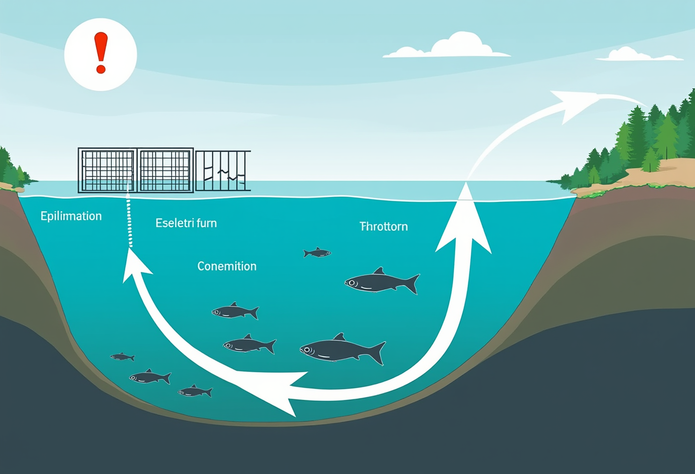
conceptual illustration of upwelling — cross-section diagram showing warm surface layer and cold anoxic bottom layer inverting due to wind, with fish icons and warning markers
Disease is the daily-grind risk. KHV in common carp activates between 18-28 °C and triggers 80-100% mortality within weeks. In tilapia, Motile Aeromonas Septicemia (MAS) is the dominant threat, accelerating when water quality declines. STP’s Animal Health Team and Mobile Diagnostic Lab perform on-site diagnostics at cage locations. That matters because most cages sit hours away from land-based labs, and every day of diagnostic delay translates into additional mortality.
Price volatility rounds out the risk picture. Farm-gate tilapia prices can fall to IDR 18,000-20,000/kg during regional peak-harvest periods. Diversifying distribution channels (collectors, traditional markets, restaurant accounts, and direct-to-consumer sales) is how operators manage that exposure.

Choosing a Feed Partner
Feed determines FCR, and FCR determines profitability. Cage operations have specific feed criteria that differ from land-based ponds:
- Floating (extruded) feed is strongly preferred for the visibility it gives operators
- Protein profiles must match the biological phase, not chase an arbitrary “high-protein” target
- Water stability matters; pellets that disintegrate within 2 minutes pollute the lake bed
- Logistics coverage near the cage location drives effective feed cost more than list price does
JAPFA, STP’s parent company, is documented as the largest single feed supplier at Lake Maninjau with 35% market share (AIMS Environmental Science, 2022), a real-world proof point of distribution reach in major cage-farming regions. STP operates five feedmills (Medan, South Lampung, Purwakarta, Gresik, Banyuwangi) covering every major KJA region. Feed formulations are developed at JARS, the JAPFA Aquaculture Research Station, with three sites in North Sumatra, West Java, and East Java; the same provinces that host Indonesia’s largest cage clusters. Lake and reservoir water differs in chemistry from coastal ponds; feed tested under those conditions is a concrete advantage, not a marketing line.
For operators looking to deepen their phase-feeding framework across freshwater species, the STP feed range for cultured fish offers a detailed phase map.

Frequently Asked Questions

What is the payback period for floating net cages in a lake versus marine cages?
For tilapia or common carp cages in lakes at a four-cage scale, payback is typically 2-3 years assuming stable prices and FCR around 1.5-1.7. For grouper or snapper in marine cages, payback runs longer at 3-5 years because construction is more expensive and weather exposure is greater, even though per-kilo prices can be three to four times higher than freshwater tilapia.

Is HDPE required for floating net cages or is bamboo acceptable?
Nothing prohibits bamboo or wood frames. SNI 8175:2015 standardizes polyethylene-frame construction, but bamboo is still common at small scale because the frame itself runs roughly IDR 10-15 million for four cages, versus IDR 25-40 million for HDPE. HDPE wins on service life (up to 15 years vs 2-3 for bamboo) and maintenance burden. For long-horizon investment, HDPE delivers lower total cost of ownership.

How is a permit obtained for a cage location on a reservoir or lake?
For inland water bodies, the provincial or regency Marine Affairs and Fisheries Office issues the location permit, cross-referenced against the local spatial plan (RTRW). For marine cages, KKP issues a PKKPRL marine space approval. Micro and small operators file a Self-Declaration through the risk-based OSS portal. Critically, prospective operators must check whether the target zone is open. Jatiluhur, Cirata, and Saguling are under active enforcement.

Can floating cages be installed in fast-flowing rivers?
Technically yes, but the ideal current range is 0.1-0.3 m/second. Below 0.1 m/s, water exchange is too slow to clear metabolites and maintain oxygen. Above 0.3 m/s, nets risk damage and fish experience chronic stress. Currents above 0.5 m/s are generally not recommended. River siting also involves the relevant river-basin authority, which sits outside KKP’s direct jurisdiction.

How many people are needed to manage four floating cages?
Four cages of 4 × 4 m stocked with 10,000 fish can be managed by 1-2 people for daily operations: feeding 3-4 times per day, daily water-quality checks (DO, temperature), net inspection, and periodic grading. Sites far from shore need a night watchman. Expanding to 10-20 cages typically requires a team of 3-5 to maintain operational efficiency and biosecurity oversight.

What is the emergency response to a mass mortality event from upwelling?
Immediate action: partial harvest of surviving fish to salvage market value. If DO starts dropping (a DO meter is non-negotiable), portable paddle-wheel aerators buy time. Long-term measures: reduce stocking to 70-80% of maximum capacity, install DO meters with alarms below 4 ppm, diversify across multiple lakes, and carry aquaculture insurance. The Lake Maninjau event of December 2025 (1,428.73 tons lost, IDR 32.86 billion in damages) confirms upwelling is recurring rather than freak.

What is a safe stocking density for tilapia in cages?
Tilapia stocking density in cages spans 30-130 fish/m³ depending on management. Moderate-intensification systems for first-time operators typically settle around 100 fish/m³. Biological performance starts to degrade above roughly 173 fish/m³, with slower growth, higher FCR, and increased disease vulnerability. For a four-cage 4 × 4 × 3 m configuration (~48 m³ effective volume per bag), initial stocking of 2,000-2,500 fish per cage is a reasonable starting point.

Floating net cage aquaculture is a real opportunity, but the opportunity is gated by numerical discipline: FCR, survival rate, sale price, and operating cost. Operators who track all four, who match feed to phase, and who design upfront mitigation against systemic risks like upwelling are the ones still harvesting at cycle ten and beyond. STP, the aquaculture arm of JAPFA, has operated as a total-solution aquaculture company since 1987, supplying not just feed but also disease diagnostics through its Animal Health Team and Mobile Diagnostic Lab and formulation research through JARS. For cage operators working to push FCR down and biomass survival up, partnering with a feed supplier that has documented field presence in similar conditions is one of the more meaningful decisions made on day one, well before the first batch of fingerlings hits the water.

