Article Metadata
title: "Function and Benefits of Paddlewheel Aerators in Shrimp Ponds"
meta_title: "Paddlewheel Aerator Shrimp Pond: Functions & HP Sizing"
meta_description: "Paddlewheel aerator shrimp pond guide: 4 core functions, 1 HP per 500 kg biomass rule, DO targets above 4 ppm, sizing table by stocking density."
slug: "paddlewheel-aerator-shrimp-pond"
language: "en"
primary_keyword: "paddlewheel aerator shrimp pond"
secondary_keywords:
- "paddlewheel aerator vannamei"
- "shrimp pond aeration"
- "dissolved oxygen shrimp pond"
- "shrimp aerator HP calculation"
- "aerator placement shrimp pond"
- "energy-saving shrimp aerator"
- "intensive vannamei aeration"
- "shrimp pond oxygen requirement"
- "AT21 aerator"
- "shrimp pond central drain"
internal_links:
- url: "https://stpaquaculture.com/en/news/budidaya-udang-vaname"
anchor: "intensive vannamei farming"
- url: "https://stpaquaculture.com/en/news/pakan-udang-vaname"
anchor: "vannamei shrimp feed"
- url: "https://stpaquaculture.com/en/news/benur-udang-vaname"
anchor: "quality vannamei post-larvae"
external_citations:
- url: "https://onlinelibrary.wiley.com/doi/10.1111/jwas.12753"
context: "Boyd 2021 JWAS — 1 HP per 400-500 kg biomass rule; 11.5 GJ/MT Asian paddlewheel energy consumption"
- url: "https://ejournal-balitbang.kkp.go.id/index.php/salamata/article/view/17360"
context: "Permen KP No. 75/2016 — DO above 4 ppm, temperature 28-31 C, vannamei water quality standards"
- url: "https://www.fao.org/4/ac006e/AC006E04.htm"
context: "FAO Penaeid Shrimp Manual — DO critical thresholds 2.7 ppm field mortality"
- url: "https://ejournal.undip.ac.id/index.php/saintek/article/view/35669"
context: "Wafi et al. UNDIP — aeration electricity 15% of production cost; 0.97-1.07 kW per 2 HP unit"
brief_id: "kincir-tambak-udang-01"
word_count: 1720
publish_month: "2026-05"

Function and Benefits of Paddlewheel Aerators in Shrimp Ponds
The paddlewheel aerator shrimp pond setup is one of the most familiar sights in commercial vannamei farming worldwide, and yet it remains one of the most under-engineered. Blades spin at the surface and that is what most operators see, but the actual job covers four overlapping tasks: holding dissolved oxygen above the safety line, generating horizontal flow, sweeping sludge toward the central drain, and stripping ammonia and hydrogen sulfide out of the water column. This article walks through what paddlewheels really do, the operational gains and losses tied to each function, a sizing formula based on biomass, placement and scheduling rules, and the energy-efficient options available to farmers operating in Indonesian conditions.
The timing matters. Aeration electricity accounts for roughly 15 percent of total production cost in intensive vannamei systems, according to Wafi et al. at Universitas Diponegoro. Stocking densities keep climbing as well; KKP field trials have run super-intensive cycles at 750 to 1,250 shrimp per square meter. Every misjudgment in aerator count, placement, or runtime feeds straight into FCR, survival, and margin per cycle. Before debating feed brands or post-larvae genetics, the aeration layer must be solid. That is doubly true for farms running intensive vannamei farming at the higher end of the density curve.
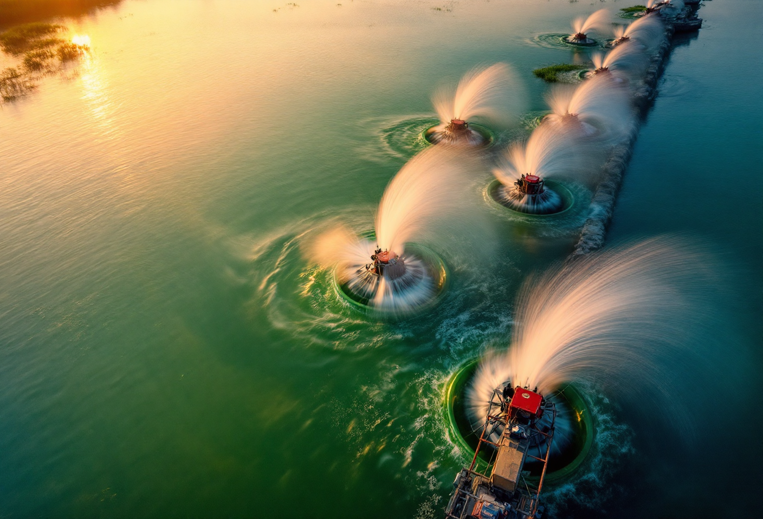
hero, row of 6-8 paddlewheel aerators spinning in an intensive vannamei pond at sunrise, white water spray, orange sky, healthy green phytoplankton water, aerial-low perspective from the dike

What Is a Paddlewheel Aerator and Why It Is Non-Negotiable
A paddlewheel aerator (kincir tambak udang) is an electric-motor-driven device that rotates paddles at the pond surface to perform four interlinked tasks: raise dissolved oxygen above 4 ppm at dawn, create horizontal circulation, push sediment toward a central drain, and accelerate the release of toxic gases such as ammonia and hydrogen sulfide. For intensive vannamei ponds, the global rule of thumb sits at 1 HP of installed aeration for every 500 kg of peak shrimp biomass, equivalent to 2 HP per metric ton.
The technology took commercial hold in Taiwan during the 1980s and spread into Southeast Asia through the 1990s, first for black tiger shrimp and then dominating intensive Litopenaeus vannamei production after the early 2000s transition. Boyd (2021, Journal of the World Aquaculture Society) estimates that roughly four of every five million metric tons of pond-farmed penaeid shrimp come from systems using mechanical aeration. In practice, paddlewheels become mandatory once stocking density crosses 50 shrimp per square meter, which means nearly every commercial vannamei pond in the world depends on them.
How does the paddlewheel differ from other aerators?
- Paddlewheel: solid oxygen transfer, excellent horizontal circulation, good sediment centralization, durable in brackish water.
- Root blower with diffusers: highest oxygen transfer efficiency at roughly 3 to 5 kg O2 per kWh, but limited to vertical circulation only.
- Nano-bubble diffuser: best per-watt oxygenation, expensive upfront, no sediment-sweeping function.
- Venturi aerator: simple, no gearbox, capacity too limited for large intensive ponds.
That mix explains why paddlewheels remain the backbone of vannamei aeration. The sediment-driving role is not something a diffuser-only system can replicate at comparable cost. Farms stocking quality vannamei post-larvae at intensive densities have no realistic alternative to designing the paddlewheel layout properly from day one.

Four Core Functions of Paddlewheel Aerators
The four functions are tightly coupled. Neglect one and cycle performance drops even if the paddlewheels are visibly spinning.
1. Surface oxygenation. Paddles transfer atmospheric oxygen into the water column by generating turbulence in the top layer. Standard Aeration Efficiency for paddlewheels falls between 2.6 and 3.0 kg O2 per kWh in clean freshwater test conditions (Boyd, 1998, Aquacultural Engineering). Operational targets sit at 4 ppm or higher at dawn and 5 to 6 ppm during the day, anchored by Permen KP No. 75 Tahun 2016 on intensive vannamei water quality.
2. Water circulation. Paddle rotation creates horizontal flow that prevents thermal and oxygen stratification between the surface and pond bottom. The same current distributes plankton and feed particles evenly, which improves feeding efficiency and eliminates the dead anoxic pockets that often form in corners.
3. Sediment centralization to the central drain. This is the function rookies overlook. When paddlewheels are angled correctly at 30 to 45 degrees relative to the dike wall, the circular current drives feces, uneaten feed, and molted shells toward the pond center. A properly built central drain then evacuates that bottom waste efficiently between cycles.
4. Off-gassing of ammonia and hydrogen sulfide. Surface agitation accelerates the release of NH3 and H2S generated by shrimp metabolism and organic decomposition. Permen KP 75/2016 caps ammonia at 0.1 mg per liter for vannamei ponds, a level very difficult to hold without active surface aeration.
Note: shrimp oxygen consumption can double for every 10 degree Celsius rise in temperature (Q10 effect). Indonesian ponds routinely reach 31 to 32 degrees Celsius mid-afternoon, which means real oxygen demand sits above the textbook figures calculated at a 25 degree baseline.

Operational Benefits: What Goes Wrong When Aeration Is Light
The numbers speak. At intensive densities of 100 to 150 shrimp per square meter, ponds with properly sized aeration consistently hit efficient FCR. KKP research published in Media Akuakultur recorded FCR of 1.36 at 1,000 shrimp per square meter and 1.40 at 750. When DO regularly dips below 3 ppm, shrimp stop feeding, molting stalls, and FCR climbs to 1.8 or higher. A 0.4-point FCR swing on an 8-ton biomass cycle equals roughly 3,200 kg of additional feed, which lands directly on the profit-loss statement.
The typical losses from under-aerated ponds break down as follows:
- Dawn DO drops below 3 ppm, triggering hypoxic stress, reduced feed intake, and elevated susceptibility to Acute Hepatopancreatic Necrosis Disease (AHPND or EMS).
- Temperature and oxygen stratify, leaving the pond bottom anoxic and accelerating hydrogen sulfide accumulation that is toxic even at trace concentrations.
- Sediment scatters uncontrolled, the central drain underperforms, and between-cycle bottom cleaning costs rise.
- Ammonia accumulates, slowing molts and pulling average daily growth (ADG) from a healthy 0.17 to 0.25 grams per day down toward less than 0.1 g per day.
- Survival drops, with a single dawn-DO crash event capable of taking 5 to 15 percent of the population.
The economic damage shows up fast. FAO data document significant field mortality once DO falls to 2.7 ppm, and mass kills below 1.2 ppm (FAO Penaeid Shrimp Manual). Equally important, proper aeration is what makes investment in premium vannamei shrimp feed actually pay back. The best formulation in the world cannot be metabolized efficiently if shrimp sit below the DO threshold for hours every morning.

How Many Paddlewheels Are Needed? Formula and Worked Example
The base rule is simple: 1 HP of paddlewheel aeration per 500 kg of peak shrimp biomass. Two independent sources converge on the same figure. Boyd (2021, JWAS) auditing Asian shrimp farms reports installed capacity of 2.0 to 3.33 HP per metric ton, and KKP BPBAP Situbondo uses the same 500 kg per HP figure in its official technical SOP.
How to calculate:
- Set stocking density, for example 100 shrimp per square meter, and pond area, for example 0.5 hectare or 5,000 square meters.
- Estimate population: 100 multiplied by 5,000 equals 500,000 shrimp.
- Assume average harvest weight of 15 grams, so peak biomass equals 7,500 kg.
- Divide by 500 kg per HP: 7,500 divided by 500 equals 15 HP minimum.
- Add a 20 to 30 percent safety factor to absorb dawn DO drops and high-temperature spikes, totaling roughly 18 to 20 HP.
- Install as 9 to 10 units of 2 HP paddlewheels, or a mix of 2 HP and 3 HP units.
The table below summarizes common scenarios in intensive shrimp farming.
Stocking density | Pond area | Peak biomass | Minimum HP | 2 HP units | Category
100 PL/m² | 0.3 ha | ~4,500 kg | 9 HP | 5 units | Standard intensive
100 PL/m² | 0.5 ha | ~7,500 kg | 15 HP | 8 units | Standard intensive
100 PL/m² | 1 ha | ~15,000 kg | 30 HP | 15 units | Standard intensive
150 PL/m² | 0.3 ha | ~6,750 kg | 14 HP | 7 units | High intensive
150 PL/m² | 0.5 ha | ~11,250 kg | 23 HP | 12 units | High intensive
200 PL/m² | 0.3 ha | ~9,000 kg | 18 HP | 9 units | Super-intensive
Assumptions: harvest weight 15 g, safety factor 1.0x (minimum). At densities above 300 shrimp per square meter, paddlewheels alone are not sufficient; combinations of paddlewheel, root blower, and submersible pump become standard (Syah et al., KKP Media Akuakultur).
A useful Boyd 2021 finding: paddlewheels are often run beyond actual need during the first two-thirds of the cycle. In the first month of blind feeding, with biomass under 500 kg per hectare, half the units can sit idle during daylight and only run from late afternoon through dawn. Energy savings during this phase can reach 30 to 40 percent without compromising DO.
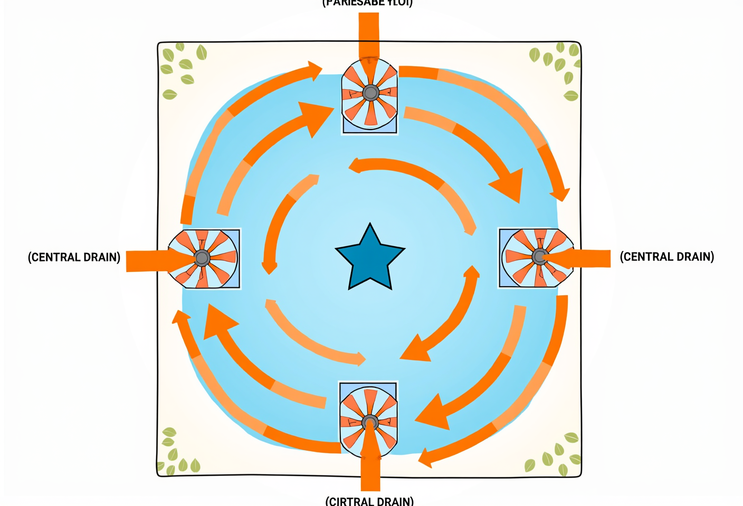
top-view diagram of a square shrimp pond with 4 paddlewheels in the corners, orange arrows showing circular flow, star symbol at center marking the central drain where sediment collects, labels reading Circular flow and Central drain, blue-orange flat design palette

Aerator Placement and Operating Schedule
Adequate HP is meaningless if placement is wrong. The geometry rules for paddlewheels in square or rectangular ponds:
- Angle: 30 to 45 degrees to the dike wall, facing inward. Steeper angles create colliding currents; flatter angles fail to sweep sediment.
- Distance from dike edge: 2 to 4 meters, to avoid eroding the dike from paddle spray.
- Paddle submersion depth: 8 to 10 cm below the water surface, roughly one-third to one-half of paddle height. Too deep wastes power; too shallow reduces oxygen transfer.
- Spacing between units: 8 to 15 meters, so the current from one unit feeds into the next and forms a continuous circular pattern.
For circular ponds, increasingly popular in modern intensive setups, paddlewheels can be installed along a single side facing the desired flow direction. Pond geometry alone supports natural circular flow formation.
Operating schedules follow biomass, not the calendar. In the blind feeding phase, days 1 to 30 of culture, 12 to 16 hours per day is typically enough. Once biomass crosses 50 percent of peak target, 20 to 24 hour operation becomes standard, particularly from 22:00 through 09:00 when photosynthesis stops but respiration continues. DO bottoms out around 05:00 to 06:00, so the full aerator array must be running through that window without exception.

Energy-Efficient Aerators: Modern Options for Indonesian Conditions
Electricity is the cost variable most often underplanned. Wafi et al. (UNDIP) measured a 2 HP paddlewheel pulling 0.97 to 1.07 kW during low-load periods, climbing to roughly 1.5 to 1.9 kW under full load. An intensive 1-hectare pond running 16 units of 2 HP paddlewheels for 20 hours per day consumes around 17,000 to 22,000 kWh per month on aeration alone. Translated to per-ton-of-shrimp basis, Boyd (2021) estimates 11.5 to 28.8 GJ per metric ton for Asian paddlewheel systems.
What separates an energy-efficient paddlewheel from a generic one:
- IE3 or higher efficiency-class motor.
- Hydrodynamic paddle profile rather than flat-plate generics.
- Double-sealed bearings rated for brackish water.
- Corrosion-resistant frame, stainless steel or food-grade HDPE.
- Gearbox using lubricants readily available on the local market, so routine maintenance stays affordable.
For Indonesian operating conditions, the ATD (Aquaculture Technology Development) division of STP, based in West Java, has engineered two aerator variants tailored to local power supply quality and brackish-water exposure. AT21 ME500 targets small to medium ponds, typically under 0.5 hectare of intensive culture, with a compact motor suited to multi-pond layouts. Third-party data from the WWF Indonesia Aquaculture Challenge database indicate a 2 HP variant in the 500 to 2,200 watt range producing roughly 6,000 liters of oxygenated flow per minute. These figures are indicative and should be confirmed directly with the STP technical team for the official specification.
AT21 ME1500 offers higher capacity for medium to large ponds at 1 hectare and above, with indicative oxygenation output around 12,000 liters per minute on the 3 HP variant. For ponds with high peak biomass and a strict 4 ppm DO target at dawn, fewer units of higher individual capacity can deliver the same total HP with fewer installation points. Both AT21 models come out of ATD STP, the internal division focused on on-farm technology for Indonesian farmers, and complement the broader STP package alongside feed, post-larvae, and field technical support.
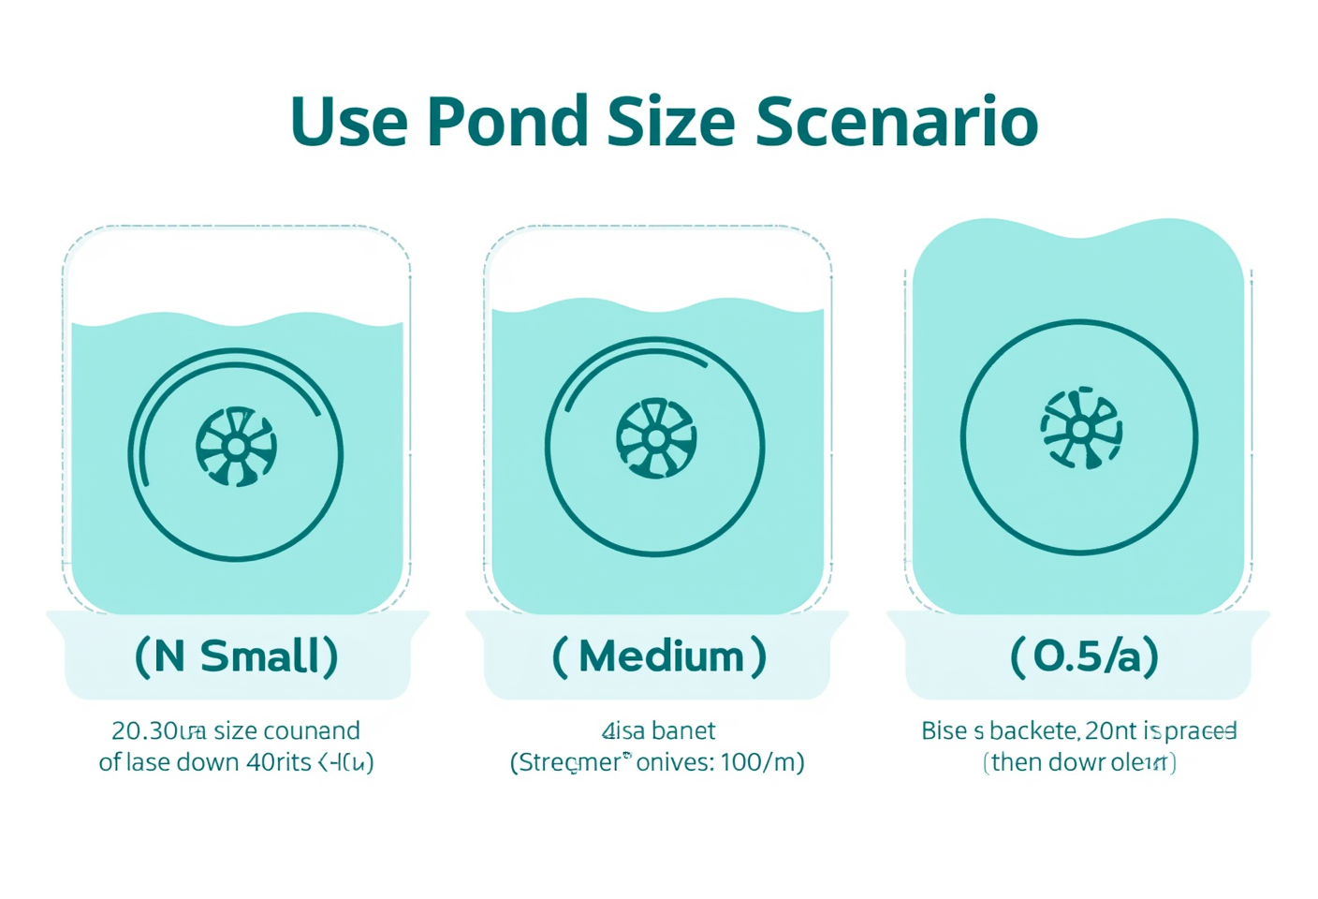
vertical infographic titled How Many Aerators Do I Need with 3 pond scenarios small 0.3 ha medium 0.5 ha large 1 ha showing icons and required 2 HP paddlewheel unit counts, blue-teal flat modern palette

Maintenance and Troubleshooting
Maintenance follows a daily, weekly, monthly rhythm. Daily: check rotation, listen for abnormal sounds, feel the motor housing for excess heat. Weekly: clean marine growth, barnacles, algae, and shells from paddles and frame. Monthly: change gearbox oil every 3,600 operating hours, inspect motor capacitors, tighten loosened bolts.
The most common field failures:
- Sudden motor burnout: almost always caused by single-phasing, the loss of one of three phases from the utility supply, hitting a three-phase motor. Install an AVR or phase-failure relay as a protective measure.
- Gearbox oil leak: worn oil seal from missed oil changes. Damage escalates fast; gears can seize within days.
- Broken paddles: usually from collisions with debris that enters the pond, ropes, plastic, branches. Install simple inlet screens.
- Weak capacitor: motor hums but does not spin. The component is cheap; replace immediately rather than waiting for the motor winding to burn out.
Keep at least one spare paddlewheel per pond ready to install. A single-unit failure during a critical DO window can cost far more than a backup unit ever does.

Frequently Asked Questions

What does a 2 HP shrimp pond paddlewheel consume per month?
A 2 HP paddlewheel draws roughly 1.0 to 1.9 kW depending on motor efficiency and load. Running 24 hours per day for 30 days, consumption lands between 720 and 1,368 kWh per unit per month. An intensive 1-hectare pond with 15 units of 2 HP aerators can therefore use 16,000 to 22,000 kWh per month on aeration alone, which is why motor efficiency rating is a make-or-break purchasing criterion.

Can paddlewheels be replaced entirely by blowers or nano-bubble diffusers?
Not for open intensive ponds. Fine-bubble diffusers are 2 to 3 times more efficient at oxygen transfer per kWh, but they cannot generate the horizontal current that sweeps sludge to the central drain. Modern intensive operations combine the two: paddlewheels for circulation and sediment centralization, diffusers for bottom-zone oxygenation at hot spots. Most commercial ponds run both technologies in parallel.

What is the typical service life of a shrimp pond paddlewheel?
A well-built paddlewheel with corrosion-resistant materials and routine maintenance runs 5 to 10 years. Bearings, gearbox seals, and paddles wear faster than motors. The two biggest life-shorteners are unstable voltage and skipped maintenance. Hold voltage at 380 to 400 V for 3-phase motors and change gearbox oil every 3,600 operating hours to hit the upper end of that range.

What is the quickest way to size aerator HP for my pond?
Estimate peak biomass by multiplying population by average harvest weight, divide by 500 kg per HP, then multiply by 1.2 to 1.3 as a safety factor. Example: 500,000 shrimp at 15 g average equals 7,500 kg, divided by 500 equals 15 HP minimum, scaled up to roughly 18 to 20 HP installed. Convert to 2 HP units by dividing total HP by 2 and cross-check against the scenario table above.

Are STP AT21 aerators compatible with standard pond electrical installations?
Based on available ATD STP information, AT21 is designed for Indonesian pond electrical supply conditions, with a power range of approximately 500 to 2,200 watts in the indicative WWF database data. Voltage compatibility and 1-phase versus 3-phase configurations vary by site, so confirm the model variant directly with the STP technical team before purchasing, particularly for locations with unstable utility supply.

How do you diagnose a paddlewheel that stops mid-cycle?
Check in sequence: (1) the breaker panel for a tripped MCB from overcurrent, (2) the motor capacitor for single-phase units (the single most common failure), (3) cables and terminals for loose connections, (4) debris blocking the paddle shaft, (5) the motor itself. If the motor smells burnt or runs unusually hot, shut it down immediately and call a technician rather than restarting.

Why does pond DO crash so often around dawn?
At night, phytoplankton photosynthesis stops while respiration continues across shrimp, bacteria, plankton, and sediment. DO drops steadily through the night and bottoms out around 05:00 to 06:00. Dense plankton blooms worsen the effect. The remedy is to run paddlewheels for 24 hours once biomass passes 50 percent of peak target, monitor dawn DO at least three times per week, and keep a backup generator on standby in areas with unreliable utility supply.
Intensive vannamei farming is no longer about installing as many paddlewheels as the budget allows. It is about installing the right number, in the right positions, with the motor efficiency that compresses the electricity bill without compromising dawn DO. As a total solution aquaculture company since 1987, STP supplies not only feed and post-larvae but also pond technology engineered by ATD so that Indonesian farmers can run cycles with healthier margins. For specifications on AT21 units, integration with the STP shrimp feed line, and aerator layout design, contact the STP technical team. Aeration designed properly from day one is always cheaper than rescuing a cycle already under stress.

