Article Metadata
title: "Best Catfish Feed Recommendations for Rapid Growth: A Phase-by-Phase Guide with FCR Targets"
meta_title: "Best Catfish Feed for Rapid Growth: 2026 Guide"
meta_description: "Catfish feed recommendations by growth phase, protein 28-40%, target FCR 1.0-1.3, plus a worked cost example for stocking 1,000 catfish fingerlings."
slug: "best-catfish-feed-rapid-growth"
language: "en"
primary_keyword: "catfish feed"
secondary_keywords:
- "catfish feed for rapid growth"
- "high protein catfish feed"
- "catfish FCR"
- "floating catfish pellet"
- "catfish fingerling feed"
- "catfish grow-out feed"
- "catfish pellet size by phase"
- "BSF maggot alternative feed"
- "catfish feed price"
- "catfish harvest weight"
internal_links:
- url: "https://stpaquaculture.com/en/news/pakan-ikan-budidaya-terbaik-stp"
anchor: "STP feed range for cultured fish"
- url: "https://stpaquaculture.com/en/news/pakan-ikan-nila"
anchor: "tilapia feed"
external_citations:
- url: "https://kkp.go.id/news/news-detail/menteri-trenggono-berhasil-tingkatkan-produksi-perikanan-budi-daya-136-di-2024-vQq0.html"
context: "Indonesia catfish production 2024 reached 1,157,755 tonnes"
- url: "https://ejournal-balitbang.kkp.go.id/index.php/megaptera/article/view/11836"
context: "Jurnal Megaptera 2022: FCR 1.0 achieved at 3x daily feeding with FR 8%"
- url: "https://mutiara.al-makkipublisher.com/index.php/al/article/view/489"
context: "EM4 probiotic on intensive Sangkuriang catfish: FCR 1.56, profitability +30%"
brief_id: "pakan-ikan-lele-01"
target_word_count: 1850
word_count: 1887
publish_month: "2026-05"

Best Catfish Feed Recommendations for Rapid Growth: A Phase-by-Phase Guide with FCR Targets
Catfish feed is the single variable that decides whether a production cycle closes on day 65 with an FCR of 1.2, or drags on to day 110 with margins quietly eroding. This article breaks down what actually accelerates growth in African catfish (Clarias gariepinus) culture: protein requirements by growth phase, the case for floating versus sinking pellets, pellet sizing matched to mouth gape, realistic field FCR targets, and a worked numeric example for stocking 1,000 fingerlings. The final sections place STP SPLA 12 and the wider STP freshwater feed range on the phase-by-phase recommendation map.
Indonesia produced 1,157,755 tonnes of farmed catfish in 2024, up from 1,136,619 tonnes in 2023 according to the Ministry of Marine Affairs and Fisheries (KKP). The volume is no accident: catfish remains the freshwater commodity with the most consistent margin in the region thanks to its short cycle, hardy biology, and stable demand from food-service buyers. Globally, the FAO species fact sheet positions Clarias gariepinus as one of the fastest-growing tropical aquaculture finfish, with countries in Sub-Saharan Africa and Southeast Asia steadily expanding production. Yet across smallholder operations from Java to Vietnam, the same complaint surfaces: FCR drifting above 1.7, harvests with uneven size grading, and feed bills that grow faster than the fish.
The root cause is almost always the same. The feed in use does not adapt to the growth phase of the animal.
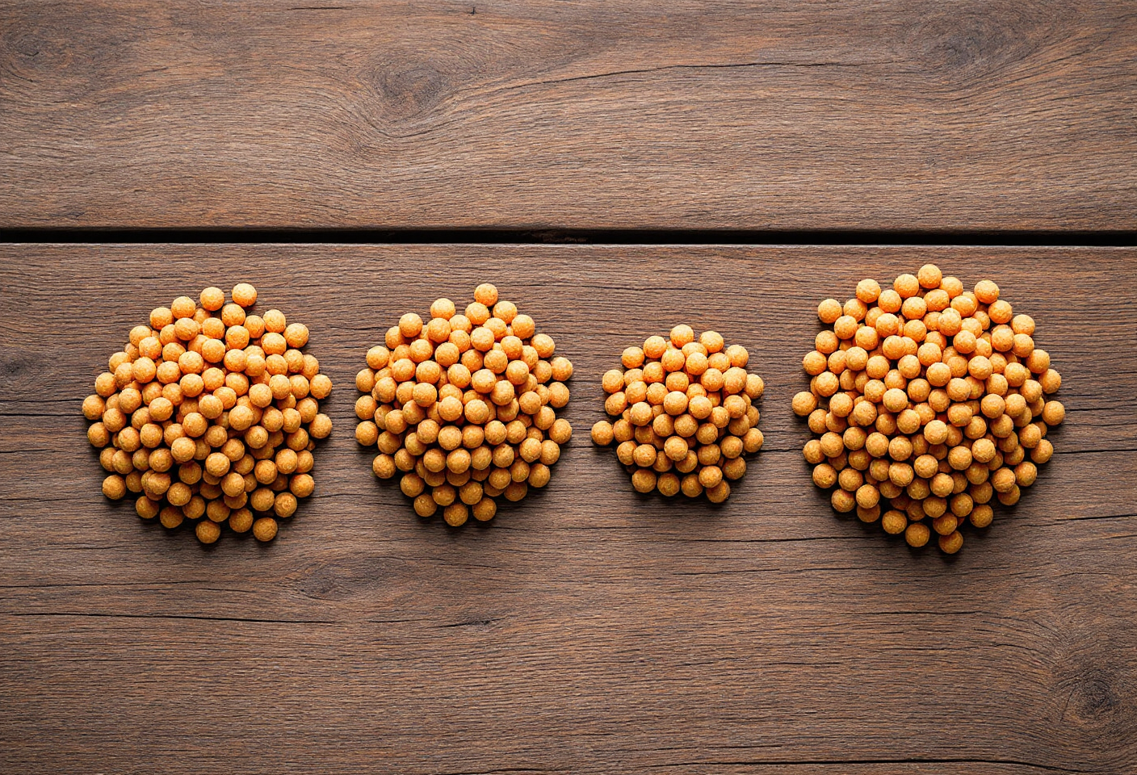
hero — catfish pellets in graduated sizes from 0.6 mm to 4 mm arranged on a timber surface, labelled by phase: fry, fingerling, grow-out

Why Catfish Growth Falls Short of Target
Feed is the dominant line item in intensive catfish budgets. Industry estimates commonly cited across Indonesian and Southeast Asian extension materials put the share at 60 to 70 percent of total production cost, although no single KKP or FAO publication anchors that figure as a formal statistic. The practical takeaway holds either way: feed efficiency equals business efficiency.
A reasonable target for an intensive cycle is a harvest weight of 8 to 10 fish per kilogram (roughly 100 to 125 grams each) within 60 to 75 days. Semi-intensive systems typically need 90 to 120 days for the same size class. What happens in the field instead: day 75 arrives, fish are still grading at 12 to 14 per kilogram, and feed stock is running low.
The diagnosis usually traces back to a handful of failure points.
- Protein mismatched to phase. Fingerlings are pushed onto grow-out pellet because of price; average daily gain (ADG) stalls at 0.8 grams per day when the genetic ceiling is 1.5 to 2 grams.
- Feeding rate set by guesswork. Many farmers size daily ration against pond volume instead of an updated biomass estimate. Surplus feed accumulates on the pond floor.
- Frequency stacked at the wrong hours. Catfish are nocturnal. Feedings concentrated during midday miss the window of strongest appetite.
- Pellet quality below spec. Pellets that disintegrate within five minutes in water both waste protein and drag down water quality.
The FCR reference table below provides a quick benchmark for diagnosing where a cycle sits.
Culture condition | Target FCR | Notes
Intensive optimal (commercial feed >30% protein, calibrated FR) | 0.9-1.2 | Hard to achieve; requires tight feed and water management
Intensive field average | 1.2-1.5 | Realistic for standardised systems
Semi-intensive or feed mismatched to phase | 1.5-2.0 | Acceptable; investigate as it nears 2.0
Red flag | >2.0 | Audit feed, water quality, and disease vectors immediately
Sources: compiled from Jurnal Megaptera (KKP, 2022) and Mutiara: Multidisciplinary Scientific Journal (2025).

What Makes Catfish Feed Effective for Rapid Growth
Effective catfish feed for accelerated growth is a pellet with 28 to 40 percent crude protein adjusted by phase, 5 to 8 percent fat, granule size matched to mouth gape, and water stability of at least 10 minutes. Floating pellets are typically more efficient because they allow direct visual monitoring of appetite at the pond surface and enable satiation feeding without overfeed losses.
Six parameters deserve a check before any sack of feed enters the storage shed.
- Crude protein by phase: 38-40 percent for fry, 32-35 percent for fingerling, 30-33 percent for grow-out, and 26-30 percent for finisher. Indonesia’s SNI 01-4087-2006 standard sets a minimum of 30 percent for intensive Clarias dumbo feed.
- Crude fat 5-10 percent, weighted higher in early phases (>10 percent for larvae) and tapering to 5-8 percent at grow-out.
- Crude fibre capped at 4.5-6 percent. Excess fibre depresses digestibility.
- Pellet diameter sized to mouth gape: 0.6-1 mm for hatchery, 1-2 mm for fingerling, 2-3 mm for grow-out, 3-4 mm for finisher.
- Water stability of at least 10 minutes. Pellets that fragment in 3 to 5 minutes leach protein into the water column and trigger ammonia spikes.
- Buoyancy. Floating pellets unlock the satiation-feeding method, which compresses FCR by removing the guesswork from daily ration.
Catfish are natural bottom feeders, yet in intensive systems they train quickly to surface feed. The efficiency argument for floating pellet is not about biological preference. It is about control: the farmer sees uneaten pellet and stops feeding before waste accumulates.
Strong commercial formulations also build in vitamin C and probiotic support. A 2025 study published in Mutiara: Multidisciplinary Scientific Journal by Bahri, Zubaidah and Handajani examined Sangkuriang catfish under intensive culture and found that EM4 probiotic supplementation produced the best FCR at 1.56, saved roughly IDR 4,325 (around USD 0.27) per kilogram of fish harvested against the control, and lifted profitability by 30 percent.
A practical note on credibility: formulations from established mills pass through laboratory and field validation across a range of water profiles. STP, for example, runs the JAPFA Aquaculture Research Station (JARS) at three sites in North Sumatra, West Java, and East Java, where freshwater feed formulations are calibrated against varying salinity, temperature, and natural food availability.

Catfish Feed Recommendations by Growth Phase
This is the core of the article. The pellet that suits a 2-gram fingerling is not the pellet that suits an 80-gram grower. Splitting the cycle into phases gives operators a framework for purchasing, storing, and rotating pellet stock at the shed.
Phase | Body weight | Protein (%) | Pellet size | Feeding rate | Frequency | Phase duration
Larva / early fry | <1 g | 38-40 | 0.6-1 mm | 5-10% BW | 5-6x/day | 0-15 days
Fingerling | 1-10 g | 35-38 | 1-2 mm | 5-7% BW | 4-5x/day | 15-40 days
Grow-out | 10-80 g | 30-35 | 2-3 mm | 3-5% BW | 3-4x/day | 40-65 days
Finisher | >80 g | 28-32 | 3-4 mm | 2-3% BW | 3x/day | 65-75 days
Sources: KKP extension materials (Pamekasan Fisheries Department), Minapoli production guide, and SNI 01-4087-2006.

Larva to early fingerling (days 0 to 15)
During the first 10 days, fry depend on live feed: Tubifex worms or finely minced egg yolk. From day 10 onward, introduce 0.6-1 mm starter pellet gradually, mixed with the live ration until fry consistently strike pellet at the surface.

Fingerling to grow-out (days 15 to 65)
This is the fastest growth window in the cycle. Healthy fish entering this stage can climb from 3 grams to 80 grams in 50 days at an ADG near 1.5 grams per day.
For the grow-out and finisher phases, one commercial option available across the Indonesian market is STP SPLA 12, a floating catfish pellet with minimum 32 percent protein and minimum 8 percent fat, supplied in 1 mm, 2 mm, and 3 mm sizes, packed in 30 kg sacks. Based on STP distributor listings as of May 2026, the product carries KKP registration and is documented as TÜV Rheinland and ISO 9001:2015 certified, with marketplace prices in the range of IDR 420,000 to 430,000 (approximately USD 26 to 27) per 30 kg sack. For a fuller view of the STP feed range for cultured fish, including freshwater lines such as PA GOLD, NGA 10, and STP SPF Extruder, that landing page serves as the primary reference point.

Finisher (days 65 to 75)
Heading into harvest, many operators drop crude protein to 28-30 percent for cost efficiency, since protein-to-flesh conversion slows as biomass grows. Frequency stays at 3 per day with feeding rate around 2.5 percent of body weight, then tapers in the final two weeks for a purging window before capture.
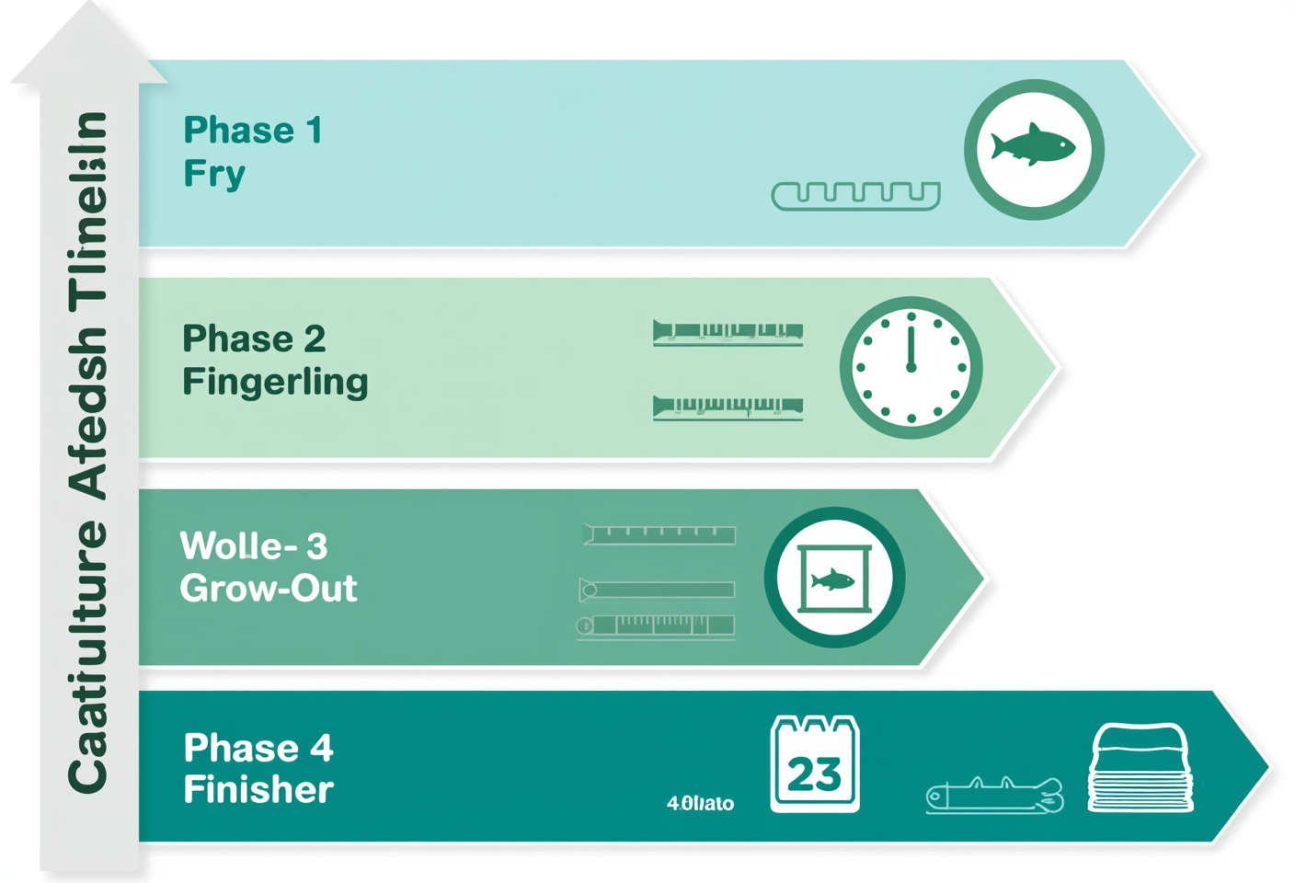
vertical infographic of catfish feed table by phase with columns for protein, pellet size, feeding rate, and duration

Worked Example: Feed Requirement for 1,000 Catfish Fingerlings
Theoretical numbers earn their keep when projected onto a concrete scenario. Assume a stocking of 1,000 fingerlings averaging 3 grams in a tarpaulin pond, with stocking density within the standard 200-400 fish per square metre.
Baseline assumptions:
- Starting biomass: 1,000 fish × 3 g = 3 kg
- Target harvest weight: 100 g per fish (10 fish per kg, local market grade)
- Survival rate: 90 percent → 900 fish at harvest
- Harvest biomass: 900 × 100 g = 90 kg
- Target FCR: 1.3 (realistic for commercial feed with 30%+ protein)
Feed requirement:
- Total feed = harvest biomass × FCR = 90 kg × 1.3 = 117 kg
- Rounded stock = roughly four 30 kg sacks
Estimated feed cost at IDR 425,000 per sack (around USD 26.50):
- Total feed cost = 4 × IDR 425,000 = IDR 1,700,000 (approximately USD 106)
- Feed cost per kilogram of fish harvested = IDR 1,700,000 / 90 kg = about IDR 18,900 per kg (around USD 1.18)
- At a local farm-gate price of IDR 20,000-25,000 per kg, the margin on the feed line remains intact before fingerling, power, and labour costs are layered in.
The detail that operators often miss is the pellet-size rotation. Those four sacks should not all be 3 mm grade. Roughly half a sack of 1 mm pellet covers early fingerling, 1.5 sacks of 2 mm pellet handles the transition, and 2 sacks of 3 mm pellet carries the grow-out to finisher window. A mistimed rotation means fingerlings choking on oversized pellet or grow-out fish wasting energy on undersized granule.

Combining Commercial Feed with BSF Maggot and Fermented Inputs
Partial substitution of commercial pellet with alternative ingredients has gained traction since pellet prices climbed through 2022-2024. The two front-runners are black soldier fly (BSF) larvae (Hermetia illucens) and fermented agricultural by-products.
Fresh BSF maggot carries 30-50 percent crude protein with a relatively complete amino acid profile. Published Indonesian studies suggest substitution at 20-30 percent of the commercial ration remains safe, with FCR typically rising 0.1 to 0.2 points. Research from Bandung Institute of Technology (ITB) has demonstrated substitution as high as 54 percent without significant growth depression, provided overall nutritional balance is maintained. Internationally, FAO and recent peer-reviewed work in Animals and Aquaculture Reports support BSF as a viable protein partial-replacement for African catfish.
A cost note worth flagging: the 15-25 percent feed-cost saving is only realised when maggot is produced on-farm. Maggot purchased ready-made through the supply chain often runs more expensive per kilogram of crude protein than commercial pellet.
For fermented inputs, tofu byproduct fermented with yeast or EM4 for 24-48 hours improves digestibility and introduces probiotic activity to the gut. This is best deployed as a 10-15 percent supplement rather than a primary substitute. Operations that combine commercial pellet, fermented carbohydrate, and partial BSF in a disciplined ratio gain cost flexibility without sacrificing FCR targets.
Multi-species pond management is not new. Many catfish operators also run tilapia feed cycles in parallel ponds, since the protein profile by phase is broadly comparable and feed rotation logistics can be integrated.
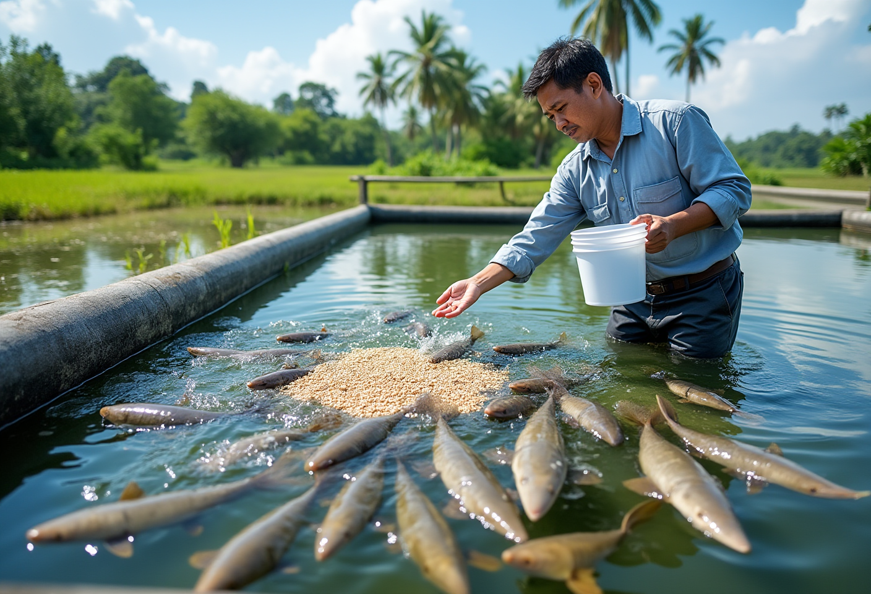
realistic photograph of an open catfish pond at midday, dozens of catfish surfacing for floating pellets, water tinted green with healthy phytoplankton, farmer holding a feed bucket at pond edge

Field Signals of Feed Mismatch and How to Correct Them
Not every cycle runs smoothly. Sometimes growth stalls, and the answer is rarely to push more feed through the system. The right response starts with reading the signals the fish are sending.
Five field indicators come up most often in operator audits:
- Sudden drop in appetite. Pellets sit on the surface for more than 15 minutes. Check water temperature and ammonia before blaming the feed.
- FCR jumps above 1.5 when the same feed previously delivered 1.2. The batch may have shifted, or pellets may have absorbed humidity in storage.
- Pale skin and dull pigmentation. Indicates vitamin deficiency or digestive disturbance. Audit vitamin C and gut condition.
- Uneven size grading. Wide variation within a single pond. Usually not a feed problem; it points to feeding dominance, where larger fish monopolise feed points. Distribute feeding points more evenly.
- Uneaten pellet clumping on the pond floor. Low-grade sinking pellet or chronic overfeed. Switch to quality floating pellet or reduce feeding rate.
Before changing brand, run a 7-to-10-day correction: drop feeding rate by 10 percent, raise frequency from 3 to 4 times per day, and weight the schedule toward evening hours, since catfish activity peaks after dusk. Jurnal Megaptera (KKP, 2022) recorded a treatment at 3 feeds per day with FR 8 percent that hit FCR 1.0 and protein utilisation of 89.6 percent in Sangkuriang catfish. A 4-feed-per-day treatment at FR 10 percent produced higher absolute growth but lower feed efficiency. The trade-off depends on priorities: maximise ADG or maximise feed efficiency.
If the 10-day correction does not restore performance, then consider a feed change or call a diagnostic service. STP’s Animal Health Team operates a Mobile Diagnostic Lab that supports field-level diagnosis when feed issues coincide with disease symptoms such as skin lesions, white spot, or abnormal swimming behaviour.

Frequently Asked Questions

How many times per day should adult catfish be fed?
Catfish in the grow-out phase (above 50 grams) are typically fed 3 to 5 times daily, with the schedule weighted toward late afternoon and evening due to their nocturnal activity pattern. Jurnal Megaptera (KKP, 2022) reported that 4 feeds per day at 10 percent feeding rate delivered the highest growth, while 3 feeds per day at 8 percent FR produced the most efficient FCR at 1.0. The choice depends on whether ADG or feed efficiency carries the higher business weight.

Can rice bran or kitchen scraps replace catfish feed?
Not as a primary substitute. Rice bran and kitchen scraps carry crude protein levels far below the catfish minimum requirement (30 percent for the grow-out phase per SNI 01-4087-2006). The consequence is FCR spikes, stunted growth, and water quality deterioration from undigested residue. Rice bran can serve as a supplement at no more than 10-15 percent of the total ration, ideally after fermentation to lift digestibility.

Floating or sinking catfish pellet, which performs better?
Floating pellet is generally preferred for catfish grow-out because it enables visual appetite monitoring. Operators can stop feeding before residue accumulates, so the satiation method compresses FCR. Sinking pellet is harder to monitor and risks fouling the pond floor. Most premium commercial catfish feeds on the Indonesian market, including STP SPLA 12, are formulated as floating pellets for this reason.

What does catfish feed cost per 30 kg sack in 2026?
As of May 2026, grow-out catfish feed prices range from IDR 270,000 to IDR 470,000 (approximately USD 17 to USD 29) per 30 kg sack, or roughly USD 0.55 to 1.00 per kilogram depending on brand and quality tier. Economy brands sit near the lower bound; premium brands reach the upper bound. STP SPLA 12 listings cluster around IDR 420,000-430,000 per sack. Prices vary by e-commerce platform and distribution region.

How are catfish fingerlings trained to accept floating pellet?
From day 1 to day 10, fry rely on live feed such as Tubifex worms. Introduce 0.6-1 mm pellet gradually from days 10 to 15, mixed with live feed. Drop pellet at the same point each feeding so fry learn the location and schedule. Within 5 to 7 days, the majority of the cohort accepts pellet consistently. Pellet diameter must remain below mouth gape to avoid rejection.

Can tilapia feed be used for catfish and vice versa?
Nutritionally, tilapia and catfish grow-out feeds share a similar protein band of 26-32 percent. Tilapia feed can substitute for catfish feed in an emergency but performance is suboptimal because vitamin, mineral, and palatability profiles differ by species. High-protein catfish feed can be fed to tilapia with minimal issue. For best results, use feed formulated for the target species and phase.

What is the most common cause of slow catfish growth despite quality feed?
Three causes dominate field complaints: (1) excessive stocking density that intensifies feeding competition and depresses water quality, (2) feeding frequency stacked during midday when catfish are least active, and (3) poor water parameters: elevated ammonia or low dissolved oxygen suppress appetite. Audit these three before changing feed brand.

Catfish that harvest on schedule with controlled FCR are the product of a few consistent decisions: protein matched to phase, floating pellet stable in water, frequency aligned with nocturnal behaviour, and quick corrections when field signals appear. STP, part of JAPFA and operating since 1987, sits on the Indonesian freshwater feed map with formulations validated at JARS and supported by field technical teams. For operators planning the next cycle, the practical starting point is to calibrate feed by phase, run the numbers using the worked example above, and optimise harvest outcomes with the right feed at the right stage of growth.

