Article Metadata
title: "How to Calculate Tilapia Feed Requirements per 1,000 Fish: A Cycle-Long Planning Method"
meta_title: "Tilapia Feed Calculation per 1,000 Fish (Full Cycle)"
meta_description: "How to calculate tilapia feed requirements per 1,000 fish: daily formula, biomass sampling, phase table, FCR target, and 30 kg sack conversion."
slug: "tilapia-feed-calculation-per-1000-fish"
language: "en"
primary_keyword: "tilapia feed calculation"
secondary_keywords:
- "how to calculate tilapia feed"
- "tilapia feed requirements per 1000 fish"
- "tilapia feed conversion ratio"
- "tilapia feeding rate by phase"
- "tilapia biomass sampling"
- "tilapia FCR"
- "tilapia grow-out feed schedule"
- "ABC feeding method tilapia"
- "tilapia feeding chart"
- "Oreochromis niloticus feed requirement"
- "tilapia pellet protein percentage"
- "tilapia feed planning"
internal_links:
- url: "/en/news/tilapia-feed"
anchor: "tilapia feed"
- url: "/en/news/vannamei-shrimp-farming"
anchor: "vannamei shrimp farming"
- url: "/en/news/best-aquaculture-fish-feed-stp"
anchor: "STP aquaculture feed range"
external_citations:
- url: "https://www.kkp.go.id/bppsdmkp/atasi-biaya-pakan-ikan-tinggi-kkp-gelar-pakan-mandiri-di-4-lokasi65c30c153c8f0/detail.html"
label: "KKP RI: feed is 60-70% of fish farming production cost"
- url: "https://www.seafdec.org.ph/tilapia/"
label: "SEAFDEC/AQD: Farming Tilapia reference"
- url: "https://www.fao.org/fishery/en/culturedspecies/oreochromis_niloticus"
label: "FAO: Oreochromis niloticus cultured species fact sheet"
- url: "https://azramedia-indonesia.azramediaindonesia.com/index.php/Kapalamada/article/view/2277"
label: "Jurnal Kapalamada: FCR Analysis of Tilapia in Lake Batur Floating Cages"
target_word_count: 1900
word_count: 1799
publish_month: "2026-05"
brief_id: "pakan-ikan-nila-01"

How to Calculate Tilapia Feed Requirements per 1,000 Fish: A Cycle-Long Planning Method
Most tilapia farmers stocking 1,000 fingerlings cannot say, to within a sack or two, how much feed the cycle will consume. They estimate, top up mid-cycle, and absorb a cashflow surprise around week 10. This article walks through a quantitative method for tilapia feed calculation: the daily formula, biomass sampling cadence, a worked example, and conversion to 30-kilogram commercial sacks.

Why Tilapia Feed Calculations Miss the Mark in the Field
Feed accounts for 60 to 70 percent of total production cost in tilapia aquaculture, according to figures published by Indonesia’s Ministry of Marine Affairs and Fisheries (KKP). At that share, every percentage point of waste is real margin lost, and most waste traces to imprecise planning rather than feed quality.
The pattern is familiar. A smallholder stocks 1,000 fingerlings of Oreochromis niloticus at five grams each and feeds by visual estimate. By week six the fish are 50 grams apiece. By week fourteen, biomass has multiplied roughly thirty-fold, the feed bag empties in three days instead of two weeks, and the cycle ends at FCR 1.8: the producer pays for roughly 40 kilograms of feed that produced no flesh.
Larger operations avoid this drift by treating feed as a spreadsheet line. Smaller producers can apply the same discipline with three numbers: biomass, feeding rate, FCR target.
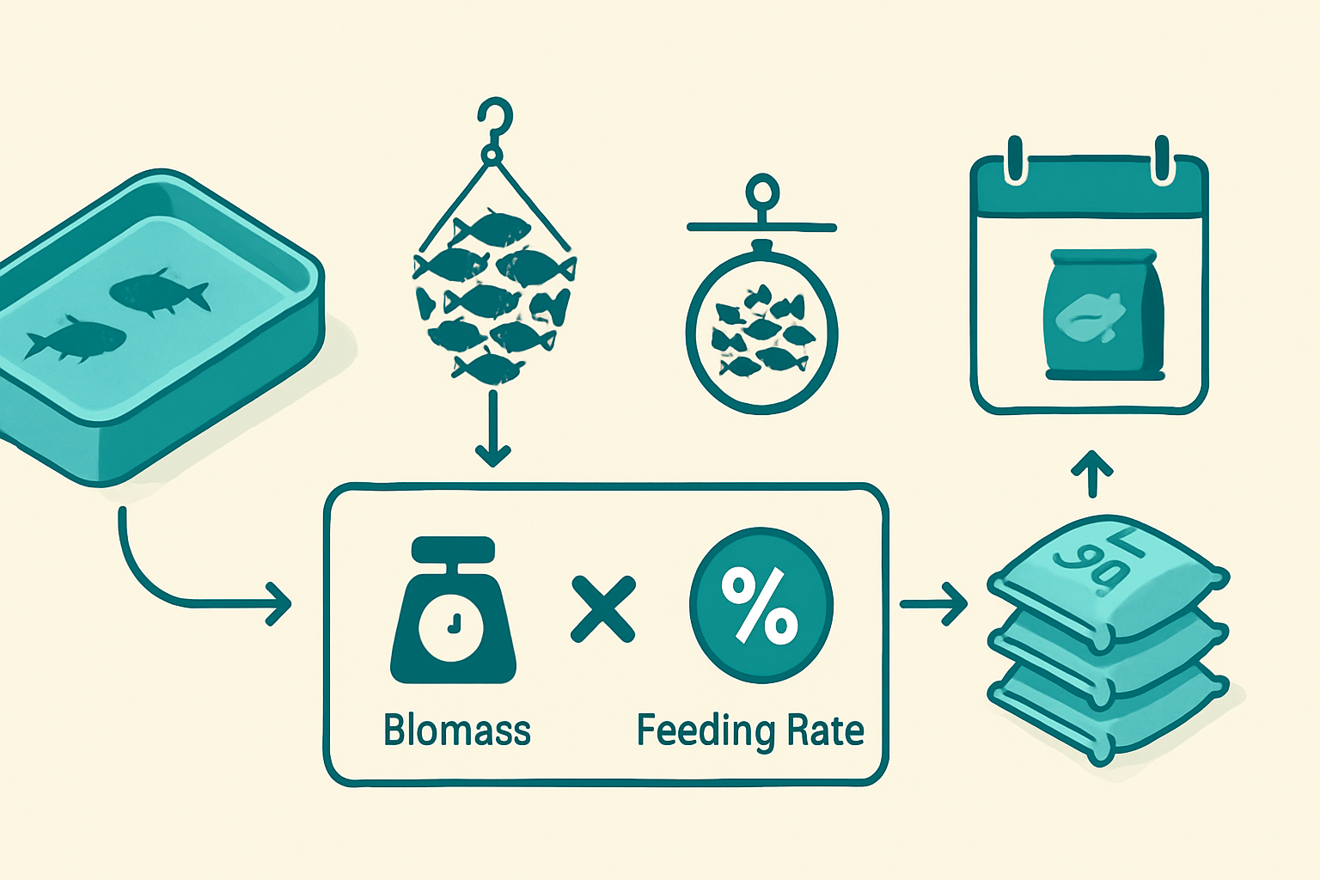
Isometric infographic showing the feed-calculation flow — pond icon with tilapia, sampling arrow (“30 fish → mean body weight”), biomass × feeding rate formula box, daily feed kg output, and 30 kg sack conversion. Clean modern flat style in aquaculture blue and green, mobile-readable, language-neutral for bilingual reuse.

What Are Tilapia Feed Requirements Across a Full Cycle?
Tilapia feed requirements are the total quantity of feed planned from stocking to harvest, computed by multiplying live pond biomass by a phase-specific feeding rate. For a 1,000-fish stocking targeting 250 g harvest weight over a 16-week cycle, the cumulative requirement lands between 240 and 290 kilograms, or eight to ten 30-kilogram sacks, at a Feed Conversion Ratio of 1.15 to 1.3.
A rule of thumb: at FCR 1.2, every kilogram of harvested tilapia costs 1.2 kilograms of feed. Survival rate, ADG, and phase-appropriate protein push that ratio up or down. The method below holds whether the operation runs ponds, tanks, biofloc, or floating cages.

Three Methods for Calculating Tilapia Feed Requirements
Different planning horizons call for different tools. Three methods cover the field-tested cases in Southeast Asian tilapia operations.
Method 1: ABC feeding (percent of body weight). Multiply biomass from the latest sample by a phase-specific feeding rate: 5 to 7 percent for fry, 3 to 4 percent for fingerlings, 2 to 3 percent for grow-out, 1.5 to 2 percent pre-harvest. SEAFDEC/AQD’s tilapia farming reference documents 2–3 percent for semi-intensive and 3–5 percent for intensive systems.
Method 2: Biomass tracking via sampling. Catch 30 to 50 fish from multiple pond points every 7 to 14 days. Weigh collectively, divide by count for Mean Body Weight (MBW), then recalculate biomass: MBW × estimated survivors. Feed the new figure on the next dose.
Method 3: FCR-target back-calculation. Useful before stocking. Start from target harvest biomass (1,000 fish × 0.9 survival × 250 g = 225 kg), multiply by planned FCR (1.2) for total feed (270 kg), then convert to sacks (270 ÷ 30 = 9 sacks). Lock the procurement budget at the start of the cycle.
The core formula stays the same across all three:
Daily Feed (kg) = Total Biomass (kg) × Feeding Rate (%)
Biomass (kg) = Number of live fish × Mean Body Weight (kg)
FCR = Total Feed Given (kg) ÷ (Harvest Biomass − Stocking Biomass)
Sack Conversion = Total Feed (kg) ÷ 30 kg per sack
An operator who can apply those four lines on paper can plan a cycle. One who cannot is feeding by intuition.

Worked Example: Calculating Feed for 1,000 Tilapia to Harvest
A 16-week cycle in a tarpaulin or concrete pond at moderate intensity. Assumptions:
- Stocking: 1,000 post-larvae at 5 g each (initial biomass: 5 kg)
- Target harvest: 250 g mean body weight
- Survival rate: 90 percent
- Target FCR: 1.15 to 1.3
- ADG: 1.5–2.2 g/day across the cycle
The table maps the cycle phase by phase, drawing on JARS (JAPFA Aquaculture Research Station) trial ranges and SEAFDEC field references, cross-checked against Lake Batur floating-cage FCR data (1.06 to 1.39 across 20 producers).
Phase | Week | MBW (g) | SR (%) | Live Fish | Biomass (kg) | Feeding Rate | Daily Feed (kg) | Phase Feed Total | STP Feed
Fry | 1–3 | 5 → 15 | 96 | 960 | 5 → 14.4 | 6% | 0.3 → 0.9 | ~6 kg | PA GOLD (40% protein, 3% crude fiber, crumble)
Fingerling | 4–7 | 15 → 50 | 93 | 930 | 14 → 47 | 4% | 0.6 → 1.9 | ~26 kg | STP NGA 10 (32% protein)
Early grow-out | 8–11 | 50 → 120 | 91 | 910 | 45 → 109 | 3% | 1.3 → 3.3 | ~64 kg | STP NGA 10 → transition to STP SPF Extruder
Late grow-out | 12–14 | 120 → 200 | 90 | 900 | 108 → 180 | 2.5% | 2.7 → 4.5 | ~110 kg | STP SPF Extruder (26% protein, 6% fat)
Pre-harvest | 15–16 | 200 → 250 | 90 | 900 | 180 → 225 | 1.8% | 3.2 → 4.1 | ~52 kg | STP SPF Extruder (frequency drops to 2×/day)
TOTAL | 16 wk | — | 90 | 900 | 225 at harvest | — | — | ~258 kg ≈ 9 sacks @ 30 kg
Run the FCR check: 258 kg of feed against a biomass gain of (225 − 5) = 220 kg yields an actual FCR of 1.17, within target.
Phase-by-phase product placement reflects biological need. In the first three weeks, when fry mouths only handle crumble or fine powder, PA GOLD (40 percent protein, 3 percent crude fiber) supports the protein-to-tissue conversion the early window demands. Between weeks four and eleven, as fish move from 15 to 120 grams, STP NGA 10 at 32 percent protein covers fingerling and early grow-out, with formulation supporting fillet quality and phosphorus absorption. From week twelve, when biomass is largest and feed efficiency dominates the economics, STP SPF Extruder (26 percent protein, 6 percent fat) delivers the FCR profile this phase requires.
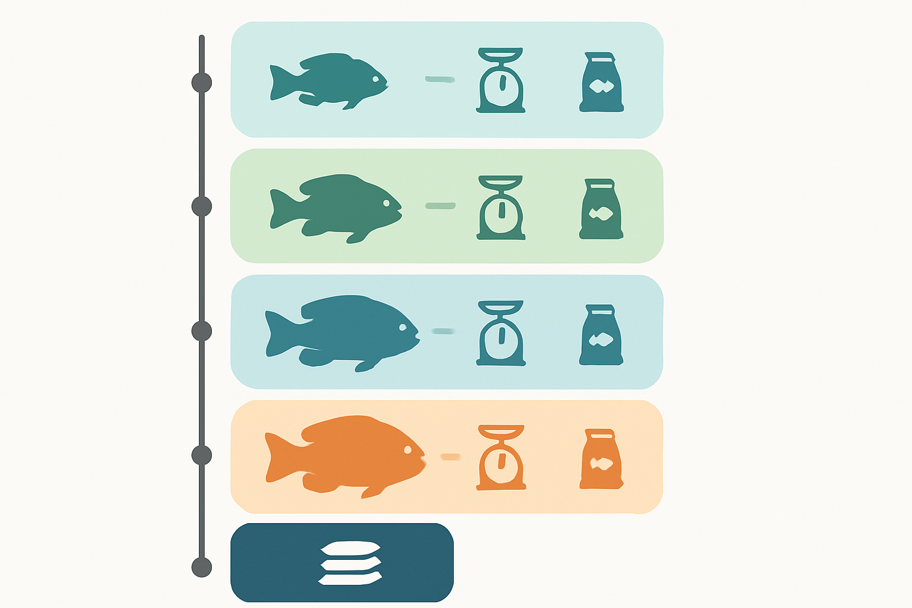
Print-friendly worked-example table titled “Feed Requirements for 1,000 Tilapia — 16-Week Cycle”. Columns: Phase, Week, MBW, Feeding Rate, Phase Feed. Highlight the total row (~258 kg / 9 sacks). Color-coded by phase, WhatsApp-shareable layout. Keep numeric overlay minimal so any text rendering imperfections are easy to correct in post.

Phase-by-Phase Tilapia Feeding Chart (Printable Reference)
The table below distills feeding rate, frequency, and pellet specification into a single page to pin near the feed shed. Each row is a sampling checkpoint; once biomass is updated, the daily dose recomputes from the rate column.
Phase | Fish Weight (g) | Week | Feeding Rate (% biomass/day) | Frequency | Protein (%) | Pellet Form
Fry / starter | 1–15 | 1–3 | 5–7% | 3× daily | 35–40% | Crumble / fine powder
Fingerling | 15–50 | 4–7 | 3–4% | 3× daily | 30–32% | 1–2 mm pellet
Early grow-out | 50–120 | 8–11 | 2.5–3% | 2–3× daily | 28–32% | 2–3 mm pellet
Late grow-out | 120–200 | 12–14 | 2–2.5% | 2–3× daily | 26–28% | 3 mm pellet
Pre-harvest | 200–250+ | 15–16 | 1.5–2% | 2× daily | 26% | 3 mm pellet
For phase-specific product selection and the nutritional rationale behind each tier, see STP’s reference guide on tilapia feed. Operators on mixed-species sites should note that the same ABC feeding logic applies to vannamei shrimp farming, though shrimp rates and frequencies differ.

How to Sample Tilapia Biomass So the Numbers Stay Honest
A feed plan built on a stale biomass figure compounds error week by week. The remedy is sampling discipline.
Sampling protocol:
- Every 7–14 days, cast-net across three or four pond points to avoid positional bias.
- Net 30–50 fish per sample (3–5 percent of the population); 50–100 fish for larger ponds.
- Weigh the sample on a hanging scale; divide by count for Mean Body Weight.
- Multiply MBW by estimated live fish to update biomass.
- Recalculate the next dose: New biomass × current phase feeding rate.
Warning signs the daily dose has drifted:
- Uneaten pellets after 15 minutes. Reduce feeding rate by 0.5 percent on the next dose.
- Sudden ammonia or nitrite spike. Overfeeding is the first suspect; cut the dose and aerate.
- Weekly FCR climbing above target. The likely cause is phantom feeding: continuing to feed at full rate while silent mortality has reduced the live population. Jurnal Kapalamada documents this pattern in Lake Batur floating cages, where producers with phantom feeding reached FCR 1.39 versus 1.06 in disciplined operations.
A field rule: feed the fish you have, not the fish you stocked.

Converting the Plan into Budget and Cashflow
The calculation converts directly into procurement. 258 kg ÷ 30 kg/sack = 8.6, rounded up to 9 sacks. At typical Southeast Asian grower-feed prices, total feed cost per 1,000 fish lands in the USD 200 to USD 280 band, with variance driven by brand, wholesaler, and freight. Validate against local listings.
Procurement tactics smaller producers under-use:
- Buy in two tranches. Three to four sacks at stocking cover weeks 1–7; the remaining five to six purchased around week 8 avoid holding 200 kg past a 90-day shelf life.
- Lock the phase product, not the brand. Match starter feed to first-three-week protein and pellet-form requirements, then transition. Brand-switching mid-phase causes off-feeds and short-term FCR spikes.
- Track actual versus planned weekly. A column for “feed delivered” against “feed budgeted” surfaces problems by week 4, not week 14.
For operators matching the full line to phase, the STP aquaculture feed range covers fry through pre-harvest under one formulation philosophy developed at JARS.
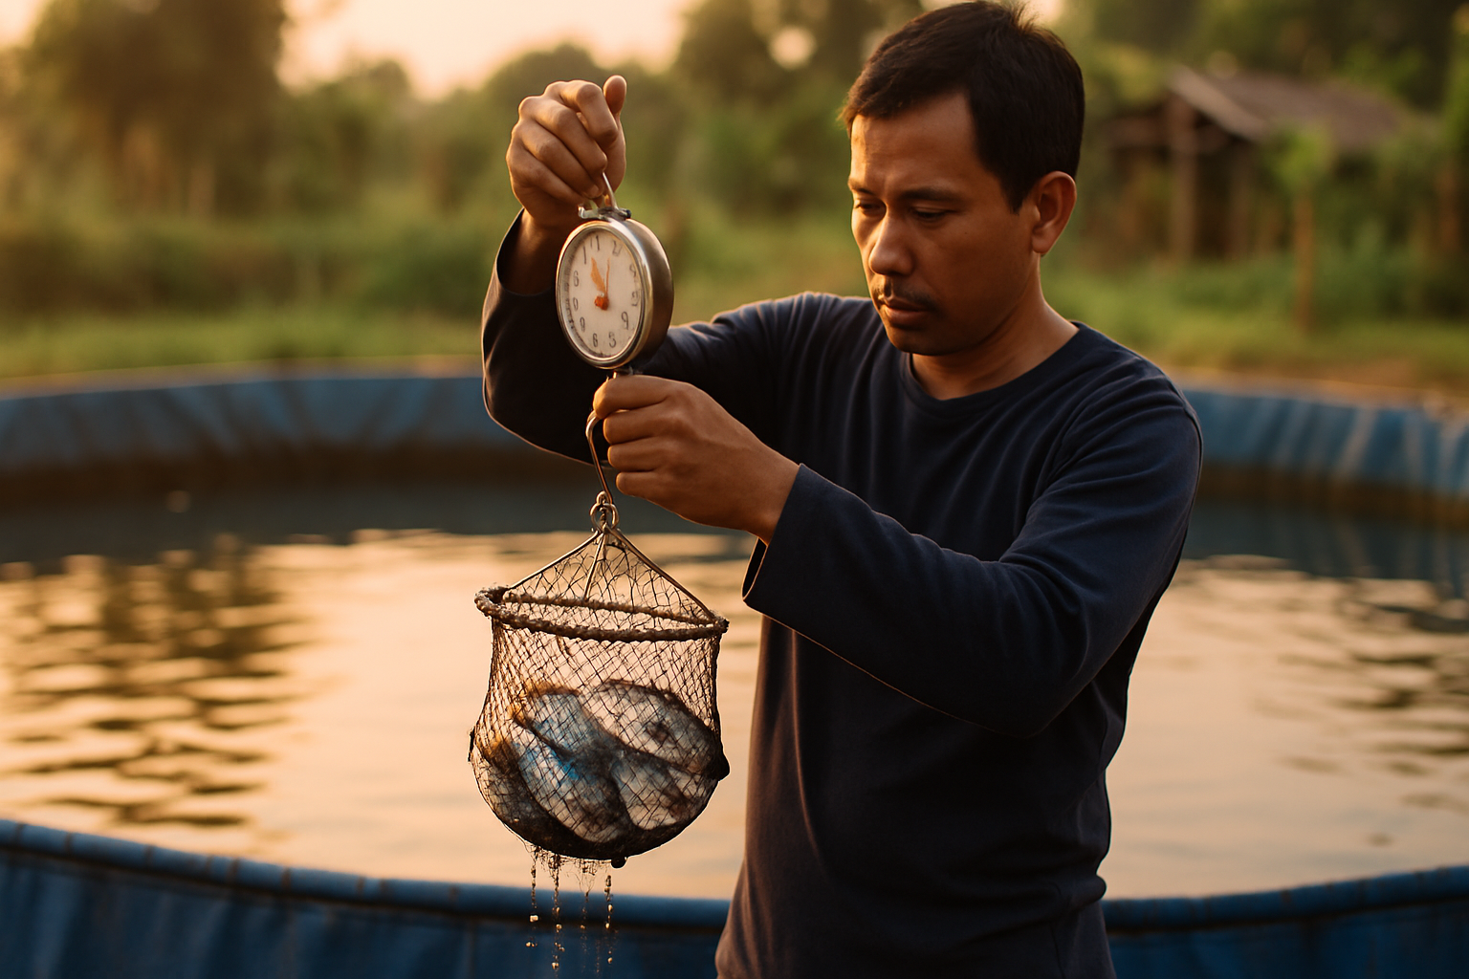
Editorial documentary photograph — an Indonesian smallholder farmer at the edge of a blue tarpaulin pond, weighing a netted sample of small-to-medium tilapia on a hanging scale. Rural Indonesian setting, golden-hour light, authentic field work (not stock photography). No brand labels visible on clothing or feed packaging.

Frequently Asked Questions

How much feed do 1,000 tilapia need to harvest?
For a 16-week cycle stocked at 5 grams and harvested at 250 grams with 90 percent survival, 1,000 tilapia require 240 to 290 kilograms of feed, or eight to ten 30-kilogram sacks. The range reflects FCR between 1.15 and 1.3. Biofloc, pond preparation, and sampling discipline shift the actual figure within that band.

How do you calculate tilapia FCR?
FCR equals Total Feed Delivered (kg) ÷ Biomass Gain (kg), where biomass gain is harvest biomass minus stocking biomass. A cycle producing 220 kg of gain from 258 kg of feed yields FCR 1.17. Field-tested ranges for intensive tilapia in Indonesia sit between 1.06 and 1.5; values above 1.8 usually signal overfeeding, water-quality issues, or phantom feeding.

What feeding rate should tilapia receive per day?
Feeding rate is a percentage of live biomass and varies by phase. SEAFDEC documents 2–3 percent per day for semi-intensive systems and 3–5 percent for intensive. Beginners can default to 3 percent, but rates climb to 5–7 percent in the fry phase and drop to 1.5–2 percent pre-harvest. Recalibrate after each biomass sampling.

How often should tilapia be fed?
Three times daily during fry and fingerling phases (typically 8 a.m., 1 p.m., 5 p.m.) and two to three times daily through grow-out and pre-harvest. Biofloc operations occasionally feed four times daily during initial mixing, but most pond systems gain nothing from higher frequency. More than three feedings for adult tilapia tends to produce uneaten pellets and ammonia spikes.

What protein percentage does tilapia feed need by phase?
Fry require 35–40 percent protein for tissue formation, with PA GOLD sitting at the upper end (40 percent). Fingerling and early grow-out shift to 30–32 percent (STP NGA 10 at 32 percent). Late grow-out and pre-harvest drop to 26–28 percent for feed-conversion efficiency (STP SPF Extruder at 26 percent, 6 percent fat).

When should feed be switched between phases?
Transition by mean body weight, not calendar week. Move from PA GOLD to STP NGA 10 when MBW crosses 15 grams. Switch to STP SPF Extruder at 50–60 grams. Run a 5–7-day transition by blending old and new feed at decreasing ratios (75/25 → 50/50 → 25/75) to avoid off-feeds.

How does survival rate change the feed plan?
A 10-point drop in survival has an outsized accounting impact. A cycle ending at 70 percent survival rather than 90 percent yields 175 kg of harvest instead of 225 kg, but the feed already delivered is now spread across fewer fish, pushing apparent FCR to 1.5 or above. The fix is honest mortality tracking: deduct missing fish from biomass at every sampling.

Tilapia feed planning is arithmetic: biomass, rate, and FCR target, applied weekly against a sample. Operators who run the calculation see waste before it reaches the harvest table, and buy feed against a number rather than a feeling.
As a total solution aquaculture company operating since 1987, STP (Suri Tani Pemuka), the aquaculture division of JAPFA, delivers tilapia feed across the full cycle through formulations developed at JARS. The range covers PA GOLD at starter, STP NGA 10 at grow-out, and STP SPF Extruder at pre-harvest, each matched to the protein, energy, and pellet-form requirements the calculations above assume. STP also extends technical field service and Mobile Diagnostic Lab support to producers validating feed-planning numbers against in-pond performance.

