Article Metadata
title: "7 Signs Your Business Has Outgrown Spreadsheets and Needs SAP Business One"
meta_title: "SAP Business One: 7 Signs Your Business Needs It"
meta_description: "7 signs your business needs SAP Business One — from a 10-day month-end close to data that won't sync. Plus when you DON'T need an ERP yet, and the go-live phases."
slug: "signs-business-needs-sap-business-one"
language: "en"
primary_keyword: "sap business one"
secondary_keywords:
- "signs you need an ERP"
- "when SMEs should move to ERP"
- "limitations of accounting software"
- "ERP system for SMEs"
- "slow month-end close"
- "data not integrated"
- "migrating from Excel to ERP"
- "ERP implementation readiness"
- "SAP Business One for small business"
internal_links:
- url: "https://www.soltius.co.id/id/blog/pengertian-sap-business-one-dan-kegunaannya"
anchor: "what SAP Business One is"
- url: "https://www.soltius.co.id/id/solutions-by-products/software-erp-sap-business-one"
anchor: "SAP Business One ERP software"
- url: "https://www.soltius.co.id/id/blog/8-modul-sap-indonesia-yang-paling-banyak-digunakan"
anchor: "most-used SAP modules"
external_citations:
- url: "https://news.sap.com/2025/12/global-success-of-sap-business-one/"
context: "Install base 83,000+ companies, 170+ countries, 1.2 million users, 10 new customers per day"
- url: "https://www.antaranews.com/berita/4397157/kemenkop-ukm-255-juta-umkm-telah-go-digital"
context: "Indonesian SME digital-adoption context: 25.5 million of ~64 million MSMEs had gone digital as of July 2024"
brief_id: "sap-business-one-01"
target_word_count: 2000
publish_month: "2026-05"
word_count: 1935
editor_note: "EN internal links reverted to the /id/ canonical Soltius URLs. The /en/ blog and solutions slugs could not be verified as live parallels of the /id/ originals, and shipping unverified /en/ paths risks 404s. Per product_matrix.md guidance ('point to /en/ equivalents where they exist; otherwise keep the /id/ URL'), the safe default is the verified /id/ URLs. Swap to /en/ once those slugs are confirmed live."

7 Signs Your Business Has Outgrown Spreadsheets and Needs SAP Business One
The question “what is SAP Business One” is easy enough to answer. The harder one comes next: does your business actually need it yet, or is the bookkeeping you run today still good enough? This article isn’t a definition piece. It’s a diagnostic tool. What follows are seven signs that typically surface when a small or medium-sized enterprise (SME) starts hitting the ceiling of its old system, each with a measurable threshold you can check against your own operation. If three or more feel familiar, you are probably at the point where a serious ERP like SAP Business One deserves a real look.
Most growing businesses still run far short of an integrated system. The pattern is visible even in markets where SMEs dominate the economy: in Indonesia, where micro, small, and medium enterprises contribute roughly 61% of GDP and employ 97% of the workforce, only 25.5 million of about 64.2 million business units had entered the digital ecosystem as of July 2024, and many of those stopped at selling online rather than running integrated operations (Indonesia’s Ministry of Cooperatives and SMEs, reported via Antara News). The takeaway holds internationally: most companies in growth mode are still leaning on Excel and standalone accounting software. While transaction volume stays low, that works fine. The trouble starts when the business grows faster than its systems.
In short: A business usually starts needing SAP Business One when the monthly close takes more than 10 working days, data is scattered across spreadsheets that don’t reconcile, and cross-department reports take days to compile. SAP Business One is an integrated ERP for small and medium-sized enterprises that unifies finance, sales, purchasing, and inventory in one system — available on-premise or in the cloud.

Infographic checklist of the 7 signs a business needs SAP Business One — each sign with an icon (hourglass for slow close, cracked spreadsheet for Excel dependence, two out-of-sync warehouses for disconnected data), corporate blue-and-white style, English labels

Why so many SMEs stay on manual bookkeeping too long
There’s an expensive misconception in circulation: “ERP is for big companies.” That belief leads owners to postpone the move until the system is genuinely overwhelmed, usually during peak season, the exact moment there’s no slack to fix anything.
In reality the trigger isn’t company size. It’s transaction volume and complexity. A mid-sized FMCG distributor processing thousands of transactions a day can need an integrated system sooner than a larger services firm with simpler dealings. A pharmacy chain with three branches, a multi-outlet retailer, an importer juggling several currencies: they hit the wall not because they’re big, but because they’re complex.
The cost of waiting rarely shows up on a profit-and-loss statement, yet it’s real. A finance team that spends most of its time gathering data instead of analyzing it. Stock that exists in the system but is empty on the shelf. Decisions made on last week’s report rather than today’s reality. All of it erodes margin without ever appearing as a single line on the balance sheet.

What are the signs your business already needs SAP Business One?
Here are the seven that come up most often. What separates this list from a generic checklist: each sign has a threshold you can measure yourself.
- The monthly close takes more than 10 working days. The 10-working-day mark is a common practitioner benchmark, not the result of a formal study, but a reasonable field reference. If finance can only lock the current month’s books in the second week of the next month, the system is holding the team back, not helping it.
- Excel has become a “database,” not just a tool. When the team builds and maintains separate Excel files for stock, sales, and cash, and those files become the single source of truth, you are effectively running a fragile information system with no version control.
- Data across divisions or warehouses won’t reconcile. Stock reports from different warehouses frequently disagree with the financial records. A small discrepancy that keeps recurring is a symptom, not a coincidence.
- Manual re-entry between systems. The same sales figure is retyped onto a purchase form, then keyed again into the books. Every re-keying is a chance to mistype and an hour of work burned.
- Management reports take days. When a director asks for a report today but it only lands three days later because someone has to compile it by hand, your decision speed is capped by your reporting speed, not by the market.
- Audits and transaction trails are hard to follow. Tracing one invoice back to its purchase order, to the goods receipt, then to the payment, inside a single system, should take seconds. If it means reassembling the story from several files, your audit trail is fragile.
- Growth is breaking the system you have. The system slows down, throws errors, or can’t handle the transaction surge at peak season. This is the most visible sign, and usually the last one owners admit to.
All seven don’t have to appear at once. In implementation practice, the common pattern is a reinforcing combination of signs 1, 3, and 5 (slow close, unreconciled data, slow reporting) feeding off each other. Three consistent signs are enough to start taking an ERP seriously.
# | Sign | Threshold to watch
1 | Slow monthly close | >10 working days to close the current month
2 | Excel as a “database” | Separate files for stock, sales, and cash become the source of truth
3 | Data won’t reconcile | Inter-warehouse stock reports often disagree with the books
4 | Manual re-entry | The same data is retyped into more than one system
5 | Slow reports | Management reports need 3+ days to compile
6 | Audits are hard | Can’t trace invoice → PO → goods receipt → payment in one system
7 | System overwhelmed | Slows or errors as volume or number of locations rises

Where does accounting software hit its limit? The boundary SMEs often miss
Many owners assume the fix is more powerful accounting software. Often, that isn’t the problem at all.
Accounting software is built for one thing: recording historical financial data such as the general ledger, receivables, and payables. It works per department, in silos. ERP works on a fundamentally different model. One sales transaction automatically updates stock, purchasing, and the financial reports in real time, from a single central database. That’s what “single source of truth” means: one set of data every division trusts.
While transactions are few and there’s a single location, this boundary isn’t felt. The breaking point arrives when three things grow at once: transaction volume, number of locations, and number of people who need the same data. At that point, bolting on “bigger accounting software” solves nothing, because the problem isn’t recording capacity. It’s the absence of integration across functions.
Aspect | Standard accounting software | SAP Business One (ERP)
Primary focus | Historical financial data | Real-time operations across departments
Integration | Siloed — finance only | Finance + Sales + Purchasing + Inventory linked
Data updates | Manual / periodic | Automatic — one transaction updates every related module
Multi-location / warehouse | None or very limited | Supported natively
Scalability | Strains as locations/entities grow | Modular — add new modules as needed
Best fit | ≤5 users, low volume, single location | Growing SMEs: multi-location, high transaction volume
If you find yourself constantly “patching” accounting software with a row of Excel files alongside it, that’s the signal you actually need an ERP, not a bigger ledger.
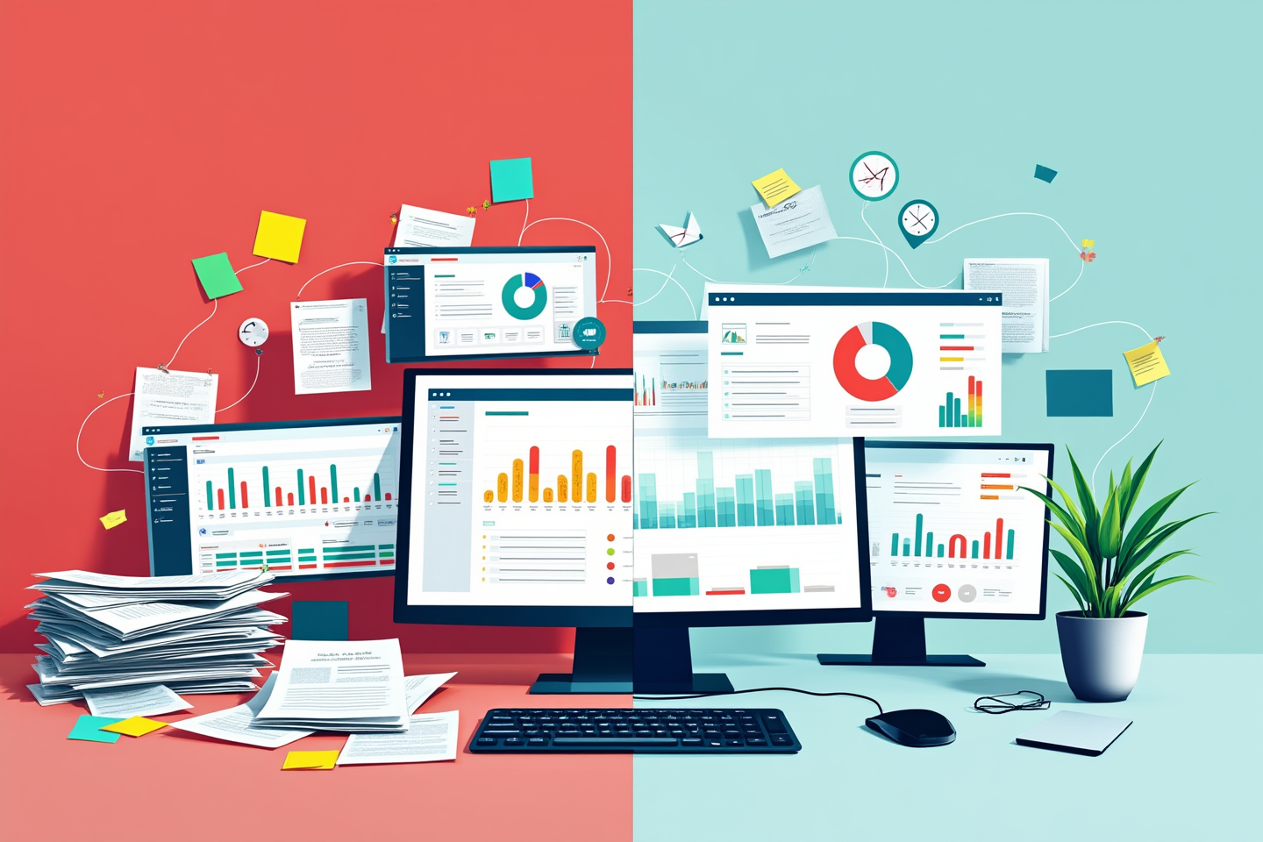
Side-by-side diagram — left “Accounting Software” one isolated Finance box with dashed arrows to Excel (red/grey); right “SAP Business One ERP” an integrated flow Finance-Sales-Inventory-Purchasing connected to one database (green/blue)

Why SAP Business One, and not just any “ERP”?
Once the symptoms are clear, the question shifts: which ERP makes sense for a growing SME? Here it helps to separate SAP Business One from its larger sibling, SAP S/4HANA, which targets big corporations. SAP Business One is purpose-built for the small and medium segment, so the “SAP is only for giants” misconception doesn’t apply.
For SMEs that recognize the signs above, SAP Business One unifies finance, sales and CRM, purchasing, and inventory in one integrated system — available on-premise or as SAP Business One HANA on Cloud from Soltius, a cloud package accessible anytime over the internet and able to connect to point-of-sale (POS) apps. The system is modular: a business can start with the core modules, then add Production, Project Management, or HR as needs grow. The database runs on SAP HANA (in-memory, for fast reporting and analytics) or Microsoft SQL Server.
The scale isn’t an empty claim. According to SAP News (December 2025), SAP Business One is now used by more than 83,000 companies across 170+ countries with around 1.2 million users, adding roughly 10 new customers a day, many of them starting at SME scale. The “70,000+” figure still circulating on many local sites is out of date.
This article deliberately skips the long definition. If you still want to ground yourself in the concept first, read what SAP Business One is; to compare capabilities and deployment options when sizing up a vendor, the SAP Business One ERP software page carries the detail.

Signs you DON’T need to move yet (and what to fix first)
Competitors rarely write this section, which is exactly where honesty builds trust. Not every business that feels “messy” is automatically ready for an ERP. An implementation forced onto an unprepared organization usually fails, and the failure isn’t the technology, it’s internal readiness.
You likely don’t need to rush if the following conditions aren’t yet met:
- Business processes aren’t documented. If the sales, purchasing, and approval flows still live “in the head” of the owner or a handful of people, an ERP will encode the chaos rather than tidy it.
- Master data is still dirty. Duplicate product codes, inconsistent customer or vendor names, mixed units of measure. Migrating dirty data into a new system just relocates the problem.
- The team isn’t committed to training. An ERP demands new work habits. Without the time commitment to learn, even the most capable system gets “worked around” through Excel again.
- Transaction volume is still low and single-location. For a business with fewer than five users, limited transactions, and one location, tidy accounting software is still adequate. Don’t buy a tractor for a backyard vegetable patch.
So before talking implementation, sort out process documentation and master-data cleanup first. Neither job is glamorous, but most of an implementation’s success is decided here, long before the system is switched on.

Once you’re sure: a quick look at the road to go-live
When the signs are clear and the organization is ready, implementation becomes a structured process. SAP’s official methodology, the Accelerated Implementation Program (AIP), splits a project into five phases (SAP Learning).
Phase | Name | Primary focus | Typical duration
1 | Project Preparation | Handover, installation, team setup | 1–2 weeks
2 | Business Blueprint | Mapping processes to configuration; per-division workshops | 2–4 weeks
3 | Project Realization | Configuration, data migration, customization | 4–8 weeks
4 | Final Preparation | UAT and end-user training | 2–3 weeks
5 | Go-Live & Support | System live; post-go-live hypercare | 1–2 weeks
For an SME with well-documented processes, the typical total runs 3–6 months to go-live; simpler cases with clean data can finish in around 8–10 weeks. That’s a common industry range, not a fixed promise. The more customization and the more entities or locations involved, the longer it stretches, sometimes to nine months. That’s why agreeing on a realistic scope during the Business Blueprint phase matters so much.
The safest approach is phased: switch on the three core modules first (Finance, Sales & CRM, and Purchasing & Inventory), stabilize, then add the advanced ones. To understand which modules businesses lean on most, the rundown of most-used SAP modules is a good starting point.
One cost point that’s often misread: for on-premise perpetual licenses, annual maintenance typically runs 18–20% of the license value per year, following common industry practice. On a cloud or subscription model, maintenance is folded into the monthly fee, so there’s no separate maintenance line.
An experienced partner carries a lot of weight here. As an SAP Platinum Partner through United VARs membership and part of the Metrodata Group since 1998, Soltius supports SMEs from readiness assessment through implementation and post-go-live support.

Horizontal timeline of the five implementation phases — Project Preparation → Business Blueprint → Realization → Final Prep → Go-Live, each with an icon and typical duration, total “3–6 months” below, progressive grey-to-green color

Frequently Asked Questions

What’s the clearest sign a business needs an ERP like SAP Business One?
The clearest sign is a monthly close that takes more than 10 working days while the finance team spends most of its time gathering data rather than analyzing it. Other signs: stock reports that won’t reconcile across warehouses, sales and finance data split across Excel, and heavy manual re-entry between divisions. If more than three feel familiar, an ERP is worth serious consideration.

Is SAP Business One suitable for a small, growing business?
Yes. SAP Business One was designed for small and medium-sized enterprises, and more than 83,000 companies across 170+ countries use it (SAP, December 2025), many starting at SME scale. It’s modular: begin with Finance, Sales, and Inventory, then add modules as you grow. The condition is that business processes and master data are reasonably clean before implementation.

What’s the difference between regular accounting software and SAP Business One?
Accounting software focuses on historical financial data such as the general ledger, receivables, and payables, and works in silos. SAP Business One is an integrated ERP: one sales transaction automatically updates stock, purchasing, and financial reports in real time from a single database, with no re-entry. As transaction volume and locations grow, that gap becomes a real bottleneck.

How long does SAP Business One implementation take to go-live?
For an SME with well-documented processes, a typical implementation takes 3–6 months from kickoff to go-live; a standard process with clean data can finish in around 8–10 weeks. What extends it: heavy customization, dirty master data, or many locations. This is a common industry range; the actual timeline is set with the consultant during the Business Blueprint phase.

Which SAP Business One modules should be deployed first?
Most phased implementations start with three core modules: Finance (accounting and reporting), Sales & CRM (sales and customers), and Purchasing & Inventory (procurement and stock). The three are integrated, so a sales transaction is reflected immediately in stock and finance. Advanced modules such as Production, Project Management, and HR are switched on once the team is comfortable with the core.

Do we have to move everything at once, or can it be phased?
It can be phased, and that’s the common practice. Start with the modules most critical to core operations (usually Finance, Sales, and Inventory), stabilize, then add the next ones. What can’t be deferred is master-data cleanup and process documentation; both must be ready before the first go-live phase to keep the implementation from unraveling.

What’s the typical annual maintenance cost?
For on-premise perpetual licenses, annual maintenance typically runs 18–20% of the license value per year, following common industry practice. For cloud or subscription models, maintenance is usually bundled into the monthly fee, so there’s no separate line. The exact figure depends on configuration, user count, and the agreement with the implementation partner.
Recognizing the signs above is the first step; choosing the right way to deploy is the next. If a business already shows three or more signs and its internal processes are reasonably ready, the moment to move to an integrated system has likely arrived. Soltius Indonesia, with experience since 1998 as one of the country’s largest SAP implementation partners, supports SMEs from readiness assessment through post-go-live support. The goal isn’t to sell the biggest system; it’s to find the configuration that genuinely fits the scale and rhythm of the business.

