Article Metadata
title: "Practical Tips for Successful Vannamei Shrimp Pond Operations: A 12-Step SNI-Aligned Playbook"
meta_title: "Vannamei Shrimp Pond: 12-Step Success Playbook"
meta_description: "Practical tips for vannamei shrimp pond operations: prep, post-larvae, phased feeding, SNI water quality, AHPND/WSSV biosecurity, export-grade harvest."
slug: "vannamei-shrimp-pond-success-tips"
language: "en"
primary_keyword: "vannamei shrimp pond"
secondary_keywords:
- "intensive vannamei farming"
- "vannamei shrimp post-larvae"
- "vannamei shrimp feed"
- "shrimp pond water quality"
- "AHPND WSSV EHP biosecurity"
- "shrimp pond aeration"
- "shrimp FCR"
- "stocking density vannamei"
- "Litopenaeus vannamei farming"
- "shrimp pond preparation"
internal_links:
- url: "https://stpaquaculture.com/en/news/budidaya-udang-vaname"
anchor: "vannamei shrimp farming"
- url: "https://stpaquaculture.com/en/news/benur-udang-vaname"
anchor: "vannamei post-larvae"
- url: "https://stpaquaculture.com/en/news/pakan-udang-vaname"
anchor: "vannamei shrimp feed"
external_citations:
- url: "https://kkp.go.id/news/news-detail/kkp-pamerkan-potensi-udang-indonesia-di-shrimp-summit-2025-bali-BrmY.html"
context: "Indonesia 2024 shrimp exports: US$1.68 billion across 214,580 tons to 87 countries (KKP / Shrimp Summit 2025)"
- url: "https://ejournal3.undip.ac.id/index.php/jmr/article/view/35632/0"
context: "Journal of Marine Research, Universitas Diponegoro, Vol 12 No 2, May 2023: AHPND detected in vannamei ponds in Bangkalan via nested PCR"
- url: "https://www.globalseafood.org/advocate/annual-farmed-shrimp-production-survey-a-slight-decrease-in-production-reduction-in-2023-with-hopes-for-renewed-growth-in-2024/"
context: "Global Seafood Alliance: 2023 farmed shrimp production survey; Indonesia ranked fifth globally"
brief_id: "tambak-udang-vaname-01"
word_count: 1852
publish_month: "2026-05"

Practical Tips for Successful Vannamei Shrimp Pond Operations: A 12-Step SNI-Aligned Playbook
Running a vannamei shrimp pond that harvests at SNI benchmark, cycle after cycle, has very little to do with luck. It comes down to a fixed sequence of technical decisions: dry-out depth, post-larvae certification, phased feeding, biosecurity protocols, and the willingness to read water before reading WhatsApp messages. This article distills 12 operational tips, anchored in Indonesia’s official intensive farming standard (SNI 01-7246-2006) and current field practice in vannamei shrimp farming. You will get a per-phase checklist, a water-quality reference table, and the early signals of AHPND, WSSV, and EHP that most operators miss until mortality is already past 50 percent.
Vannamei is no minor commodity. Indonesia exported US$1.68 billion of shrimp in 2024 across 214,580 metric tons to 87 countries, with the United States absorbing 63.7 percent of total value at roughly US$1.07 billion (KKP, 2025). Globally, Litopenaeus vannamei accounted for 5.6 million metric tons of farmed shrimp in 2023, with Ecuador, China, India, Vietnam, and Indonesia together producing 74 percent of supply (Global Seafood Alliance). The Indonesian government’s stated target is US$2 billion in exports and 2 million tons of national production. The gap between target and realization is where disciplined pond management earns its margin.
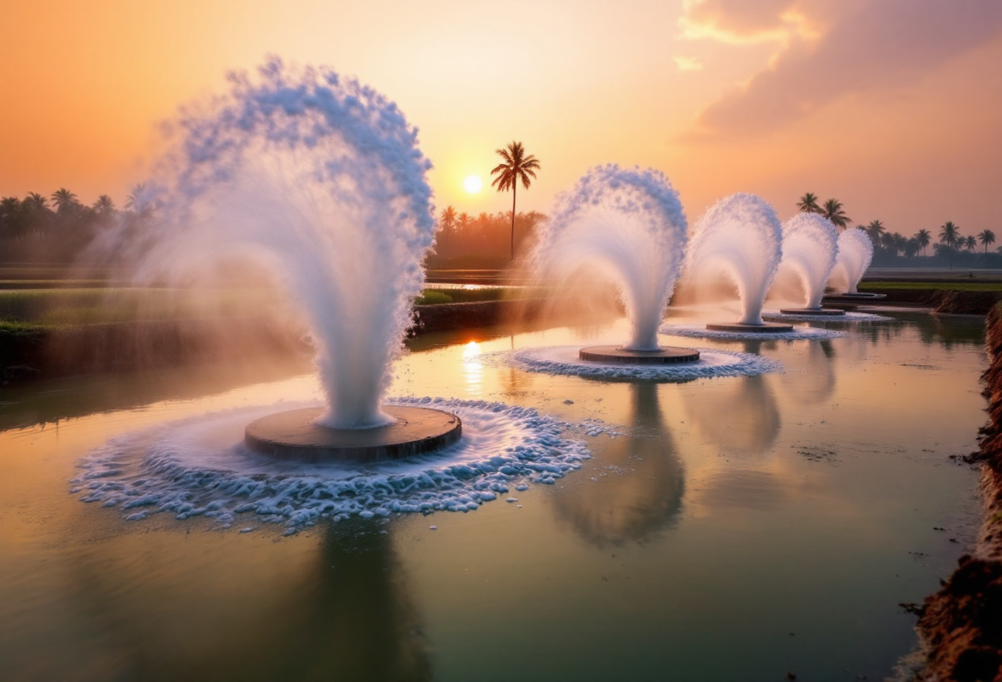
hero shot of an intensive vannamei shrimp pond at golden hour with paddle-wheel aerators spinning and white foam trails across a dark green pond surface; tropical Indonesian coastal setting

Why Vannamei Ponds Often Underperform
A vannamei shrimp pond is a coastal or brackish-water culture system producing Litopenaeus vannamei at stocking densities ranging from 10 to 500 post-larvae per square meter depending on system intensity. Strong harvests rest on three pillars: post-larvae quality (PL10 to PL15 minimum, or PL30 for accelerated cycles), precise feed and dissolved-oxygen management (DO at or above 4 ppm), and a tight biosecurity protocol that pre-empts AHPND, WSSV, and EHP.
SNI 01-7246-2006 sets the Indonesian intensive vannamei benchmark: survival rate (SR) 80 to 90 percent, FCR 1.4, ADG 0.2 grams per head per day, and a minimum production of 15,000 kg per hectare per cycle. Many small and mid-scale ponds harvest well below that 15-ton target. Three causes dominate the failure pattern:
- Inconsistent post-larvae quality: non-SPF sources, uneven size cohorts, or stocking-day stress that compromises the first 30 days.
- Imprecise feeding and aeration: feeding without feeding-tray reads, or pre-dawn DO crashes with no aerator backup.
- Late disease detection: AHPND, WSSV, and EHP are typically confirmed only after visible mass mortality, well past the 24-to-72-hour intervention window.
These pillars interlock. Premium post-larvae cannot survive collapsing water quality, and faultless aeration cannot stop a virus that arrived with unfiltered intake water. Each tip below is mapped to one of four phases: preparation, stocking, grow-out, and harvest.

Pond Preparation: The Phase Most Often Cut Short
More than a third of failed cycles trace back to a rushed preparation phase. Before water enters and post-larvae are released, run this sequence:
- Dry the pond bottom for 7 to 14 days. The goal is to kill residual pathogens and oxidize organic load. For ponds with a recent WSSV history, extend to 14 days or more.
- Apply CaCO3 at 1 to 2 tons per hectare. This neutralizes soil pH and binds heavy metals. Ponds converted from black tiger shrimp (Penaeus monodon) operations typically need 2 to 3 tons per hectare to compensate for accumulated organic load.
- Disinfect bottom and equipment. This is the step most often skipped under cycle-turnaround pressure. Perosolv from STP’s ATD division, a combination of nano-silver (min 4.5 mL/L) and hydrogen peroxide (min 49.5 percent), generates hydroxyl radicals that disable viral DNA. It also acts as an algicide with minimal environmental footprint.
- Fill in stages through a fine-mesh filter. A 200-to-300-micron screen blocks wild fish eggs, crustacean pests, and virus vectors. Unfiltered intake is the equivalent of leaving the door open to WSSV from surrounding waters.
- Baseline the water before stocking. Confirm pH (target 7.5 to 8.5), salinity (15 to 25 ppt optimal, with tolerance from 5 to 35 ppt), and alkalinity (100 to 150 ppm). Record the readings. Do not rely on memory.
A field note worth carrying: in many coastal Java sites, alkalinity drops at the start of the rainy season. Dolomite applied at 50 to 100 kg per hectare typically stabilizes the system before the cycle begins.

Selecting and Stocking Post-Larvae: The First 30 Days Decide Everything
No grow-out program can rescue post-larvae that enter stressed or pathogen-bearing. Selection and stocking determine what happens in the first 30 to 40 days, the same window in which AHPND typically strikes.
Verify these criteria for vannamei post-larvae before payment:
- Stage at PL10 to PL15 minimum for standard cycles; uniform length and weight across individuals in the same bag.
- Active swimming against the current when the test container is stirred.
- Transparent body coloration with no dark patches on the hepatopancreas.
- Written SPF (Specific Pathogen Free) certification from the hatchery, documented, not verbal.
- Salinity and formalin stress-test results showing SR at or above 85 percent after 30 minutes.
For operators looking to shorten the grow-out cycle, Super PL STP offers post-larvae raised to the PL30 stage in a biosecure hatchery. Because the animals enter the pond larger and more resilient, harvest can arrive roughly 20 days earlier than with standard PL10 to PL15 stock, with tighter size uniformity and higher survival.
Stocking density is the next decision. Traditional systems run 10 to 50 PL per square meter; semi-intensive 50 to 100; intensive 100 to 300 (100 to 150 is the realistic entry point for first-time intensive operators). Research at Universitas Airlangga has documented supra-intensive runs at 400 to 500 PL per square meter, producing roughly 57 tons per hectare over a 96-day cycle in 900-square-meter circular ponds. The recurring mistake is stocking at 300 PL per square meter on infrastructure built for 100, a panic situation by day 45.
Release in early morning or late afternoon when pond temperature sits below 30°C. Acclimate for 30 to 45 minutes using drip acclimation to equalize the bag’s temperature and salinity with the receiving pond.
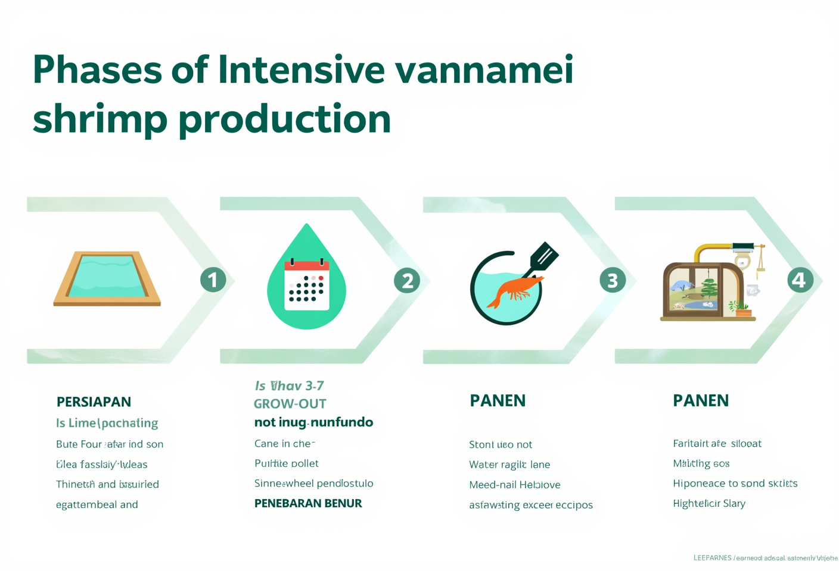
horizontal infographic showing the four phases of the vannamei production cycle (Preparation, Stocking, Grow-out, Harvest) with clean icons and short tip bullets under each phase

Phased Vannamei Feed Management: What Changes from PL to Harvest
Operators moving up from semi-intensive to intensive often ask the same question: does feeding really need to change with phase, or is one good feed enough? Quantity is only one variable. Nutrient profile, pellet size, and feeding frequency all shift with the biology of the animal.
Feeding frequency in intensive systems runs 4 to 6 times per day, following ABC feeding principles (Adjust, Blind, Check). Early-cycle daily feed can equal roughly 50 percent of shrimp biomass; near harvest, that ratio drops to about 3 percent. Feeding trays (anco) are installed at 4 to 6 points per hectare and evaluated 1 to 2 hours after each feeding. Leftover above 10 percent means reduce the next dose by 20 to 30 percent. Tray fully cleared within an hour means add 5 to 10 percent.
STP’s vannamei shrimp feed line is built around these biological phases:
Phase | Shrimp weight | STP product | Key spec | Frequency
Post-larvae to early grow-out | PL10 to PL30 | STP PV | Post-larvae starter formulation | 5 to 6 times/day
Nursery to grow-out | 0.5 to 5 g | STP SGH | Gut health, antioxidant capacity | 5 times/day
Main grow-out | 5 to 15 g | STP SGH MAX | “Next Level of Growth”: attractability, immunity, stress control | 4 to 5 times/day
Pre-harvest / finishing | 15 to 20 g and above | STP TOV | Performance feed, biomass and finishing | 3 to 4 times/day
This phased approach is aligned with the SNI FCR benchmark of 1.4. In practice, efficient intensive operations hold FCR in the 1.2 to 1.5 range. Lower readings (1.2 to 1.3) are typical in circular ponds with biofloc or tight water management; 1.4 to 1.5 is more representative of conventional rectangular intensive ponds.

Water Quality and Aeration: The Pillar That Decides the Cycle
Of all the variables, water quality is the least forgiving. A DO crash to 2.5 ppm at 04:00 can kill 30 percent of biomass in four hours. A temperature spike to 33°C without water exchange suppresses appetite and triggers chronic stress.
The table below combines SNI 01-7246-2006 targets with the field ranges most operators actually encounter:
Parameter | SNI optimal | Typical field range | Monitoring frequency
Temperature | 28–32°C | 28–32°C | 2–3× daily
Salinity | 24–30 ppt | 15–29 ppt | 1× daily
pH | 7.8–8.7 | 7.6–8.5 | 2× daily (morning, afternoon)
Dissolved oxygen | ≥4.14 mg/L | ≥4 ppm minimum (morning) | 2–3× daily
Secchi (transparency) | 30–100 cm | 25–45 cm | 1× daily
Alkalinity | 100–150 ppm | 124–180 ppm | 1× weekly
Ammonia (NH3) | <0.1 mg/L | 0.02–0.8 mg/L | 2× weekly
Nitrite (NO2) | <0.5 mg/L | 0.02–19 mg/L | 2× weekly
Aeration is the variable under direct operator control. At intensive density of 100 to 150 PL per square meter, typical aeration requirements run roughly 1 HP per 400 to 500 kg of projected harvest biomass. To hold DO above 4 ppm continuously, AT21 ME500 aerators (for small to medium ponds) or AT21 ME1500 (for larger ponds) from STP’s ATD division provide an energy-efficient option that can run 24 hours without inflating electricity cost per kilogram of shrimp produced.
A practical note: do not wait until sunrise to read DO. Install a logging DO meter that records hourly, or at minimum sample manually at 03:00 to 04:00 for the first two nights of every cycle to map the daily low. Many week-two losses come not from pathogens but from a paddle wheel that stopped overnight unnoticed.

Shrimp Stop Eating Suddenly? Reading Early Disease Signals
Every operator meets this scenario eventually, usually between day 30 and day 60. A sudden appetite drop is the first signal, and the response window is only 24 to 72 hours before mass mortality begins.
The three dominant disease threats and their early indicators:
- WSSV (White Spot Syndrome Virus). Small white spots on the carapace and head, reddish-yellow body coloration, animals clustering at the pond edge. Mortality reaches 90 to 100 percent within 3 to 7 days post-infection. The 2019 outbreak caused losses of around 20 percent across Indonesian production.
- AHPND / EMS. Caused by Vibrio parahaemolyticus, attacks the hepatopancreas. Early signs: pale or shrunken hepatopancreas, empty gut, gradual deaths starting around day 20. Mortality can reach 100 percent in under 40 days. A 2023 peer-reviewed study confirmed AHPND in vannamei ponds in Bangkalan, East Java, using nested PCR (Journal of Marine Research, Universitas Diponegoro, Vol 12 No 2, May 2023).
- EHP (Enterocytozoon hepatopenaei). A microsporidian that is not directly lethal but stunts growth severely. Signature pattern: stagnant growth with little to no mortality, uneven size distribution, and a steadily worsening FCR.
Routine biosecurity, in place from day one, should already include footwear washes, chlorine dipping at every entry point, dedicated tools per pond, working pest fencing, and limited visitor access. Daily health notes (coloration, swimming behavior, gut content, hepatopancreas status) should be logged manually or via a pond-management app.
For confirmation, visual observation alone is insufficient. PCR testing is the only reliable identification of the pathogen. STP’s Animal Health Team and Mobile Diagnostic Lab enable on-site PCR diagnosis without shipping samples to an external laboratory. In an AHPND outbreak, every 12-hour delay can translate to a double-digit percentage loss in biomass.
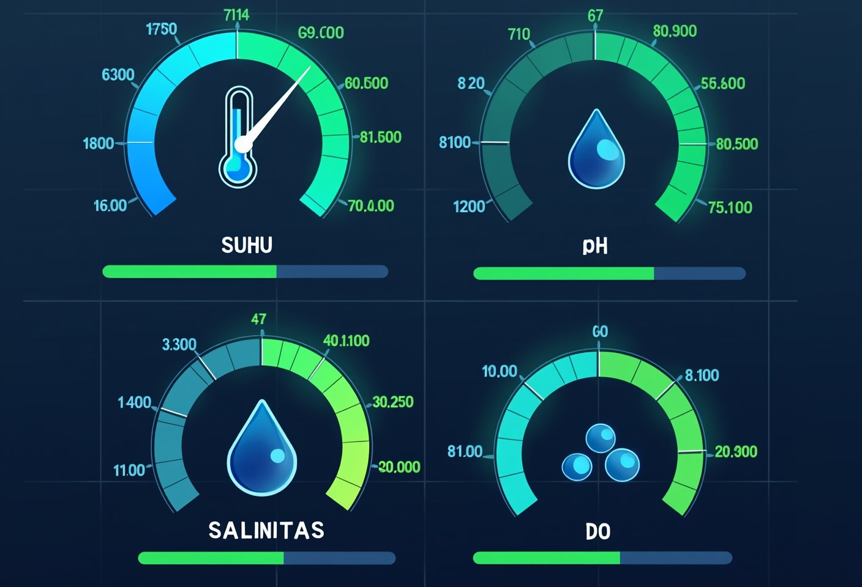
dashboard-style data visualization of vannamei water-quality parameters (pH, temperature, salinity, DO) shown as gauge dials with optimal green zones clearly marked

Harvest Timing and Post-Harvest Handling
Harvest timing decides final margin. Pull too early and the price per kilogram drops with the size class. Pull too late and FCR balloons while disease risk climbs in the final week.
Harvest indicators for a 100-to-120-day intensive cycle:
- ABW 15 to 20 g: local market grade (50 to 70 head per kg).
- ABW 20 to 25 g: standard export grade (40 to 50 head per kg).
- ABW 25 to 30 g: premium export grade (30 to 40 head per kg), typically requiring 110 to 130 days.
- FCR approaching 1.5: feed efficiency is declining; harvest window opening.
- Biological signals: carapace thickening, reduced activity, lower molting frequency.
For healthy intensive ponds, a partial harvest at day 70 to 80 (ABW 12 to 15 g) frees space for the remaining cohort to reach export grade by day 100 to 120. This staggered approach commonly adds 10 to 15 percent to total cycle revenue. Ice slurry should be staged at pond edge before netting begins; bringing core temperature below 4°C within the first 10 minutes preserves quality to the processing plant.
Do not refill immediately after harvest. A full dry-out and disinfection of 10 to 14 days is the buffer that determines whether the next cycle inherits this cycle’s pathogen load. With a disciplined inter-cycle gap, an intensive vannamei operation can realistically run 2 to 3 cycles per year.

Frequently Asked Questions

How long is the grow-out cycle for vannamei in an intensive pond?
Intensive vannamei cycles run 90 to 120 days at stocking densities of 100 to 150 post-larvae per square meter. Shrimp typically reach average body weight (ABW) of 15 to 20 grams, the standard local-market size. Premium export grade at ABW 20 to 30 grams generally requires 110 to 130 days. SNI 01-7246-2006 sets minimum production of 15,000 kg per hectare per cycle as the intensive benchmark.

What is the difference between intensive and semi-intensive vannamei farming?
Intensive systems stock at 100 to 300 post-larvae per square meter, run full aeration, and feed 4 to 6 times daily via feeding trays, targeting 14 to 18 tons per hectare per cycle. Semi-intensive systems stock 50 to 100 per square meter, rely partly on natural pond productivity, and yield 3 to 8 tons per hectare. The choice depends on capital, aeration capacity, and the operator’s water-management bandwidth.

What is the optimal stocking density for vannamei?
For first-time intensive operators, 100 to 150 post-larvae per square meter is the realistic starting point. This range is manageable with standard aeration (roughly 1 HP per 400 to 500 kg of projected biomass) and twice-to-thrice daily DO monitoring. Above 200 per square meter, aeration capacity, water exchange, and monitoring labor must all scale up proportionally.

Why do vannamei often die in the first 30 to 40 days?
Early-cycle mass mortality typically points to three causes: AHPND/EMS driven by Vibrio parahaemolyticus, with mortality up to 100 percent in 40 days; WSSV, which kills 90 to 100 percent of stock in 3 to 7 days; and substandard post-larvae (below PL10 or non-SPF). Mitigation comes down to certified SPF stock, thorough pre-stocking disinfection, and daily monitoring through feeding trays and visual checks.

Can a vannamei pond be built on former black tiger shrimp ground?
Yes, with thorough rehabilitation. Former Penaeus monodon ponds typically carry high organic sediment loads and the risk of residual WSSV in the substrate. Required steps: full dry-out of 14 days or more, aggressive liming at 2 to 3 tons CaCO3 per hectare, bottom disinfection with H2O2- or chlorine-based products, and full water-quality testing before the first stocking to confirm SNI-range parameters.

How do you detect WSSV, AHPND, and EHP early?
Early detection starts with daily visual checks: shrimp clustering at the pond edge (oxygen stress), white spots on the carapace (WSSV), pale hepatopancreas (AHPND), or stagnant growth with no mortality (EHP). Accurate confirmation requires PCR testing. STP’s Animal Health Team and Mobile Diagnostic Lab provide on-site PCR diagnosis, eliminating the delay of shipping samples to external laboratories.

How many cycles per year are realistic for an intensive vannamei pond?
With 100-to-120-day cycles plus 10 to 14 days of inter-cycle preparation, intensive vannamei ponds realistically run 2 to 3 cycles per year. Two cycles is the standard most Indonesian operators sustain. Three cycles is achievable under stable climate conditions and disciplined management, but it raises the risk of pathogen accumulation if preparation biosecurity is compromised.

Strong harvests in vannamei ponds are not the product of one decisive action: they are the cumulative result of 12 technical decisions running from pond preparation to harvest day. As a total solution aquaculture company operating since 1987, STP supplies not only feed but also certified post-larvae, on-farm technology, and field technical support, including the Mobile Diagnostic Lab and the KAVAS program, which has supported over 124 small-scale shrimp farmers across Indonesia. For operators aiming to push pond productivity toward SNI benchmarks and export grades, an integrated approach combining Super PL STP post-larvae, the phased vannamei feed range, ATD aeration and disinfection, and Animal Health Team support aligns directly with modern intensive practice. Explore further technical guidance on vannamei shrimp farming at intensive scale in Indonesia.

