# Adlib ads 参考附录

# 申明

本文档属于上海数凹科技有限公司机密(secret)级别，只限于内部使用。如果违反，公司将保留追究泄密的权利。

|  |  |  |  |
| --- | --- | --- | --- |
| 版本 | 日期 | 作者 | 备注 |
| V0.1 | 2016/11/30 | Andy.zhou | 创建文档 |
|  |  |  |  |

Table of Contents

Adlib ads 参考附录 1

申明 2

1 文档说明 5

2 类型说明 6

3 web页面 7

3.1广告计划 7

3.1.1列表 7

3.1.2新建 7

3.1.3编辑 8

3.1.4删除 8

3.2单元 8

3.2.1单元列表 8

3.1.2 新建单元 9

3.1.3 编辑单元 10

3.1.4 定向设置 11

3.1.5删除单元 12

3.3 创意 13

3.3.1创意列表 13

3.3.2 新建创意 14

3.3.3 更新创意 18

3.3.4 删除创意 21

3.4 关键词 22

3.4.1 关键词列表 22

3.4.2 新建关键词 23

# 1 文档说明

该文档是广告计划相关的一些概念和常量说明，起附录和参考作用。

# 2 数据类型说明

## 2.1 创意类型Json格式

### 2.1.1 图片

{

"main_img": {

"url": "http://dsp.adclick.com.cn", //图片url，string，必须

"w": 180, //图片宽度，int，必须

"h": 120 //图片高， int，必须

}

}

### 2.1.2 Flash

{

"flash": {

"url": "http://dsp.adclick.com.cn", //flash url， string， 必须

"w": 180, //flash宽，int， 必须

"h": 120 //flash高，int，必须

}

}

### 2.1.3 视频

{

"video": {

"url": "http://dsp.adclick.com.cn", //video url， string， 必须

"duration": 15, //视频时长，int，必须，单位：秒

"w": 180, //视频宽，int，必须

"h": 120 //视频高，int， 必须

“xy_radio”: "AD_16:9",// 􀇫􀂷􀄶: AD_16:9, AD_4:3

}

}

### 2.1.4 原生

{

"title": "xxxxx", //标题，string，必须

"icon_img": { //icon 图片，可选

"url": "http://iconurl", //url， string， 必须

"w": 100, //宽，int，必须，

"h": 100 //高，int，必须

},

"logo_img": { //logo图片，可选

"url": "http://logourl", //url，string，必须

"w": 100, //宽，int，必须

"h": 100 //高，int，必须

},

"main_img": { //广告主图片，可选

"url": "http://mainimgurl", //main url，string，必须

"w": 100, //宽，int，必须

"h": 111 //高，int，必须

},

"desc": "descriptions", //描述，string，可选

"rating": "3", //app rating，string，可选

"downloads": "1000", //app下载量，string，可选

"cta_text": "xxx", //call to action 按钮显示文字，string，可选

"sponsored": "dmtect", //赞助商，string，可选

"price": "100", //商品原始价格，string，必须

"sale_price": "88", //商品折后价格，string，必须

"phone": "136xxx", //联系电话，string，必须

"address": "shanghaipudong", //联系地址，string，必须

"desc2": "dddd", //对desc的补充说明，显示在第二行，必须

"display_url": "dsp.adclick.com.cn" //显示在广告中的链接，string，必须

}

### 2.1.5 文字

{

"title": "xxxxx", //文字标题，string，必须

"desc": "descriptions" //描述，string，必须

}

### 2.1.6 图文

{

"title": "xxxxx", //文字标题，string，可选

"desc": "descriptions", //描述，string，可选

"main_img": { //广告主图片，可选

"url": "http://", //主url，string，必须

"w": 100, //宽，int，必须

"h": 100 //高，int，必须

}

}

## 2.2 广告单元定向

具体见excel表格

|  |  |  |
| --- | --- | --- |
| type | 类型名称 | 内容 |
| 1 | valid_adx | 投放的adx(各adx之间以逗号分隔): 0 – 百度bes 1 – 百度百川 2 – tanx adx 3 - 腾讯 adx e.g.“0,1” 表示投放到bes和百川 注：不存在或status不为0，表示不限制 |
| 2 | adview_type | 投放的流量类型(0 – web, 1 – wap, 2- app) 注：单选，必填。不存在或status不为0表示不投放 |
| 3 | regions | 投放的地域(各地域之间以逗号分隔) 注：不存在或status不为0，表示不限制 |
| 4 | blocked_regions | 地域黑名单 注：同上 |
| 5 | ad_select | BCE广告优选定向（逗号分隔） e.g.“欧莱雅，兰蔻” 表示只对这两个词感兴趣的人群投放广告。使用广告优选定向，需要开通”BCE广告优选”服务，请 咨询你的客户经理。 注：不存在或status不为0，表示不限制 |
| 6 | cycle | 循环搁置，指定在一周的哪些天哪些小时进行投放，一周7(天) * 24(小时) = 168 bit的16进制表达。 e.g.000000000000000000000000000000000000000003， 共168/4 = 42个字符，字符取值[0-F]。 从右至左： 第一个字符：周一的 0-3 四个小时； 第二个字符：周一的 4-7四个小时；以此类推。 因此，上述示例表示只在周一的0点和1点进行投放。 注：不存在或status不为0，表示不限制 |
| 7 | cookies | e.g. “905D83D761B，905D83D761A” 表示只对这两个cookie代表的人群投放广告。 这里的cookie可以填写：1.ADX发送给DSP的userid 2.DSP域下的用户cookie 3.移动设备imei 4.移动设备imei-md5 5.移动设备imei-sha1 6.ios设备idfa 7.ios设备idfa-md5 8.ios设备idfa-sha1 9.android设备android-id 10.android设备android-id-md5 11.android设备android-id-sha1 注：不存在或status不为0，表示不限制 |
| 8 | blocked_cookies | cookie黑名单（逗号分隔） e.g. 同上 |
| 9 | sites | 站点定向（多个站点之间以逗号分隔），支持URL，站 点，主域三种定向 e.g. http://www.baidu.com (URL匹配)， www.baidu.com(站点匹配)， baidu.com(主域匹配) 注：不存在或status不为0，表示不限制 |
| 10 | blocked_sites | 站点黑名单（逗号分隔） e.g. 同上。 注：不存在或status不为0，表示不限制 |
| 11 | os | 操作系统定向（多个操作系统之间以逗号分隔）默认支持 项： 0 – WINDOWS 1 – MAC 2 – LINUX 3 – IOS 4 – ANDROID e.g. 0,1 表示定向Windows和MAC操作系统； 3,4 表示定向移动IOS和安卓系统 注：不存在或status不为0，表示不限制 |
| 12 | carrier | 运营商定向（多个运营商之间以逗号分隔）默认支持项： 0 – 电信 1 – 移动 2 – 联通 3 – 网通 e.g. 0,1 表示定向电信和移动客户； 2,3 表示定向联通和网通客户。 注：不存在或status不为0，表示不限制 |
| 13 | connection_type | 连网类型定向（多个连网类型之间以逗号分隔）默认支持 项： 0 – WIFI 1 – 2G 2 – 3G 3 – 4G 4 - Earthnet e.g. 0,1 表示定向WIFI和2G客户 2,3 表示定向3G和4G客户 注：不存在或status不为0，表示不限制 |
| 14 | start_time | 开始投放时间, 格式为int64类型时间戳。 注：不存在或status不为0，表示不限制 |
| 15 | end_time | 结束投放时间, 格式为int64类型时间戳。 注：不存在或status不为0，表示不限制 |
| 16 | adslot | 广告位定向（多个广告位之间以逗号分隔） e.g. "2135" 表示定向广告位 id=2135 的广告位。 注：不存在或status不为0，表示不限制 |
| 17 | freq_imp_daily | 每日展现频次控制 不存在或status不为0，表示不限制 |
| 18 | freq_click_daily | 每日点击频次控制 不存在或status不为0，表示不限制 |
| 19 | browser | 浏览器定向，多个浏览器之间以逗号分隔 0 - 微软IE 1 - Chrome 2 - Firefox 3 - Safari 4 - Opera 5 - 微软Edge 6 - 微信浏览器 7 - QQ浏览器 8 - 360浏览器 9 - UC浏览器 10 - 搜狗浏览器 不存在或status不为0，表示不限制 |

## 2.3 IAB内容分类体系

|  |  |
| --- | --- |
| **Value** | Category Name |
| **IAB1** | **Arts & Entertainment** |
| IAB1-1 | Books & Literature |
| IAB1-2 | Celebrity Fan/Gossip |
| IAB1-3 | Fine Art |
| IAB1-4 | Humor |
| IAB1-5 | Movies |
| IAB1-6 | Music |
| IAB1-7 | Television |
| **IAB2** | **Automotive** |
| IAB2-1 | Auto Parts |
| IAB2-2 | Auto Repair |
| IAB2-3 | Buying/Selling Cars |
| IAB2-4 | Car Culture |
| IAB2-5 | Certified Pre-Owned |
| IAB2-6 | Convertible |
| IAB2-7 | Coupe |
| IAB2-8 | Crossover |
| IAB2-9 | Diesel |
| IAB2-10 | Electric Vehicle |
| IAB2-11 | Hatchback |
| IAB2-12 | Hybrid |
| IAB2-13 | Luxury |
| IAB2-14 | MiniVan |
| IAB2-15 | Mororcycles |
| IAB2-16 | Off-Road Vehicles |
| IAB2-17 | Performance Vehicles |
| IAB2-18 | Pickup |
| IAB2-19 | Road-Side Assistance |
| IAB2-20 | Sedan |
| IAB2-21 | Trucks & Accessories |
| IAB2-22 | Vintage Cars |
| IAB2-23 | Wagon |
| **IAB3** | **Business** |
| IAB3-1 | Advertising |
| IAB3-2 | Agriculture |
| IAB3-3 | Biotech/Biomedical |
| IAB3-4 | Business Software |
| IAB3-5 | Construction |
| IAB3-6 | Forestry |
| IAB3-7 | Government |
| IAB3-8 | Green Solutions |
| IAB3-9 | Human Resources |
| IAB3-10 | Logistics |
| IAB3-11 | Marketing |
| IAB3-12 | Metals |
| **IAB4** | **Careers** |
| IAB4-1 | Career Planning |
| IAB4-2 | College |
| IAB4-3 | Financial Aid |
| IAB4-4 | Job Fairs |
| IAB4-5 | Job Search |
| IAB4-6 | Resume Writing/Advice |
| IAB4-7 | Nursing |
| IAB4-8 | Scholarships |
| IAB4-9 | Telecommuting |
| IAB4-10 | U.S. Military |
| IAB4-11 | Career Advice |
| **IAB5** | **Education** |
| IAB5-1 | 7-12 Education |
| IAB5-2 | Adult Education |
| IAB5-3 | Art History |
| IAB5-4 | College Administration |
| IAB5-5 | College Life |
| IAB5-6 | Distance Learning |
| IAB5-7 | English as a 2nd Language |
| IAB5-8 | Language Learning |
| IAB5-9 | Graduate School |
| IAB5-10 | Homeschooling |
| IAB5-11 | Homework/Study Tips |
| IAB5-12 | K-6 Educators |
| IAB5-13 | Private School |
| IAB5-14 | Special Education |
| IAB5-15 | Studying Business |
| **IAB6** | **Family & Parenting** |
| IAB6-1 | Adoption |
| IAB6-2 | Babies & Toddlers |
| IAB6-3 | Daycare/Pre School |
| IAB6-4 | Family Internet |
| IAB6-5 | Parenting - K-6 Kids |
| IAB6-6 | Parenting teens |
| IAB6-7 | Pregnancy |
| IAB6-8 | Special Needs Kids |
| IAB6-9 | Eldercare |
| **IAB7** | **Health & Fitness** |
| IAB7-1 | Exercise |
| IAB7-2 | A.D.D. |
| IAB7-3 | AIDS/HIV |
| IAB7-4 | Allergies |
| IAB7-5 | Alternative Medicine |
| IAB7-6 | Arthritis |
| IAB7-7 | Asthma |
| IAB7-8 | Autism/PDD |
| IAB7-9 | Bipolar Disorder |
| IAB7-10 | Brain Tumor |
| IAB7-11 | Cancer |
| IAB7-12 | Cholesterol |
| IAB7-13 | Chronic Fatigue Syndrome |
| IAB7-14 | Chronic Pain |
| IAB7-15 | Cold & Flu |
| IAB7-16 | Deafness |
| IAB7-17 | Dental Care |
| IAB7-18 | Depression |
| IAB7-19 | Dermatology |
| IAB7-20 | Diabetes |
| IAB7-21 | Epilepsy |
| IAB7-22 | GERD/Acid Reflux |
| IAB7-23 | Headaches/Migraines |
| IAB7-24 | Heart Disease |
| IAB7-25 | Herbs for Health |
| IAB7-26 | Holistic Healing |
| IAB7-27 | IBS/Crohn’s Disease |
| IAB7-28 | Incest/Abuse Support |
| IAB7-29 | Incontinence |
| IAB7-30 | Infertility |
| IAB7-31 | Men’s Health |
| IAB7-32 | Nutrition |
| IAB7-33 | Orthopedics |
| IAB7-34 | Panic/Anxiety Disorders |
| IAB7-35 | Pediatrics |
| IAB7-36 | Physical Therapy |
| IAB7-37 | Psychology/Psychiatry |
| IAB7-38 | Senor Health |
| IAB7-39 | Sexuality |
| IAB7-40 | Sleep Disorders |
| IAB7-41 | Smoking Cessation |
| IAB7-42 | Substance Abuse |
| IAB7-43 | Thyroid Disease |
| IAB7-44 | Weight Loss |
| IAB7-45 | Women’s Health |
| **IAB8** | **Food & Drink** |
| IAB8-1 | American Cuisine |
| IAB8-2 | Barbecues & Grilling |
| IAB8-3 | Cajun/Creole |
| IAB8-4 | Chinese Cuisine |
| IAB8-5 | Cocktails/Beer |
| IAB8-6 | Coffee/Tea |
| IAB8-7 | Cuisine-Specific |
| IAB8-8 | Desserts & Baking |
| IAB8-9 | Dining Out |
| IAB8-10 | Food Allergies |
| IAB8-11 | French Cuisine |
| IAB8-12 | Health/Lowfat Cooking |
| IAB8-13 | Italian Cuisine |
| IAB8-14 | Japanese Cuisine |
| IAB8-15 | Mexican Cuisine |
| IAB8-16 | Vegan |
| IAB8-17 | Vegetarian |
| IAB8-18 | Wine |
| **IAB9** | **Hobbies & Interests** |
| IAB9-1 | Art/Technology |
| IAB9-2 | Arts & Crafts |
| IAB9-3 | Beadwork |
| IAB9-4 | Birdwatching |
| IAB9-5 | Board Games/Puzzles |
| IAB9-6 | Candle & Soap Making |
| IAB9-7 | Card Games |
| IAB9-8 | Chess |
| IAB9-9 | Cigars |
| IAB9-10 | Collecting |
| IAB9-11 | Comic Books |
| IAB9-12 | Drawing/Sketching |
| IAB9-13 | Freelance Writing |
| IAB9-14 | Genealogy |
| IAB9-15 | Getting Published |
| IAB9-16 | Guitar |
| IAB9-17 | Home Recording |
| IAB9-18 | Investors & Patents |
| IAB9-19 | Jewelry Making |
| IAB9-20 | Magic & Illusion |
| IAB9-21 | Needlework |
| IAB9-22 | Painting |
| IAB9-23 | Photography |
| IAB9-24 | Radio |
| IAB9-25 | Roleplaying Games |
| IAB9-26 | Sci-Fi & Fantasy |
| IAB9-27 | Scrapbooking |
| IAB9-28 | Screenwriting |
| IAB9-29 | Stamps & Coins |
| IAB9-30 | Video & Computer Games |
| IAB9-31 | Woodworking |
| **IAB10** | **Home & Garden** |
| IAB10-1 | Appliances |
| IAB10-2 | Entertaining |
| IAB10-3 | Environmental Safety |
| IAB10-4 | Gardening |
| IAB10-5 | Home Repair |
| IAB10-6 | Home Theater |
| IAB10-7 | Interior Decorating |
| IAB10-8 | Landscaping |
| IAB10-9 | Remodeling & Construction |
| **IAB11** | **Law, Gov’t & Politics** |
| IAB11-1 | Immigration |
| IAB11-2 | Legal Issues |
| IAB11-3 | U.S. Government Resources |
| IAB11-4 | Politics |
| IAB11-5 | Commentary |
| **IAB12** | **News** |
| IAB12-1 | International News |
| IAB12-2 | National News |
| IAB12-3 | Local News |
| **IAB13** | **Personal Finance** |
| IAB13-1 | Beginning Investing |
| IAB13-2 | Credit/Debt & Loans |
| IAB13-3 | Financial News |
| IAB13-4 | Financial Planning |
| IAB13-5 | Hedge Fund |
| IAB13-6 | Insurance |
| IAB13-7 | Investing |
| IAB13-8 | Mutual Funds |
| IAB13-9 | Options |
| IAB13-10 | Retirement Planning |
| IAB13-11 | Stocks |
| IAB13-12 | Tax Planning |
| **IAB14** | **Society** |
| IAB14-1 | Dating |
| IAB14-2 | Divorce Support |
| IAB14-3 | Gay Life |
| IAB14-4 | Marriage |
| IAB14-5 | Senior Living |
| IAB14-6 | Teens |
| IAB14-7 | Weddings |
| IAB14-8 | Ethnic Specific |
| **IAB15** | **Science** |
| IAB15-1 | Astrology |
| IAB15-2 | Biology |
| IAB15-3 | Chemistry |
| IAB15-4 | Geology |
| IAB15-5 | Paranormal Phenomena |
| IAB15-6 | Physics |
| IAB15-7 | Space/Astronomy |
| IAB15-8 | Geography |
| IAB15-9 | Botany |
| IAB15-10 | Weather |
| **IAB16** | **Pets** |
| IAB16-1 | Aquariums |
| IAB16-2 | Birds |
| IAB16-3 | Cats |
| IAB16-4 | Dogs |
| IAB16-5 | Large Animals |
| IAB16-6 | Reptiles |
| IAB16-7 | Veterinary Medicine |
| **IAB17** | **Sports** |
| IAB17-1 | Auto Racing |
| IAB17-2 | Baseball |
| IAB17-3 | Bicycling |
| IAB17-4 | Bodybuilding |
| IAB17-5 | Boxing |
| IAB17-6 | Canoeing/Kayaking |
| IAB17-7 | Cheerleading |
| IAB17-8 | Climbing |
| IAB17-9 | Cricket |
| IAB17-10 | Figure Skating |
| IAB17-11 | Fly Fishing |
| IAB17-12 | Football |
| IAB17-13 | Freshwater Fishing |
| IAB17-14 | Game & Fish |
| IAB17-15 | Golf |
| IAB17-16 | Horse Racing |
| IAB17-17 | Horses |
| IAB17-18 | Hunting/Shooting |
| IAB17-19 | Inline Skating |
| IAB17-20 | Martial Arts |
| IAB17-21 | Mountain Biking |
| IAB17-22 | NASCAR Racing |
| IAB17-23 | Olympics |
| IAB17-24 | Paintball |
| IAB17-25 | Power & Motorcycles |
| IAB17-26 | Pro Basketball |
| IAB17-27 | Pro Ice Hockey |
| IAB17-28 | Rodeo |
| IAB17-29 | Rugby |
| IAB17-30 | Running/Jogging |
| IAB17-31 | Sailing |
| IAB17-32 | Saltwater Fishing |
| IAB17-33 | Scuba Diving |
| IAB17-34 | Skateboarding |
| IAB17-35 | Skiing |
| IAB17-36 | Snowboarding |
| IAB17-37 | Surfing/Bodyboarding |
| IAB17-38 | Swimming |
| IAB17-39 | Table Tennis/Ping-Pong |
| IAB17-40 | Tennis |
| IAB17-41 | Volleyball |
| IAB17-42 | Walking |
| IAB17-43 | Waterski/Wakeboard |
| IAB17-44 | World Soccer |
| **IAB18** | **Style & Fashion** |
| IAB18-1 | Beauty |
| IAB18-2 | Body Art |
| IAB18-3 | Fashion |
| IAB18-4 | Jewelry |
| IAB18-5 | Clothing |
| IAB18-6 | Accessories |
| **IAB19** | **Technology & Computing** |
| IAB19-1 | 3-D Graphics |
| IAB19-2 | Animation |
| IAB19-3 | Antivirus Software |
| IAB19-4 | C/C++ |
| IAB19-5 | Cameras & Camcorders |
| IAB19-6 | Cell Phones |
| IAB19-7 | Computer Certification |
| IAB19-8 | Computer Networking |
| IAB19-9 | Computer Peripherals |
| IAB19-10 | Computer Reviews |
| IAB19-11 | Data Centers |
| IAB19-12 | Databases |
| IAB19-13 | Desktop Publishing |
| IAB19-14 | Desktop Video |
| IAB19-15 | Email |
| IAB19-16 | Graphics Software |
| IAB19-17 | Home Video/DVD |
| IAB19-18 | Internet Technology |
| IAB19-19 | Java |
| IAB19-20 | JavaScript |
| IAB19-21 | Mac Support |
| IAB19-22 | MP3/MIDI |
| IAB19-23 | Net Conferencing |
| IAB19-24 | Net for Beginners |
| IAB19-25 | Network Security |
| IAB19-26 | Palmtops/PDAs |
| IAB19-27 | PC Support |
| IAB19-28 | Portable |
| IAB19-29 | Entertainment |
| IAB19-30 | Shareware/Freeware |
| IAB19-31 | Unix |
| IAB19-32 | Visual Basic |
| IAB19-33 | Web Clip Art |
| IAB19-34 | Web Design/HTML |
| IAB19-35 | Web Search |
| IAB19-36 | Windows |
| **IAB20** | **Travel** |
| IAB20-1 | Adventure Travel |
| IAB20-2 | Africa |
| IAB20-3 | Air Travel |
| IAB20-4 | Australia & New Zealand |
| IAB20-5 | Bed & Breakfasts |
| IAB20-6 | Budget Travel |
| IAB20-7 | Business Travel |
| IAB20-8 | By US Locale |
| IAB20-9 | Camping |
| IAB20-10 | Canada |
| IAB20-11 | Caribbean |
| IAB20-12 | Cruises |
| IAB20-13 | Eastern Europe |
| IAB20-14 | Europe |
| IAB20-15 | France |
| IAB20-16 | Greece |
| IAB20-17 | Honeymoons/Getaways |
| IAB20-18 | Hotels |
| IAB20-19 | Italy |
| IAB20-20 | Japan |
| IAB20-21 | Mexico & Central America |
| IAB20-22 | National Parks |
| IAB20-23 | South America |
| IAB20-24 | Spas |
| IAB20-25 | Theme Parks |
| IAB20-26 | Traveling with Kids |
| IAB20-27 | United Kingdom |
| **IAB21** | **Real Estate** |
| IAB21-1 | Apartments |
| IAB21-2 | Architects |
| IAB21-3 | Buying/Selling Homes |
| **IAB22** | **Shopping** |
| IAB22-1 | Contests & Freebies |
| IAB22-2 | Couponing |
| IAB22-3 | Comparison |
| IAB22-4 | Engines |
| **IAB23** | **Religion & Spirituality** |
| IAB23-1 | Alternative Religions |
| IAB23-2 | Atheism/Agnosticism |
| IAB23-3 | Buddhism |
| IAB23-4 | Catholicism |
| IAB23-5 | Christianity |
| IAB23-6 | Hinduism |
| IAB23-7 | Islam |
| IAB23-8 | Judaism |
| IAB23-9 | Latter-Day Saints |
| IAB23-10 | Pagan/Wiccan |
| **IAB24** | **Uncategorized** |
| **IAB25** | **Non-Standard Content** |
| IAB25-1 | Unmoderated UGC |
| IAB25-2 | Extreme Graphic/Explicit Violence |
| IAB25-3 | Pornography |
| IAB25-4 | Profane Content |
| IAB25-5 | Hate Content |
| IAB25-6 | Under Construction |
| IAB25-7 | Incentivized |
| **IAB26** | **Illegal Content** |
| IAB26-1 | Illegal Content |
| IAB26-2 | Warez |
| IAB26-3 | Spyware/Malware |
| IAB26-4 | Copyright Infringement |

# 3 web页面

## 3.1广告计划

### 3.1.1列表

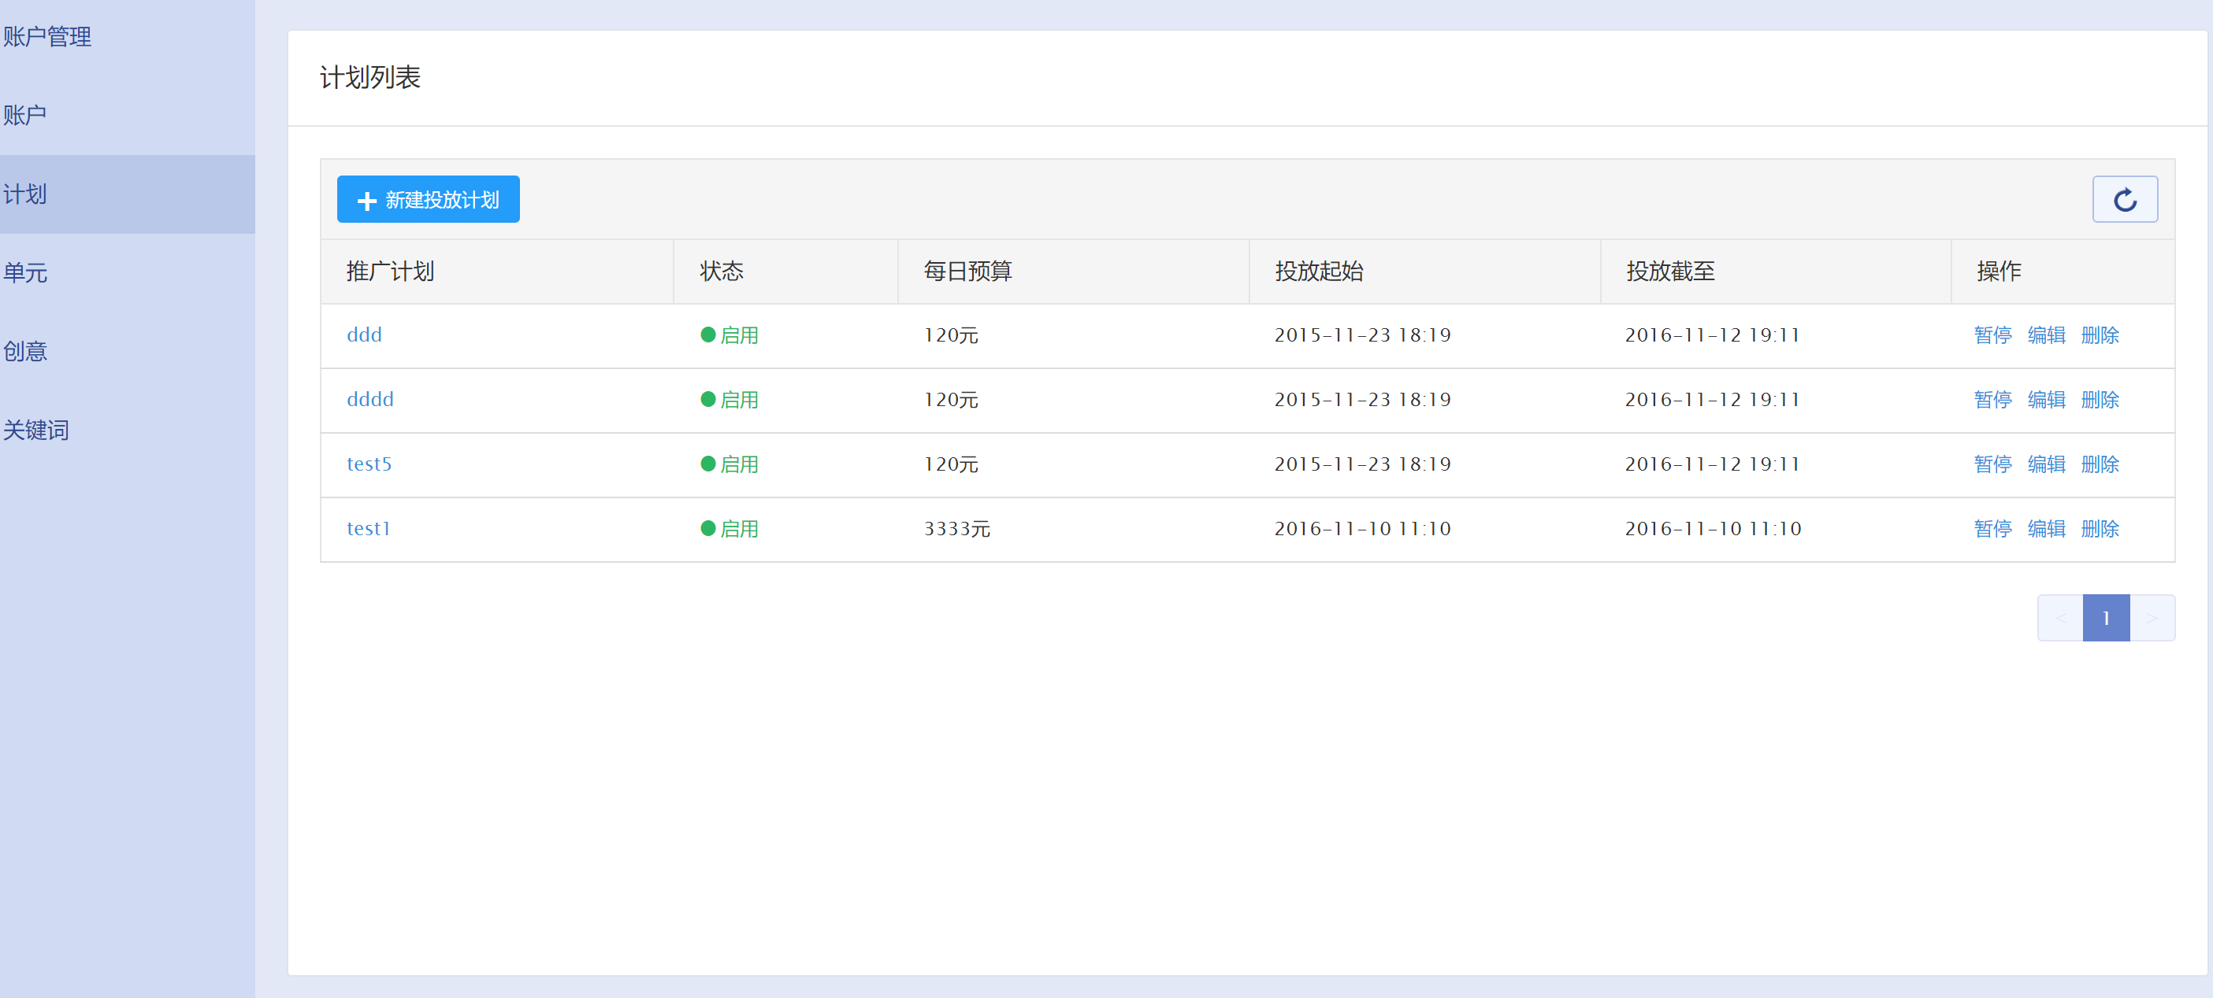

### 3.1.2新建

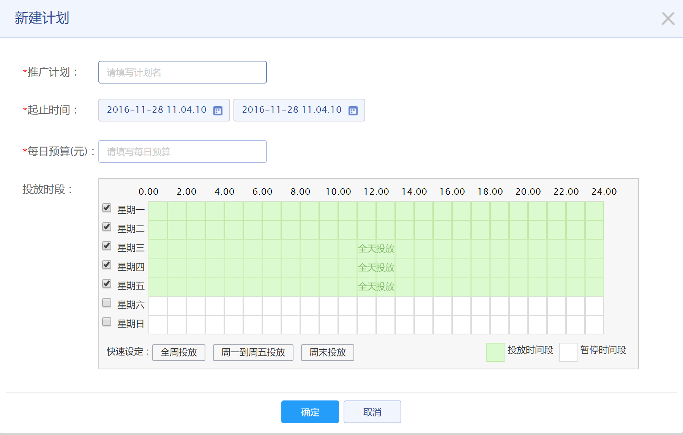

### 3.1.3编辑

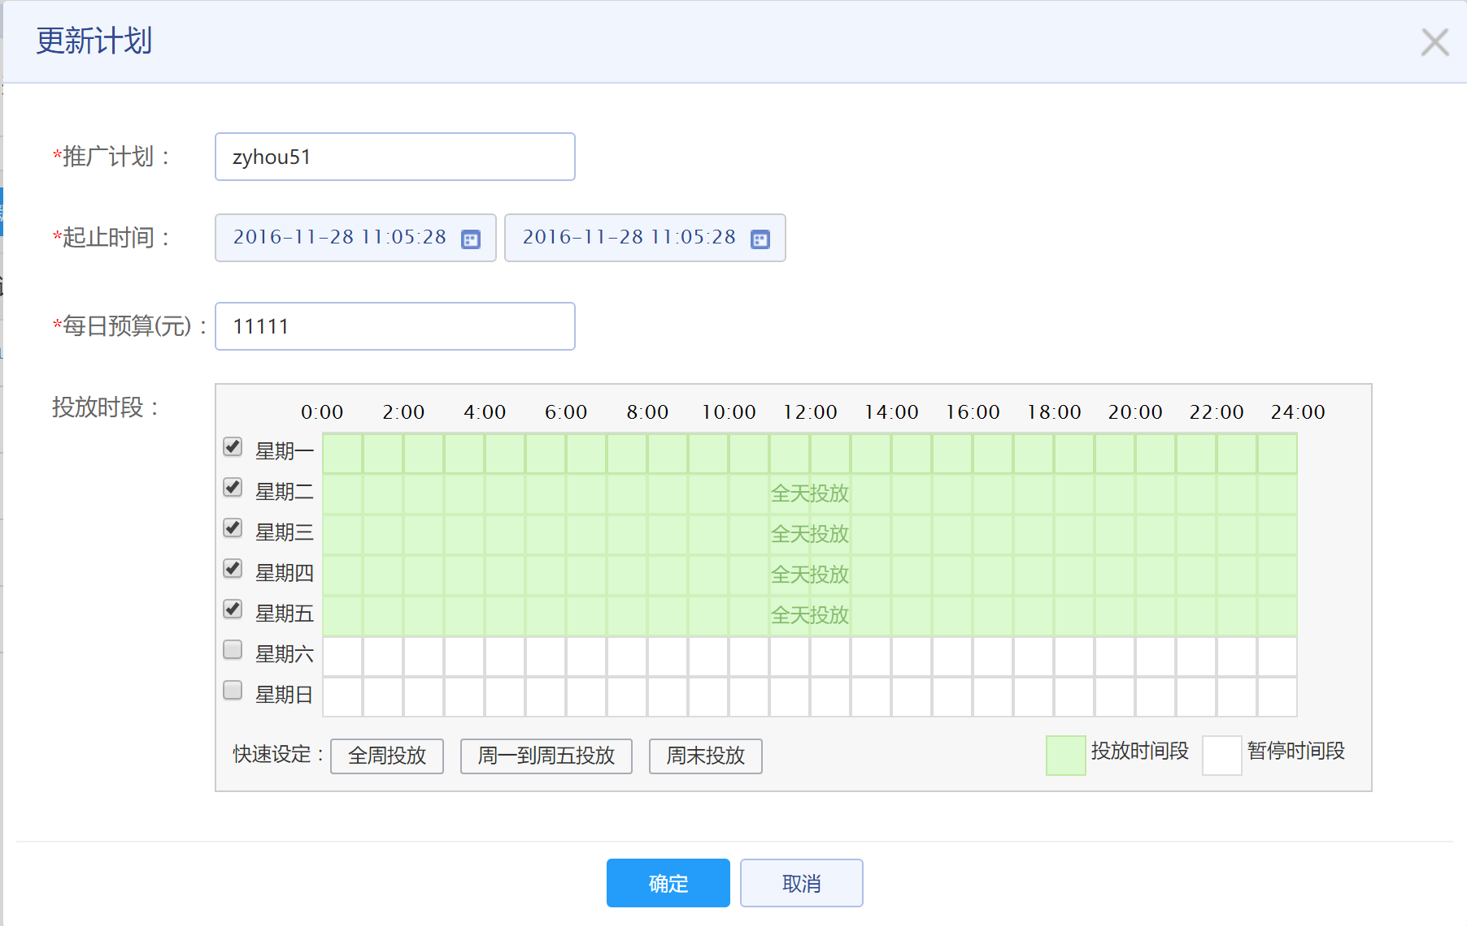

### 3.1.4删除



## 3.2单元

### 3.2.1单元列表

基于计划

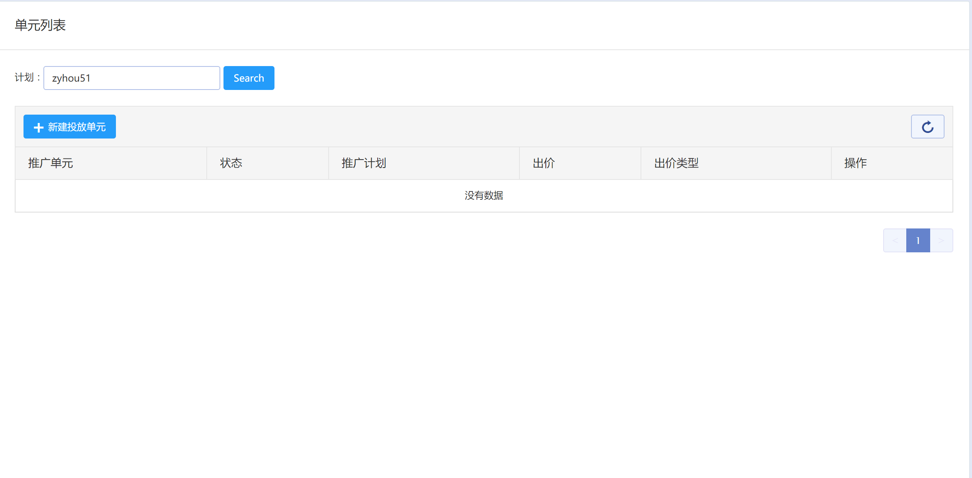

### 3.1.2 新建单元

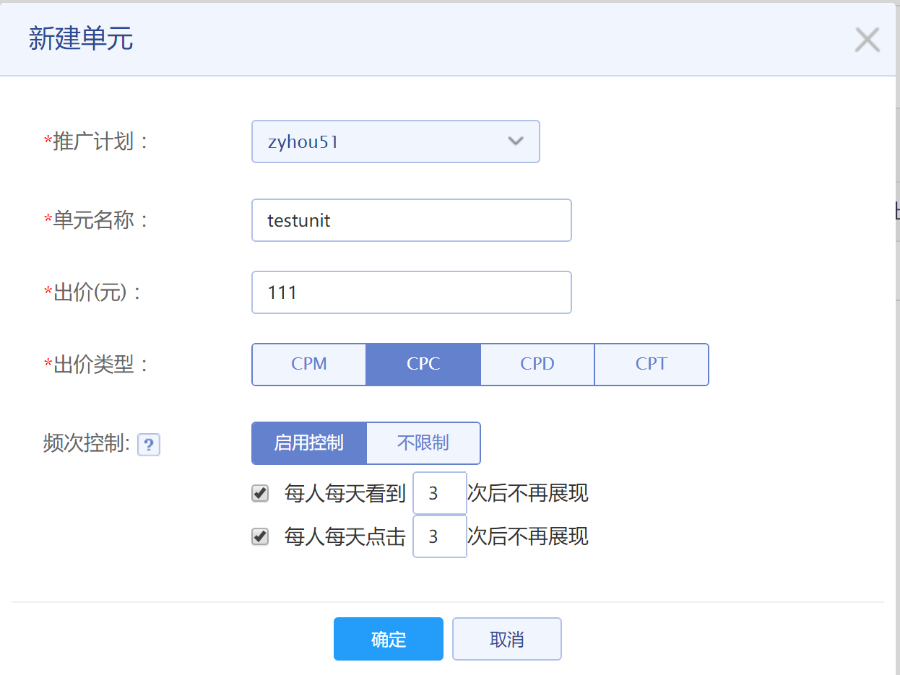

### 3.1.3 编辑单元

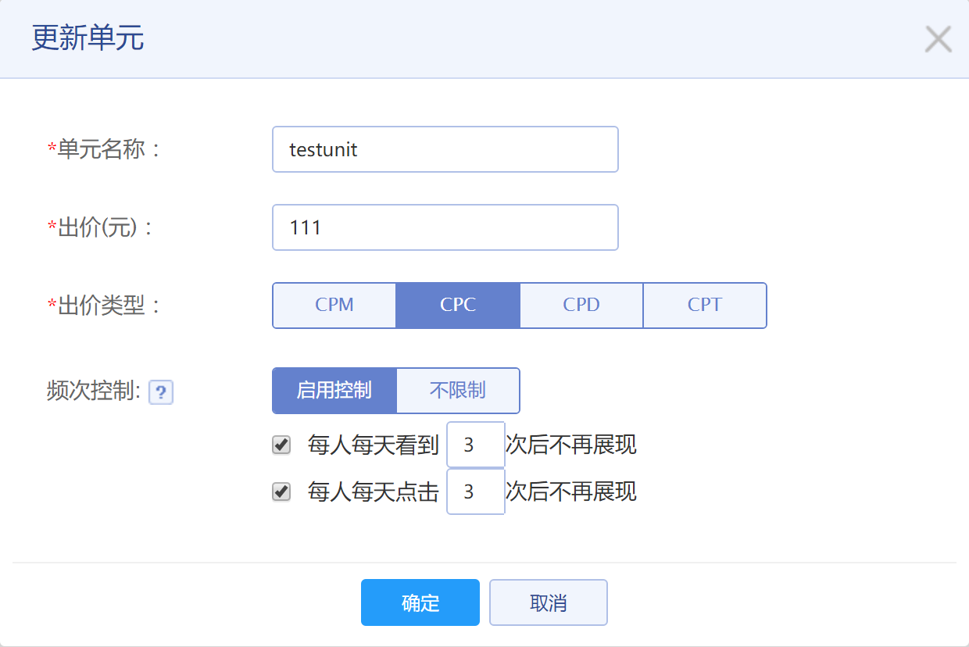

### 3.1.4 定向设置

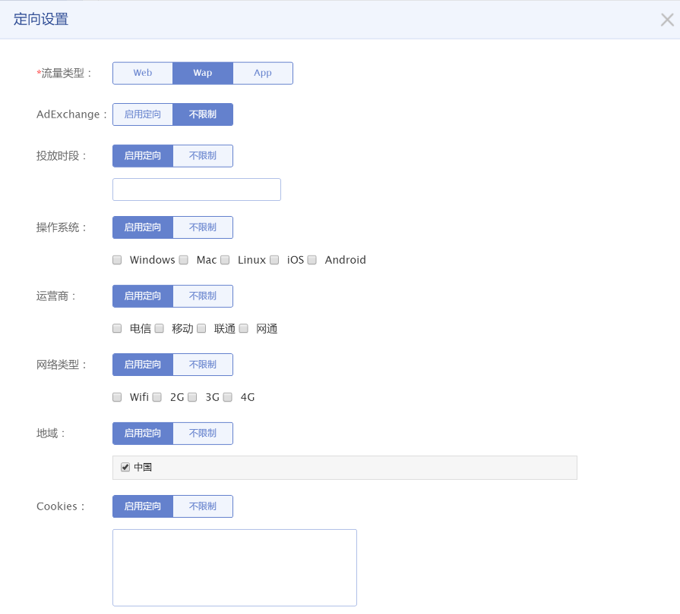

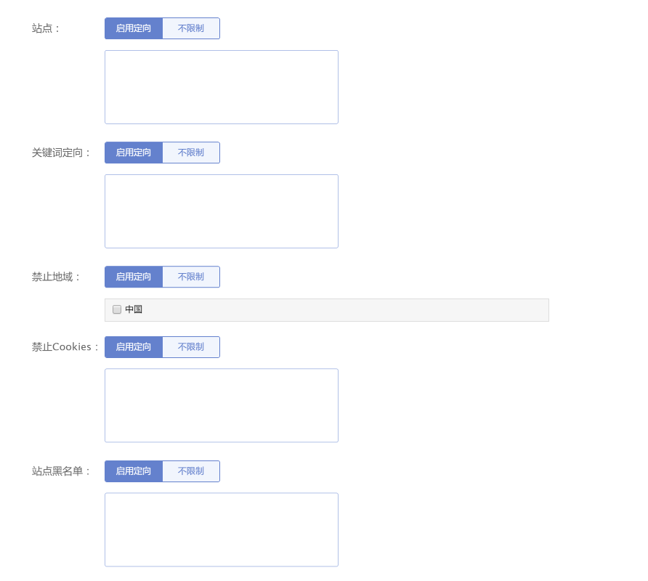

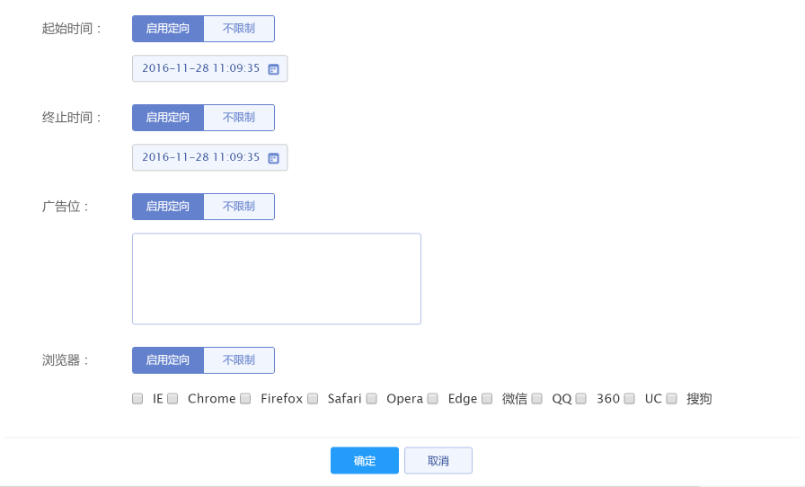

### 3.1.5删除单元



## 3.3 创意

### 3.3.1创意列表

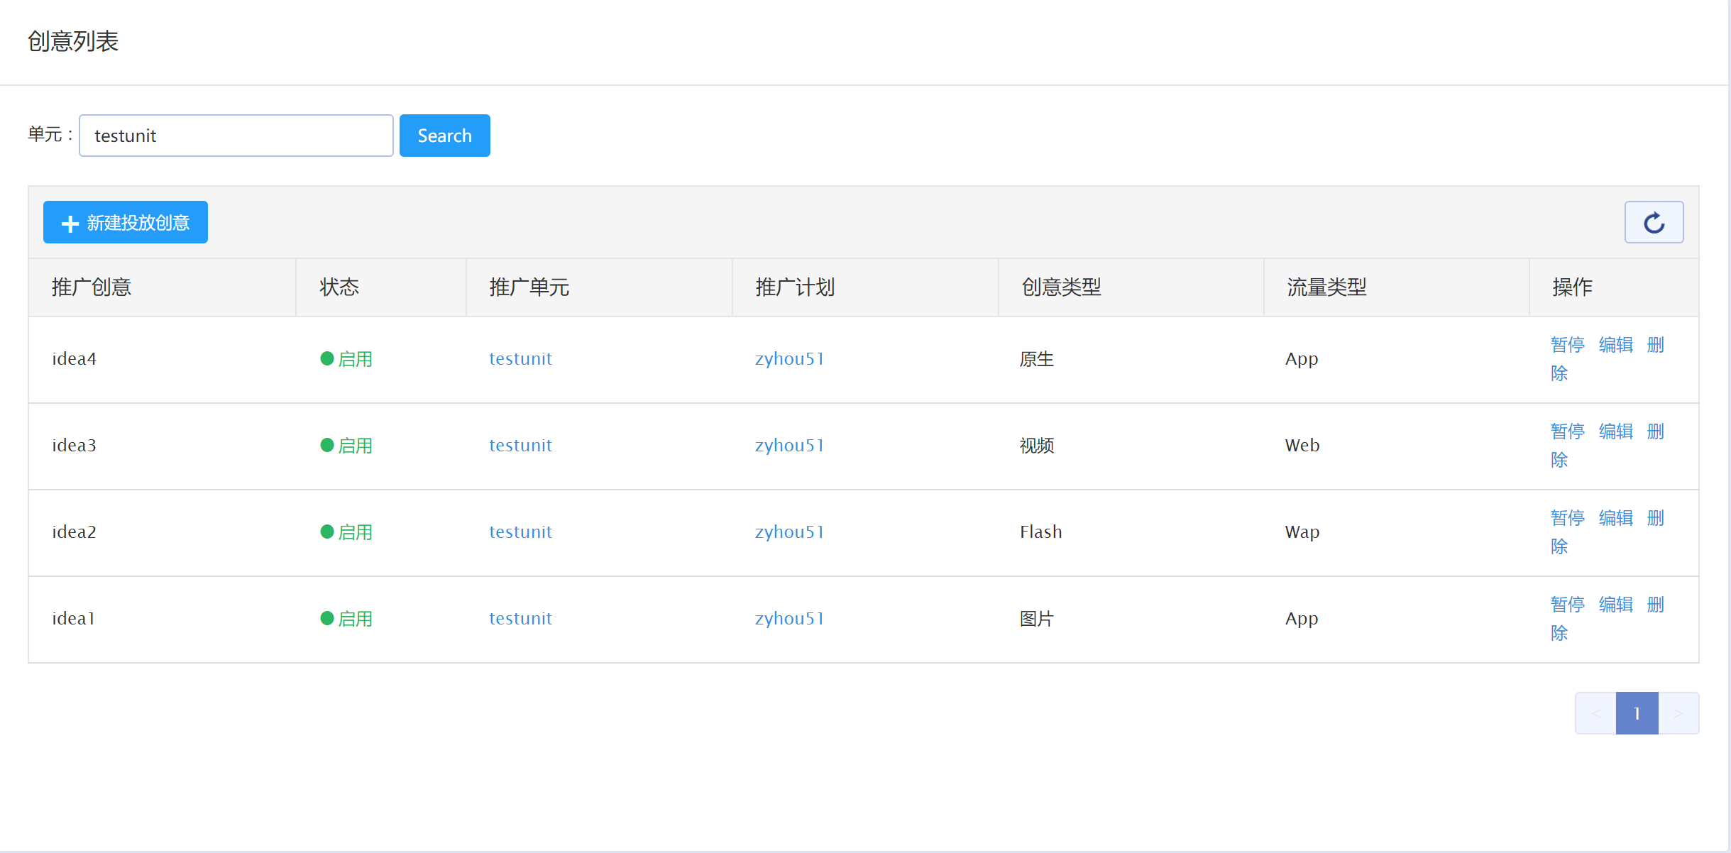

### 3.3.2 新建创意

#### 3.3.2.1 创意类型图片

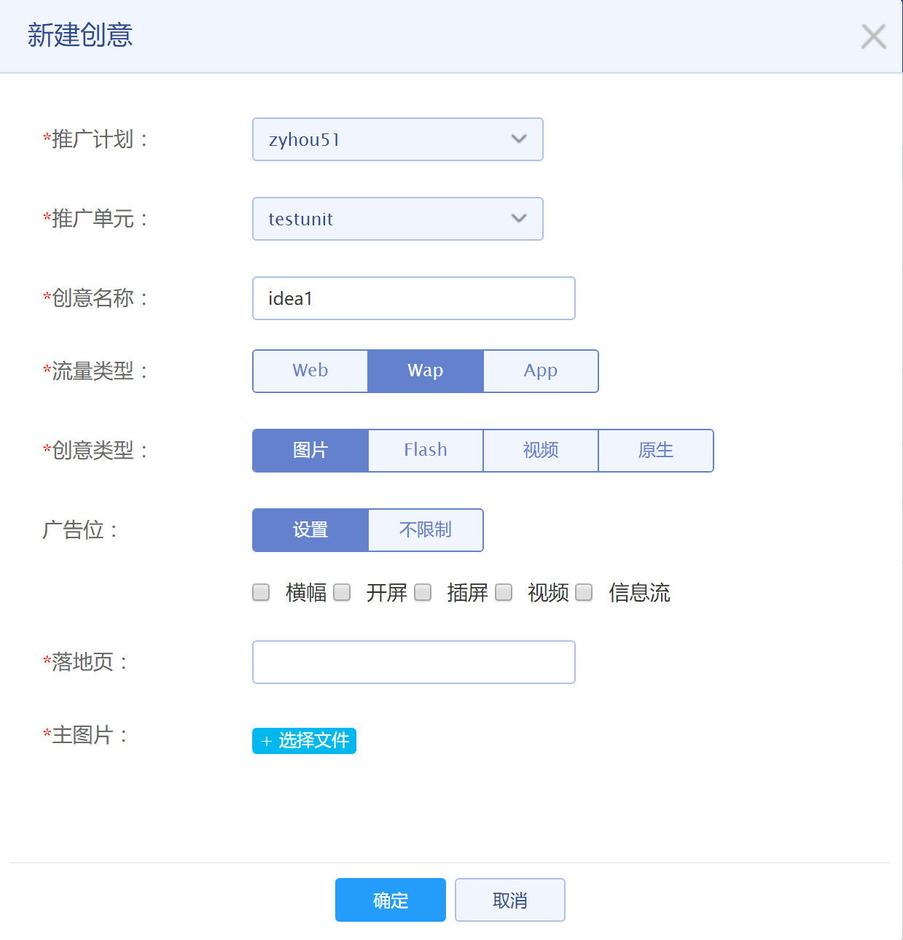

#### 3.3.2.2 创意类型flash

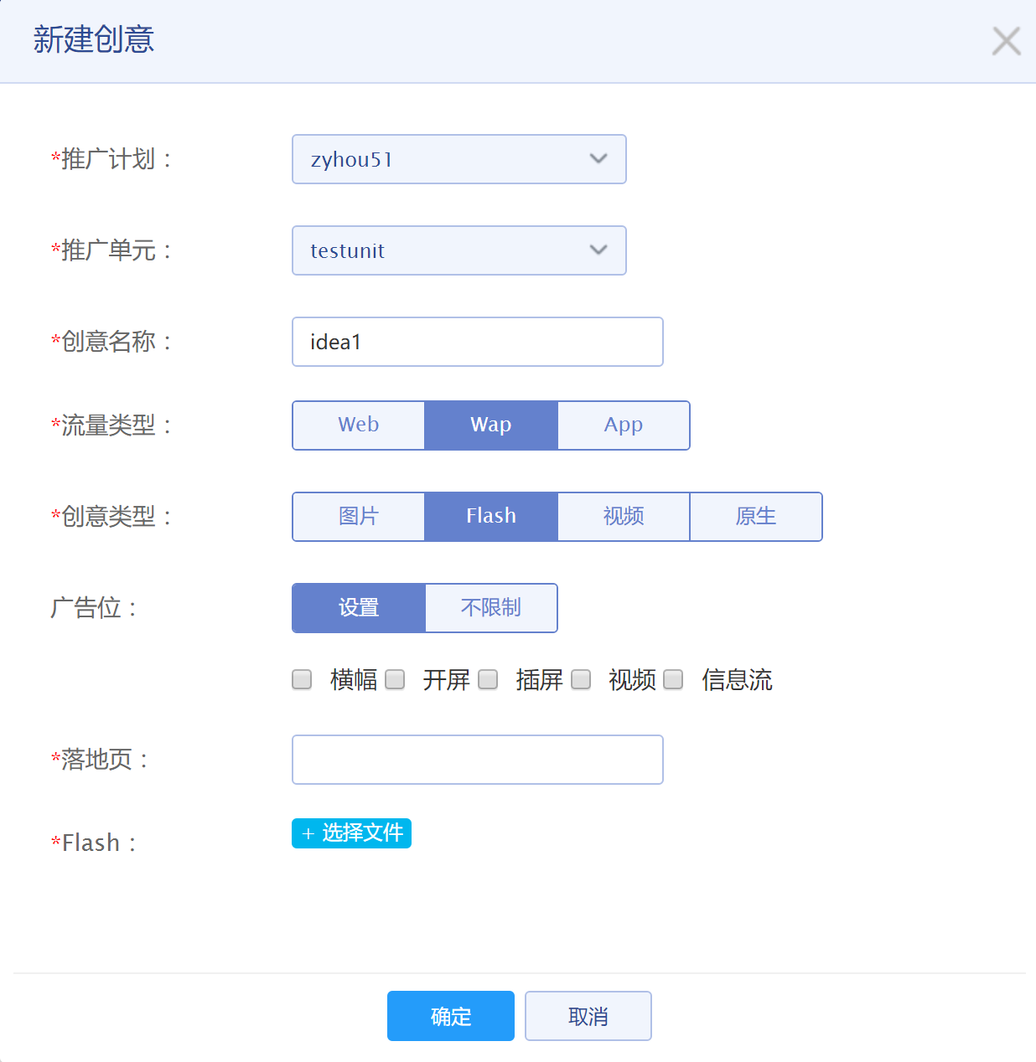

#### 3.3.2.3 创意类型视频

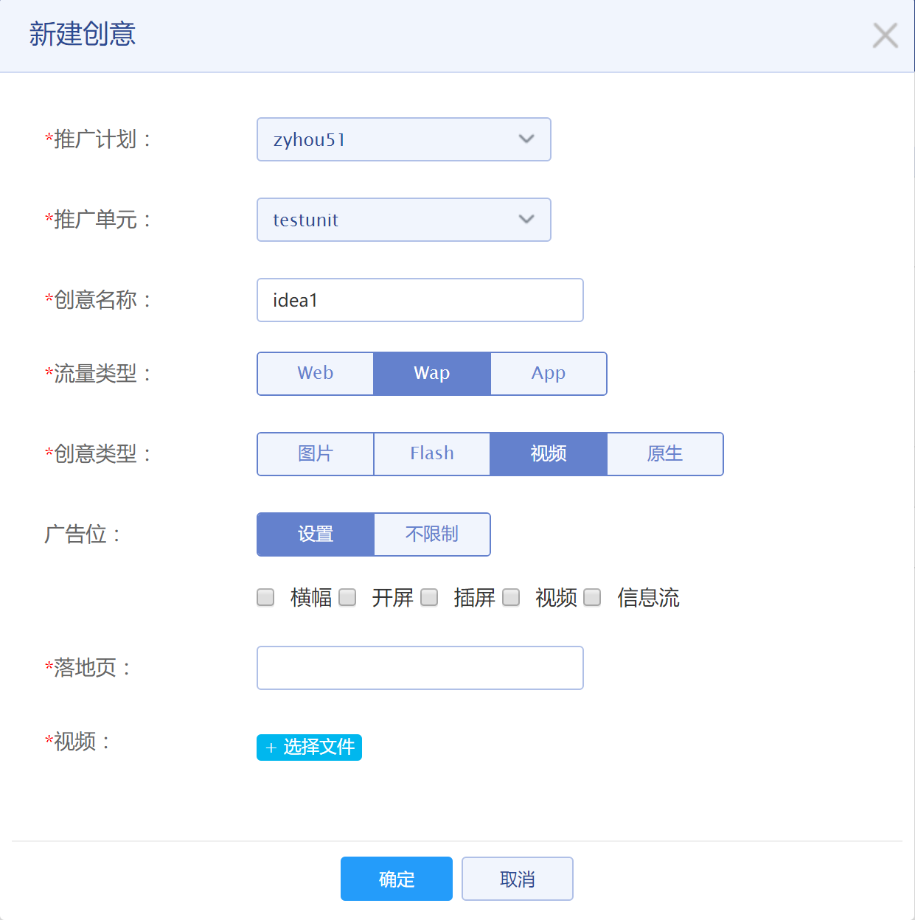

#### 3.3.2.4 创意类型原生

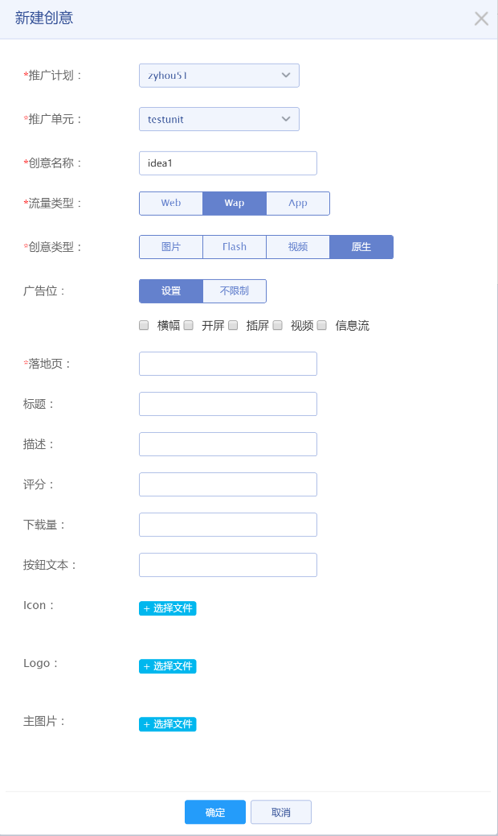

### 3.3.3 更新创意

#### 3.3.3.1创意类型图片

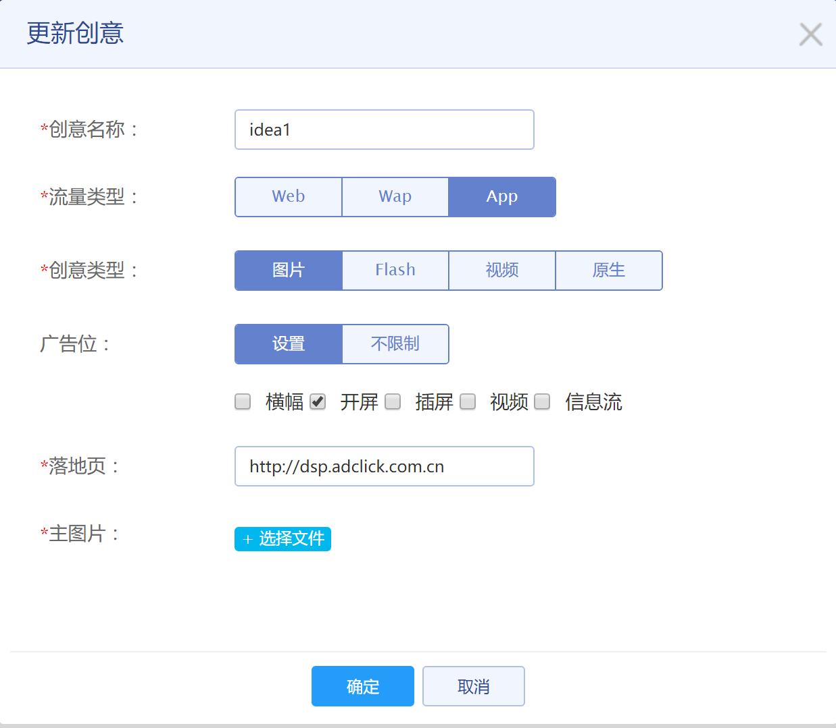

#### 3.3.3.2 创意类型flash

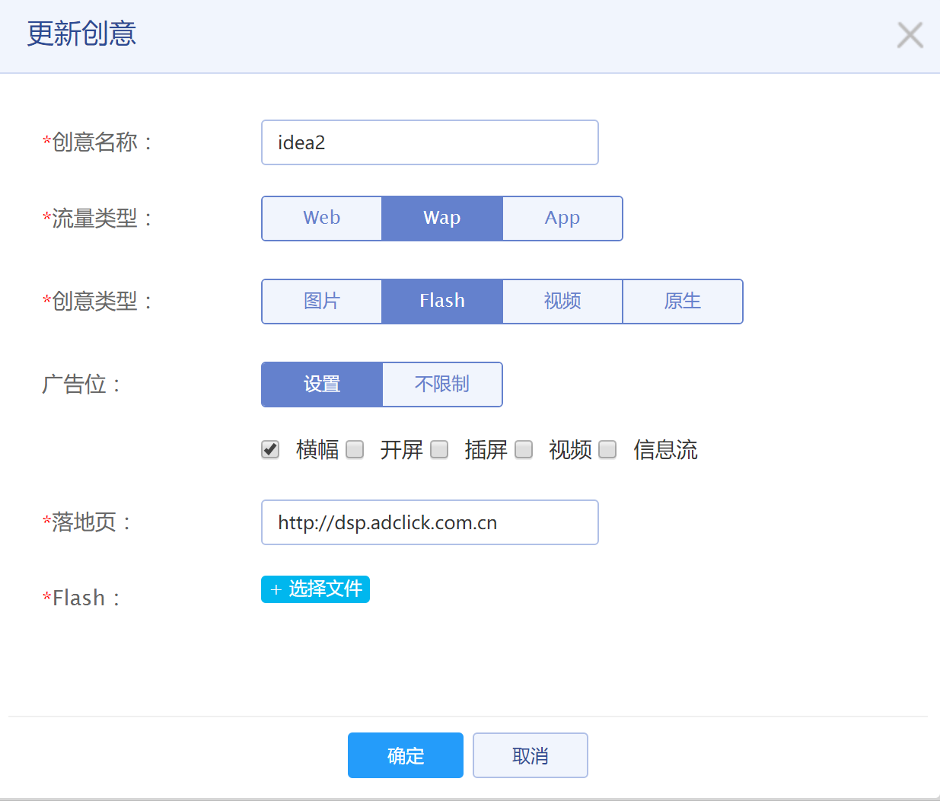

#### 3.3.3.3 创意类型视频

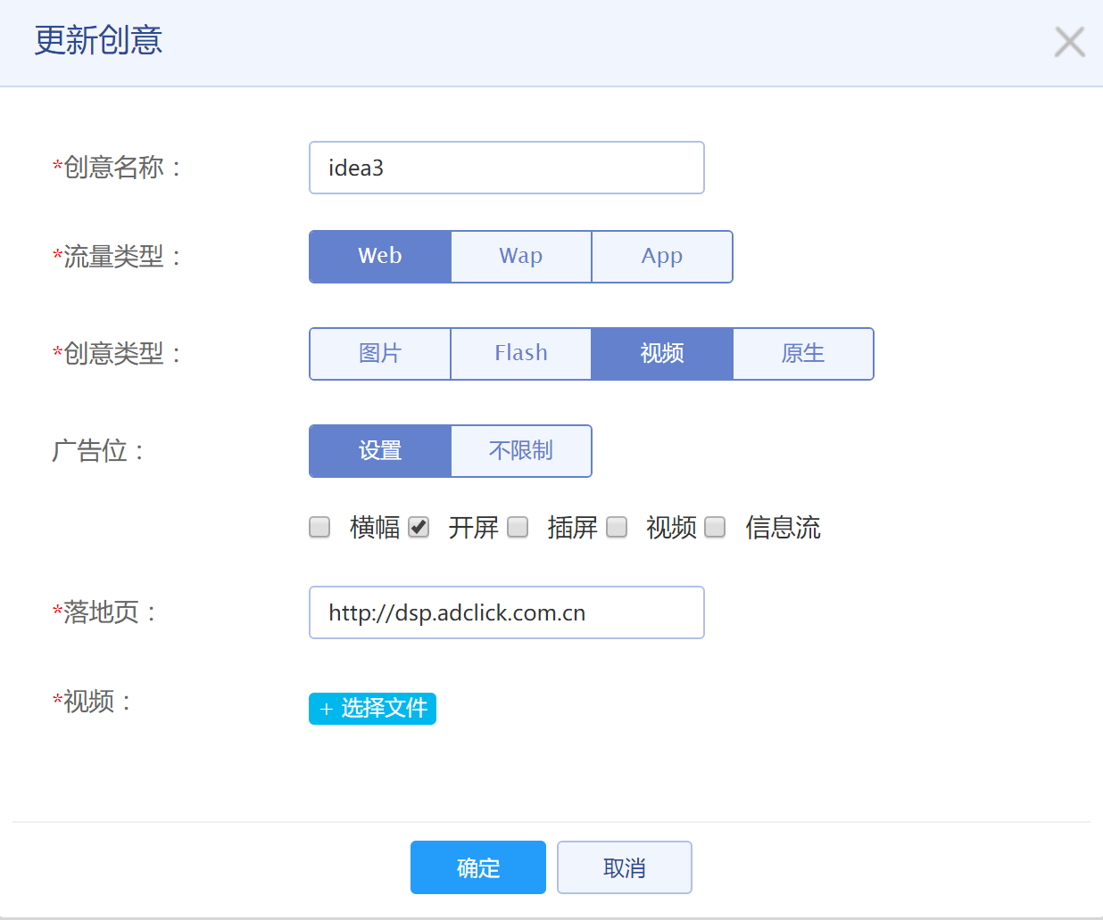

#### 3.3.3.4 创意类型原生

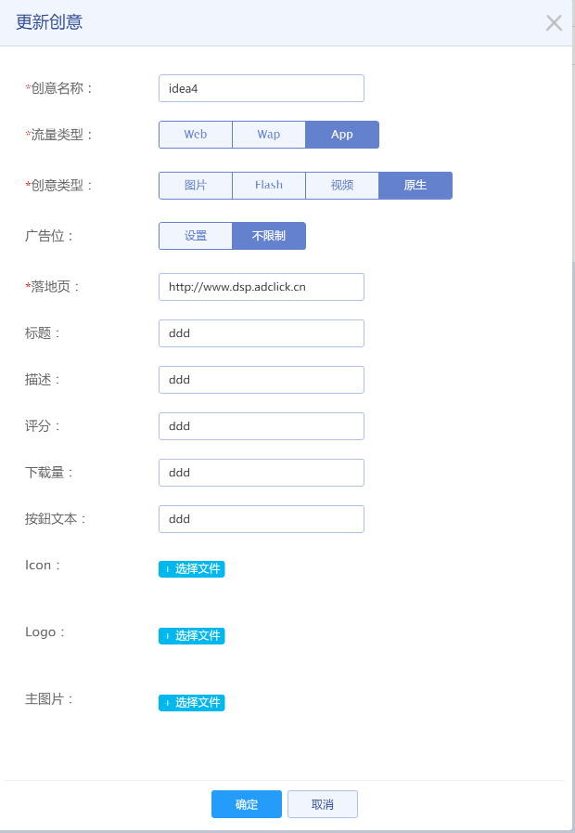

### 3.3.4 删除创意



## 3.4 关键词

### 3.4.1 关键词列表

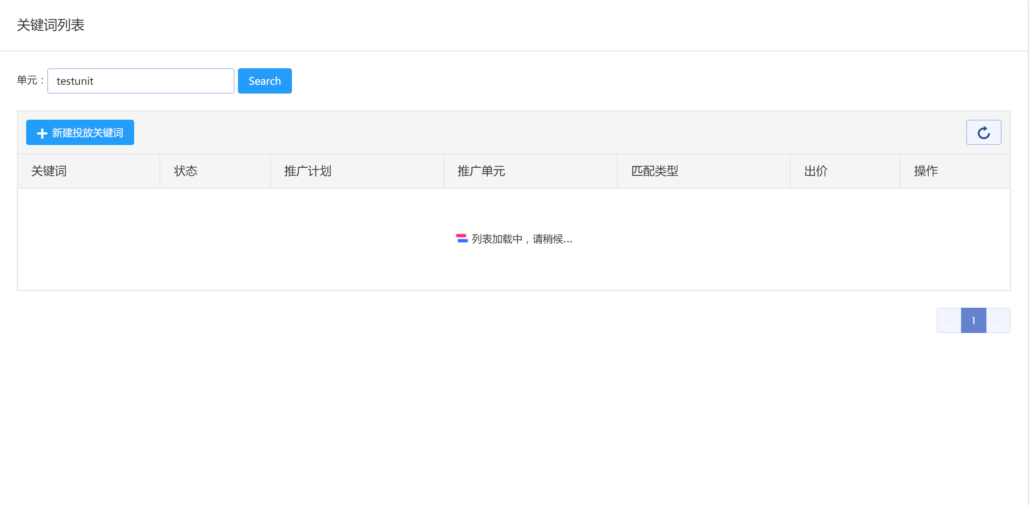

### 3.4.2 新建关键词

