report-neural-interfaces

Neural interfaces: the term is frequently used to describe electronic devices that are placed on

the outside or inside of the brain or other components of the central and peripheral nervous system, such as nerves and links between nerves and muscles, to record or stimulate activity – or both.

The first is to fulfil the potential of neural interfaces in medicine

by advancing innovation, lowering cost and ensuring that safe, effective treatments can be approved efficiently and disseminated to millions who could benefit. The second is to manage the risks associated with wider societal use of neural interfaces in everyday life, as they emerge from specialised markets such as computer gaming and become available to consumers.

All technologies create both benefits and risks and this report seeks to set out a course towards maximising the former while minimising the latter.

The neural revolution could be part of driving advances in human well-being that exceed those brought about by the industrial and digital revolutions.

good

In the medical world

people could undergo ‘whole brain diagnosis’ to identify their unique talents and challenges

there are opportunities to enhance or supercharge the brain itself

Not only thoughts, but sensory experiences, could be communicated from brain to brain.

Bad

Military and security applications are among those that raise the greatest concerns

The prospect of cognitive enhancement also raises issues of access and fairness.

Access to peoples’ thoughts, moods and motivations could lead to abuse of human rights.

our choices can be reduced to a set of neurobiological processes, leaving no room for individual agency or moral responsibility.

enhance human abilities could lead to overdependence on them and a consequent attrition of pure human cognitive capacities.

Every technology carries its own negativity, which is invented at the same time as technical progress

These things are a long way off but not impossible in some form.

Changes that could transform society do not depend on inventing new technologies

but on innovation.

Beyond the medical world, a range of external interfaces have been researched, trialled and in some cases commercialised, causing excitement among gamers and ‘brain-hackers’.

The most extensively used form of internal interface today is the cochlear implant

DBS

Interfaces have also been used to treat eople who have suffered damage to parts of the nervous system

One of the most mature external interface echnologies is Functional Electrical Stimulation (FES)

A wide range of interface technologies is used in neuroscience research.

Outside medicine, external interfaces are increasingly being used to play games, control equipment and attempt enhancements of memory, concentration and physical performance.

When users are in a relaxed state, accompanied by the prevalence of alpha waves, the steel is mainly silent. When users are more mentally active, the brain’s beta rhythms

act to move the squares and fill the room with the sounds of crashing steel

How neural interfaces work

On and off

Brain controlled movement

Aha

Basic thought thansference

Brains are flexible, imprecise, error-prone and slow; computers are inflexible, precise, deterministic and fast

The brain is the most complex organ in the uman body, and consequently remains

one of science’s greatest mysteries. Neuroscientists have made major progress in mapping the structure and function of different areas of the brain. But many unanswered questions remain.

What’s probable by 2040?

Beyond medicine, interfaces are expected to become widely used for gaming, fitness and well-being.

If we use neural interfaces to do something, is it us as humans doing it? Or is it the technology?

The concept of ‘normal’ itself is not universal, nor is ‘normality’ universally desired.

make people better than well

f cognitive enhancement confers a long- term advantage to users who can afford it, his increases inequity within generations; if those users are then better able to afford enhancement for their children, disadvantage is multiplied across generations.

Neural interfaces are still at the stage of detecting and transferring very simple signals... They remain a long way from meeting a richer definition of ‘mind reading’ as deciphering someone’s more complex cognitive processes and inner thoughts.

“ Debates about risk are often highly technical while, at the same time, being as much about values and choices, about who benefits and who pays… When governance goes wrong, we can miss out on major potential benefits, or suffer needlessly.”

Design and Analysis of a Hardware-Efficient ompressed Sensing Architecture for Data Compression in Wireless Sensors

From the protocol layer down to the cir- cuit level most of the challenges are related to the stringent energy constraints of each sensor node [1].

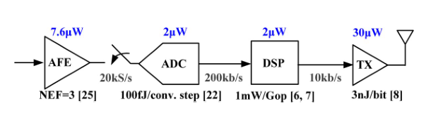

their associated energy cost and power consumption at a given samplerate.AsFig.1shows,thecosttowirelesslytransmitdata is orders of magnitude greater than for any other function.

state-of-the-art radio transmit- ters exhibit energy-efficiencies in the nJ/bit range while every

other component consumes at most only tens of pJ/bit. This cost disparitysuggeststhatsomedatareductionstrategyatthesensor node should be employed to minimize the energy cost of the system.

reducebothenergyconsump- tion and data throughput

However, the filtered data often contains limited information.

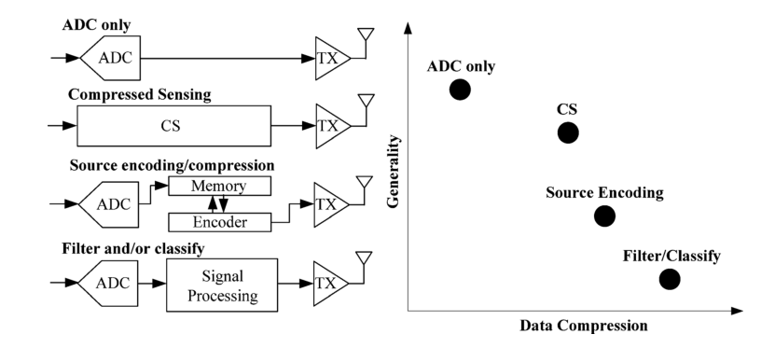

For wireless sensor applications, this combination of characteristics is particularly attractive as it would enable a single hardware interface across many applications while simultaneously ad- dressing the energy cost of wireless transmission.

sampled data at a rate proportional to the information content

where canrangebetween1and [15].Thelesscoher- ence between and , the fewer the number of measurements needed to recover the signal.

In terms of hardware cost and complexity, it is desirable if the signal basis, , does not need to be known a priori in order to determine a viable sensing matrix, . Fortunately, random sensing matrices with sufficient sample size exhibit low coher- ence with any fixed basis [17]. As suggested in [17], this means that a random sensing matrix can be employed as a universal encoder and acquire the sufficient measurements needed to en- able signal reconstruction of any sparse signal without knowing a priori what the proper basis for the signal is. We leverage this principle to build a generic infrastructure for data acquisi- tionandcompressionthatisagnostictothetypeofsignalsbeing acquired, provided that they are sparse.

A 75-µW, 16-Channel Neural Spike-Sorting Processor With Unsupervised Clustering

NEURONS use electrical signals called action potentials or spikes as one of the primary ways of communicating with each other. Invasive electrode recordings of extracellular voltage fluctuations contain a wealth of information regarding neuronal activity with great precision in space (recording diamaters on the order of a few ) and time (sampling intervals on the order of 100 ). Analysis of such signals has not only contributed to our understanding of brain functionality but have led to the development of brain–machine interfaces which decode signals to drive external applications

Additionally, because transmitting cluster IDs requires 20 lower data rates than transmitting spike features, on-chip clustering allows us to support a higher number of channels for a given system power consumption.

Neuropixels Data-Acquisition System A Scalable Platform for Parallel Recording of 10,000+ Electrophysiological Signals

Although the site density of neural probes has scaled-up significantly in the past few years, the scaling capability of the data-acquisition systems connected to such probes is still limited.

We focused on the recording of full-band electrophysiological signals without using data compression techniques.