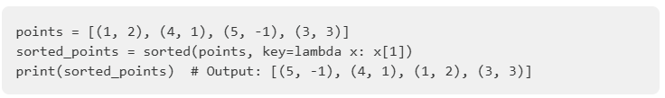

**Lambda regelt!**add =lambda x,y: x + y  
result = add(2,3)

**Exception**

try:  
 erg = 10 / 0  
except ZeroDivisionError:  
 print(‘Lampe an‘)

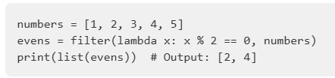

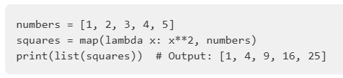

**Doppeltes Lottchen**a = [1, 1, 2, 3, 4, 5, 5, 5, 6, 7, 2, 2]  
print(list(set(a)))  
# [1, 2, 3, 4, 5, 6, 7]

**List’ig**a = [1, 2, 3, 4, 2, 2, 3, 1, 4, 4, 4]  
print(max(set(a), key = a.count)) #4

**Collections**from collections import Counter  
colors = ['red', 'blue', 'yellow', 'blue', 'red', 'blue']  
counter = Counter(colors) # Counter({'blue': 3, 'red': 2, 'yellow': 1}) counter.most_common()[0] # ('blue', 3)

**Enumerate**for i, elem in enumarate(‘Wie gender ich H.So..?‘):  
# 19, h  
# 20, n

**Join Me!**liste = sorted(liste, key=lambda buch: buch.titel) return f'{'\n'.join([(str(x)) for x in liste])}'

**Memory**'abgeben' if alle_berabeitet else "nicht abgeben"

80 65 83 86 79 83 83  
Oberfähnrich

random.choice([‘ja’, ‘nein’])

def baujahr(self):  
 a = sorted([x for x in self.flotte], key=lambda x: x.baujahr)  
 return '\n'.join([f'{str(x.baujahr)} {x.name}' for x in a])

liste = [Schiffe(*x)for x in data_set}

[meineKlasse.hinzu(x) for x in liste]