

**Advanced Programming Report**

**Face Mask Detection System**

Students: Serik Sanzhar, Nuraliyev Ibragim,   
Alkhaidar Daryn

Group: IT-2201

Astana, 2024

**Content**

**Introduction:** 3

**Problem:**  3

**Available Solutions:**  3

**Current work:** 3

**Data and Methods:** 4

**Information about the data:** 4

**Data Analysis and Visualizations:** 4

**Result:** 7

**Discussion:** 8

**Next steps:** 8

# **Introduction:**

## **Problem:**

The Mask Detection System aims to build a system that detects whether individuals are wearing masks in images or live video streams. The goal is to enhance public safety by identifying compliance with mask-wearing guidelines, especially during situations like the COVID-19 pandemic.

Background Information:

With the emergence of COVID-19, mask detection systems have become increasingly important in various settings, including public spaces, transportation hubs, and workplaces. These systems typically employ computer vision techniques to analyze images or video frames and identify whether individuals are wearing masks.

## **Available Solutions:**

Popular approaches for mask detection include using pre-trained deep learning models like convolutional neural networks (CNNs) and fine-tuning them on mask detection datasets. Data augmentation techniques can also be employed to enhance model performance, especially when training data is limited.

[Face mask detection using deep learning: An approach to reduce risk of Coronavirus spread](https://doi.org/10.1016/j.jbi.2021.103848)

# **Current work:**

During the work time we have used these steps, in order to obtain our final project:

Data Collection: Collect images or video frames containing individuals with and without masks. Ensure that the dataset is diverse and representative of real-world scenarios.

Data Preprocessing: Preprocess the images by resizing, normalizing, and augmenting them to improve model generalization.

Training: Train the model using the collected dataset, adjusting hyperparameters as needed. Monitor training performance and employ techniques like early stopping to prevent overfitting.

Evaluation: Evaluate the trained model on a separate validation or test dataset to assess its performance in terms of accuracy, precision, recall, and F1 score.

Deployment: Deploy the trained model as a mask detection system capable of processing images or live video streams in real-time. Integrate the system with existing surveillance systems or deploy it as a standalone application.

# **Data and Methods:**

## **Information about the data:**

The dataset used in this project comprises images categorized into two classes: 'with_mask' and 'without_mask'. Each image represents a person's face either wearing a mask or not wearing a mask. The dataset is collected from various sources, including online repositories and self-generated images.

Dataset: <https://humansintheloop.org/resources/datasets/medical-mask-dataset/>

## **Data Analysis and Visualizations:**

Data Distribution: The dataset contains a total over 6000 images and 20 classes, and we have used only 900 images labeled as 'with_mask' and 900 images labeled as 'without_mask'. This distribution helps understand the class balance and potential biases, also accelerates the processing time.

Prior to implementing the face mask detection system, we conducted a thorough data analysis to prepare and train a model using our dataset. This crucial step involved assessing the validation accuracy and uncovering underlying patterns within the data.

Here are several visualizations generated during the data analysis phase:

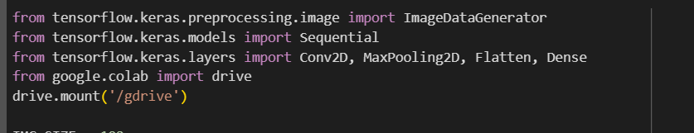

*Figure 1. Imported libraries*

Besides **matplotlib.pyplot**, the code also utilizes several components from the TensorFlow and Keras libraries for building and training a convolutional neural network (CNN) model for face mask detection and google colab library for using google drive.

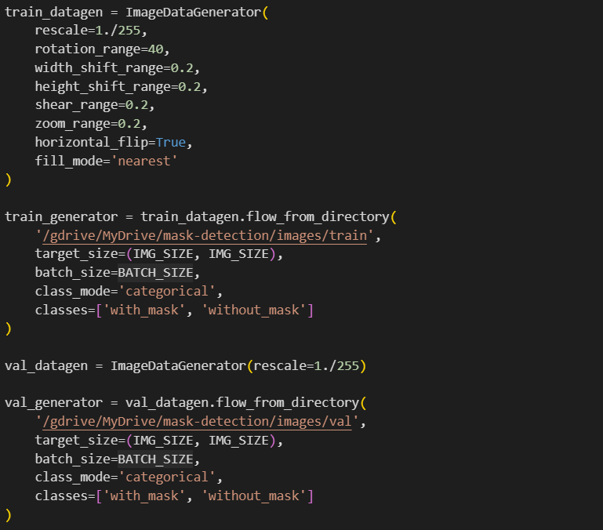

*Figure 2. Preprocessing image data for training and validation*

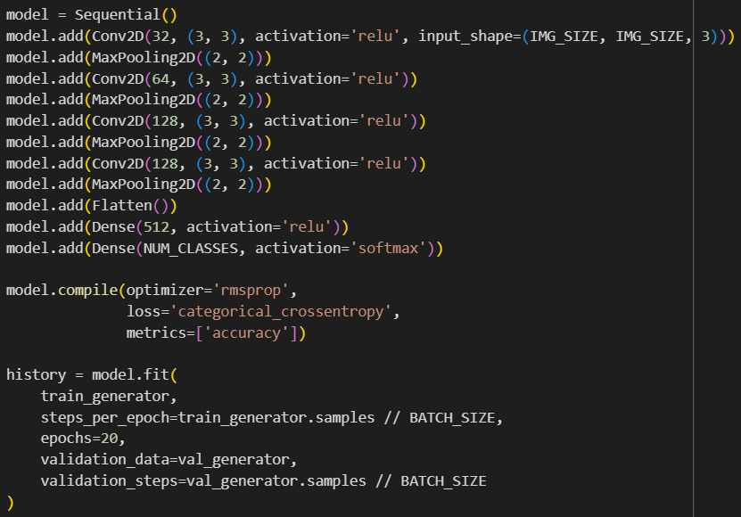

*Figure 3. Model*

The code defines a CNN model, compiles it with appropriate settings, and trains it using the provided data generators, ultimately providing insights into the model's performance through training history.

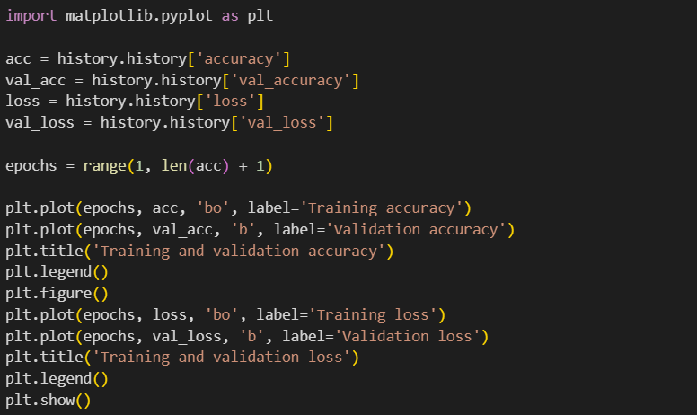

*Figure 4. Model plot*

# **Result:**

The face mask detection system project is designed to improve public safety by automatically identifying individuals not wearing masks in various environments such as public transportation, retail stores, and workplaces. Using advanced computer vision technology and machine learning algorithms, the system determines whether a person's face is covered by a mask or not, thereby ensuring compliance with mask requirements and regulations.

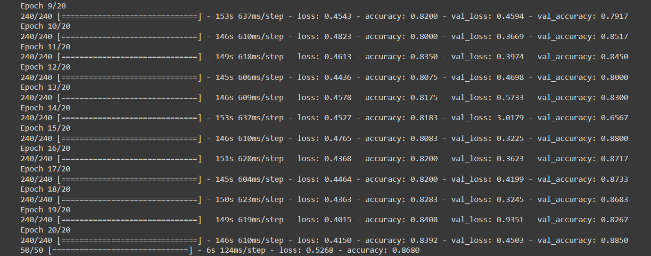

*Figure 5. Val_accuracy*

As it can be seen, here the validation accuracy is more than 0.8, it means our designed model will identify a person wearing mask or not without any difficulties.

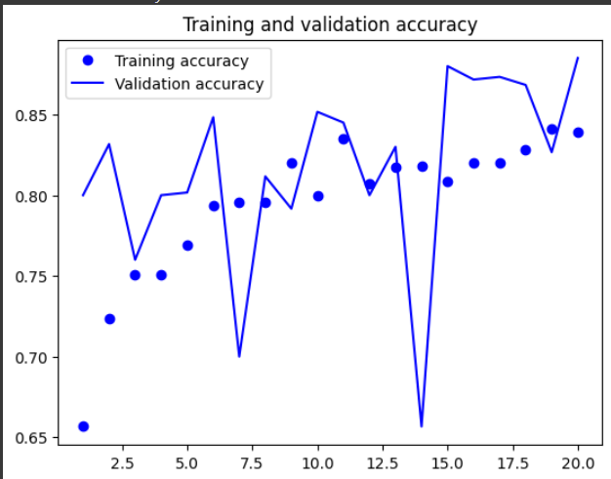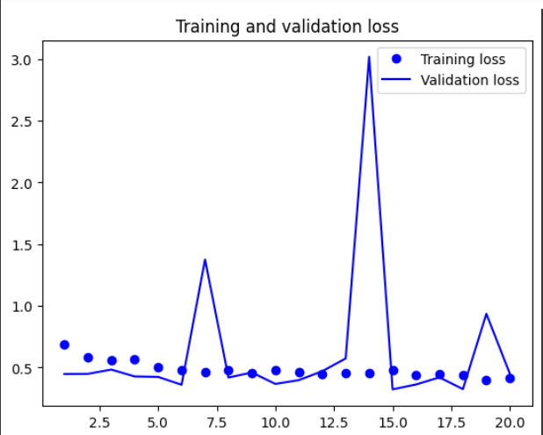

*Figure 6. Training and validation plot*

# **Discussion:**

Our results mark a substantial advancement in enhancing the mask detection experience for users. Leveraging sophisticated computer vision algorithms and meticulous data analysis, we are dedicated to refining our mask detection system. Future iterations will prioritize rectifying any limitations identified in our current implementation and integrating user feedback to enhance the accuracy and usability of the system. Through continuous refinement and adaptation, we aim to contribute significantly to public safety efforts by providing an effective and reliable tool for monitoring mask compliance in various settings.

## **Next steps:**

After creating a website that identifies people wearing masks or not, here are some next steps we consider to improve and expand our mask detection system:

Evaluate the performance of our mask detection model on different hardware configurations to ensure optimal inference speed.Improve the user interface of our website to make it more intuitive and user-friendly.

Integrate our mask detection system with existing surveillance systems or security cameras to automate the process of monitoring mask compliance in public spaces, workplaces, or transportation hubs.Ensure compliance with privacy regulations and guidelines when deploying our mask detection system in public spaces or workplaces.

Regularly monitor the performance of our mask detection system in real-world scenarios and collect feedback from users or stakeholders to identify areas for improvement.Use our website as a platform to educate the public about the importance of wearing masks for public health and safety.