Solution 4.1.1:
- Handle
  - In the Windows operating system, an object is a single, run-time instance of a statically defined object type. An object type comprises a system-defined data type, functions that operate on instances of the data type, and a set of object attributes. User programs may acquire access to operating system objects via handles.
- Process
  - Represents an instance of a running program
  - You create a process to run a program
  - Starting an application creates a process
  - Process defined by:
    - Address space
    - Resources (e.g. open handles)
    - Security profile (token)
- Thread
  - An execution context within a process
  - Unit of scheduling (threads run, processes don’t run)
  - All threads in a process share the same per-process address space

Solution 4.1.2:
Preemptive scheduling:
- Threads are forced (interrupted) by the scheduler to give up the CPU at certain points in time (after quantum expires).
- The Round-Robin scheduling algorithm is preemptive.
Non-preemptive scheduling:
- A running thread may continue execution until it voluntarily gives up CPU.
- The FIFO (FCFS) scheduling algorithm is non-preemptive.

Preemption and context switch is overhead. Therefore, a non-preemptive scheduler would be optimal if maximizing a system’s throughput was the only optimization goal.

The Windows scheduler in server systems has been optimized towards maximum throughput by using a quantum value six times higher than in client versions of Windows.

Solution 4.1.3:
Consider a uni-processor system that uses a round-robin algorithm with 16 priorities (0-15, 0 = lowest, 15 = highest priority) for CPU scheduling. The lengths of the time quantum shall be 20ms. Context switching time is negligible. Let us assume that the system schedules threads. Running threads will not be interrupted until quantum end (Scheduling decisions are only be made at quantum end).
Our system has a workload of three single-threaded processes. These processes (threads) have the following parameters:

Thread ID | Ready at | Execution time
Th1 | t = 0ms | 70ms
Th2 | t = 15ms | 90ms
Th3 | t = 30ms | 80ms

- The Gantt chart below illustrates the execution of these threads under the assumption that they all are executed at a static priority of 8.
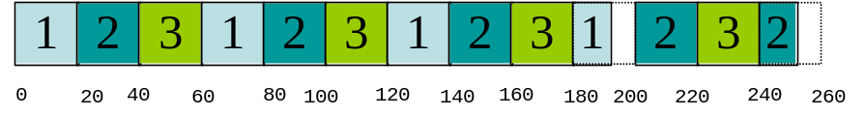

- How does the execution order change if Th3 is executed with priority 9. Th1 shall be executed with priority 7 and get into an I/O wait state after 16ms execution time. Th1’s priority is being boosted by 3 after I/O completion.
Th1 leaves its wait state at t = 50ms. Th1’s priority then shall be decreased by 1 at quantum end until it reaches its base priority of 7.
The corresponding Gantt chart is shown below.
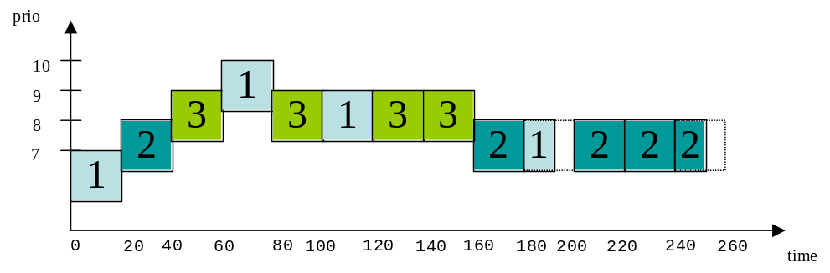

Solution 4.1.4:
The five-state model for process/thread scheduling can be described as follows: Newly created threads start there live in “init” state. After appropriate data structures are initialized (thread control block - TCB), the thread’s state is changed to “ready”. From “ready” state, a thread may get selected for execution and its state is changed by the scheduler to “running”. For a given system, there is exactly one thread in “running” state per processing unit.
When the “running” thread issues an I/O request, it might block and change its state into “waiting”. Alternatively, a “running” thread’s time slice (quantum) may expire, in which case the thread’s state is changed back to “ready”. A “waiting” thread can move into “ready” state once the reason for its blocking disappears (I.e.; the I/O operation completes). Finally, a “running” thread might execute its last instruction - in which case its state changes to “terminated”.
The benefits of multithreaded programming are:
- Higher Responsiveness by using dedicated threads for handling user events
- Simpler Resource Sharing since all threads in a process share same address space
- Utilization of Multiprocessor Architectures
- Multiple threads may run in parallel
Each Windows process initially contains one thread.

