© 2005 David A. Solomon and Mark Russinovich

Solution 8.1.1:
Give a short explanation of the following terms and its usage in context of the Windows NTFS file system to your instructor:
- Sectors are hardware-addressable blocks on a storage medium. Hard disks for x86 systems almost always define a 512-byte sector size. Thus, if the operating system wants to modify the 632nd byte on a disk, it must write a 512-byte block of data to the second sector on the disk.
- Clusters are the addressable blocks that many file system formats use. Cluster size is always a multiple of the sector size, as shown in Figure 12-1. File system formats use clusters to manage disk space more efficiently; a cluster size that is larger than the sector size divides a disk into more manageable blocks. The potential trade-off of a larger cluster size is wasted disk space, or internal fragmentation, that results because file sizes typically are not perfect multiples of cluster sizes.
- Metadata is data stored on a volume in support of file system format management. It is not typically made accessible to applications. Metadata includes the data that defines the placement of files and directories on a volume, for example.

Solution 8.1.2:
Explain to your instructor how a multilevel directory structure could be simulated with a single-level directory structure in which arbitrarily long names can be used!
How would your approach change when file names were limited to seven characters?
What are the restrictions if you wanted to simulate multilevel sub-directories within a single NTFS directory? Contrast Windows-API and POSIX naming schemes and their restrictions.

If arbitrarily long names can be used then it is possible to simulate a multilevel directory structure, for example by using the “:” character to indicate the end of a subdirectory (scheme A)
If file names were limited to seven characters, then the above scheme could not be used. However, one could designate a special file as a symbol table (directory) to map arbitrarily long names into shorter arbitrary names, which are then used for actual file access (scheme B).
The Windows-API supports file names with a length of 255 characters (There is a special syntax that allows file names starting “\\?\” to be up to 32.000 characters long. This syntax works with the Unicode versions of the I/O API functions). However, since the Windows-API is case-preserving but not case-sensitive, file names that differ only in capitalization of one or more letters cannot be distinguished.
In contrast, the POSIX naming scheme supported by NTFS is case-sensitive (Use FILE_FLAG_POSIX_SEMANTICS to create POSIX-named files with CreateFile()). But since POSIX names on NTFS are restricted to 128 characters, the above-mentioned scheme B had to be used to simulate multilevel sub-directories within a single NTFS directory, both with the POSIX and the Windows-API naming schemes.

Solution 8.1.3:
Explain to your instructor the semantics of the change-directory command “cd”. Why is this command implemented as an internal function of the command processor in Windows (cmd.exe, command.com, ksh.exe)?
How many working directories does Windows maintain for each process?

The “cd” command (change directory) implemented in many command processors changes the current working directory for a Windows process. If “cd” were implemented as a separate program, its execution would not affect the working directory of the parent process (the command processor).
Windows maintains information about the current working directory for each drive letter (up to 26). Thus, changing the current working directory for the specified drive letter (or the current one if no drive letter is given), the API function SetCurrentcDirectory() and “cd” on Windows command processors provide special syntax for changing the current drive (namely specifying the drive name only; i.e. “D:”).

Solution 8.1.4:
Explain to your instructor the on-disk representation of an NTFS file. How does NTFS support hard links? Contrast the Windows implementation of hard links with the Unix implementation.
Windows NTFS uses a master file table (MFT) to store files on disk. The MFT contains file records – NTFS metadata is stored within special files whose file records are part of the MFT as well. The standard structure of a file record for a short file is depicted below. Among the standard information for a file is its file name.
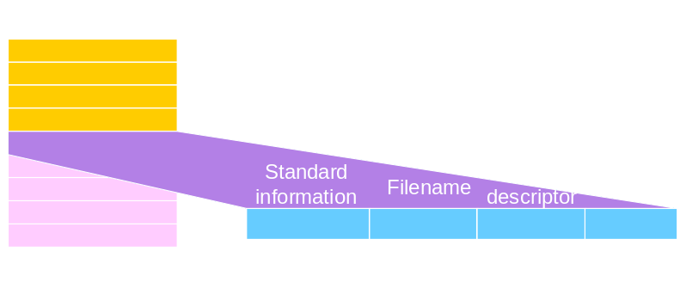

Since NTFS files are series of attribute-value pairs, attributes may occur more than once. This technique is being used to implement hard links. Files with a link count greater one simply contain multiple file names as part of their standard information.
Unix – in contrast – stores file content in blocks that are accessed through so-called inodes. The inode structure contains a number of file attributes – such as modification time – but not the file name. Instead, files are named by maintaining the link between file name and corresponding inode within a directory. Hard links are implemented by having multiple directories containing links to the same inode – with possibly differing file names.

