Qbit Order Management System Frontend Design

目录

Qbit Order Management System Frontend Design 1

System Name 1

Logo 1

Navigation 1

Pages: 1

URL 4

## System Name

**Qbit**, where Q stands for **Quantitative**, and **bit** addresses the digital world. And the **Qbit** sounds like **Cupid**, who makes match between lovers by his famous arrow, while **Qbit** makes match between our customers: buyers and sellers.

## Logo

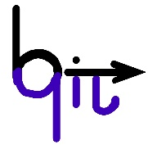

## Navigation

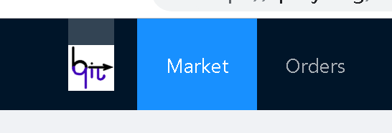

Two main header menus are

* **Market**: Entry point for open market information
* **Orders**: Entry point for our order management functionality

## Pages:

1. **Market Overview**:

Display all the underlying’s real time information, includes: Code, Name, Change Percentage, Trade, Open, High, Low, Settlement, Volume, Turnover Ratio, Amount, NMC, etc. But if it’s not during the transaction time window, then the data will be the last trading day’s data. And in that case, an Alert Window will be pop up.

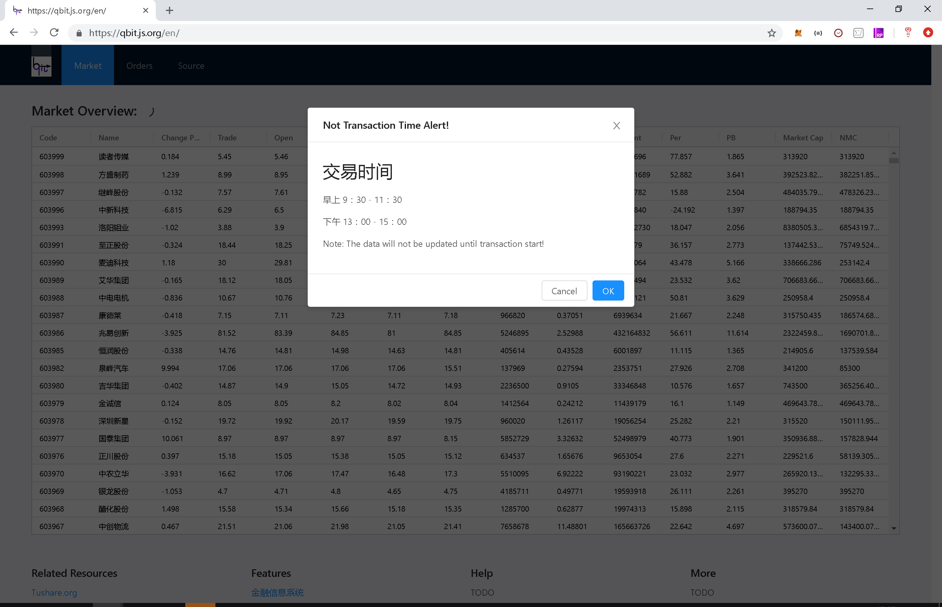

The popup is closeable so the users can check the data in real time or in a static way.

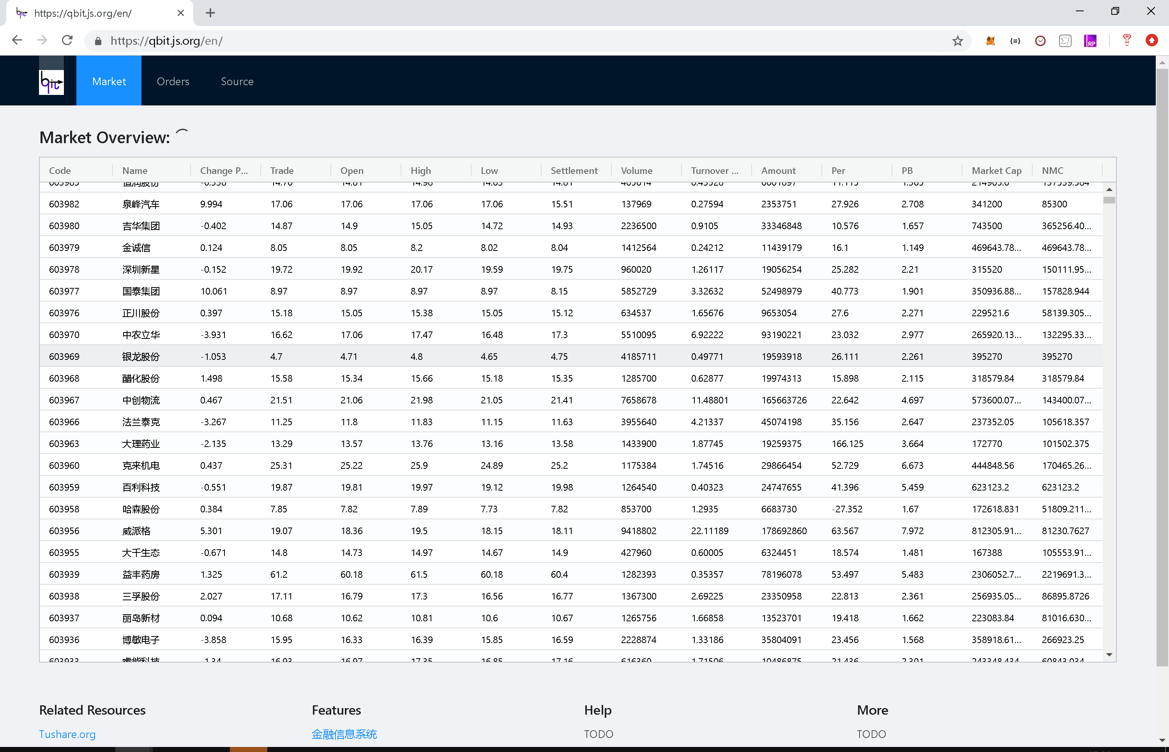

1. **Blotter Detail page:**

If user clicks on the row of the overall market data, the blotter detail of the selected underlying will be displayed. Which will show the bid and asks and the best offer as follows:

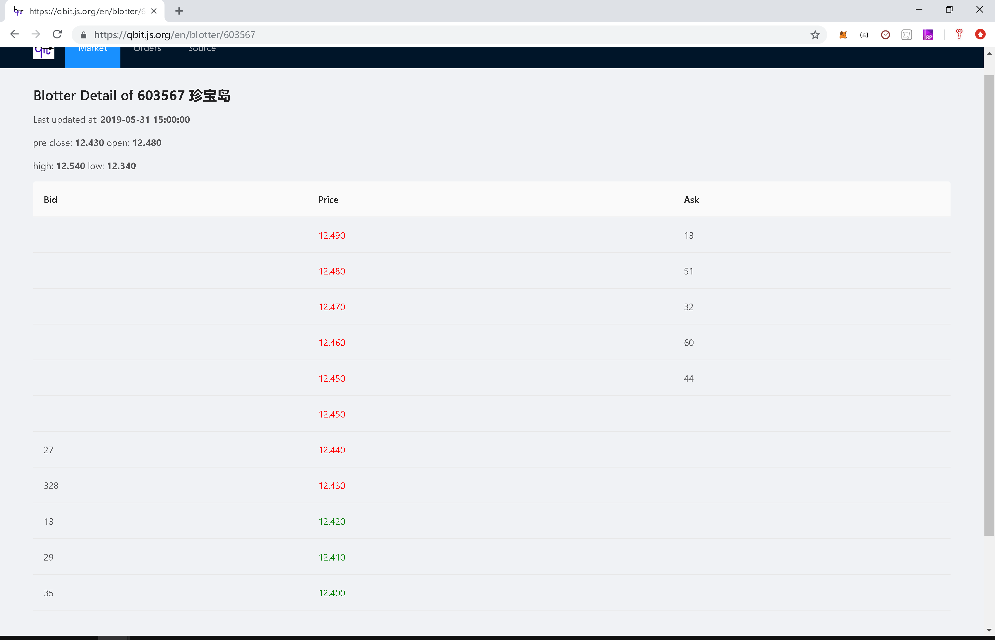

1. **Orders page:**

Orders page lists all the orders received and displays the latest ones in the top. The status column show the order’s status, if it is not completed, then it can be edited.

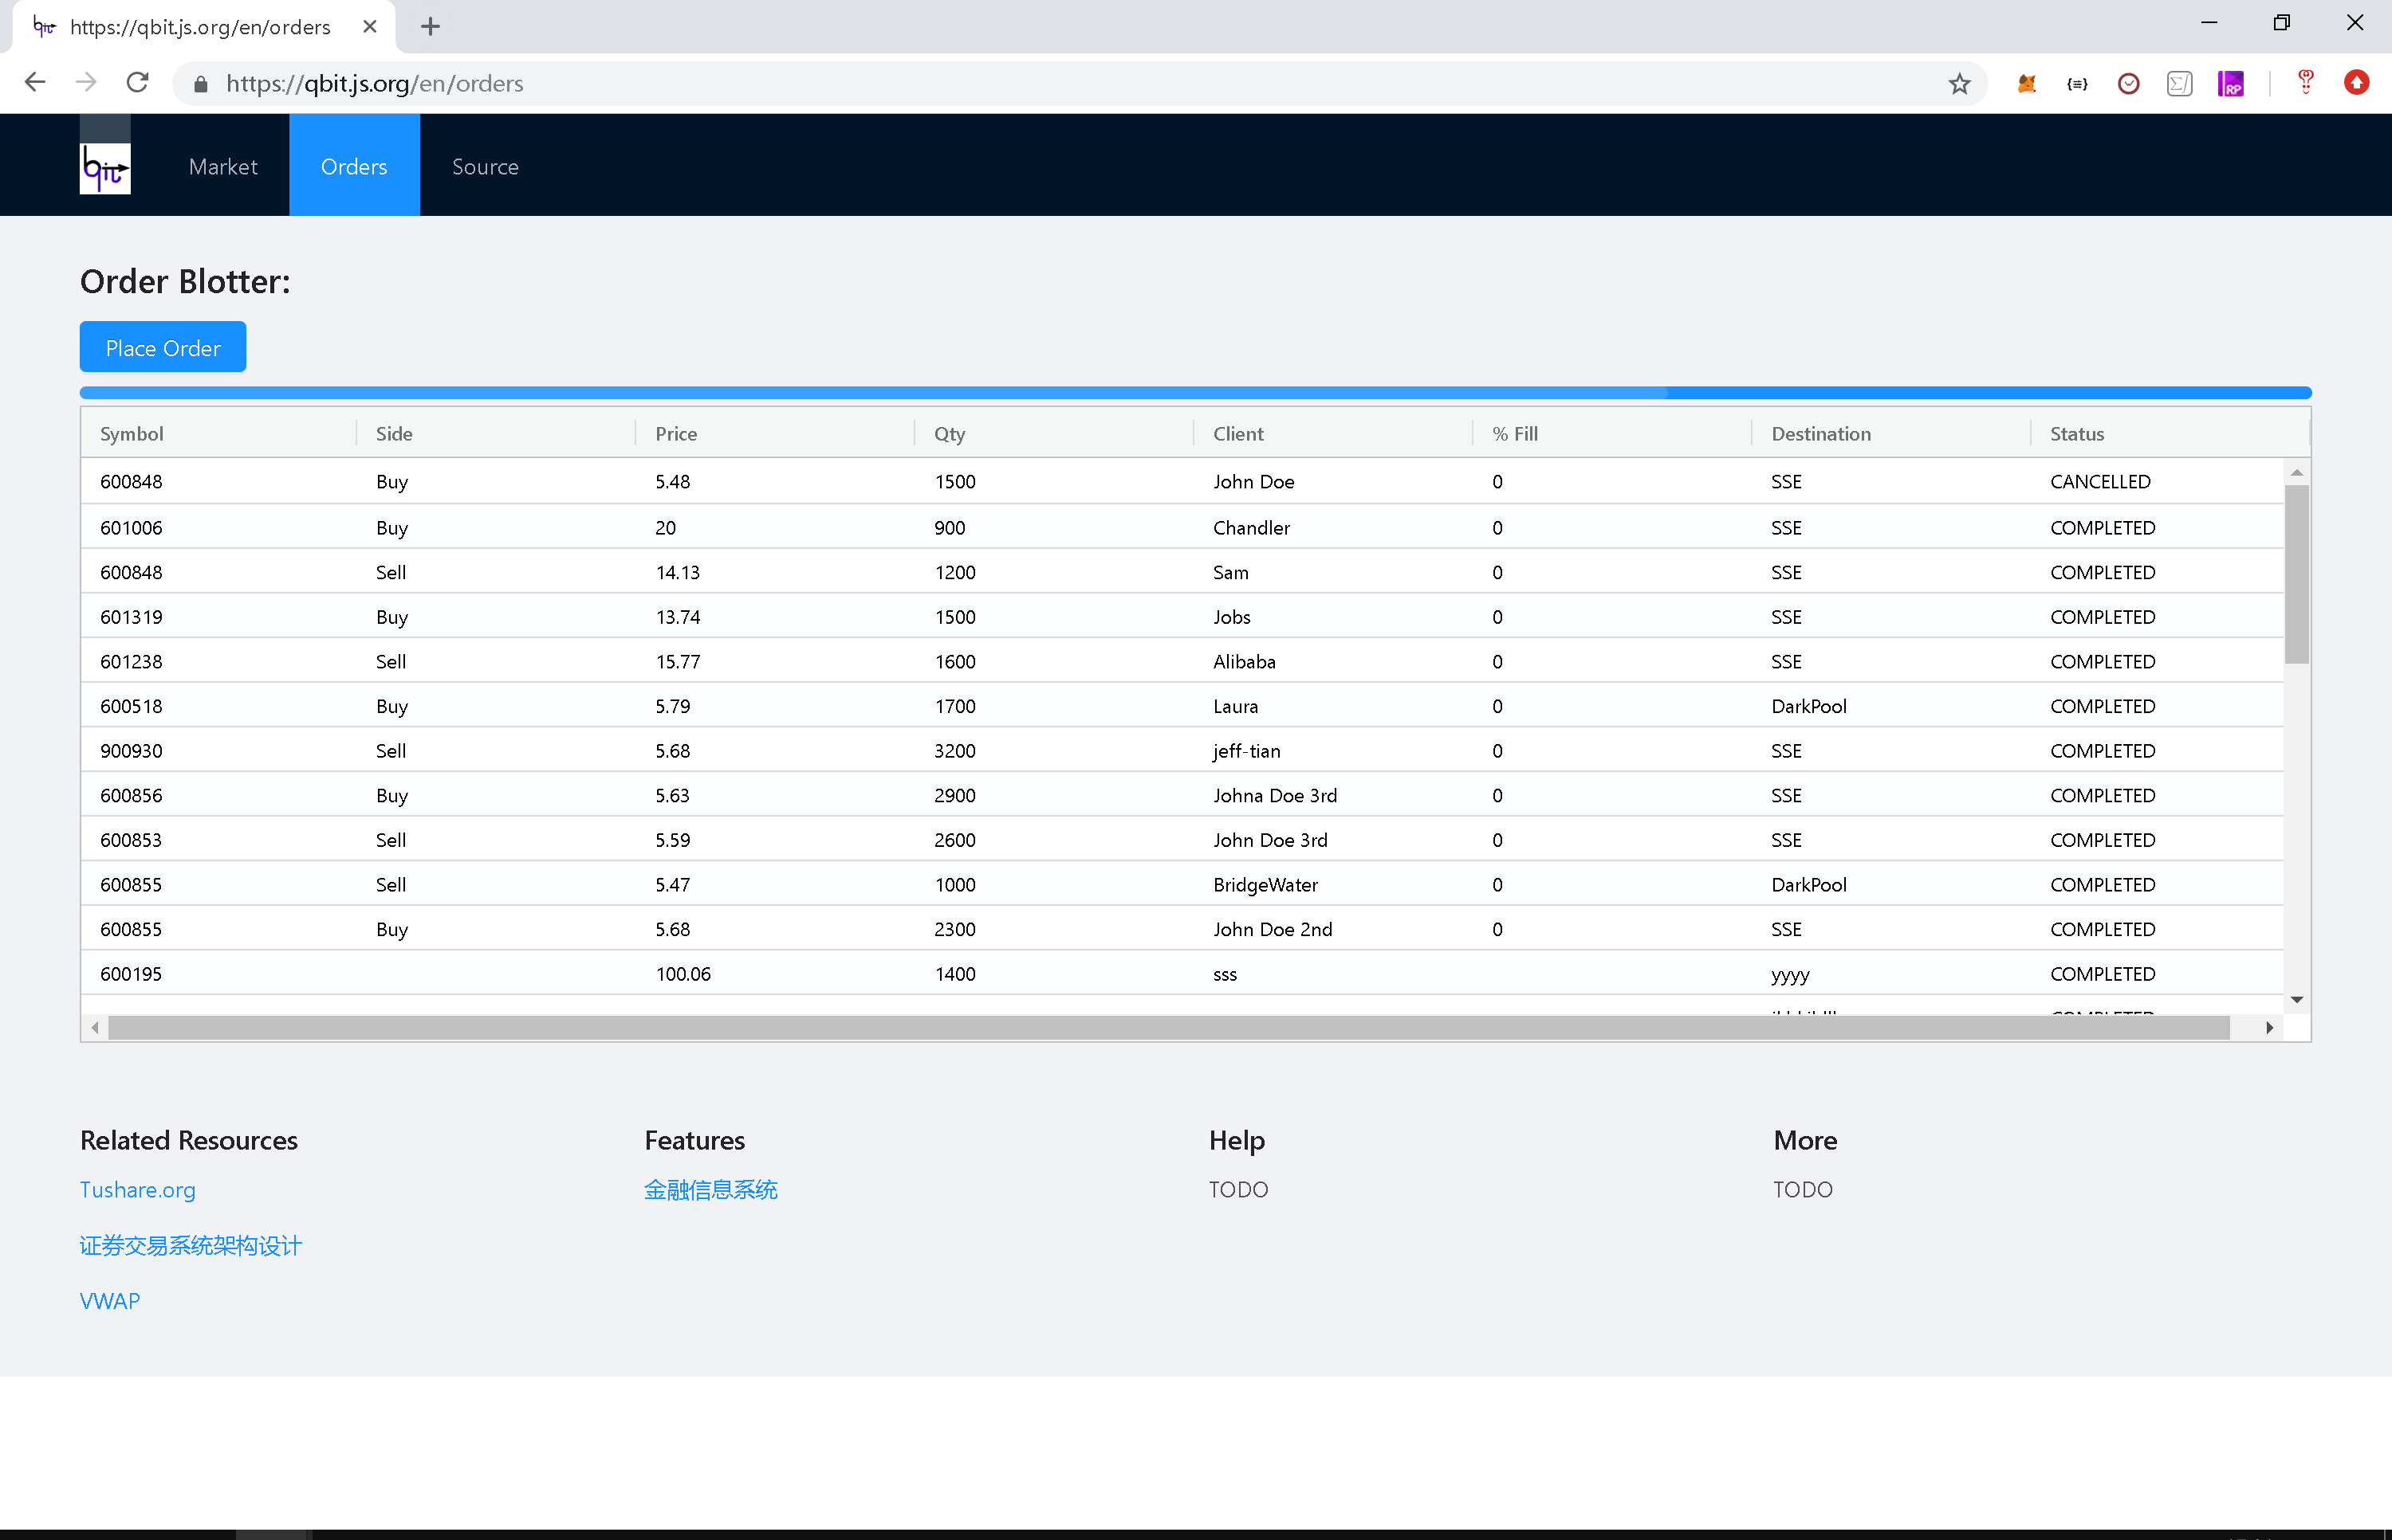

1. **New Order placement Window:**

By clicking the “Place order” button you can issue a new order request. You need to specify the Symbol, Side, Price, Quantity, Client and Destination information.

1. **Amendment Window:**

By clicking the non completed order in the Orders page, you can open an Order Amendment Window and edit the relevant fields that you want to modify:

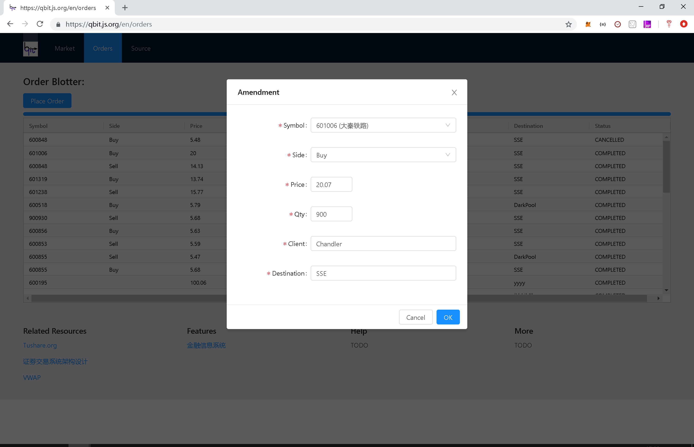

## URL

<https://qbit.js.org>