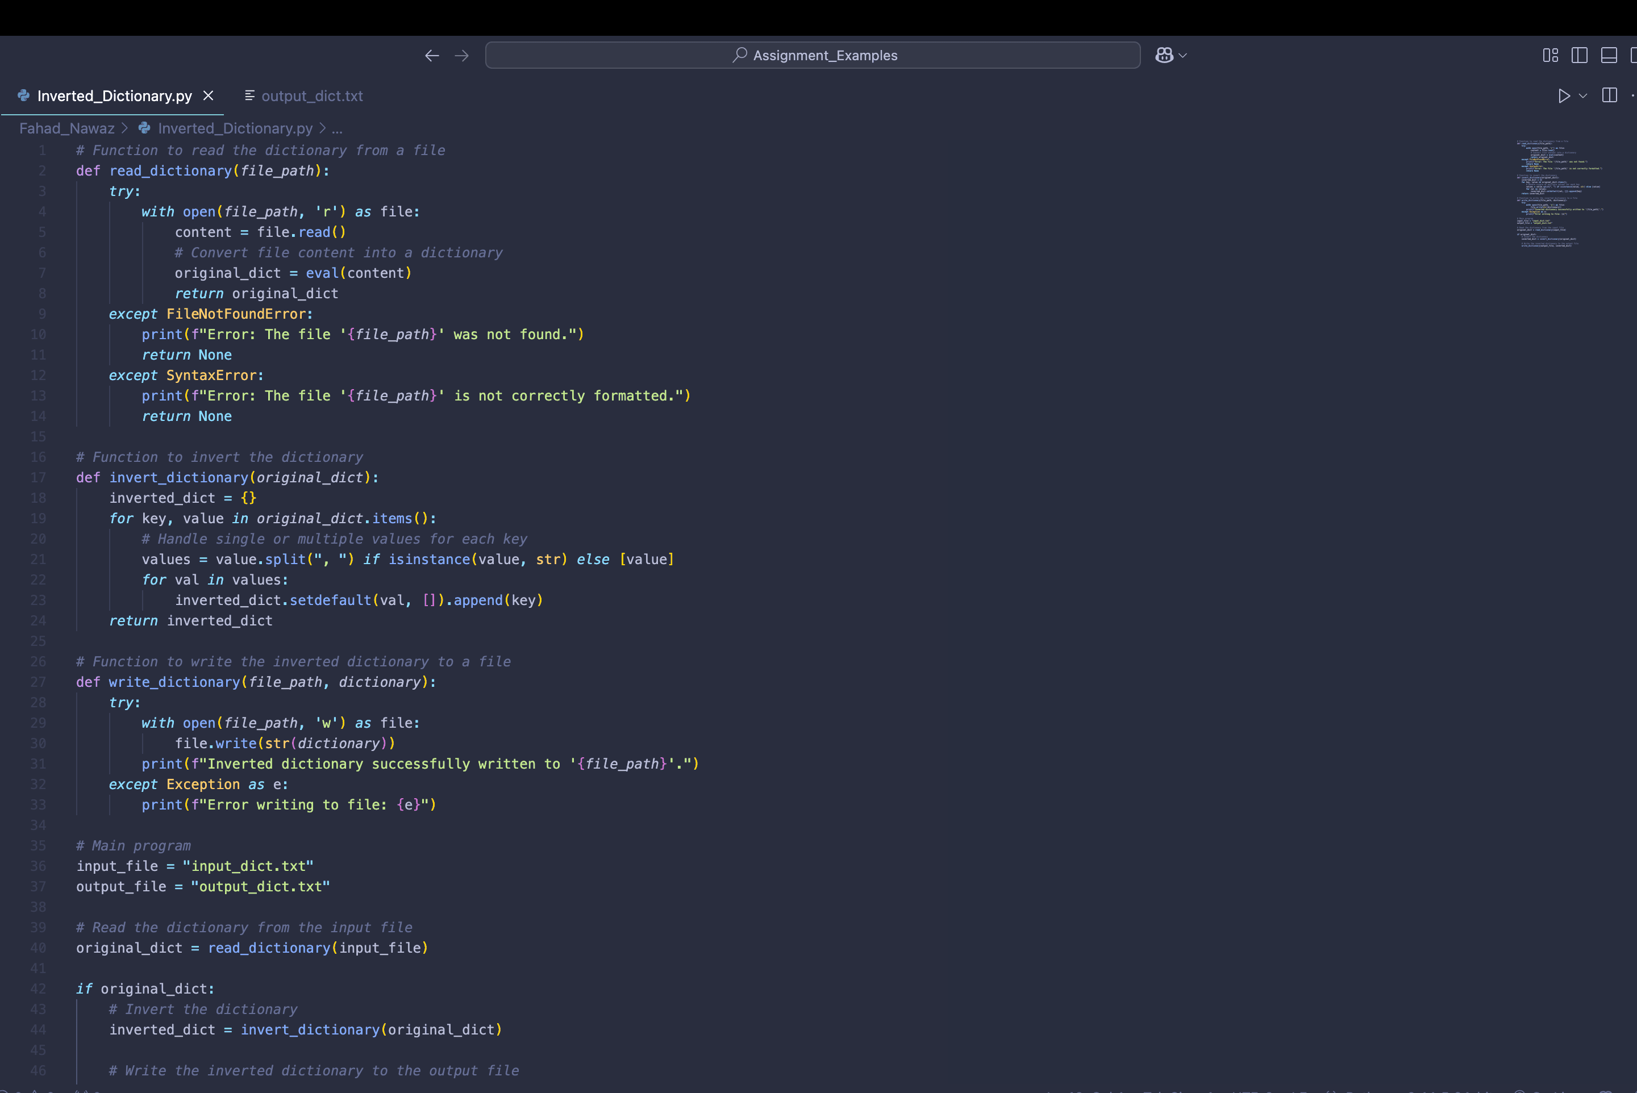

### Technical Explanation

The provided Python program performs the following steps:

1. **Reading the Input File**:
   * The read_dictionary function reads the dictionary from the input_dict.txt file using the open() function.
   * It uses the eval() function to convert the string content of the file into a Python dictionary.
   * Exception handling is implemented to catch FileNotFoundError if the file does not exist and SyntaxError if the file content is not correctly formatted.
2. **Inverting the Dictionary**:
   * The invert_dictionary function processes the original dictionary, swapping its keys and values.
   * If a value contains multiple entries (e.g., "black, green"), it splits the value into separate entries.
   * The setdefault method is used to group multiple keys under the same value in the inverted dictionary.
3. **Writing the Output File**:
   * The write_dictionary function writes the inverted dictionary to output_dict.txt in string format using open() in write mode.
   * It also includes general exception handling to manage unforeseen errors during the write operation.
4. **Output**:
   * The output file (output_dict.txt) contains the inverted dictionary, ensuring that all keys are mapped to their corresponding values in a clear, structured manner.

### References

Downey, A. (2015). *Think Python: How to Think Like a Computer Scientist*. Green Tea Press. <https://greenteapress.com/thinkpython2/thinkpython2.pdf>  
Python Tutorial: File Objects - Reading and Writing to Files. (n.d.). YouTube. <https://youtu.be/Uh2ebFW8OYM>