**Prince Ikede**

HW1

My views are different I added and edited the second prompt.

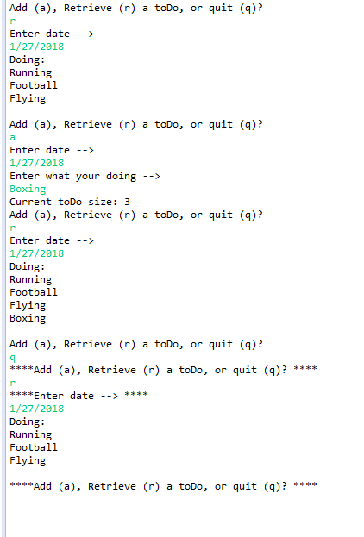

I have two different designs

I also have hysterics used in mine

I used a list of days in my design

I made a day object for data handling

I didn’t use a hash map or keys