Vowel Description

Essential reading: Ashby & Maidment, Chapter 5

Aim: To introduce the basics of vowel description and the main characteristics of the vowels of RP English.

Definition of vowel: Vowels are produced without any major obstruction of the airflow; the intra-oral pressure stays low, and vowels are therefore sonorant sounds. Vowels are normally voiced. Vowels are articulated by raising some part of the tongue body (that is the front or the back of the tongue not the tip or blade) towards the roof of the oral cavity (see Figure 1).

Front vowels are produced by raising the front of the tongue towards the hard palate. Back vowels are produced by raising the back of the tongue towards the soft palate. Central vowels are produced by raising the centre part of the tongue towards the junction of the hard and soft palates.

The height of a vowel refers to the degree of raising of the relevant part of the tongue. If the tongue is raised so as to be close to the roof of the oral cavity then a close or high vowel is produced. If the tongue is only slightly raised, so that there is a wide gap between its highest point and the roof of the oral cavity, then an open or low vowel results. Vowels produced with tongue positions between high and low are sometimes called mid. Vowels between close and mid are called half-close (or high mid, or close mid – the terms are interchangeable); vowels between open and mid are half-open (or low mid, or open mid).

Vowel quality is also affected the position of the lips. The lips may be rounded, neutral, or spread. For most purposes a two-way classification of rounded and unrounded is adequate. With practice, one can learn to round or unround the lips independently of the tongue position. Adding lip rounding to a close front vowel [i], we obtain a vowel which is symbolised [y] and is like that heard in French lune [lyn] "moon" or rue [ry] "street". Adding rounding to a quality [e], we obtain [ø], a vowel heard in French deux [dø] "two". If conversely we take away rounding from [u], leaving the tongue position unchanged, we obtain [ɯ], an unrounded vowel like that which many Japanese have in a word such as Fuji.

Examples: Table 1 uses keywords from RP English to exemplify the three main aspects of vowel quality: location, height and lip posture. The shaded cells in the table indicate lip-rounding.

Monophthong vs diphthong: In certain languages (English is one) the quality of a vowel can change within a single syllable. Such vowel-glides are known as diphthongs. Vowels whose quality remains relatively constant are known as monophthongs. The diphthongs of RP English are shown in Table 2, where they are classified as closing, meaning that the final target quality is closer than that at the start, and centring, meaning that the glide is towards a [ə] quality. (Don't be misled by the spelling of vowels in English. For example, the vowel in bead in English is a monophthong, even though we use two vowel letters in the spelling. On the other hand, the vowel in the first syllable of holy is a diphthong in many accents, but it is spelled with just one alphabetic symbol).

The vowel quadrilateral: It was formerly thought that the location of the highest point of the tongue within the oral cavity directly determines vowel quality (though we now understand that view is a considerable oversimplification) Seen from the side, the area in the oral cavity within which the highest point of the tongue moves about to produce different vowels is roughly elliptical in shape; for convenience in drawing , this shape is regularised as the vowel quadrilateral of standard proportions (Figure 2). The quality of a particular vowel can be indicated by plotting its location somewhere on the diagram, meaning that the vowel sounds as if it is produced with the highest part of the tongue in the location shown. Strictly, then, the vowel quadrilateral represents an auditory space, rather than an accurate articulatory one. Lip-rounding is not indicated on the diagram in any standard way.

Cardinal Vowels: The phonetic symbols arranged around the quadrilateral in Figure 2 do not represent the vowel sounds of any particular language, but instead a range of language-independent qualities which can be used as reference points (the cardinal vowels. The cardinal vowels are auditorily agreed qualities and must be learnt from a teacher or from a recording.

There are in fact two sets of cardinal vowels the primary set [i e ɛ a ɑ ɔ o u], numbered 1 - 8, (in which 1 - 5 are unrounded and 6 - 8 rounded) and the secondary set [y ø œ ɶ ɒ ʌ ɤ ɯ], numbered 9 – 16 (Figure 3). The secondary cardinal vowels are related to the primary ones by reversing the lip-posture, so for example vowel 1 is close, front, unrounded and vowel 9 is close, front, rounded and vowel 8 is close, back rounded, so vowel 16 is close, back, unrounded

However, vowels 1 and 5 can be given an articulatory specification. No 1 is produced with the frontest, closest position of the tongue which does not produce audible friction and No 5 is produced with the backest, openest possible tongue position, again without audible friction. Notice that between close and open there are two mid heights. So [e] and [ɛ] represent unrounded mid front vowels differing somewhat in height, while [o] and [ɔ] are both rounded back vowels, with [ɔ] somewhat more open.

The vowels of the IPA (Figure 4). The vowel quadrilateral shown on the IPA chart incorporates all the cardinal vowels, together with a number of additional symbols to represent other commonly encountered vowel sounds, such as [æ] and [ə].

Vowel diacritics: Vowel quality can be symbolised by using diacritics attached to an appropriate (cardinal) vowel symbol. In the DIACRITICS part of the IPA chart (see Figure 5), the diacritics are shown attached to cardinal vowel No 2.
Obviously the diacritics can be used in combination, so the English KIT vowel, [ɪ] could be symbolised [ë̝] and the English vowel [ʊ] in a word like put could be symbolised [ö̝] if we wanted to start with a cardinal vowel symbol as basis.
Vowel quantity: Some languages make distinctive use of vowel length. A long vowel in such languages can be symbolised with a following length mark, thus [ɑ] is a short unrounded back open vowel and [ɑː] is its long counterpart. Maori (New Zealand) is one example of a language which has long and short versions of all its five vowel qualities. Most accents of English have vowel length distinctions, but usually the long and short members of a pair are also distinguished by clear quality differences as well.

 | Front | Central | Back
Close (High) | FLEECE |  | GOOSE
Half-close (High-mid) | KIT |  | FOOT
Mid | DRESS | NURSE/commA | THOUGHT
Half-open (Low-mid) | TRAP |  | LOT
Open (low) |  | STRUT | START

Table 1. Approximate qualities of some RP vowels. (Shaded cells indicate lip-rounding). Compare the qualities plotted in Figure 6.

Closing diphthongs | Front starting point | Central starting point | Back starting point
Closing diphthongs | FACE  GOAT  CHOICE  PRICE MOUTH

Centring diphthongs | Front starting point |  | Back starting point
Centring diphthongs | NEAR  SQUARE |  | CURE

Table 2. Classification of RP diphthongs. Compare the qualities plotted in Figure 6.

1 Ear training exercises
Q1 You will hear items of the form CVCV. Indicate whether the first vowel is rounded or unrounded.
1 rounded unrounded
2 rounded unrounded
3 rounded unrounded
4 rounded unrounded
5 rounded unrounded

Q2 You will hear items which contain two vowels. Indicate whether the second vowel is front or not. If it is not front, it will be either central or back.
1 front not front
2 front not front
3 front not front
4 front not front
5 front not front

Q3 You will hear items which contain one vowel. Indicate whether the vowel is a monophthong or a diphthong.
1 monophthong diphthong
2 monophthong diphthong
3 monophthong diphthong
4 monophthong diphthong
5 monophthong diphthong

Q4 You will hear items which contain two vowels. Indicate whether the first vowel is high (=close mid or close) or low (=open mid or open).
1 high low
2 high low
3 high low
4 high low
5 high low

___________________________________________________________________________

2 Find the odd one out in each of the following sets of vowels, and say why:
- [ɑ i o ɒ ɯ]
- [u ø ɒ e y]
- [i y u o ɨ]
- [ɛ a ɑ ɔ e]
- [y ɛ æ o œ]
3 Kirghiz vowel harmony. Kirghiz is a Turkic language spoken in parts of Afghanistan and China and in Khirgizia in Central Asia. Look at the list of words below. Each is given in its stem form and also in a form carrying a suffix meaning with or by.
Data from Comrie, B. (1981).The languages of the Soviet Union. Cambridge: Cambridge University Press. pp 59-61.

Stem form Suffixed form
[ɑlmɑ] [ɑlmɑdɑn] apple
[et] [etten] meat
[tuz] [tuzdon] salt
[tokoj] [tokojdon] forest
[iʃ] [iʃten] work
[køl] [køldøn] lake
[ʒɯl] [ʒɯldɑn] year
[yj] [yjdøn] house

(a) What determines whether the first consonant of the suffix is [t] or [d]?
(b) Complete the following table using symbols from the Kirghiz words above.

 | Unrounded | Vowels | Rounded | Vowels
 | Front | Back | Front | Back
High
Non-high

(c) From the evidence above, which of the following statements are true?
All the vowels in a Kirghiz word agree in rounding.
All the vowels in a Kirghiz word agree in frontness or backness.
All the vowels in a Kirghiz word agree in being high or non-high.

(d) Kirghiz forms ordinal numbers (meaning first, second, third etc) by adding to the basic number words a suffix of the form [VntʃV], where both V's stand for high vowels. Here are some Kirghiz numbers. What are the corresponding ordinal numbers? (If the number ends in a vowel, the first V of the suffix is left out)

one [bir] three [ytʃ]
four [tørt] five [beʃ]
six [ɑltɯ] nine [toɡuz]
ten [on] twenty [ʒɯjɯrmɑ]

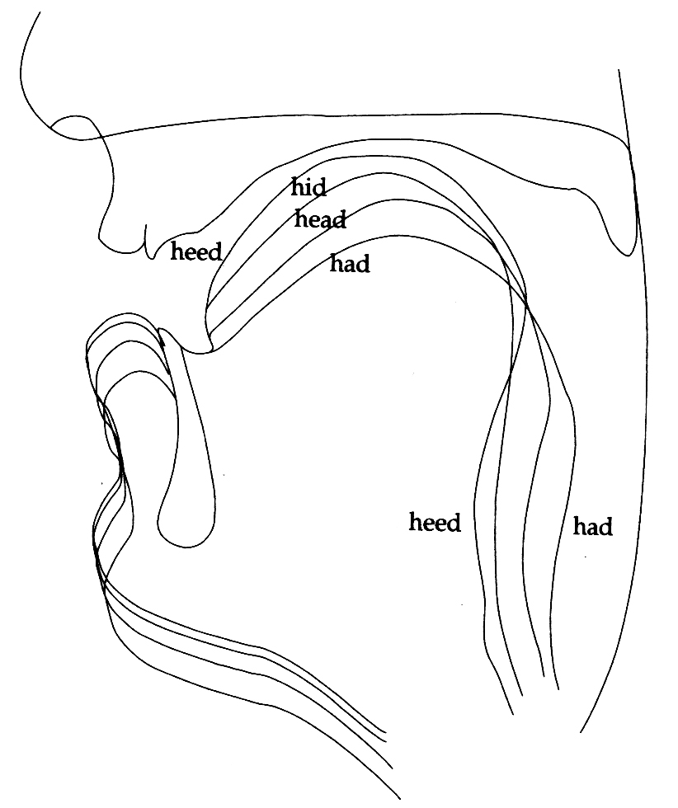
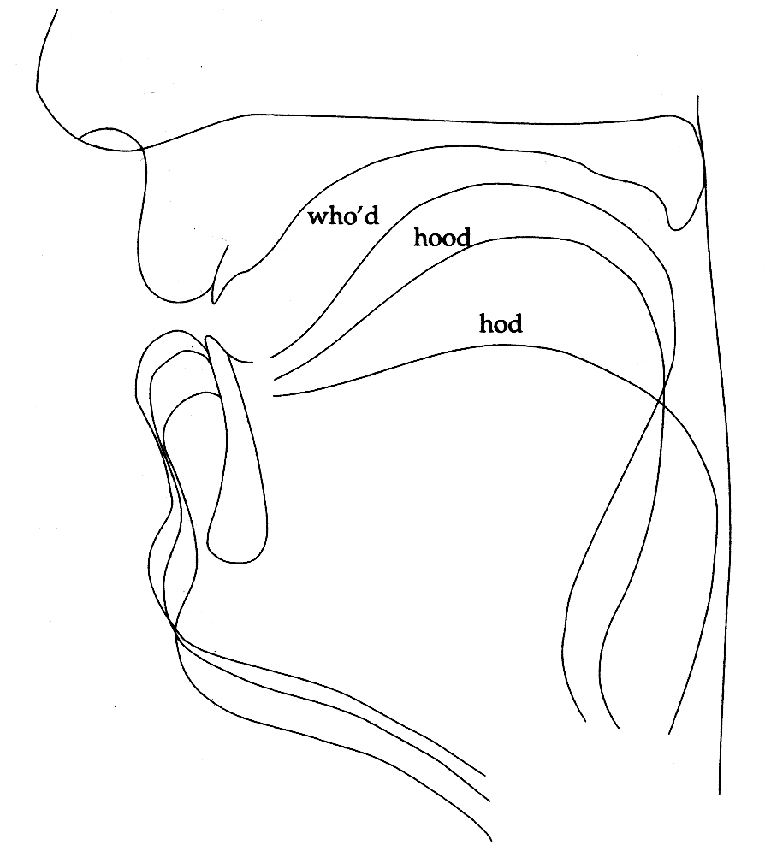

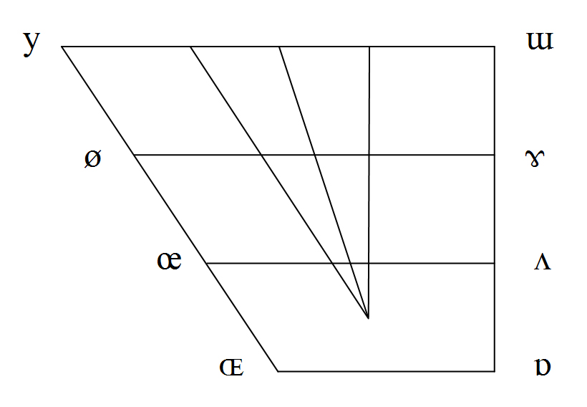
Figure 1. Tongue shapes in American English front vowels (left) and back vowels (right). X-ray data averaged over 5 speakers. From Ladefoged, P. (2005). Vowels and consonants. Second edition, Oxford: Blackwell. pages 122-123.
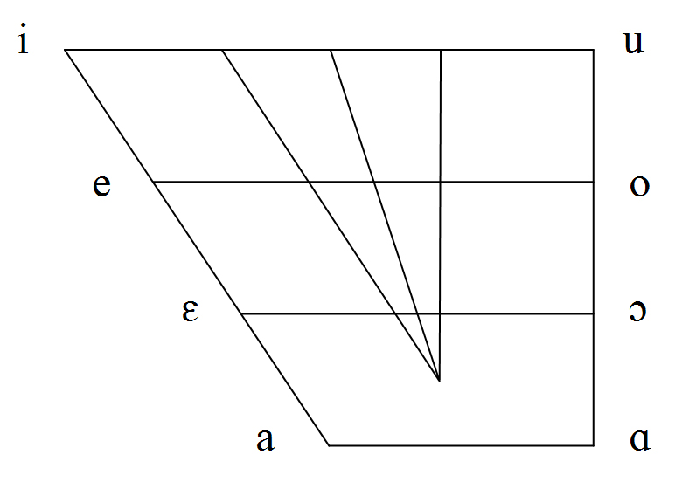

Figure 2. Primary cardinal vowels (left) and Figure 3, secondary cardinal vowels (right). From Ashby and Maidment (2005), page 78.
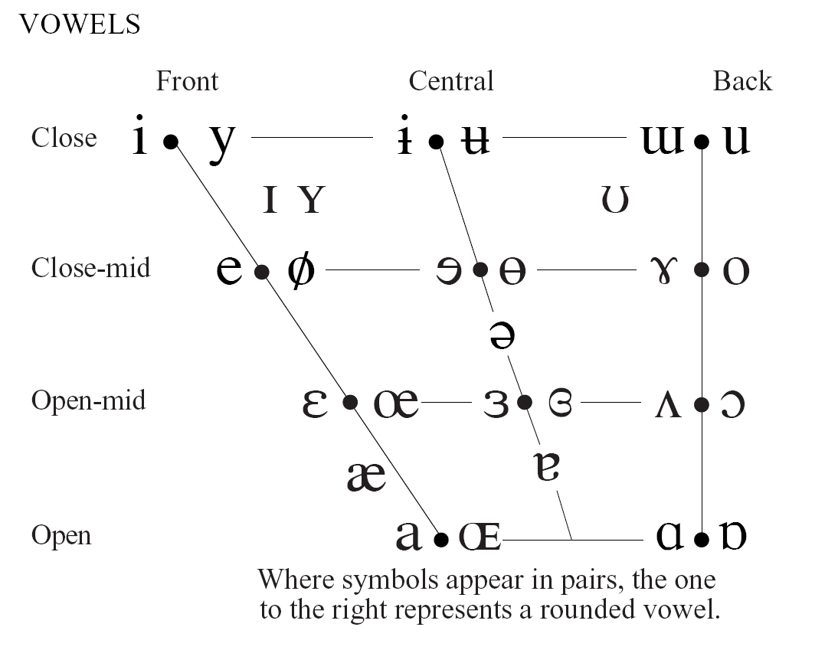
Figure 3. The vowel quadrilateral
on the IPA chart.

Figure 5. Vowel diacritics
ë centralized
e̞ lowered
e̝ raised

Figure 6. Approximate qualities of British English (RP) vowels and diphthongs.
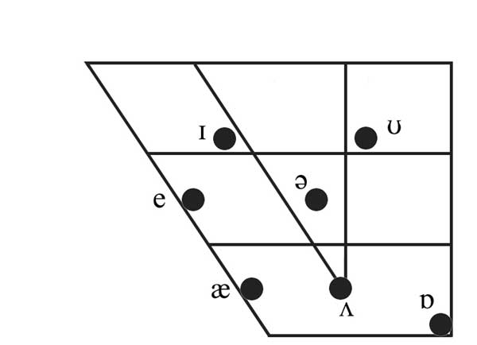
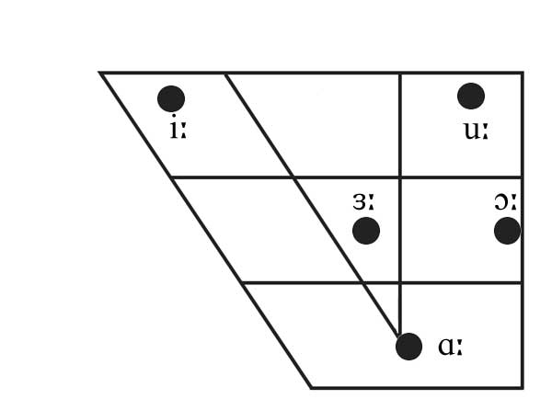

Short monophthongs Long monophthongs
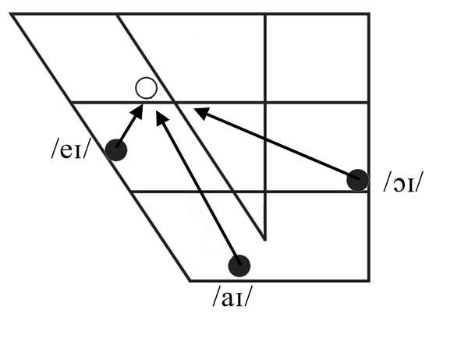
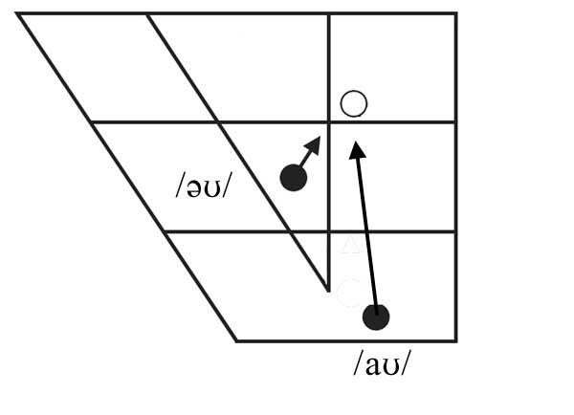

Diphthongs which close towards /ɪ/ Diphthongs which close towards /ʊ/
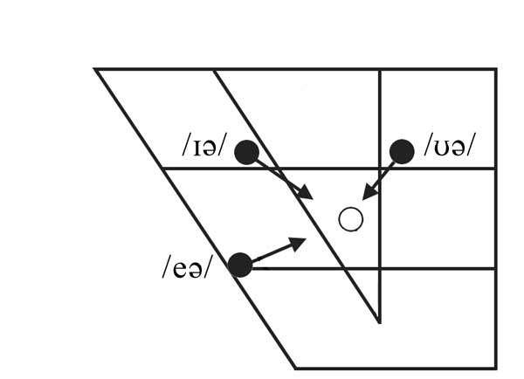

Centring diphthongs

Figures © 2006, M.G. Ashby.

