The IPA and the sounds of the World’s languages. Ejectives, implosives, clicks
Essential reading:
Ashby and Maidment (2005) Chapters 1 and 7.

The International Phonetic Alphabet aims to provide symbols for the sounds encountered in every language. One of the original Principles of the IPA expresses this aim as follows:

There should be a separate sign for each distinctive sound; that is, for each sound which, being used instead of another, in the same language, can change the meaning of a word.

Notice that this amounts to a statement of the phoneme principle. It means that the IPA should contain a suitable symbol for the principal allophone of any phoneme in any human language. See IPA Handbook (1999:27).

The range of possible human sound types is much larger than the set of sounds actually found in languages. The consonant chart on the alphabet of the IPA has several empty boxes, corresponding to articulations which have no symbols. For instance, there are no symbols in the box where the manner lateral fricative intersects with the place palatal. But palatal lateral fricatives can easily be made (and in fact fricative allophones of palatal laterals have been reported).

If a language is discovered which makes contrastive use of a sound which was previously no more than a possible human sound, then a new symbol will be required in the IPA. For instance the 1989 revision added a symbol [ʙ] for a voiced bilabial trill. Prior to 1977, the voiced bilabial trill was noted only as a possibility, but then it was reported that two languages, Kele and Titan (Papua New Guinea) have bilabial and tongue-tip trills in contrast. As a temporary measure, the investigators had used [ʙ] to represent the bilabial trill and that is the symbol that was eventually adopted for the IPA.

The 2005 revision added a new symbol [] for the voiced labiodental flap, a sound now documented as occurring in more than 70 languages of north central Africa. (This symbol is available in the latest Unicode font, Charis SIL, with the code E25F).

Air-stream mechanisms. One important way in which consonant sounds can differ has not yet been considered: the use of different air-stream mechanisms. All the sounds we have considered so far have used the pulmonic airstream mechanism (air from the lungs). This is the basis of all normal speech in all languages, and many languages (e.g. English) use no other airstream. The lungs supply a large volume of air under pressure, enough to power the production of long stretches of speech without pauses for breath. However, small volumes of air (enough to power the production of a single consonant segment) can be compressed (or, alternatively, rarefied) by muscular action in the mouth or pharynx, without using lung air at all. Consonants produced this way are ejectives, implosives and clicks. These are very much like extra manners of articulation and were at one time put on the IPA chart as if they were manners of articulation; but they are now under "Consonants - Non Pulmonic". In the languages which use them, these non-pulmonic sounds are interspersed into speech like any other consonants.

Ejectives are the commonest type of non-pulmonic sound; they occur in many languages of America and Africa. Ejectives are symbolised by adding an apostrophe to the symbol for any voiceless obstruent [pʼ] [tʼ] [kʼ] [tʃʼ] [sʼ]]. In the production of an ejective, the glottis is closed, and the air which is compressed (and eventually pushed out) is that between the closed glottis and the articulation in the oral cavity. For this reason, the name of the airstream is egressive glottalic.
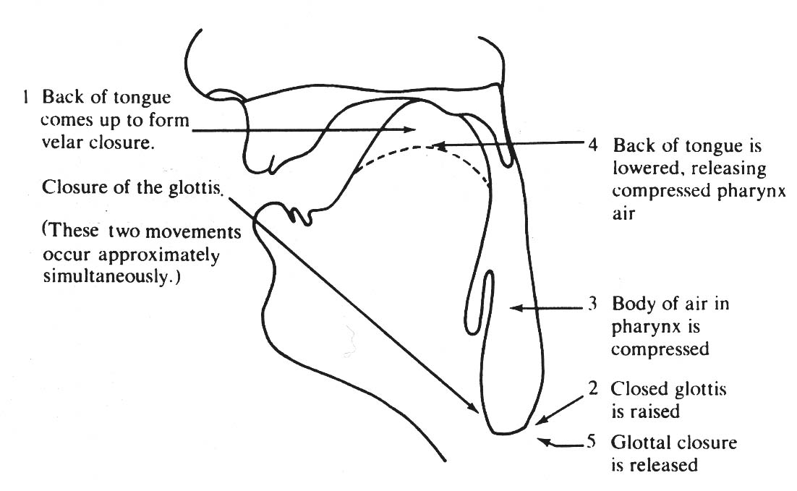

Figure 1 The sequence of events in the production of a typical ejective.

The sequence of events in the production of a voicless velar ejective plosive [kʼ] is as follows. Refer to figure 1.

(1) the back of the tongue rises to form a closure on the velum, just as for any velar stop. At about the same time, the glottis closes. The velum is also in its raised position, closed against the rear wall of the pharynx, so that no air can escape through the nose. (2) the closed glottis is raised (the whole larynx moves up) reducing the volume of the pharynx cavity and thus (3) increasing the pressure of the air in the pharynx. (4) the back of the tongue is lowered, just as for the release of an ordinary velar stop, thus releasing the compressed pharynx air and producing an audible explosion. The glottis remains closed during the release and for a short time afterwards. Finally (5) the glottal closure is released - for instance, the vocal folds may begin to vibrate for a following vowel. This description is of an ejective plosive, and this is the commonest type of ejective found in languages. Other types are possible, however, and ejective affricates and ejective fricatives are found in languages.

Occasionally, one encounters speakers of English who sometimes use ejectives as stylistic variants of ordinary English plosives at the ends of words.

Implosives are the next most common type of non-pulmonic sound. They occur in numerous languages of America, Africa and Asia. Implosives use the glottalic ingressive airstream; instead of moving up to compress the air in the pharynx, the glottis is moved down so as to enlarge the pharynx and produce suction. The symbols for implosives always have a hook attached to the top right: [ɓ ɗ ɠ].

Implosives are essentially reverse ejectives, but the straightforward voiceless examples are very rare in languages. The implosives commonly encountered have a further small complication in that they are voiced. Instead of being completely closed as it is pulled down, the glottis is vibrating to produce voice. Obviously, to produce voice, air from the lungs must be flowing up through the glottis. Voiced implosives thus employ two air-steam mechanisms simultaneously.
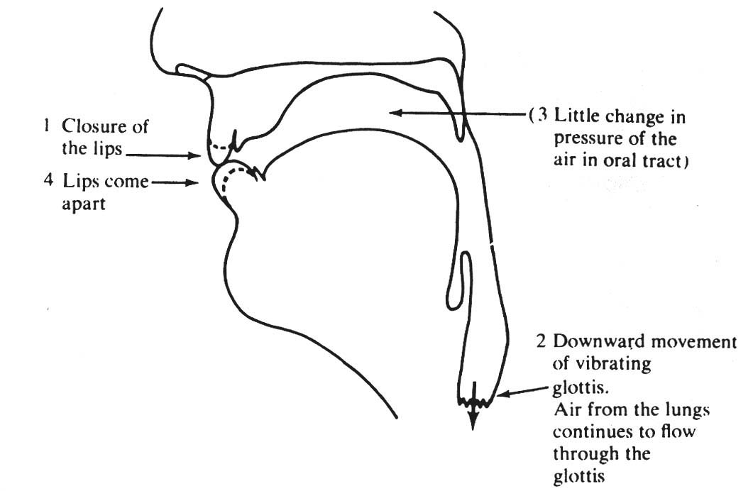

Figure 2 The sequence of events in the production of a typical implosive.

The sequence of events in a typical voiced implosive, [ɓ] is as follows. Refer to Figure 2. (1) the lips close, as for any bilabial stop. (2) as the vocal folds continue vibrating in a flow of lung air, the whole larynx is moved down, thus enlarging the pharynx and tending to reduce the pressure of air inside it. (3) the reduction in air pressure may not be very great, because it is offset by further air from the lungs flowing through the glottis to keep vocal fold vibration going. When (4) the lips are opened, air pressure in the mouth is still a little below atmospheric pressure, so airflow (briefly) is inwards. An implosive is recognised not from ingressive flow but from the characteristic sound which results from the complex change of shape during the production of the consonant. The type of vocal fold vibration is also affected in a characteristic way.

Implosives sound like rather peculiar fully-voiced plosives. In certain languages, implosives contrast with voiced pulmonic plosives. In others (Swahili is an example) implosives occur, but as allophones of voiced plosives. Languages which have ejectives and implosives in contrast with each other are rare, but not unknown.

Clicks are found only in Southern Africa, in all of the Khoisan languages (this group includes the various Bushman languages) and also in certain neighbouring Southern Bantu languages (e.g. Zulu). The two groups are unrelated, and it is believed that the Bantu languages which have clicks must have borrowed them from Khoisan. Clicks are not rare as paralinguistic signals - a kissing noise, the "tut-tut" of disapproval, the "clip-clop" in imitation of horses' hooves and the "gee-up" sound are all clicks. These are bilabial [ʘ], dental [ǀ], (post)alveolar [ǃ] and alveolar lateral [ǁ̰].
Clicks use the ingressive velaric airstream.
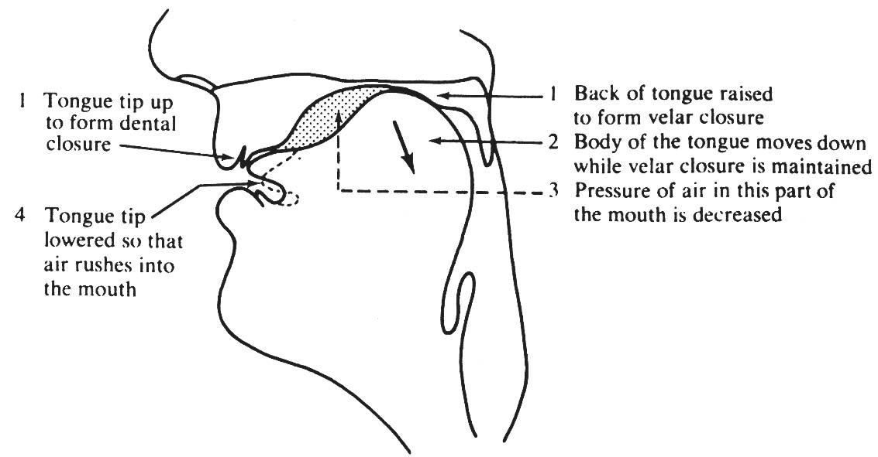

Figure 3 The sequence of events in the production of a typical click.

Refer to Figure 3 for the estimated sequence of events in a Zulu dental click [ǀ]. (1) the tongue tip forms a dental closure, just as it would for a dental plosive. At the same time, the back of the tongue is raised to touch the velum, so that a small volume of air is trapped between the tongue and the upper surface of the mouth. (2) while the two closures are maintained, the body of the tongue moves down so as to enlarge the volume (and thus (3) decrease the pressure of the enclosed air). (4) the dental closure is released and a characteristic sound is heard as air rushes in.

Because clicks use only air in the mouth, the larynx and the nasal cavities can be used to add various modifications. If the velum is open and the vocal folds are vibrating, the click is said to be voiced and nasalized (it might be more accurate to say that the click is accompanied by voice and nasality). These are symbolized [ŋ͡ʘ] [ŋ͡ǀ] [ŋ͡ǃ] [ŋ͡ǁ]. If a click is accompanied by voice, but not by nasality, the click is said to be voiced, and these are symbolized [ɡ͡ʘ] [ɡ͡ǀ] and so on. Clicks such as these which are voiced, or voiced-and-nasalized, use the pulmonic air-stream mechanism as well as the velaric.

