Place and manner of articulation

Essential reading: Ashby and Maidment (2005) Chapters 3 & 4

Aim: To outline the production of consonant sounds in terms of their place and manner of articulation.

Having passed through the larynx, air enters the **vocal tract**, which is usually visualised at its central (mid-sagittal) plane, as seen in a lateral x-ray (see Figure 1). The lowest part is the **pharynx**. The vocal tract branches into the oral and nasal cavities. The entrance to the nasal cavity is controlled by the **velum** (or soft palate) which can be raised, forming a **velic** closure against the rear wall of the pharynx, thus preventing air from entering the nasal cavity, or lowered, allowing flow into the nasal cavity and thus out of the nostrils.

The upper surface of the oral cavity is formed by the **hard** **palate**, and the moveable soft palate. Around the palate is a ridge holding the teeth; the portion of this behind the upper incisors is referred to as the **alveolar** **ridge**. Various parts of the tongue (see Figure 2) can be made to approach or touch the upper surface of the mouth, and complete airtight closures are possible at a range of locations, the closure being made not only on the mid-line where it is usually visualised, but across the width of the cavity and back along the tongue rims. The space between the teeth can be altered by adjusting the jaw opening, while the lips can assume a range of adjustments, again including complete closure.

The location along the vocal tract where a consonantal obstruction is formed is called the **place of articulation**. If a constriction is made at the lips or the glottis, there are two moving articulators; at other locations, there is generally a **passive** articulator (which does not move), and an **active** articulator (which moves toward the passive articulator). For most articulations the commonly used name is based on the passive articulator concerned. Places of articulation are listed in Table 1.

**Manner of articulation** refers to the type of obstruction used in the production of a consonant – whether, for example, the airflow is blocked completely for a brief time (yielding the manner known as **plosive**) or simply obstructed so that noisy turbulent flow occurs (the manner known as **fricative**) and so on.

Manners of articulation are summarised in Table 2. The main difference among manners is in degree of constriction, but manner also incorporates

* the **nasal/oral** distinction: the velum may be open as in [m] or [n], permitting flow via the nose, or closed)
* the **central/lateral** distinction: airflow is central – along the mid-line of the tract – in most sounds, but is diverted to the side(s), in lateral sounds such as [l].
* the **rate** of an articulatory manoeuvre; for instance, if the tongue tip and blade make one brief flick sealing against the alveolar ridge the resulting sound is called a tap, symbolised [ɾ] , but the same closure made at a slower rate will be a plosive.

|  |  |  |  |  |  |  |  |  |  |  |  |
| --- | --- | --- | --- | --- | --- | --- | --- | --- | --- | --- | --- |
|  | **LABIAL** | | **CORONAL** | | | | **DORSAL** | | |  |  |
| *place* | **bilabial** | **labio-dental** | **dental** | **alveolar** | **post-alveolar** | **retroflex** | **palatal** | **velar** | **uvular** | **pharyngeal** | **glottal** |
| *English sounds* | p b m | f v | θ ð | t d s z l n | ʃ ʒ tʃ dʒ ɹ |  | j | k ɡ ŋ |  |  | h ʔ |
| *other sounds (sample)* | ɸ β | ɱ |  |  |  | ʈ ɖ ʂ ʐ | c ɟ ç ʝ | x ɣ | q ɢ χ ʁ | ħ ʕ |  |
| *passive articulator* |  | upper teeth | upper teeth | alveolar ridge | rear of alveolar ridge | hard palate | hard palate | velum | uvula, back of velum |  |  |
| *active articulator* | lips | lower lip | tongue tip/blade | tongue tip/blade | tongue tip/blade | tongue tip | front of tongue body | back of tongue body | back of tongue body | epiglottis, tongue root | vocal folds |

Table 1. Places of articulation

|  |  |
| --- | --- |
| *place* | **labial-velar** |
| *English sound* | w |
| *other sounds (sample)* | k͡p ɡ͡b |
| *articulations* | bilabial + velar |

Table 1(a). Characteristics of English [w], which is a double articulation. Labial-velars commonly pattern like labials.

|  |  |  |  |  |
| --- | --- | --- | --- | --- |
| **manner** | **English sounds** | **other sounds (sample)** | **stricture** | **sonorant or obstruent** |
| plosive | p t k b d ɡ (ʔ) | ʈ ɖ c ɟ q ɢ | closure (stop) | obstruent |
| nasal | m n ŋ | ɱ ɳ ɲ ɳ | oral closure (stop) + nasal airflow | sonorant |
| trill |  | ʙ r ʀ | repeated brief closures | sonorant |
| tap or flap |  | ɾ | one rapid closure | sonorant |
| fricative | f θ s ʃ v ð z ʒ h | ç x | constriction, turbulent flow | obstruent |
| lateral fricative |  | ɬ ɮ | median closure + lateral narrowinɡ | obstruent |
| (central) approximant | w ɹ j | ɥ ɰ | wide approximation | sonorant |
| lateral approximant | l | ʎ ɭ | median closure + lateral wide approximation | sonorant |
|  |  |  |  |  |
| affricate | tʃ dʒ | p͡ɸ b͡β k͡x | closure (stop) followed by homorganic friction | obstruent |
|  |  |  |  |  |

Table 2. Manners of articulation

Obstruent and Sonorant: Articulations may be divided into two large classes. All **obstruent** articulations share the characteristic of increased air pressure inside the vocal tract, which is caused by a radical obstruction of the route by which the airstream exits. Obstruent manners are plosive, fricative (including lateral fricative), and affricate. In **sonorant** articulations the airstream is relatively unobstructed and there is little or no rise in air pressure inside the vocal tract. Sonorant manners are nasal, approximant, lateral approximant. Vowels are also sonorant.

Liquids and semivowels: [ɹ] and [l] sounds are usually distinguished from other approximants like [w] and [j] by the use of the term **liquid**. Approximants such as [j] and [w] articulated with the front or back of the tongue (not the tip or root) resemble short versions of vowels and are sometimes called **semi-vowels**.

Two sounds are said to be **homorganic** if they use the same articulators. So [p] and [b] are homorganic because they are both bilabial. Sometimes the term is applied more broadly, so for example [p] and [f] could be said to be (near-) homorganic because both are labial.

**Exercises**

1 Look at the following set of consonant symbols:

[ t w f m k l ]

Of the sounds they represent:

1. which are voiceless? ………………………………
2. which are plosives? ………………………………
3. which are fricatives? ………………………………
4. which are sonorants? ………………………………
5. which are alveolar? ………………………………

2 Circle the words:

(a) that begin with a bilabial consonant:

*man fat psalm palm boat coat*

(b) that begin with a velar consonant:

*cod quick road know heart goat*

1. that begin with a labiodental consonant:

*fat thick short cheese van meet*

1. that begin with an alveolar consonant:

*zip not lid sat top den*

1. that begin with a dental consonant:

*that song face thought week shape*

1. that end with a fricative:

*wish rang beige boss raise force laugh edge breathe*

1. that end with a nasal:

*line wing lamb may*

1. that end with a plosive:

*bell tip lot dumb rub wide leg rough shock*

1. that begin with an approximant:

*win you rose one use law*

1. in which the consonant in the middle is voiced:

*looking weather busy robin fishing comic leisure*

3 Transcribe the following words:

(1) plank (2) beep (3) easy (4) paper (5) votes (6) muddy

Now perform the following operations and retranscribe the words:

(a) delete all voiceless plosive sounds

(b) change all bilabials into alveolars of the same manner and voicing

(c) change all plosives into the nearest fricative

(d) change all voiced fricatives into voiced affricates

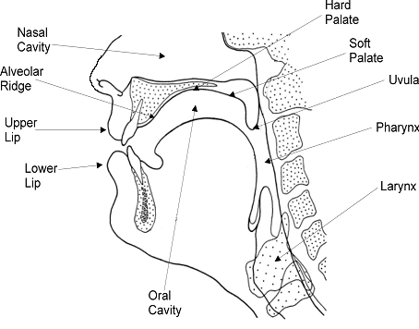

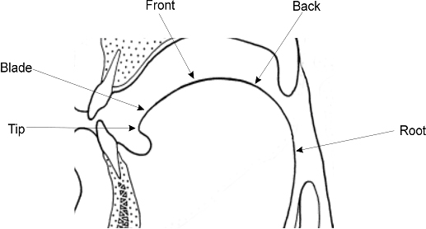Figure 3. Vocal tract outlines (after Ladefoged, *A course in phonetics*)

Figure 2. Regions of the tongue

Figure 1. A mid-sagittal section of the vocal tract

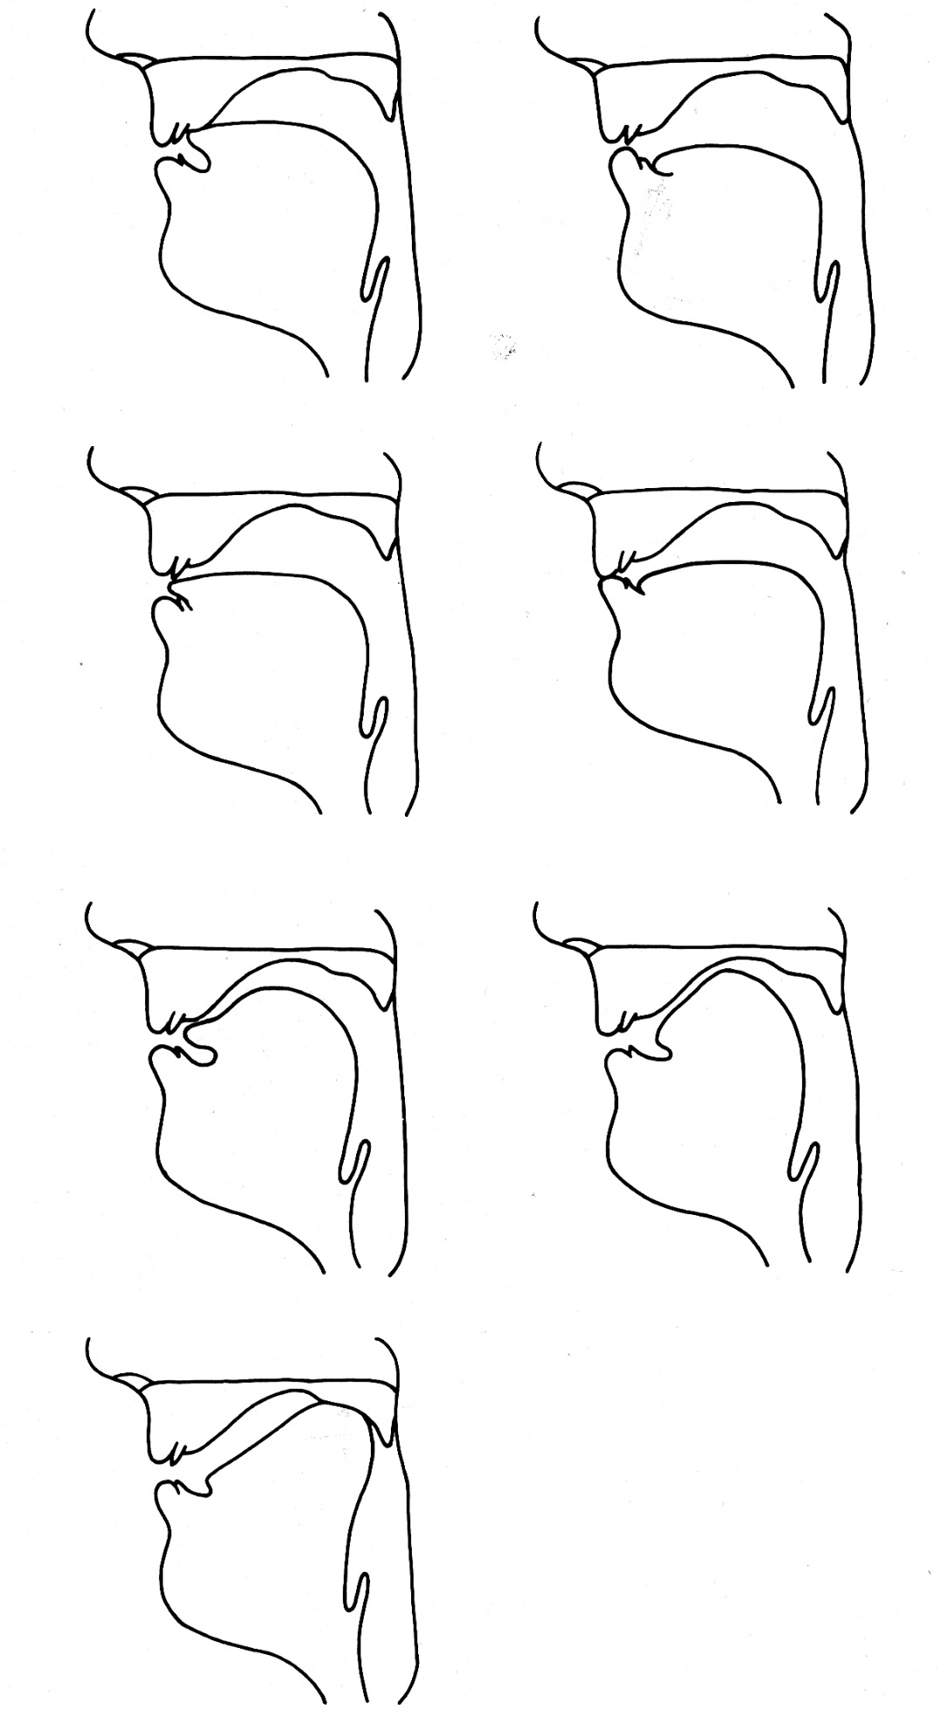

alveolar

labiodental

bilabial

dental

postalveolar fricative

alveolar fricative

velar

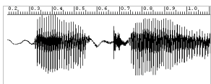

[ɑtɑ]

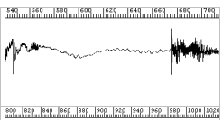

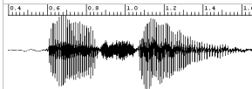

[ɑsɑ]

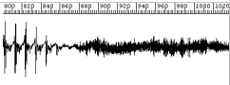

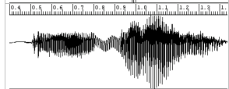

[ɑmɑ]

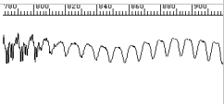

Figure 4. Speech waveforms illustrating plosive, fricative and nasal manners. The lower panels show a magnified portion from the middle of each sequence.

Ear Training Practice:

Q1 You will hear items of the form VCV. Indicate whether the consonant has audible friction or not.

1 audible friction no audible friction

2 audible friction no audible friction

3 audible friction no audible friction

4 audible friction no audible friction

5 audible friction no audible friction

Q2 You will hear items which end with a consonant. Indicate whether the final consonant is velar or at some other place of articulation.

1 velar other

2 velar other

3 velar other

4 velar other

5 velar other

Q3 You will hear items with varying structures. Indicate whether the items contain a median approximant or not.

1 yes no

2 yes no

3 yes no

4 yes no

5 yes no