FEWD-Lab 01:
1. Write webpage to display the screen below when opened in a browser:
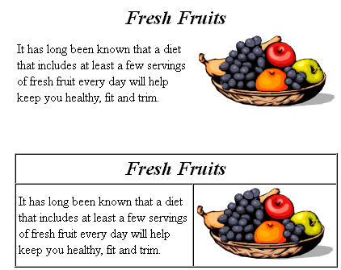

2. Write webpage to display the screen below when opened in a browser:
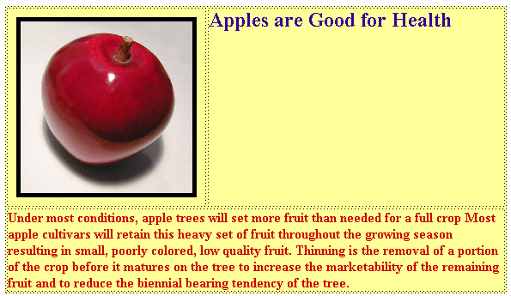

3. Write webpage to display the screen below when opened in a browser:
