Written Tutorial
ACE-Step XL 1.5 Premium v5.2
Installation, song generation, remix/repaint, audio processing, SAM Audio, presets, datasets, LoRA training, and cloud deployment
Source video: https://youtu.be/9C_6qNKjgpA | Subtitle: captions (2).srt | Captures: live local app plus selected 4K video frames
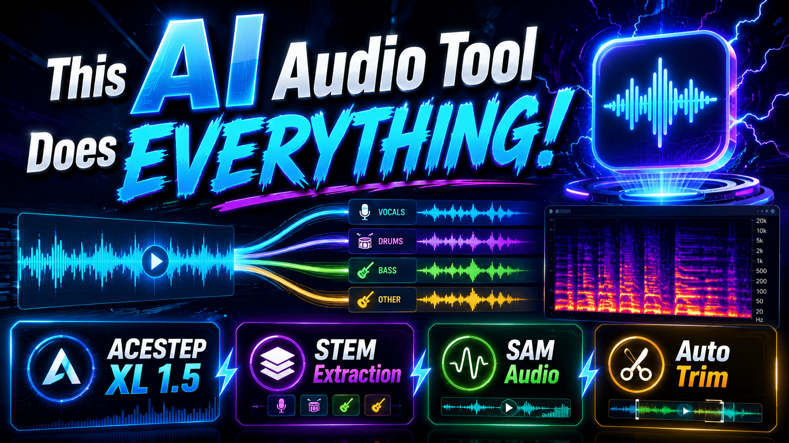
Figure 1. Supplied YouTube thumbnail for the public ACE-Step XL 1.5 tutorial. Click the thumbnail to open the video.

How To Use This Tutorial
This guide turns the full video tutorial into a written operating manual. It combines the tutorial subtitles, real live screenshots from the local ACE-Step app, a newly generated 20-second demo song, an Audio Processing run made from that song, and selected 4K frames from the source video for the Windows/cloud installation chapters.
Responsible use. The source tutorial states that the application should be used respectfully and for research/education. For remix, repaint, extraction, and pitch work, use material you own, have permission to process, or are allowed to use.

Artifact | Location
Generated demo MP3 | G:\ACE_Step_v1\ACE-Step_Premium\outputs\0021\8642a822-c4d0-ff4a-531f-6d5cfb334381.mp3
Processed demo WAV | G:\ACE_Step_v1\ACE-Step_Premium\outputs\audio_processing_0004\8642a822-c4d0-ff4a-531f-6d5cfb334381_processed.wav
Live app screenshots | C:\actep_step_tutorial2\screenshots
Video installation/cloud frames | C:\actep_step_tutorial2\screenshots\video_frames

Source Video, Thumbnail, Links, And Chapters
The public video description presents this as a full ACE-Step XL 1.5 Premium guide for local AI music generation, remix, repaint, stem extraction, audio processing, SAM Audio segmentation, Windows installation, RunPod, Massed Compute, SimplePod, and Linux/cloud workflows.
Resource | Link
Tutorial video | Forget Suno: Run the Ultimate AI Music Studio LOCALLY (100% Free)
Channel | SECourses
App/latest zip and Patreon post | Patreon ACESTEP XL Premium SAM Audio post
Windows requirements guide | Windows requirements guide
Discord/help/community | SECourses Discord server

Video duration: 1:15:09. Published: June 17, 2026. The thumbnail shown on the cover is the supplied YouTube thumbnail from the tutorial.

Video Chapters
Time | Chapter
0:00 | Intro: ACESTEP XL 1.5 Premium local music, segmentation and processing tutorial
0:52 | Fast song generation examples across styles in under one minute
1:55 | Output manifest proof, 40-second generation time and supported models
2:29 | Turbo/SFT/Base models, LoRA support, GPU presets and Torch Compile boost
3:10 | Remix feature preview, same-lyrics requirement and responsible usage note
4:16 | Repaint mode: regenerate and merge only a selected song section
5:38 | Extract mode: stems, silence trimming, all-stems and batch folders
6:30 | Lego mode: add an instrument stem such as guitar into existing audio
7:25 | Audio Processing presets and manual enhancement controls for AI songs
8:35 | Auto-Editor silent trim for tutorials, videos, audio and workflow export
9:48 | DaVinci/Premiere/Final Cut/ShotCut/Kdenlive timeline export demo
11:01 | SAM Audio Segment: BF16 models, VRAM presets and advanced segmentation
11:47 | SAM outputs demo: vocals, drums, bass, remaining audio and saved files
12:47 | Custom SAM prompts, semicolon batch segmenting and speech cleanup example
14:19 | Batch processing, load metadata, manifests, saved settings and presets
15:09 | Why local open-source models matter and where to run ACESTEP
15:55 | Windows install begins: Patreon zip, changelog, attachments and download
16:53 | Windows requirements tutorial before Python/CUDA/C++/FFmpeg setup
17:29 | Extract zip safely, avoid bad paths and run Windows_Install_or_Update.bat
18:24 | Automatic VENV, FFmpeg, UV install, model downloads and hash verification
19:24 | Turbo default vs all-model download for SFT/Base and BF16 safetensors
20:32 | First Windows launch, default Generate Song test and CMD progress
21:44 | Model recommendations, VRAM tiers, languages, vocals and MP4 image output
23:29 | Torch Compile setup for faster repeated generations
24:05 | Outputs folder, model switching and full remix setup workflow
25:24 | Practical remix loop: adapted lyrics, strength, reference audio and seed lock
28:03 | Repaint workflow with source range preview, generated result and comparison
29:13 | Recap: extraction, Lego, audio processing and SAM text-prompt usage
30:20 | Windows wrap-up, LoRA training teaser and move to cloud installs
31:16 | RunPod setup: credits, template, CUDA filters, GPU choice and storage
34:53 | Upload zip in Jupyter Lab, extract, run instructions and handle installs
35:43 | RunPod errors, resume behavior, model downloads and hash verification
38:04 | Start ACESTEP on RunPod with Gradio Live, proxy ports and persistence
40:18 | Add 7860/7861 ports, verify storage reuse and rerun installer after resume
42:10 | RunPod connection troubleshooting and Gradio Live recommendation
44:12 | Fix corrupted VENV/stale handle errors, reinstall safely and retest
47:24 | Successful RunPod relaunch, default generation, nvitop and loading tips
49:26 | RunPod first load vs fast inference, 15-second second generation example
51:02 | Download outputs and delete RunPod pods/storage to stop spending
53:30 | Massed Compute setup: coupon, Creator image, GPU prices and ThinLinc
57:13 | Massed install from extracted folder, Linux notes and ultra-fast downloads
59:18 | Start app on Massed Compute via localhost or Gradio Live
1:00:23 | Default Massed generation, nvitop, faster loading and speed test
1:02:03 | Sync/download outputs and delete Massed Compute instance safely
1:03:25 | SimplePod setup: template, persistent volume, pricing and GPU choice
1:06:39 | Jupyter upload, direct file browser, install command and model downloads
1:08:21 | Start SimplePod, Gradio Live, default generation and one-time load errors
1:09:31 | nvitop monitoring, newer driver/CUDA details and generation completion
1:10:42 | Direct output/model downloads through SimplePod file browser
1:11:42 | Delete instance, keep storage, relaunch GPU and verify install
1:13:15 | Discord, subreddit, changelog, update guidance and support links
1:14:30 | Final cleanup: terminate servers, delete storage and LoRA training outro

1. What ACE-Step XL 1.5 Premium Is
ACE-Step XL 1.5 Premium is a local-first music generation and audio utility suite. The video presents it as more than a song generator: the same interface also includes advanced generation modes, remix/repaint workflows, stem extraction, LEGO-style stem addition, SAM Audio segmentation, Auto-Editor trimming, mastering-style audio processing, dataset tools, and LoRA/LoKr training pages.
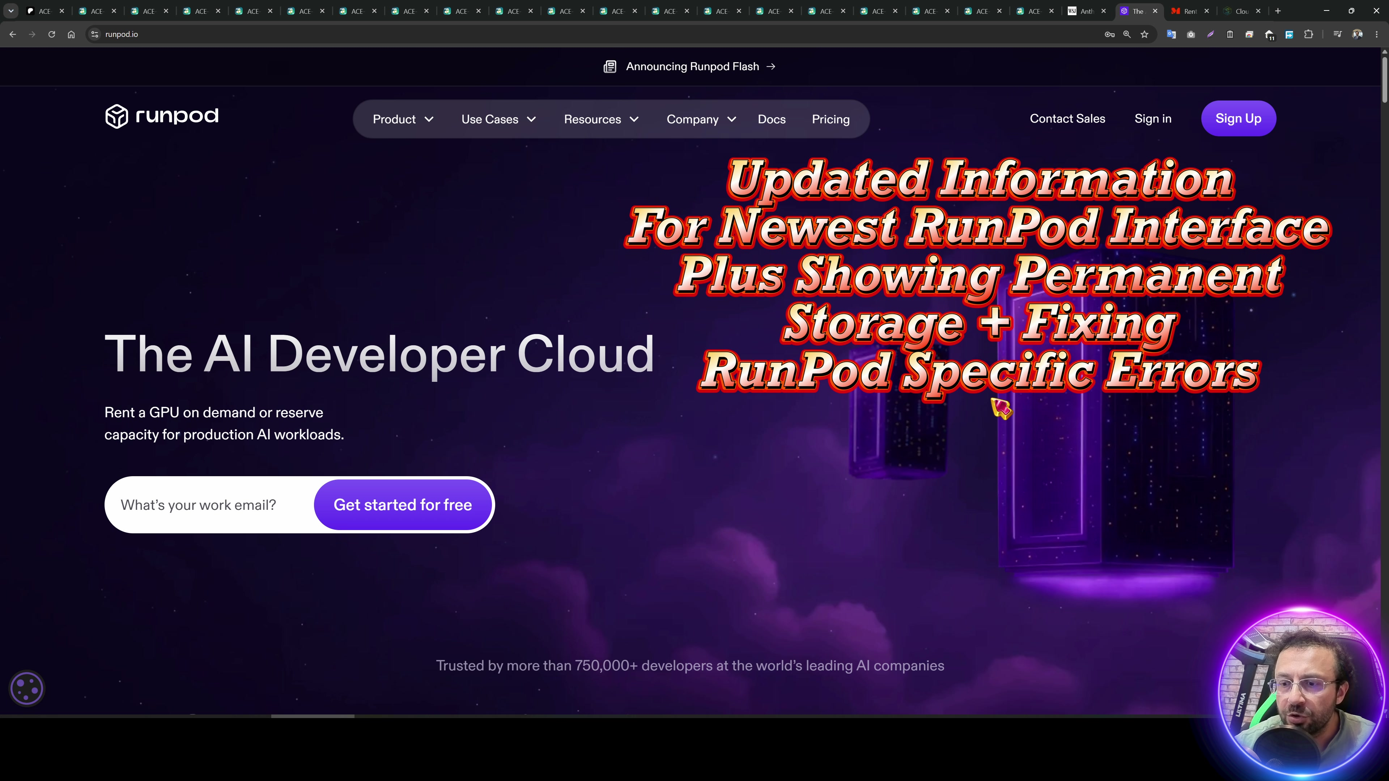
Figure 2. Video introduction: the tutorial covers installation and usage across Windows and cloud GPU providers.
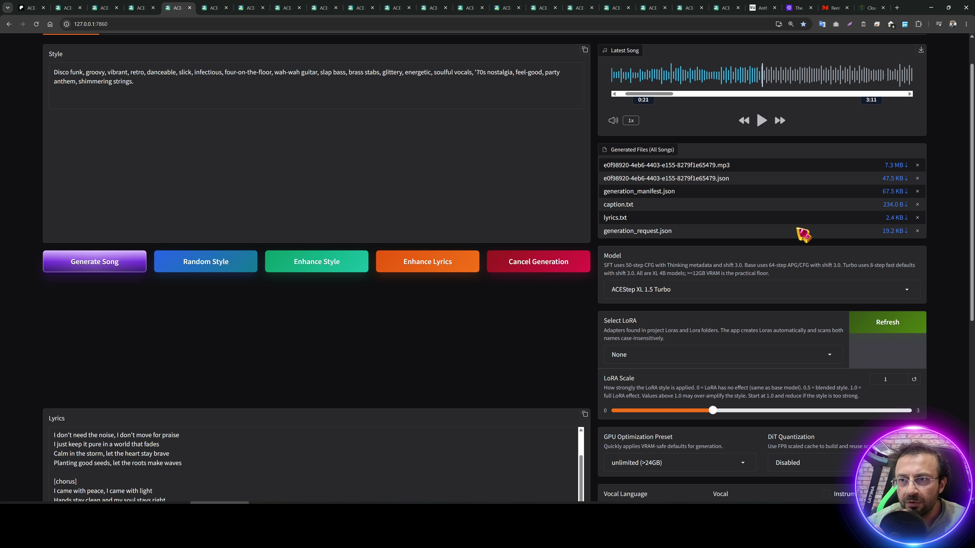
Figure 3. Video overview: ACE-Step is positioned as a full music-generation and audio-processing suite.
- Main job: generate complete songs from a style prompt, structured lyrics, model choice, duration, language, and seed settings.
- Advanced job: remix, repaint, extract, LEGO-add, complete, retake, edit, and reuse LM code hints when the selected model supports the mode.
- Audio job: trim silence, export audio/video, enhance or pre-master generated songs, and optionally run pitch correction with DiffPitcher.
- Segmentation job: use SAM Audio with quick prompts, custom prompts, explicit spans, or batch prompt lists to extract target audio and save the remaining audio.
- Operations job: use the Library, Load Metadata, Results, and preset system to restore, inspect, score, save, and reuse generation runs.

2. Install And Start On Windows
The Windows flow in the video uses the provided batch files. Extract the ZIP, keep the folder structure intact, run the installer/update script, optionally download all models, then start the app with the Windows launcher.
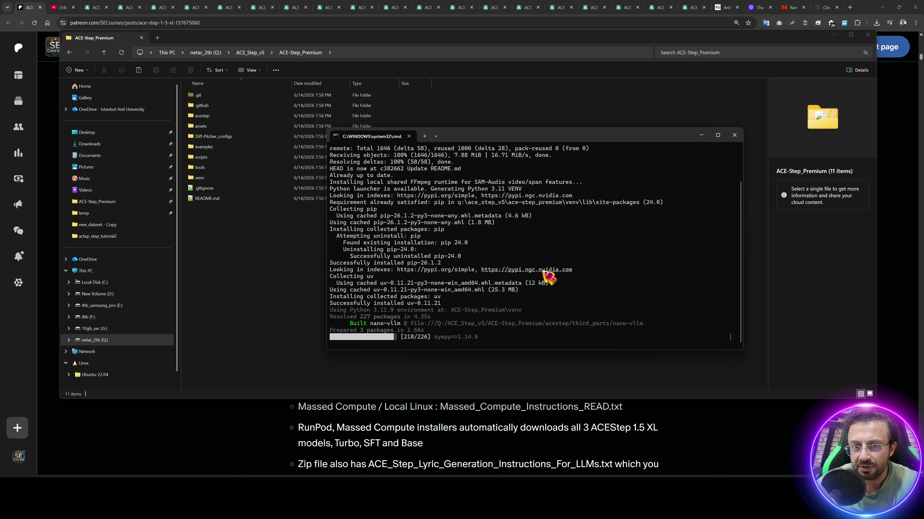
Figure 4. Windows installer running from the extracted ACE-Step Premium folder.
- Extract the ACE-Step Premium ZIP to a path with enough free disk space for the virtual environment, model files, outputs, and FFmpeg runtime.
- Run Windows_Install_or_Update.bat. The installer creates the Python virtual environment, downloads/uses shared FFmpeg, installs packages with UV, and prepares the app.
- Run Windows_Download_All_Models.bat if you want SFT and Base models in addition to the automatically available Turbo path.
- Run Windows_Start_App.bat. In this workspace the launcher started ACE-Step at http://127.0.0.1:7862 because other Gradio apps were already using 7860/7861.
- Watch the command window for model download, model load, generation, and error details. The video recommends trusting the terminal status more than only the browser UI.
Model availability. Turbo is the quick default. SFT and Base require additional model files. Remix is recommended with SFT in the video; some modes are marked Base-only or unavailable until the matching model is selected.

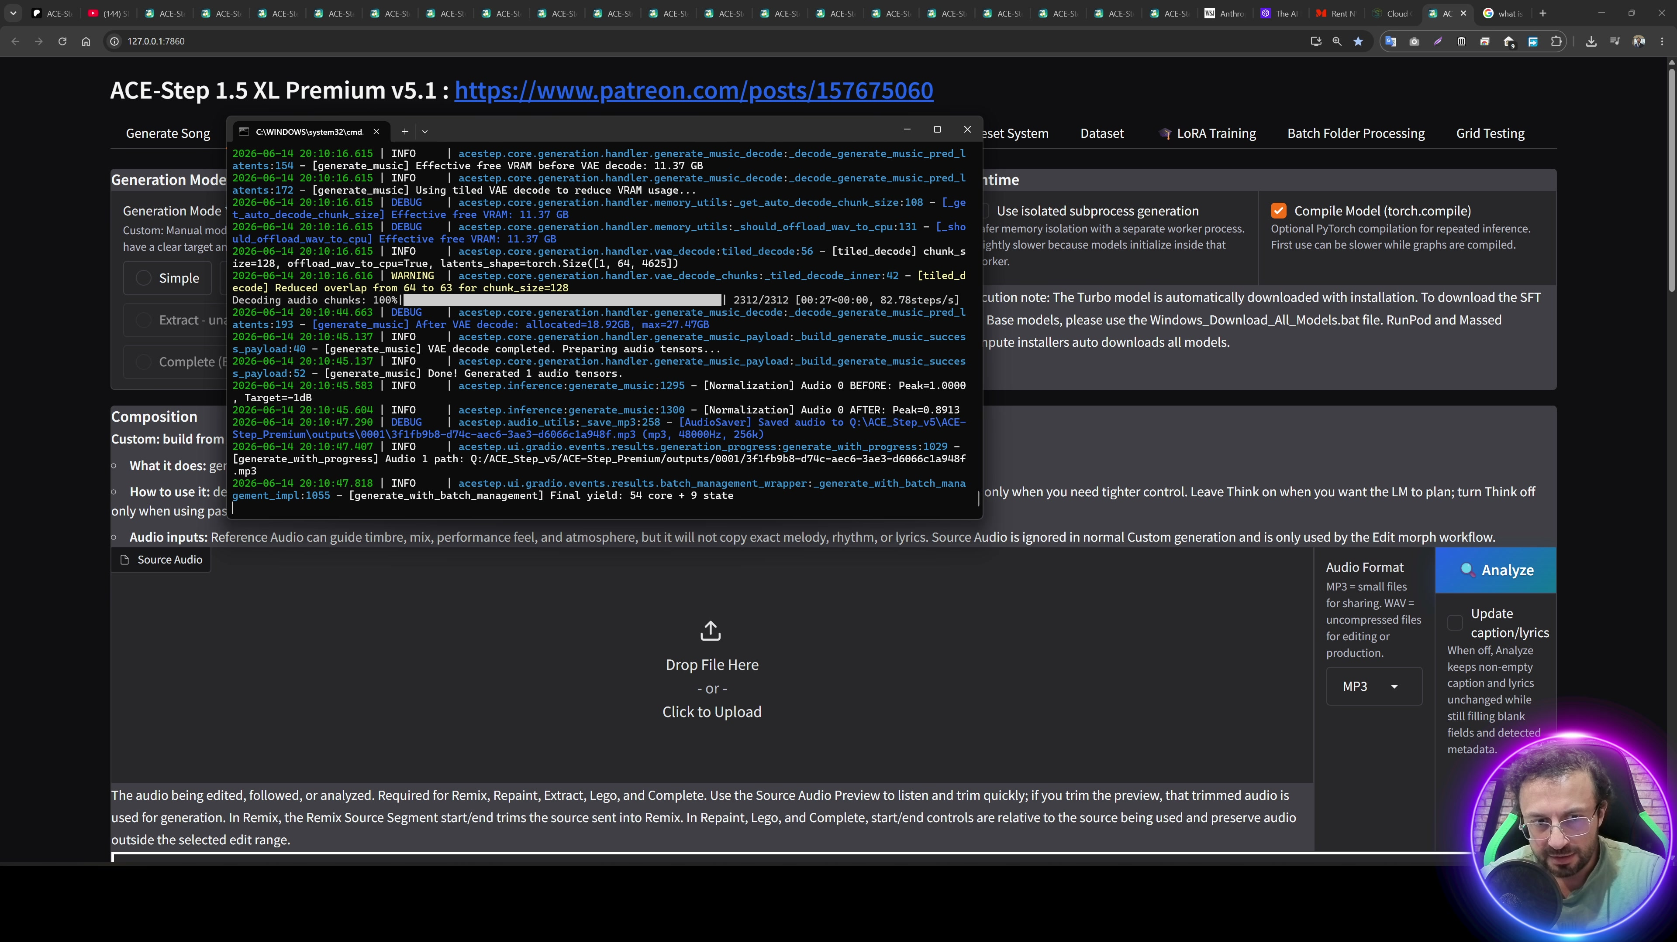
Figure 5. Windows first generation stage from the source video.

3. Quick Song Generation
The Generate Song tab is the fast path. It exposes the controls most users need: style, lyrics, model, LoRA, GPU preset, quantization, language, vocal type, instrumental toggle, duration, count, seed, optional MP4 image, and video resolution.
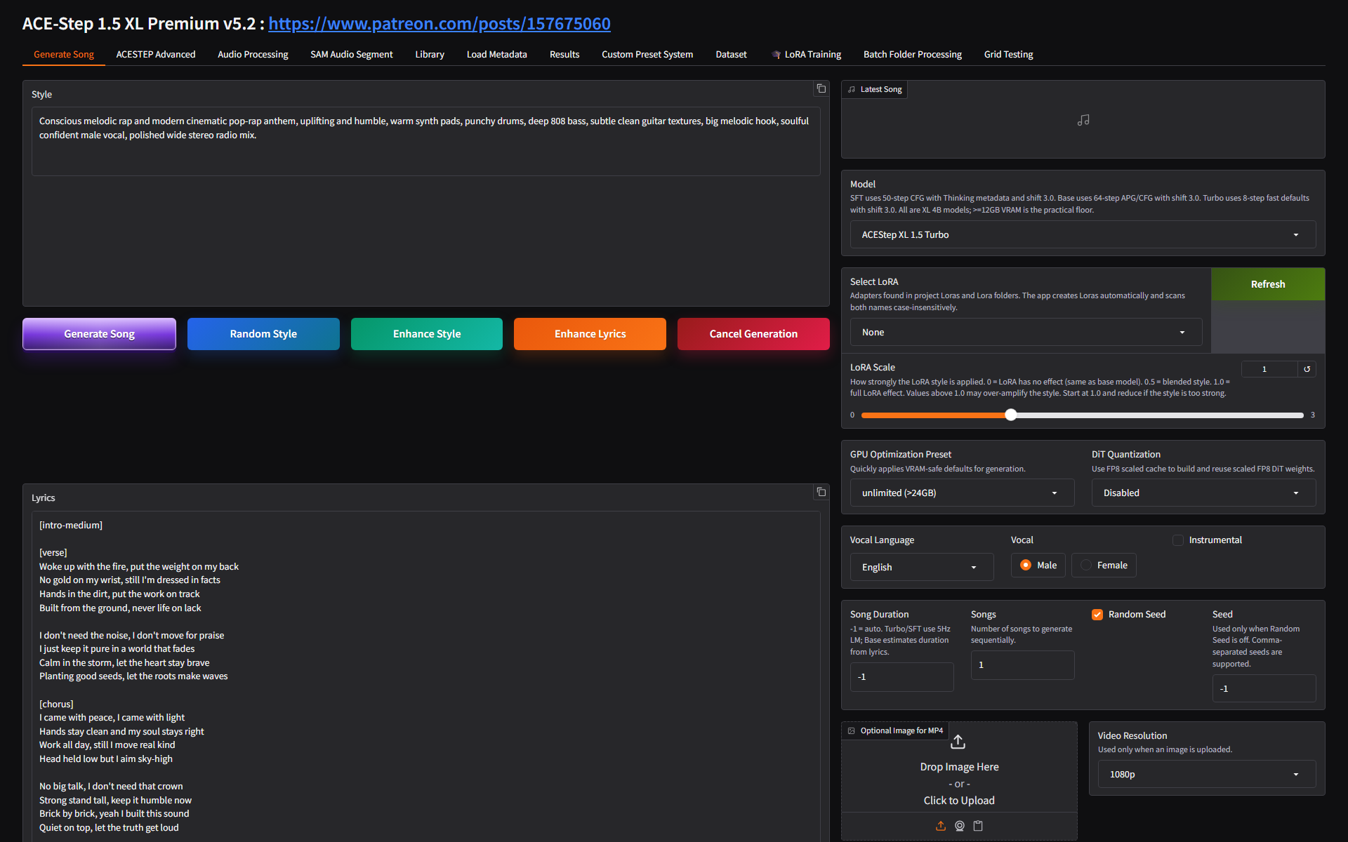
Figure 6. Live Generate Song tab before the demo prompt was entered.
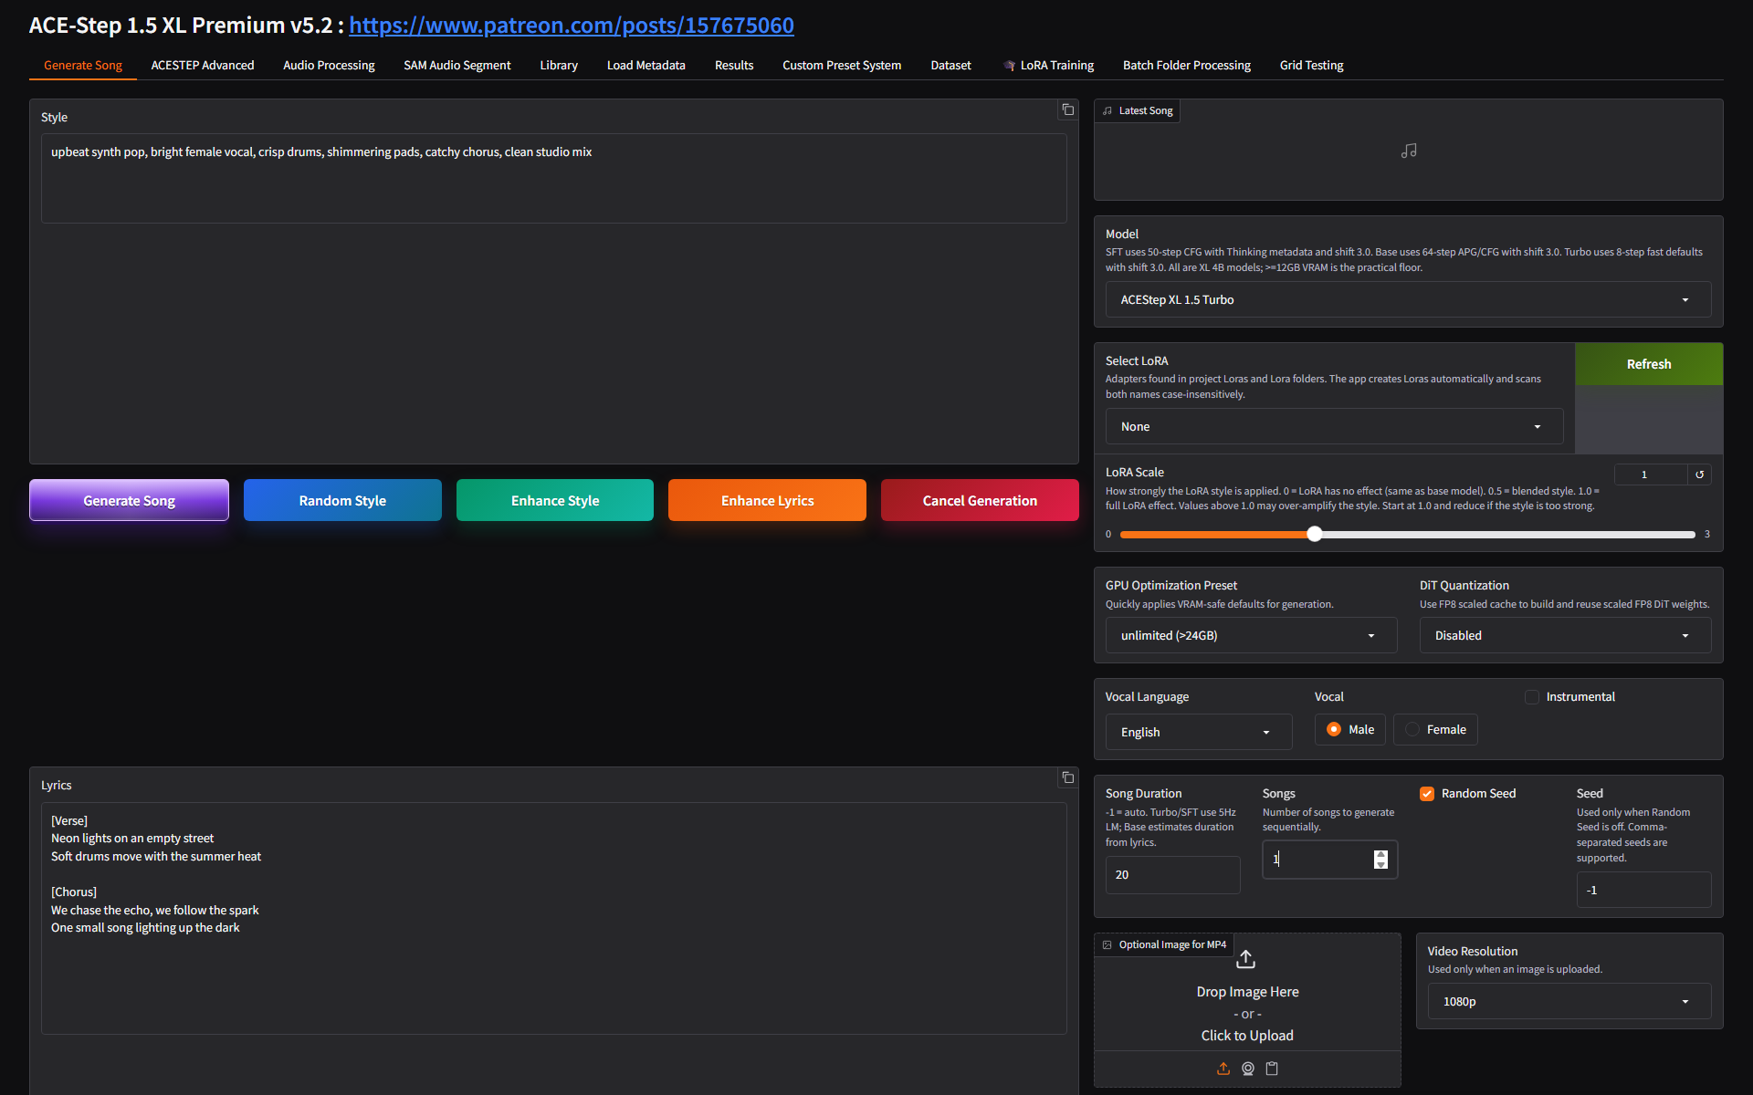
Figure 7. Live Generate Song tab filled with a short synth-pop style prompt and structured lyrics.
- Write a concise Style prompt that describes genre, vocal character, instrumentation, production quality, tempo or mood, and mix target.
- Write Lyrics with section tags such as [Verse] and [Chorus]. The included ACE_Step_Lyric_Generation_Instructions_For_LLMs.txt file can be given to an LLM to format lyrics or style prompts.
- Select the Model. Start with ACE-Step XL 1.5 Turbo to verify the machine and workflow quickly.
- Leave GPU Optimization Preset and DiT Quantization at safe defaults unless you are solving VRAM pressure or repeating a known workflow.
- Set Song Duration and Songs. The demo run used 20 seconds and 1 song.
- Use Random Seed while exploring. When a promising result appears, uncheck Random Seed and keep the seed so future edits stay comparable.
- Click Generate Song and monitor the Status field plus the terminal window.
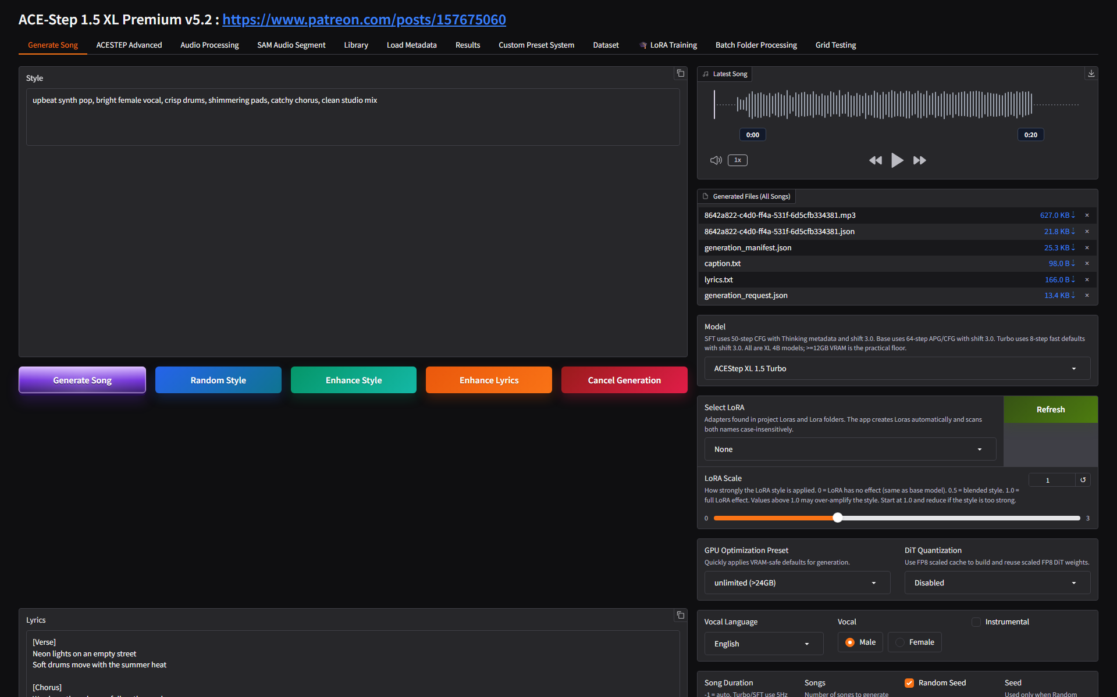
Figure 8. The real demo generation completed in the local app and produced MP3 plus metadata files.
Control | Use it for
Random Style | Quickly create a starting style prompt.
Enhance Style | Ask the local enhancement logic/model to improve the style prompt.
Enhance Lyrics | Improve lyric structure or phrasing before generation.
Cancel Generation | Stop a run from the UI. If subprocess mode is enabled, cancellation is isolated from the main app.
Open Outputs Folder | Open the app's outputs directory where audio, manifests, lyrics, captions, sessions, and metadata are saved.

4. Results, Seeds, And Reuse
The tutorial stresses generating repeatedly until you have a good base result, then locking the seed and making controlled edits. This is especially important for remix and repaint work, where small prompt or range changes can be tested against the same underlying random state.
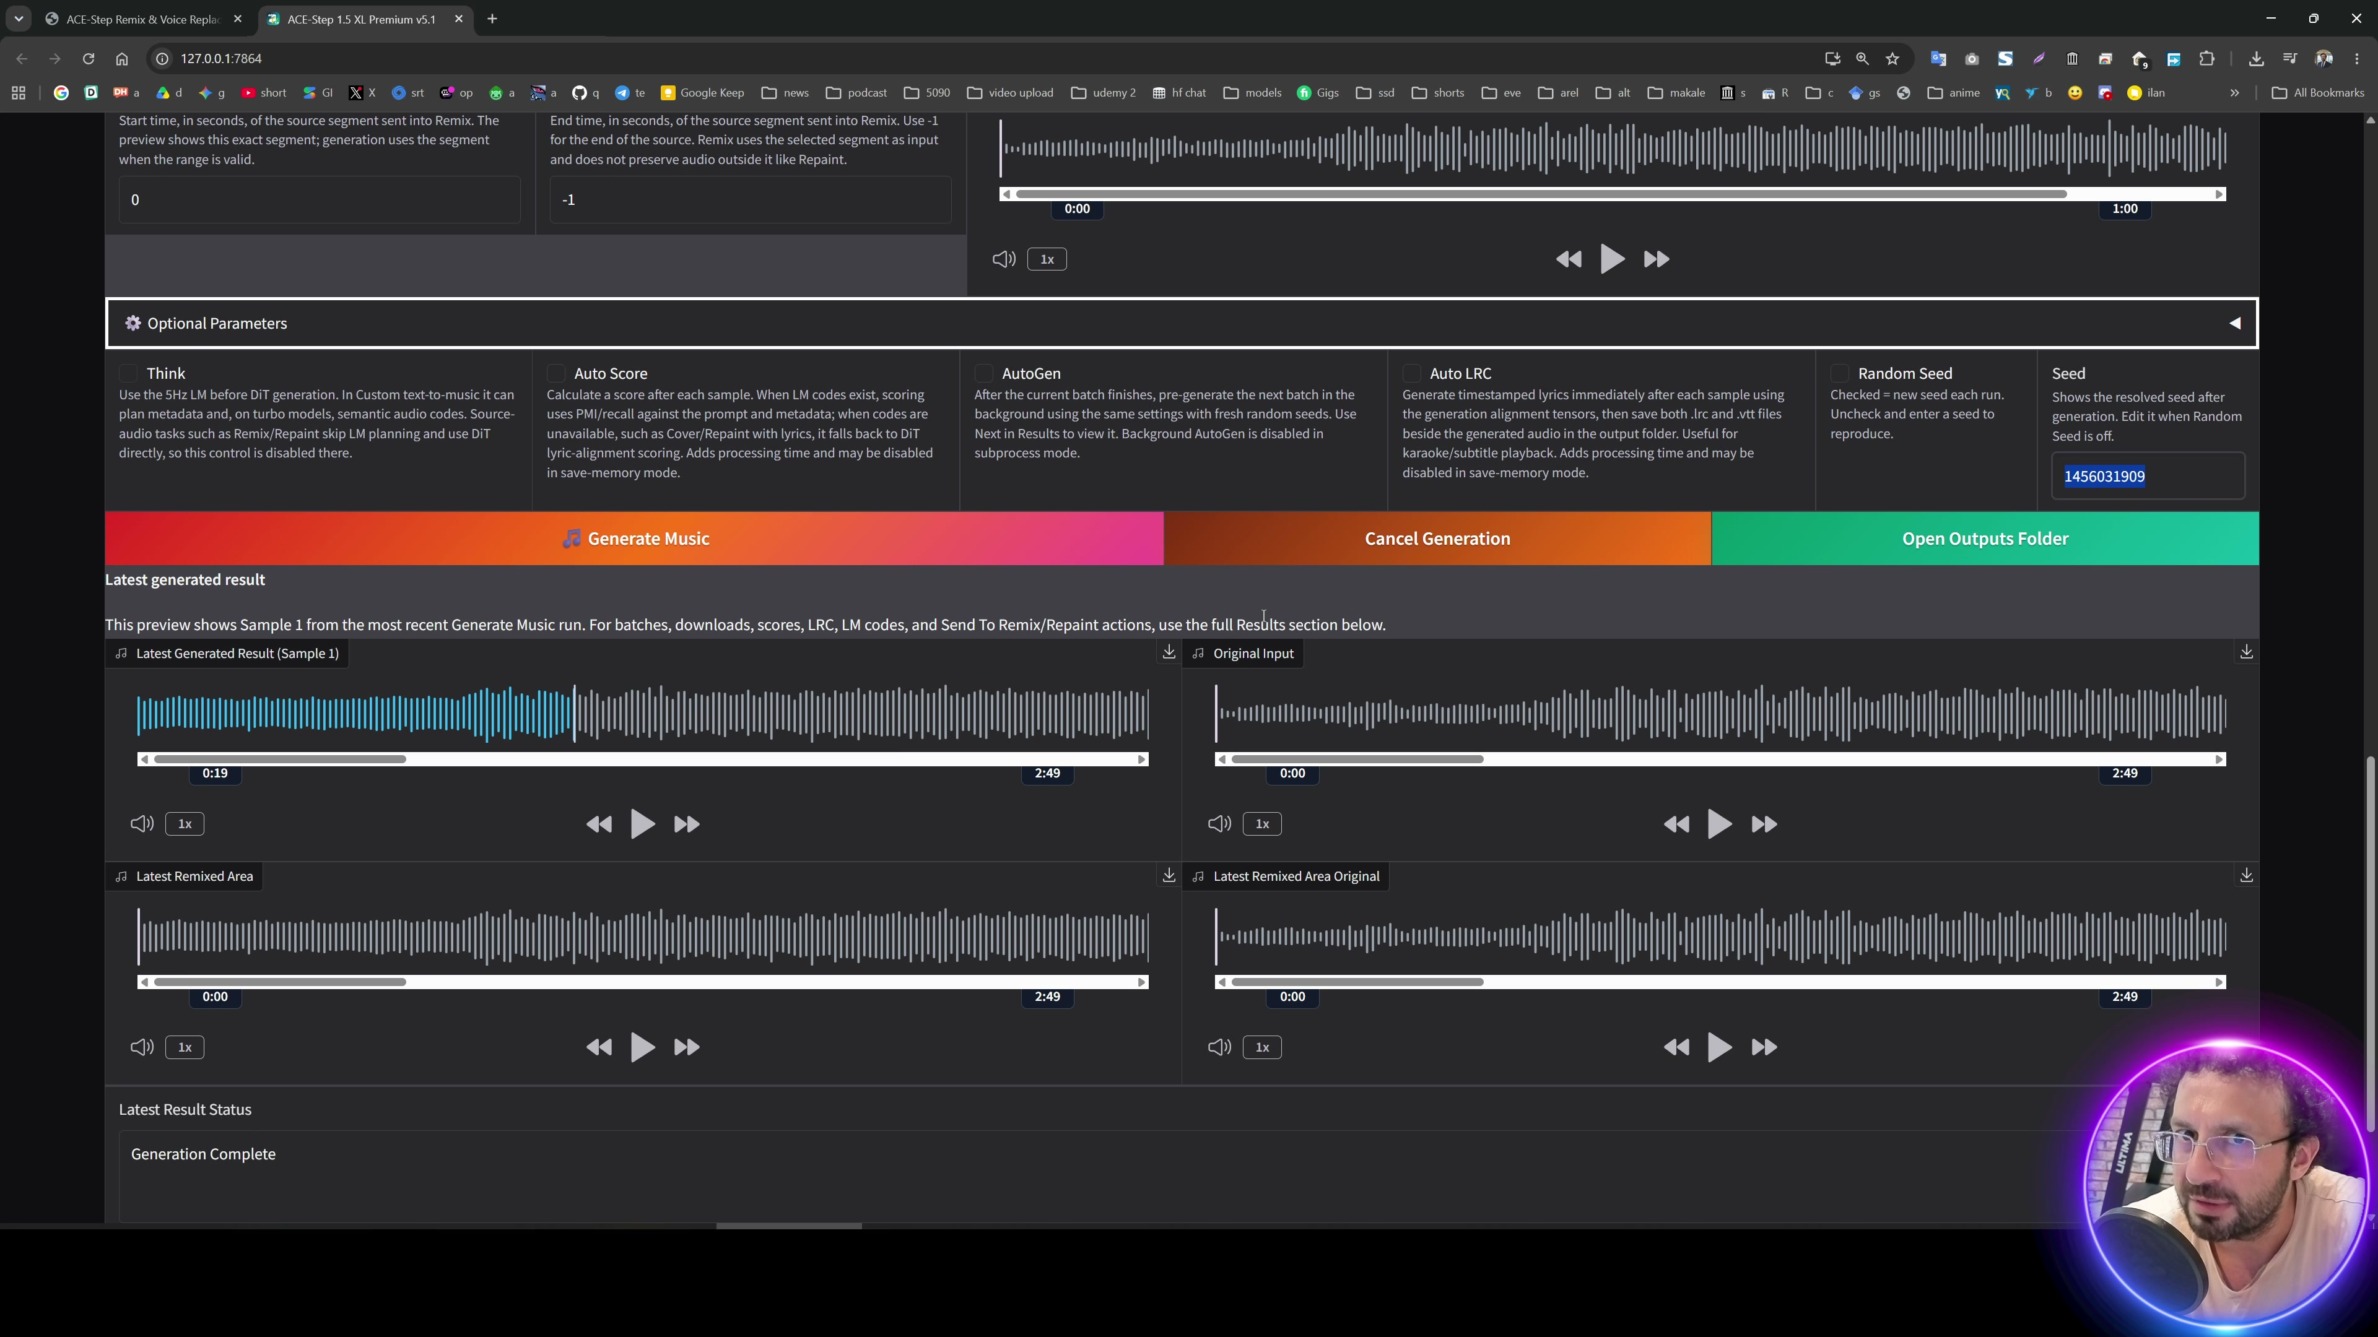
Figure 9. Source-video seed/remix discussion: lock a good seed before making small changes.
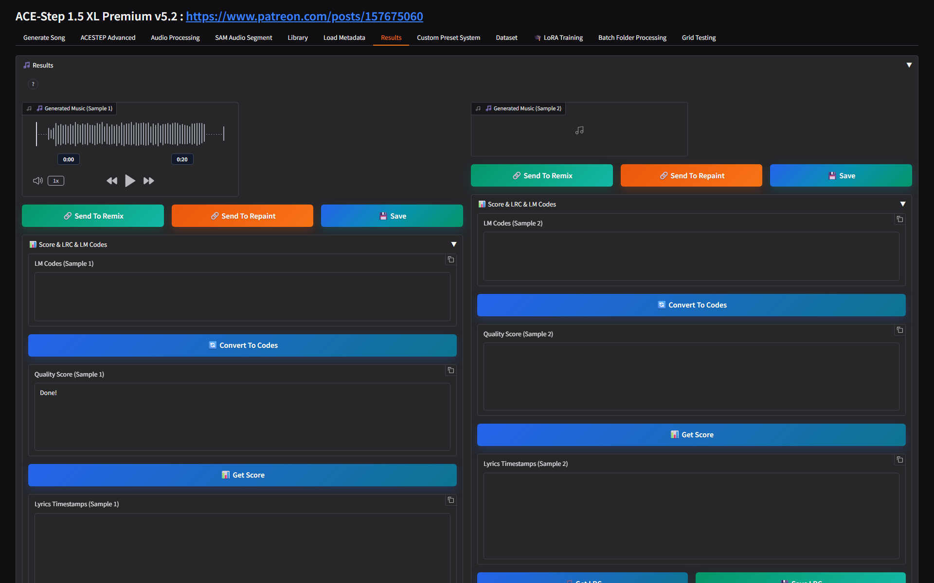
Figure 10. Live Results tab after the demo run, with Send To Remix, Send To Repaint, Save, score, LRC, and LM code tools.
- Send To Remix loads the generated song as Source Audio and prepares the advanced Remix workflow.
- Send To Repaint loads the generated song and prepares a repaint range workflow.
- Convert To Codes reuses the musical plan as LM Codes Hints in compatible Custom workflows.
- Get Score and Get LRC create quality-score and lyric-timestamp artifacts for the selected result.
- Save and All Generated Files expose the generated files for download or reuse.

5. Advanced Generation Modes
The ACESTEP Advanced tab is the full workstation. It exposes generation mode, runtime settings, source/reference audio, LM code utilities, advanced prompts, metadata, sampler settings, output settings, and batch processing.
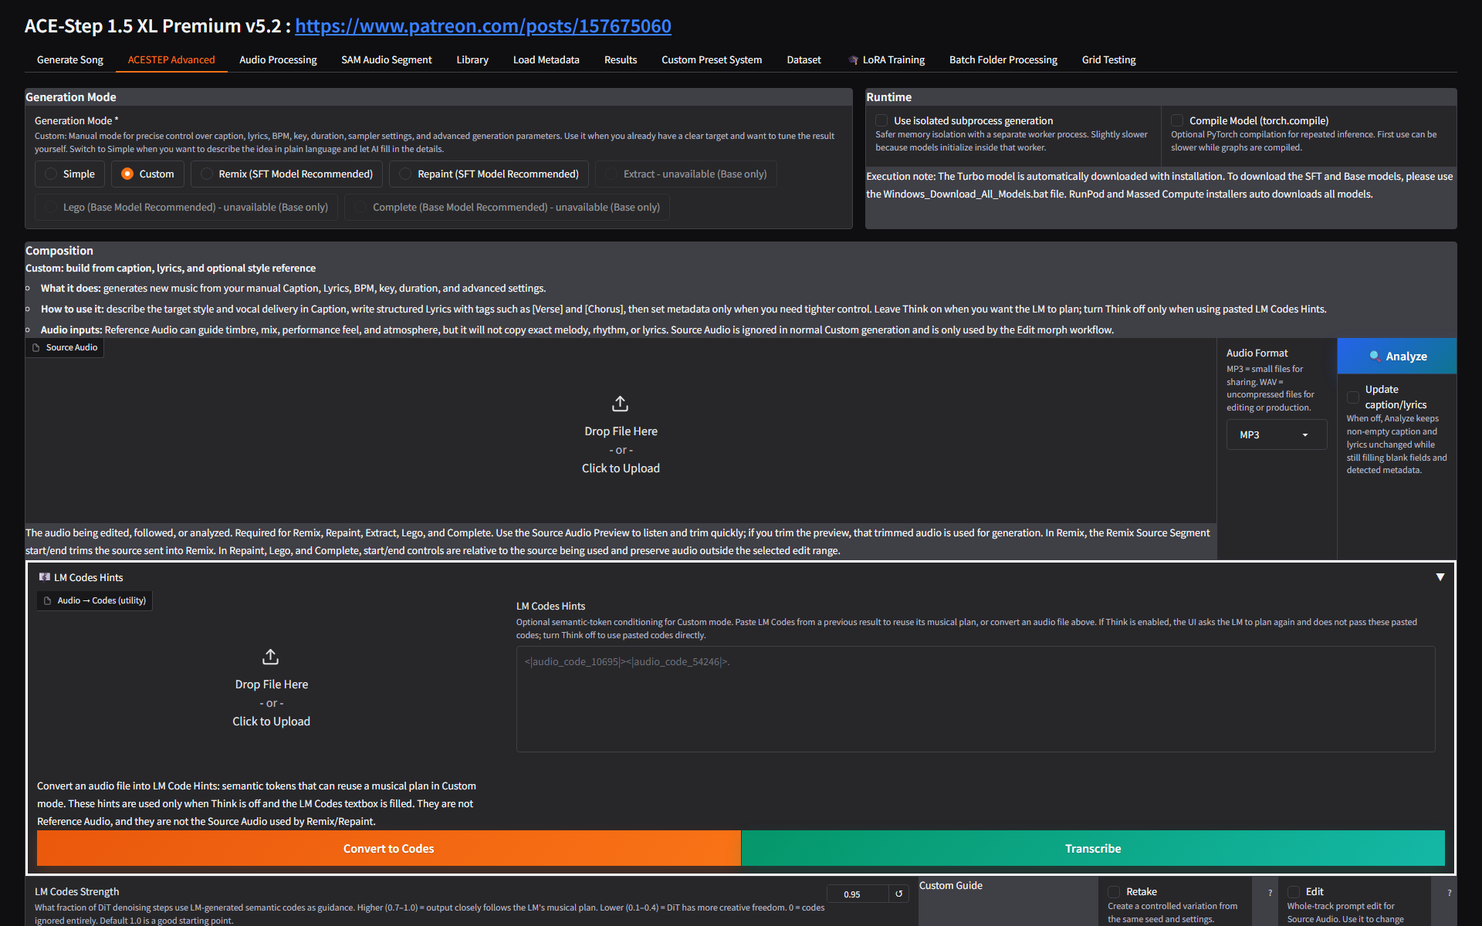
Figure 11. Advanced tab: generation mode, runtime, composition guide, source audio, and LM code utilities.
Mode | When to use it
Simple | Plain-language generation when you want the app to fill many details.
Custom | Precise manual control over caption, lyrics, BPM, key, time signature, language, duration, and advanced settings.
Remix | Create a new version from source audio. The video recommends SFT for Remix and keeping the same lyrics for best results.
Repaint | Replace or modify a selected time range while preserving the rest of the source audio.
Extract | Use ACE-Step extraction/stem workflows where the selected model supports it.
LEGO | Add a new stem to existing audio, such as adding a guitar stem to a track.
Complete | Continue or complete source audio when the selected model supports it.

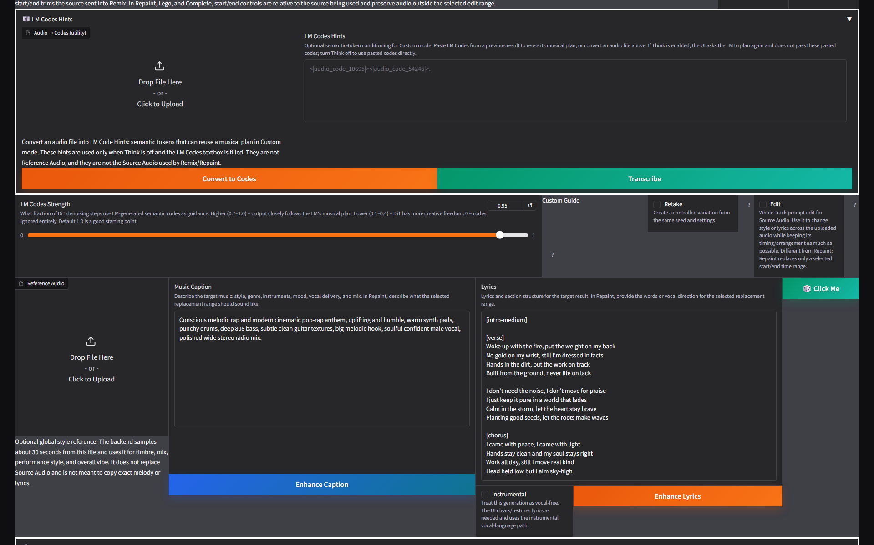
Figure 12. Advanced Source Audio area for remix, repaint, extract, LEGO, complete, and analysis workflows.
Figure 13. Advanced metadata, auto toggles, generation, seed, Think, score, and LRC controls.
- Source Audio is required for Remix, Repaint, Extract, LEGO, and Complete. Use the preview/range tools so the source segment is exactly what you intend.
- Reference Audio guides timbre, mix, performance feel, and atmosphere; it is not meant to copy exact melody, rhythm, or lyrics.
- BPM Auto, Key Auto, TimeSig Auto, Language Auto, and Duration Auto are useful when you want the model to infer metadata.
- Think enables LM planning. Turn it off only when deliberately using pasted LM Codes Hints.
- Retake creates controlled variation from the same seed/settings. Edit changes the whole uploaded source using source and target prompts.
Figure 14. Engine Settings: GPU tier, checkpoint, model path, device, VAE, LM backend, Flash Attention, offload, compile, LoRA, and inference settings.

6. Remix, Repaint, Extract, LEGO, And Auto-Editor Features
The first part of the video demonstrates feature outcomes before the installation section. The important operational point is that these features are not separate apps; they are modes and panels inside the same ACE-Step interface.
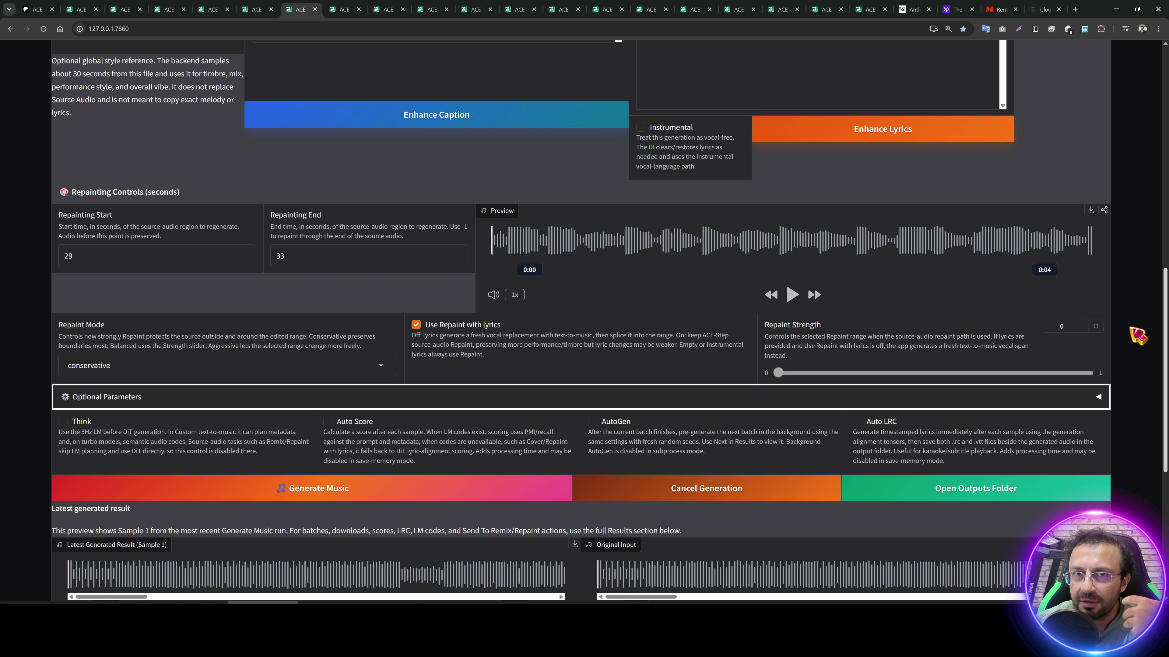
Figure 15. Source-video remix comparison. Remix works best when the lyrics match the source song.
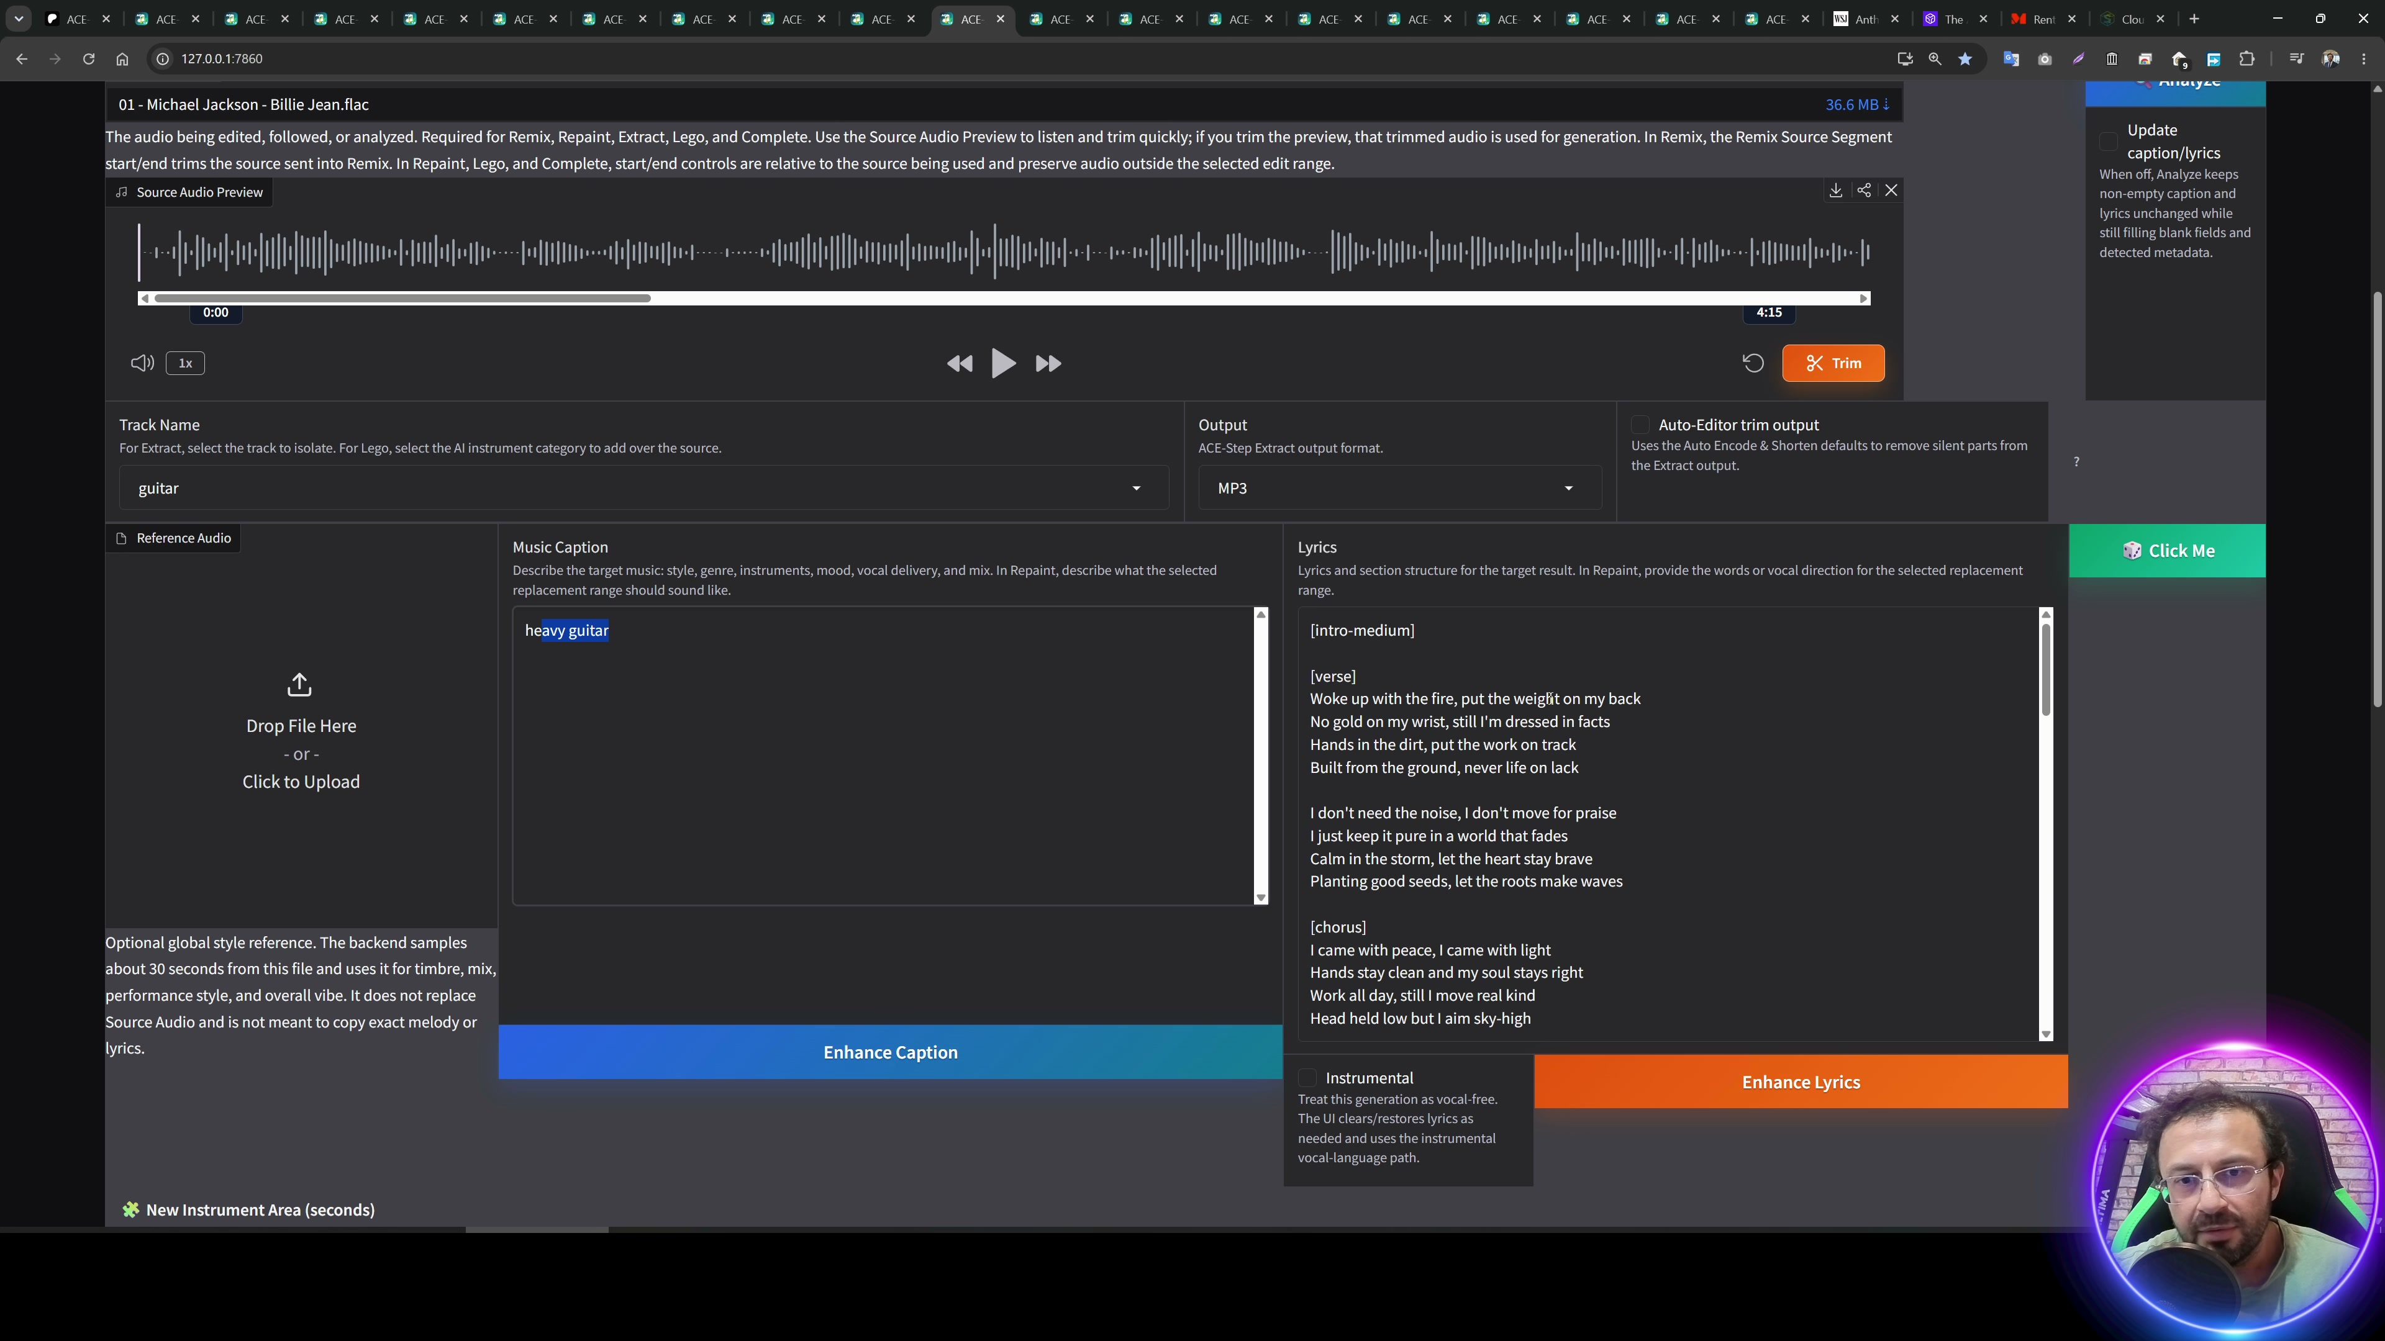
Figure 16. Source-video extract/LEGO demonstration. Extraction can create stems; LEGO can add a new stem to existing audio.
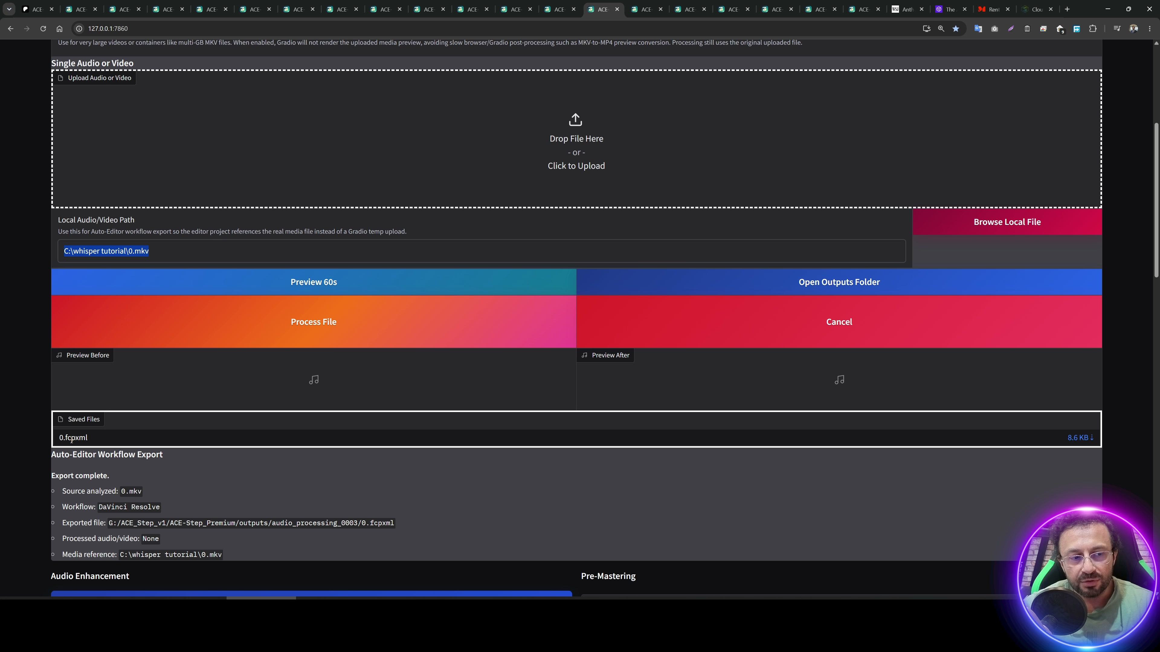
Figure 17. Source-video Auto-Editor demonstration: silent sections can be trimmed from long audio/video.
- For Remix, upload the source song, keep the same lyrics, use SFT when available, and start with the default remix strength before changing one variable at a time.
- For Repaint, set Repainting Start and End carefully, preview the selected range, then choose repaint mode and strength.
- For Extract, choose Track Name or Extract All Stems. Batch folder processing can extract from multiple files.
- For LEGO, choose or describe the new stem to add and use source audio as the foundation.
- For Auto-Editor, set threshold, margin, mincut, and minclip. Workflow export can produce an editor timeline instead of rendering media.

7. Audio Processing
Audio Processing is used on uploaded/local audio or video and can also be applied automatically to generated songs. It includes format output, Auto-Editor trimming, video re-encode controls, audio enhancement stages, pre-mastering stages, DiffPitcher, and batch folder processing.
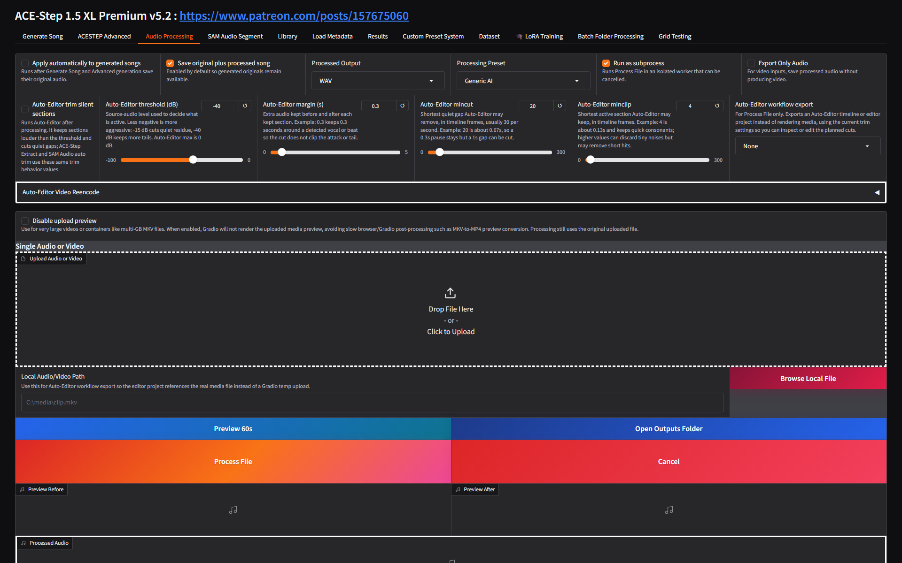
Figure 18. Audio Processing overview with output format, preset, subprocess, Auto-Editor, local path, and Process File controls.
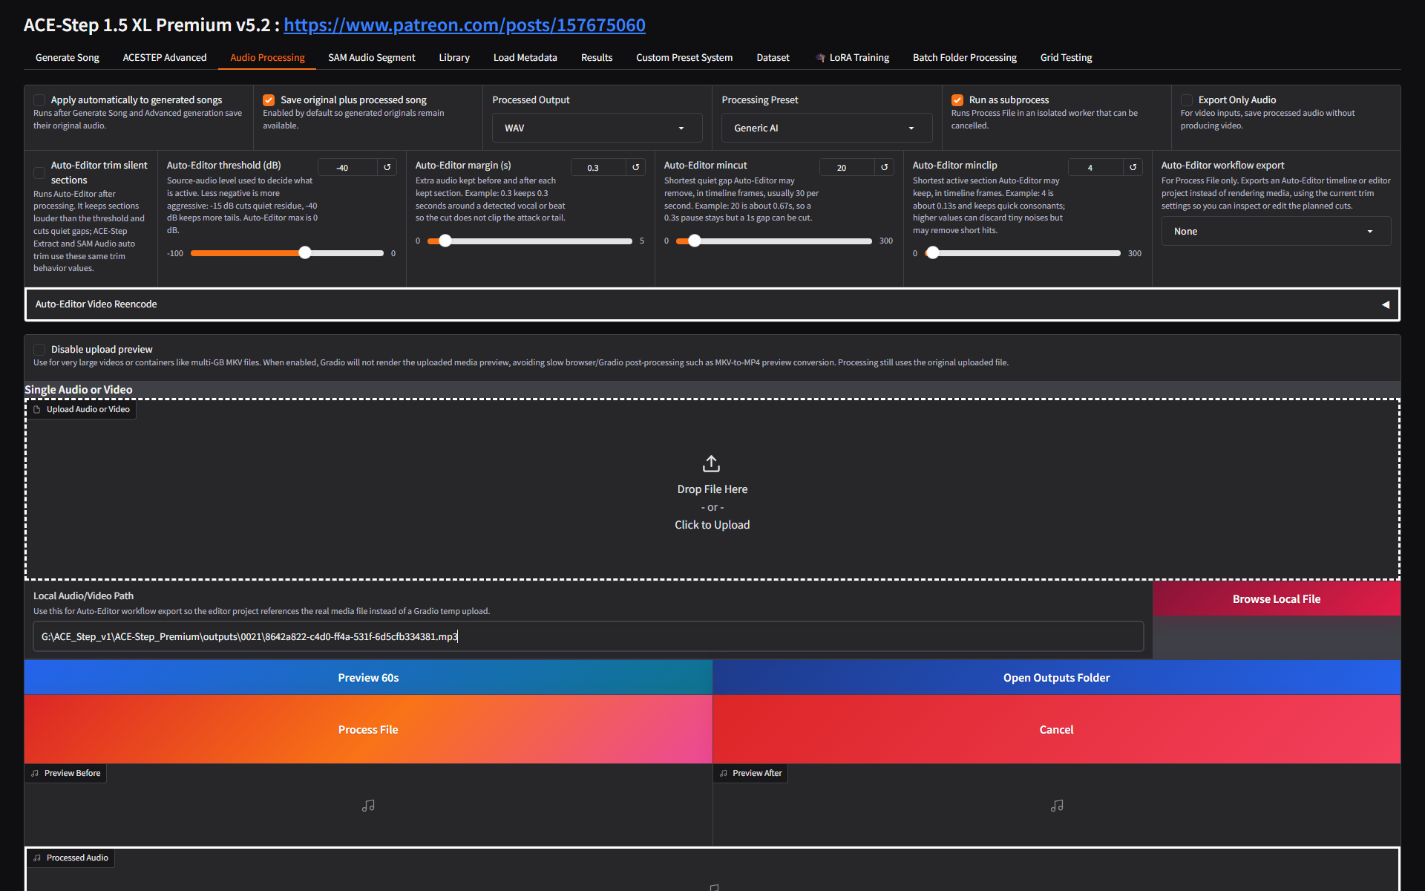
Figure 19. The generated demo song loaded into Audio Processing through the Local Audio/Video Path field.
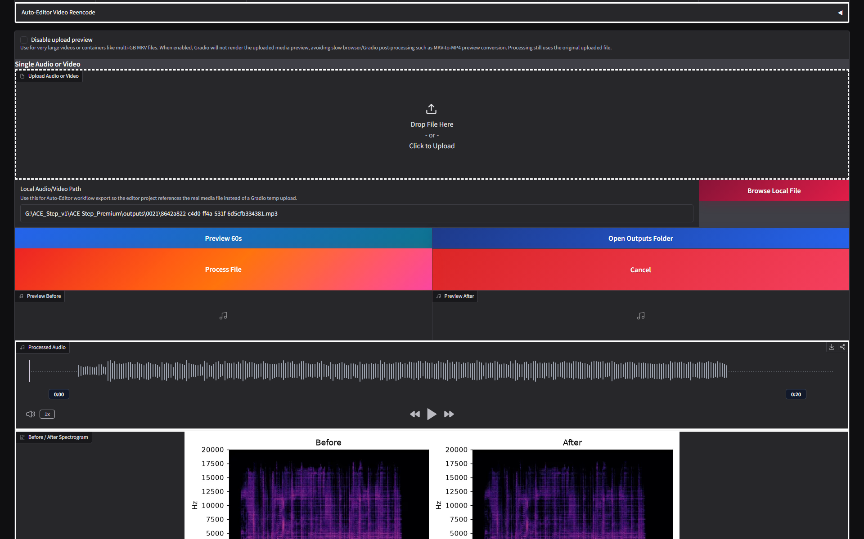
Figure 20. The generated demo song after processing, with processed waveform and before/after spectrogram.
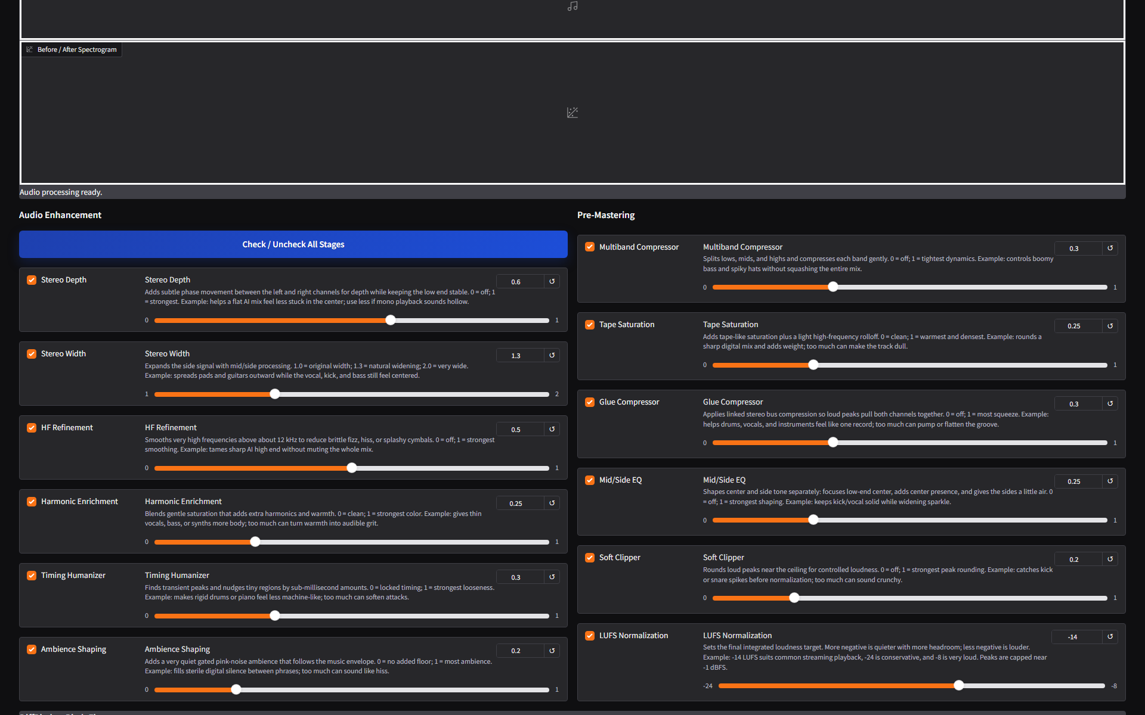
Figure 21. Audio Enhancement and Pre-Mastering controls.
Figure 22. DiffPitcher pitch fixer controls for isolated vocals with a guide vocal or MIDI score.
- Use Save original plus processed song when you want the original and processed outputs side by side.
- Use Export Only Audio for video inputs when you only need the audio result.
- Disable upload preview for very large MKV or multi-GB media so Gradio does not spend time rendering browser previews.
- Use DiffPitcher only when the vocal is isolated but singing the wrong notes and you have a valid guide vocal or MIDI melody.
- Use batch folder processing when the same audio-processing preset should run across many files.

8. SAM Audio Segment
SAM Audio Segment is a heavier but more flexible segmentation system. It can extract target audio from a prompt, save the residual/remaining audio, process video inputs, use explicit span anchors, and run batch prompt lists separated by semicolons.
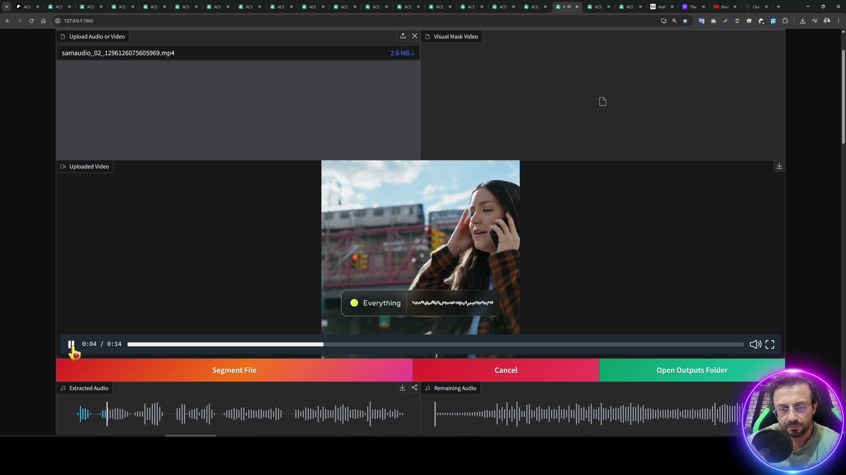
Figure 23. Source-video SAM Audio demonstration with extracted and remaining audio outputs.
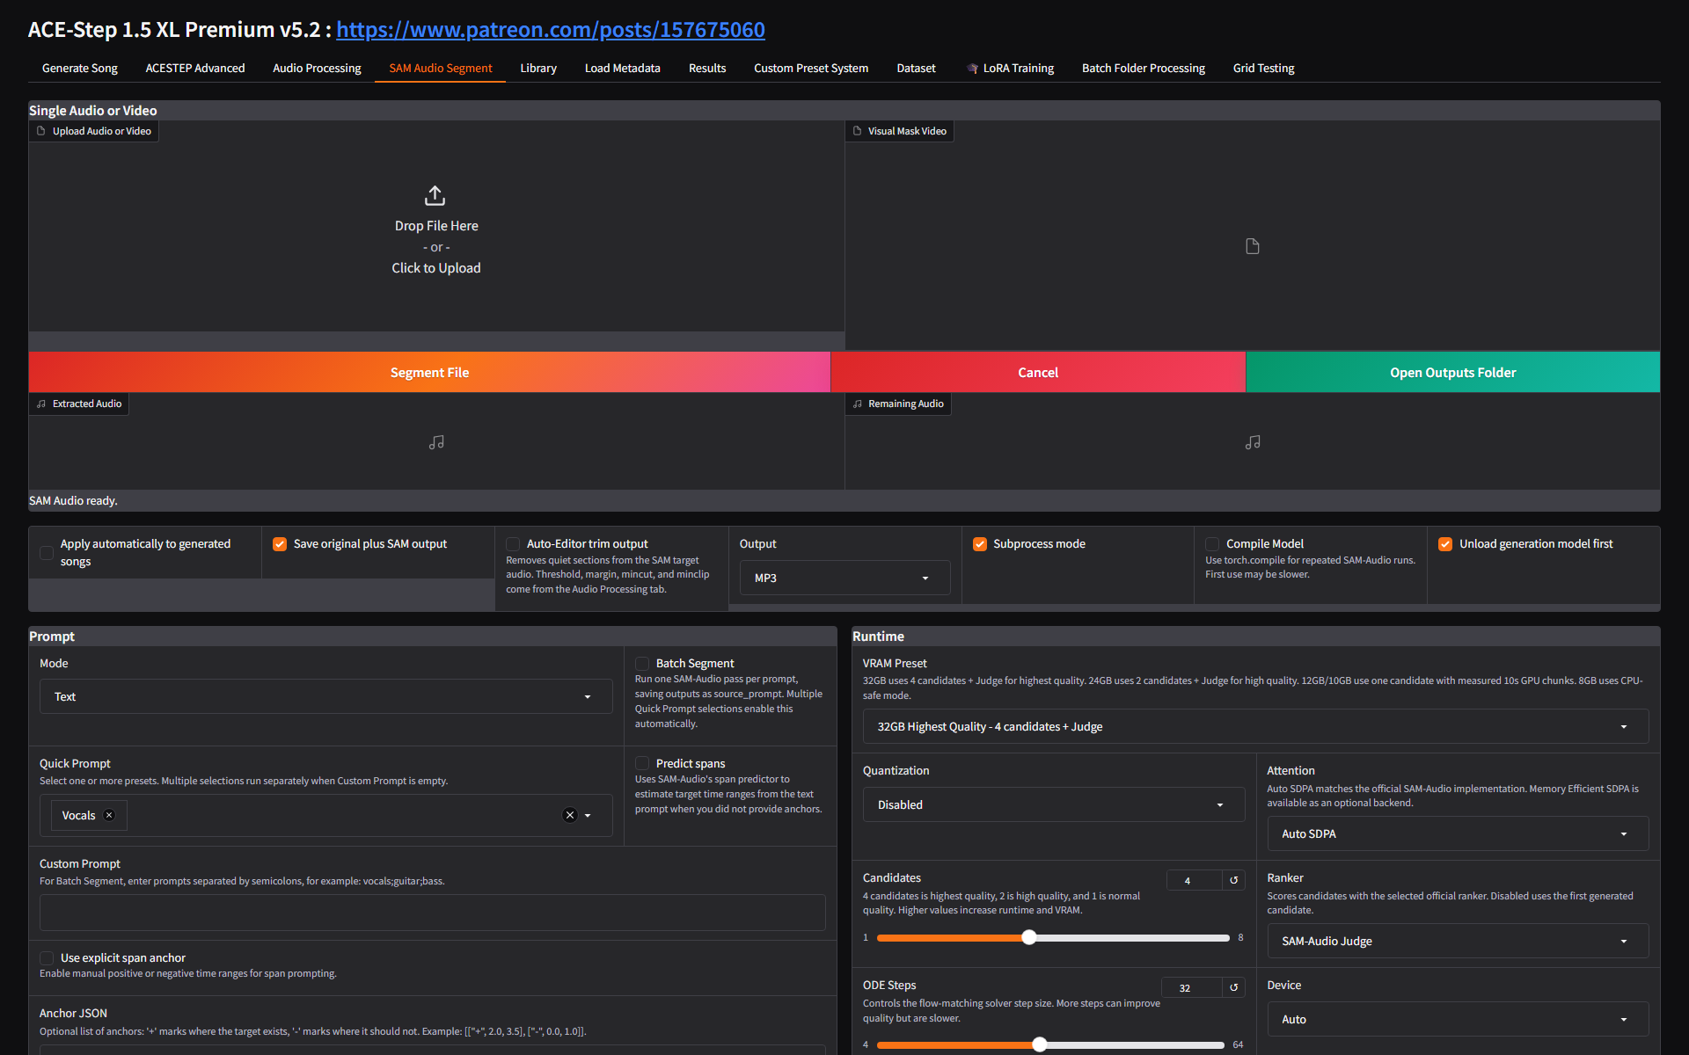
Figure 24. Live SAM Audio Segment overview with upload, visual mask, extracted/remaining outputs, and automatic processing options.
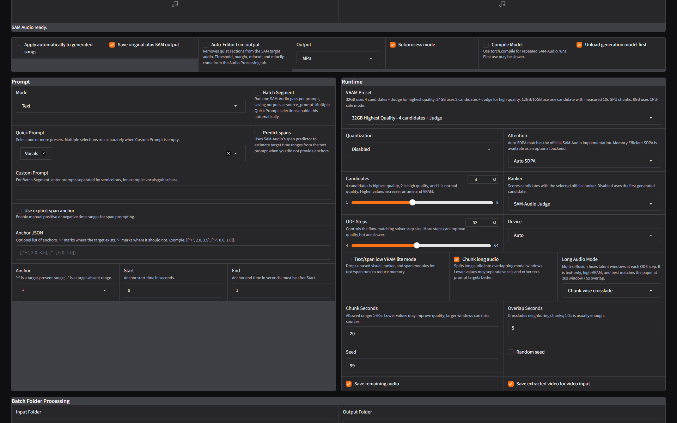
Figure 25. SAM prompt and runtime controls: quick prompt, custom prompt, batch segment, spans, VRAM preset, candidates, ranker, ODE steps, and device.
- Upload an audio or video file. Optionally upload a visual mask video for video-guided workflows.
- Choose Mode and Quick Prompt, or type a Custom Prompt such as vocals, guitar, bass, drums, applause, or another target.
- Enable Batch Segment when you want several prompts in one run; separate prompts with semicolons.
- Use Predict spans when you want SAM Audio to estimate target time ranges from text.
- Use explicit span anchor only when you can provide positive/negative time anchors as JSON.
- Choose a VRAM preset and candidate count that match the GPU. Higher candidate counts can improve quality but cost runtime and VRAM.

9. Library, Metadata, Presets, Dataset, And Training Pages
The remaining app tabs are operational pages: they help you find previous generations, restore metadata, manage presets, inspect datasets, and train adapters.
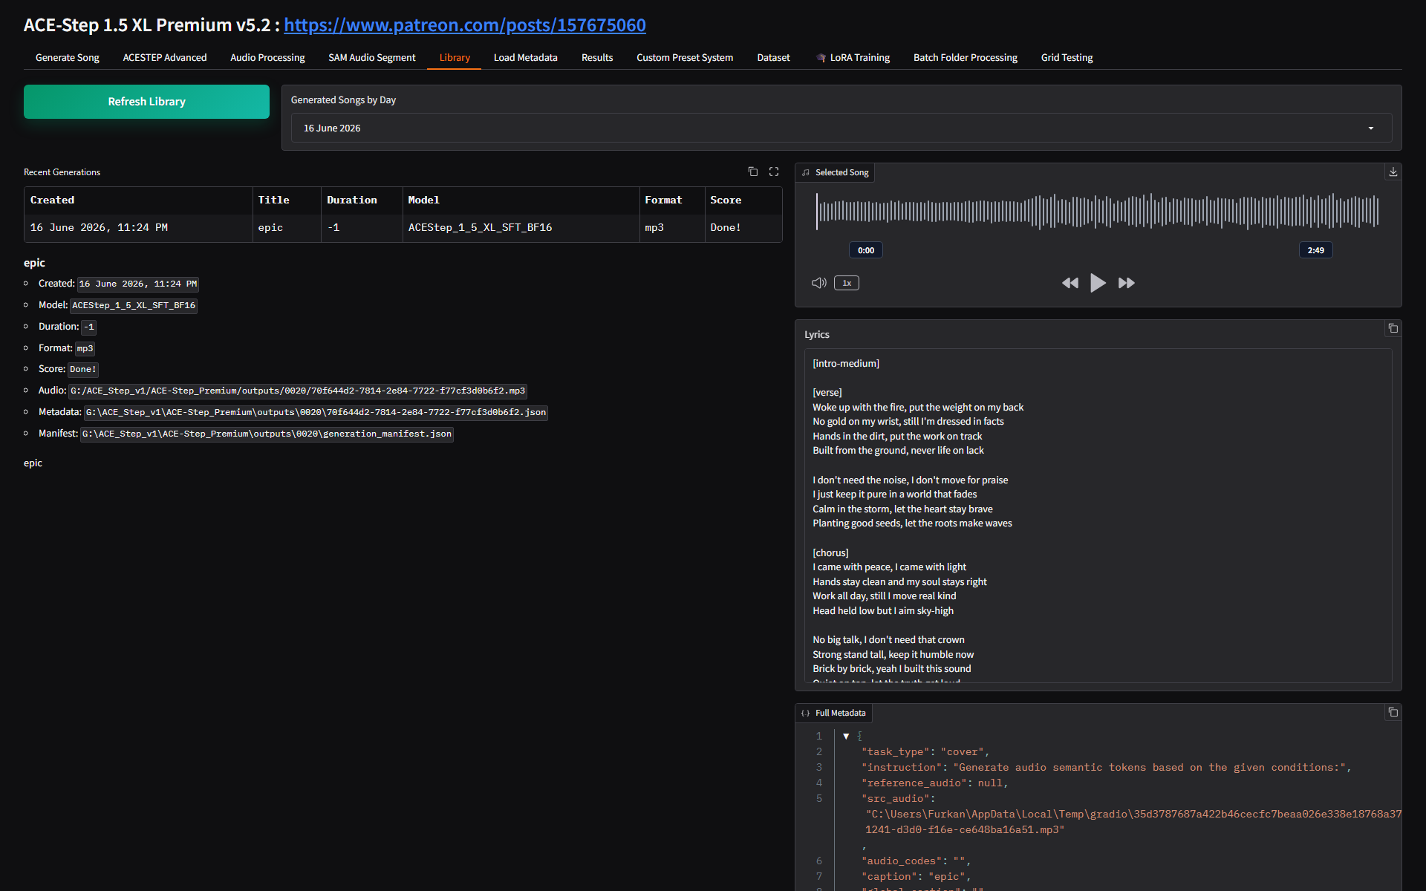
Figure 26. Library tab for refreshing generated songs, browsing by day, selecting a song, and reading metadata.
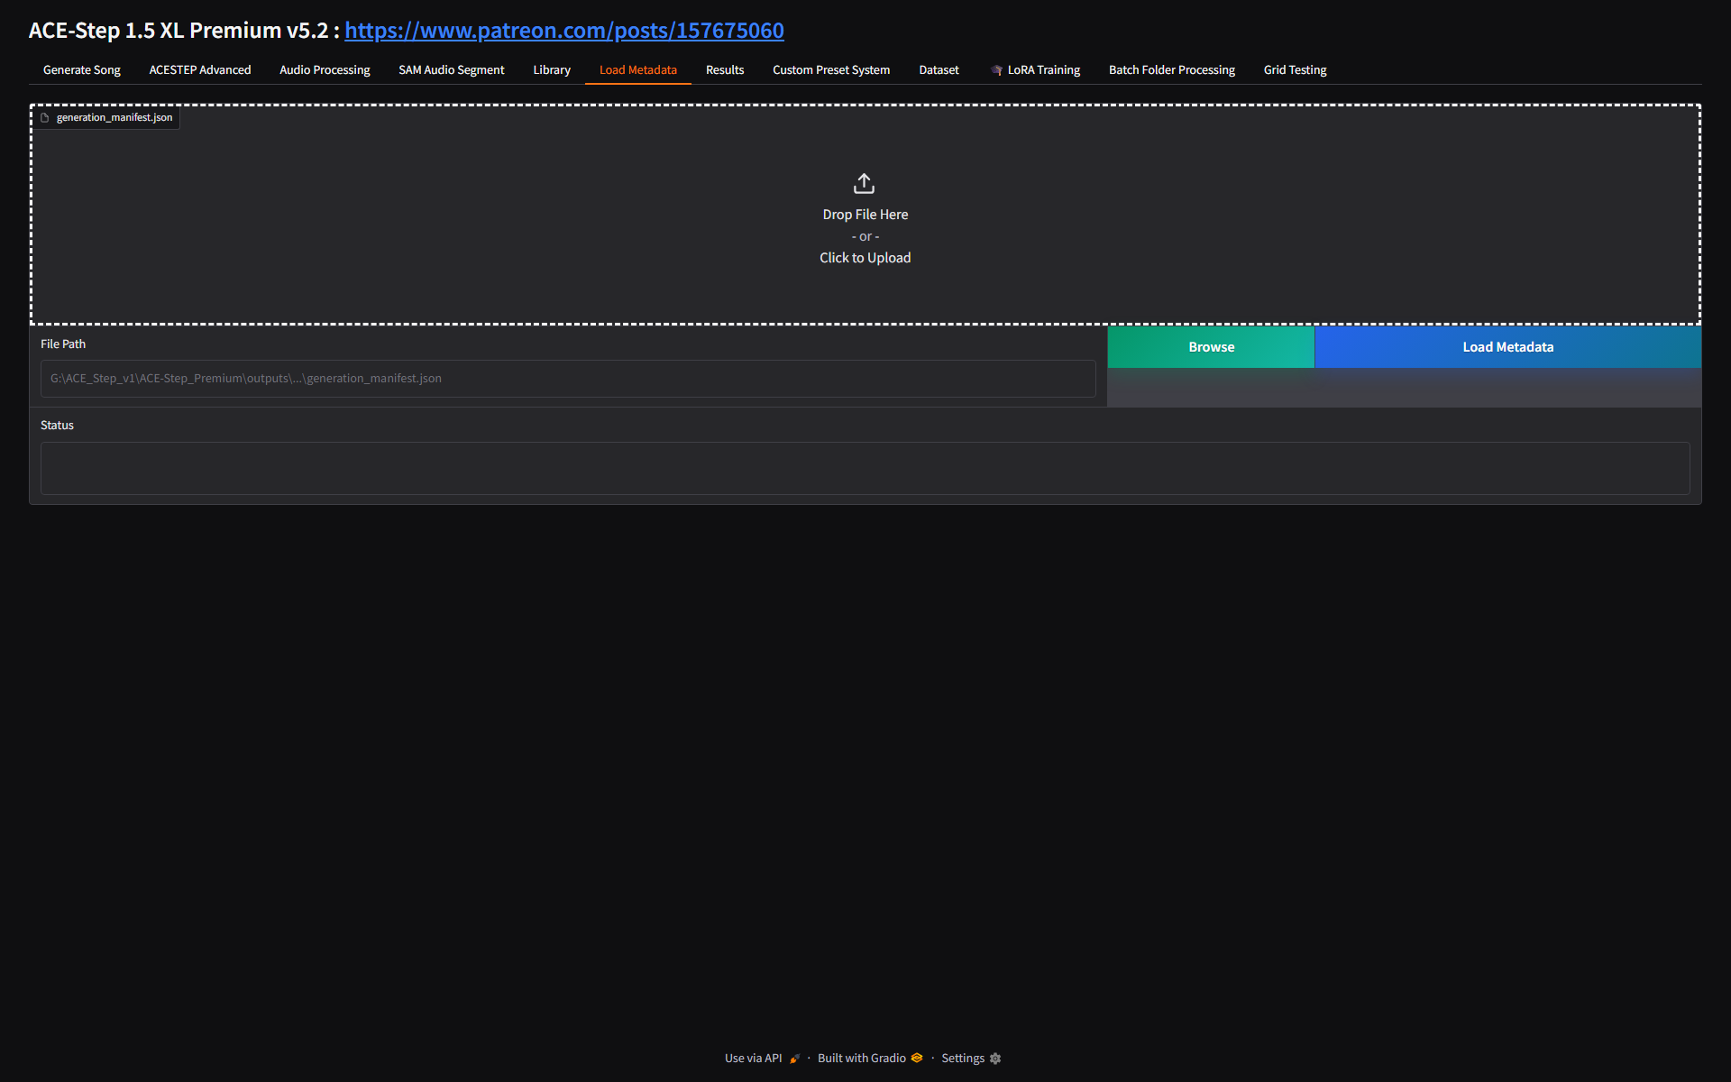
Figure 27. Load Metadata tab for loading generation_manifest.json or a manifest file path.
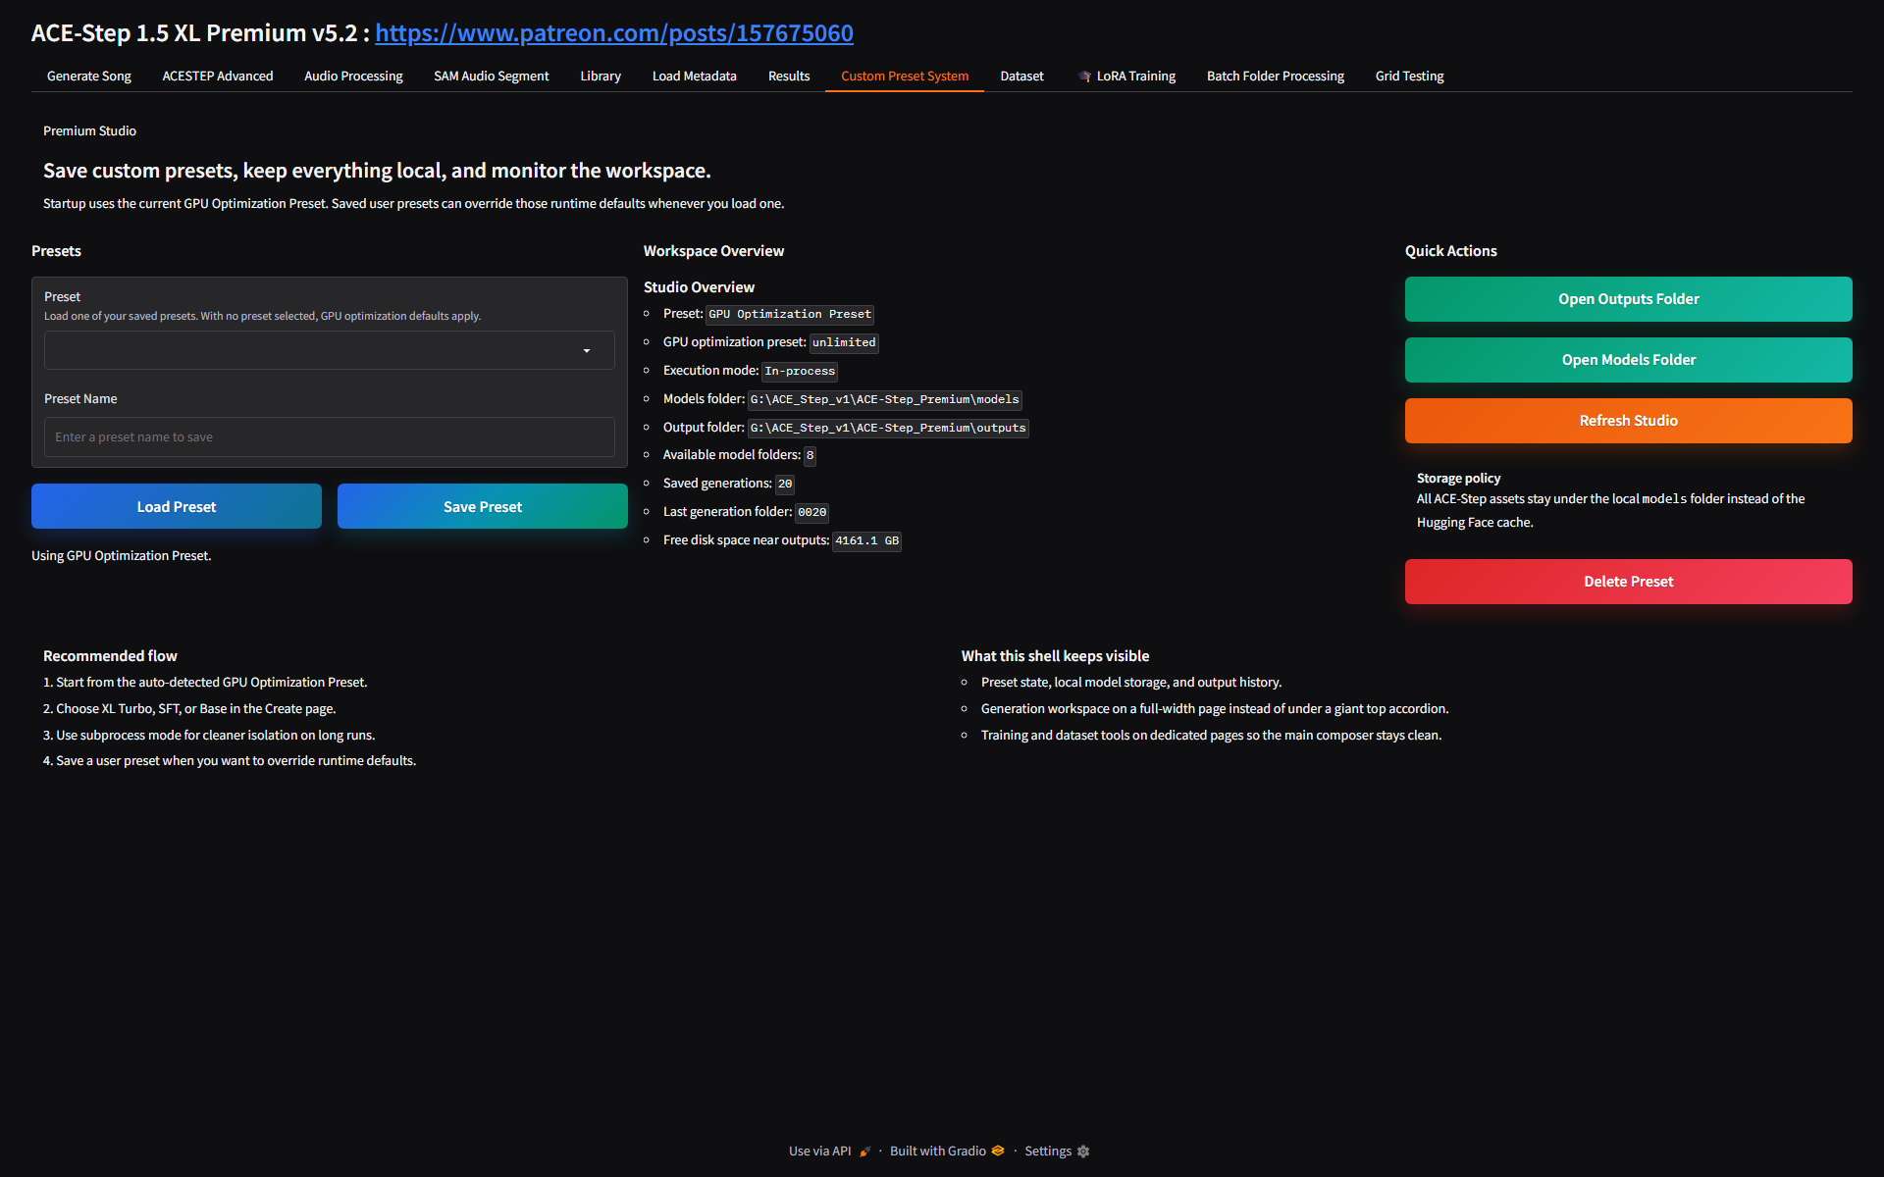
Figure 28. Custom Preset System for loading, saving, deleting, and refreshing studio settings.
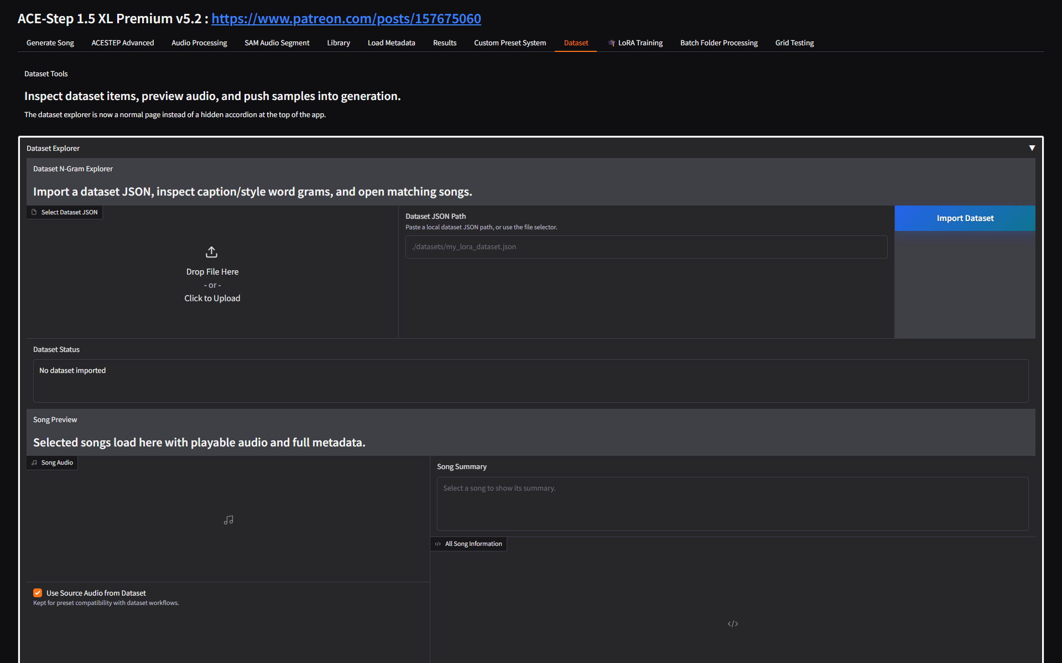
Figure 29. Dataset browser for importing dataset JSON, inspecting n-grams, and using dataset audio in generation.
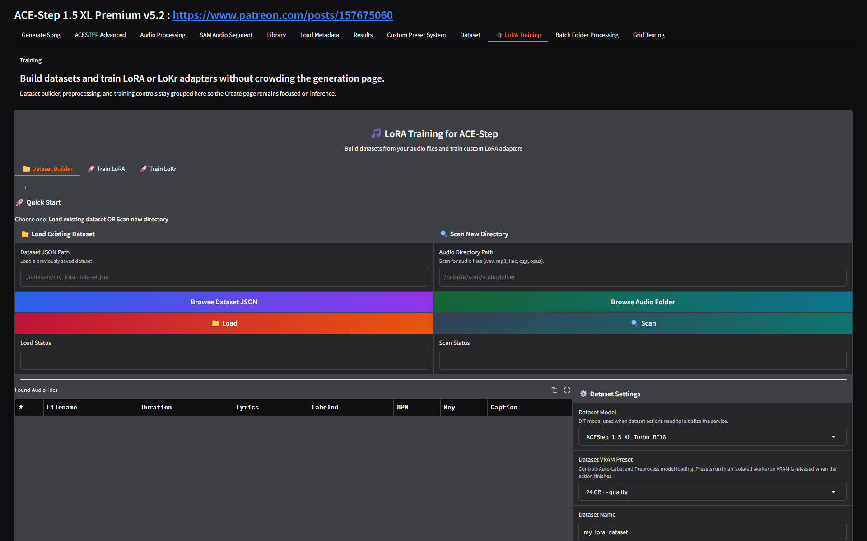
Figure 30. LoRA Training area: Dataset Builder tab for scan, auto-label, review, save, and preprocess steps.
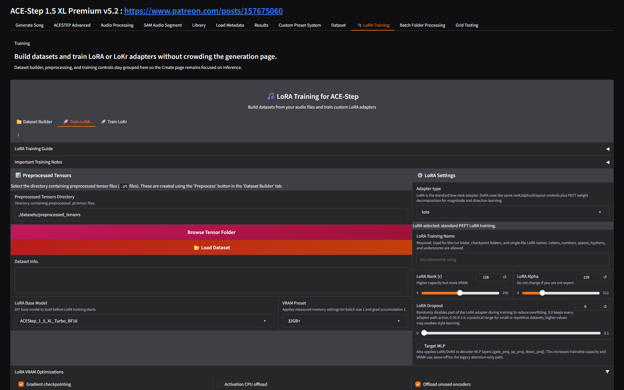
Figure 31. Train LoRA tab with tensor dataset, base model, VRAM preset, adapter settings, rank/alpha/dropout, and optimizer controls.
- Use Library when you want to find a past song by day and inspect its lyrics/metadata.
- Use Load Metadata when you have a generation_manifest.json and want to restore a generation into the UI.
- Use Custom Preset System to persist frequently used model, GPU, LoRA, audio, and generation defaults across sessions.
- Use Dataset Builder to scan audio, auto-label captions/lyrics/BPM/key/time signature, review samples, and save a dataset JSON.
- Use Preprocess before training; it creates tensor files for faster LoRA or LoKr training.
- Use Train LoRA/Train LoKr only after preparing a clean dataset. The video states LoRA training is intended for a separate deeper tutorial.

10. RunPod Deployment
The RunPod chapter focuses on using persistent network storage, choosing a GPU/region, dealing with slow or unreliable installs, using the Gradio live URL, monitoring with nvitop, and terminating resources safely.
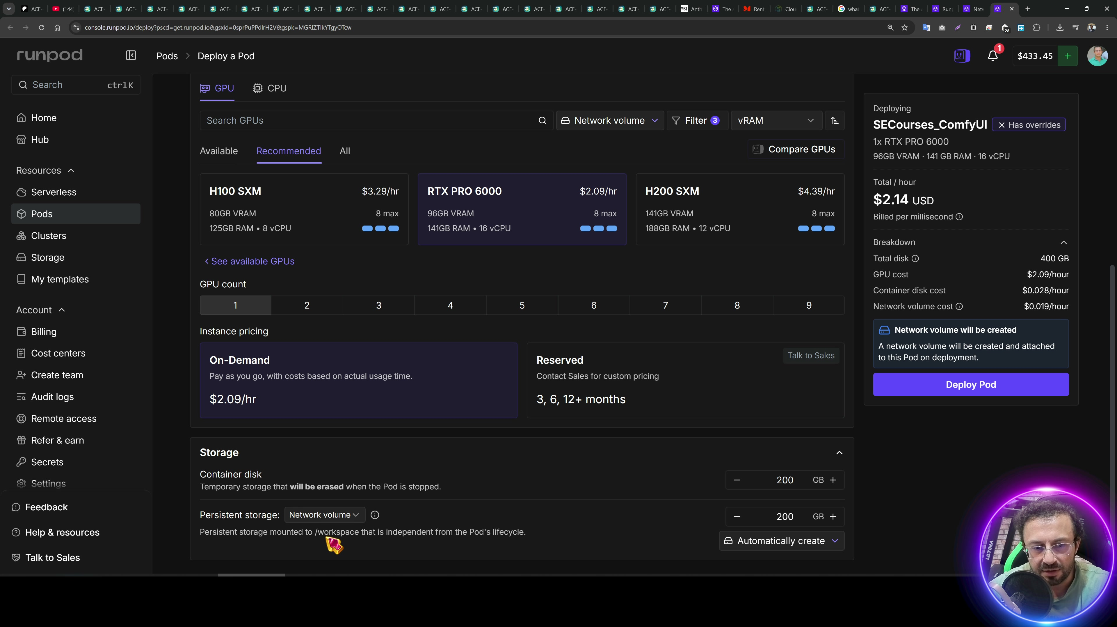
Figure 32. RunPod storage/region setup from the source video.
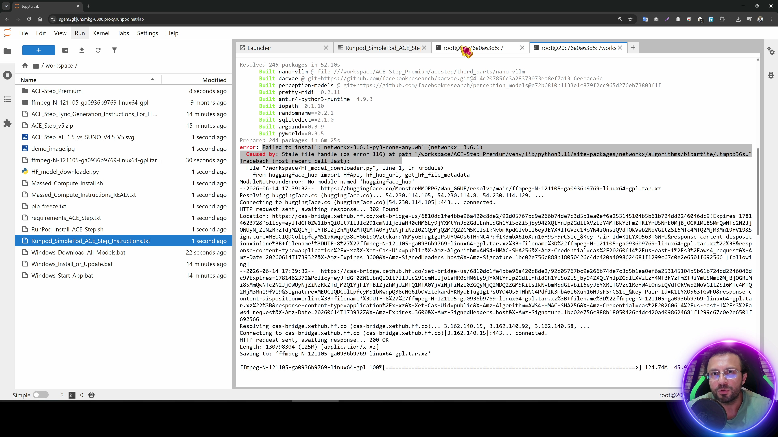
Figure 33. RunPod install stage. The tutorial notes RunPod can be erratic; rerun the installer if an OS/server error interrupts it.
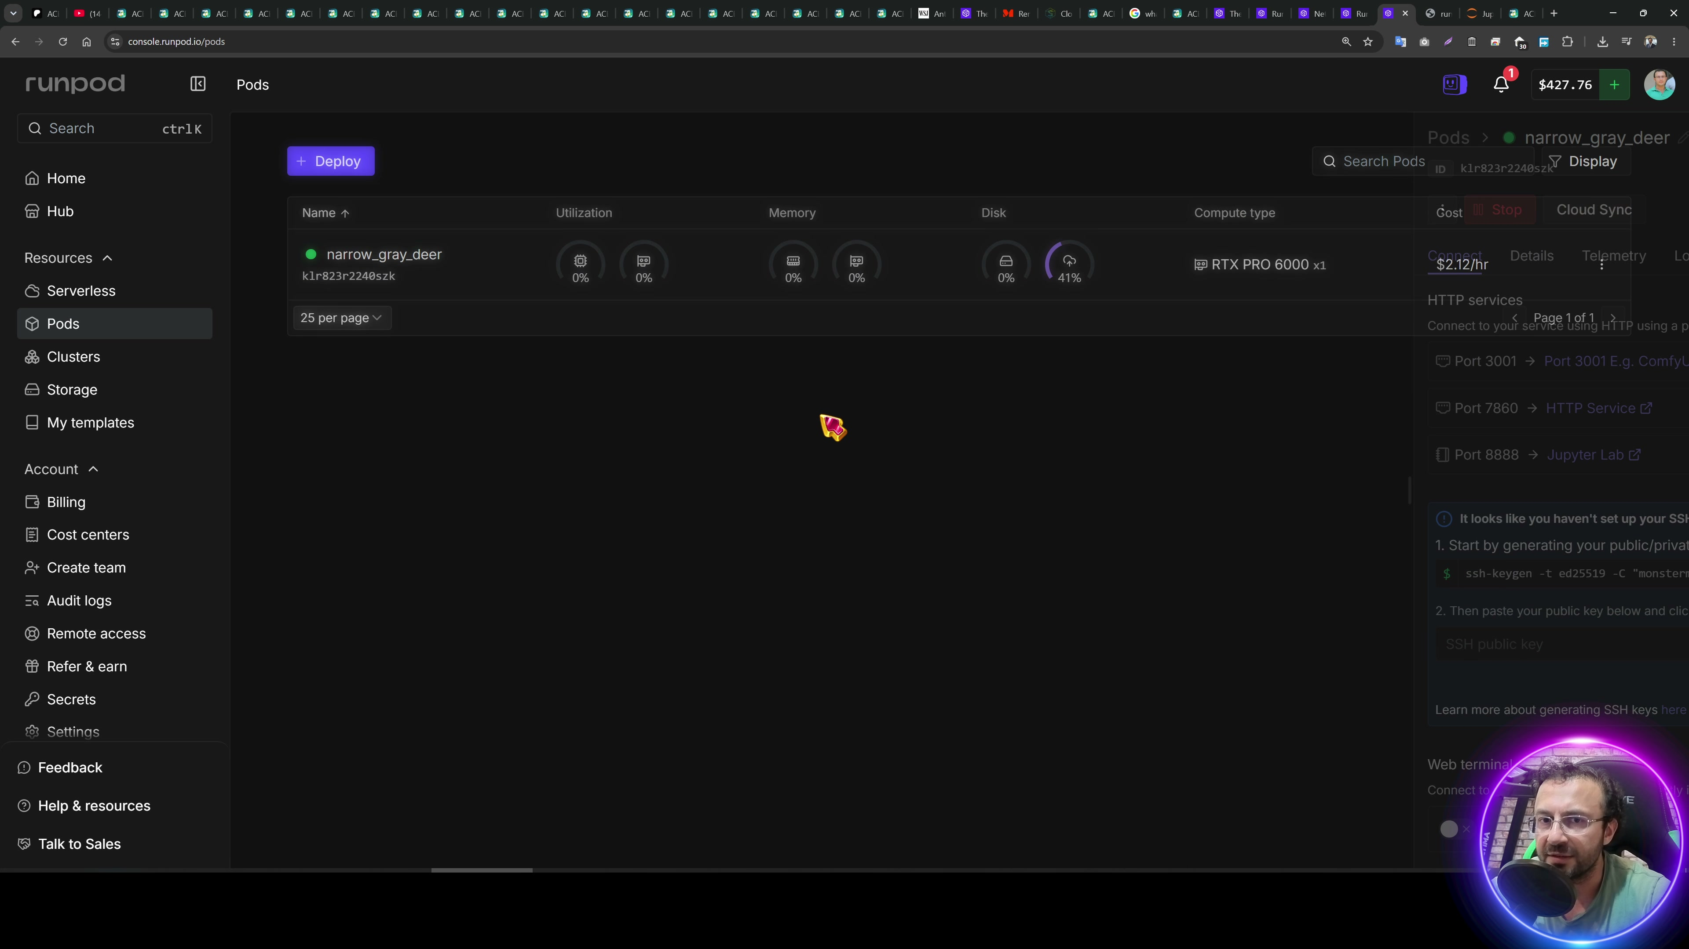
Figure 34. RunPod pod services. The video recommends Gradio live over the RunPod proxy when the proxy causes problems.
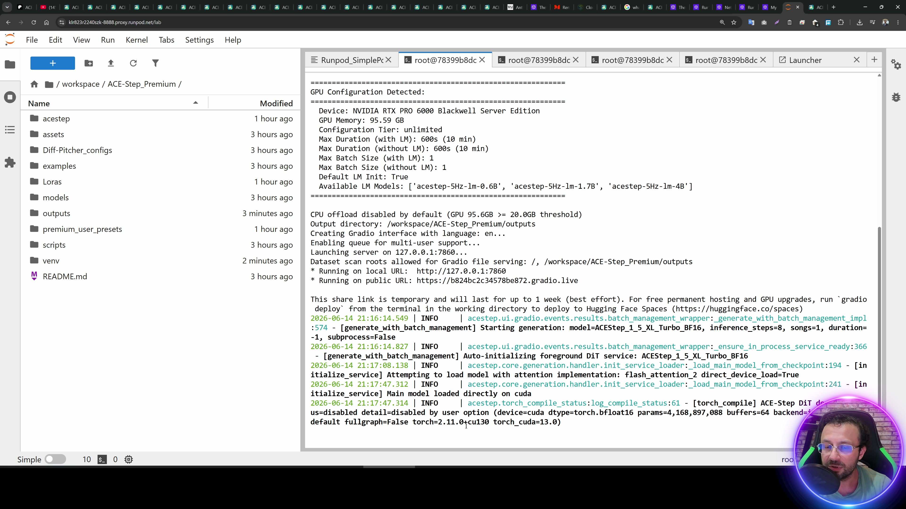
Figure 35. RunPod monitoring with nvitop and terminal status while models load.
- Create persistent network storage in the same region as the GPU you intend to rent.
- Deploy the pod/template with the storage mounted. Choose a GPU with enough VRAM for the selected model and quality target.
- Run the installer. If RunPod throws an OS/server error, run the installer again; it should resume from completed work.
- If installation stalls from excessive parallelism, delete the virtual environment, lower installer thread count as shown in the video, and rerun.
- Start the app and prefer the Gradio live link when the RunPod proxy is unreliable. If port 7860 does not open, try the port shown by the terminal, sometimes 7861.
- Use nvitop to monitor GPU memory and load. First model load can be slow on RunPod storage; later generations are faster.
- Download outputs from JupyterLab by right-clicking the outputs folder and downloading it as an archive.
- Stop or terminate the pod deliberately. Delete storage too if you no longer want monthly storage charges.

11. Massed Compute Deployment
The Massed Compute chapter is similar to the Linux/cloud workflow but the tutorial emphasizes faster disk performance and lower friction compared with RunPod. The tradeoff called out in the video is the lack of the same persistent network storage flow.
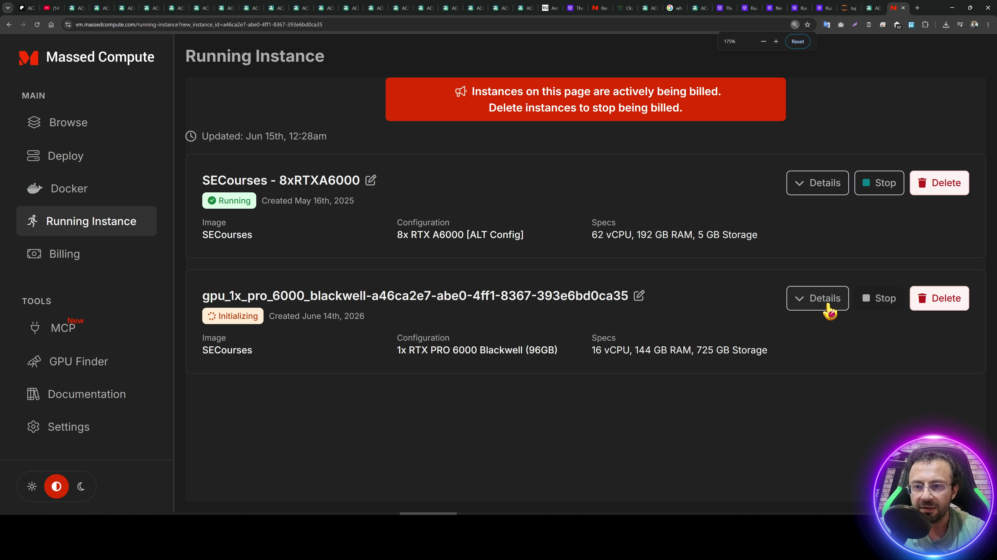
Figure 36. Massed Compute GPU/image selection from the source video.
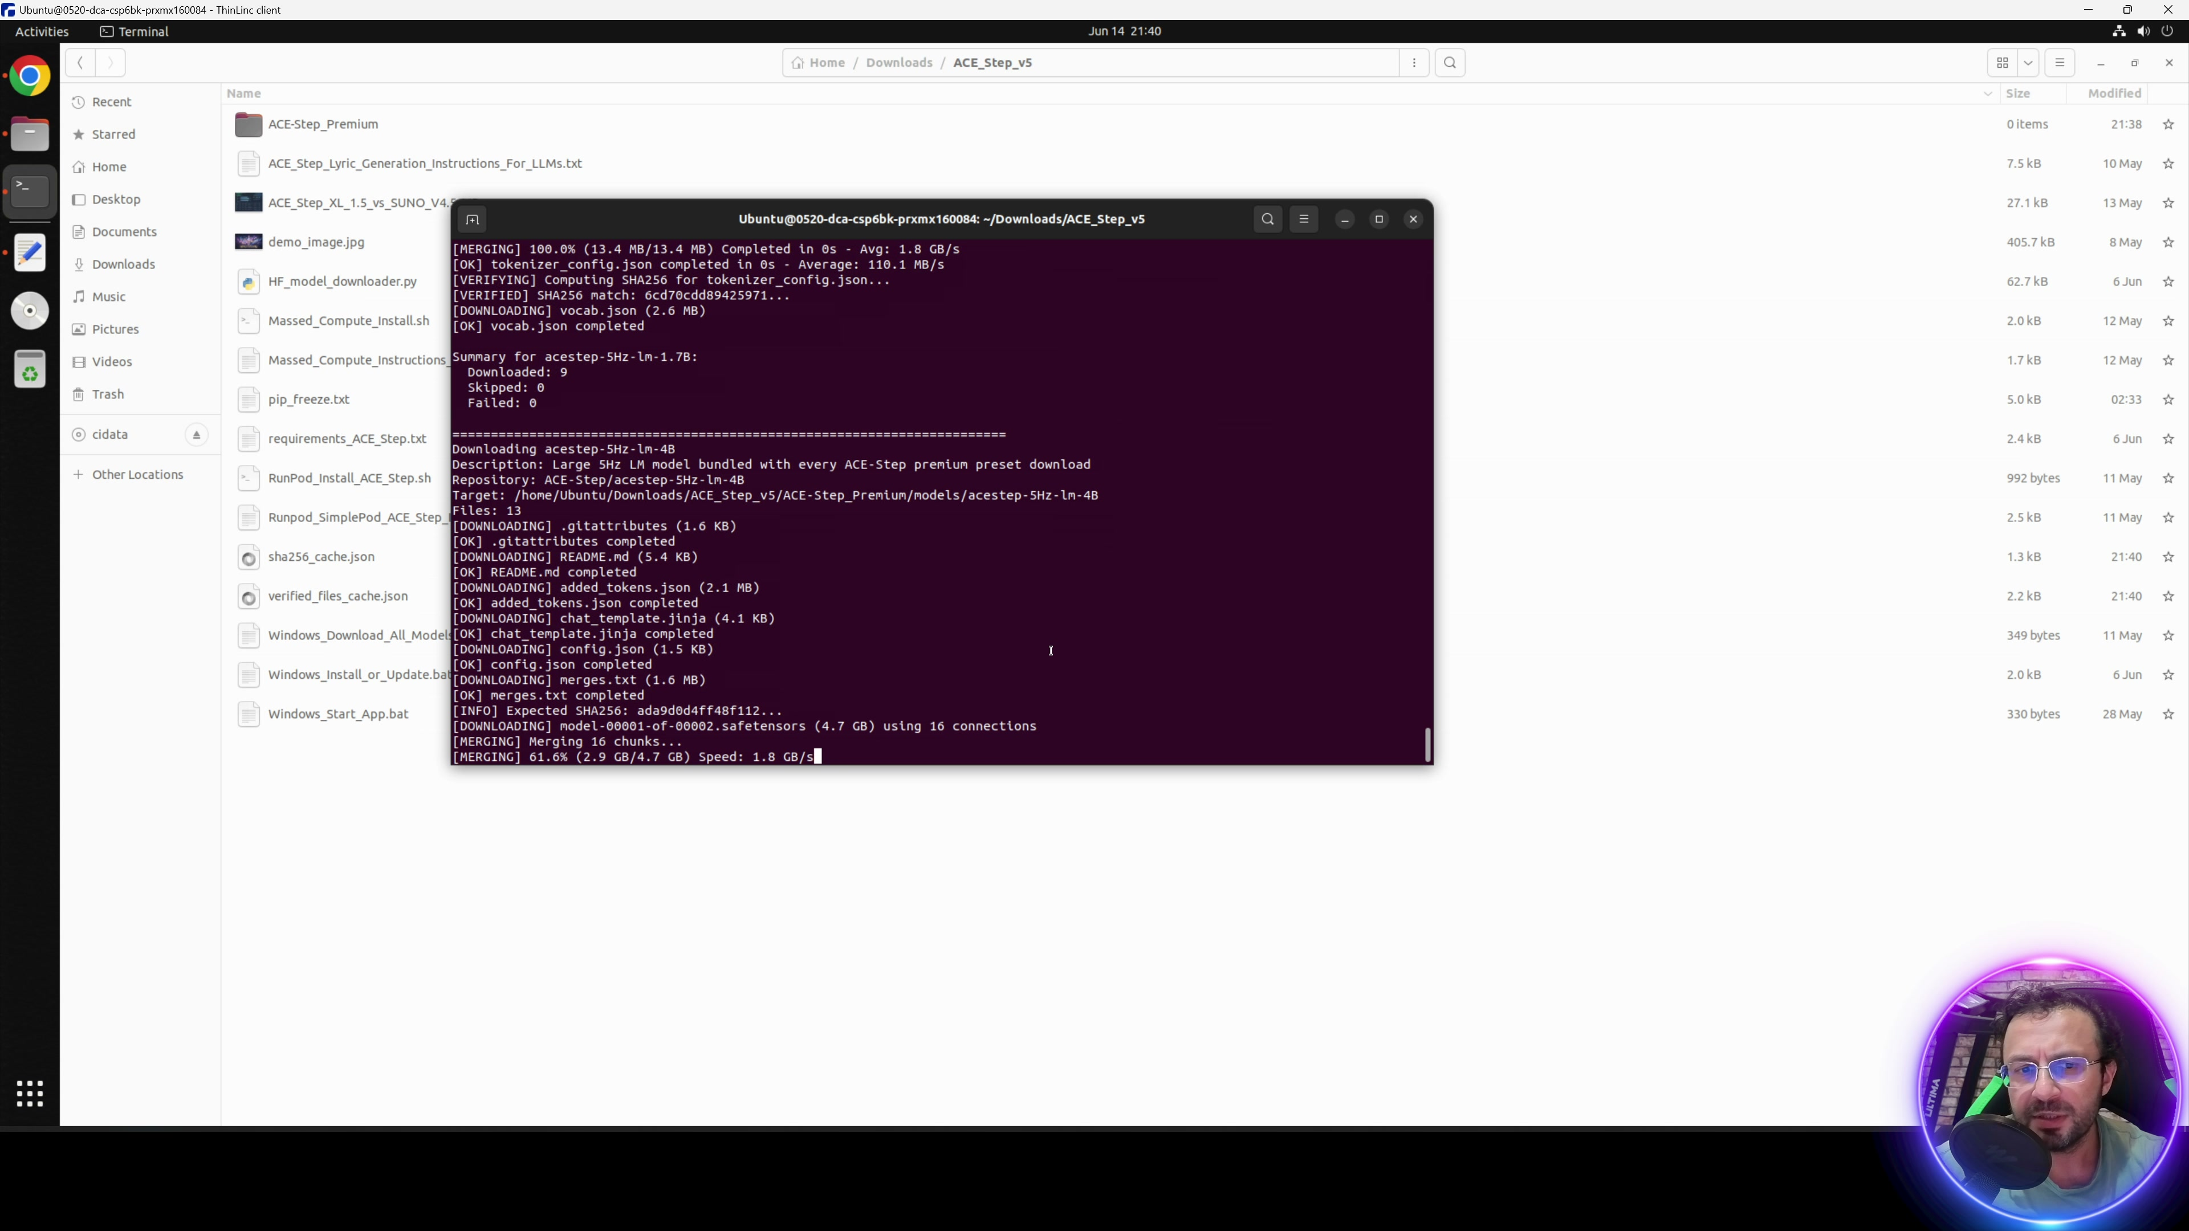
Figure 37. Massed Compute installation running from the extracted folder.
- Choose the creator category and the SECourses image when following the video workflow.
- Select a GPU appropriate for ACE-Step XL 1.5. The tutorial mentions RTX Pro 6000 and RTX 5090 class GPUs.
- Upload the ACE-Step ZIP to Downloads, extract it, open the Massed_Compute_Instructions_READ.txt file, and copy the install command.
- Open a terminal inside the extracted ACE-Step folder and run the command from that location.
- Start ACE-Step and use the Gradio live URL. If Gradio live shows a transient error, refresh the page.
- Back up large outputs or model/data folders to Hugging Face, Google Drive, OneDrive, or another storage service if you need to recreate the machine later.

12. SimplePod Deployment
The SimplePod chapter uses the RunPod/SimplePod instruction file and shows a persistent-storage flow that resembles RunPod. The tutorial demonstrates starting, generating, monitoring, stopping, and resuming from the same storage volume.
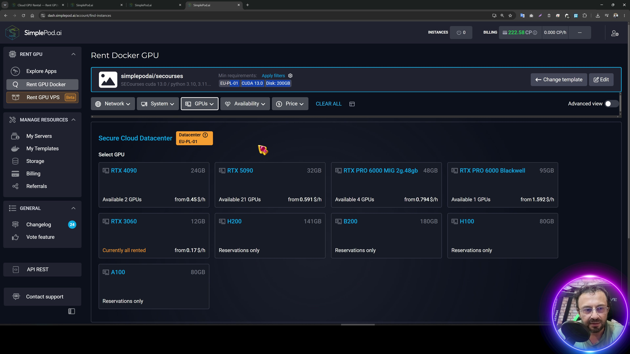
Figure 38. SimplePod setup and Jupyter workspace from the source video.
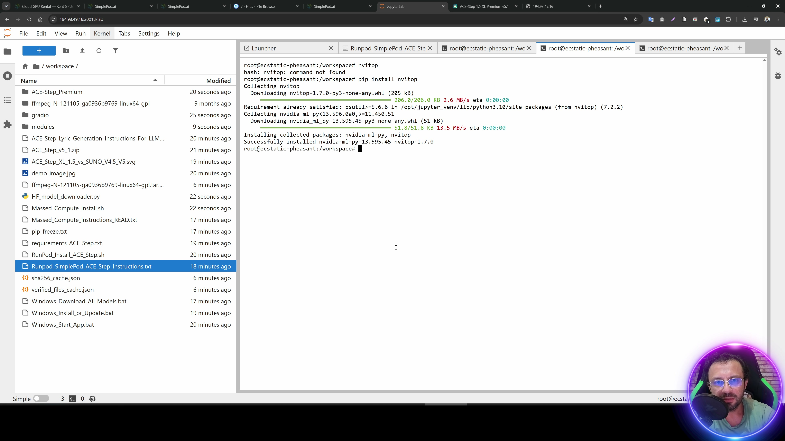
Figure 39. SimplePod generation/monitoring stage with nvitop installation.
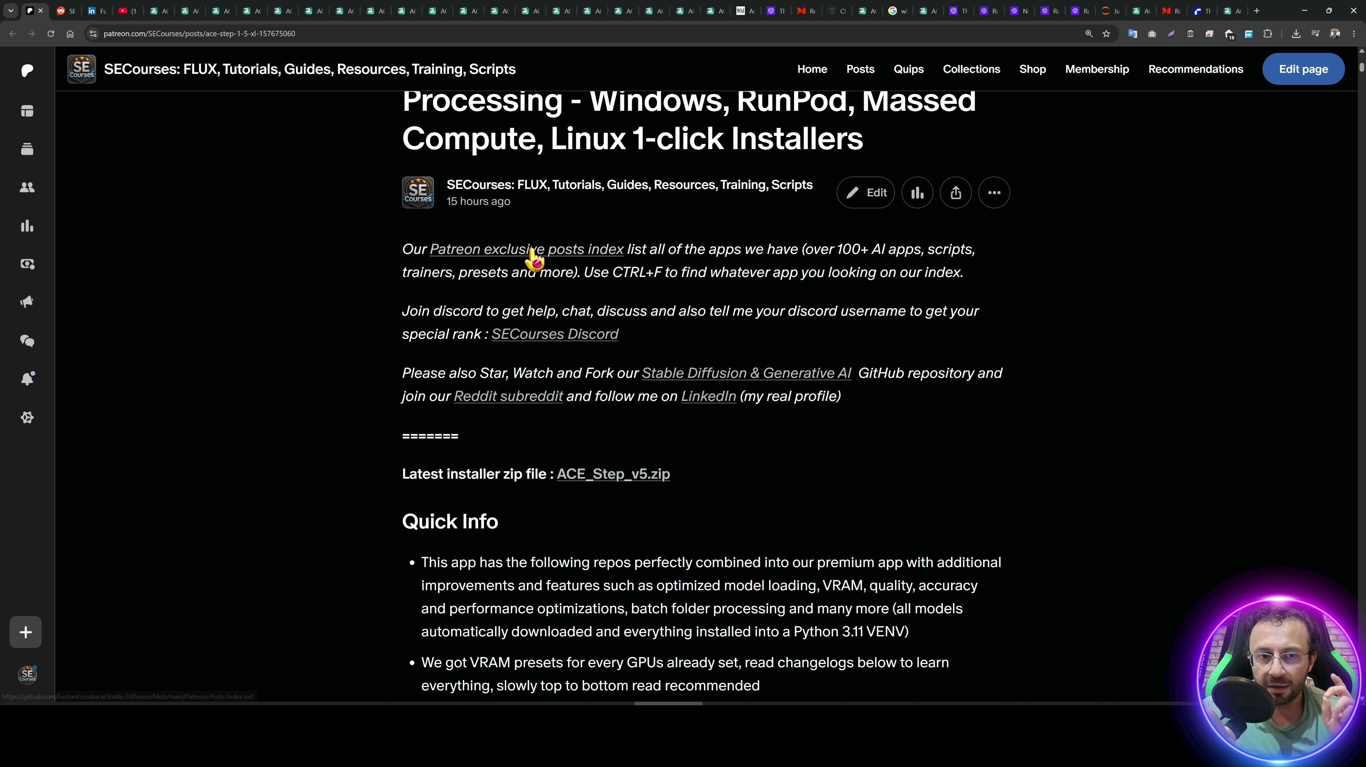
Figure 40. SimplePod resume workflow: use the template link, select the existing volume, choose GPU, and restart.
- Register, add credits, and create/use persistent storage as shown in the instruction file.
- Open the template link, attach the storage volume, choose a GPU, and run the machine.
- Use the JupyterLab or console link to run the installer/start commands from the workspace.
- If the Gradio live page throws a first-click error, refresh or click again after the page is fully loaded.
- Install nvitop when you want GPU/VRAM visibility: pip install nvitop, then run nvitop.
- To resume, reuse the template link, attach the same volume, select a GPU, start the machine, and run the app start command again.
- Stop/terminate compute and remove storage when finished to avoid unwanted billing.

13. Troubleshooting And Best Practices
Problem | Practical response
Gradio page errors after opening | Refresh the browser or click the action again after the page finishes loading, especially on Gradio live links.
RunPod installer error | Rerun the installer. If the venv is corrupt, delete only the virtual environment and run the installer again.
Very slow first generation | Wait for model load and monitor the terminal/nvitop. Subsequent runs are usually faster once models are loaded.
Remix quality unstable | Use SFT when available, keep the same lyrics, generate until you get a good base, then lock the seed.
Large video upload slow | Use Disable upload preview in Audio Processing or supply a local path when available.
Need repeatable settings | Save a preset and keep generation_manifest.json with the audio output.
VRAM pressure | Use GPU Optimization Preset, quantization, offload controls, smaller duration/count, lower SAM candidates, or a larger GPU.
Cloud cost risk | Stop/terminate compute and delete storage volumes when the tutorial work is finished.

