# HashiRWA: Japan Agri-RWA Gateway with AI

By Sapient Predictive Analytics Pte Ltd

## Overview

HashiRWA is a working prototype demonstrating how Japanese agricultural producers can onboard their products as real-world assets (RWA). The demo simulates the flow from producer onboarding → admin review → public marketplace → cryptographic proof of listing.

## Key Features

* 🌱 Onboarding — Producers register with product, certification, harvest date, lot size.
* ✅ Admin Review — Submissions can be approved or rejected for compliance.
* 🛒 Marketplace — Approved products are listed publicly with details.
* 🔗 Proof of Listing — Each listing generates a SHA-256 hash + downloadable JSON metadata (simulated “on-chain”).

## Screenshots (Visual Proof)

• Landing Page (HashiRWA title + how it works card)



• Onboarding Form (producer input fields)

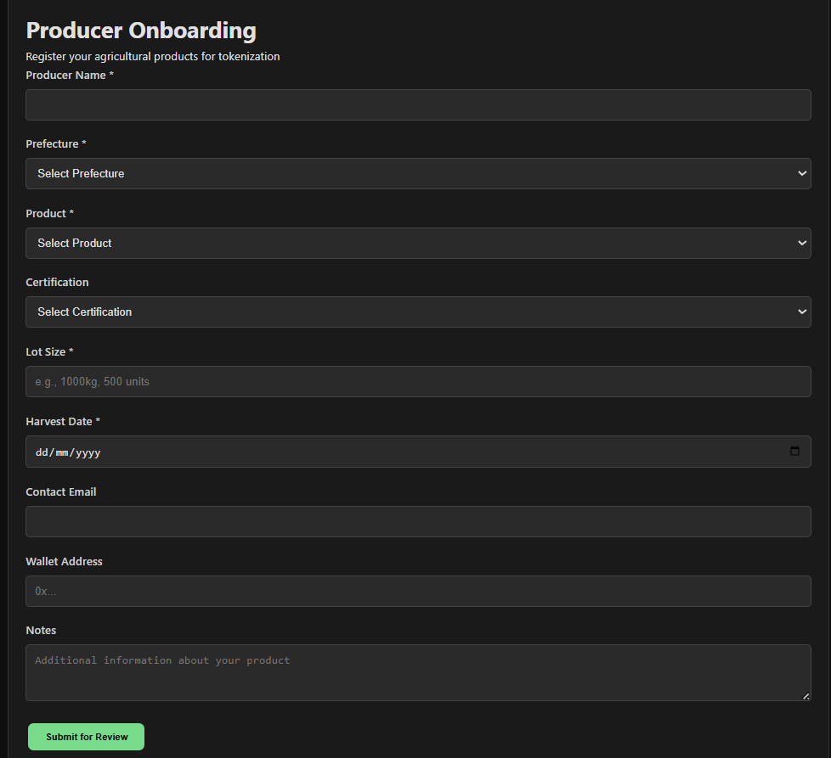

• Marketplace View (approved assets with proof link)

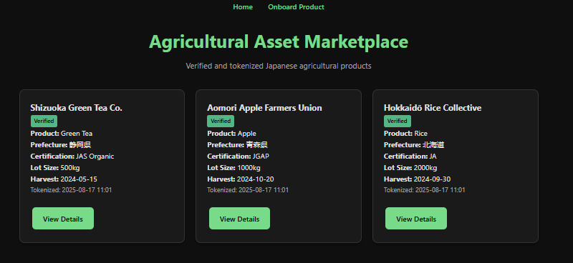

## Tech Stack

Python + Flask (backend)

JSON for data persistence (local simulation)

Minimal CSS dark theme UI

## Access

GitHub Repo (code + documentation): https://github.com/fuguswarm/hashirwa-demo

## Disclaimer

This is a proof-of-concept demo. “On-chain” functionality is simulated via cryptographic hashing. A full blockchain deployment will be implemented in later phases.

© 2025 HashiRWA