EE577 Lab3 Report

Spring 2017

Huayu Fu

4745159848

3/10/2017

1)The spice file screenshot

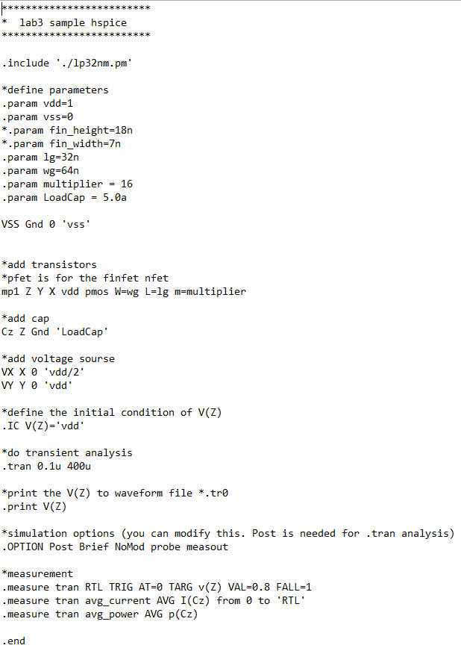

2)Script screenshot

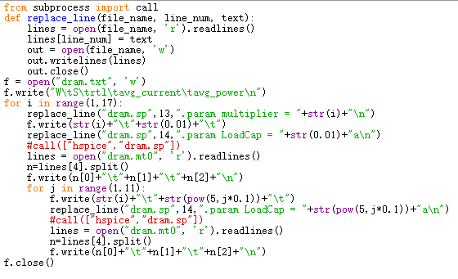  
3) dram.txt screenshot

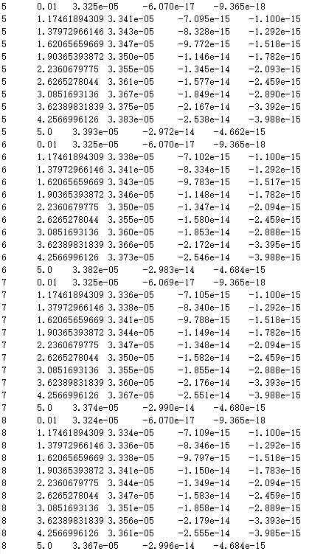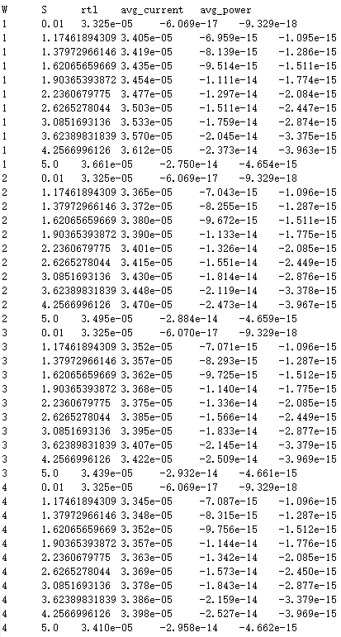

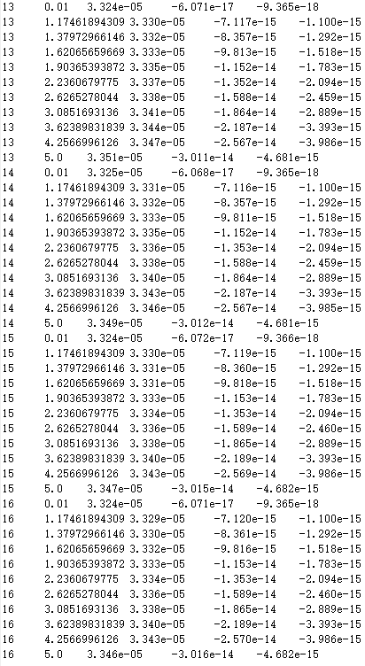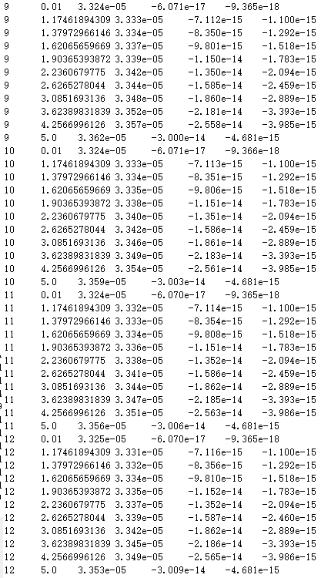  
4) analysis.m screenshot

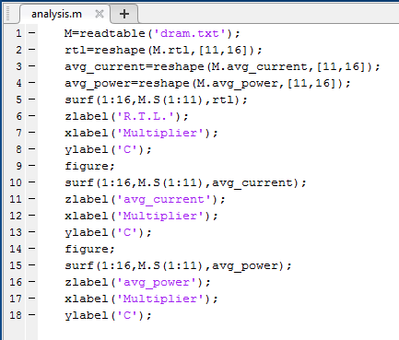

5) 3D graphs of R.T.L., Iavg and Pavg

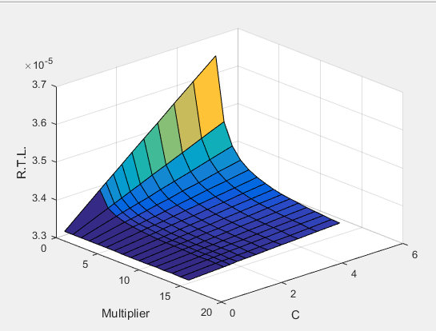

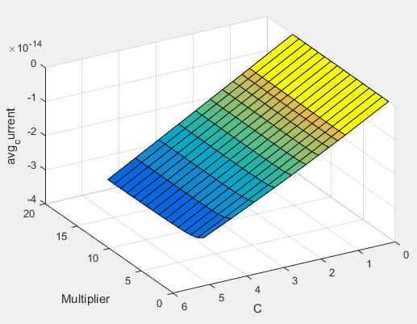

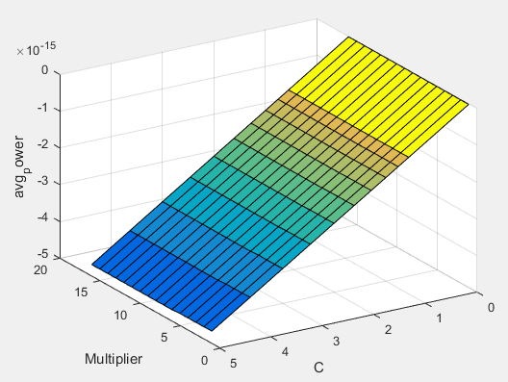  
6) Calculated statistic values

i. R.T.L.

Min = 3.3240e-05

Max = 3.6610e-05

STD = 4.8914e-07

Average = -1.4648e-14

ii. avg_current

Min = -3.0160e-14

Max = -6.0680e-17

STD = 8.2980e-15

Average = -1.4648e-14

Average = -1.4648e-14

iii. avg_power

Min = -4.6840e-15

Max = -9.3290e-18

STD = 1.3060e-15

Average =-2.2887e-15