**BASIC TASKS**

1.

a. The hierarchy from the most general to the most specific is:

Mammals (a broad class of warm - blooded vertebrates that have hair or fur and produce milk for their young)

Primates (a group of mammals characterized by advanced cognitive development, grasping hands and feet, and forward - facing eyes)

Monkeys (a subgroup of primates, usually having a long tail and being more arboreal in nature)

Humans (a species of primates with advanced cognitive abilities, bipedal locomotion, and complex language and culture)

b. The hierarchy from the most general to the most specific is:

Software System (a collection of programs and related data that provide the instructions for telling a computer what to do)

Operating System (a type of software system that manages computer hardware and software resources and provides common services for computer programs)

Linux (an open - source operating system)

Windows (a commercial operating system)

Database management system (a software system designed to manage databases)

Oracle (a commercial database management system)

Mysql (an open - source database management system)

Chrome (a web browser, which is a type of software application that uses the services of an operating system to access and display web content)

Definitions in the context of the Entity - Relationship (ER) Model:

2.

a. Entity: An entity is a real - world object or concept about which data is stored. For example, in a university database, a "student" is an entity. Entities have attributes that describe their characteristics.

b. Entity type: An entity type is a category of entities that have the same set of attributes. For example, the entity type "student" has attributes like student ID, name, date of birth, etc. All entities of the "student" type will have these (or a similar set of) attributes.

c. Entity instance: An entity instance is a specific occurrence of an entity type. For example, "John Doe" with student ID 12345 is an instance of the "student" entity type.

d. Optional: In an ER model, an optional relationship or attribute means that it is not required. For example, a "student" entity may have an optional "middle name" attribute. The presence of a middle name is not necessary for every student entity instance.

e. Mandatory: A mandatory relationship or attribute in an ER model is one that must be present. For example, a "student" entity must have a "student ID" attribute. Every instance of the student entity type must have a value for this attribute.

f. Cardinality: Cardinality in an ER model describes the number of entities in one entity set that can be associated with the number of entities in another entity set through a relationship. For example, in a "course - enrollment" relationship, the cardinality might be that a "course" can have many "students" (1:N), meaning one course can have multiple student enrollments.

3.

Definition of Data Model: A data model is an abstract model that organizes data elements and standardizes how they relate to one another and to the properties of real - world entities.

Three reasons why data modelling is important:

①Clarity and Communication: It provides a clear and consistent way to communicate the structure and requirements of a data - related system among different stakeholders such as developers, database administrators, and business analysts. For example, when designing a new e - commerce application, a data model helps everyone understand how customer orders, products, and payments are related.

②Data Integrity: Data modelling helps in ensuring data integrity by defining the rules and constraints for data. For instance, in a banking system data model, it can define that a bank account must have a unique account number and a non - negative balance. This ensures that the data stored in the database is accurate and consistent.

③System Design and Development: It serves as a blueprint for the design and development of database systems and software applications. For example, when building a content management system, the data model guides the developers in creating the appropriate database tables and relationships to store and manage content such as articles, images, and user comments.

4.

a. The ER diagram represents a firm with different entities and their relationships. The firm has branches, each branch contains one or more departments. Departments are made up of employees. Employees can be part of only one department. A department must have at least one employee. An employee may manage at most one department and a department must be managed by exactly one employee. Additionally, employees can participate in multiple projects and a project must have at least one employee.

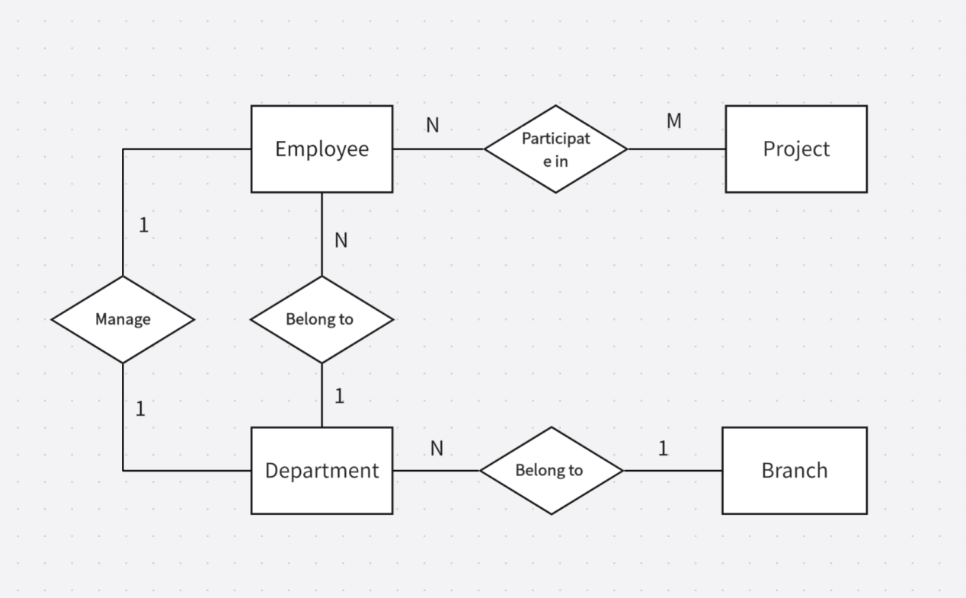

1. 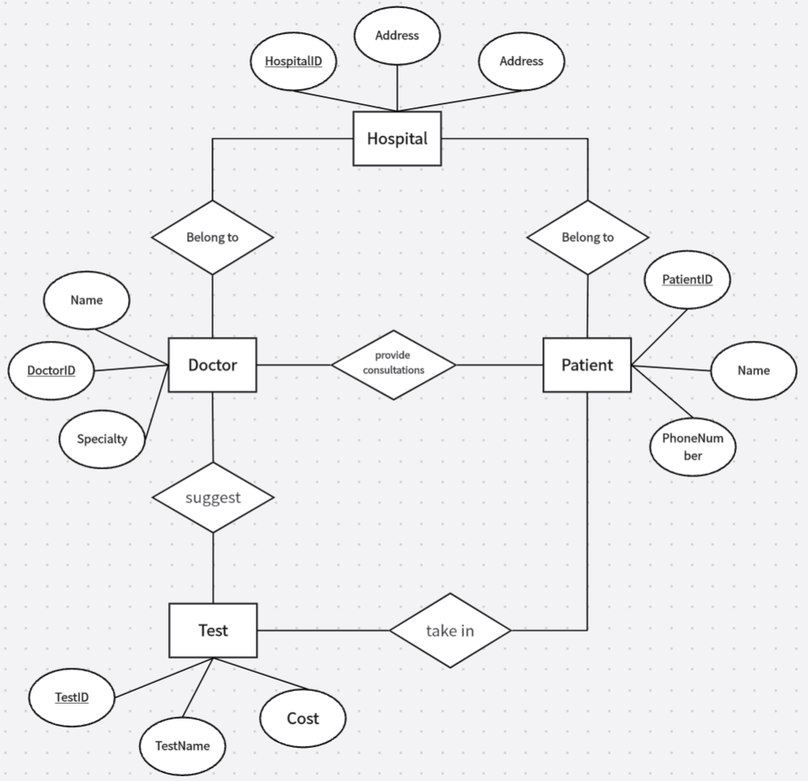

**MEDIUM** **TASKS**

6.

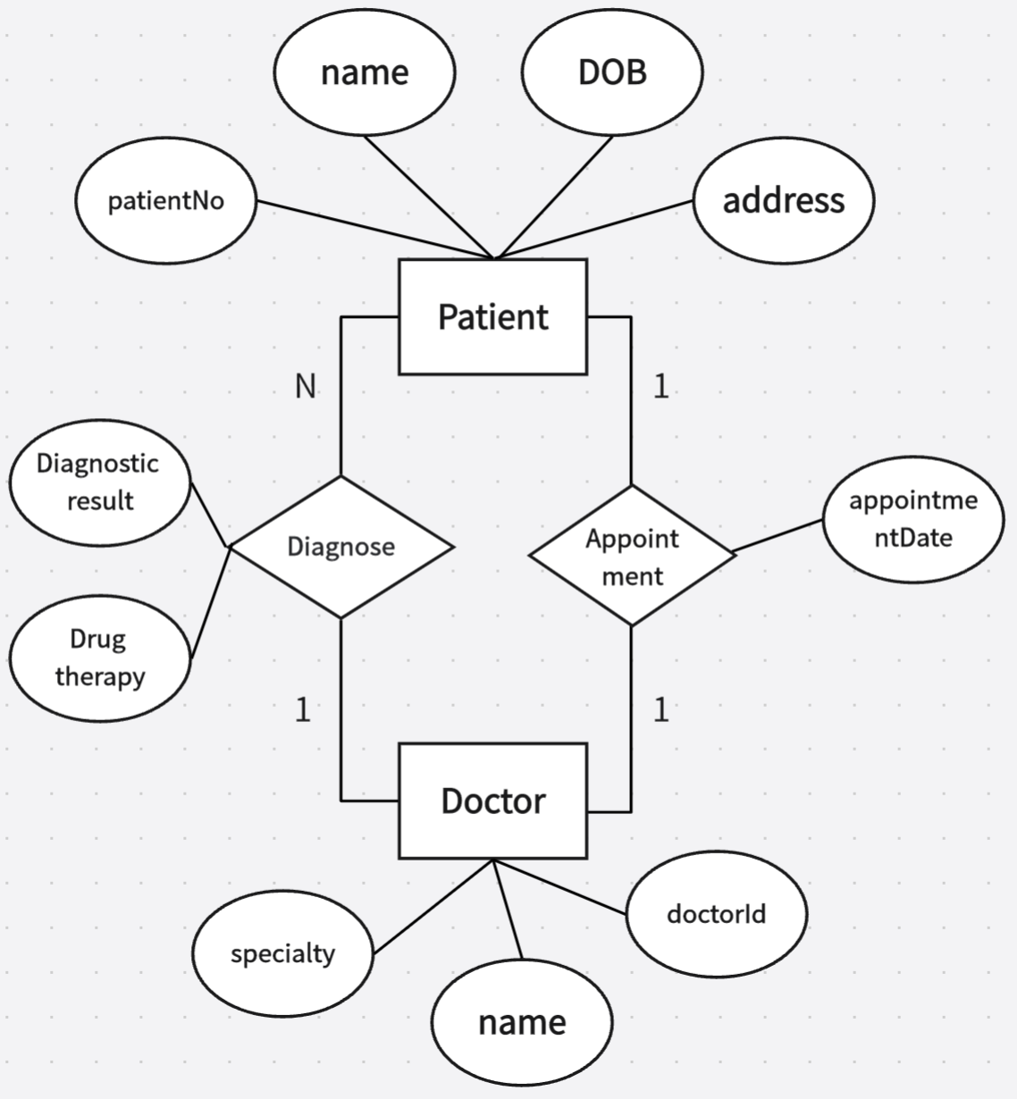

7.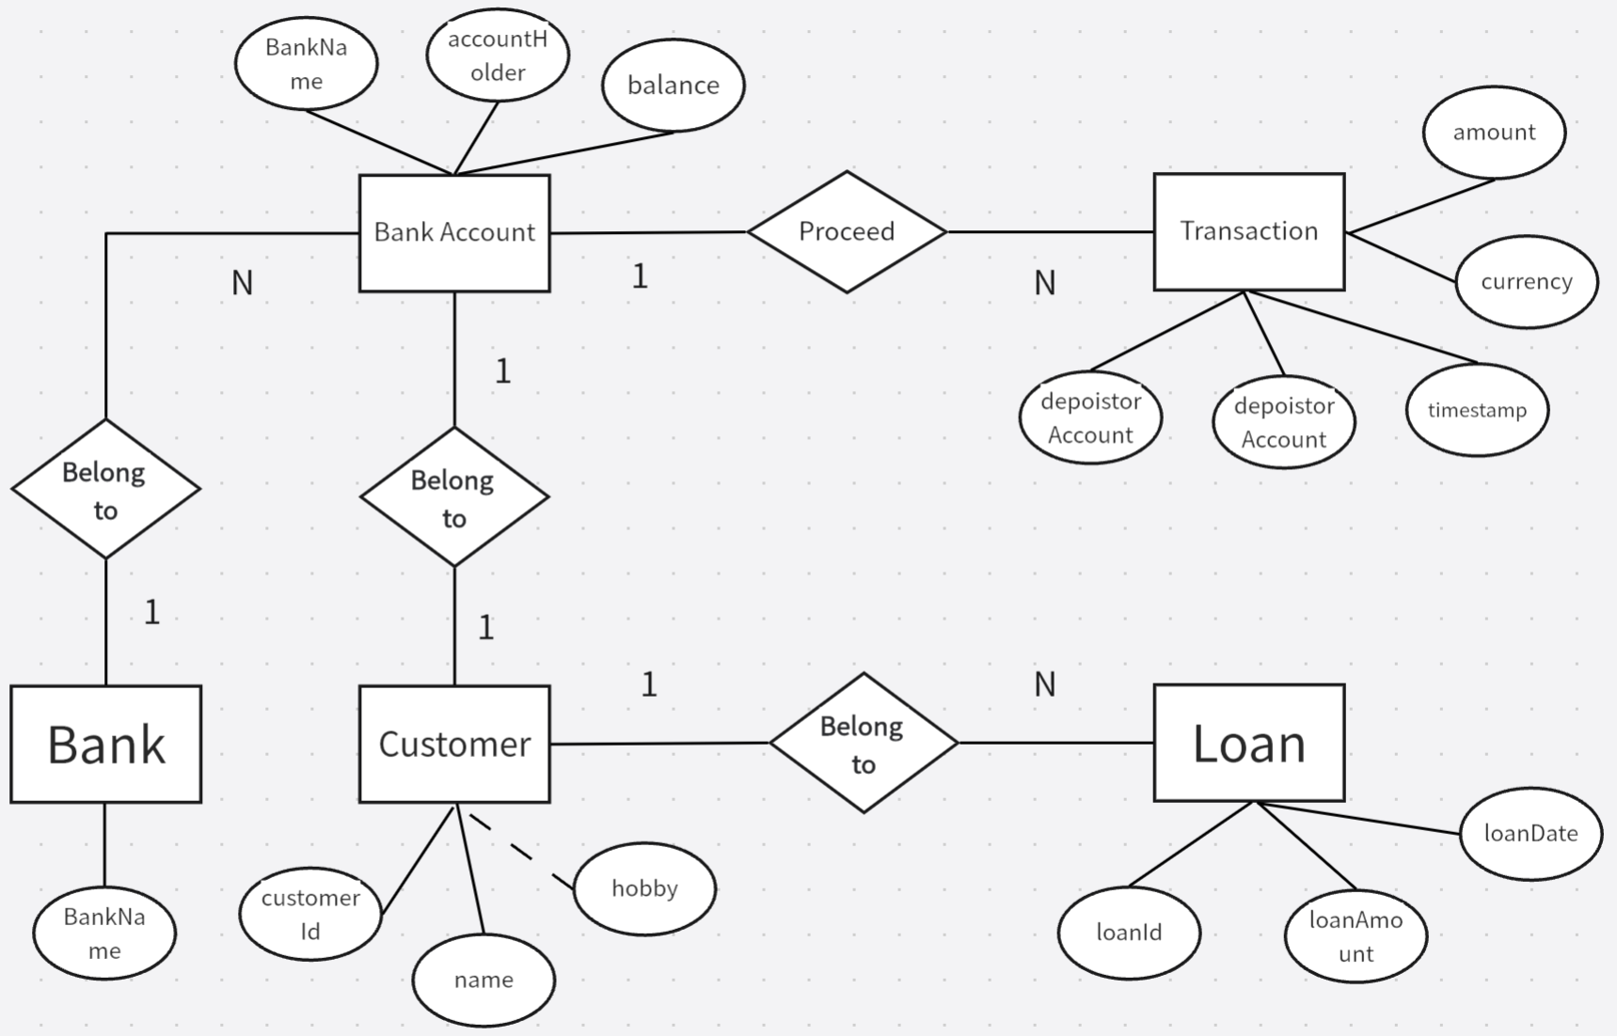

**ADVANCED TASKS**

8.

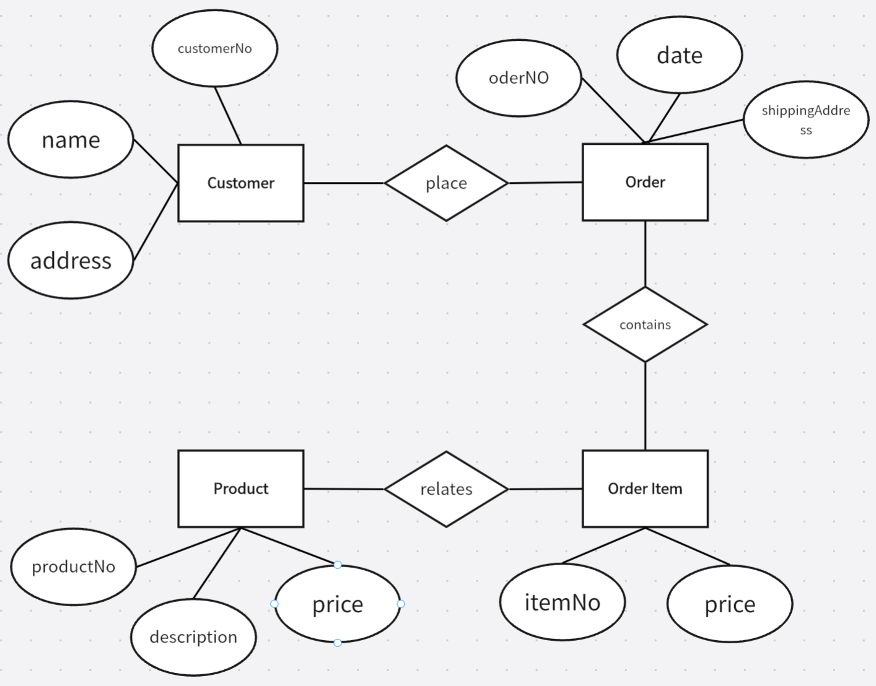

9.

