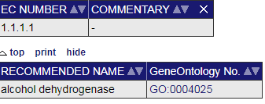

EC NUMBER = tab740sr0c0

RECOMMENDED NAME = tab29r0sr0c0



CAS REGISTRY NUMBER = tab3r0sr0c0

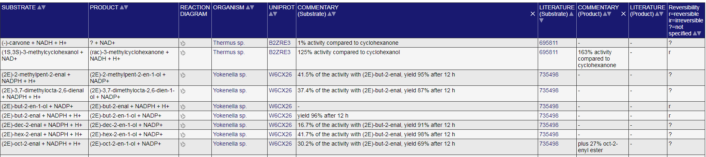

SUBSTRATE = tab37r0sr0c0

ORGANISM = tab37r0sr0c3

UNIPROT = tab37r0sr0c4

LITERATURE = tab37r0sr0c6

LITERATURE:网站有自己的文献号码，需要点进去，提取一下文献全名和相应的DOI号码

LITERATURE = meta.id()

ORGANISM:不用点进去，写上去就好

UNIPROT：暂时只写代码

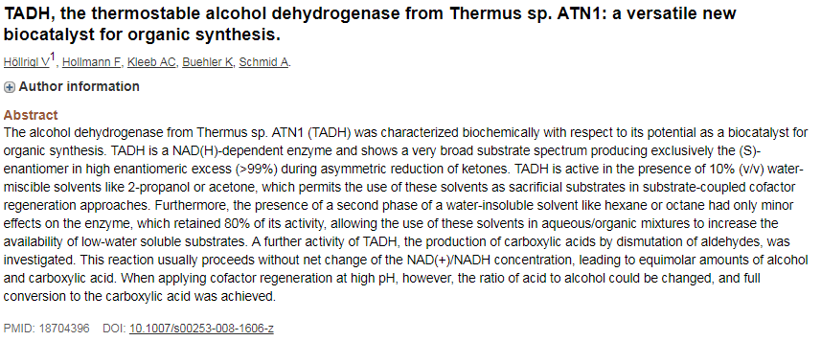

TITLE = h1 (pick 2nd element)

DOI = a[ref="aid_type=doi"]

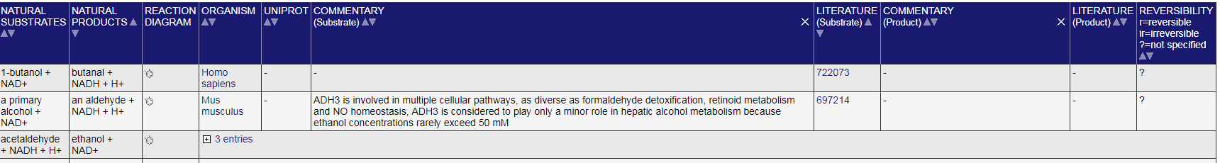

NATURAL SUBSTRATE = tab17r0sr0c0

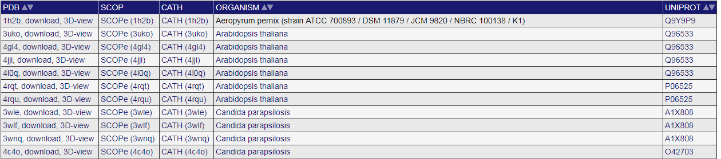

PDB = tab23r0sr0c0

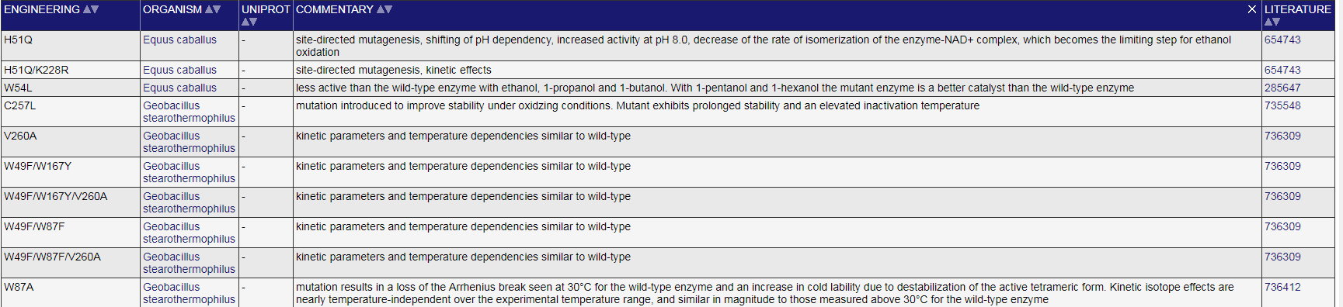

ENGINEERING = tab8r0sr0c0