CMPUT 291 - Fall 2016
Assignment One

(group assignment)

Due date: January 29, 2018, 5pm (submission details)

Regarding possible clarifications
No clarifications or answers to questions regarding this assignment will be given here or otherwise after 5pm on January 28!
Read the assignment specifications, the description of the deliverables, and the submission instructions carefully!
Additional clarifications may be posted through the course forums. Make sure you are subscribed to the discussion forum and pay attention to postings regarding this assignment!

Introduction
The goal of this assignment is to practice the concepts of database design, using Entity-Relationship Modeling, as well as mapping an ER model into a Relational Model. This assignment has two parts.

Part I - Modeling
Suppose a waste management company hired you to build a database that keeps track of their operations, which includes information about personnel, garbage trucks, customer accounts, and the different types of garbage containers it can deploy to customers. Given the (partial) specification of the data below, your job is to turn this specification into an ER diagram. Your ER diagram should capture all the information and constraints in the specification, and should not contain redundant entities, relationships, attributes, or constraints. Your notation must be consistent with the notation used in this course (meaning the course notes and the Kifer-Bernstein-Lewis book).
You will be working in groups of 2-3 students, registered in CMPUT 291, who can be in different lab sections.

Database Specification
The waste management company keeps record of its personnel, which includes account managers and drivers. Each person is uniquely identified by a personnel id (pid) and has additional information including name, phone, email, and address. Each person also may have a supervisor among the personnel of the company. Each account manager has in addition a home office location and a job title (indicating the size of accounts he/she manages - major accounts manager, medium accounts manager, or small accounts manager). Each driver also has a driver certification.
The waste management company also maintains information about trucks for picking up different kinds of garbage containers. Each truck has a unique model number and is of a certain type (front loader, roll-off, or garbage bin collector). Some drivers own their truck, which they then drive to fulfill services (a truck can only be owned by a single driver, and a driver can only own one truck that he uses for the company). All trucks have a single maintenance record, which is kept by the company. A maintenance record has an ID and consists of descriptions of individual mechanical inspections or repairs that the truck had at a specific date, starting with an initial inspection when the truck is added to the fleet.
The waste management company provides different services to different kinds of customers. An individual services consist of deploying (i.e., providing, and regularly emptying) specialized, large garbage containers (e.g., for chemical waste, recycling, or construction waste) to customer sites, as requested by a customer. To that end, the company maintains a record of all its garbage containers, each of which has a unique id, a type, and can hold one or more different waste types (e.g., hazardous, recycling, construction, organic material).
Customers are represented by accounts, which are managed by account managers. A manager can manage multiple accounts, and each account is managed by exactly one account manager. Each account represents a "Master Service Agreement” that has a unique account number, the customer name, the customer's main contact information, the type of customer (municipal, commercial, industrial, or residential), the start and end date of the master service agreement, and the dollar amount per month charged to the customer for the total services. Under each customer account (Master Service agreement), the company keeps track of the specific services provided to a customer. For instance, a customer might be a construction company that needs waste containers for different types of construction materials at different building sites. An individual service for a customer is described by a running service number, a location (where a specific container is deployed), the type of container that is needed at that location, a description of the pick-up schedule for the location (e.g.: "every Monday of every week" or "on the first Wednesday of each month"), a contact for that service, an estimate of what it costs the waste management company to provide this service, and a suggested price for this service.
The waste management company also keeps track of how and when individual services are fulfilled. A particular services is fulfilled at a particular point in time, by a driver, using a specific truck, dropping off an empty container for the specific service and, at the same time, picking up the (full) waste container. The first time a container is dropped off at a service location there is obviously not container to be picked up. To be able to represent this initial drop-off of a container without complications, you can assume that there is a (imaginary) "Null garbage container", which a driver "picks up" the first time, when there is no real container to be picked up at a service location.

Part II - Mapping
Map the following ER diagram into relational tables using the rules discussed in class. Give the complete CREATE TABLE commands for each necessary table. Choose CHAR as the domain for all attributes.

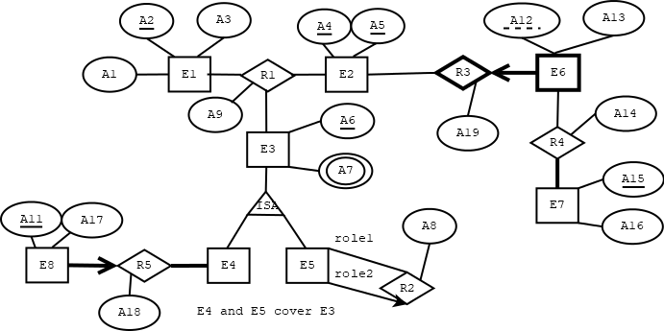
Deliverables
Submit a single document for your group. The submitted document is expected to have the following pieces:
- For Part I: (1) one ER diagram for each group member prepared individually and commented on by another member of the group, (2) one ER diagram prepared as a group possibly more comprehensive or accurate than the individually prepared diagrams.
- For Part II: the relation schemata in form of CREATE TABLE statements obtained when mapping the given ER-model in Part II to a Relational data model. Only one mapping should be submitted for the whole group.
The delivered hard-copy of the ER model should be produced using Google Drawings, or Dia, or an equivalent drawing program (i.e., not hand-drawn). You must use the notation introduced in class (and the Kifer-Bernstein-Lewis textbook). The hard-copy of your CREATE TABLE statements must be typed. If you are making any assumptions in your modeling or mapping, state them clearly in your submission; but note that additional assumptions cannot violate the specification given here and any possible clarification posted later in the course forums. Acknowledge explicitly the use of any source of information other than the course textbook and class notes.

Submission Details
Your submission must be typed and printed (except the comments made by group members on individual solutions, which can be hand-written), as well as preceded by a cover page that includes the names of all group members, their lab sections and the assignment number. The cover page must also include the names of anyone other than the group members that you may have collaborated with (to the extent that is allowed by our course policies); if you did not collaborate with anyone outside your group, explicitly include a line stating that you did not collaborate with anyone else. A submission without a cover page or with missing information on the cover page can lose 5% or more of the total mark. Also a non-typed document can lose another 5% or more of the total mark.
Each individual solution for Part I must include the name of the person who prepared it and the name of the person who read it and provided comments on it. Your group solution must be clearly marked since that is the solution that will be marked for thoroughness and accuracy. Your mark for Part I is based on your group solution, your individual solution and your comments on the solution of another group member. At least 70% of the mark will be given to the group solution though.
For Part II, only one group solution must be submitted. In cases where multiple solutions are submitted for Part II, or a group solution for Part I is not clearly marked, we reserve the right to pick any of the submitted solutions randomly and only mark that solution.
Assignments should be submitted as hard copies at the designated drop box, located on the first floor of the CSC building, across from the room CSC 1-45. Drop your assignment in the box designated for this course (CMPUT 291). See the course outline for the late hand-in policy.

