The Zenoh Report
November 2025



I would like to open this installment of the Zenoh Report announcing, as per tradition, that Zenoh User Meeting 2025 (#ZUM25) will take place on December 12th, from 3 PM to 6 PM CET. The event will be a hybrid gathering hosted at ZettaScale HQ in Paris and streamed live on YouTube, Twitter, and LinkedIn.

ZUM is, at its core, a celebration of our community: the brilliant minds building real systems, solving real problems, and pushing Zenoh into new territory. Whether your experience is about performance, robotics, integration, IoT, or a creative use of Zenoh, we’d love to feature your story.

You’re welcome to give a short 20–25 minute talk (live or remote) on your project, lessons learned, and what Zenoh has meant in your journey. We’ll take care of the logistics — you bring the story and the passion. 🚀
If you’re interested, please contact me by November 20th so we can reserve your slot and coordinate the session details.

🚀 Technology Highlights: Embedded Rust

Rust adoption has been steadily growing to the point of becoming the leading programming languages of choice for new adventures in system programming and networking. The main reasons to choose Rust are often related to its memory and concurrency safety as well to the “zero-cost” abstractions. The push toward security by design we discussed in the last instalment is accelerating this trend..

Another strength, often overlooked, is Rust’s support for embedded programming. Rust can be run bare-metal over an increasing number of targets in combination with Rust-based OSes such as RTIC, TockOS, OxideOS, and ArielOS, or on C/C++ based OSes such as FreeRTOS and Zephyr. Finally, embedded async Rust applications can also leverage the Embassy executor and its ecosystem to run essentially bare metal and reduce the footprint and latency when compared to a traditional embedded OS.

Hardware support has been steadily expanding and maturing. ARM support is relatively strong and recently Espressif announced the release of esp-hal 1.0.0: an officially supported bare-metal (no_std) hardware abstractions for Espressif devices, including some support for RISC-V-based ESPs. This marks the first officially supported Rust HAL from a hardware vendor — a key milestone for commercial adoption.

I hear more and more projects starting to use Rust in embedded systems. We may be reaching the inflection point where hardware support, tools and libraries are sufficiently mature to support the transition from innovators to early adopters.

If you’d like to dive into the world of embedded Rust, here are some essential references:

The Embedded Rust Book. The definitive guide for embedded Rust development, maintained by the Rust Embedded Working Group. Covers development environment setup, best practices, and effective patterns for embedded software development.​

The Discovery Book. Hands-on introductory course for microcontroller-based embedded systems using Rust. Three versions available targeting different hardware platforms: micro:bit v2 (latest), micro:bit v1, and STM32F3Discovery.​

Embedded Rust Bookshelf
Central hub for all official embedded Rust documentation maintained by the Embedded Working Group.​

ESP-HAL Documentation
If you are targeting ESP Hardware then the Rust and Embedded Rust on ESP are the right place to start

🐉 Release Tracker

Zenoh Imoogi

Zenoh 1.6.x is codenamed Imoogi after the Korean dragon that ascends to greatness. This release elevates the Zenoh ecosystem with key refinements and critical improvements. Imoogi focuses on stabilizing and extending the groundbreaking features introduced in version 1.5.0, bringing enhanced shared memory capabilities, improved configuration management, better scalability, and expanded language binding support.

Key highlights of this release include:
- Shared Memory. Typed buffers, better allocators, flexible builders, buffer resizing, implicit SHM optimisations for large payloads, and pre‑commit pages — all delivering major throughput gains.
- Configuration. Improved configuration parameters and enhanced downsampling controls.
- API. Full SHM API in Zenoh‑Python, major updates in Zenoh‑C and Zenoh‑TS, and streamlined plugin interfaces.

- Zenoh-Pico. Advanced Pub/Sub support with TLS security, bringing enterprise-grade security and reliability features to constrained devices.

- Scalability. Fixed critical peer-to-peer topology issues and optimized discovery message processing, drastically reducing CPU consumption especially for ROS 2 use cases.
- Zenoh Shell. NuZe, combines Nushell’s powerful structured data scripting with Zenoh commands, providing a convenient tool for testing, debugging, and building interactive Zenoh applications.
- Documentation. Significantly improved the Rust documentation and expanded with usage examples and cross-references, improved README.

The full release blog is available here.

The next minor release of the 1.6.x series will bring few more improvements, including support for weighted graphs routing. Stay tuned!

🆕 New Projects

zenoh-nostd
Following its demonstration at ROSCon25, we have now made zenoh-nostd publicly available. This is an implementation of Zenoh targeting Rust no-std and no alloc environments. The implementation currently supports Pub/Sub and Queries will be landing before the end of the year. The current implementation leverages Embassy, but we plan to provide both a sync and an async version of the stack. Give it a try and let us know your thoughts!

🆕 Tip of the month

Many of you have seen me running Zenoh routers on WiFi-Routers and asked how to replicate it. Before explaining the required steps, let me explain why this is a good idea.

​​Running Zenoh directly on the WiFi router minimises air‑time usage. When an application talks to a Zenoh router running elsewhere, the WiFi router must receive the traffic and forward it — consuming air‑time twice. Running Zenoh *on the access point itself* halves this overhead, which is especially valuable when the router must forward data to many clients.

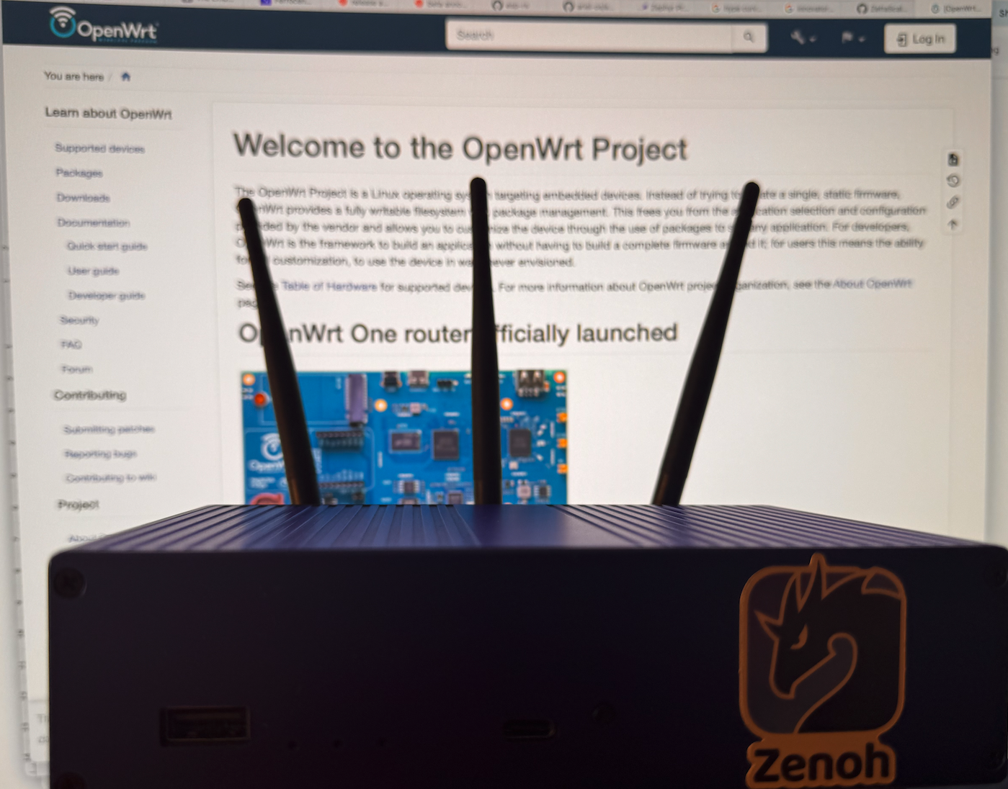

With this kind of deployment you can optimise the use of the air-time to communicate and thus optimise the throughput of your WiFi.

Additionally, if you have multiple wireless access points you can route across them through Zenoh over a fixed network, making it easy to scale your system and exploiting locality.

That said, let’s see how we can get this running. First, you need to get your hands on a WiFi Router supported by OpenWRT (see https://toh.openwrt.org/?view=normal). Next you need to check if the relevant target for your router is supported by the Rust compiler (https://doc.rust-lang.org/nightly/rustc/platform-support.html). In the picture above I am using an OpenWrt One, but I’ve also used LinkSys Routers without issues.

Assuming that you have the right hardware at hand, the first step is to install OpenWRT on your WiFi Router. Once that is done, you need to cross compile the Zenoh router. This is really straightforward, simply do:

$ cargo install cross --git https://github.com/cross-rs/cross
$ cross build --target=YOUR_TARGET_HERE --release --bin zenohd

If you want to enable statistics then do:

$ cross build --target=YOUR_TARGET_HERE --release --features “stats” --bin zenohd

For instance for the OpenWRT One the command would be:

cross build --target=aarch64-unknown-linux-musl --release --bin zenohd

If your router runs on an ARM7 you’ll probably have to use armv7-unknown-linux-musleabihf or armv7-unknown-linux-musleabi

Once cross compiled just copy it over and run it. Ideally you’ll want to ensure that the Zenoh router is started as a service when the WiFi router boots.

That’s it!

🌍 Community Spotlight

The number of Zenoh related projects keeps growing steadily. This month I’d like to highlight the Awesome Zenoh repository, which tracks community projects. If you want your project featured, simply submit a Pull Request.

📰 Hot from the Press

Below is a selection of announcements and articles recently published:
- A look at the Robot Operating System. A nice article on ROS2 from Chris Lalancette explaining Zenoh’s benefits in Robotics.

- Designing for Distributed Heterogeneous Modularity: On Software Architecture and Deployment of the MoonBots. Nice article comparing Zenoh and DDS in supporting moon exploration robots.

- We’re rolling out Zenoh RMW in production! 🚀. Dexory announces that they are rolling Zenoh into production

📅 Events
Catch up with us at:
- ROSCon FR & DE 2025 — 17-20 Nov 2025, Strasbourg (FR)
- ROSCon India 2025 — 18-20 Dec 2025, Pune (IN)
That’s it for this month’s report! Don’t forget to:
⭐ Star us on GitHub
💬 Join the Zenoh Discord
📣 Spread the word

