The Zenoh Report
January 2026 / December 2025

We have just stepped into a brand new year, a year which I am sure, will be full of happenings. Before we move into the content of this Zenoh Report, allow me to wish you a healthy, joyful and successful 2026!

But before we continue… and in case you had not noticed – The Zenoh Report is written completely by hand. In other terms, it is not generated, edited, reviewed, or corrected with AI tools. Why? Because I want it to speak with my voice, talk with my accents, and keep my editorial style. AI tools are great, but this is a conversation between me and you, and I want it to be done with my voice. Those of you who know me sufficiently well won’t be surprised, since they will know that I’ve never had anybody write for me, or accepted any form of ghost writing.

#ZUM25 In a Nutshell
As per our tradition, last December 12th we held the Zenoh User Meeting 2025 (#ZUM25). We had a great pack of speakers and I’d like to thank them one by one, following the order of their great presentations. Great thanks to David Crawley (video), Aaron Chong (video), Edgar Riba (video), Guillaume Doisy (video), Fredric Olsson (video), Alejandro Hernandez-Cordero (video) and Leonard Assouline (video). The recording of the event is available here.

Their presentations gave insights on how Zenoh is used today in robotics, fleet management, maritime applications and secure group communication.

On our side we went through the Zenoh releases we rolled out in 2025 and their key features, which you can see summarised below.

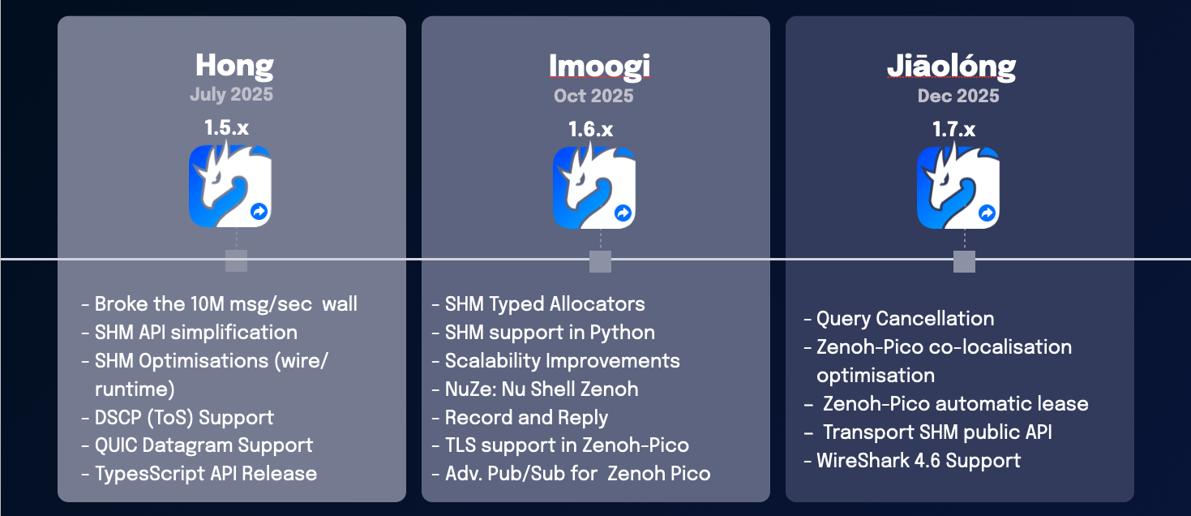

We introduced regionalisation, which is an extension of Zenoh’s routing architecture, and algorithms, to allow for an arbitrary number of routing levels. This will massively improve scalability and we plan to start dropping features as soon as next month.

Finally, we announced 📢 that we have started to work on Zenoh 2.0 and we plan to release it in the second half of 2026.

🚀 Technology Highlights: Physical AI

I had the pleasure to moderate the Physical AI Panel at the ROSCon India. In preparing the panel, I had a chance to dig a little deeper into the topic and realise that concepts are not so crisply defined. It was interesting to realise how many people have a “computational-learning” view of our intelligence, and how some examples I gave challenged their perspective.

But before we go any further, I suggest you do a little test. Take a look at these definitions of Physical AI and Embodied AI, can you spot the differences?

Now let’s go one step further. I strongly suggest you read through the article Physical Intelligence as a New Paradigm by Meitin Sitti (Physical Intelligence Department of the Max Planck Institute). This article opens with a crisp and well written classification of the different “kinds” of intelligence where Sitti makes the difference between Computational Intelligence (CI), Physical Intelligence (PI) and Embodied Intelligence (EI). Notice that he does not use the term AI, which I think is right. We need first to agree on what is what, before understanding how to create its “artificial” twin.

To make it simple we can say that Computational Intelligence (CI), is about cognitive processes, such as reasoning, classification, etc., this has been historically the focus of traditional AI. Physical Intelligence (PI), can be defined as physically encoding sensing, actuation, control, memory, logic, computation, adaptation, learning and decision-making into the body of an agent.

PI differs from the Embodied Intelligence (EI) field, which since PI only focuses on the physical intelligence encoded in the body, EI focuses on the tight coupling between an agent’s body, the brain and the environment.

The term Embodied Intelligence was introduced in the 80s by Roney Brooks when he proposed that we should forget about symbol processing, internal representation, and high-level cognition, and focus on the interaction with the real world. His main point was that “intelligence requires a body” and as a consequence the new paradigm was called embodied intelligence. The book How the Body Shapes the Way We Think is a good reading if you want to further explore the cognitive implications of having a body.

Now armed with these definitions, let’s try to decipher what the industry and investors really mean when they say Physical AI and whether that is any different from Embodied AI.

If you read once more the definitions provided by NVIDIA for Physical AI and Embodied AI – which I had provided above and asked you to spot the differences – you’ll notice that they sound more like the ideas behind Embodied Intelligence – in other terms give a body to AI and make it interact with the real world, make it learn through interacting with the real world.

I think it would be more appropriate to use the Embodied AI for the forms of artificial intelligence that rely on a body and its ability to interact with the real world. I would reserve the term Physical AI for any form of artificial intelligence that is embedded in the body. Notice that Physical AI, isn’t necessarily about software, it encompasses materials that show “intelligent behaviour”.

Hopefully this column will create some good debate and will contribute to further clarify the terms that we are using in our community.

References:
[1] Physical Intelligence as a New Paradigm, Meitin Sitti
[2] What is Physical AI, NVIDIA
[3] What is Embodied AI, NVIDIA
[4] How the Body Shapes the Way We Think

🐉 Release Tracker

Zenoh Jiaōlóng

With Jiāolóng, finally land some features that have been on our wish list for some time. Two of my favourites are query cancellation and Zenoh-Pico colocalization. The full release blog is available here, but let’s focus on these two features.

Query cancellation is about the ability to cancel an outstanding query through a cancellation token. The code below shows an example in which a query is cancelled if a result is not received within 5 seconds.

let ct = zenoh::cancellation::CancellationToken::default();
let query = session
.get(key_expression)
.callback(|reply| {println!("Received {:?}", reply.result());})
.cancellation_token(ct.clone())
.await
.unwrap();
tokio::task::spawn(async move {
tokio::time::sleep(std::time::Duration::from_secs(5)).await;
ct.cancel().await.unwrap();
});
let reply = query.recv();

Technically, if your goal was to bound the maximum amount of time that you’d spend blocked on a query waiting for replies, you could have used a timeout – which is supported already. But cancellation tokens allow you to cancel a query depending on applications specific logic, which may have nothing to do with a timeout.

Zenoh-Pico co-localisation optimization ensures that any Zenoh interaction, such as pub/sub or query/reply happening in the context of the same session, will be shortcut to a local call – no serialization, no system call, nothing, just a function call. This optimisation greatly reduces latency and CPU utilisation.

🆕 New Projects

zenoh-fs
I wrote zenoh-fs some time back as a quick and dirty experiment to show a possible implementation of a latency-tolerant distributed filesystem in Zenoh – thus technically, it is not exactly a new project. That said, I never gave it much visibility. But in the past few days I decided to revamp the project to support a Zenoh community member who was dealing with sending extremely large files across the internet through paths that could not guarantee sufficiently stable connectivity.

To understand the problem let’s make an example. Imagine that I have a sufficiently large file, say several tens or hundreds of gigabytes, or more, which I want to transfer reliably between A and B. A and B are connected over the internet, but they may get disconnected for an unpredictable amount of time, and may even get rebooted.

Let’s assume that A and B are already using Zenoh for some telemetry data, for queryables, etc., and we want to solve this problem using Zenoh. First we should realise that traditional reliability protocols won’t simply cut it – and this has nothing to do with Zenoh, that same would be true for MQTT, TCP/IP, HTTP, etc., the challenge is posed by the nature of traditional reliability protocols. Let’s try to understand why.

To make the number simple, let’s assume that I am sending a file that is 8192 MB large (for simplification, I am assuming that M is 10^6 as opposed to 2^10) . If we keep Zenoh as a reference, with the default configuration, it will fragment this message into 10^6 fragments each of 8192 bytes.

Now we need to make some assumptions on topology. Let’s assume that there are three hops in the route that leads from A to B, in other terms A->X->Y->Z->B. The default zenoh reliability is hop-to-hop, as such, it is sufficient that Y crashes – or gets partitioned long enough to look as if it has crashed – for us to lose the end-to-end reliability.

Zenoh also provides end-to-end reliability through the advanced pub/sub APIs. With proper tuning this will make it work to deal with short enough partitions, or any crash of X, Y, or Z, but won’t cover the case in which B or A would crash. Imagine B crashing after having received 99.999% of the file… All that work would be wasted.

zenoh-fs was designed to show one approach to solve this problem. It is inspired by latency tolerant networking protocols It leverages Zenoh’s filesystem to store extremely large files as a set of fixed size fragments. It implements a protocol to get these files, leveraging checkpointing, on the filesystem, to ensure that even across restarts it will resume from where it left. The README.md contains a relatively detailed explanation of how to get started.

The nice thing about zenoh-fs is that you don’t need to use an API to interact with it, you just need to drop digest in the right directory. The project provides some simple command line utility that can be used to easily upload and download files.

Eventually, I think this is a reliability mode that we support in the core Zenoh, it does not require an extension to the protocol but zfsd could become a zenoh plugin.

📰 Hot from the Press
One for the news that I guess you did not miss was IBM’s acquisition of Confluent. With its Kafka based offer, Confluent consistently positioned as the The Central Nervous System for Modern Business and IBM move was motivated by the desire to let enterprise data flow toward the brain.

The parallel with Zenoh is unavoidable. Zenoh is emerging as The Central and Peripheric Nervous System of Robotics and alike. I’ve been making this point for some time… I am sure in a few years more people will see the parallel.
That’s it for this month’s report! Don’t forget to:
⭐ Star us on GitHub
💬 Join the Zenoh Discord
📣 Spread the word

