The Zenoh Report
February 2026

This issue we’ll cover (1) the origin of St. Valentine – I know this has nothing to do with Zenoh, but it is still a good read, (2) Zenoh’s Genesis, (3) Zenoh 1.8.0 – Coming Features, (4) Zenoh 2.0, (5) Queryables and Key Expressions Constraints.

St. Valentine
It is not a coincidence that I decided to release the February issue of The Zenoh Report on Valentine’s Day. This has become a highly commercialised and consumeristic celebration… But that should not stop us from recalling where it came from and how we should use this day as a source of reflection and inspiration toward higher good.

The origin of the S. Valentine is most probably related to at least three different Saint Valentinus all of them martyred on Feb 14th around the 3rd century AD during Roman persecutions. One of these martyrs, Valentinus of Rome, was a priest who was executed under Claudius II because he secretly married young couples in spite of the ban set by the emperor Claudius who thought that married young men did not make good soldiers. Saint Valentinus of Terni instead was martyred around 273 AD for refusing to renounce his faith and for converting others. A third S. Valentinus was from Africa, but the reasons for his martyr did not make it to us.

It should also be noticed that in Roman times, the Lupercalia purification and fertility festival was roughly between the 13th and 15th of February involving animal sacrifice, ritual running, and other weird stuff meant to promote fertility.

Many historians think the Church’s institution of Saint Valentine’s feast near this date helped absorb or displace Lupercalia, preserving themes of fertility and pairing while rejecting the more violent or sexual aspects. Some accounts also note that this period in the natural year, around mid‑February, was associated with the coming of spring and new life, which reinforced the symbolic link to renewal and union.

Not that we have reviewed the history of this day, let’s look at how its meaning has transformed throughout the centuries.

In cultural and historical terms, the date carries echoes of fertility, renewal, and matchmaking inherited from Lupercalia and the bird‑mating symbolism of medieval Europe.

In Christian terms, Saint Valentine represents faithful, self‑sacrificing love: a person who risked and gave his life to uphold marriage and his beliefs, so love here is understood as covenant, fidelity, and charity.

In contemporary popular practice, Valentine’s Day signifies the public expression of romantic attachment—affirming bonds, desire, and emotional intimacy—often narrowed to couple love but increasingly also used to celebrate friendship and care more broadly.

It is interesting to see how the meaning of this celebration has been evolving. Personally I remain attached to the interpretation of Saint Valentine as faithful, self‑sacrificing love: a person who risked and gave his life to uphold his beliefs, fidelity, and charity. Considering the world we live in, I think that on this 14th of February 2026, we should all embrace this interpretation and understand that we build the world that we’ll be leaving to our kids. Our decisions, our actions as well as our acceptance of the unjust, for convenience, opportunism, fear, and gregarious behaviour shape the world we live in.

Happy Saint Valentinus.

Zenoh Genesis
As we started this issue with reviewing the history and the meaning of Saint Valentine, I don’t think there would be a better moment to do the same for Zenoh and talk about its genesis.

Let’s make a 16 year jump back in time… Still with me?

Technological Context
In those days I was PrismTech’s CTO and I was serving as a OMG DDS SIG co-chair (I was one of the founding members) and I had the opportunity to work on some of the early Extremely Large Scale Systems – back then these scales were mostly found in military and aerospace applications and increasingly in Smart Cities. Working on these early systems, made it crystal clear that DDS would not scale as is. This 2009 presentation “Scaling the Data Distribution Service to Global Networks” is one of the many examples of my efforts to sensibilize the community of vendors of upcoming challenges along with a sensible solution.

The problem wasn’t just scaling out, it was also scaling down. In other terms, DDS was not designed to target neither constrained hardware nor constrained networks. Other protocols had been introduced to deal with constrained environments, such as CoAP. This protocol worked best when integrating small divides with web applications, mostly in IoT scenarios, but the model was still somewhat cloud-centric and client/server. At this point some of you are wondering about MQTT. This protocol, coming from the late 90s, had been popularised by IBM as the holy grail of IoT. Its broker based approach, suits those applications that can rely on a broker being available somewhere on the cloud, or on your system, but is problematic for anything that is high performance and which requires low latency communication, especially when spatial locality can be exploited. The MQTT paradox is that even two devices sitting on the same network, talk through a broker sitting on a cloud which is usually thousands of kilometers away.

As I kept working on these systems another challenge crystallised in front of my eyes. DDS and other Pub/Sub technologies had brought location transparency for data in movement. In other terms consumers of data (subscribers) simply needed to express their interest, by naming data. Then, Data would flow, without having to know if there were publishers or where they were.

However, once data would be stored somewhere, location transparency was gone. As a consequence of this model for data at rest, cloud-based storage started thriving, since with cloud there is a single place where to store and retrieve data. However this model does not work well with applications that require low latency access to stored data, applications that can’t guarantee they are always connected to the cloud, or applications that are inherently infrastructure-less. For these applications it is not possible to have a single place where to store and retrieve data, but at the same time having multiple makes it hard to keep track of where is what.

Back in those days, these large scale systems that today we’d classify as cloud-to-microcontrollers were dock taped together by assembling a series of protocols each of which could work on a given system segment, crossing the fingers and hoping for decent end-to-end semantics.

This is what I usually refer to as the Digital Frankenstein era.

My discomfort with this way of building systems was growing to the point of becoming unbearable. I had to do something.

I started working on the idea of coming up with a protocol that could work efficiently from the microcontroller up to the data-center, would not have any topological constraints and would provide unified abstraction for dealing with data in movement (pub/sub) and data at rest (distributed queries).

But let me discuss the topological dimension for a moment. Back in those days, mainstream protocols implementing Pub/Sub would take one of two approaches, either they would be peer-to-peer assuming that each peer can directly communicate with every other pear, or else they would embrace the broker-based architecture, in which a special node, the broker is responsible for mediating communication between applications. Notice that neither of these approaches alone covers the needs of a large scale system. Flat peer-to-peer networks a la DDS don’t scale, while brokered systems are too fragile with respect to loss of connectivity and are not suitable for high performance. Wouldn’t it be great to have a protocol that does not impose any topological constraint, and allows you to use the topology that makes sense on a given system segment?

These were the premises under which I started working on a new protocol which I decided to call Zenoh.

But why Zenoh?

The Name
Here we have to go back to my roots. I am Sicilian by blood and culture, by that I mean really an orthodox Sicilian. Which means I am one of those increasingly rare people for whom a given word is more than like a sealed contract. Few people realise the role that Sicily played in the Ellenic times, fewer realise that Archimedes was from Syracuse, that Plato studied and lived in Syracuse for some years as he was trying to implement the model described in his Republic. Eventually, Dionisus (father), who was not at all thrilled by the idea, sold him as a slave. Gladly some of his disciples learned to buy back his freedom.
When I was growing up, there were no avengers, or X-men, and we were nurturing ourselves with the hellenic anthology, myths, heroes, the adventures of the iliad and the odyssey. It was hard for me to escape its fascination, everywhere I would turn my eyes, there would be a trace of these old stories and myths. Every morning while waking up I’d see the cyclops, that’s how we call the rocks thrown by Polypheme to Ulysses. When going to visit my grandma I’d see the river that was born from the tears of a nymph Galatea. If I would turn my head away from the sea then I’d see the mighty Etna, the home of Hephaestus. But Etna for me meant also the incredible life of Empedocles and consequently the pre-Socratic philosophers – of which , one of my favourites is Zeno, Zenone or Zenon d’Elée depending on the spelling in your language.

I liked Zenon, because since I was a kid I was fascinated by infinity and its paradoxes. I recall spending hours in summer nights laying on the ground and looking at the sky full of stars and thinking about them – where I come from we can clearly see the milky way, the moonless summer sky is really beautiful.

But that’s not the only Zenon that marked me. While growing up, I was completely mesmerized by Marcus Aurelius meditations, which was the way in which I was introduced to stoicism. Stoicism was founded in Athens by Zenon of Citium,

Thus as you may gather, Zenoh is a reference to these philosophers and also the acronym of ZEro Network OverHead.

Notice that the difference between Zenon and Zenoh is less than a letter, it is just the overshoot of the “h”.

Zenoh
We have learned about the circumstances under which Zenoh was born. Let’s now review its fundamentals. As I explained above, I had set for myself the goal of deriving a set of unified abstractions to deal with data in motion and data at rest, without any constraints on scale in other terms scale up/scale-down and scale-out. Eventually it became clear that the abstraction used to represent wells of data on the network can be also used to abstract computations. As a consequence, besides providing location transparent abstractions for data in movement and data at rest, Zenoh ended up also providing location transparent abstractions for computations.
For those of you that are new to Zenoh and want to get a good grasp of it I suggest watching some of the videos included as part of the Advanced Zenoh Tutorial.

Zenoh 1.8.0 – Coming Features
The next release will be 1.8.0 and will come with a few improvements, some stabilised API which I’ll discuss later and, based on our current plans, the initial drop of regionalization.

Regionalisation is something we’ve been working on for a few months, this feature will generalise Zenoh routing from a two level system to an arbitrary number of routing regions.

The example below visualises the current model, as highlighted on the diagram, all routers belong to the same link-state domain. This means that the routing state space scales linearly in the number of routers, as essentially the shortest path has to be computed for every possible destination and the next hope for a given destination has to be stored.

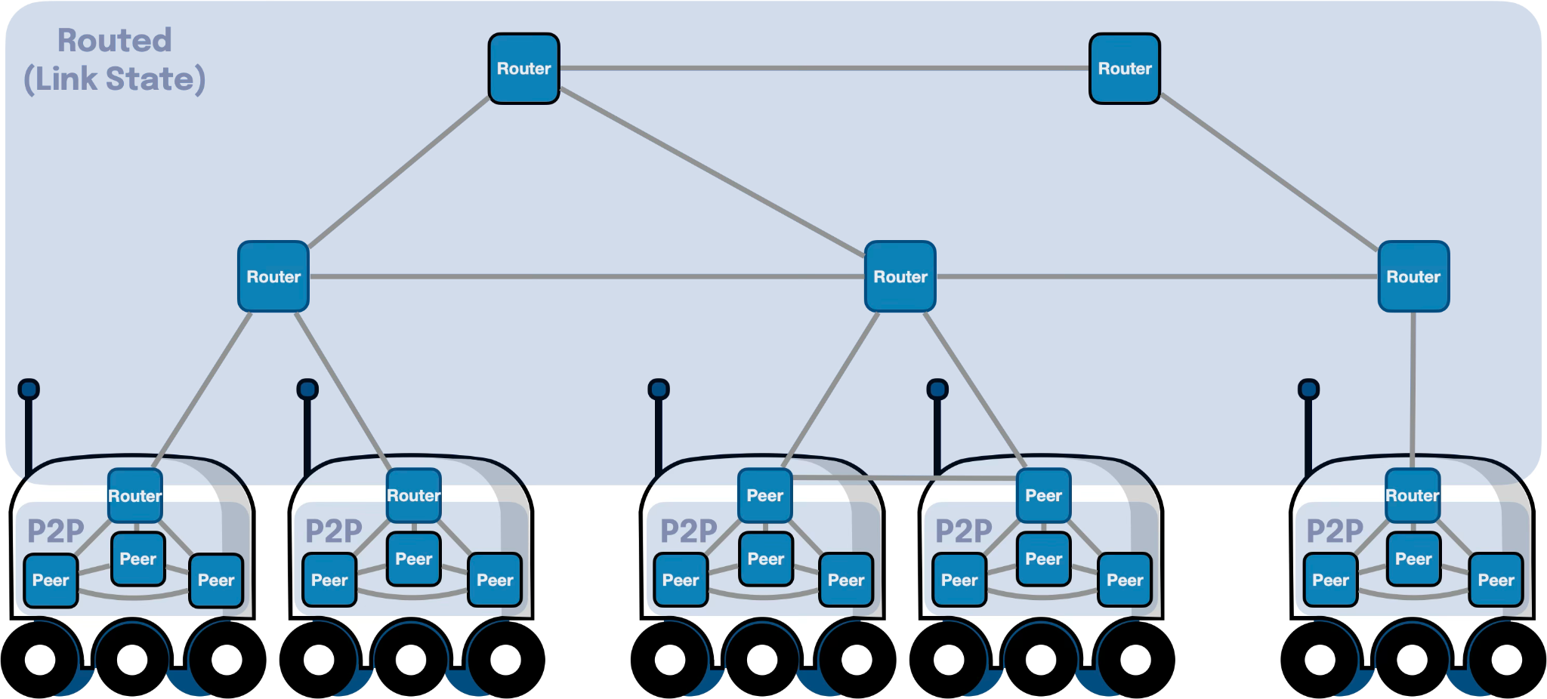

To further Zenoh scalability we have worked on adding regions. Now every Zenoh runtime can operate like a gateway with a north and a south. The “routing” mechanism used in the north and and the south are independent and this basic mechanism can be used to create an arbitrary number of routing regions.

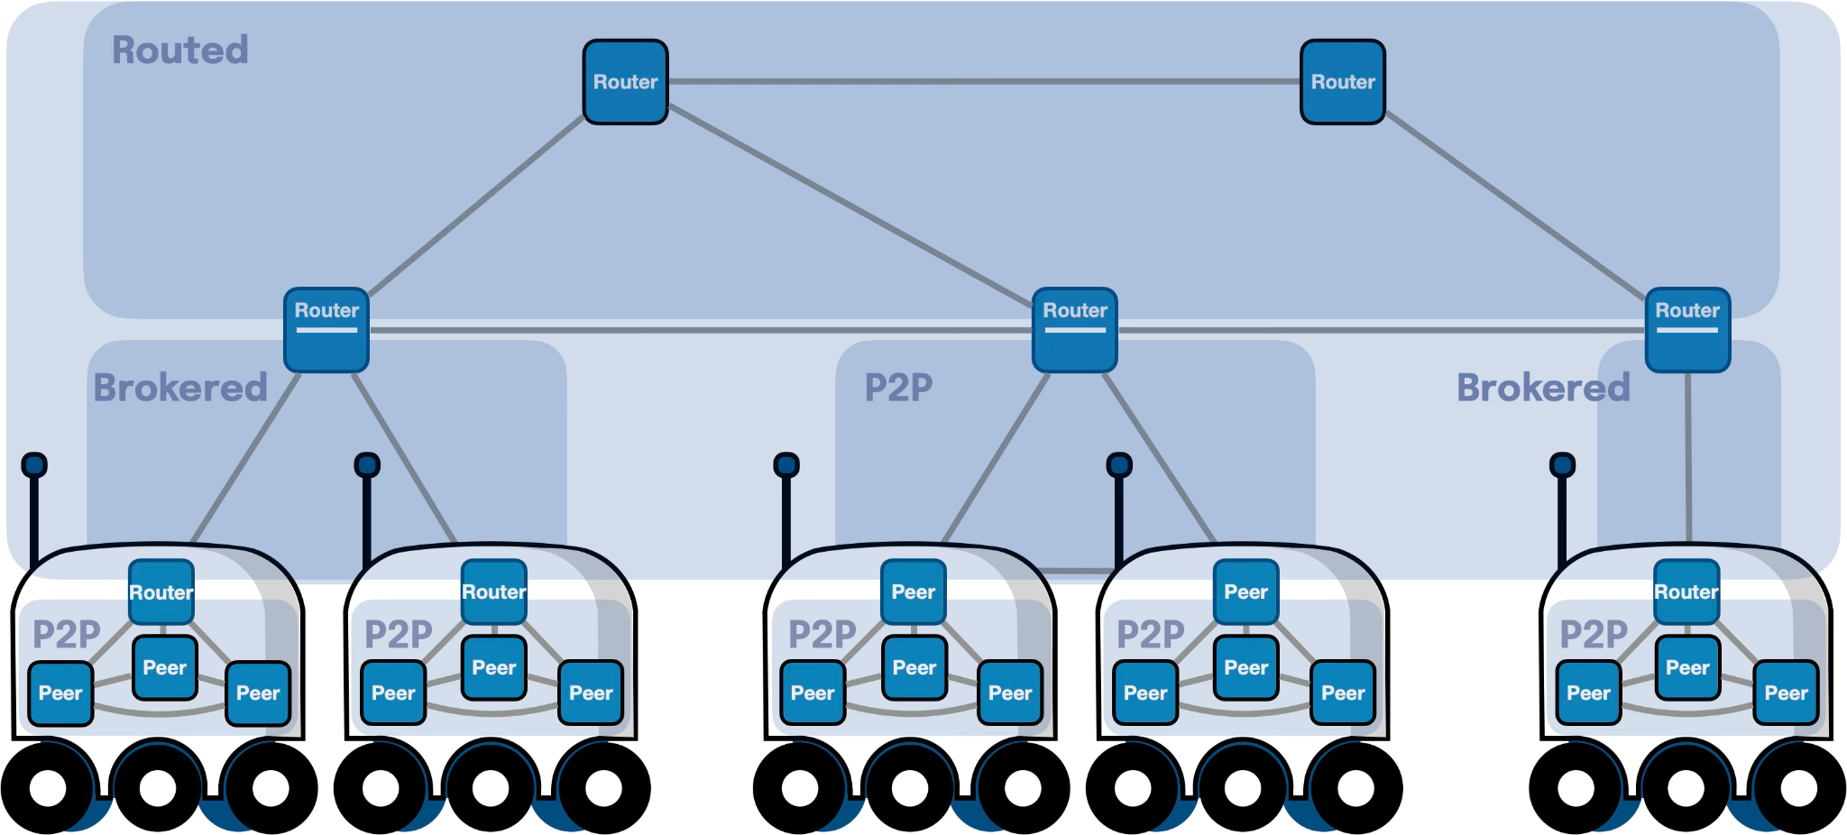

Zenoh 2.0
As we had announced at the Zenoh User Meeting back in December, we plan to release Zenoh 2.0 in the second half of 2026. At this stage the features we are considering are the following:

- Zenoh-ID based routing. This feature will add native support for routing toward a specific zenoh runtime, identified by a given zenoh-id. It has multiple applications; first, it will help in making admin-space queries more efficient with respect to the generated traffic. Additionally, an alternative to breadcrumbs to route replies to a query.
- Session Establishment. We have a new session establishment handshake that reduces traffic and reduces the time to establish as well as re-establish a session.
- Code Simplification. One of the motivations for zenoh-nostd was to refactor and massively simplify the Zenoh protocol related code. Now we plan to roll the protocol implementation of zenoh-nostd in main-stream Zenoh and share the same crates with zenoh-nostd.
- Configuration Refactoring. Zenoh’s is extremely configurable, but the current configuration has some unnecessary complexities as well as inconsistencies. As part of the 2.0 release we plan to simplify and address existing inconsistencies.
- Protocol Improvements. We plan some additional protocol improvements addressing different aspects, more information to come.

If you have any specific requests or wishes for Zenoh 2.0 please reach out the development team on Zenoh’s Discord Server.

Queryable / Query and key constraints
Today I want to clarify something about queryable and queries. Originally in Zenoh there were no constraints on the keys returned by a queryable when responding to a given query. In other terms, when receiving a query for a key expression KE, a queryable could respond with a finite list of key values (k1, v1), (k2, v2),... (kn,vn) where ki did not have to match KE. To make this concrete I could receive a query for the key alpha/* and reply with foo/bar. This caused some confusion in both users and even some team members. Thus a few years ago it was decided to constraint, by default, the replies of a queryables to be key/values whose keys have to match the key expression portion of the query – worth recalling that a query can use a selector in general composed by a key expression and a predicate.

Let’s make this clear with a code example:

let queries = z.declare_queryable("bar/baz/**").wait().unwrap();
while let Ok(query) = queries.recv() {
let kexpr = query.key_expr().to_string();
let reply_keyexpr = format!("foo/{}", kexpr);
query.reply(&reply_kexpr, "This will fail".as_bytes())?
}

In the code snipped above, the reply will return an Error because of the reply key not intersecting with the queryable key. This is a good property when using queryables to represent the reading half of a data store. However, Zenoh’s queryables are a generic mechanism that allows to trigger computations based on key matching. There are plenty of use cases in which you don’t want to submit yourself to this constraint. One example could be a key (re)mapper service, or anything that translates keys.

That said, there is a workaround, you could reply to the mapped key as the body and move the actual body to an attachment or vice-versa. But that forces you to send two keys, which is a waste of bandwidth and an unnecessary complication.

If you find yourself building an application where you require queryables to return keys that don’t intersect with the key in the query, there is a way out. This API has been unstable for some time but will be stabilised in the next release (v1.8.0). Here is an example of how to use it:

let mut builder = z
.get(“bar/baz/one”)
.accept_replies(zenoh::query::ReplyKeyExpr::Any).wait()?;

As you can see in the code above, you can control when issuing a query whether you accept to have replies that don’t match the query key.

No changes required on the queryable side.

