College/University Search Guide

Hi 10th grade admission officers! Hope this guide will help you know your representing colleges/universities a little bit better and good luck to your college fair prep!

University: University of Virginia
Class: 10.6
Admission Officers:

[General Introduction]

Mission:
The University of Virginia is a public institution of higher learning guided by a founding vision of discovery, innovation, and development of the full potential of talented students from all walks of life. It serves the Commonwealth of Virginia, the nation, and the world by developing responsible citizen leaders and professionals; advancing, preserving, and disseminating knowledge; and providing world-class patient care.
We are defined by:
- Our enduring commitment to a vibrant and unique residential learning environment marked by the free and collegial exchange of ideas;
- Our unwavering support of a collaborative, diverse community bound together by distinctive foundational values of honor, integrity, trust, and respect;
- Our universal dedication to excellence and affordable access.

History:
The University of Virginia, abbreviated as 'UVa', is located in Charlottesville, Virginia, USA [26]. It is a public comprehensive research university. It was founded in 1819 by Thomas Jefferson, the third president of the United States and the author of the Declaration of Independence [25]. It was the first university in the United States to be independent of the church and is also an institution listed in the UNESCO World Heritage List.

Location:
The University of Virginia (UVA) is located in Charlottesville, Virginia. This charming city is approximately 120 miles southwest of Washington, DC ,and offers a pleasant mix of urban and rural settings.

Student population:
Undergraduate Students on Grounds 18K
Graduate and Professional Students on Grounds 9k
International Students on Grounds 3k
Countries Represented by International Students on Grounds 109

School size
It has a total undergraduate enrollment of 17,901 (fall 2024), its setting is city, and the campus size is 1,682 acres. The student-faculty ratio at University of Virginia is 14:1, and it utilizes a semester-based academic calendar.

School tradition:
Academical Village
As part of his vision for UVA, Thomas Jefferson wanted students and professors to live as neighbors, to bridge the gap between academic life and student life. Professors would live in the pavilions located around the Lawn, and students would live in the rooms surrounding the Lawn. Also home to the Rotunda, the Lawn is the only UNESCO World Heritage Site located at a college in the United States. The University Guide Service offers historical tours to illuminate the University’s long history and tell the stories of those who built the foundations of UVA. To this day, students and professors still live on the Lawn, showing that this tradition has embedded itself into student life at UVA. You can find the Lawn at the center of student life on Grounds and a few of your classmates in the M.S. in Commerce Program living on the Range. Conveniently, Rouss & Robertson Halls, where classes are held, is located at the south end of the Lawn, making it an excellent location for students to take a quick study break outside when the weather is nice.

Secret Societies
Secret societies have a long history at UVA. These societies engage in traditions and activities unique to each of their organizations and often donate money to support different clubs and institutions at the University. They also often honor students who aren’t in those societies by inviting them to dinners or recognizing them with letters. You can find many of their logos painted around prominent walking spaces on Grounds. The McIntire School of Commerce even has one of its own that offers awards to students at the end of each year!

Honor Code
A staple at UVA, the Honor Code states that students will never lie, cheat, or steal. This code is in place to this day, and many students leave their belongings around Grounds or are given take-home exams since the community of trust is so strong here. The Honor Code was previously a single-sanction system, which meant expulsion for those found guilty of a violation. Students have recently voted to remove the single sanction, demonstrating the power of student self-governance. You can learn more about the Honor Code here or during a tour.

Convocation and Final Exercises
Finally, Convocation and Final Exercises are two traditions you’ll experience with your classmates. At the beginning of their time at UVA, all new students are invited to Convocation, during which they sign the Honor Code and are inducted into the University community. Convocation takes place facing the Rotunda. At the end of their time at UVA, students graduate and face Old Cabell Hall, away from the Rotunda, after walking the Lawn. The tradition symbolizes taking the knowledge they’ve learned at UVA (represented by the Rotunda, which used to be a library) and using it to make a difference in the world (symbolized by the Blue Ridge Mountains, which are located behind Old Cabell Hall). This tradition is a great way to finish your time at UVA with friends you’ve made at the School.

Graduation crowd at UVA

Student Events
While UVA has a rich history, in recent years, it has added many traditions that have quickly become popular among the University community.

Trick-or-Treating on the Lawn (TOTOTL)
On the Thursday of Halloween Weekend, families in Charlottesville bring their kids and dress up in costumes to go trick-or-treating on the Lawn. This is my absolute favorite event of the year, and it is a nice way to bridge the UVA and Charlottesville communities.

Lighting of the Lawn (LOTL)
Perhaps the most significant event that takes place every year, Lighting of the Lawn (LOTL) started after 9/11 to bring the community together. The event has since transformed into the huge light show that it is today. LOTL features events at the South Lawn and a capella performances until the light show at night’s end. This is another favorite event of mine (even though I’m biased, since I was on the committee to plan this). If a friend of yours in the program lives in a Lawn Range room, this is a night when they very well may throw a get-together with the program before attending the show.

Lighting of the Lawn crowd at UVA

Rotunda Sing
Rotunda Sing is the first event that happens on Grounds, taking place during Welcome Week and featuring performances from every a capella group. UVA is well regarded for its a capella groups, and it’s a great way to spend time with new friends in the M.S. in Commerce Program.

SpringFest
SpringFest is the major event that takes place in the spring semester. Hosted by UPC, the event offers free food to students and features musical performances in the University amphitheater. It’s an excellent way to celebrate the nice weather after the cold winter months.

4th Year 5k
The Peer Health Educators host the hugely popular 4th Year 5k, which takes place across Grounds on the morning of the last home football game of the year and concludes at the Lawn, where snacks are available for racers. The event’s male and female winners are honored at the football game, later that day. The 4th year 5k is a great way to end a fun football season (the shirts are also famously nice)!

Pancakes for Parkinson’s
During Pancakes for Parkinson’s, student volunteers cook pancakes to raise funds for the the Michael J. Fox Foundation. This event, which takes place on the Lawn, often features UVA President Ryan cooking pancakes alongside students and is a great way to be charitable and spend time with friends.

These are just a few of the long list of traditions you can expect to participate in at UVA. A more exhaustive list is linked here if you care to explore the different traditions UVA offers

Rankings:
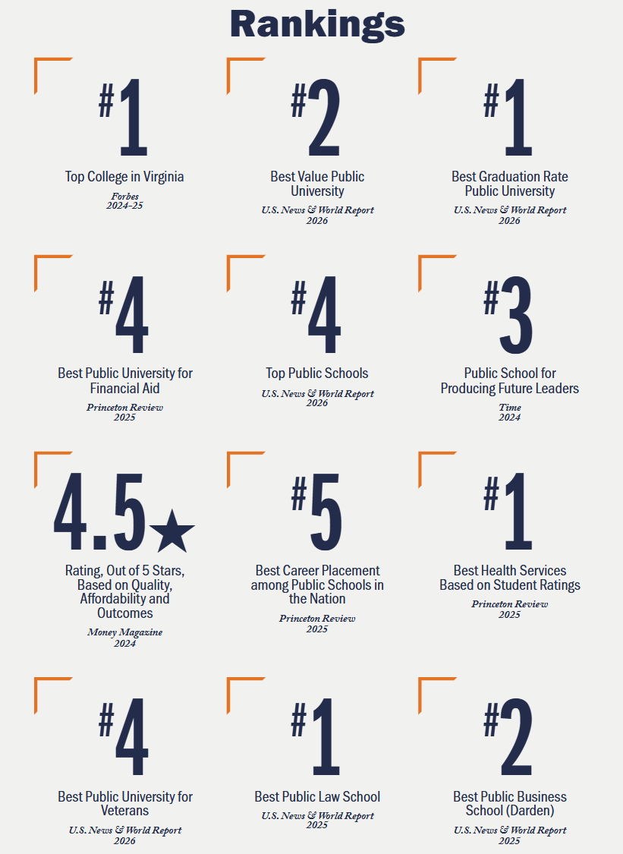

[Academics]

Departments &schools:
The University of Virginia comprises 12 schools in Charlottesville, the College at Wise in Southwest Virginia, and UVA Northern Virginia representing nine UVA schools in Fairfax and two in Arlington, as well as a comprehensive health system and six pan-University research institutes.
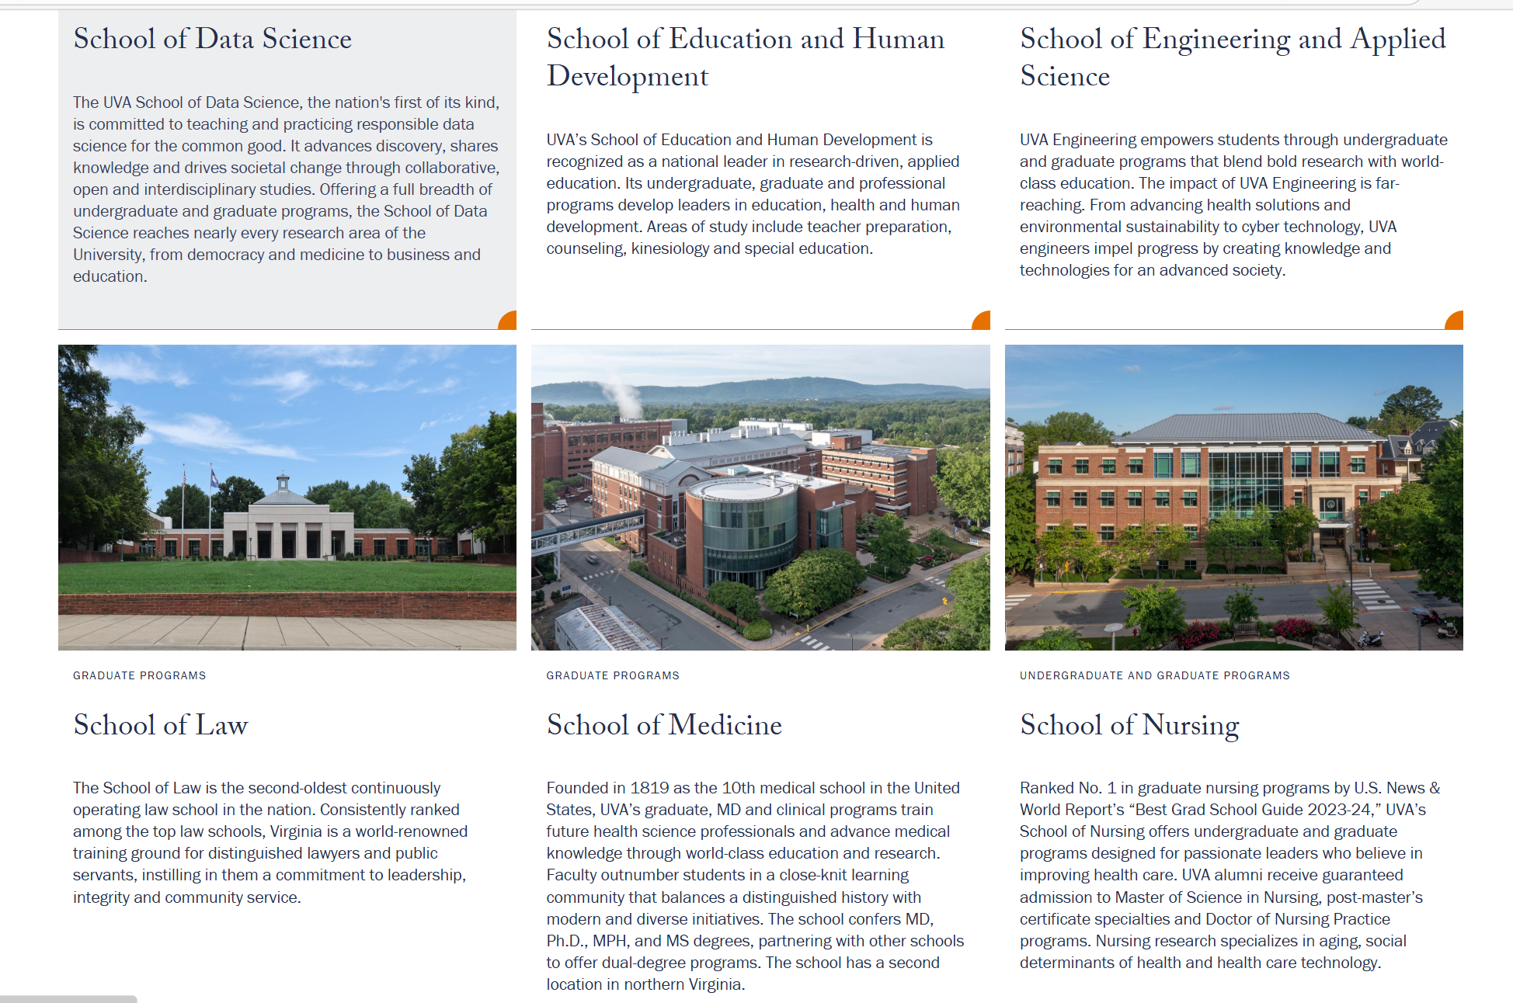

Programs of study, majors, minors

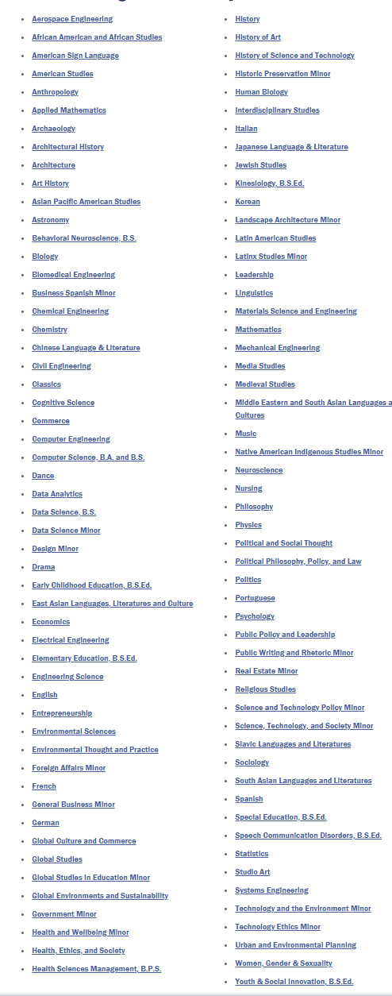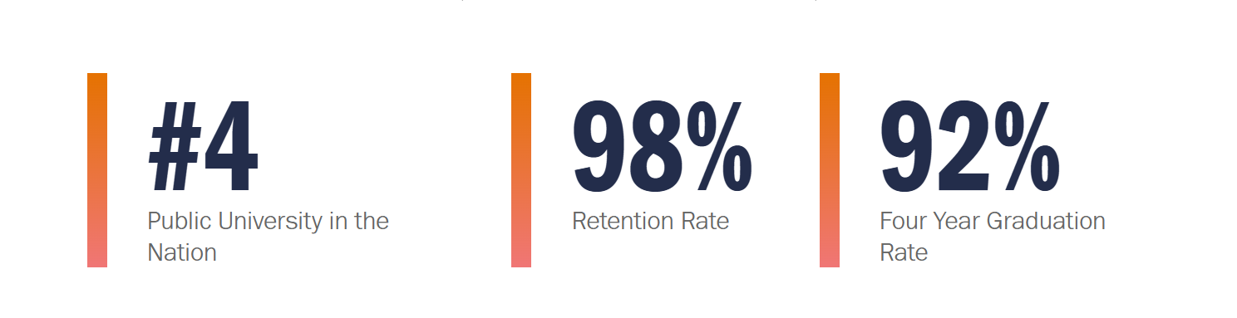

Research opportunities
UVA provides a wide variety of research opportunities work in labs including department of nursing, engineering and applied science, cognitive science and etc.

Academic aid
UVA combines rigorous studies with the support and advising resources needed to help undergraduate students thriveand reach their academic goals. This commitment to achievement, along with plentiful opportunities for service andleadership as part of a vibrant University community, prepares UVA students for fulfilling lives and careers
Academic Pathways
Areas of study that speak to students' passions will shape their future. UVA ensures students' choices aren't limited, offering many majors, minors and dual-degree opportunities.
Academic Support
Student academic success is the University's toppriority, and it shows. Through programs such as peercoaching and tutoring and STEM support initiatives,every student can thrive.
Academic Advising
UVA is committed to helping students take advantage of everything the University has to offer with access to resources and services.
Find Research Opportunities
The team at the Office of Citizen Scholar Development can help undergraduates find opportunities to get started in research. They offer workshops, advising, access to funding, and more.

…

[Social life]

Residential life
Supporting Students, Engaging Leaders
We pride ourselves on maintaining a residential program firmly rooted in the spirit of student self-governance. To this end, Housing & Residence Life (HRL) recruits and selects upwards of 240 students each year to serve as peer leaders who are in turn a means of support for their fellow students.
Resident Staff members work closely with a group of dedicated HRL professionals to establish residence halls and apartments as welcoming, secure living areas that represent and promote the high standards of achievement and conduct expected of students at the University of Virginia.

Furthermore, students are immediately given the opportunity to lead within their residential community as first years through the Residential Leadership Experience. Students living on-Grounds are elected to represent their class as a member of the First Year Council or their residence hall in their respective Association Council.
Programs and events sponsored by HRL staff and communities are intended to engage and inform, always in pursuit of our overarching goal to create welcoming communities.

Residential Events
Programs and events allow us to put our mission in motion. Students and staff work collaboratively to create community, offering special and everyday occasions that engage and educate. We provide facts and information to enrich your day-to-day, but also opportunities that may be memories in the making. It’s all part of a day in the life at UVA.

Arts & athletics
The arts are central to life at the University of Virginia. UVA offers access to world-class art and performances at Old Cabell Hall, The Fralin Museum of Art, the Kluge-Ruhe Aboriginal Art Collection and three state-of-the-art theaters.
Through UVA Arts and signature events, such as the Virginia Film Festival, the University cultivates a vibrant community that promotes creative expression and unites artists and performers across the commonwealth, nation and world.
The University of Virginia's athletic program, known as the Cavaliers (or affectionately as the Wahoos), represents a proud and integral part of the institution's commitment to educational excellence . Competing in the Atlantic Coast Conference (ACC) at the NCAA Division I level, UVA fields 27 varsity sports and has established itself as a national powerhouse . The Cavaliers have captured numerous NCAA championships across a diverse range of sports, including historic dominance in men's soccer (with seven titles), sustained success in men's lacrosse (five NCAA titles), a thrilling baseball College World Series victory in 2015, and a recent unprecedented five-peat by the women's swimming and diving team . This tradition of excellence extends from iconic venues like Scott Stadium and John Paul Jones Arena to the athletes themselves, who are defined by their pursuit of championships, academic achievement, and service to the community

[Study abroad opportunities]
Curriculum and Learning | UVA SCPS
…

[Career development]
UVA Career Center
The UVA Career Center supports all UVA students and serves as a central hub for satellite career services offices that are embedded in other colleges on Grounds. By engaging with Career Counselors, UVA Alumni networks, and industry-specific opportunities, the UVA Career Center enables students of all years to create the foundation of their career journey while at the University.
Global Internships Office (GIO)
Exploring applied learning opportunities abroad. There are many avenues to explore if you are keen to apply the skills and knowledge you have developed in the classroom to real-world international settings.

Reports & statistics
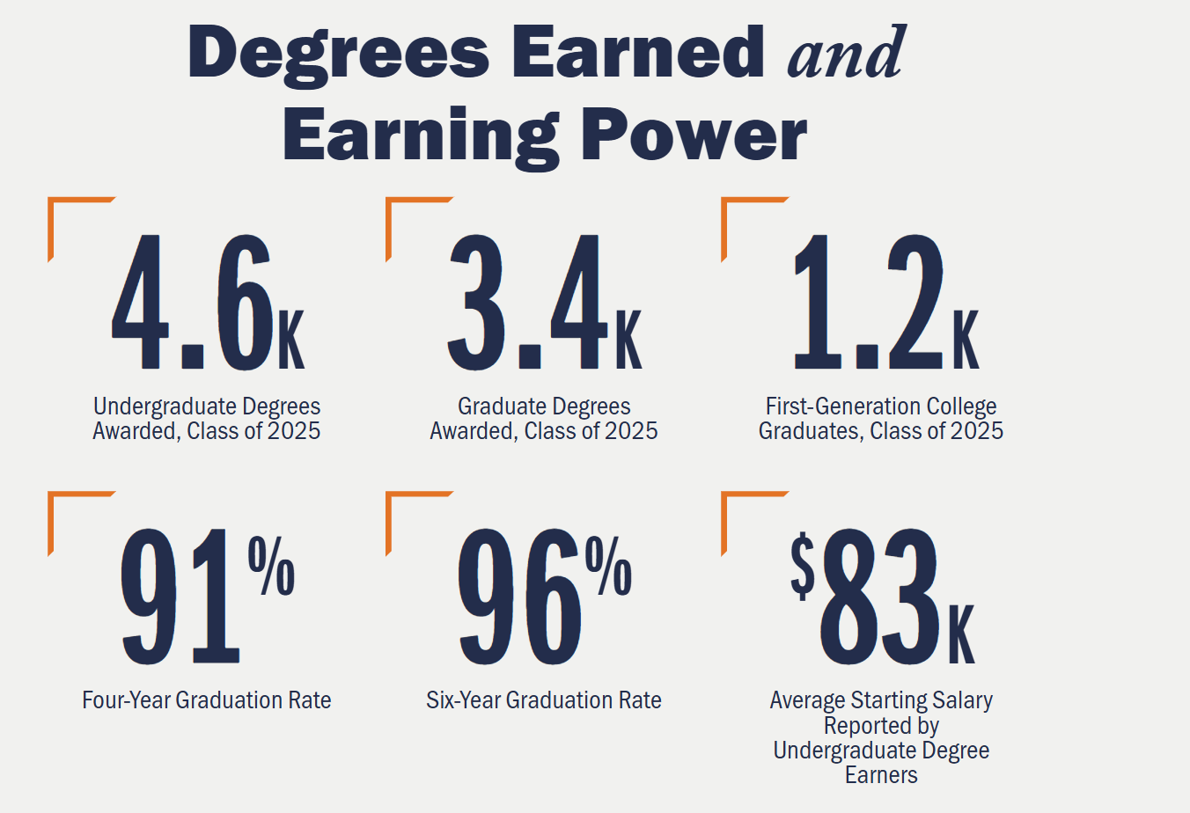

…

[Admission requirement]
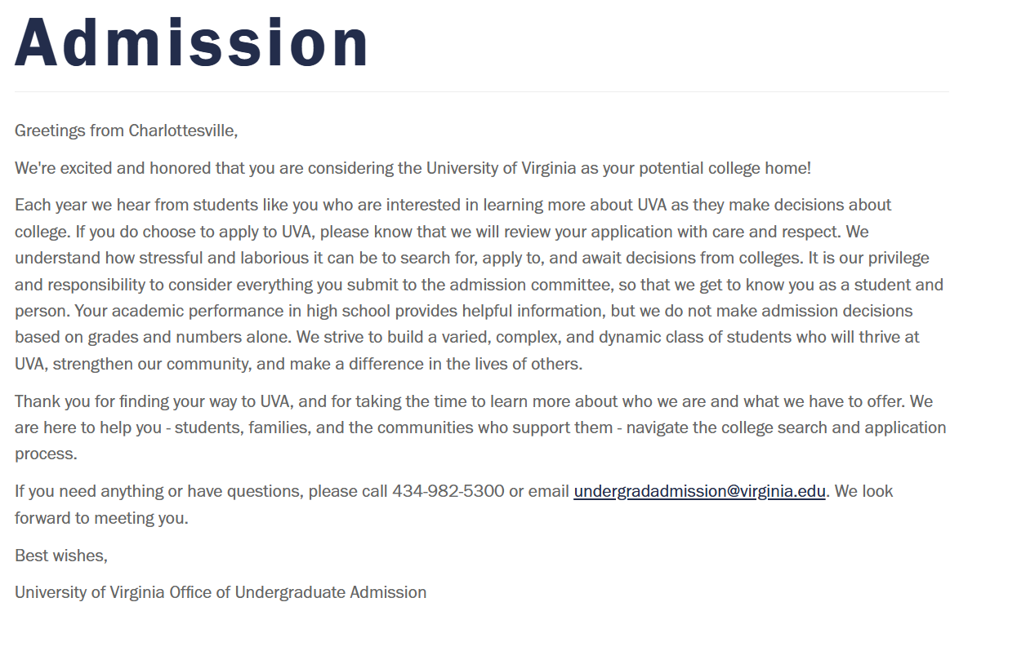

Characteristics & Qualities of Competitive Applicants
Students who are academically successful, capable and/or have the potential to contribute to our vibrant intellectual community at UVA
Successful applicants are students who have done well academically within the context of their high school or college setting, based on their coursework and grades. While taking into consideration what is offered and recommended within a student's school, we are interested in applicants who embrace academic challenges across the curriculum, and who are successful within the classroom space.

We are looking for students who love to learn, solve problems, and are actively engaged with peers in the classroom. These students might have a breadth of academic interests, or they might be more singularly focused on one area of study in college. Most first year applicants are unsure of their intended major or college course of study when they apply, and that is fine. A student's academic focus is only a factor when it applies to their choice of undergraduate school at UVA. First year applicants applying to the College of Arts and Sciences, and Schools of Architecture, Education (Kinesiology), Engineering, and Nursing are reviewed by separate admission teams. The same is true for transfer students who are also able to apply to the Batten School of Public Policy and Leadership and the School of Commerce as well as our Teaching, Youth and Social Innovation, and Speech Communication Disorders programs in the School of Education.

We welcome first year applications from, and offer admission to, students who have grown and evolved as students and young adults while in high school. Applicants do not have to present a perfect academic transcript with all A's and double-digit AP courses to be competitive to UVA as a first-year student, but we do look for applicants who have the ability to contribute to the academic life of the University.

We do not use an algorithm or formula when making admission decisions and we do not have thresholds for GPA's, test scores, or the number of AP, IB, dual enrollment, or Cambridge courses a student must take to be eligible for admission. Each applicant is unique and is reviewed within the context of their unique backgrounds, experiences, opportunities, and challenges. Applicants are encouraged to share these stories and this context, and how they have been shaped by them, in their applications.

Students with potential to live lives of purpose, impact, and service to others
Understanding that students have different opportunities based on their background, school, and community, we look for students who have the potential to make a difference in their community, in the UVA community, and in the world. UVA will support students to help them reach that potential.

We seek students who engage in impactful activities and experiences within their schools and communities, and we are especially interested in how these activities and experiences have shaped their character, skills, and knowledge. These activities need not be high school sponsored organizations or events, nor do they need to consume a student's life. We do not count the number of clubs or teams a student has been involved with during high school in order to predict their level of involvement in these, or other, organizations at UVA. We simply invite students, and those who recommend them, to share information with us that will help us to get to know the applicant as an active member of their family, high school, town, or community.

We are deeply interested in students who show kindness, care, and compassion to others and demonstrate character and integrity in all they do.

We are interested in students who directly or indirectly lead others, or who have the potential to lead, ethically and collaboratively. Students might demonstrate leadership in a variety of ways: leading school or community-based organizations, leading in their home or work, leading in the classroom, or leading by example through their character, work ethic, and an ability to build bridges.

Students who demonstrate a determination to succeed
Some students may have overcome significant challenges or shown unusual resilience in their pursuit of success. They may have succeeded in spite of limited opportunities, advantages or expectations. They may show an unusual determination in their studies, extending beyond the classroom space with their pursuit of knowledge. We encourage students to share with us any information that they feel would help us better get to know them, academically or personally.

Consistent with federal and state law, the University of Virginia does not consider a student’s racial or ethnic status, or the student’s status as the relative of a UVA graduate or a donor to UVA, when making admission decisions. Although students are free to discuss any aspects of their individual experiences in their applications, any such discussion of racial, ethnic, or relationship status will only be considered if it is tied to the student’s unique ability to contribute to the University.

Application cycles & deadlines
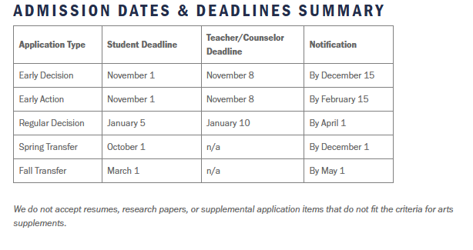

Application Review Process
Our holistic approach to the application process allows us to consider many factors as we read applications and make admission decisions. We do not use a formula, equation, or algorithm during our review.
We take great care to ensure that the application review is comprehensive, thoughtful, and personal. We are grateful to every applicant who has put their faith in us. As such, every application is read by at least one member of our evaluation team and all applications are handled with the utmost respect.
We employ approximately 60 application readers each year. Application readers are often assigned to an evaluation team that is responsible for a geographic region of the state, country, or world. For our first-year application review we divide the regions into several groups:
- Virginians (subdivided by high school or region of the state)
- Non-Virginians who attend high school in the US, and
- International applicants and US citizens/Permanent Residents who live abroad.
Students from these groups are in separate and distinct application pools therefore they are not competing directly with one another for a space in the class. Similarly, students applying to different UVA schools (Arts & Sciences, Engineering, Architecture, Nursing, Education, etc.) are not in the same application pool and are not competing with one another.
Each year we seek to enroll a balance of Virginians and non-Virginians. Most years that balance is approximately 70% Virginian overall. International students are included in the non-Virginian applicant pool and make up approximately 5-6% of the incoming first year students. There are ~3,970 new first year students each fall and ~600 fall transfers. The University also enrolls a small (60-70 students) cohort of transfers in the spring term.
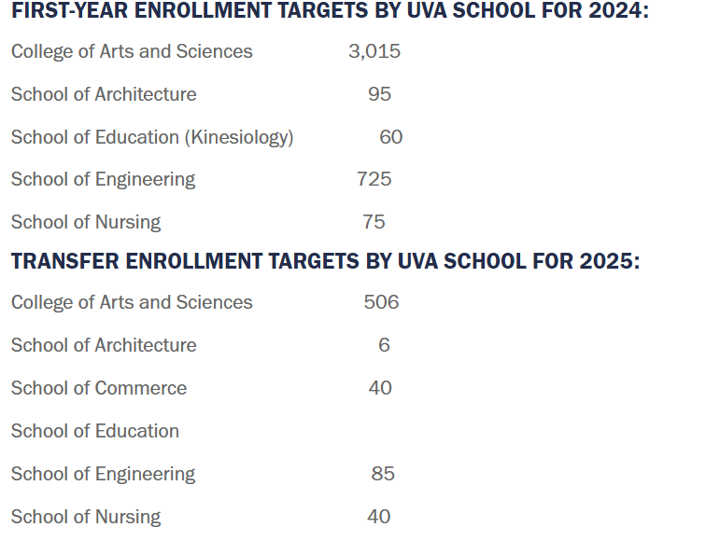
First year students can apply using our Early Decision, Early Action, or Regular Decision plan. Admission rates vary each year but there is no advantage applying to one plan over the other. We offer the exact same financial aid award, regardless of the admission plan. For context, approximately 10% of the total number of offers of admission are made in our Early Decision round.
We seek to enroll students and classes that are in-line with our institutional mission and values. Our students bring with them different opinions, beliefs, backgrounds, life experiences, and political leanings. They come from every corner of the state and globe, and many are the first in their families to attend college.
Race is not a factor in admission decisions. Neither is a student's family history with UVA. We do not have check boxes for race or UVA family affiliation on our application or on our application review form used by readers. At no point during our review does anyone involved in reading applications have access to reports or collective class data that includes race, ethnicity, or family tie to UVA. However, a student's life experience - which can include race/ethnicity, first generation student status, gender, neighborhood, etc. - can be included and we invite students to share any information they feel would help us get to know them on their Common Application.
Admission rates vary depending upon the school and year and are largely driven by application volume. The majority of applicants are capable of being successful students at UVA and we cannot offer admission to every qualified applicant. We are eager to help students find a pathway to UVA through our first-year review or transfer process and we are happy to assist students and families as they make their college decisions.

Large Language Models/ Generative AI
We are interested in who you are, and we value what you have to say. While AI tools can be helpful in generating ideas and centering your thoughts, essays and personal statements that rely more on AI than your original thoughts miss the mark in one incredibly important way: they lack your voice, your ideas, and your very personal reflection on how your experiences have shaped you.
The essays and written supplements are your opportunity to express what is important to you in your own words. Generative AI may play a minor role in your final product by helping you brainstorm essay topics or check for grammar mistakes, but we ask that you do not cut and paste any part of your essay or personal statements from an AI tool. All final submitted materials should be your original work.
As an applicant to UVA, we ask you to sign an honor statement before submitting the Common Application because the UVA community is anchored by trust and integrity. Our students pledge not to lie, cheat, or steal, and we ask the same of our applicants. By agreeing to this honor statement, you are pledging that the application materials you submit to us are your original work, not primarily a product of AI. Thank you for trusting us with your words and your stories.

Early Decision vs. Early Action vs. Regular Decision
We maintain a consistent review throughout the application process so there is no advantage to choosing one application plan over another. We hope to offer students multiple options and the ability to choose the option that is best suited for them. All students applying for financial aid who have submitted the required documents by the priority deadlines will receive a preliminary aid award shortly after admission decisions are released. Below is additional information about our application choices.
Early Decision is a binding admission plan for students who have determined that UVA is their first choice and who feel they can present a strong application without senior grades being reviewed. Students admitted through the Early Decision admission plan are required to cancel their applications elsewhere and enroll in UVA. Decisions of admit, deny, or defer will be released by December 15th. Admitted students are expected to submit deposits by January 15.
Early Action is a non-binding and unrestrictive admission plan that may be an attractive option for those feel they can present a strong application without senior grades being reviewed. We aim to release decisions of admit, deny, or defer by February 15th. Students admitted through the Early Action admission plan will have until May 1 to reserve a spot by in the incoming class.
Regular Decision is a non-binding and unrestrictive admission plan that allows students more time to complete the application and to have grades from the first term of their senior year considered in the review. Students will be notified of their admission decisions of admit, deny, or waiting list by April 1 Students admitted through the Regular Decision admission plan will have until May 1 to reserve a spot in the incoming class.
If you would like to change your chosen plan for Early Decision or Early Action, you must email us by 5 PM on November 6th.

School Choice & Academic Interests
There are eight undergraduate schools at UVA. First-year applicants can apply to:
College of Arts & Sciences
School of Architecture
School of Engineering
School of Nursing
Kinesiology

Those interested in the McIntire School of Commerce, Batten School for Leadership and Public Policy, School of Data Science, or programs in the School of Education and Human Development other than Kinesiology should apply to the College of Arts and Sciences.

You may list two academic interests in addition to your undergraduate school choice. Unless you are applying to the School of Nursing or Kinesiology program, you will not declare a major at UVA until the end of your first or second year.

You may change your school/program of entry by emailing us by 5 PM on November 22nd (Early Decision/Early Action) and January 15th (Regular Decision). Admitted students should plan to enroll in the school to which they have applied.

Transfer students, please consider the transfer course requirements for each school when making your selection.

Standardized Testing
Test Optional
If you're applying for first year admission for Fall 2026, you'll have the choice of sharing or not sharing standardized test scores. Whichever path you choose, we'll consider your application with care and respect, and you won't be disadvantaged because of the choice you've made. The transfer process remains test optional.
You may change your test optional decision by emailing us by 5 PM on November 22nd (Early Decision/Early Action) and January 15th (Regular Decision).
Reporting Scores
Applicants who wish to have SAT, ACT, AP, or IB testing considered during the application process should opt to submit scores and self-report them on the application. After the deadline, applicants may submit updated scores through their portal. Admitted students who applied with testing and decide to enroll at UVA must request official score reports for verification. Our ETS code is 5820. Our ACT code is 4412.
Super-scoring
Super-scoring has been the a long-held practice at UVA. For applicants submitting test scores, we consider the best combination of section scores without recalculation. Report your scores (section scores for the SAT or composite and sub-scores for the ACT) as they appear on your official score report. Our system will do the rest for you.
The ACT Writing sections are not used in our review.
TOEFL/IELTS
Students whose first language is not English or who have attended an English-speaking school for fewer than two years are encouraged to provide evidence of their English proficiency by submitting the results of the TOEFL or the IELTS.

School Forms & Recommendations
We require the secondary school report and one teacher evaluation from an academic subject teacher for each first-year application.
Your school counselor can submit the secondary school report online. A counselor recommendation can be submitted with the secondary school report. Your academic teacher recommendation should also be submitted online. In addition to the secondary school report, your counselor should submit the school profile and your transcript(s) online.
If your counselor is unable to write a recommendation letter, please request that the secondary school report still be completed and submitted online. If your counselor is unable to provide a written recommendation, you may submit a recommendation from another school administrator or academic teacher if possible. Please know that in this situation, a counselor recommendation is not required for your application to be reviewed.
If your school is unable to submit these documents electronically, they can be mailed.

Arts & Architecture Supplements
Arts Supplements
The Admission Office actively seeks artists, musicians, dancers and students in all areas of theatre to invigorate our community through their dedication to the arts.
Students who exhibit exceptional talent in the arts may submit an arts portfolio through the Common Application via Slideroom. This portfolio is an optional part of the application process and is intended for those who plan to engage seriously in the University’s arts departments as students. Completed portfolio evaluations are shared with the admission committee and are considered as part of the overall application review. These portfolios are not required to enroll in arts-related classes at the University of Virginia and will only be used for the admission process. If a student who has already submitted their Common App wants to submit an art supplement, they may create a Slideroom account using their Common App ID.
Supplemental portfolios must be received by the application deadline and adhere to departmental guidelines to guarantee review.
Architecture Supplements
All transfer applicants interested in majoring in Architecture are required to submit a portfolio following the guidelines and submission requirements on the School of Architecture website. Transfer applicants interested in Urban Planning and Architectural History are not required to submit portfolios.

Residency
If you wish to claim entitlement to Virginia in-state educational privileges pursuant to the Code of Virginia, Section 23-7.4, you must complete the residency section of the application. If supporting documents are requested after an application is submitted, fax them to 434-982-2663. See the Office of Virginia Status website for more information.

Demonstrated Interest
We do not track attendance at tours, information sessions, high school visits, or other programs (commonly referred to as demonstrated interest) to use during the application review.

Submitting Updates After Deadline
All application updates should be uploaded via the student portal. Applicants received an email with login credentials for the portal a few days after their Common App was received. Once the "upload" button is clicked for a document, it is automatically added to your file and will be visible to admission staff. Only required components are shown on the checklist in the portal.

Please do not email updates or duplicates to admission officers.

Large Language Models/Generative AI
We are interested in who you are, and we value what you have to say. While AI tools can be helpful in generating ideas and centering your thoughts, essays and personal statements that rely more on AI than your original thoughts miss the mark in one incredibly important way: they lack your voice, your ideas, and your very personal reflection on how your experiences have shaped you.
The essays and written supplements are your opportunity to express what is important to you in your own words. Generative AI may play a minor role in your final product by helping you brainstorm essay topics or check for grammar mistakes, but we ask that you do not cut and paste any part of your essay or personal statements from an AI tool. All final submitted materials should be your original work.
As an applicant to UVA, we ask you to sign an honor statement before submitting the Common Application because the UVA community is anchored by trust and integrity. Our students pledge not to lie, cheat, or steal, and we ask the same of our applicants. By agreeing to this honor statement, you are pledging that the application materials you submit to us are your original work, not primarily a product of AI. Thank you for trusting us with your words and your stories.

Statistics
The statistics below are the result of a holistic application review process. We do not have GPA or testing cut-offs or targets. While we do seek to maintain a 2/3 majority of Virginians in our student population, we do not have quotas for specific high schools, towns, counties, or regions.
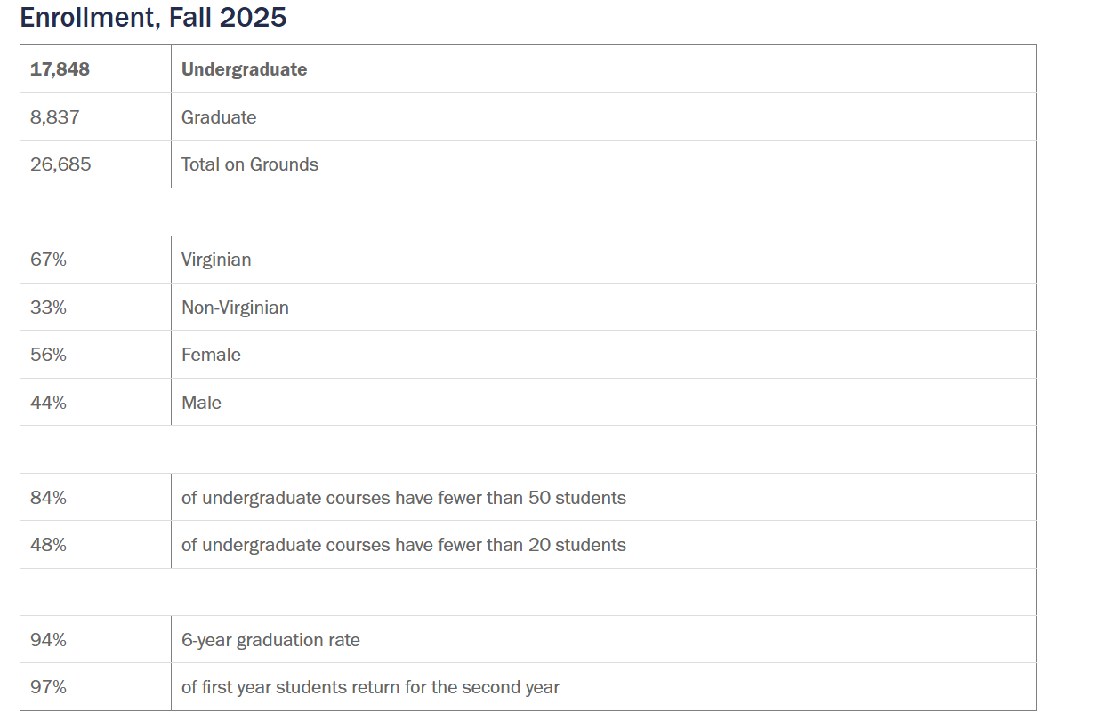
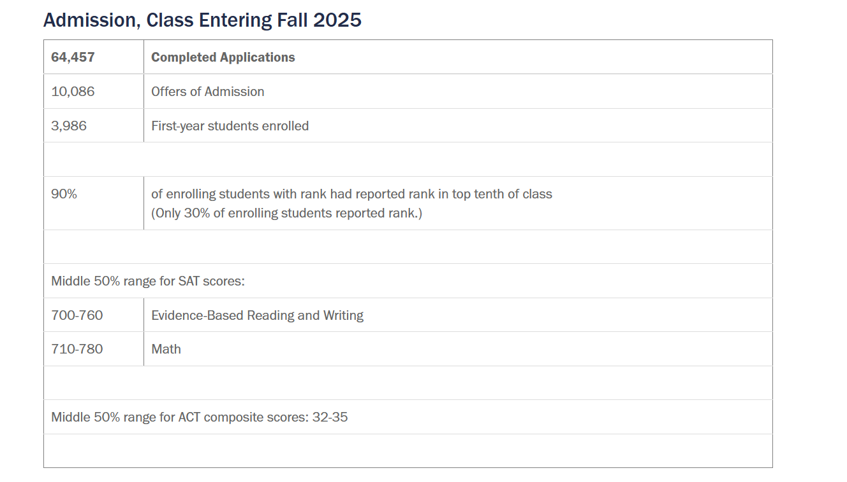

FAQ (Frequently asked questions)

When will I get an admission decision?
Early Decision applicants can expect decisions on or around December 15th. Early Action applicants can expect decisions by February 15. Regular Decision applicants can expect decisions by April 1. Keep an eye on the admission blog and our social media accounts for updates!
Does UVA offer application fee waivers?
Yes. You are eligible to receive an application fee waiver if:
- You are enrolled in or eligible to participate in the federal free or reduced price lunch program.
- You have received or are eligible to receive and SAT or ACT fee waiver.
- Your annual family income falls within the income eligibility guidelines set by the USDA Food and Nutrition Service.
- Your family receives public assistance.
- You are enrolled in a federal, state, or local program that aids students from low-income families (e.g., GEAR UP, TRIO such as Upward Bound or others).
- You live in a federally subsidized public housing, a foster home or are homeless.
- You are a ward of the state or an orphan.
- You have received or are eligible to receive a Pell Grant.
- You can provide a supporting statement from a school official, college access counselor, financial aid officer, or community leader.
Students who do not meet any of these criteria but would like to request a fee waiver based on extenuating circumstances should contact the Office of Admission.
Does UVA super-score the SAT or ACT?
For applicants submitting test scores, it has been the Office of Admission’s long-standing policy to consider the best test scores submitted by applicants. We use the top score from each SAT section across all administrations of the same exam. We hope you will submit all of your scores knowing that we will recombine the sections to get the best possible set of scores. If reporting an ACT score, report the composite and sub-scores as they appear on your official score report without any recalculation.

Can I submit a recommendation from someone who knows me outside of school?
We require one recommendation from a teacher of an academic subject so that we can learn more about your school performance. While you are welcome to submit an extra recommendation, we prefer letters that provide insight into your classroom style.
Members of the UVA community may submit recommendations using this form.

Will you fill the majority of the class through Early Decision?
We will not fill our class during the Early Decision process. We hope that you will submit your application when you feel it is in a strong position. Remember that Regular Decision applicants will have grades from the first semester of senior year in their files before we finalize our decisions.

What percentage of applicants are admitted?
We have pledged to maintain a 2/3 majority of Virginia residents in our student population, but 2/3 of our applicants tend to come from out-of-state. As a result, our offer rate for Virginia residents tends to be much higher than the rate for out-of-state students. Last year, we admitted 25.5% of the Virginia residents and 13% of the non-Virginians. You can see data from previous years on the Office of Institutional Assessment website.

Is a student's level of interest used in the selection process?
No. When we read your application, we will not use previous contact as a factor in our review.

What AP/IB/A level scores do I need to get credit?
We generally give credit for scores of 4 or 5 on AP exams and 5, 6, or 7 on Higher Level IB exams. There are some exceptions to this and practices can vary from one school to another. The Undergraduate Record has specific information about AP and IB credit.

Does UVA prefer AP, IB, Cambridge or dual enrolled curricula?
We do not have a preference for one type of course. We suggest that students take advantage of advanced course options at their high school, regardless of the type of curriculum available.

Do you prefer applicants submit the SAT or ACT?
We are test optional for the Fall 2026 cycle and have no preference between the SAT and ACT.

What minimum GPA and test scores do I need to be admitted?
We don't have a minimum GPA. We don't have a minimum SAT score.
As strange as these answers sound, they're both true. A cumulative GPA only reveals so much; it says little about the difficulty of a student's course load, or whether a student's grades have improved over time, or the level of grade inflation (or deflation) in a student's school. If we established a firm minimum GPA, a point below which no applicant would have any chance of being admitted, we'd miss a fair number of students who might make UVA a better, stronger place.
The same is true for SAT scores. Most people who work in admission at highly selective universities believe that standardized testing is a useful but imprecise instrument. Setting an absolute minimum would be asking these tests to do something they weren't designed to do.
Of course, our applicant pool is broad and deep, so most admitted students have excelled in school and scored well on the SAT or ACT. But remember that we don't have set minimums for either and we try hard to take into account all of the information we see in each application.

International Student & Scholar FAQ: Status, Entry, Rights | International Students & Scholars Program

Contact information
Admission (Undergraduate)
Peabody Hall
P.O. Box 400160
Charlottesville, VA 22903-4160
Phone: 434-982-3200
Office of Major Events
Madison Hall
1827 University Avenue
Charlottesville, VA 22903
Phone: 434-982-3099
Dean of Students
Peabody Hall
P.O. Box 400708
Charlottesville, VA 22904
Phone: 434-924-8900
Education Abroad
(International Studies Office)
208 Minor Hall
P.O. Box 400165
Charlottesville, VA 22904
Phone: 434-982-3010
Athletics (Virginia Athletics Communications)
John Paul Jones Arena
295 Massie Road
Charlottesville, VA 22904 (Room 154)
P.O. Box 400853
Phone: 434-982-5500

