  - Capacitive Series

Tactile Data Acquisition Glove
  - Capture Contact and Force Data from Human Demonstrations
The Apex Sensing Tactile Data Acquisition Glove captures contact locations, timing and forces during human demonstrations for physical AI model training. It adds tactile measurements to human-centric datasets, complementing video and hand-motion data to characterize how people grasp and manipulate objects.
Flexible capacitive sensor arrays on the fingertips and palm capture normal and shear force data at 240 Hz. Export recordings as CSV for dataset preparation or stream data over TCP into multimodal collection pipelines. The glove runs standalone or alongside third-party hand-tracking systems.
7 Sensing Regions | 290 Sensing points | 240 Hz | < 80 g
Five fingertips & two palm regions | Per glove | Tactile sampling rate | Weight per glove

Core capabilities and applications

Fingertip and palm coverage
7 sensing regions cover the five fingertips, central palm and pinky-side palm (hypothenar). Capture region-level contact and force distributions throughout each demonstration.

High-density tactile sensing
290 sensing points per glove, sub-2.5 mm fingertip spatial resolution and a normal-force detection threshold below 0.2 N resolve localized contact and light touch for dexterous manipulation and contact-state analysis.

Normal and shear force data
Measure normal force together with shear magnitude and direction to characterize tangential loading and contact transitions, for studying grasp stability, incipient slip and contact-state dynamics.

Glove-specific calibration
Per-glove force calibration files and one-click zeroing after donning compensate for fit-dependent baseline variation and unloaded offsets, supporting consistent measurements across users, gloves and collection sessions.

Offline export and live streaming
Export to CSV or stream via TCP/JSON for dataset archiving, offline analysis and real-time integration with your acquisition stack, data processing, model training and validation pipelines.

Lightweight wired acquisition
Under 80 g per glove, USB-powered, with total system power below 1 W. Minimal wearable burden and simple setup support repeated demonstrations and long-duration data collection.
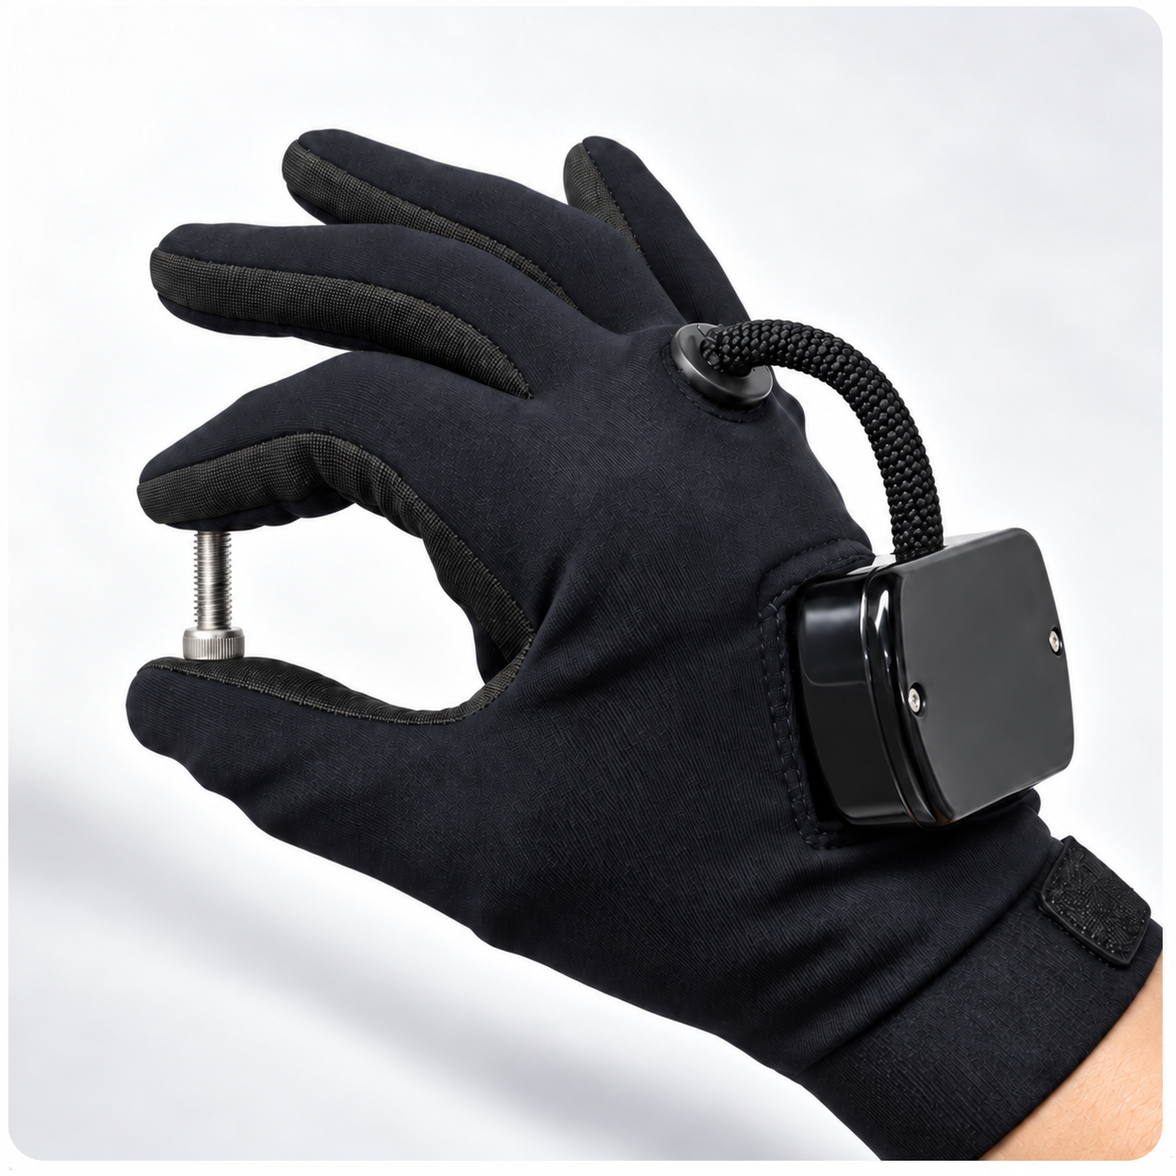
Tactile data collection during human manipulation using the Tactile Data Acquisition Glove.
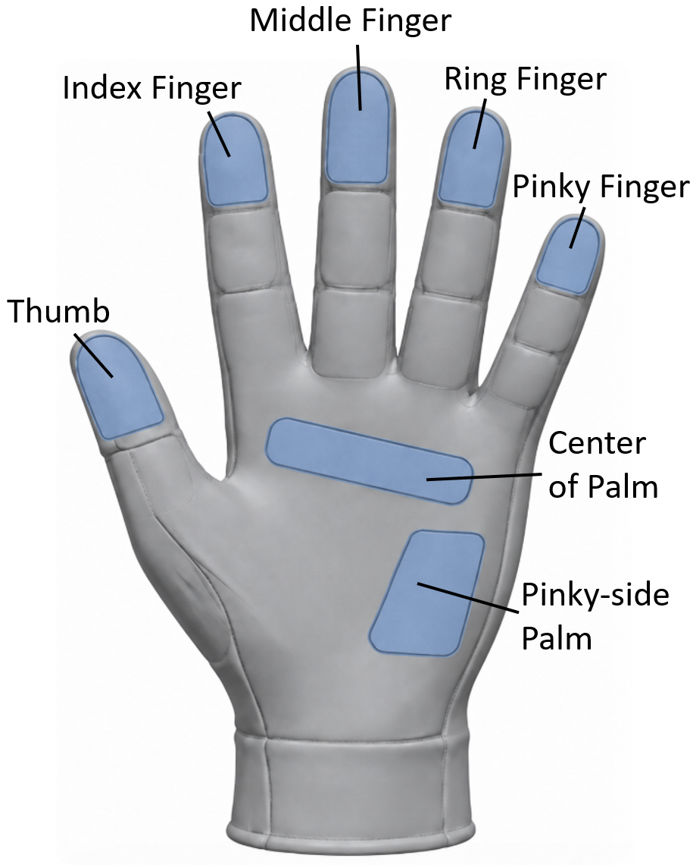
7 tactile sensing regions across the fingertips and palm

From setup to usable data
Connect the glove to a PC over USB and start recording. The acquisition software provides live tactile heatmaps, recording, playback and export. CSV files are organized by hand and sensing region, ready for dataset curation. For live pipelines, TCP streaming sends device and channel metadata before tactile frames, making each stream self-describing for your data platform and training workflow.
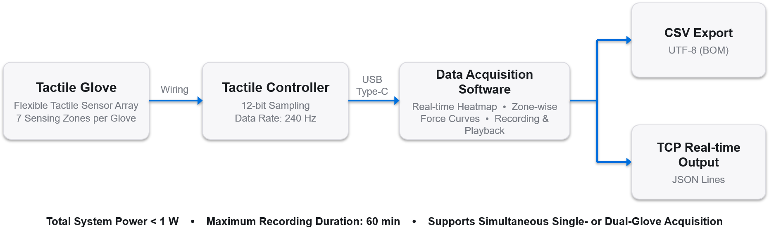
Tactile data collection and export workflow.

Technical specifications
Parameter | Specification | Parameter | Specification
Sensing technology | Capacitive | Sampling rate | 240 Hz (full-hand scan)
Sensing modality | Normal and shear force | ADC resolution | 12-bit
Sensing regions | 5 fingertips + 2 palm regions  (central and hypothenar) | Power and interface | USB Type-C  System power < 1 W
Sensing points per glove | 290 | Operating system | Windows 10 / 11 (64-bit)
Minimum detectable normal force | Fingertip: < 0.2 N  Palm: < 0.8 N | Recording duration | Up to 60 min per session
Maximum detectable normal force | Fingertip: 15 N  Palm: 15 N | Data export | CSV (UTF-8 with BOM)
Normal force resolution | 0.1 N | Real-time output | TCP streaming / JSON Lines
Maximum detectable shear force | Fingertip: 8 N  Palm: 8 N | Interface languages | English
Shear direction resolution | < 10° | Glove size | XL, 260 × 160 mm
Spatial resolution | Fingertip: < 3.5 mm  Palm: < 5 mm | Glove weight | < 80 g
Operating environment | −5 to 45 °C

Configuration and package contents
Hardware configuration. Each glove provides 290 sensing points across seven regions. Sold in left–right pairs. Each glove has a unique device ID and a dedicated force-calibration file.
Package contents. Left and right tactile gloves, controller, USB cable, glove-specific force-calibration files, acquisition software and user manual.
Optional integration. Pair with a third-party hand-tracking system to view tactile and hand-pose data in one interface. Device compatibility, recorded data streams and time alignment are confirmed per setup. Contact us to confirm Linux, SDK and ROS support for your application.
Specifications based on Apex Sensing software V1.1.3 and hardware V1.0. Oct 2026. Performance depends on hand size and fit.

