
FULAI TACTILE GLOVE
User Manual
Tactile data acquisition glove and FULAI Data Acquisition Software
Software FULAI Data Acquisition Software V1.1.6
Hardware FULAI Tactile Glove V3.0 – V3.4
Platform Windows 10 / 11 (64-bit)
Release date 2026-11-04

Introduction
The FULAI Tactile Glove is a high-density tactile sensing glove designed for robotic manipulation and human–object interaction research. Tactile sensor arrays on the fingertips and palm measure both normal and shear forces, capturing the full contact pressure distribution and per-zone forces whenever the hand interacts with an object.
The companion FULAI Data Acquisition Software provides real-time pressure heatmaps and zone force plots, session recording and playback, CSV export, and real-time data streaming over TCP in JSON Lines format. It supports single-hand and dual-hand acquisition, with built-in force calibration import and tactile zeroing, so glove data can feed directly into your algorithms and robotic systems.
Tactile acquisition runs standalone and does not require a third-party hand tracking system. To capture hand pose as well, add the optional hand tracking hardware and enable Pose Data in the software (see Appendix A).
This manual covers FULAI Data Acquisition Software V1.1.6 and FULAI Tactile Glove V3.0 to V3.4. The software requires 64-bit Windows 10 or 11 and a graphics card that supports OpenGL 3.3 or later.

Key features
Feature | Description
Real-time display | Live pressure heatmap of the hand and force–time plots for each sensing zone.
Recording and playback | One-click recording with playback at 0.5×, 1.0×, 1.5×, or 2.0×. There is no limit on recording duration or number of recordings; storage is limited only by available disk space. Recording stops automatically if the device disconnects or the disk becomes full (see Chapter 10).
CSV export | Export recordings to CSV, including the left and right Glove IDs, calibration status, zone forces, and per-taxel pressure.
TCP streaming | Stream data in real time over TCP in JSON Lines format (default 127.0.0.1:9870) for use in other applications.
Calibration and zeroing | Import the force calibration file for each glove. Tare the tactile sensors with one click after putting on or reconnecting the glove.

Contents
Introduction 1
1. Product Overview 3
2. Specifications 4
2.1 General 4
2.2 Tactile Sensing 4
2.3 Electronics 5
2.4 Data Processing 5
3. Quick Start 6
4. Hardware Setup 9
4.1 Package Contents 9
4.2 Connecting the Hardware 9
5. Installation and Startup 11
5.1 System Requirements 11
5.2 Installation 11
5.3 Starting the Software 11
5.4 Finding the COM Port 11
5.5 Troubleshooting a Blank 3D Viewport (OpenGL) 12
6. Connecting the Gloves 13
7. Force Calibration and Tactile Zeroing 15
7.1 Importing Force Calibration 15
7.2 Tactile Taring 16
8. Main Window 17
8.1 Toolbar 19
8.2 Mouse Controls 19
8.3 Keyboard Shortcuts 20
9. Interpreting the Pressure Heatmap and Zone Force Plots 21
10. Recording, Playback, and Data Management 22
10.1 Recording 22
10.2 Recording Rate and Duration 22
10.3 Storage Location 22
11. CSV Data Format 24
11.1 Recording Information Columns 24
11.2 Zone Force Columns 24
11.3 Per-Point Columns 25
12. TCP / JSON Streaming 26
12.1 The meta Message 26
12.2 The frame Message 27
13. Display Settings and Demo Mode 28
14. Pre-Recording Checklist 29
15. Troubleshooting 30
16. Default Settings 31
16.1 User Settings 31
16.2 Factory Connection Defaults 31
17. Technical Support 32
Appendix A. Hand Pose Tracking (Optional) 33
A.1 Connecting via the Wireless Receiver 33
A.2 Pose Calibration 33
A.3 Hardware Calibration 34
A.4 Connecting via UDP 34
A.5 Troubleshooting 35
Appendix B. Glossary 36

1. Product Overview
The FULAI Tactile Glove captures tactile data during hand–object interaction, including the pressure at each taxel and the normal and shear forces in each sensing zone. Paired with the FULAI Data Acquisition Software, it supports the complete data acquisition workflow, from real-time visualization and recording to playback, CSV export, and real-time TCP streaming.
If you are new to the glove, start with Chapter 3, Quick Start, to connect the device, tare the sensors, and make your first recording. For an overview of the main window, see Chapter 8.

2. Specifications

2.1 General
Parameter | Value
Glove size | XL, 260 × 160 mm
Weight | < 80 g
Sensing zones | 7 zones on the fingertips and palm: five fingertips, palm, and hypothenar (thenar zone optional)

2.2 Tactile Sensing
Parameter | Value
Force sensing | 3D force (normal + shear)
Sensing points per hand | V3.0: 415; V3.1: 401; V3.2 / V3.3 / V3.4: 562
Normal force trigger threshold | Fingertip: < 0.4 N; palm: < 3 N
Normal force range | Fingertip: 15 N; palm: 25 N
Normal force resolution | 0.1 N
Normal force accuracy | Fingertip: 20–30% FS; palm: 30% FS
Shear force trigger threshold | Fingertip: < 1 N; palm: < 4 N
Shear force range | Fingertip: 8 N; palm: 15 N
Shear force resolution | < 1 N
Shear direction resolution | < 10°
Shear force accuracy | 2 N
Spatial resolution, fingertip | < 2.5 mm
Spatial resolution, palm | < 4 mm
Point-to-point uniformity | < 20%
Unit-to-unit consistency | < 35%
Signal drift, constant load | < 10% per decade of time (log₁₀ t)
Signal drift, temperature | < 1% / °C
Cycling stability | Fingertip: < 25% @ 50% FS; palm: < 35% @ 50% FS

Test conditions
- Trigger threshold: The palm is tested with a 10 mm diameter flat-ended rigid cylindrical indenter. All other zones are tested with a 15 mm diameter indenter.
- Normal force accuracy: Same indenters as above. Accuracy = |mean measured value − applied force| / full scale × 100%, taken at the point of maximum error within the range.
- Shear force accuracy: Same indenters as above, with shear applied along the sensing surface. Accuracy = |mean measured value − applied shear force| / full scale × 100%, taken at the point of maximum error.
- Point-to-point uniformity: A 70% FS load is applied to all fingertips and recorded once values are stable. Coefficient of variation = standard deviation / mean × 100%.
- Unit-to-unit consistency: 10 randomly selected units, 70% FS load, recorded once values are stable. Coefficient of variation = standard deviation / mean × 100%.
- Signal drift, constant load: 15 mm indenter, 10% FS load, signal monitored for 8 hours. Drift = |initial output − final output| / (full-scale output × log₁₀(time span in seconds)) × 100%.
- Signal drift, temperature: 8 mm indenter, 280 g static load, temperature raised from 30 °C to 50 °C. Temperature coefficient = (output at high temperature − output at reference temperature) / (full-scale output × temperature difference) × 100%.
- Cycling stability: 15 mm indenter, 50% FS load, signal compared before and after 1,000 load cycles. Drift = (maximum output − minimum output) / full-scale output × 100%.
Note FS = full scale. Actual performance depends on hand shape, glove fit, test method, and software settings.

2.3 Electronics
Parameter | Value
Power supply | USB Type-C
Power consumption | < 1 W
Controller internal bus | UART, 2 Mbps
ADC resolution | 12-bit
Frame rate | 100 Hz (8 sensor boards polled in 10 ms)

Note The 2 Mbps rate refers to the internal UART bus between the controller and the sensor boards. The Tactile Baud Rate setting in the software (default: 2000000) configures the serial link between the computer and the controller. Although the values are numerically the same, they apply to separate communication links.

2.4 Data Processing
Algorithm | Runs on | Description
Normal force | Software (PC) | Converts sensor signals to force using the glove's force calibration file (JSON).
Shear force | Software (PC) | Estimates shear magnitude and direction for each sensing zone.

3. Quick Start
Follow these steps to connect the glove, zero the sensors, and record and export tactile data.
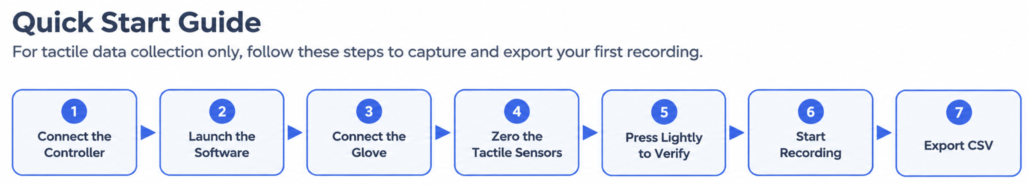
Figure 1. Quick Start workflow.
- Connect the Tactile Controller. Connect the Tactile Controller to your computer via USB. In Device Manager, check that a new COM port appears.
- Start the software. Double-click Fulai_Tactile_Glove_Production.exe. Check that the window title reads Tactile Data Acquisition and the status bar shows software version V1.1.6.
- Configure the data connection. Open Settings → Data Connection and select Tactile Data. Select the Glove Version shown on the glove label and the correct COM port. For tactile-only recording, leave Pose Data cleared.
- Enter Glove IDs and import calibration. Enter the Left Glove ID and Right Glove ID, then import the force calibration file for each glove. The calibration status changes to Imported.
- Connect. Click Connect. The button changes to Disconnect, and Tactile Status in the status bar shows Connected.
- Zero the sensors. Open your hand naturally without touching anything, then click Tactile Zero in the title bar. The icon briefly turns green.
- Check the response. Press lightly on an object. The pressure heatmap and zone force plots should respond immediately.
- Record. Click Start Recording, perform the task, then click Stop Recording. The recording status changes to Completed.
- Export. Export the recording to CSV. Check that the file opens correctly in Excel as UTF-8 and contains the Elapsed Time (s) column.
Tip Force calibration is performed at the factory. You only need to re-import the calibration file when you switch to a different computer or glove. For day-to-day use, simply run Tactile Zero each time you don the glove, reconnect it, or before an important recording.

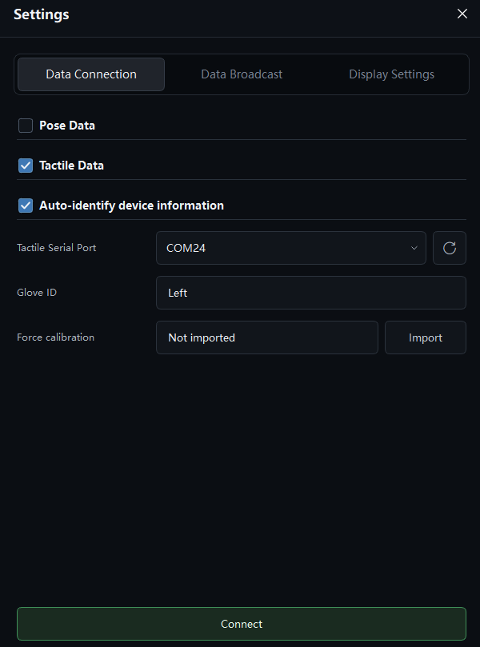
Figure 2. Data Connection page before connecting. Select the glove version, hand, and COM port, enter the Glove IDs, and import the force calibration files. After you connect, the button changes to Disconnect and device information is detected automatically.

Figure 3. Title bar. The first circular-arrow icon from the left is Tactile Zero (Tare).

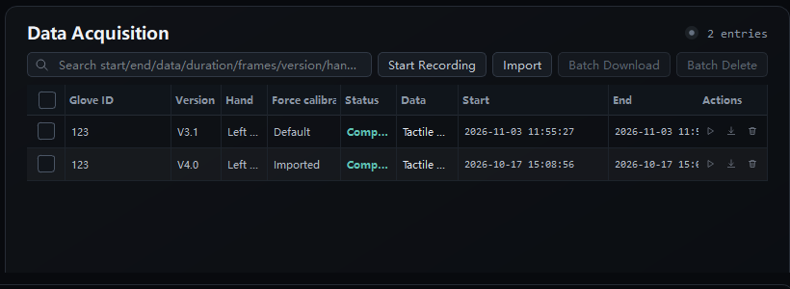
Figure 4. Recording panel. Click Start Recording; while recording, the button changes to Stop Recording.
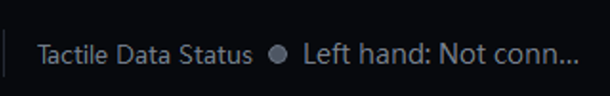
Figure 5. Tactile Data Status in the status bar, shown here as not connected. Make sure the glove is connected before you start recording

4. Hardware Setup

4.1 Package Contents
- Tactile gloves (left, right, or as ordered)
- Tactile Controller with USB cable
- Force calibration file for each glove, typically named <Device Code>_left.json / <Device Code>_right.json
- FULAI Data Acquisition Software installer or extracted folder

4.2 Connecting the Hardware
Each glove connects to your computer through a Tactile Controller. The controller connects to the computer via USB and to the glove via its glove cable. For single-hand acquisition, connect only the glove you intend to use.
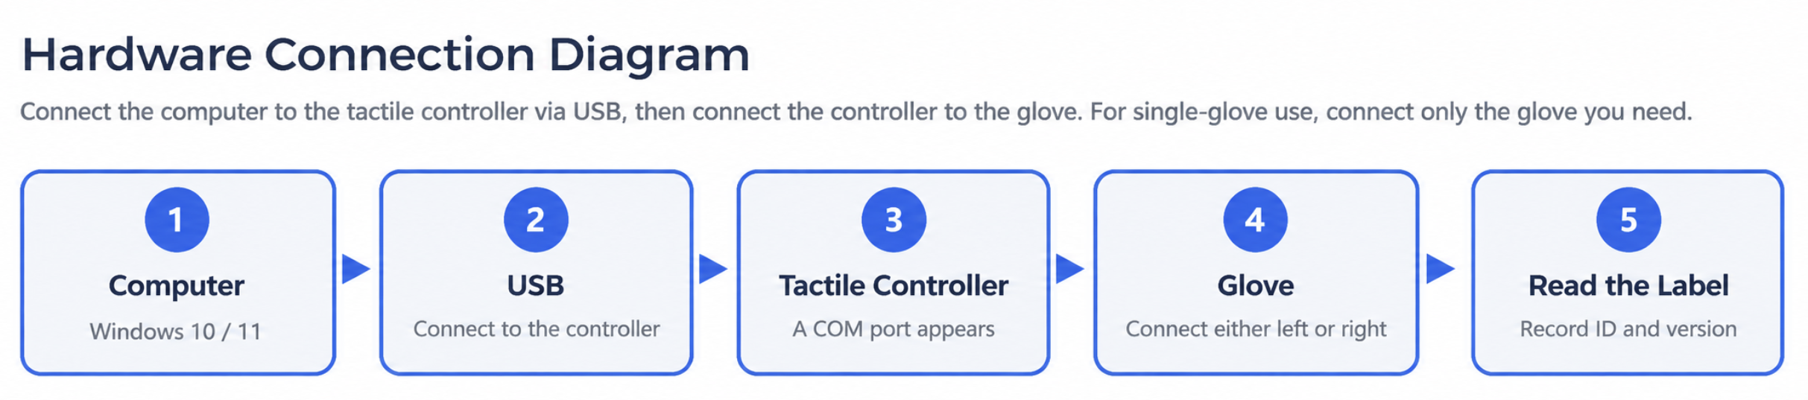
Figure 6. Hardware connection.
- Install FULAI Data Acquisition Software V1.1.6 on your computer (Windows 10 / 11).
- Connect the Tactile Controller via USB. It is identified as VID:PID 0483:5740.
- Open Device Manager → Ports (COM & LPT) and check that a new COM port appears. The default Tactile Baud Rate in the software is 2000000.
- Under Hand Selection, select Left or Right for single-hand recording. For dual-hand recording, select Both and assign a different COM port to each hand.
- Select the Glove Version that matches the wrist label, enter the label's Device Code in the matching Left Glove ID or Right Glove ID field, and import the force calibration file.
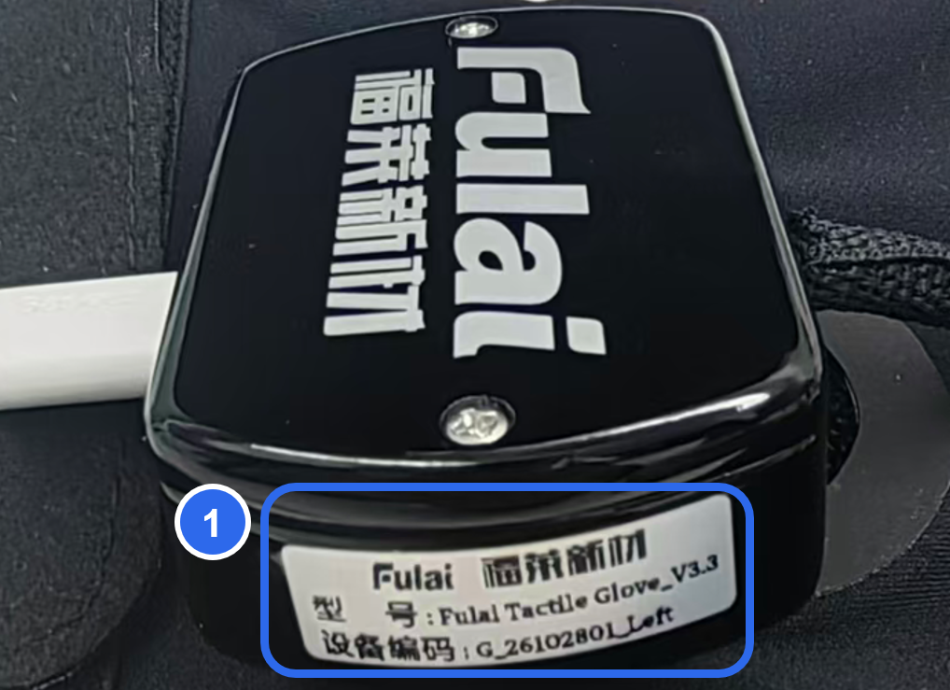
Figure 7. Label location. ① The white label is on the side of the wrist controller.
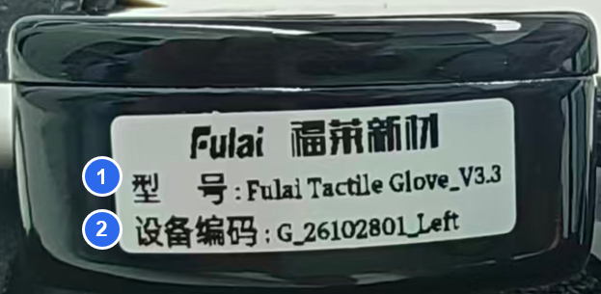
Figure 8. Label detail. ① Model → Glove Version in the software. ② Device Code → Left Glove ID or Right Glove ID.
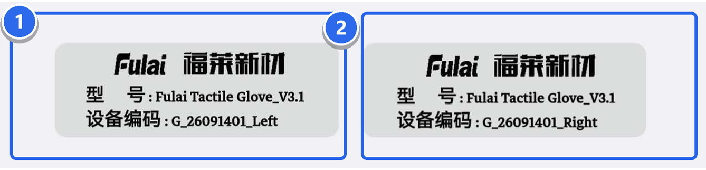
Figure 9. Left and right glove labels. ① Left. ② Right. Import the matching force calibration file for each hand; do not swap them.
The table below shows how the wrist label fields correspond to the software settings. Each glove has a unique Device Code. Make sure the left and right Glove IDs are not swapped, and do not enter the Model in a Glove ID field.
Setting | Description
Single-hand mode | Select Left or Right under Hand Selection. Configure and connect only that glove.
Dual-hand mode | Each glove uses its own COM port. Select the port for each hand separately.
Right-hand auto-detect | Auto-detect is enabled for the right-hand port by default. To use only the left hand, select Left and configure the left-hand COM port.
Left / Right Glove ID | The Device Code on the wrist label. Enter each glove's ID separately.
Glove Version | The Model on the wrist label. For example, if the label reads FulaiTactileGlove_V3.1, select V3.1.
Force calibration | The calibration file must match the glove and its version. Import a separate file for each hand.

5. Installation and Startup

5.1 System Requirements
- Windows 10 or Windows 11, 64-bit
- Dedicated graphics or recent integrated graphics with OpenGL 3.3 support
- A free USB port. For dual-hand recording, the computer must be able to enumerate two serial ports at the same time.

5.2 Installation
- Get the FULAI Data Acquisition Software package from FULAI or the designated download channel.
- Extract it to a local folder, for example D:\FULAI\Gloves. Do not run the software from inside the archive.
- Administrator rights are usually not required. If your antivirus software blocks the program, add the folder to its allow list and try again.
- If no COM port appears in Device Manager, install the USB-to-serial driver for the controller (typically CH340, CP210x, or STM32 VCP, depending on your device).

5.3 Starting the Software
Open the installation folder and double-click Fulai_Tactile_Glove_Production.exe. You can also run RUN_APP.cmd.
When only tactile data is enabled, the title bar shows Tactile Data Acquisition and the window title is FULAI Tactile Data Acquisition. The status bar shows the software version (V1.1.6).
Note Only one instance of the software can run at a time. If you start it again, a message appears and the open window is brought to the front. This prevents two processes from competing for the same serial port.

5.4 Finding the COM Port
- Plug in the Tactile Controller.
- Right-click Start → Device Manager, then expand Ports (COM & LPT).
- Note the new COM port number, for example COM24.
- In the software, go to Settings → Data Connection, click the refresh button next to the port list, and select that COM port.
Tip To confirm which port belongs to the controller, unplug it. Its COM port disappears, and appears again when you plug it back in.

5.5 Troubleshooting a Blank 3D Viewport (OpenGL)
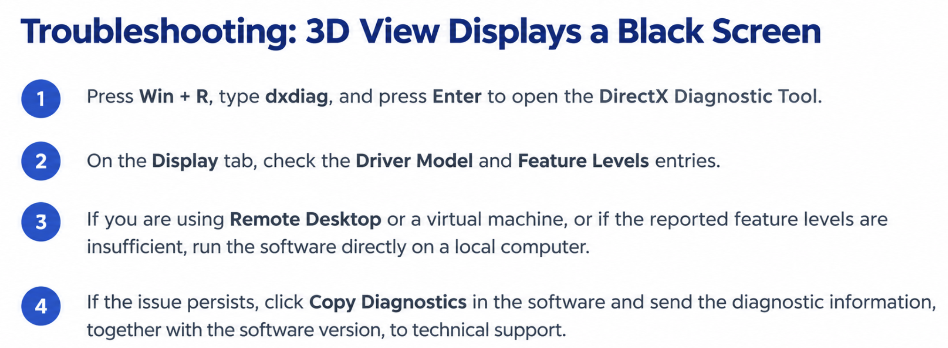
Figure 10. Troubleshooting a blank 3D viewport.
Rendering the 3D hand model requires OpenGL 3.3 or later. Remote desktop sessions, virtual machines, and systems without GPU hardware acceleration typically cannot provide OpenGL 3.3, so the viewport may appear black. If this happens, run the software directly on a local computer and make sure your graphics driver is up to date. If the issue persists, click Copy Diagnostics and send the diagnostic report, along with your software version, to FULAI support.

6. Connecting the Gloves
Click the Settings icon in the title bar and open the Data Connection tab. Configure the glove version, serial port, Glove ID, and force calibration file, then click Connect. Figure 2 shows an example of a completed configuration.
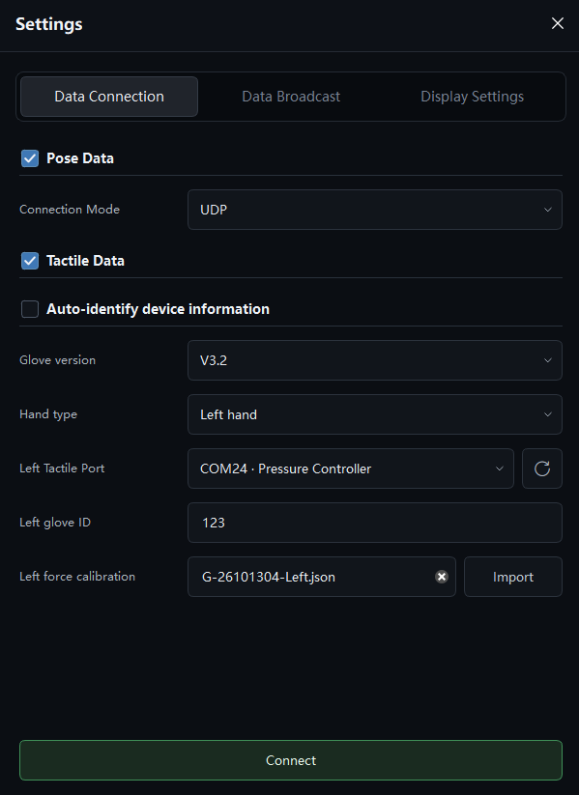
Figure 11. Data Connection page with Auto-identify device not selected.
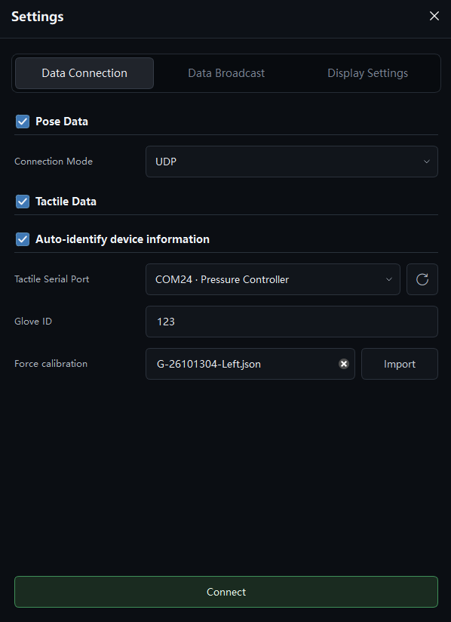
Figure 12. Data Connection page with Auto-identify device selected.
State | Port lists | Button
Factory default, no device | Both show Not Connected | Connect
Connected | COM port of each glove in use | Disconnect

- Select Tactile Data. Leave Pose Data cleared.
- Select the Glove Version shown on the wrist label. The default is V3.1; change it if your glove is V3.0, V3.2, V3.3, or V3.4. The V3.2 setting also applies to V3.3 and V3.4 gloves.
- Select the COM port for each glove you use. In single-hand mode, only that hand's settings are shown. In dual-hand mode, set a port for each hand.
- Leave Tactile Baud Rate at 2000000.
- Enter the Device Code from the left glove's label in Left Glove ID, and from the right glove's label in Right Glove ID. If you use only one hand, leave the other field empty.
- Import Left Force Calibration and Right Force Calibration.
- Click Connect at the bottom. The button changes to Disconnect.
- Optional: click Auto Detect. If the glove firmware reports device information, the software reads the version and hand automatically, so you do not need to enter them.
Check Tactile Status in the status bar shows Connected and the COM port in use.

Glove version | Points per hand | Symptom if the wrong version is selected
V3.0 | 415 | Wrong heatmap shape; calibration import reports a channel count mismatch.
V3.1 | 401 | Same as above.
V3.2 / V3.3 / V3.4 | 562 | Same as above. The thumb has 90 hardware channels, of which 82 valid points are exported.

Important When both gloves are connected, each must use a different COM port.

7. Force Calibration and Tactile Zeroing
Force calibration, calibration import, and tactile zeroing serve different purposes at different stages.
Function | Purpose | Performed by | When
Force Calibration | Maps raw sensor ADC values to actual force. | FULAI (usually) | At the factory. If needed, a technician or customer can recalibrate with FULAI guidance.
Import (Left / Right Force Calibration) | Loads a glove's calibration parameters into the software. | User or system integrator | After changing computers, reinstalling the software, or changing gloves.
Tactile Zero | Removes the sensor offset in the current unloaded state. | User | After putting on or reconnecting the glove, and before each recording session.

7.1 Importing Force Calibration
Each glove ships with its own force calibration files, typically named <Device Code>_left.json and <Device Code>_right.json. Before importing, enter the matching Left Glove ID or Right Glove ID; otherwise the software asks you to enter the Glove ID first.
Import a separate file for each hand. The file's channel count must match the selected Glove Version, or the import fails.
If no glove-specific file is imported, the software uses its built-in default calibration: the status bar shows Default and the settings page shows Not Imported. The default calibration still outputs force and pressure, but the values are not specific to your glove. Import the glove's own calibration file before any quantitative recording.
After a successful import, the status changes to Imported and the file is saved locally to:
%APPDATA%\FULAI\Fulai_Tactile_Glove\tactile_calibration\<Glove ID>\<Version>\left.json
%APPDATA%\FULAI\Fulai_Tactile_Glove\tactile_calibration\<Glove ID>\<Version>\right.json

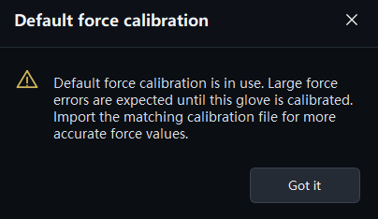
Figure 13. Default calibration notice. Import the glove-specific calibration file before quantitative recording.
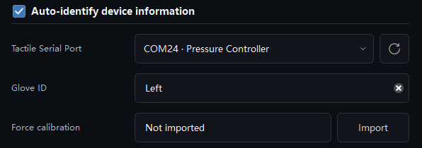
Figure 14. When no glove-specific calibration file has been imported, the Force calibration field shows Not imported. Import a calibration file for each hand separately.

7.2 Tactile Taring
Tactile Taring is the first icon in the title bar (see Figure 3).
- Check that Tactile Status in the status bar shows Connected.
- Open your hand naturally. Do not press on any object or make a fist.
- Click Tactile Taring (circular-arrow icon) in the title bar. When the icon briefly turns green, taring is complete.
Check With no load, the heatmap is almost blank. When you press lightly, the heatmap and zone force plots rise immediately.

Note Zeroing is not available in Demo Mode. Zero again after reconnecting the controller, changing users, or putting the glove back on.

8. Main Window
The main window consists of four areas: the tactile view, the zone force plots, the Recording panel, and the status bar. Zone force plots are displayed separately for each hand and each sensing zone, in Newtons (N). If the right-hand panel extends beyond the window, scroll down to view the remaining plots and the Recording panel. The window title updates automatically to reflect the enabled data types.
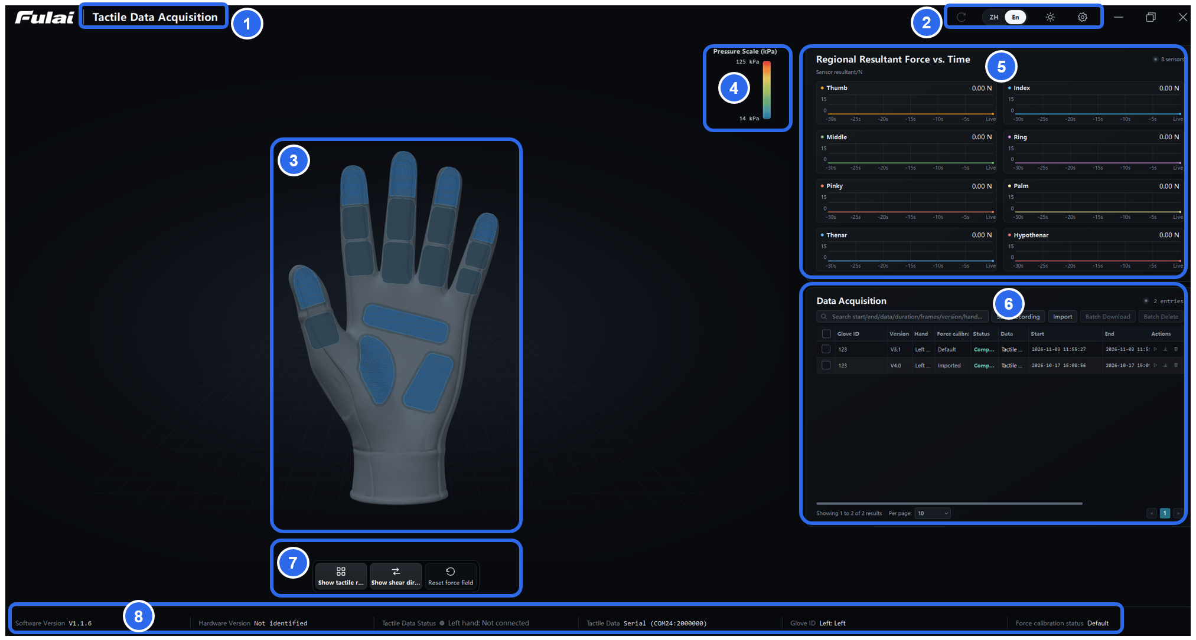
Figure 15. Main window. Left: tactile view. Right: zone force plots, with the Recording panel below. Bottom: status bar.
No. | Area | Description
① | Title | Changes with the enabled data types: Tactile Data Acquisition (tactile only), Hand Pose Data Acquisition (pose only), Tactile and Hand Pose Data Acquisition (both), or Data Acquisition (neither).
② | Title bar buttons | From left to right: Tactile Zero (circular arrow), language switch (Chinese / English), Settings, Minimize, Maximize, Close.
③ | 3D hand / point map | Shows the pressure heatmap. When pose data is enabled, also shows the hand pose.
④ | Pressure color scale | Pressure range of the current heatmap, in kPa.
⑤ | Zone force plots | Force over time for each hand and sensing zone, in N.
⑥ | Recording panel | Start and stop recording, play back, import, and export.
⑦ | Toolbar | Display toggles such as tactile zones and shear direction.
⑧ | Status bar | Software version, hardware version, connection status, COM port, left and right Glove IDs, and force calibration status.

Figure 16. Title example.
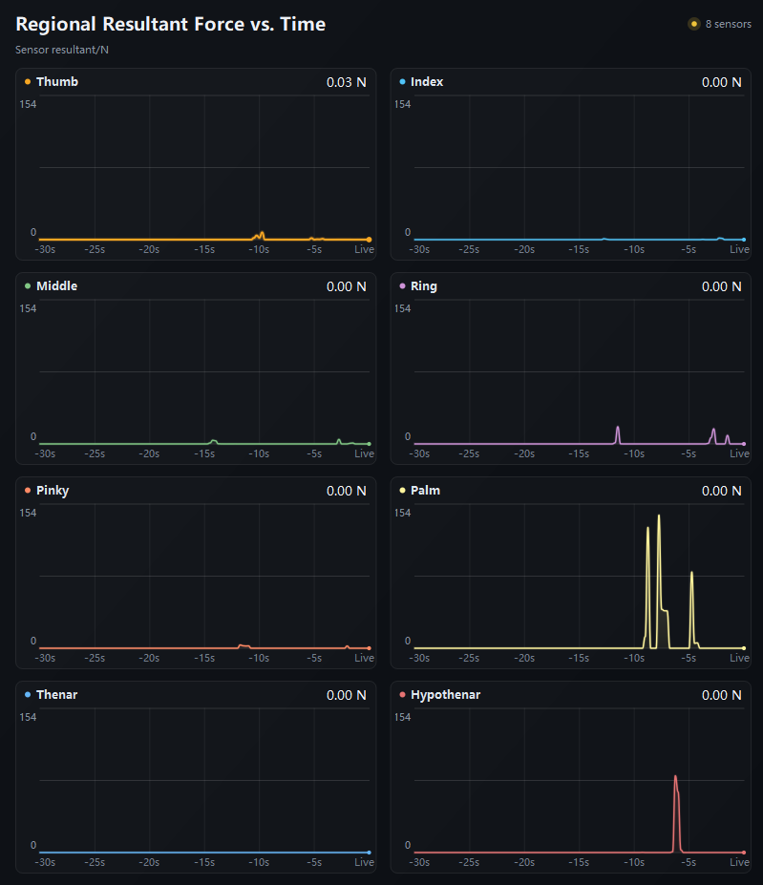
Figure 17. Zone force plots. Each sensing zone has its own plot showing force over time, in N.
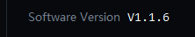
Figure 18. Software version in the status bar.
Figure 19. Tactile Status in the status bar, shown here as not connected.
Figure 20. Left and right Glove IDs in the status bar.
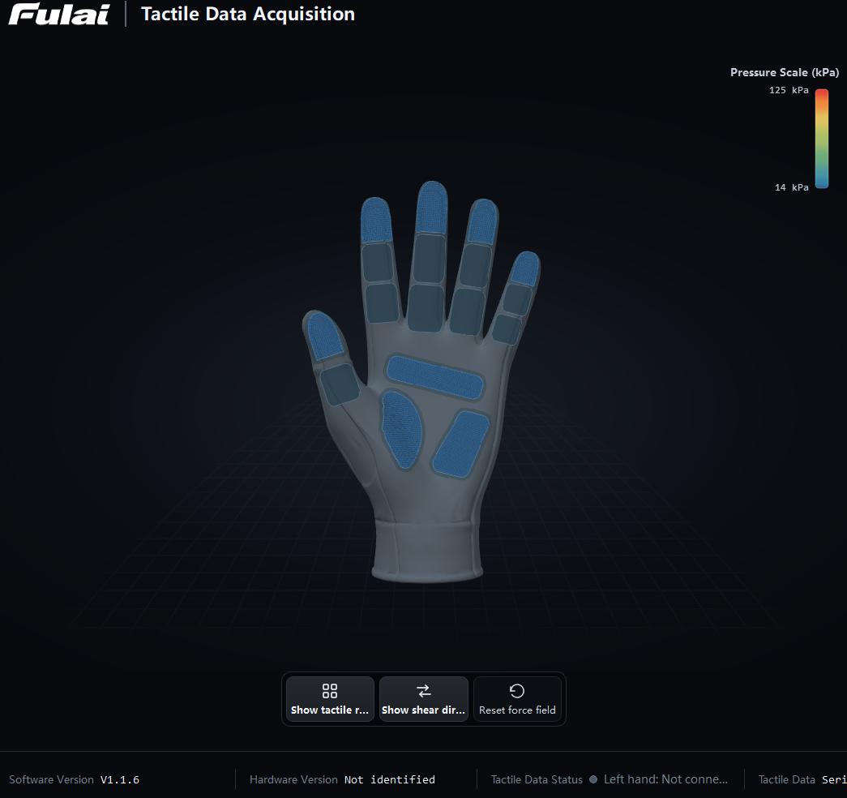
Figure 21. Tactile view and toolbar.

8.1 Toolbar
Button | Available | Function
Show Pressure Layer | Always | Show or hide the heatmap.
Show Tactile Zones | Always | Show or hide the tactile coverage zones.
Show Shear Direction | Always | Show or hide the shear force arrows.
Animations | Demo Mode only | Select a built-in motion.
Loop Single | Demo Mode only | Switch the demo playback mode.
Show Skeleton | Pose data enabled | Show the skeleton reference.
Calibrate Neutral Pose (R) | Pose data enabled | Reset to the neutral pose. Shortcut: R.
Full Software Calibration | Pose data enabled | 7-step range-of-motion and thumb contact calibration.
Reconnect Glove | Pose data enabled | Reconnect the pose device.
Reset View | Pose data enabled | Reset the 3D view. You can also double-click with the left mouse button.
Reset Force View | Always | Restore the default view of the tactile display.

8.2 Mouse Controls
Input | Action
Left-drag | Rotate
Right-drag or middle-drag | Pan
Scroll wheel | Zoom
Left double-click | Reset view

8.3 Keyboard Shortcuts
Key | Action
R | Calibrate Neutral Pose (pose mode only, when the button is visible)

9. Interpreting the Pressure Heatmap and Zone Force Plots
The pressure heatmap color-codes the pressure at each taxel, with warmer colors indicating higher pressure. By default, taxels below 5 kPa are not colored, and taxels at or above 125 kPa are shown at full saturation. These thresholds affect only the visualization; they do not alter the recorded data.
The zone force plots show the total normal force in each sensing zone, in newtons (N), and are not clipped by the heatmap’s upper threshold. Both the glove-specific calibration and the built-in default calibration produce pressure values, but only the glove-specific calibration should be used for quantitative analysis.
Symptom | Solution
No heatmap when pressing | Verify that the device is connected and data is updating. If you need to re-zero, remove all external load first, run Tactile Zero with the glove unloaded, then reapply load and check the response. If the data changes but the heatmap appears faint, make sure Show Pressure Layer is enabled and check the heatmap thresholds.
High pressure with no external force | Hold your hand open without touching anything. Inspect the glove for localized pressure points, fabric wrinkles, or mounting preload, and confirm that the selected glove version matches the calibration file. Then run Tactile Zero again and check both the numerical values and the heatmap. If the issue persists, suspend quantitative data acquisition and contact FULAI support.

10. Recording, Playback, and Data Management
Record from the Recording panel (Figure 4). Before you start, check Tactile Status in the status bar (Figure 5) and zero the sensors.

10.1 Recording
- Make sure the tactile gloves are connected and zeroed. Scroll down the right-hand panel to the Recording panel.
- Click Start Recording. The new recording shows the status Recording.
- When you have finished, click Stop Recording.
- Search, browse, play back (0.5× / 1.0× / 1.5× / 2.0×), export to CSV, or delete recordings as needed.
Check After you stop, the status changes to Completed, and the recording can be played back and exported.

Important A recording in progress cannot be played back or deleted. Deleted recordings cannot be recovered.
Export important data right after recording and check the file. Do not rely on the recording list in the software as your only backup.

10.2 Recording Rate and Duration
Item | Value
Recording rate | Live: saved as device data arrives. Demo: approx. 30 Hz.
Recording duration | No limit
Number of recordings | No limit; depends on free disk space
Recording stops when | You click Stop Recording, the device disconnects, or the disk is full
CSV layout | One row per sample
File size | No fixed limit; depends on configuration, duration, and free disk space

10.3 Storage Location
Recordings are stored in a local database:
%APPDATA%\FULAI\Fulai_Tactile_Glove\acquisition_records.sqlite

All recording history is stored in this database file. If the file is deleted or the operating system is reinstalled, your recordings cannot be recovered. Export and back up important data promptly.
When you click Export, the save dialog opens in your Downloads folder by default. We recommend naming each CSV file after its recording ID, for example L-12.csv. Left- and right-hand data are written to a single CSV file and share a common Elapsed Time (s) column; if only one glove is connected, the columns for the other hand are filled with zeros. Each CSV file also includes the glove version and both Glove IDs. The software version is displayed in the status bar.
File size depends on the glove version, effective sampling rate, recording mode, and duration. Before a long session, check the available disk space and consider splitting the session into separate recordings for each phase of the experiment.

11. CSV Data Format
CSV files are UTF-8 encoded with a byte order mark (BOM). The first row contains the column names, and each following row is one sample. Per-point columns are named <Hand>_<Zone>_<Index>(kPa), for example Left_Thumb_01(kPa). Hardware channel numbers (A1, A2, …) are not used.
Columns fall into three groups: recording information, zone force and shear data, and per-point pressure data. Files normally contain columns for both hands. If only one glove is connected, the other hand's values are 0. The CSV does not contain joint angle data.

11.1 Recording Information Columns
Column | Description | Unit / values | Example
Record ID | ID of this recording | — | G-2026101609-Right
Source | Live or demo data | Live / Demo | Live
Recorded Data | Data types in this recording | — | Tactile Data Acquisition
Version | Glove version | — | V3.1
Left Glove ID | Left Glove ID from the settings | — | G-20260917-Left
Right Glove ID | Right Glove ID from the settings | — | G-20260909-Right
Force Calibration | Calibration source | Imported / Default | Imported
Hand | Hand selection | Left / Right / Both | Left
Start Time | Date and time of the sample | yyyy-MM-dd HH:mm:ss | 2026-09-11 15:19:33
Sample Index | Frame number | Starts at 0 | 0
Elapsed Time (s) | Time since recording started | s | 1.2333
Peak Pressure (kPa) | Highest pressure in the frame | kPa | 22.000
Active Sensors | Number of sensing points above 5 kPa in this sample | Count | 12

Active Sensors uses a fixed 5 kPa threshold that does not change with the heatmap display threshold. When you import an existing CSV, its Active Sensors values are kept; if they are missing, they are calculated with this threshold. Recordings from earlier versions are played back with their original counts.

11.2 Zone Force Columns
Each hand has 7 sensing zones, in this order: thumb, index, middle, ring, little finger, palm, and hypothenar, plus an optional thenar zone between the palm and hypothenar (not fitted by default). Each zone has 5 columns. Force is in N; shear magnitude and its X and Y components are relative values; shear direction is in degrees.
Column (example: left thumb) | Description | Unit
Left_Thumb_Force(N) | Total normal force in the zone | N
Left_Thumb_Shear(rel) | Shear magnitude | Relative
Left_Thumb_ShearDirection(deg) | Shear direction | Degrees
Left_Thumb_ShearX(rel) | Shear X component | Relative
Left_Thumb_ShearY(rel) | Shear Y component | Relative

11.3 Per-Point Columns
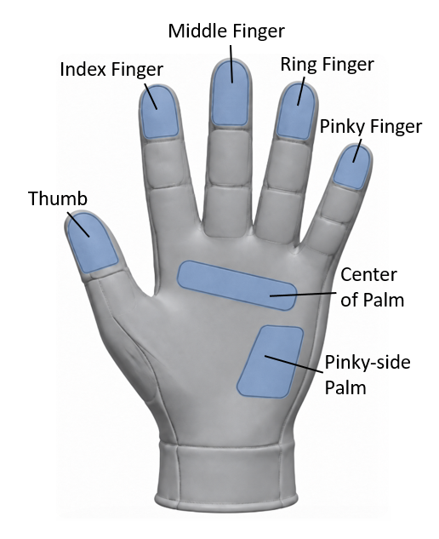
Figure 22. Sensing zone names.
Per-point columns follow the zone force columns and are in kPa. The software converts the tared ADC value of each point to force (N) using the force calibration, then to pressure (kPa) using the area of the point. Without a glove-specific file, the built-in default calibration is used and the units are the same. If the calibration appears abnormal, stop quantitative recording, check the file and glove version, and import it again.
Points are numbered from 01 within each zone. For example, on V3.2 / V3.3 / V3.4 gloves, the left thumb columns are Left_Thumb_01(kPa) to Left_Thumb_82(kPa); right-hand columns start with Right. Each hand is numbered separately and written in zone order.
On V3.2 / V3.3 / V3.4 gloves, the thumb has 90 hardware channels, of which the software exports 82 valid points. CSV files you import must contain an Elapsed Time (s) or elapsed_s column.
The table below lists the valid sensing points per zone and per hand for each glove version.
Version | Thumb | Index | Middle | Ring | Little | Palm | Thenar | Hypo-thenar | Total
V3.2 / V3.3 / V3.4 | 82 | 90 | 90 | 90 | 90 | 42 | 38 / 0* | 78 | 562
V3.1 | 50 | 50 | 50 | 50 | 50 | 42 | 37 | 72 | 401
V3.0 | 50 | 50 | 50 | 50 | 50 | 42 | 45 | 78 | 415

* The thenar zone is optional and not fitted by default. The total of 562 excludes it.

12. TCP / JSON Streaming
To stream tactile data to another application in real time, enable TCP output under Settings → Data Broadcast.
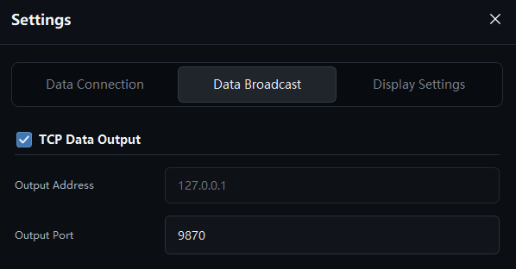
Figure 23. Data Broadcast settings. The software acts as a TCP server and is enabled by default at 127.0.0.1, port 9870.
Item | Description
Role | The FULAI software is the TCP server; your application connects as a client.
Default state | Enabled. Disable it if you do not need to stream data.
Default address / port | 127.0.0.1:9870
Encoding | UTF-8
Format | JSON Lines: one JSON object per line, terminated by a newline
Protocol ID | tactile-glove-jsonl/1
Send interval | Pending data is sent in batches approximately every 8 ms. Actual output depends on device updates; each batch can contain one frame per hand.
Slow clients | If the client reads more slowly than data is sent, only the latest frame is kept. Missed frames are not resent.
Reconnection | Clients can reconnect at any time. On each new connection, the server first sends a meta message.

12.1 The meta Message
When a client connects, the server first sends a message with type set to meta. It describes the protocol, glove version, channel count, calibration source, and sensing zones. The example below shows selected fields; refer to the received message for the complete set.
{
"type": "meta",
"protocol": "tactile-glove-jsonl/1",
"channel_count": 401,
"glove_version": "v3.1",
"glove_id": "G-202609-099",
"calibration_source": "imported",
"zones": [
{ "name": "Thumb", "address": 1, "offset": 0, "count": 50 }
]
}

12.2 The frame Message
After the meta message, the server sends one frame message per hand for each data update.
Field | Description
type | Always frame.
seq | Incrementing sequence number.
timestamp | Unix time in seconds, with three decimal places.
hand | left or right.
glove_id | Glove ID. Left-hand frames carry the left Glove ID; right-hand frames carry the right Glove ID.
calibration_source | imported: glove-specific calibration. bundled: built-in default calibration. Check values_unit for the actual unit.
values | 1D array in hardware channel order. In N with a valid force calibration; otherwise tared ADC values. See values_unit. Its length equals channel_count in the meta message.
zones[].sum | Sum of all channels in the zone. See zone_value_unit.
zones[].shear | Relative shear value.
pose | Valid only when pose data is enabled and available for this hand. Ignore it for tactile-only use.
values_unit / zone_value_unit | N: valid force calibration. tared_adc: tared ADC values. Determine the unit from these fields, not from the calibration source.

Important With a valid force calibration, TCP values are point forces (N) in hardware channel order, while CSV per-point columns are pressures (kPa) in valid-point order. When the calibration source is bundled, the built-in default calibration is used. Always read the unit fields in your client; do not infer the unit from the calibration source alone.

13. Display Settings and Demo Mode
Open Settings → Display Settings. Changes take effect immediately and are saved automatically.
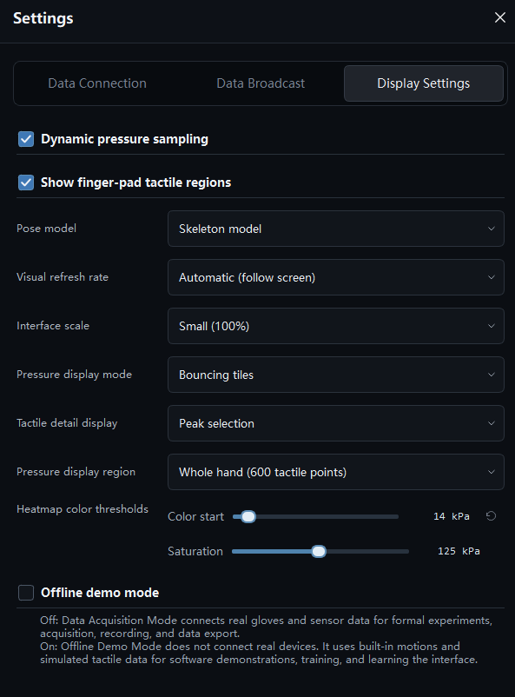
Figure 24. Display Settings.

When Offline Demo Mode is on, the software plays built-in motions with simulated tactile data and does not connect to a real device. Select a demo motion with Animations in the toolbar. Before recording real data, turn off Offline Demo Mode, check the connection status, and zero the sensors again.
Check When recording real data, the status bar must show Connected for the real device, not Demo Mode.

14. Pre-Recording Checklist
Check the following before each recording session. You can print this list for use in the lab.
 | Item
☐ | The Tactile Controller is plugged in and its COM port appears in Device Manager.
☐ | Tactile Data is selected under Settings → Data Connection. For tactile-only recording, Pose Data is cleared.
☐ | Glove Version matches the Model on the glove label.
☐ | Left Glove ID and Right Glove ID match the Device Code on each wrist label and are not swapped.
☐ | The force calibration for each glove is imported, and the status bar shows Imported.
☐ | Tactile Status in the status bar shows Connected.
☐ | Tactile Zero was run with the hand unloaded, and the icon briefly turned green.
☐ | Light pressure moves the heatmap and zone force plots together.
☐ | If streaming to another application, TCP output is on and the client can connect.
☐ | After recording, the CSV is exported and the Elapsed Time (s) column and Glove IDs are verified.

15. Troubleshooting
Problem | Solution
"Program is already running" message | Switch to the open window. You do not need to start the software again.
Software does not start or crashes | Check that the package was fully extracted. Add the folder to your antivirus allow list. Do not run the software from inside the archive.
Black 3D view | Update the graphics driver. Remote desktop sessions, virtual machines, and environments without hardware acceleration often cannot provide OpenGL 3.3; run the software on a local computer. If it still fails, click Copy Diagnostics (see Section 5.5).
No COM port | Try another USB port, install the serial driver, and click refresh in the software.
Port in use | Close other programs using the COM port, and make sure only one instance of the software is running.
Tactile disconnected or not detected | Reconnect the USB cable, refresh the COM port list, and check that the baud rate is 2000000.
Left / right port error | Do not select the same COM port for both hands. Assign a specific port to each hand.
No heatmap when pressing | Check that the device is connected and data is updating. To zero again, first remove all external load, zero in the unloaded state, then apply load again and check the response. If the data changes but the heatmap is faint, check that the pressure layer is on and review the heatmap thresholds.
High pressure with no external force | Open your hand without touching anything. Check the glove for local pressure points, wrinkles, or assembly preload, and confirm that the glove version and calibration file match. Then zero again and check both the values and the heatmap. If the problem persists, stop quantitative recording and contact FULAI support. Raising the display threshold only hides the problem; it does not remove abnormal pressure data.
Left and right heatmaps are swapped | Check the COM port and calibration file assigned to each hand. Confirm them against the wrist labels and import the correct files.
Force values are clearly wrong | Make sure the glove's own force calibration file is imported and the glove version matches. Without it, force and pressure data are not suitable for quantitative analysis.
Lag or stuttering | Turn off unnecessary display effects, split long sessions into shorter recordings, and make sure your TCP client reads data promptly.
Garbled characters in the CSV | The file is UTF-8 with BOM. In Excel, open it with Data → From Text/CSV and select UTF-8.
Can data from different gloves get mixed up? | No. Each glove has its own Glove ID and calibration file. Make sure you select the correct COM port for each glove.
Glove battery empty or wireless disconnection | Tactile data is transmitted through the wired USB controller. Check the controller's power supply, the USB connection, and the cables.
Recording tactile data only | Clear Pose Data and leave Tactile Data selected.
Using one hand only | Connect only the glove you need and set the other hand's port to Not Connected.

16. Default Settings

16.1 User Settings
Setting | Default
Heatmap thresholds (lower / upper) | 5 kPa / 125 kPa
Pressure display mode | Continuous Heatmap
Interface language | Chinese (English available)

16.2 Factory Connection Defaults
Setting | Default | Notes
Glove Version | V3.1 | If you use V3.0 or V3.2 / V3.3 / V3.4 gloves, select the version shown on the wrist label.
Left / Right Glove ID | Empty | Enter the Device Code from each glove's wrist label. Each glove has its own ID.
Right-hand tactile port | Not Connected (auto-detect on) | Changes to COMxx · Pressure Controller when the controller is plugged in.
Left-hand tactile port | Not Connected | Avoids occupying a second port. Select a COM port here when using the left hand only.
Tactile Baud Rate | 2000000 | Matches the controller.
TCP output | On, 127.0.0.1:9870 | Disable it if you do not need to stream data to other applications.

Important Do not change the baud rate or other communication settings unless instructed by FULAI support.

17. Technical Support
Contact FULAI support through your contract, packing list, or sales representative. When reporting an issue, include:
- Software version (shown in the status bar)
- Hardware version / glove version
- Left and right Glove IDs (the Device Code on each wrist label)
- Force calibration file names, and whether the status shows Imported
- Screenshots of the issue
- For 3D display problems, the text from Copy Diagnostics
Local file | Path
Recording database | %APPDATA%\FULAI\Fulai_Tactile_Glove\acquisition_records.sqlite
Imported calibration files | %APPDATA%\FULAI\Fulai_Tactile_Glove\tactile_calibration\

Appendix A. Hand Pose Tracking (Optional)
This appendix applies only if you use the optional hand pose tracking hardware to capture hand pose and joint angles. For tactile-only recording, you can skip it.
The software includes the pose SDK, so it can receive glove pose data directly through the wireless receiver without a third-party pose application. Input over UDP from a third-party pose application is also supported.
Connection mode | Requirements | Configuration
Wireless Receiver | Pose gloves and the matching USB wireless receiver | Select Wireless Receiver. The software finds and connects to the receiver automatically; no COM port, IP address, or port settings are needed.
UDP | A third-party pose application with broadcasting enabled | Enter the same IP address, joint angle port, and joint position port as the sender.

A.1 Connecting via the Wireless Receiver
- Plug the wireless receiver into a USB port on your computer and turn on the pose gloves. Close any third-party pose application or serial tool that might be using the receiver.
- Go to Settings → Data Connection, select Pose Data, set Connection Mode to Wireless Receiver, and click Connect. The software finds the receiver automatically; you do not need to select a COM port.
- Follow the connection check window to complete the power-on check, the preparation pose, and the fit check. When the gloves fit well and the sensors are in place, click I'm Wearing the Gloves.
- On first use, when no calibration profile is loaded, or when prompted, run R Quick Calibration. The countdown during the preparation pose is only a guide; it does not mean that hardware calibration has succeeded.
- Check that pose data is received continuously. Then open your hand, make a fist, and touch your thumb to each finger while watching the 3D model. If only Receiver Connected is shown, also check that the gloves are switched on and sending valid pose data.
- To record tactile data at the same time, also select Tactile Data, then connect the tactile gloves, import the force calibration, and zero the sensors (see Chapters 6 and 7).
Note Tactile zeroing and pose calibration are not interchangeable. Tactile Zero removes the unloaded tactile offset; pose calibration sets the hand pose reference.

A.2 Pose Calibration
Put on the gloves correctly before calibrating. If a recording is in progress, stop and save it first. After calibrating, check that the 3D model follows your hand before you start recording.
Calibration | When to use | Completion
R Quick Calibration | First use, no calibration profile, or neutral pose drift | Hold the guided pose steady until the software reports success.
Gesture Calibration | New user, or inaccurate open/close range or thumb-to-finger contact | Complete all 7 poses and the pinch check. The result is saved automatically.
Hardware Calibration | Abnormal sensor calibration status, or when requested by FULAI support | Follow the on-screen guide. Success is confirmed by the status check.

R Quick Calibration
- Click R Quick Calibration or press R, and check which hand the window shows. With one glove connected, position that hand. With both gloves online, position both hands as prompted.
- Keep your wrist straight, your fingers straight and together, and your thumb relaxed and slightly out to the side. You can rest your elbow on the table. Hold the pose shown in the window.
- Click Ready, Start R and hold still for about 3 seconds, until the software reports success. If calibration fails, correct the pose according to the message and try again.
- Relax your hand and check that the model follows when you open your hand and make a fist. If opening, closing, or pinching is still inaccurate, continue with Gesture Calibration.

Gesture Calibration
Click Gesture Calibration to open the calibration window, click Start Calibration, and follow the image and instructions for each step:
- Straight hand (neutral)
- Open hand (range of motion)
- Fist (range of motion)
- Pinch thumb and index finger
- Pinch thumb and middle finger
- Pinch thumb and ring finger
- Pinch thumb and little finger
For each pinch, touch the pad of your thumb to the pad of the indicated finger. Open your fingers when prompted, then pinch again to verify. Wait for the software to confirm each step before moving on; do not rush through the poses.
The result is saved automatically when calibration succeeds. If the software reports a pose conflict, sampling timeout, or data interruption, correct it as prompted and try again. The time required depends on how quickly each pose is completed.

A.3 Hardware Calibration
Hardware calibration is separate from R Quick Calibration and Gesture Calibration, which are done while wearing the gloves. To start it, open the magnetic calibration panel in the connection check window, then follow the Glove Hardware Calibration window.
- Take off the gloves and prepare the calibration box. Keep away from strongly magnetic objects.
- Click Start Hardware Calibration.
- Perform the steps in the order shown: restart the device, place it as instructed, and perform the figure-eight and six-face motions.
- When calibration succeeds, put the gloves back on and run R Quick Calibration.
Note On-screen animations and countdowns are only a guide. Calibration success is confirmed by the status check.

A.4 Connecting via UDP
- Start the third-party pose application, connect the pose device, and enable data broadcasting.
- In the FULAI software, go to Settings → Data Connection, select Pose Data, and set Connection Mode to UDP.
- Enter the IP address and ports configured on the sender. When both run on the same computer, the defaults are IP address 127.0.0.1, joint angle port 9011, and joint position port 9013. If you change them on the sender, change them here as well.
- Click Connect. Check that pose data updates continuously and that the 3D model follows your hand.
Note Calibrate third-party devices according to the manufacturer's instructions. The pose calibration options available in this software depend on the current connection mode.

A.5 Troubleshooting
Problem | Solution
Receiver not found | Check the USB connection, close any program using the receiver, and connect again.
Receiver online, but pose does not update | Check that the gloves are on and charged. If raw data is received but the software reports no pose or no calibration profile, run R Quick Calibration as prompted.
Model is offset or pinching is inaccurate | Check the glove fit. Run R Quick Calibration first, then Gesture Calibration if needed.
Data interrupted during calibration | Restore the connection and try again as prompted. The end of a countdown does not mean that calibration succeeded.
No joint angles in the CSV | CSV export contains tactile data only and has no joint angle columns. Enabling pose data does not change the export format.

Appendix B. Glossary
Term | Definition
Sensing zone | A tactile coverage area: a fingertip, the palm, the hypothenar, or the optional thenar. Each hand has 7 zones.
Sensing point | A single valid sampling point within a sensing zone.
Pressure | Point force divided by the area of the point, in kPa.
Zone force | Total normal force in a sensing zone, in N.
Tactile Zero (Taring) | Captures the unloaded baseline to remove the current sensor offset.
Force calibration | The mapping from sensor signals to force.
Active sensors | Number of sensing points above 5 kPa in a sample.
Relative shear | Tangential force estimated by the software; not yet calibrated in N.
FS (full scale) | The upper limit of the measurement range.
Wireless receiver | USB device that receives wireless data from the pose gloves.
R Quick Calibration | Sets or resets the hand pose reference using the neutral pose. Not the same as Tactile Zero.
Gesture Calibration | Fits the range of motion and thumb-to-finger contact to the current user, using 7 poses and a pinch check.
UDP | Method for receiving data broadcast by a third-party pose application over the network. The address and ports must match the sender.

