Logical Scheme
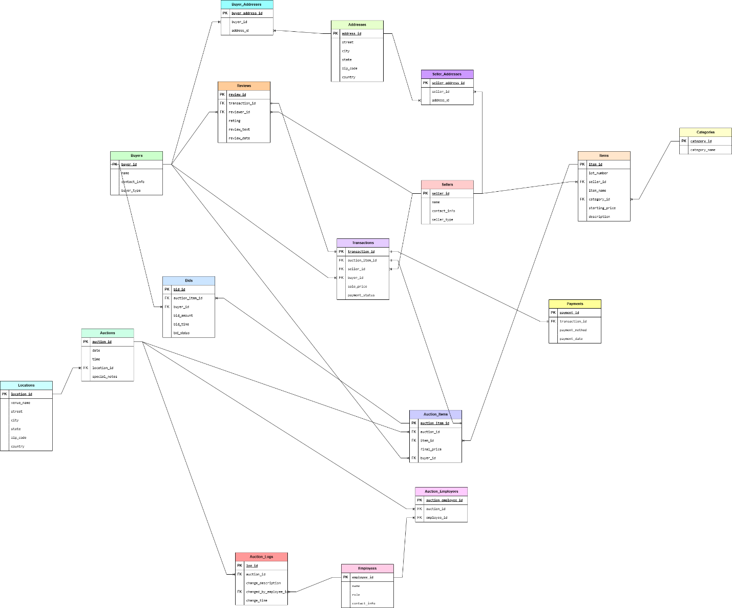

Objects

1. Table Description
Stores information about sellers who list items for auction.

Table Name | Field name | Field Description | Data Type
Sellers | seller_id | Unique ID for the seller, PK | INT (AUTO_INCREMENT)
 | name | Seller's name | VARCHAR(255), NOT NULL
 | contact_info | Seller's contact details | VARCHAR(255), NOT NULL
 | seller_address_id | References Seller_Addresses table, FK | INT
 | seller_type | Indicates if seller is Individual/Company | ENUM('Individual', 'Company'), NOT NULL

Sellers to Seller_Addresses, One-to-Many Relationship

Example with data

seller_id | name | contact_info | seller_address_id | seller_type
1 | Charles Johnson | +7(701)-123-4567 | 5 | Individual
2 | American Antiques | +7(771)-765-4321 | 8 | Company

2. Table Description
Stores information about buyers who purchase auctioned items.

Table Name | Field name | Field Description | Data Type
Buyers | buyer_id | Unique ID for the buyer, PK | INT (AUTO_INCREMENT)
 | name | Buyer's name | VARCHAR(255), NOT NULL
 | contact_info | Buyer's contact details | VARCHAR(255), NOT NULL
 | buyer_address_id | References Buyer_Addresses table, FK | INT
 | buyer_type | Indicates if buyer is Individual/Company | ENUM('Individual', 'Company'), NOT NULL

Buyers to Buyer_Addresses, One-to-Many Relationship

Example with data

buyer_id | name | contact_info | buyer_address_id | buyer_type
1 | Chloe Black | +7(701)-567-8910 | 3 | Individual
2 | The History Savers | +7(771)-897-1065 | 11 | Company

3. Table Description
Stores the addresses of sellers to avoid redundancy.

Table Name | Field name | Field Description | Data Type
Seller_Addresses | seller_address_id | Unique ID for the address, PK | INT (AUTO_INCREMENT)
 | seller_id | References Sellers table, FK | INT
 | address_id | References Addresses table, FK | INT

Links Sellers and Addresses, representing a Many-to-Many relationship.

Example with data

seller_address_id | seller_id | address_id
1 | 789 | 321
2 | 456 | 951

4. Table Description
Stores the addresses of buyers to avoid redundancy.

Table Name | Field name | Field Description | Data Type
Buyer_Addresses | buyer_address_id | Unique ID for the address, PK | INT (AUTO_INCREMENT)
 | buyer_id | References Buyers table, FK | INT
 | address_id | References Addresses table, FK | INT

Links Buyers and Addresses, representing a Many-to-Many relationship.

Example with data

buyer_address_id | buyer_id | address_id
1 | 542 | 471
2 | 1001 | 59

5. Table Description
Stores the addresses of buyers and sellers to avoid redundancy.

Table Name | Field name | Field Description | Data Type
Addresses | address_id | Unique ID for the address, PK | INT (AUTO_INCREMENT)
 | street | Street name and number | VARCHAR(255), NOT NULL
 | city | City name | VARCHAR(100), NOT NULL
 | state | State or region | VARCHAR(100), NOT NULL
 | zip_code | ZIP or postal code | VARCHAR(20), NOT NULL
 | country | Country | VARCHAR(100), NOT NULL

Addresses to Seller_Addresses & Buyer_Addresses, One-to-Many relationship

Example with data

address_id | street | city | state | zip_code | country
1 | 383 Kennedy | Springfield | Illinois | 62701 | USA
2 | 543 Winter | Salt Lake City | Utah | 84101 | USA

6. Table Description
Stores details of items that are auctioned.

Table Name | Field name | Field Description | Data Type
Items | item_id | Unique ID for each item, PK | INT (AUTO_INCREMENT)
 | lot_number | Unique identifier for an item | VARCHAR(50), UNIQUE, NOT NULL
 | seller_id | References Sellers table, FK | INT
 | item_name | Name of the item | VARCHAR(255), NOT NULL
 | category_id | References Categories table, FK | INT
 | starting_price | Initial auction price | DECIMAL(10,2) CHECK(starting_price > 0), NOT NULL
 | description | Description of the item | TEXT

Sellers to Items, one seller can have multiple items, but each item belongs to one seller

Example with data

item_id | lot_number | seller_id | item_name | category_id | starting_price | description
1 | AJ200870 | 6 | Chanel Sac a Rabat Flap Bag | 5 | 1500.00 | Chanel 'Sac a Rabat' flap bag in marine fonce satin with canted squares of dark blue sequin quilted pattern.
2 | LR489034 | 10 | US Coin Assortment | 3 | 1200.00 | NULL

7. Table Description
Stores different item categories to prevent data duplication.

Table Name | Field name | Field Description | Data Type
Categories | category_id | Unique ID for each category, PK | INT (AUTO_INCREMENT)
 | category_name | Name of the category | VARCHAR(255), UNIQUE

Categories to Itmes, a category can have many items, an item belongs to one category

Example with data

category_id | category_name
3 | Jewelry
5 | Coins

8. Table Description
Stores details of auctions where items are sold.

Table Name | Field name | Field Description | Data Type
Auctions | auction_id | Unique ID for each auction, PK | INT (AUTO_INCREMENT)
 | date | Date of the auction | DATE, NOT NULL
 | time | Time of the auction | TIME, NOT NULL
 | location_id | References Locations table, FK | INT
 | special_notes | Additional auction details | TEXT

Auctions to Locations, each auction takes place at one location, but a location can host multiple auctions
Example with data

auction_id | date | time | location_id | special_notes
1 | 2025-03-14 | 09:00:00 | 3 | Charity Auction
2 | 2019-10-09 | 12:00:00 | 11 | NULL

9. Table Description
Stores the locations where auctions take place.

Table Name | Field name | Field Description | Data Type
Locations | location_id | Unique ID for each location, PK | INT (AUTO_INCREMENT)
 | street | Street address | VARCHAR(255), NOT NULL
 | city | City name | VARCHAR(100), NOT NULL
 | state | State or region | VARCHAR(100), NOT NULL
 | zip_code | Postal code | VARCHAR(20), NOT NULL
 | country | Country | VARCHAR(100), NOT NULL

Auctions to Locations, each auction takes place at one location, but a location can host multiple auctions

Example with data

location_id | street | city | state | zip_code | country
3 | 780 Greg | Carson City | Nevada | 89701 | USA
11 | 8827 152b | Edmonton | Alberta | T5A 0A1 | Canada

10. Table Description
Links auctions and items, representing a Many-to-Many relationship.

Table Name | Field name | Field Description | Data Type
Auction_Items | auction_item_id | Unique ID for the buyer, PK | INT (AUTO_INCREMENT)
 | auction_id | Buyer's name | INT
 | item_id | Buyer's contact details | INT
 | final_price | References Addresses table, FK | DECIMAL(10,2) CHECK(final_price > 0), NOT NULL
 | buyer_id | Indicates if buyer is Individual/Company | INT

Buyers to Auction_Items, a buyer can purchase multiple auctioned items, and an item can be purchased by one buyer
Auction_Items to Auctions & Items, Many-to-Many relationship between auctions and items is handled via the Auction_Items table
Example with data

auction_item_id | auction_id | item_id | final_price | buyer_id
1 | 5 | 51 | 3000.00 | 871
2 | 9 | 13 | 1500.00 | 47

11. Table Description
Stores financial records of completed sales for auctioned items.

Table Name | Field name | Field Description | Data Type
Transactions | transaction_id | Unique ID for each transaction, PK | INT (AUTO_INCREMENT)
 | auction_item_id | References Auction_Items table, FK | INT
 | seller_id | References Sellers table, FK | INT
 | buyer_id | References Buyers table, FK | INT
 | sale_price | Final sale price of the item | DECIMAL(10,2) CHECK(sale_price > 0), NOT NULL
 | payment_status | Status of payment | ENUM ('Pending', 'Completed', 'Cancelled'), NOT NULL

Transactions to Auction_Items, Sellers, Buyers, each transaction is linked to an auctioned item, a seller, and a buyer

Transactions to Payments, One-to-One Relationship, transaction_id is a FK in the Payments table

Example with data

transaction_id | auction_item_id | seller_id | buyer_id | sale_price | payment_status
36 | 57 | 38 | 3 | 8999 | Completed
95 | 360 | 78 | 11 | 1785 | Pending

12. Table Description
Stores information about buyers who purchase auctioned items.

Table Name | Field name | Field Description | Data Type
Bids | bid_id | Unique ID for each bid, PK | INT (AUTO_INCREMENT)
 | auction_item_id | References Auction_Items table, FK | INT
 | buyer_id | References Buyers table, FK | INT
 | bid_amount | Amount offered for the item | DECIMAL(10,2) CHECK(bid_amount > 0), NOT NULL
 | bid_time | Timestamp of the bid | TIMESTAMP DEFAULT CURRENT_TIMESTAMP
 | bid_status | Current status of the bid | ENUM ('Active', 'Winning', 'Rejected') DEFAULT 'Active'

Bids to Auction_Items & Buyers, Many-to-Many relationship between buyers and auction items is handled via the Bids table

Example with data

bid_id | auction_item_id | buyer_id | bid_amount | bid_time | bid_status
55 | 89 | 101 | 6500.00 | 2010-05-12 15:24:45 | Active
312 | 127 | 97 | 2200.00 | 2025-03-12 09:30:01 | Winning

13. Table Description
Stores details of auction house employees.

Table Name | Field name | Field Description | Data Type
Employees | employee_id | Unique ID for each employee, PK | INT (AUTO_INCREMENT)
 | name | Employee's name | VARCHAR(255), NOT NULL
 | role | Role in the auction house | VARCHAR(100), NOT NULL
 | contact_info | Employee's contact details | VARCHAR(255), NOT NULL

Employees to Auction_Employees, Many-to-Many relationship between auctions and employees is handled via the Auction_Employees table

Example with data

employee_id | name | role | contact_info
3 | Daniel Smith | Manager | +7701-564-4578
7 | Noah Jackson | Manager | +771-951-7535

14. Table Description
Links employees to auctions they manage, representing a Many-to-Many relationship.

Table Name | Field name | Field Description | Data Type
Auction_Employees | auction_employee_id | Unique ID, PK | INT (AUTO_INCREMENT)
 | auction_id | References Auctions table, FK | INT
 | employee_id | References Employees table, FK | INT

Auction_Employees to Auctions & Employees, Many-to-Many relationship between auctions and employees is handled via the Auction_Employees table

Example with data

auction_employee_id | auction_id | employee_id
1 | 2 | 5
2 | 4 | 6

15. Description
Stores details of payments for auction transactions.

Table Name | Field name | Field Description | Data Type
Payments | payment_id | Unique ID for each payment, PK | INT (AUTO_INCREMENT)
 | transaction_id | References Transactions table, FK | INT, UNIQUE
 | payment_method | Mode of payment | ENUM ('Credit Card', 'Bank Transfer', 'PayPal', 'Cash'), NOT NULL
 | payment_date | Date of payment | DATE, NOT NULL

Payments to Transactions, each transaction has a corresponding payment (One-to-One relationship)

Example with data

payment_id | transaction_id | payment_method | payment_date
1 | 56 | Credit Card | 2024-08-07
2 | 15 | Cash | 2024-09-25

16. Table Description
Stores logs of changes made to auction records for tracking and security.

Table Name | Field name | Field Description | Data Type
Auction_Logs | log_id | Unique ID for each log, PK | INT (AUTO_INCREMENT)
 | auction_id | References Auctions table, FK | INT
 | change_description | Description of changes made | TEXT, NOT NULL
 | changed_by_employee_id | References Employees table, FK | INT
 | change_time | Timestamp of change | TIMESTAMP DEFAULT CURRENT_TIMESTAMP

Auction_Logs to Auctions & Employees, employees log changes made to auctions for tracking purposes.

Example with data

log_id | auction_id | change_description | changed_by_employee_id | change_time
71 | 17 | Cancelled the Transaction | 3 | 2025-01-02 15:56:47
95 | 23 | 4th bid:4500 | 11 | 2025-02-05 17:45:36
17. Table Description
Stores buyer and seller reviews on transactions.

Table Name | Field name | Field Description | Data Type
Reviews | review_id | Unique ID for each review, PK | INT (AUTO_INCREMENT)
 | transaction_id | References Transactions table, FK | VARCHAR(255), NOT NULL
 | reviewer_id | ID of the buyer or seller who submitted the review | VARCHAR(255), NOT NULL
 | reviewer_type | Specifies if reviewer is Buyer or Seller | ENUM ('Buyer', 'Seller')
 | rating | Rating given (1-5) | INT CHECK(rating BETWEEN 1 AND 5)
 | review_text | Text review content | TEXT
 | review_date | Date of review submission | DATE DEFAULT CURRENT_DATE

Reviews to Transactions, each transaction can have one review from either a buyer or a seller.

Example with data

review_id | transaction_id | reviewer_id | reviewer_type | rating | review_text | review_date
36 | 85 | 56 | Buyer | 5 | I’m glad that I’ve purchased that | 2017-07-30
52 | 75 | 85 | Seller | 3 | NULL | 2019-02-07

