# Tourism

The aim of this report is to examine why tourism is important for the economy and furthermore to brief about cities where tourists spend most money. It will also discuss some negative aspects of tourism.

## Tourism is important for the world

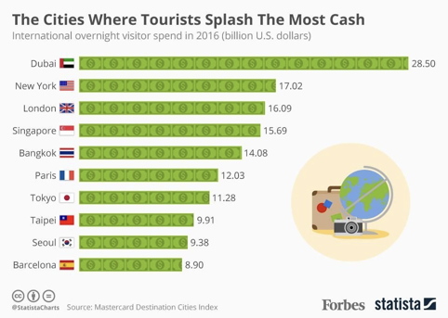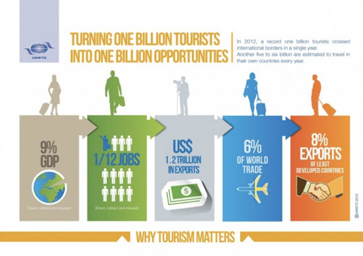Every year numerous people engage in tourism. In 2012, about one billion tourists travelled around the world. The United Nations World Tourism Organization published data on the importance of tourism: In fact, 9% of the global GDP are generated in tourism, which is $7.200 billion. One out of 12 jobs is created in the tourism sector. There is a variety of jobs: from pilots to cleaners, from food servers to hotel managers, from builders to airport staff, both skilled and unskilled laborers will find interesting job opportunities in tourism.

Furthermore, travelling is one way of creating understanding for foreign cultures and thus facilitate peace and tolerance in multicultural societies.

## Cities where tourist spend the most cash

Statistical data indicates that Dubai is the city where tourists spend the most money– mostly with their credit cards. People spend so much money in Dubai, because the main attractions are fancy malls that offer the most luxurious of high-end products. So, persons have to spend more money if they go shopping, have dinner or indulge in other activities.

## Downsides

Tourism does not only create jobs or business opportunities, it also has its negative aspects. If people travel a lot, they often travel by plane or by car, thus polluting the atmosphere with carbon emissions which trigger /cause climate change. From the Great Barrier Reef to the Brazilian rain forests, from European cities to the Arctic – sensitive areas are destroyed by tourists who come to see their beauty.

In conclusion, tourism is such a major part and opens many doors for people who may not have a job and need to enter the workforce. However, tourism has become so intense that environmental issues are now very serious – it is time to think about the environment and minimize pollution.