# Report on iPhone Sales from 2007 to 2018

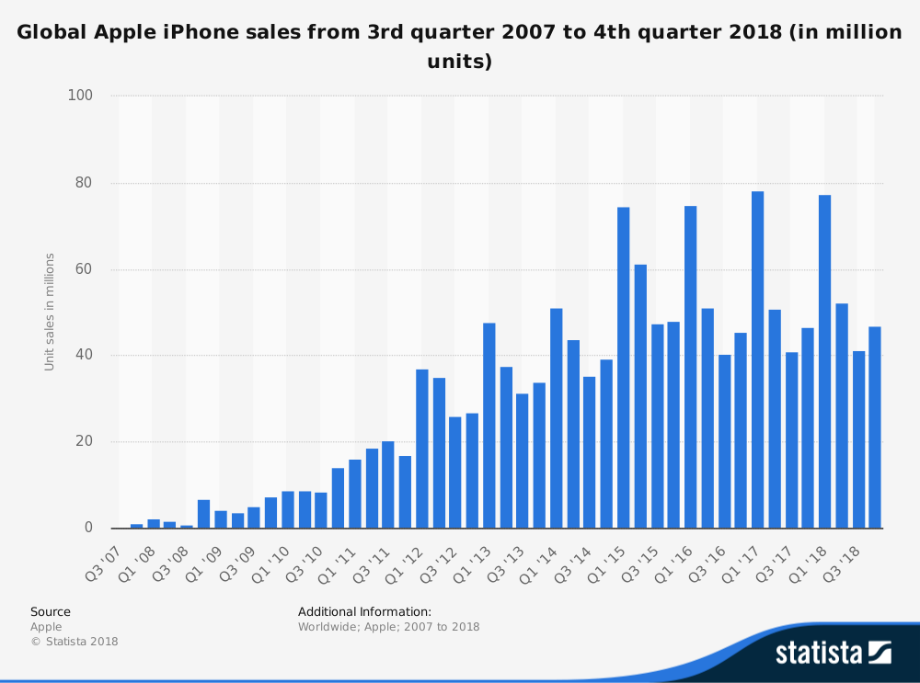

## Analysing the Statistics

This statistic shows Apple iPhone sales worldwide from the third quarter of 2007 to the company's most recent financial quarter. In the fourth quarter of 2018, 46.89 million iPhones were sold worldwide. In the 2017 fiscal year, Apple sold 216.76 million iPhones. As you can see there was a huge increase in iPhone sales. That is because in 2007 brands like Nokia and Blackberry owned 90% of the market share, while brands like Apple and Samsung were growing competitors. Nokia and Blackberry missed the smartphone upswing, because they thought that touchscreen technology would not be the next “big thing”.

Apple iPhone – additional Information   
The first generation of Apple iPhones was introduced in late 2007, bringing innovative features such as a touch screen interface and a virtual keyboard to a broader audience. The touchscreen technology was not new, in fact in the late 1990s when it was first implemented in a phone, it was not popular. Considered by many as a revolutionary product, the Apple iPhone drove the enormous growth of the smartphone market. Since its introduction to the consumer market, Apple has released eleven generations of the product, along with new features and updates. The iPhone runs on Apple’s own mobile operating system iOS, the second most widely used smartphone operating system in the market. In 2017, the iPhone made Apple the second-largest smartphone vendor in the world, with a global market share of almost 15% percent.   
  
The iPhone has changed Apple’s business dramatically. iPhone sales have risen strongly over the years, from around 1.4 million iPhones sold in 2007 to more than 216 million units worldwide in 2017. In total, Apple has sold more than one billion iPhones worldwide from 2007 to 2017. In the first quarter of 2018, iPhone sales accounted for about 70 percent of Apple’s total revenue, generating more than 61 billion U.S. dollars in revenues.

Right now, there is a down trend in iPhone sales, which is probably due to the very high prices and lack of innovation.